**BCSE203E WEB PROGRAMMMING**

**LAB EXERCISE -6**

**CSS**

**NAME: M.MENMANGAI**

**REGISTRATION NO: 23BCE1022**

**1.Apply styles using INLINE CSS to the below table (3 marks) Add pseudo-class to make initial cap using internal CSS**



**CODE:**

<!DOCTYPE html>

<html>

<head>

    <title>23BCE1022</title>

    <style>

        li::first-letter {

            text-transform: uppercase;

            color: rgb(72, 143, 193);

            font-size: larger;

        }

        li::marker {

            color: #a6acaf ;

        }

    </style>

</head>

<body>

    <table style="border: 2px solid orange; width: 35%; margin: auto; text-align: left;">

            <tr>

                <th style="background-color: orange; color: white; padding: 10px; text-align: left;font-size: larger;"><strong>LEARN DATA SCIENCE!</strong></th>

            </tr>

            <tr>

                <td>

                    <ul style="list-style-type: disc;">

                        <li style="color: rgb(72, 143, 193);font-size: larger;"><strong>unlimited jobs</strong></li>

                        <li style="color: rgb(72, 143, 193);font-size: larger;"><strong>best benefits anywhere</strong></li>

                        <li style="color: rgb(72, 143, 193);font-size: larger;"><strong>call now for an appointment</strong></li>

                    </ul>

                </td>

            </tr>

    </table>

</body>

</html>

**OUTPUT:**



**2. Design a calculator as the image shown below. Create an EXTERNAL file "calc.css" using class and ID selector for table to apply style using font and background. Link the "calc.css" file to the "calculator.html" file. Also, use suitable property to change the color of the buttons when mouse over the buttons.**

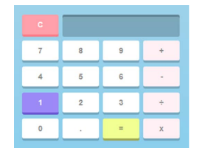

**CODE:**

**calculator.html**

<!DOCTYPE html>

<html>

    <head>

        <title>23BCE1022</title>

        <link rel="stylesheet" href="calc.css">

    </head>

    <body>

        <table id="calc">

            <tr>

                <td><input id="valc" type="button" value="C"></td>

                <td colspan="3"><input id="blanc" type="text" id="result"></td>

            </tr>

            <tr>

                <td><input class="strong" type="button" value="7"></td>

                <td><input class="strong" type="button" value="8"></td>

                <td><input class="strong" type="button" value="9"></td>

                <td><input class="strong1" type="button" value="+"></td>

            </tr>

            <tr>

                <td><input class="strong" type="button" value="4"></td>

                <td><input class="strong" type="button" value="5"></td>

                <td><input class="strong" type="button" value="6"></td>

                <td><input class="strong1" type="button" value="-"></td>

            </tr>

            <tr>

                <td><input class="strong" type="button" value="1"></td>

                <td><input class="strong" type="button" value="2"></td>

                <td><input class="strong" type="button" value="3"></td>

                <td><input class="strong1" type="button" value="÷"></td>

            </tr>

            <tr>

                <td><input class="strong" type="button" value="0"></td>

                <td><input class="strong" type="button" value="."></td>

                <td><input id="valeq" type="button" value="="></td>

                <td><input class="strong1" type="button" value="x"></td>

            </tr>

        </table>

    </body>

</html>

**calc.css**

#calc{

    border: 2px solid #aed6f1;

    background-color: #aed6f1;

    margin-left: 20px;

    margin-right: 20px;

    margin-top: 20px;

    margin-bottom: 20px;

    width: 280px;

    height: 450px;

    padding-left: 10px;

    padding-right: 10px;

    padding-top: 10px;

    padding-bottom: 10px;

}

#valc{

    width: 100%;

    padding: 20px 40px;

    background-color:#f1948a;

    color: white;

    font-size: 20px;

    font-weight: bold;

    border: none;

    border-radius: 5px;

}

#valc:hover{

    background-color: #bb8fce;

}

#valeq{

    width: 100%;

    padding: 20px 40px;

    background-color:#f7dc6f;

    color: black;

    font-size: 20px;

    font-weight: bold;

    border: none;

    border-radius: 5px;

}

input.strong{

    width: 100%;

    padding: 20px 40px;

    background-color:white;

    color: black;

    font-size: 20px;

    font-weight: bold;

    border: none;

    border-radius: 5px;

    box-shadow: 0px 4px 6px rgba(0, 0, 0, 0.3);

}

#blanc {

    padding: 20px 30px;

    font-size: 24px;

    font-weight: bold;

    border: none;

    border-radius: 5px;

    border: 2px solid #5499c7 ;

    background-color: #5499c7 ;

    text-align: right;

    color: white;

    box-shadow: 0px 4px 6px rgba(0, 0, 0, 0.3);

}

input.strong:hover

{

    width: 100%;

    padding: 20px 40px;

    background-color:#bb8fce;

    color: white;

    font-size: 20px;

    font-weight: bold;

    border: none;

    border-radius: 5px;

    box-shadow: 0px 4px 6px rgba(0, 0, 0, 0.3);

}

input.strong1 {

    background-color: #fdedec;

    width: 100%;

    padding: 20px 40px;

    color: black;

    font-size: 20px;

    font-weight: bold;

    border: none;

    border-radius: 5px;

    box-shadow: 0px 4px 6px rgba(0, 0, 0, 0.3);

}

input.strong1:hover

{

    width: 100%;

    padding: 20px 40px;

    background-color:#bb8fce;

    color: white;

    font-size: 20px;

    font-weight: bold;

    border: none;

    border-radius: 5px;

    box-shadow: 0px 4px 6px rgba(0, 0, 0, 0.3);

}

**OUTPUT:**

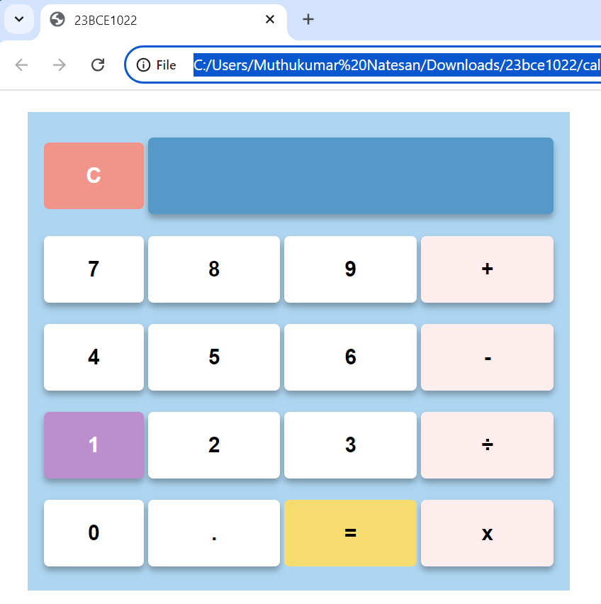

**3. Include your favourite singer's photo as an image. Add an INTERNAL CSS class named myphoto that fulfils the following requirements: (3 marks)**

**The image border is rounded, so that it appears as a circle.**

**The image width and height should both be 150px.**

**♦ The image should have a solid border with a width of 2px and be colored with your favourite color.**

**♦ Add a title to the image and apply a font change and color-change animation effect. Use percentage to apply different colors and change the font size.**

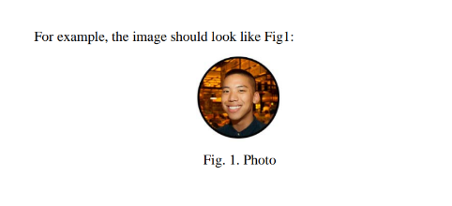

**CODE:**

<!DOCTYPE html>

<html>

<head>

    <title>23BCE1022</title>

    <style>

        img.myphoto {

            width: 150px;

            height: 150px;

            border-radius: 100%;

            border: 2px solid rgb(186, 205, 18);

        }

        h4.myphoto {

            animation: changeFontAndColor 5s infinite;

        }

        @keyframes changeFontAndColor {

            0% {

                color: yellowgreen;

                font-family: 'Courier New', Courier, monospace;

            }

            25% {

                color: yellow;

                font-family: 'Times New Roman', Times, serif;

            }

            50% {

                color: red;

                font-family: 'Segoe UI', Tahoma, Geneva, Verdana, sans-serif;

            }

            75% {

                color: blue;

                font-family: Georgia, 'Times New Roman', Times, serif;

            }

            100% {

                color: green;

                font-family: Verdana, Geneva, Tahoma, sans-serif;

            }

        }

    </style>

</head>

<body>

    <img class="myphoto" src="C:\Users\Muthukumar Natesan\Downloads\23bce1022\taylor.webp" title="Fig 1">

    <h4 class="myphoto">Fig. 1. Taylor Swift</h4>

</body>

</html>

**OUTPUT:**



**********************************************************************************