**BCSE203E WEB PROGRAMMMING**

**LAB EXERCISE -7**

**CSS**

**NAME: M.MENMANGAI**

**REGISTRATION NO: 23BCE1022**

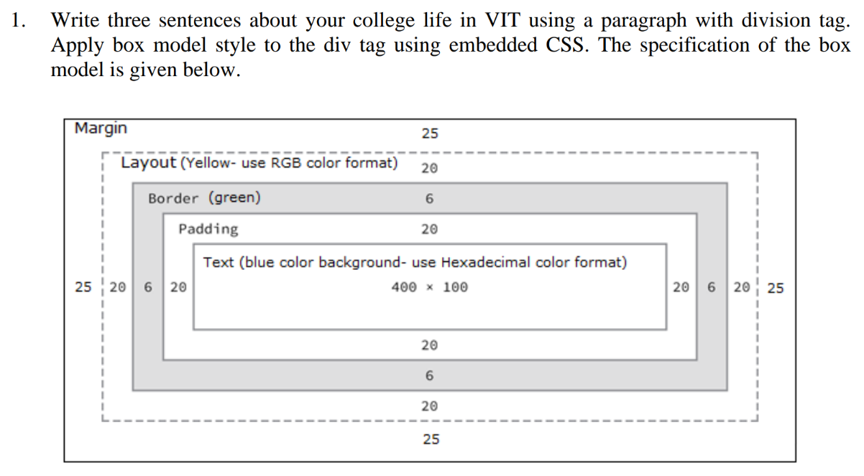

CODE:

<!DOCTYPE html>

<html>

<head>

    <title>23BCE1022</title>

    <style>

        .box {

            margin: 25px;

            outline: 20px solid rgb(255, 255, 0);

            border: 6px solid green;

            padding: 20px;

            background-color: #0000ff;

            color: rgb(192, 179, 180);

            width: 400px;

            height: 100px;

            text-align: center;

        }

    </style>

</head>

<body>

    <div class="box">

        My college life at VIT has been an eventful journey filled with new experiences.

        The vibrant campus and diverse student community have helped me grow personally and academically.

        I have enjoyed learning, making lifelong friends and participating in exciting extracurricular activities.

    </div>

</body>

</html>

**OUTPUT:  
  
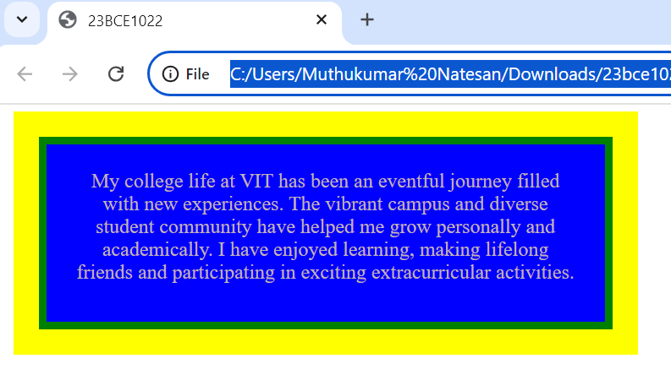**

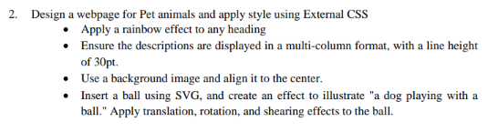

**Code:**

**pet.html:**

<!DOCTYPE html>

<html>

<head>

    <title>23BCE1022</title>

    <link rel="stylesheet" href="sty.css">

</head>

<body>

    <div class="background">

        <header>

            <h1>Pet Animals</h1>

        </header>

        <section class="description">

            <p>

                Pets are our companions, giving us unconditional love and joy.

                Dogs are loyal and active, while cats are independent and calming.

                Rabbits and birds add diversity to our homes with their unique behaviors.

            </p>

            <p>

                Pets can reduce stress, teach responsibility, and provide emotional support.

                Regular care, exercise, and affection are essential for their well-being.

                They truly become part of our family.

            </p>

        </section>

        <section class="dog-playing">

            <h1>A Dog Playing with a Ball</h1>

            <svg class="scene" width="400" height="200" xmlns="http://www.w3.org/2000/svg">

                <ellipse cx="100" cy="130" rx="60" ry="40" fill="saddlebrown" />

                <circle cx="100" cy="60" r="40" fill="saddlebrown" />

                <circle cx="85" cy="50" r="5" fill="white" />

                <circle cx="115" cy="50" r="5" fill="white" />

                <circle cx="100" cy="70" r="5" fill="black" />

                <path d="M60 45 Q55 25 80 30" fill="saddlebrown" />

                <path d="M140 45 Q145 25 120 30" fill="saddlebrown" />

                <path d="M90 80 Q100 90 110 80" stroke="black" stroke-width="2" fill="transparent" />

                <path d="M160 130 Q180 100 150 80" stroke="saddlebrown" stroke-width="6" fill="transparent" />

                <circle cx="75" cy="170" r="7" fill="saddlebrown" />

                <circle cx="125" cy="170" r="7" fill="saddlebrown" />

                <circle class="ball" cx="300" cy="130" r="20" fill="red" />

            </svg>

        </section>

    </div>

</body>

</html>

**sty.css:**

h1{

    font-size: 50px;

    font-weight: bold;

    text-align: center;

    background-image: linear-gradient(to right, red, orange, yellow, green, blue, indigo, violet);

    -webkit-background-clip: text;

    -webkit-text-fill-color: transparent;

}

.background {

    background: url('rainbow-bokeh-soft-light-abstract-background-eps-10-illustration-bokeh-particles-background-decoration-vector.jpg') no-repeat center;

    text-align: center;

}

.description {

    column-count: 3;

    column-gap: 30px;

    line-height: 30pt;

    max-width: 1000px;

    background: rgba(255, 255, 255, 0.8);

    padding: 20px;

    border-radius: 10px;

    box-shadow: 0 0 10px rgba(0, 0, 0, 0.3);

    margin: 20px;

}

.scene {

    margin-top: 20px;

}

.ball {

    animation: ball-animation 1s infinite;

}

@keyframes ball-animation {

    0% {

        transform: translate(0, 0) rotate(0) skew(0deg, 0deg);

    }

    25% {

        transform: translate(-50px, -50px) rotate(45deg) skew(10deg, 0deg);

    }

    50% {

        transform: translate(0, -100px) rotate(90deg) skew(20deg, 5deg);

    }

    75% {

        transform: translate(50px, -50px) rotate(135deg) skew(10deg, 0deg);

    }

    100% {

        transform: translate(0, 0) rotate(180deg) skew(0deg, 0deg);

    }

}

**Output:**



