Must University for Science & Technology

College of Information Technology  
computer science Department

**IS413 - Design & Implementation of Database**

**Team members**

***Amr Osama Khafagy 200031891***

***Rabea Ibrahim Ibrahim 200031640***

***Menna Tallah Ibrahim kamel 200018656  
Mayar magdy omar 200013290***

**Project name** : Dental Clinic

**Supervised by:**

**Dr. Mohamed Ibrahim**

**Eng. Mai Mohamed**

Spring 2025

**Database Schema (Before Normalization)**

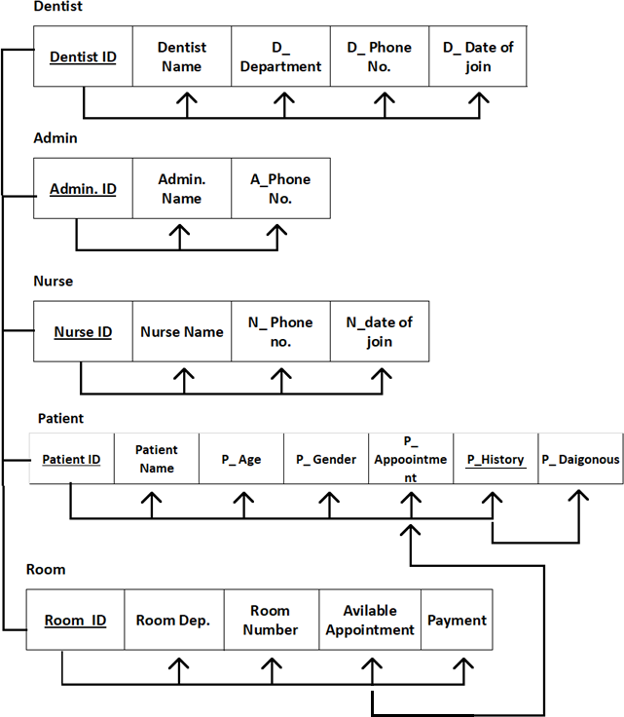

**Normalization Steps**

1. **First Normal Form (1NF)**

it appears to contain atomic values in each cell, so there are no obvious repeating groups.

# Second Normal Form (2NF)

Problem in 2NF:

2NF requires that:

* + The table must first be in 1NF.
  + All non-key attributes must be fully functionally dependent on the entire primary key (not just part of it).

In our case, if we consider the table as a whole, we might be using a composite primary key (for example, a combination of Dentist ID, Nurse ID, Patient ID, and Room ID).

Partial dependencies in this table could be:

* + Columns such as Dentist Name, D_Department, and D_Phone No. depend only on Dentist ID.
  + Columns like Patient Name, P_Age, and P_History depend only on Patient ID.
  + Similarly, Room Dep. depends only on Room ID.

These columns do not depend on the full composite key but only on a part of it. This violates 2NF, as some attributes are not fully dependent on the entire primary key.

# Solution for 2NF:

To solve this, we need to separate the table into multiple tables, each focusing on a single entity and making sure each table has a primary key on which all non-key attributes are fully dependent.

After breaking down the table, we get the following separate tables:

1. Dentist Table:
   * Attributes: Dentist ID (Primary Key), Dentist Name, D_Department, D_Phone No., D_Date of join
   * Purpose: Stores information specific to dentists.
2. Admin Table:
   * Attributes: Admin ID (Primary Key), Admin Name, A_Phone No.
   * Purpose: Stores information specific to admins.
3. Nurse Table:
   * Attributes: Nurse ID (Primary Key), Nurse Name, N_Phone no., N_date of join
   * Purpose: Stores information specific to nurses.
4. Patient Table:
   * Attributes: Patient ID (Primary Key), Patient Name, P_Age, P_Gender, P_History, P_Diagnosis
   * Purpose: Stores information specific to patients.
5. Room Table:
   * Attributes: Room ID (Primary Key), Room Dep., Available Appointment
   * Purpose: Stores information specific to rooms.
6. Appointments Table:
   * Attributes: Appointment ID (Primary Key), Dentist ID (Foreign Key), Nurse ID (Foreign Key), Patient ID (Foreign Key), Room ID (Foreign Key), Date of Appointment
   * Purpose: Links appointments to specific dentists, nurses, patients, and rooms.

Each table now has a primary key with attributes that are fully functionally dependent on it, meaning that partial dependencies have been eliminated. We have achieved 2NF by separating the data into logically distinct entities.

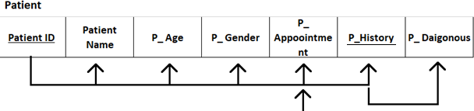

# Problem in 3NF:

3NF requires that:

* + The table must first be in 2NF.
  + There should be no transitive dependencies. This means that non-key attributes should depend only on the primary key and not on other non-key attributes.

In some of the tables resulting from 2NF, there may still be transitive dependencies. For example:

* + In the Patient Table, if P_History depends on Patient ID, but P_Diagnosis is dependent on P_History, then there is a transitive dependency. Here, P_History indirectly depends on Patient ID through P_Diagnosis.

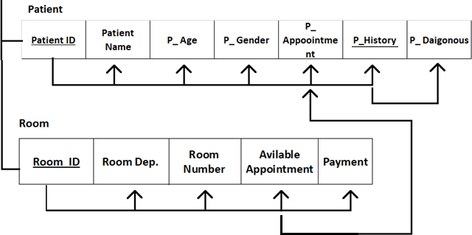

**Database Schema (After Normalization)**

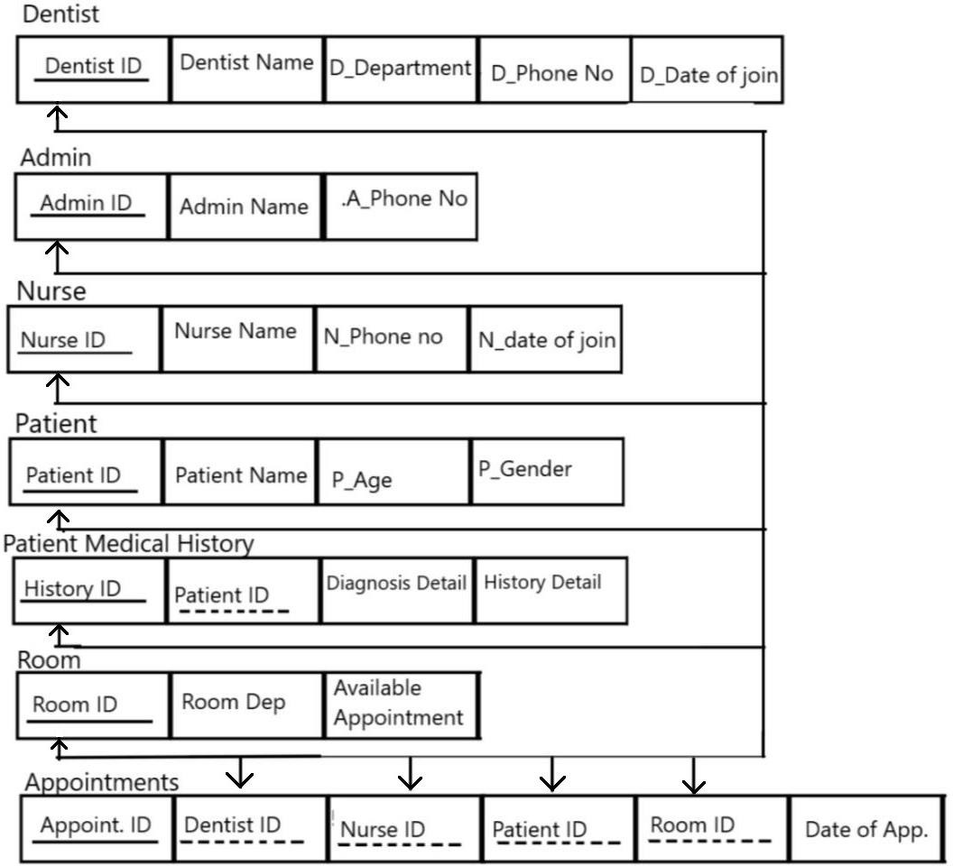

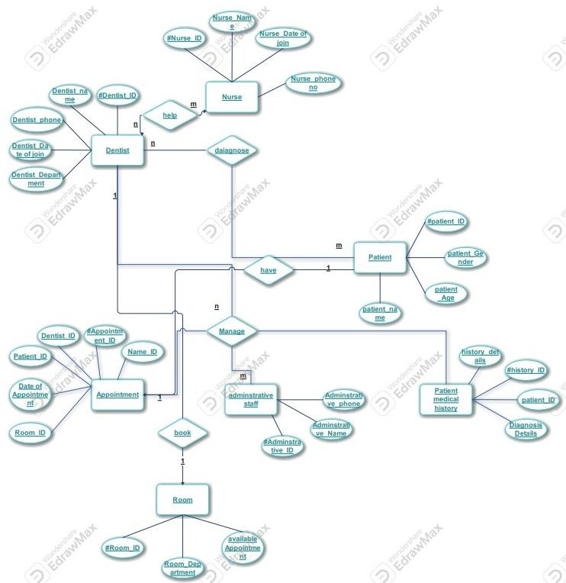**ERD**

Database Creation

CREATE DATABASE *DentalClinic*;

Table Creation

# CREATE TABLE Room (

# Room_ID INT PRIMARY KEY,

# Room_Department VARCHAR(100) UNIQUE,

# Room_Availability BIT

# );

# CREATE TABLE *Dentist* (

# Dentist_ID INT *PRIMARY KEY*,

# Dentist_Name VARCHAR(100),

# Dentist_Phone VARCHAR(20),

# Dentist_DateOfJoin DATE,

# Room_Department VARCHAR(100),

# *FOREIGN KEY* (Room_Department) *REFERENCES* Room(Room_Department)

# );

# CREATE TABLE *Nurse* (

# Nurse_ID INT *PRIMARY KEY*,

# Nurse_Name VARCHAR(100),

# Nurse_PhoneNo VARCHAR(20),

# Nurse_DateOfJoin DATE

# );

# CREATE TABLE *Patient* (

# Patient_ID INT *PRIMARY KEY*,

# Patient_Name VARCHAR(100),

# Patient_Gender CHAR(1),

# Patient_Age INT

# );

# CREATE TABLE *Administrative_Staff* (

# Administrative_ID INT *PRIMARY KEY*,

# Administrative_Name VARCHAR(100),

# Administrative_Phone VARCHAR(20)

# );

# CREATE TABLE *Appointment* (

# Appointment_ID INT *PRIMARY KEY*,

# Dentist_ID INT,

# Patient_ID INT,

# Patient_Name VARCHAR(100),

# Room_ID INT,

# DateOfAppointment DATE,

# *FOREIGN KEY* (Dentist_ID) *REFERENCES* Dentist(Dentist_ID),

# *FOREIGN KEY* (Patient_ID) *REFERENCES* Patient(Patient_ID),

# *FOREIGN KEY* (Room_ID) *REFERENCES* Room(Room_ID)

# );

# CREATE TABLE *Patient_Medical_History* (

# History_ID INT *PRIMARY KEY*,

# Patient_ID INT,

# History_Details TEXT,

# Diagnosis_Detail TEXT,

# *FOREIGN KEY* (Patient_ID) *REFERENCES* Patient(Patient_ID)

# );

Data Insertion:

INSERT INTO Room (Room_ID, Room_Department, Room_Availability)

VALUES

(1, 'Orthodontics', 1),

(2, 'Surgery', 1),

(3, 'Pediatrics', 0),

(4, 'Endodontics', 1),

(5, 'Prosthodontics', 1),

(6, 'Implantology', 1),

(7, 'Radiology', 0),

(8, 'Oral Medicine', 1),

(9, 'General Dentistry', 1),

(10, 'Hygiene', 1),

(11, 'Diagnostics', 1),

(12, 'Lab', 1),

(13, 'Reception', 1),

(14, 'Consultation', 1),

(15, 'Surgical Recovery', 1),

(16, 'X-Ray', 0),

(17, 'Sterilization', 1),

(18, 'Emergency', 1),

(19, 'Waiting', 1),

(20, 'Periodontics', 1),

(21, 'Laser Treatment', 1),

(22, 'Oral Surgery', 0),

(23, 'Maxillofacial', 1

(24, 'Anesthesia', 1),

(25, 'Microbiology', 1);

INSERT INTO Dentist (Dentist_ID, Dentist_Name, Dentist_Phone, Dentist_DateOfJoin, Room_Department)

VALUES

(1, 'Dr. Ahmed', '0100000001', '2021-01-10', 'Orthodontics'),

(2, 'Dr. Rana', '0100000002', '2021-02-11', 'Surgery'),

(3, 'Dr. Hossam', '0100000003', '2021-03-12', 'Pediatrics'),

(4, 'Dr. Mona', '0100000004', '2021-04-13', 'Endodontics'),

(5, 'Dr. Tamer', '0100000005', '2021-05-14', 'Prosthodontics'),

(6, 'Dr. Samar', '0100000006', '2021-06-15', 'Implantology'),

(7, 'Dr. Hany', '0100000007', '2021-07-16', 'Radiology'),

(8, 'Dr. Noha', '0100000008', '2021-08-17', 'Oral Medicine'),

(9, 'Dr. Fady', '0100000009', '2021-09-18', 'General Dentistry'),

(10, 'Dr. Asmaa', '0100000010', '2021-10-19', 'Hygiene'),

(11, 'Dr. Youssef', '0100000011', '2021-11-20', 'Diagnostics'),

(12, 'Dr. Farida', '0100000012', '2021-12-21', 'Lab'),

(13, 'Dr. Kareem', '0100000013', '2022-01-01', 'Reception'),

(14, 'Dr. Heba', '0100000014', '2022-01-05', 'Consultation'),

(15, 'Dr. Ibrahim', '0100000015', '2022-01-10', 'Surgical Recovery'),

(16, 'Dr. Dalia', '0100000016', '2022-01-15', 'X-Ray'),

(17, 'Dr. Walid', '0100000017', '2022-01-20', 'Sterilization'),

(18, 'Dr. Hagar', '0100000018', '2022-01-25', 'Emergency'),

(19, 'Dr. Ziad', '0100000019', '2022-01-30', 'Waiting'),

(20, 'Dr. Dina', '0100000020', '2022-02-04', 'Periodontics'),

(21, 'Dr. Omar', '0100000021', '2022-02-10', 'Laser Treatment'),

(22, 'Dr. Laila', '0100000022', '2022-02-15', 'Oral Surgery'),

(23, 'Dr. Adel', '0100000023', '2022-02-20', 'Maxillofacial'),

(24, 'Dr. Aya', '0100000024', '2022-02-25', 'Anesthesia'),

(25, 'Dr. Nour', '0100000025', '2022-03-01', 'Microbiology');

INSERT INTO Nurse (Nurse_ID, Nurse_Name, Nurse_PhoneNo, Nurse_DateOfJoin)

VALUES

(1, 'Nurse A', '0110000001', '2021-01-01'),

(2, 'Nurse B', '0110000002', '2021-01-02'),

(3, 'Nurse C', '0110000003', '2021-01-03'),

(4, 'Nurse D', '0110000004', '2021-01-04'),

(5, 'Nurse E', '0110000005', '2021-01-05'),

(6, 'Nurse F', '0110000006', '2021-01-06'),

(7, 'Nurse G', '0110000007', '2021-01-07'),

(8, 'Nurse H', '0110000008', '2021-01-08'),

(9, 'Nurse I', '0110000009', '2021-01-09'),

(10, 'Nurse J', '0110000010', '2021-01-10'),

(11, 'Nurse K', '0110000011', '2021-01-11'),

(12, 'Nurse L', '0110000012', '2021-01-12'),

(13, 'Nurse M', '0110000013', '2021-01-13'),

(14, 'Nurse N', '0110000014', '2021-01-14'),

(15, 'Nurse O', '0110000015', '2021-01-15'),

(16, 'Nurse P', '0110000016', '2021-01-16'),

(17, 'Nurse Q', '0110000017', '2021-01-17'),

(18, 'Nurse R', '0110000018', '2021-01-18'),

(19, 'Nurse S', '0110000019', '2021-01-19'),

(20, 'Nurse T', '0110000020', '2021-01-20'),

(21, 'Nurse U', '0110000021', '2021-01-21'),

(22, 'Nurse V', '0110000022', '2021-01-22'),

(23, 'Nurse W', '0110000023', '2021-01-23'),

(24, 'Nurse X', '0110000024', '2021-01-24'),

(25, 'Nurse Y', '0110000025', '2021-01-25');

INSERT INTO Administrative_Staff (Administrative_ID, Administrative_Name, Administrative_Phone)

VALUES

(1, 'Admin A', '0120000001'),

(2, 'Admin B', '0120000002'),

(3, 'Admin C', '0120000003'),

(4, 'Admin D', '0120000004'),

(5, 'Admin E', '0120000005'),

(6, 'Admin F', '0120000006'),

(7, 'Admin G', '0120000007'),

(8, 'Admin H', '0120000008'),

(9, 'Admin I', '0120000009'),

INSERT INTO Patient (Patient_ID, Patient_Name, Patient_Gender, Patient_Age)

VALUES

(1, 'Ali Hassan', 'M', 25),

(2, 'Sara Kamal', 'F', 30),

(3, 'Omar Tarek', 'M', 19),

(4, 'Nour Khaled', 'F', 23),

(5, 'Mostafa Ahmed', 'M', 35),

(6, 'Lina Mahmoud', 'F', 28),

(7, 'Tarek Hany', 'M', 40),

(8, 'Aya Ehab', 'F', 22),

(9, 'Mahmoud Zaki', 'M', 33),

(10, 'Reem Samir', 'F', 26),

(11, 'Youssef Ali', 'M', 21),

(12, 'Hana Wael', 'F', 29),

(13, 'Adel Fathy', 'M', 37),

(14, 'Dina Emad', 'F', 24),

(15, 'Amr Said', 'M', 31),

(16, 'Sally Adel', 'F', 27),

(17, 'Ibrahim Magdy', 'M', 45),

(18, 'Mariam Hossam', 'F', 20),

(19, 'Ziad Mostafa', 'M', 38),

(20, 'Fatma Sherif', 'F', 32),

(21, 'Khaled Tamer', 'M', 34),

(22, 'Yasmin Omar', 'F', 25),

(23, 'Hazem Yehia', 'M', 36),

(24, 'Layla Amr', 'F', 30),

(25, 'Hatem Osama', 'M', 39);

INSERT INTO Appointment (Appointment_ID, Dentist_ID, Patient_ID, Patient_Name, Room_ID, DateOfAppointment)

VALUES

(1, 1, 1, 'Ali Hassan', 1, '2025-05-01'),

(2, 2, 2, 'Sara Kamal', 2, '2025-05-02'),

(3, 3, 3, 'Omar Tarek', 3, '2025-05-03'),

(4, 4, 4, 'Nour Khaled', 4, '2025-05-04'),

(5, 5, 5, 'Mostafa Ahmed', 5, '2025-05-05'),

(6, 6, 6, 'Lina Mahmoud', 6, '2025-05-06'),

(7, 7, 7, 'Tarek Hany', 7, '2025-05-07'),

(8, 8, 8, 'Aya Ehab', 8, '2025-05-08'),

(9, 9, 9, 'Mahmoud Zaki', 9, '2025-05-09'),

(10, 10, 10, 'Reem Samir', 10, '2025-05-10'),

(11, 11, 11, 'Youssef Ali', 11, '2025-05-11'),

(12, 12, 12, 'Hana Wael', 12, '2025-05-12'),

(13, 13, 13, 'Adel Fathy', 13, '2025-05-13'),

(14, 14, 14, 'Dina Emad', 14, '2025-05-14'),

(15, 15, 15, 'Amr Said', 15, '2025-05-15'),

(16, 16, 16, 'Sally Adel', 16, '2025-05-16'),

(17, 17, 17, 'Ibrahim Magdy', 17, '2025-05-17'),

(18, 18, 18, 'Mariam Hossam', 18, '2025-05-18'),

(19, 19, 19, 'Ziad Mostafa', 19, '2025-05-19'),

(20, 20, 20, 'Fatma Sherif', 20, '2025-05-20'),

(21, 21, 21, 'Khaled Tamer', 21, '2025-05-21'),

(22, 22, 22, 'Yasmin Omar', 22, '2025-05-22'),

(23, 23, 23, 'Hazem Yehia', 23, '2025-05-23'),

(24, 24, 24, 'Layla Amr', 24, '2025-05-24'),

(25, 25, 25, 'Hatem Osama', 25, '2025-05-25');

INSERT INTO Patient_Medical_History (History_ID, Patient_ID, History_Details, Diagnosis_Detail)

VALUES

(1, 1, 'Cavity history', 'Tooth Decay'),

(2, 2, 'Orthodontic history', 'Braces'),

(3, 3, 'Bleeding gums', 'Gingivitis'),

(4, 4, 'Tooth pain', 'Cavity'),

(5, 5, 'Surgery in 2020', 'Root Canal'),

(6, 6, 'Tooth fracture', 'Crown'),

(7, 7, 'No history', 'Normal'),

(8, 8, 'Swollen gums', 'Gum infection'),

(9, 9, 'Tooth loss', 'Implant'),

(10, 10, 'Tooth sensitivity', 'Whitening'),

(11, 11, 'Jaw pain', 'TMJ'),

(12, 12, 'Plaque buildup', 'Cleaning'),

(13, 13, 'Dry mouth', 'Medication side effect'),

(14, 14, 'Mouth ulcer', 'Viral infection'),

(15, 15, 'Bad breath', 'Bacterial infection'),

(16, 16, 'Stained teeth', 'Smoking'),

(17, 17, 'Loose tooth', 'Gum disease'),

(18, 18, 'Gum recession', 'Brushing issue'),

(19, 19, 'Tooth grinding', 'Night guard'),

(20, 20, 'Overbite', 'Orthodontics'),

(21, 21, 'Wisdom teeth issue', 'Extraction'),

(22, 22, 'Broken crown', 'Replacement'),

(23, 23, 'Filling fell out', 'New filling'),

(24, 24, 'Mouth dryness', 'Hydration needed'),

(25, 25, 'Bleeding while brushing', 'Gum sensitivity');

Stored Procedures

-First Type:

CREATE PROCEDURE GetAllDentists

AS

BEGIN

    SELECT * FROM Dentist;

END;

EXEC GetAllDentists;

Output:

# -Second Type:

CREATE PROCEDURE GetAppointmentsByDentistID

 @DentistID INT

AS

BEGIN

    SELECT

        Appointment_ID,

        Dentist_ID,

        Patient_ID,

        DateOfAppointment

    FROM Appointment

    WHERE Dentist_ID = @DentistID;

END;

EXEC GetAppointmentsByDentistID 4;

Output:

# -Third Type:

CREATE PROCEDURE GetPatientInfo

 @minID INT,

 @maxID INT

AS

BEGIN

    SELECT Patient_ID, Patient_Name, Patient_Gender, Patient_Age

    FROM Patient

    WHERE Patient_ID BETWEEN @minID AND @maxID

    ORDER BY Patient_ID;

END;

EXEC GetPatientInfo 1, 11;

Output:

# -Fourth Type:

CREATE PROCEDURE DentalClinicProcedure

(

    @PatientCount INT OUTPUT

)

AS

BEGIN

    SELECT Patient_ID, Patient_Name FROM Patient;

    SELECT @PatientCount = COUNT(*) FROM Patient;

END;

DECLARE @Count INT;

EXEC DentalClinicProcedure @PatientCount = @Count OUTPUT;

SELECT @Count AS 'Number of Patients';

Output

Cursors

DECLARE @PatientName VARCHAR(50), @PatientAge INT;

DECLARE PatientCursor CURSOR FOR

SELECT

    Patient_Name,

    Patient_Age

FROM

    Patient;

OPEN PatientCursor;

FETCH NEXT FROM PatientCursor INTO @PatientName, @PatientAge;

WHILE @@FETCH_STATUS = 0

BEGIN

    PRINT 'Patient Name: ' + @PatientName + ', Age: ' + CAST(@PatientAge AS VARCHAR);

    FETCH NEXT FROM PatientCursor INTO @PatientName, @PatientAge;

END;

CLOSE PatientCursor;

DEALLOCATE PatientCursor;

Output:

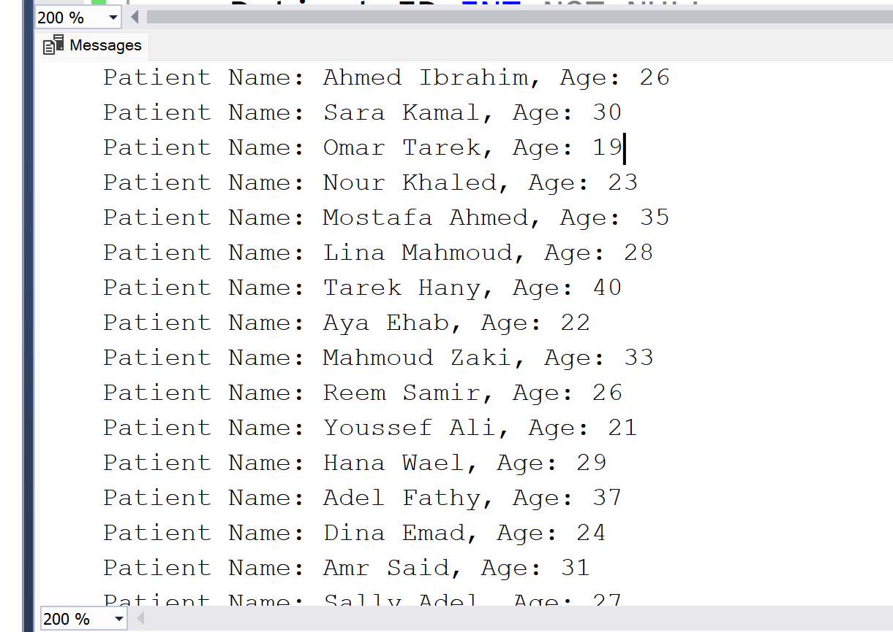

Triggers

CREATE TABLE *DentalClinicAudits* (

    Audit_ID INT IDENTITY(1,1) *PRIMARY KEY*,

    Patient_ID INT NOT NULL,

    Patient_Name VARCHAR(100) NOT NULL,

    Patient_Gender CHAR(1) NOT NULL,

    Patient_Age INT NOT NULL,

    Operation_Type VARCHAR(3) NOT NULL,

*CHECK* (Operation_Type IN ('INS', 'DEL', 'UPD'))

);

DROP TRIGGER IF EXISTS trg_patient_audit;

GO

CREATE TRIGGER *trg_patient_audit*

ON Patient

AFTER INSERT, UPDATE

AS

BEGIN

    SET NOCOUNT ON;

    INSERT INTO DentalClinicAudits (Patient_ID, Patient_Name, Patient_Gender, Patient_Age, Operation_Type)

    SELECT i.Patient_ID, i.Patient_Name, i.Patient_Gender, i.Patient_Age, 'INS'

    FROM inserted i

    LEFT JOIN deleted d ON i.Patient_ID = d.Patient_ID

    WHERE d.Patient_ID IS NULL;

    INSERT INTO DentalClinicAudits (Patient_ID, Patient_Name, Patient_Gender, Patient_Age, Operation_Type)

    SELECT i.Patient_ID, i.Patient_Name, i.Patient_Gender, i.Patient_Age, 'UPD'

    FROM inserted i

    JOIN deleted d ON i.Patient_ID = d.Patient_ID;

END;

GO

SELECT * FROM DentalClinicAudits;

Output:

Functions

# CREATE FUNCTION *dbo*.CalculateDentalCost

# (

# @Patient_ID INT,

# @Patient_Name VARCHAR(100),

# @TreatmentType NVARCHAR(50),

# @Session INT

# )

# RETURNS DECIMAL(10, 2)

# AS

# BEGIN

# DECLARE @CostPerSession DECIMAL(10, 2) = 0.00;

# DECLARE @VerifiedPatientName VARCHAR(100);

# 

# SELECT @VerifiedPatientName = Patient_Name

# FROM Appointment

# WHERE Patient_ID = @Patient_ID

# AND LOWER(TRIM(Patient_Name)) = LOWER(TRIM(@Patient_Name));

# 

# IF @VerifiedPatientName IS NULL

# BEGIN

# RETURN NULL;

# END;

# DECLARE @CleanTreatmentType NVARCHAR(50) = UPPER(LTRIM(RTRIM(@TreatmentType)));

# 

# IF @CleanTreatmentType = 'CLEANING'

# SET @CostPerSession = 400.00;

# ELSE IF @CleanTreatmentType = 'NERVE FILLER'

# SET @CostPerSession = 800.00;

# ELSE IF @CleanTreatmentType = 'FIXED'

# SET @CostPerSession = 3800.00;

# ELSE

# RETURN NULL;

# RETURN @CostPerSession * @Session;

# END;

# SELECT dbo.CalculateDentalCost(1, 'Ali Hassan', 'CLEANING', 3) AS Total_Cost;

# Output:

View

CREATE VIEW *vw_AppointmentFullDetails* AS

SELECT

    a.Appointment_ID,

    a.DateOfAppointment,

    a.Room_ID,

    p.Patient_ID,

    p.Patient_Name,

    p.Patient_Gender,

    p.Patient_Age,

    d.Dentist_ID,

    d.Dentist_Name,

    d.Dentist_Phone

FROM

    Appointment a

INNER JOIN Patient p ON a.Patient_ID = p.Patient_ID

INNER JOIN Dentist d ON a.Dentist_ID = d.Dentist_ID;

SELECT * FROM vw_AppointmentFullDetails;

Output:

*Index*

CREATE INDEX idx_Dentist

ON Dentist (Dentist_ID, Dentist_Phone, Dentist_DateOfJoin);

CREATE INDEX idx_Administrative_Staff

ON Administrative_Staff (Administrative_ID, Administrative_Name, Administrative_Phone);

CREATE INDEX idx_Appointment

ON Appointment (Appointment_ID, Dentist_ID, Patient_ID, Room_ID, DateOfAppointment);

CREATE INDEX idx_Nurse

ON Nurse (Nurse_ID, Nurse_Name, Nurse_PhoneNo, Nurse_DateOfJoin);

CREATE INDEX idx_Patient

ON Patient (Patient_ID, Patient_Name, Patient_Gender, Patient_Age);

CREATE INDEX idx_Patient_Medical_History

ON Patient_Medical_History (History_ID, Patient_ID);

CREATE INDEX idx_Room

ON Room (Room_ID, Room_Department, Room_Availability);

Basic sql

ALTER TABLE Patient

ADD Email VARCHAR(100);

ALTER TABLE Patient

DROP COLUMN Email;

DROP TABLE Nurse;

DELETE FROM Patient

WHERE Patient_Age < 20;

UPDATE Patient

SET Patient_Name = 'Ahmed Ali', Patient_Age = 35

WHERE Patient_ID = 1;

SELECT * FROM Patient;

SELECT * FROM Patient

WHERE Patient_Age > 30 AND Patient_Gender = 'M';

SELECT * FROM Patient

WHERE Patient_Age < 25 OR Patient_Gender = 'F';

SELECT * FROM Patient

WHERE Patient_Age BETWEEN 25 AND 40;

SELECT * FROM Patient

WHERE Patient_ID IN (1, 2, 5);

SELECT * FROM Patient

WHERE Patient_Name LIKE 'A%';