
AWS Serverless Task Manager
Amplify, Cognito, API Gateway, Lambda, DynamoDB, Route 53 custom domain and CloudWatch monitoring
Item | Details
Application | Serverless web application to register, log in, add and view personal tasks
Frontend | HTML / CSS / JavaScript on AWS Amplify Hosting (GitHub CI/CD)
Backend | API Gateway HTTP API, AWS Lambda (Python), Amazon DynamoDB
Authentication | Amazon Cognito User Pool with Managed Login and a JWT authorizer
Domain / DNS | www.gbgcafe.click with Amazon Route 53 and an Amplify-managed SSL certificate
Monitoring | Amazon CloudWatch dashboard, metrics and logs
Region | us-east-1
Document version | 1.0
Status | Draft
Prepared by | Menna Kamel
Date | 2026-10-07

Document Version and Change Log
Version | Date | Author | Description of change
1.0 | 2026-10-07 | Menna Kamel | Initial release: Amplify hosting, DynamoDB, IAM and Lambda, API Gateway, Cognito authentication and JWT authorizer, multi-user isolation, Route 53 custom domain, CORS, CloudWatch monitoring, logging and troubleshooting

1. Project Overview and Architecture
The AWS Serverless Task Manager is a serverless web application where users can register and log in securely, add tasks, view and search their own tasks, and sign out. Tasks are stored in Amazon DynamoDB.
The project demonstrates a complete serverless architecture with authentication, authorization, REST API communication, multi-user data isolation, DNS and custom domain configuration, monitoring, logging, troubleshooting and CI/CD through GitHub and Amplify.
Layer | AWS / Technology | Role
Source control | GitHub | Stores the code; a push triggers a deployment
Frontend hosting | Amazon Amplify | Builds and hosts the HTML/CSS/JS frontend
Authentication | Amazon Cognito | Sign up, sign in, email verification, JWT tokens
DNS | Amazon Route 53 | Resolves gbgcafe.click to Amplify
API | Amazon API Gateway (HTTP API) | HTTP entry point protected by a JWT authorizer
Compute | AWS Lambda (Python) | Processes GET and POST requests
Database | Amazon DynamoDB | Stores the tasks
Monitoring | Amazon CloudWatch | Metrics, logs and the dashboard

Final architecture
Developer --git push--> GitHub --> Amplify (Build & Deploy)

User --> Route 53 (DNS) --> www.gbgcafe.click --> Amplify Hosting
|
v
Frontend
+--------------------------------+
| |
v v
Amazon Cognito Amazon API Gateway
(Authentication) (JWT authorizer)
|
v
AWS Lambda
(task-manager-api)
|
v
DynamoDB (Tasks)

Lambda, API Gateway, DynamoDB, Amplify --> CloudWatch (Metrics + Logs)

Project structure
aws-serverless-task-manager/
├── frontend/
│ ├── index.html # application structure
│ ├── style.css # application styling
│ └── app.js # authentication and API communication
├── backend/
│ └── lambda/
│ └── handler.py # Lambda function for task requests
├── tests/
│ └── test_api.py # API-related tests
└── README.md

2. Step 1: Deploy the Frontend with AWS Amplify
The frontend is a simple HTML/CSS/JavaScript application, so no build framework is required. It is deployed with Amplify Hosting and connected to GitHub, so every push to the production branch is built and deployed automatically.
- Open AWS Console > Amplify > Create new app and choose GitHub as the source.
- Select the repository mennakamel25/AWS-Amplify and the branch main.
- Tick My app is a monorepo and set the root directory to frontend.
- Confirm the app name and the build settings below, then save and deploy.
Setting | Value
App root | frontend
Framework | None
Build command | echo "No build required"
Output directory | .
Production branch | main

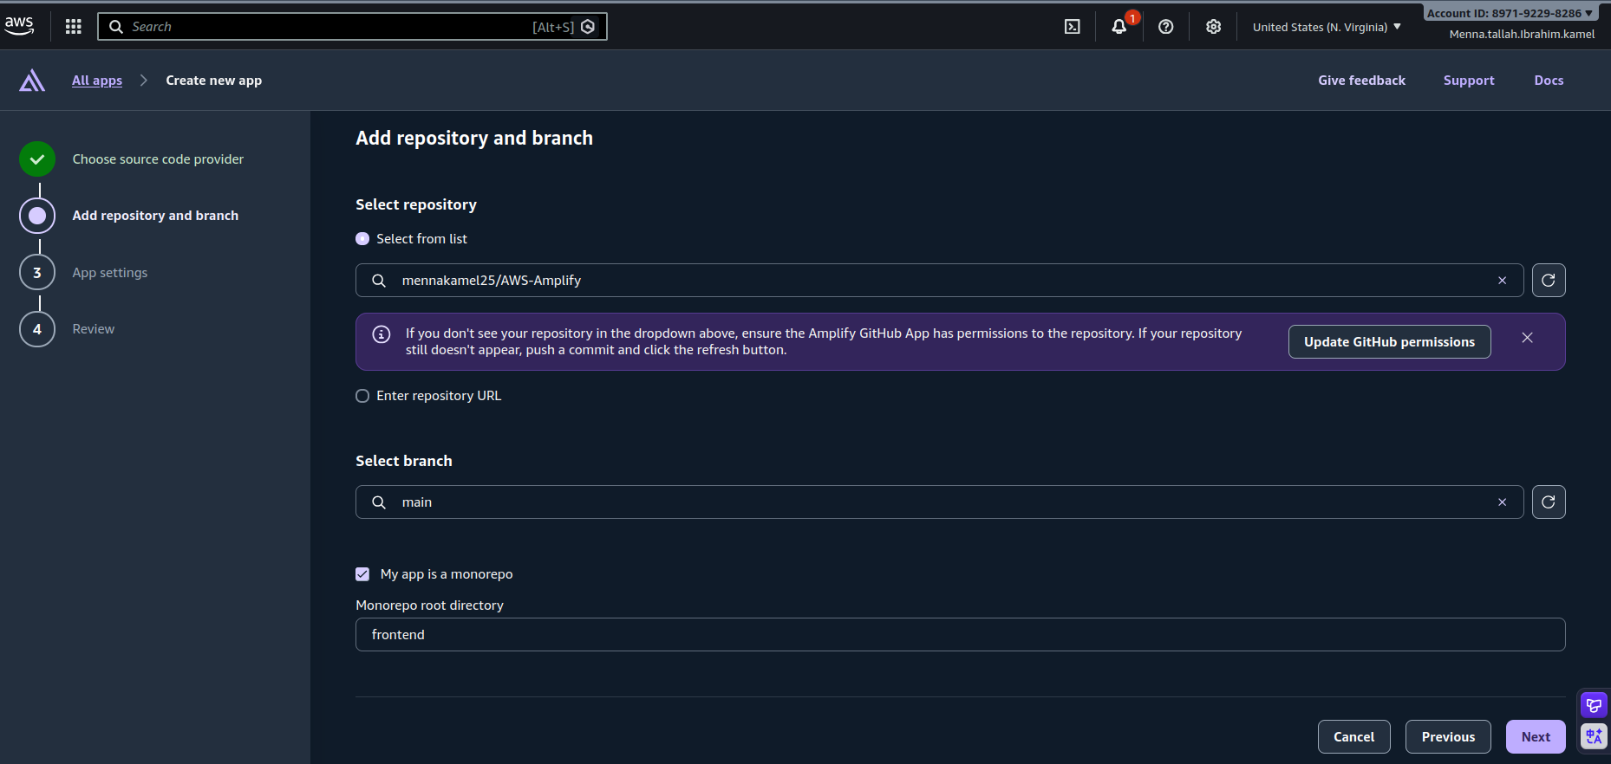
Figure 1: Amplify > Create new app: repository mennakamel25/AWS-Amplify, branch main and monorepo root frontend
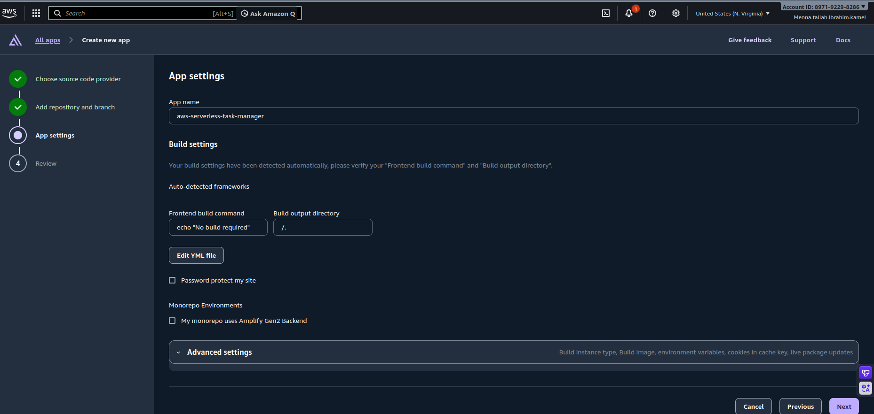
Figure 2: Amplify app settings: app name, build command and output directory
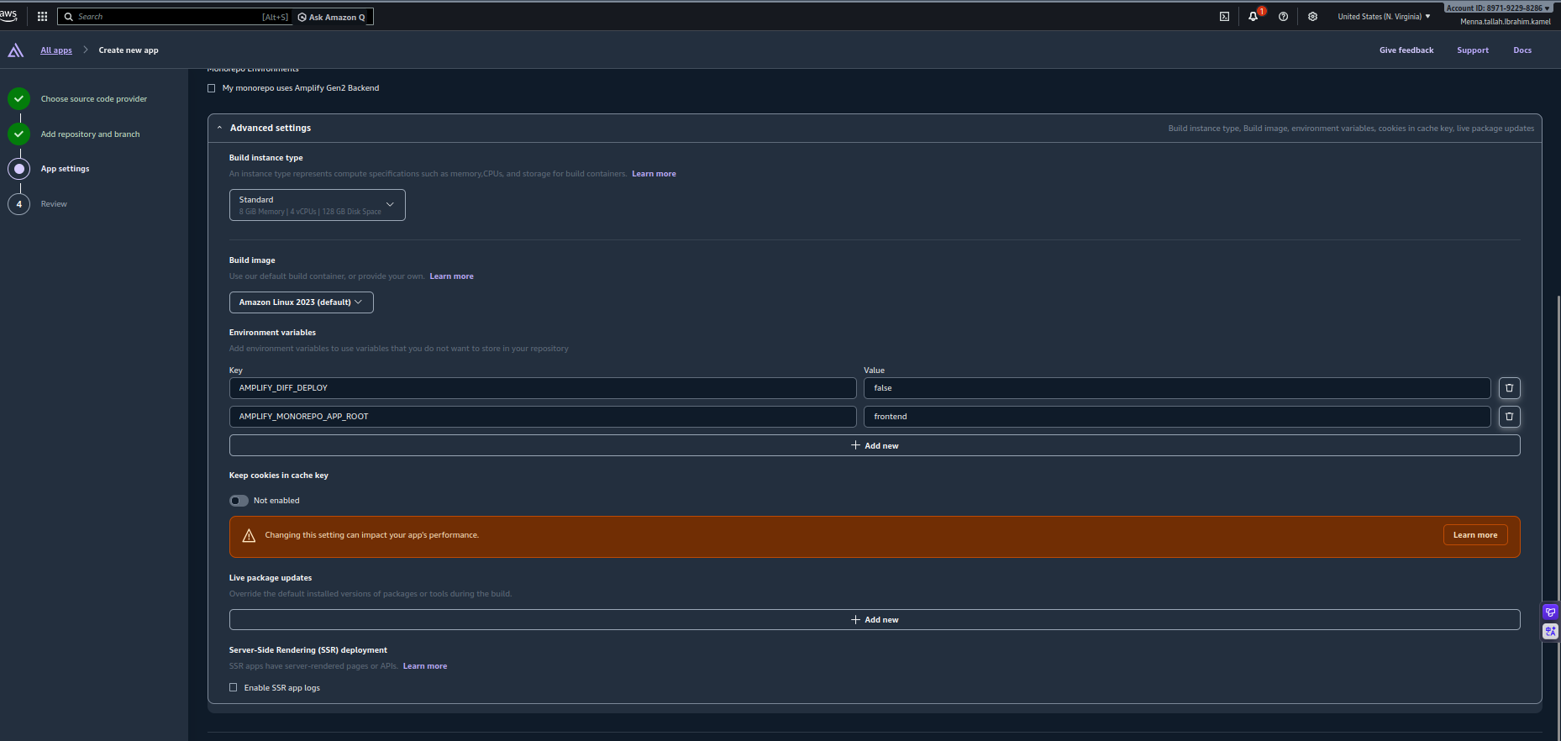
Figure 3: Advanced settings: environment variable AMPLIFY_MONOREPO_APP_ROOT = frontend
After every push the flow is: git push > Amplify detects the change > Build > Deploy > new frontend version available. Before the custom domain was configured, the application was reachable on the Amplify default URL https://main.d1pgn8um2fjyka.amplifyapp.com/.

3. Step 2: Create the DynamoDB Table
Open DynamoDB > Tables > Create table and use the values below.
Setting | Value
Table name | Tasks
Partition key | taskId (String)
Sort key | None
Capacity mode | On-demand
Table settings | Default settings

Example item
{
"taskId": "some-uuid",
"title": "Learn AWS Amplify",
"userId": "user-id"
}

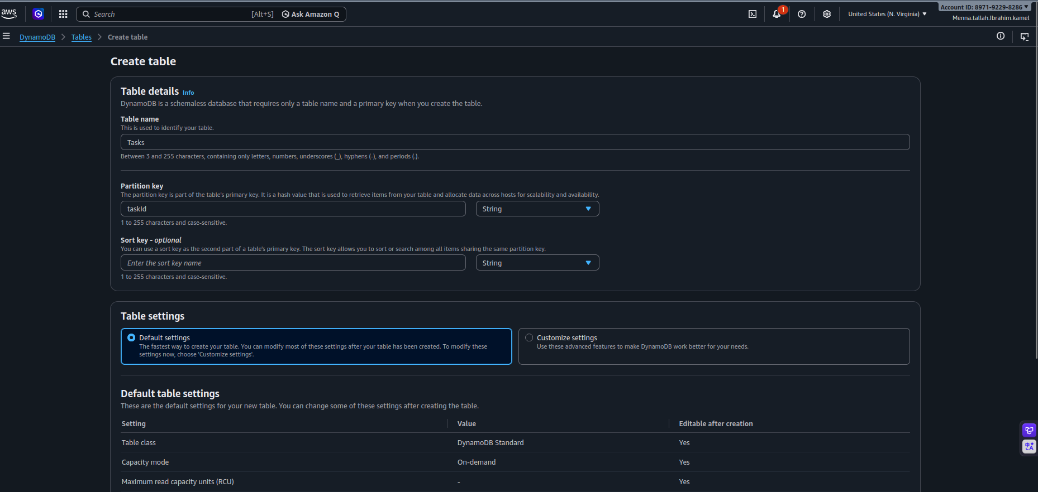
Figure 4: DynamoDB > Create table: table name Tasks and partition key taskId (String)
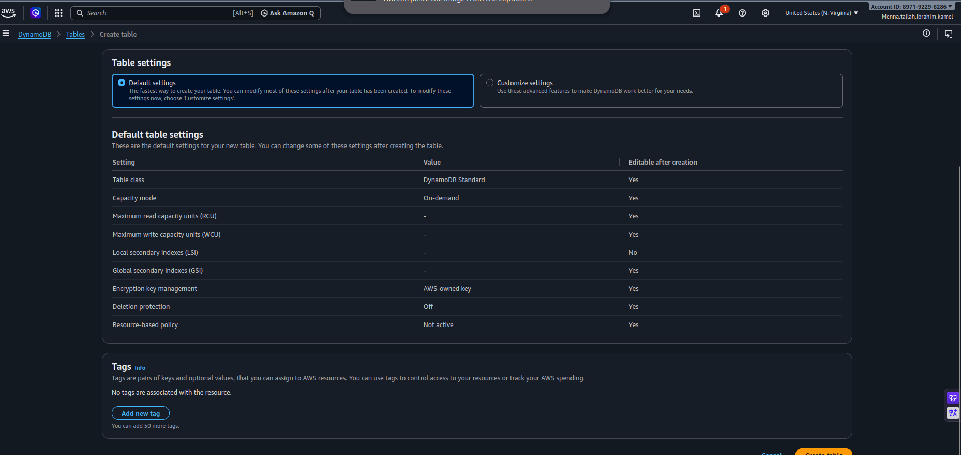
Figure 5: Default table settings with On-demand capacity mode
Old records: tasks created before multi-user support do not contain a userId. After user isolation was implemented, these records are not returned by the user-filtered application. This is expected behavior.

4. Step 3: Create the IAM Role and the Lambda Function

4.1 Lambda execution role
Create the role TaskManagerLambdaRole with the trusted entity Lambda, then attach the two managed policies below.
Policy | Purpose
AWSLambdaBasicExecutionRole | Allows Lambda to write logs to CloudWatch Logs
AmazonDynamoDBFullAccess_v2 | Allows Lambda to read and write DynamoDB

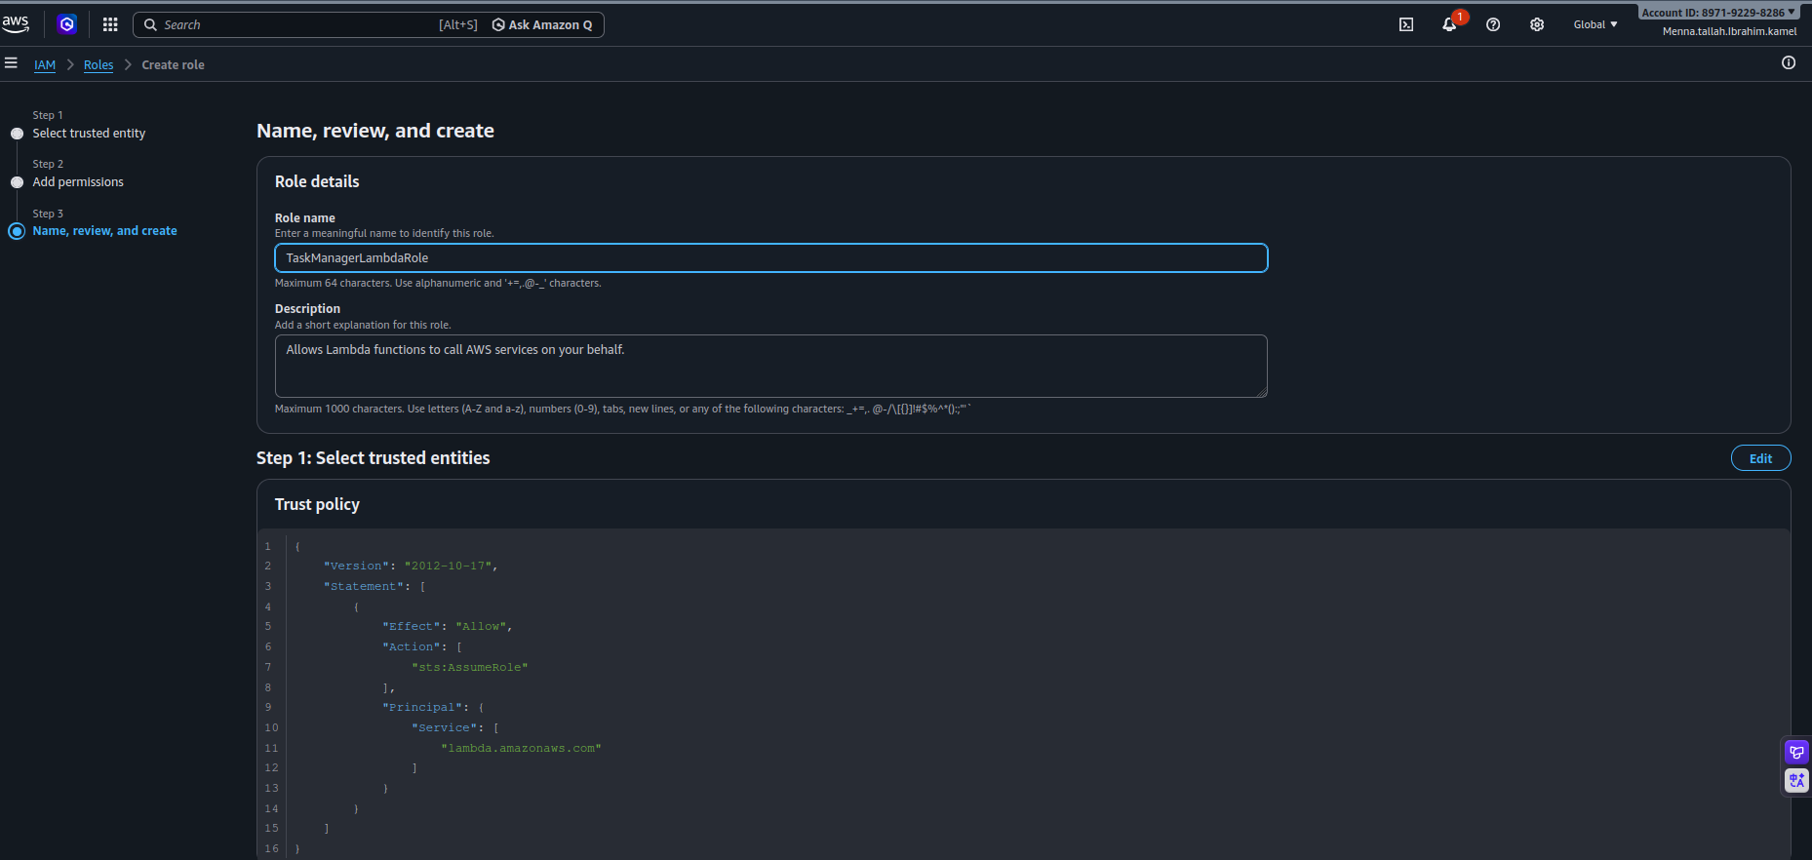
Figure 6: IAM > Create role: role name TaskManagerLambdaRole with the Lambda trust policy
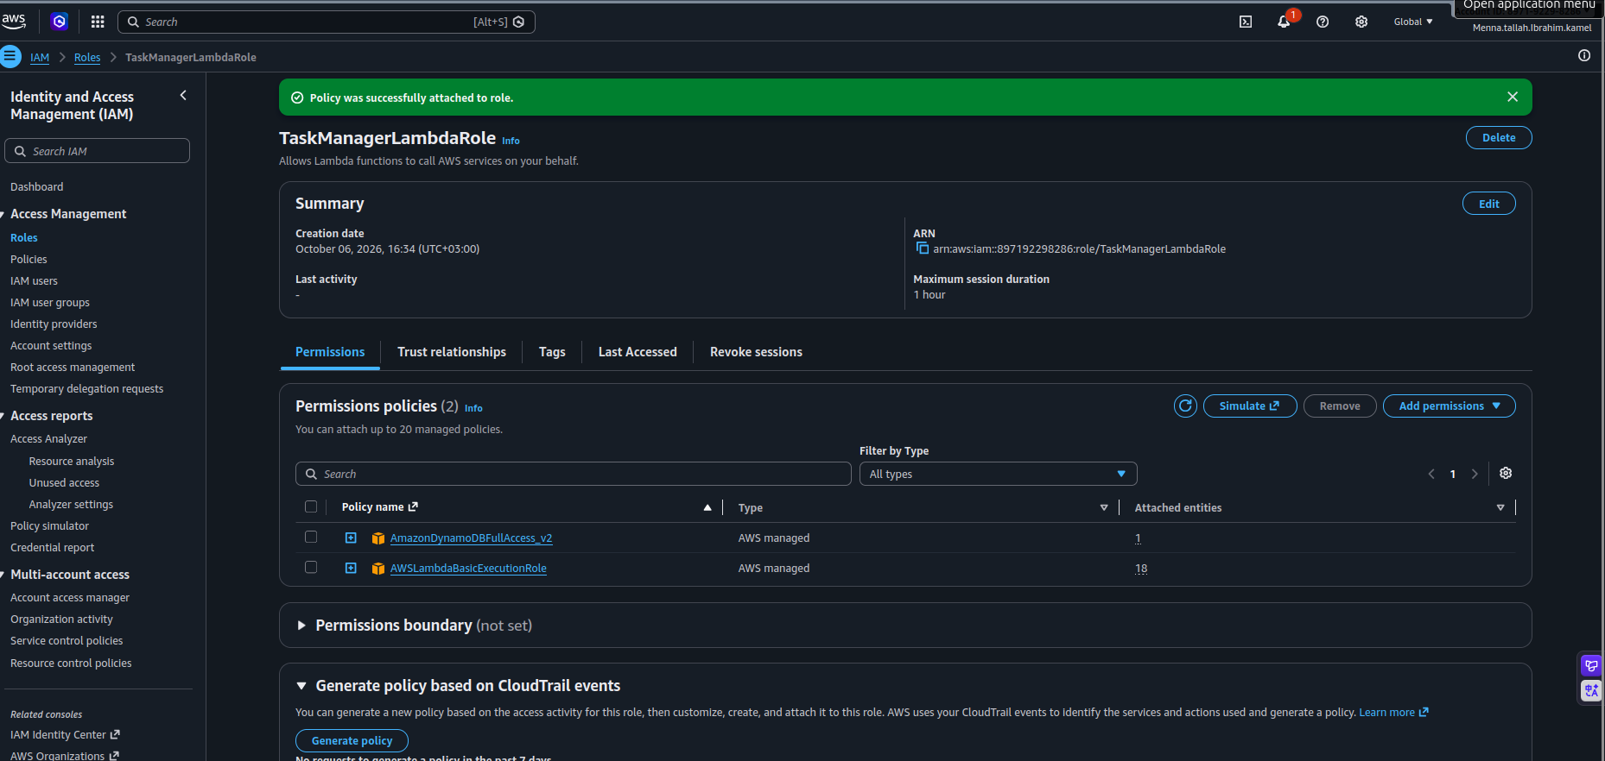
Figure 7: TaskManagerLambdaRole with both permission policies attached
Least privilege: the DynamoDB policy is broader than ideal. For a production version, replace it with a policy that grants only the required actions (for example GetItem, PutItem and Scan) on the Tasks table.

4.2 Lambda function
Create the function task-manager-api with Author from scratch and select TaskManagerLambdaRole as the execution role. The function is responsible for:
- Reading the authenticated user information from the request.
- Processing GET requests (read tasks from DynamoDB).
- Processing POST requests (create tasks in DynamoDB).
- Logging application activity to CloudWatch Logs.
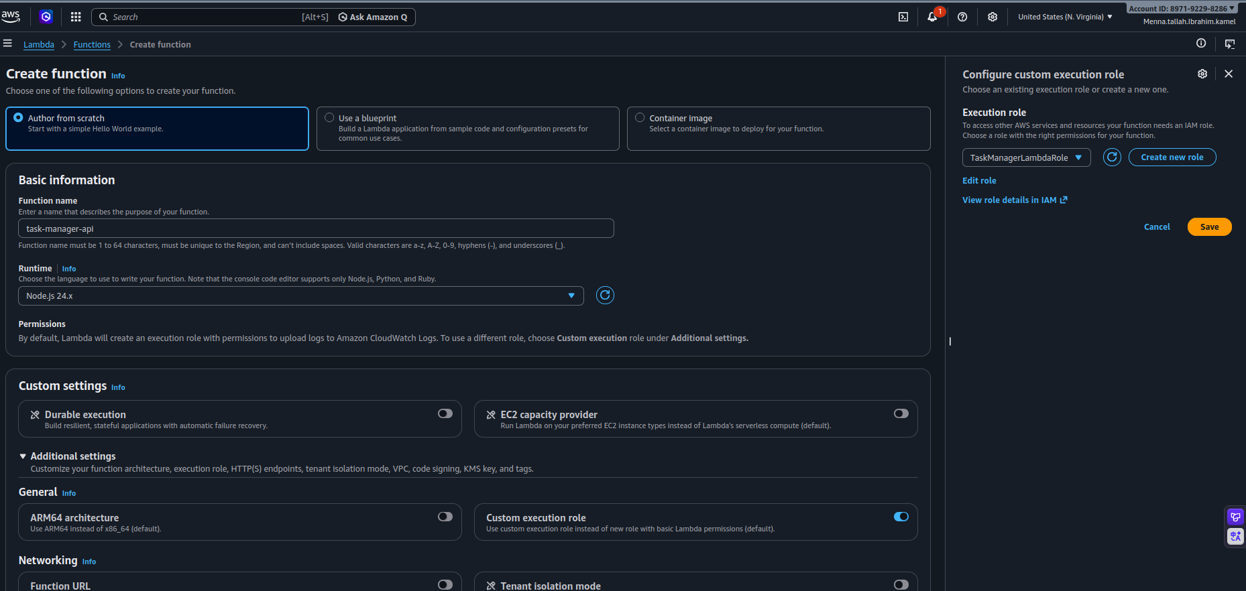
Figure 8: Lambda > Create function: task-manager-api with the custom execution role TaskManagerLambdaRole
Test the function with a test event from the Lambda console (Test tab). A successful execution returns status code 200 and a REPORT line with duration and memory usage.
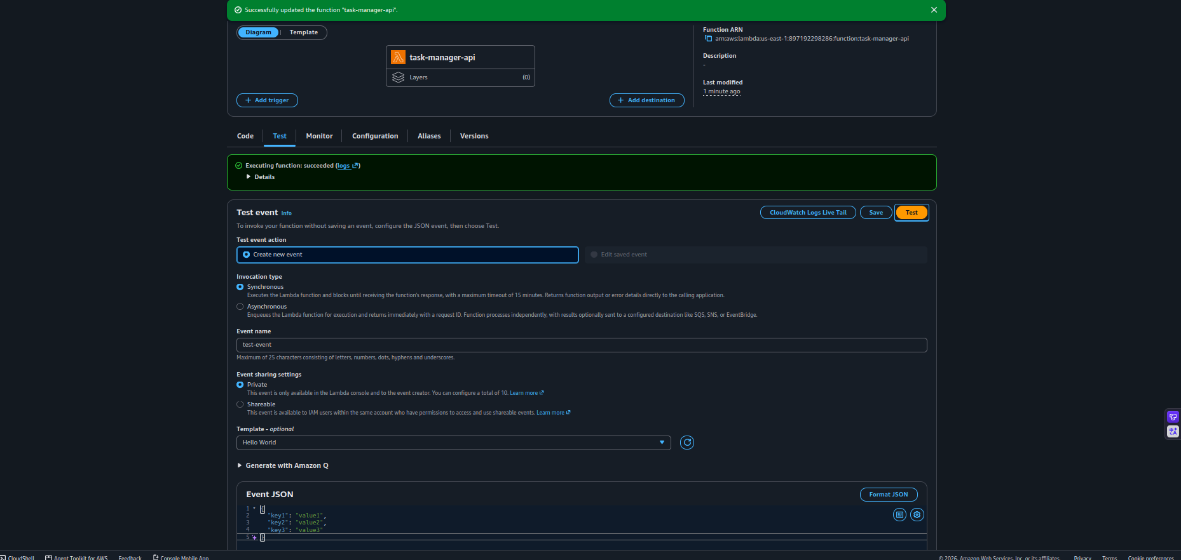
Figure 9: Lambda Test tab: creating a test event
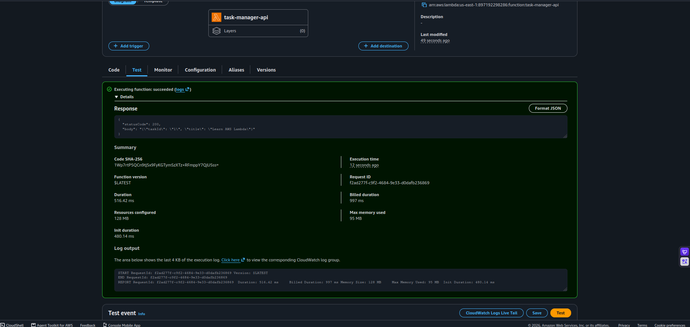
Figure 10: Lambda test result: execution succeeded with the response and log output
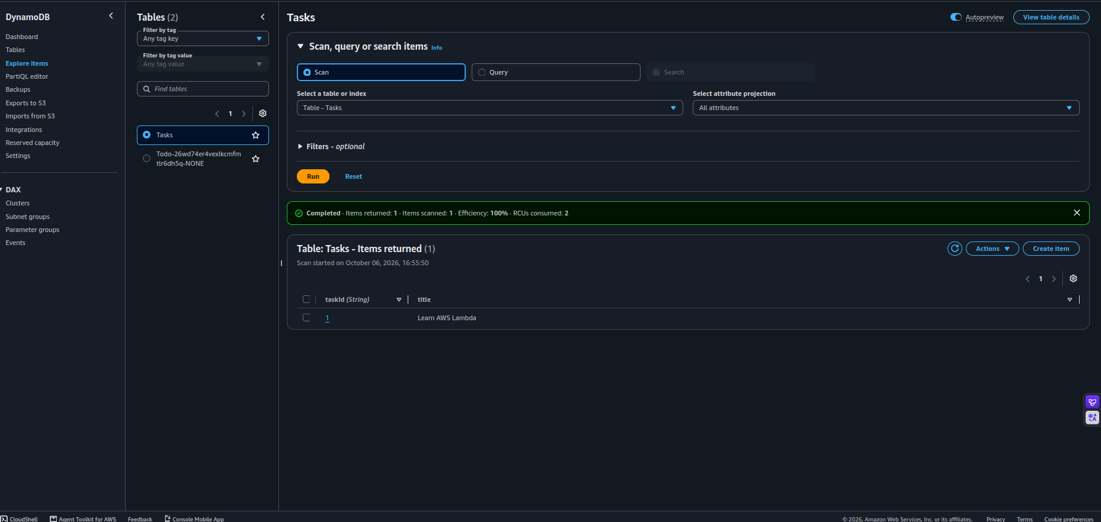
Figure 11: DynamoDB > Explore items: the task created by the Lambda test appears in the Tasks table

5. Step 4: Create the API Gateway HTTP API
API Gateway is the HTTP entry point of the backend. The frontend never accesses DynamoDB directly: requests always go through API Gateway and Lambda.
Setting | Value
API name | task-manager-api
API ID | lcjln7lx48
API type | HTTP API
Payload format version | 2.0
Integration | Lambda function task-manager-api
Invoke URL | https://lcjln7lx48.execute-api.us-east-1.amazonaws.com
Stage | $default (auto-deploy enabled)

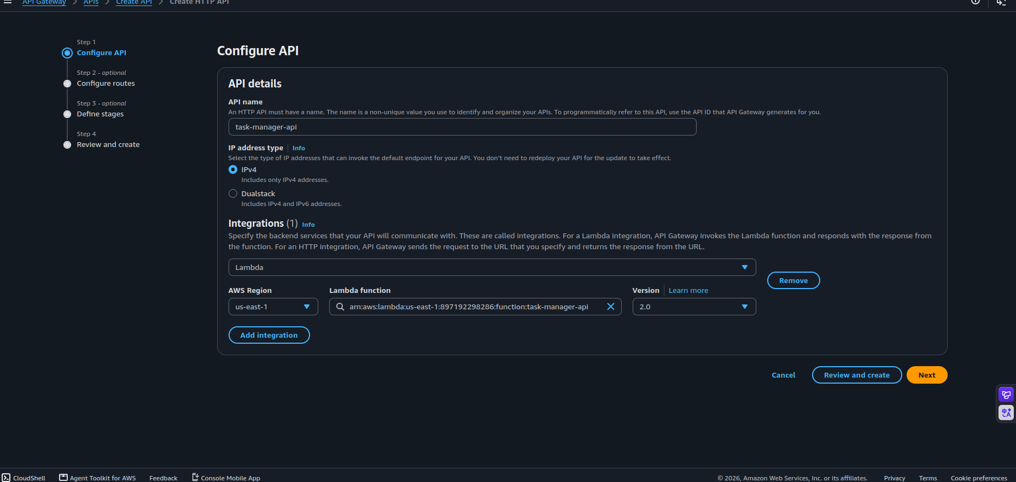
Figure 12: API Gateway > Create HTTP API with the Lambda integration (payload version 2.0)

5.1 Routes
Two routes were created. Both invoke the Lambda function task-manager-api.
GET /tasks --> Lambda task-manager-api
POST /tasks --> Lambda task-manager-api

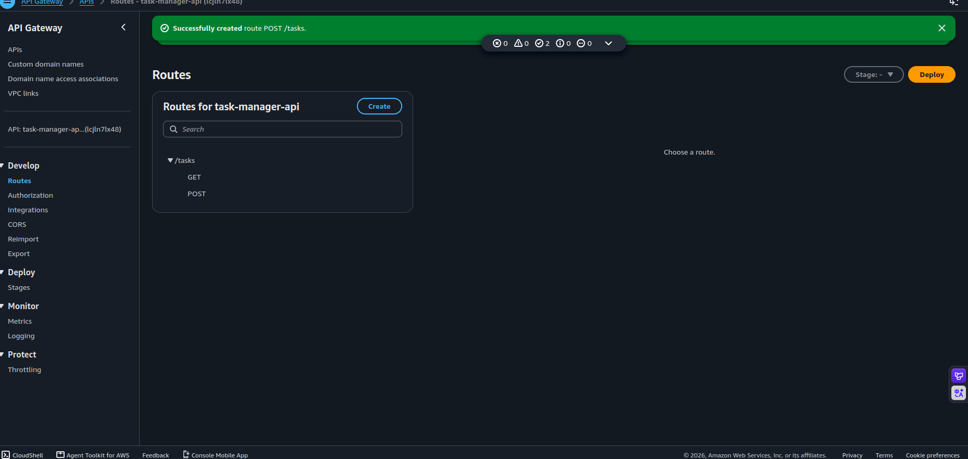
Figure 13: Routes for task-manager-api: GET /tasks and POST /tasks
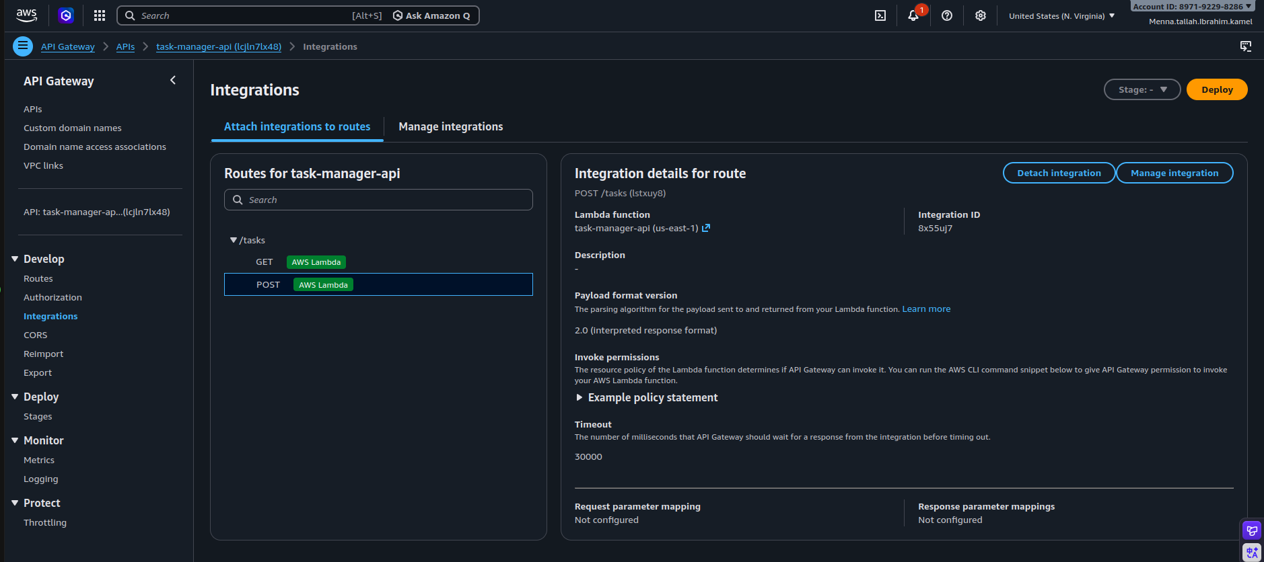
Figure 14: Integrations: each route is attached to the Lambda function (payload format 2.0)

5.2 Test the API (before authentication)
Before the authorizer was added, the API was tested from the browser and from the terminal.
curl -X POST \
https://lcjln7lx48.execute-api.us-east-1.amazonaws.com/tasks \
-H "Content-Type: application/json" \
-d '{"taskId":"4","title":"Learn Terraform"}'

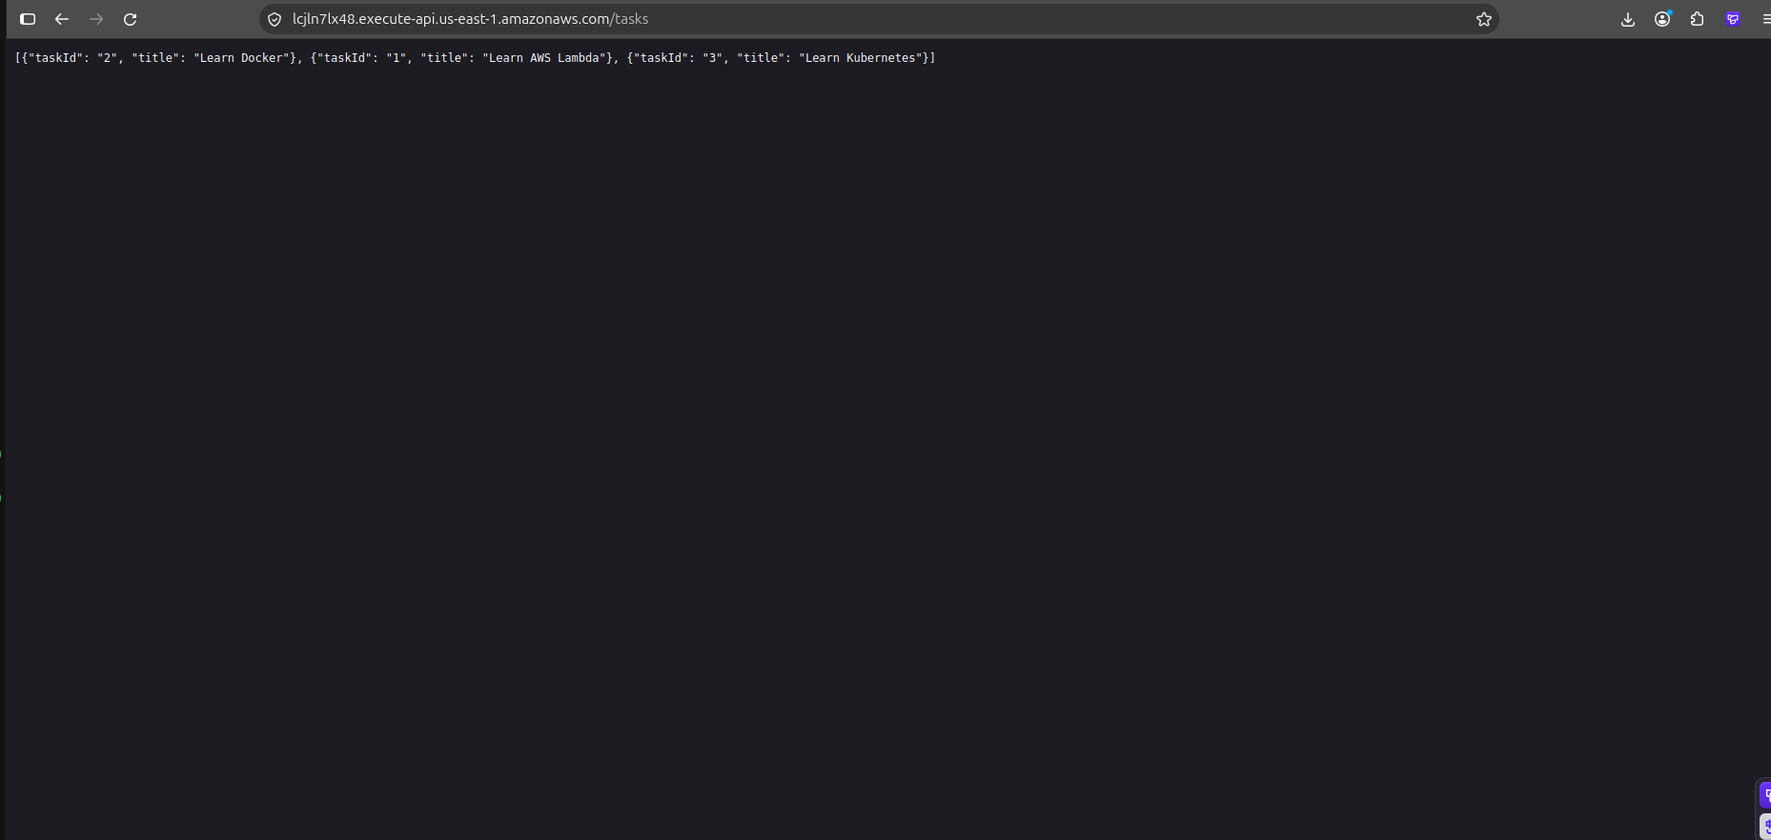
Figure 15: Browser: GET /tasks returns the stored tasks as JSON
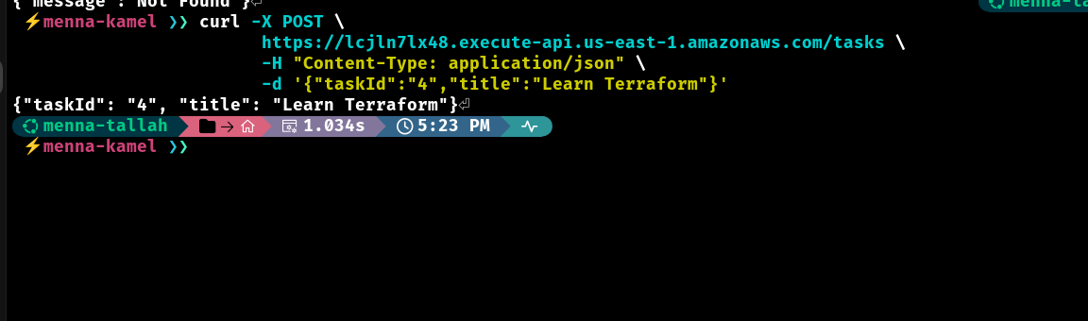
Figure 16: Terminal: POST /tasks creates a task

6. Step 5: Add Authentication with Amazon Cognito
Amazon Cognito authenticates the users. The application uses email as the sign-in identifier, self-registration is enabled, and Cognito-assisted email verification is used.
Setting | Value
User pool | User pool - i3tqd8
User pool ID | us-east-1_5PNHOhGCt
App client | task-manager-app
Client ID | ol5smuff05sa55cpbi4us96lh
Application type | Single-page application (no client secret)
Sign-in identifier | Email
Required attribute | email
OAuth flow | Authorization Code Grant
Scopes | email, openid, phone
Managed Login domain | https://us-east-15pnhohgct.auth.us-east-1.amazoncognito.com

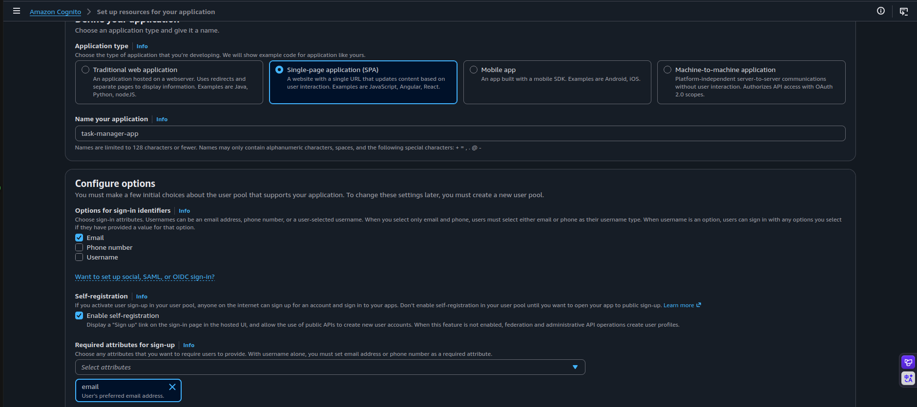
Figure 17: Cognito: application type SPA, sign-in with Email, self-registration and required attribute email
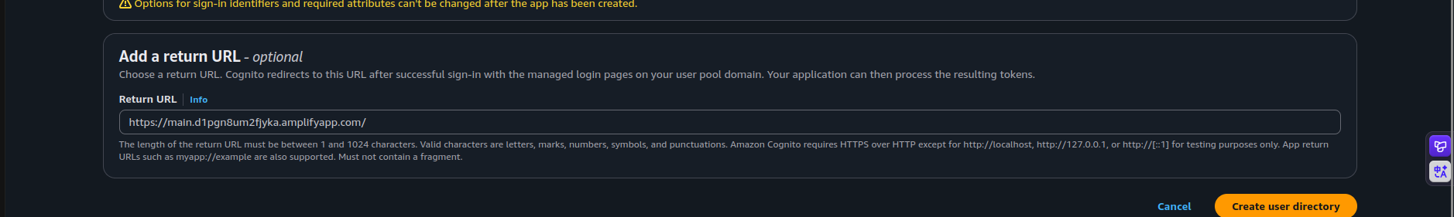
Figure 18: Initial return URL: the Amplify default domain
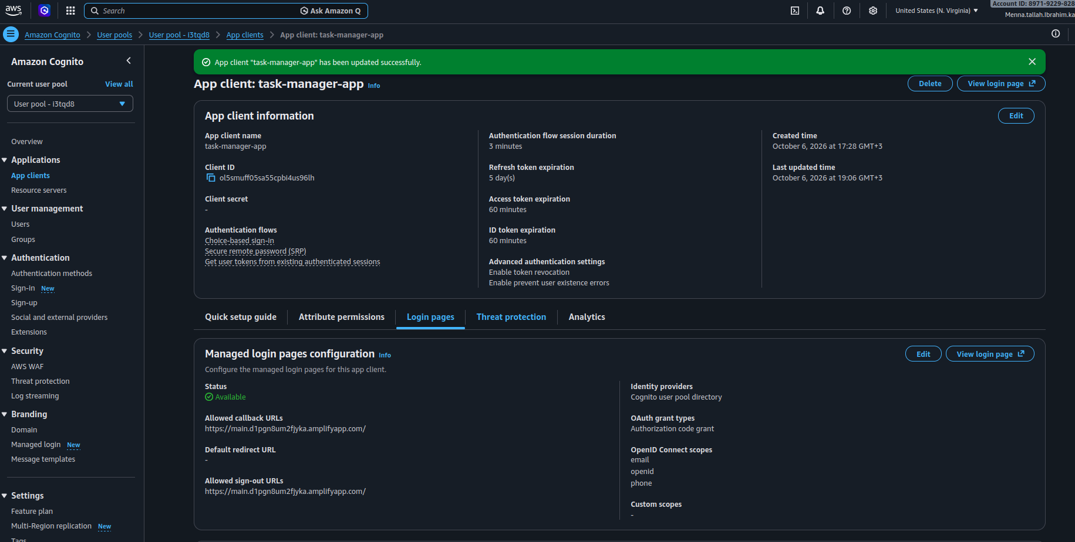
Figure 19: App client task-manager-app: client ID, token expiration and Managed login pages configuration

6.1 Sign-up, verification and sign-in flow
User --> Frontend --> Cognito Managed Login
|-- Sign up
|-- Email verification
|-- Sign in
v
Authorization code --> Frontend --> Access / ID token

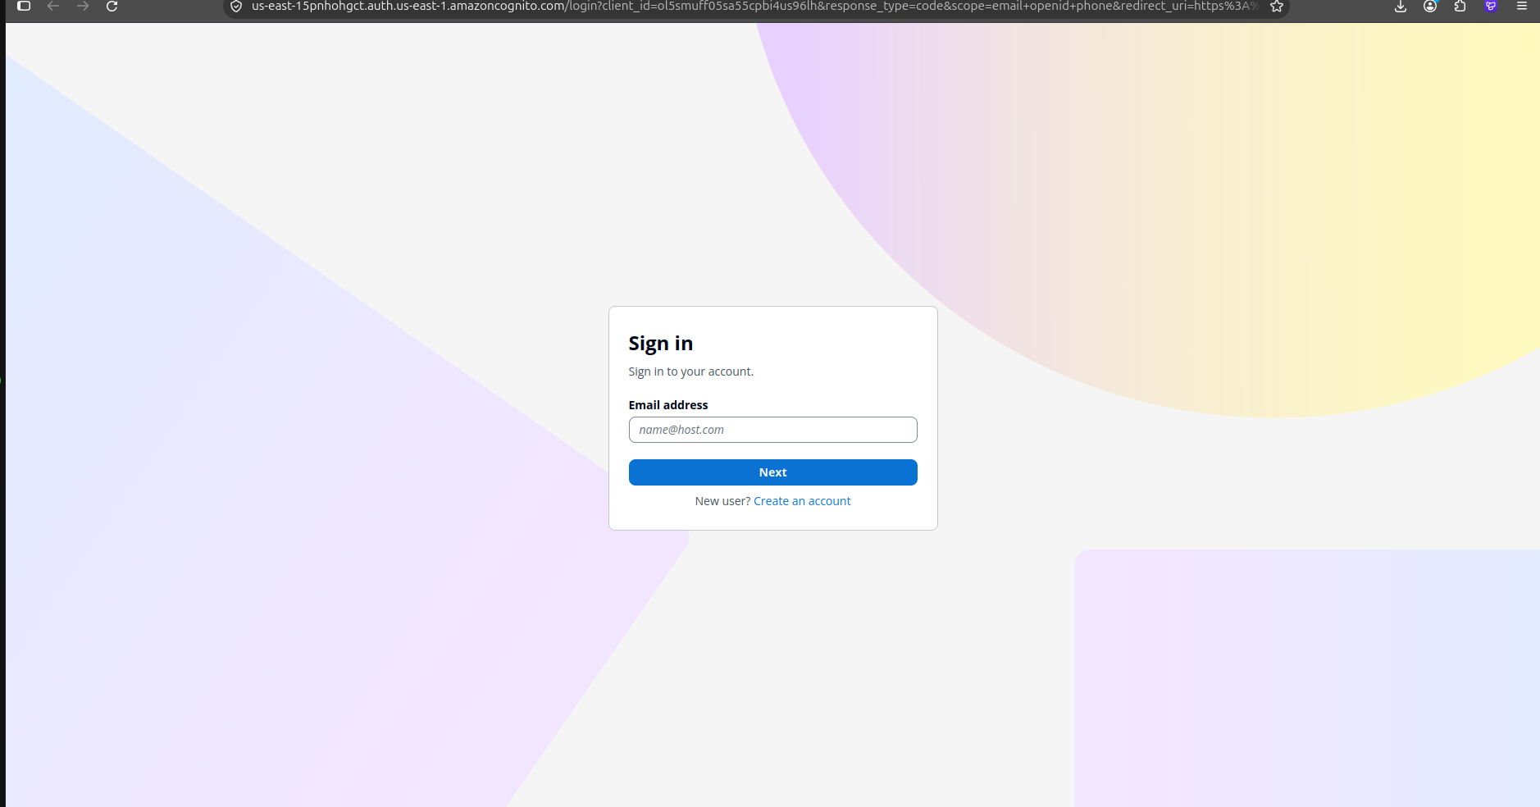
Figure 20: Cognito Managed Login: Sign in page
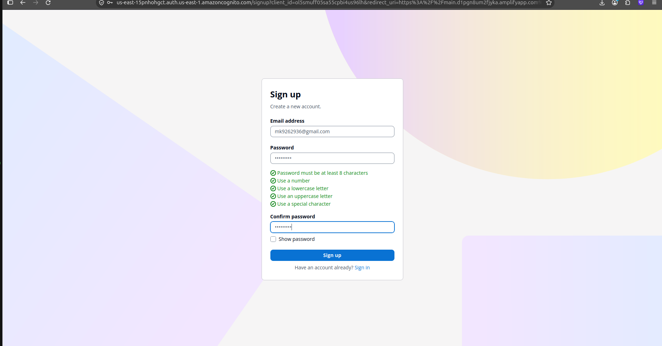
Figure 21: Sign up page: email, password rules and confirm password
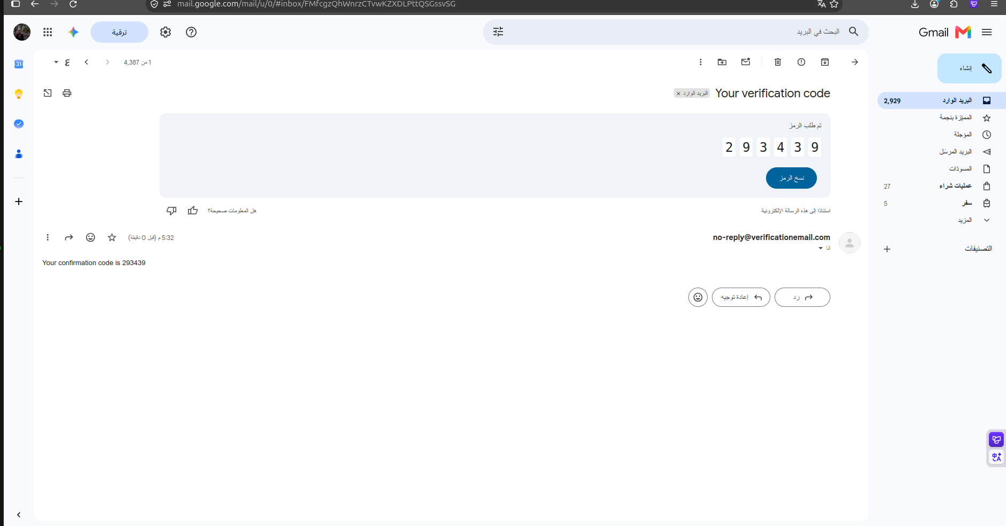
Figure 22: Verification email containing the confirmation code
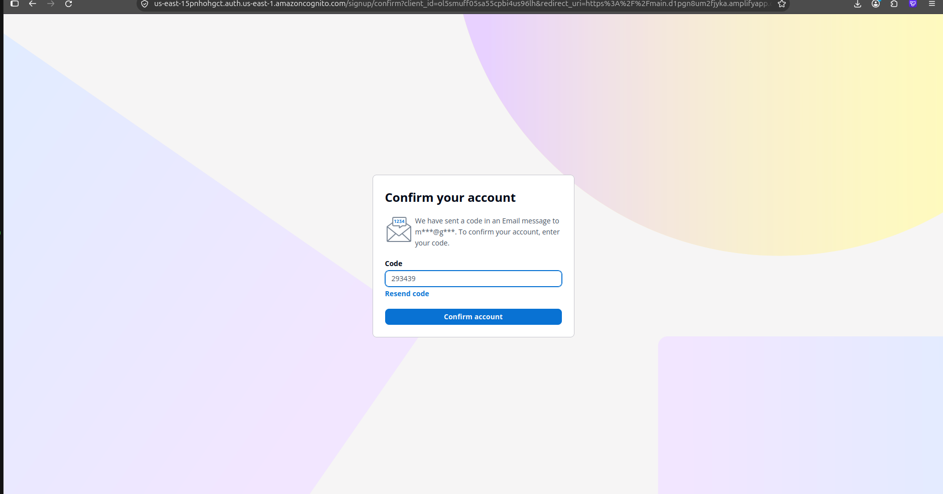
Figure 23: Confirm your account page
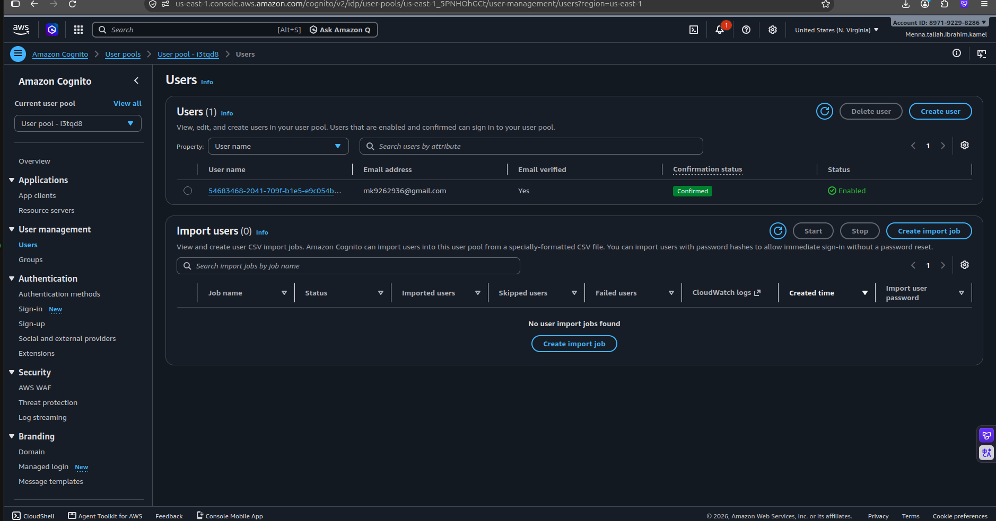
Figure 24: Cognito > Users: the new user with Email verified = Yes and status Confirmed
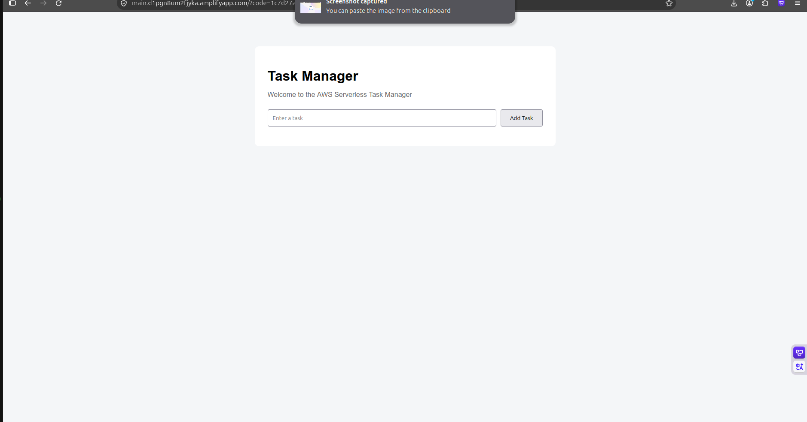
Figure 25: Frontend after the first login on the Amplify domain

7. Step 6: Protect the API with a JWT Authorizer
The API is protected with a JWT authorizer connected to Amazon Cognito. Cognito authenticates the user; API Gateway authorizes access to the protected routes by validating the JWT.
Setting | Value
Authorizer name | CognitoAuthorizer
Authorizer ID | ke5zl4
Type | JWT
Identity source | $request.header.Authorization
Issuer | https://cognito-idp.us-east-1.amazonaws.com/us-east-1_5PNHOhGCt
Audience | ol5smuff05sa55cpbi4us96lh
Attached to | GET /tasks and POST /tasks

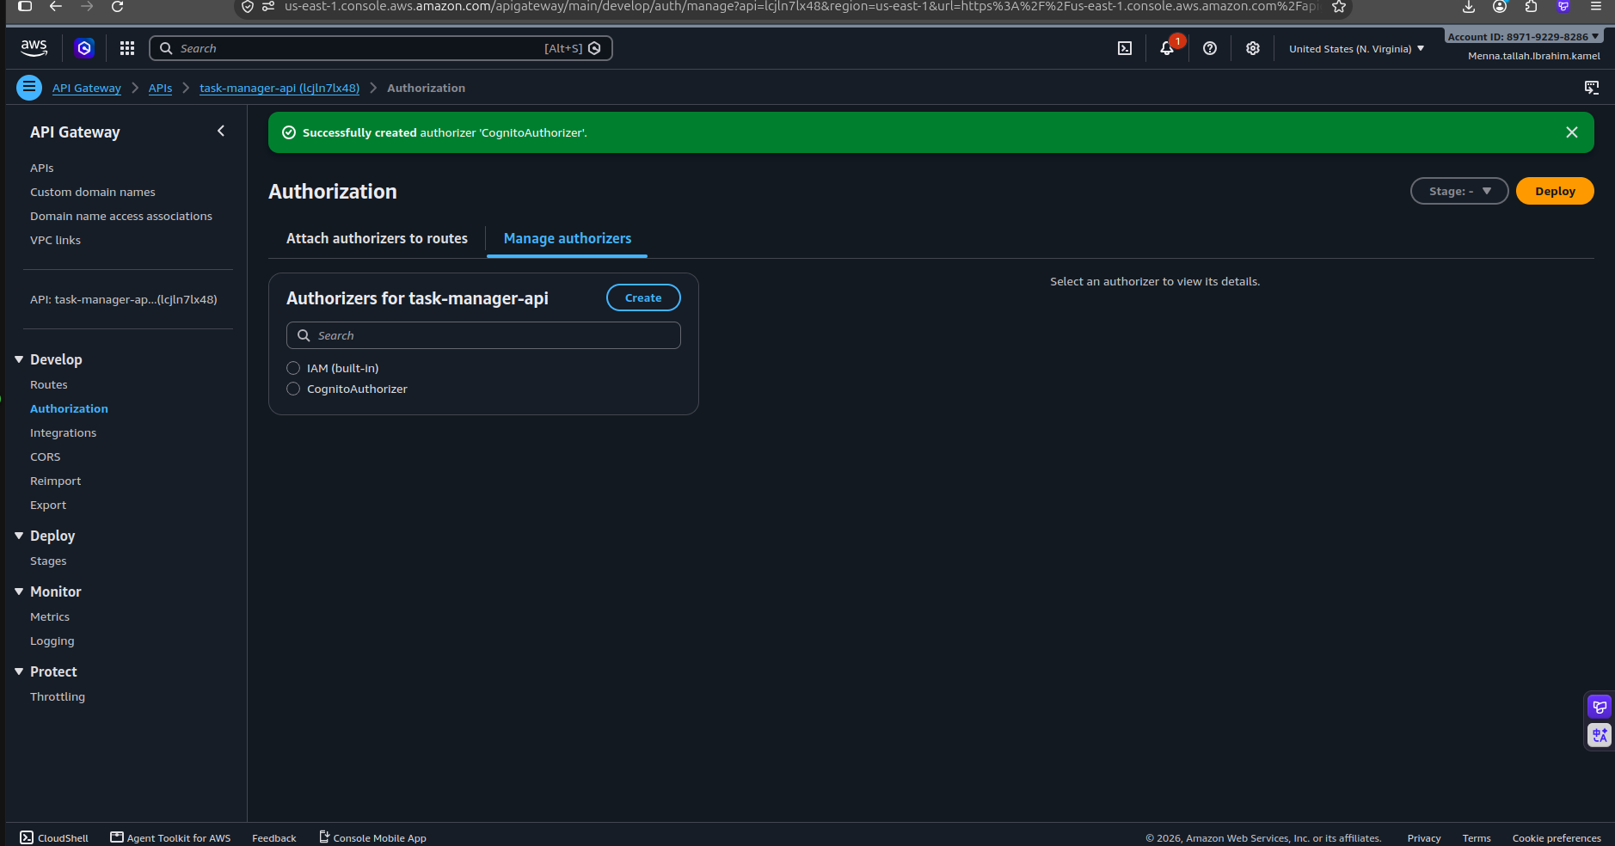
Figure 26: API Gateway > Authorization: authorizer CognitoAuthorizer created
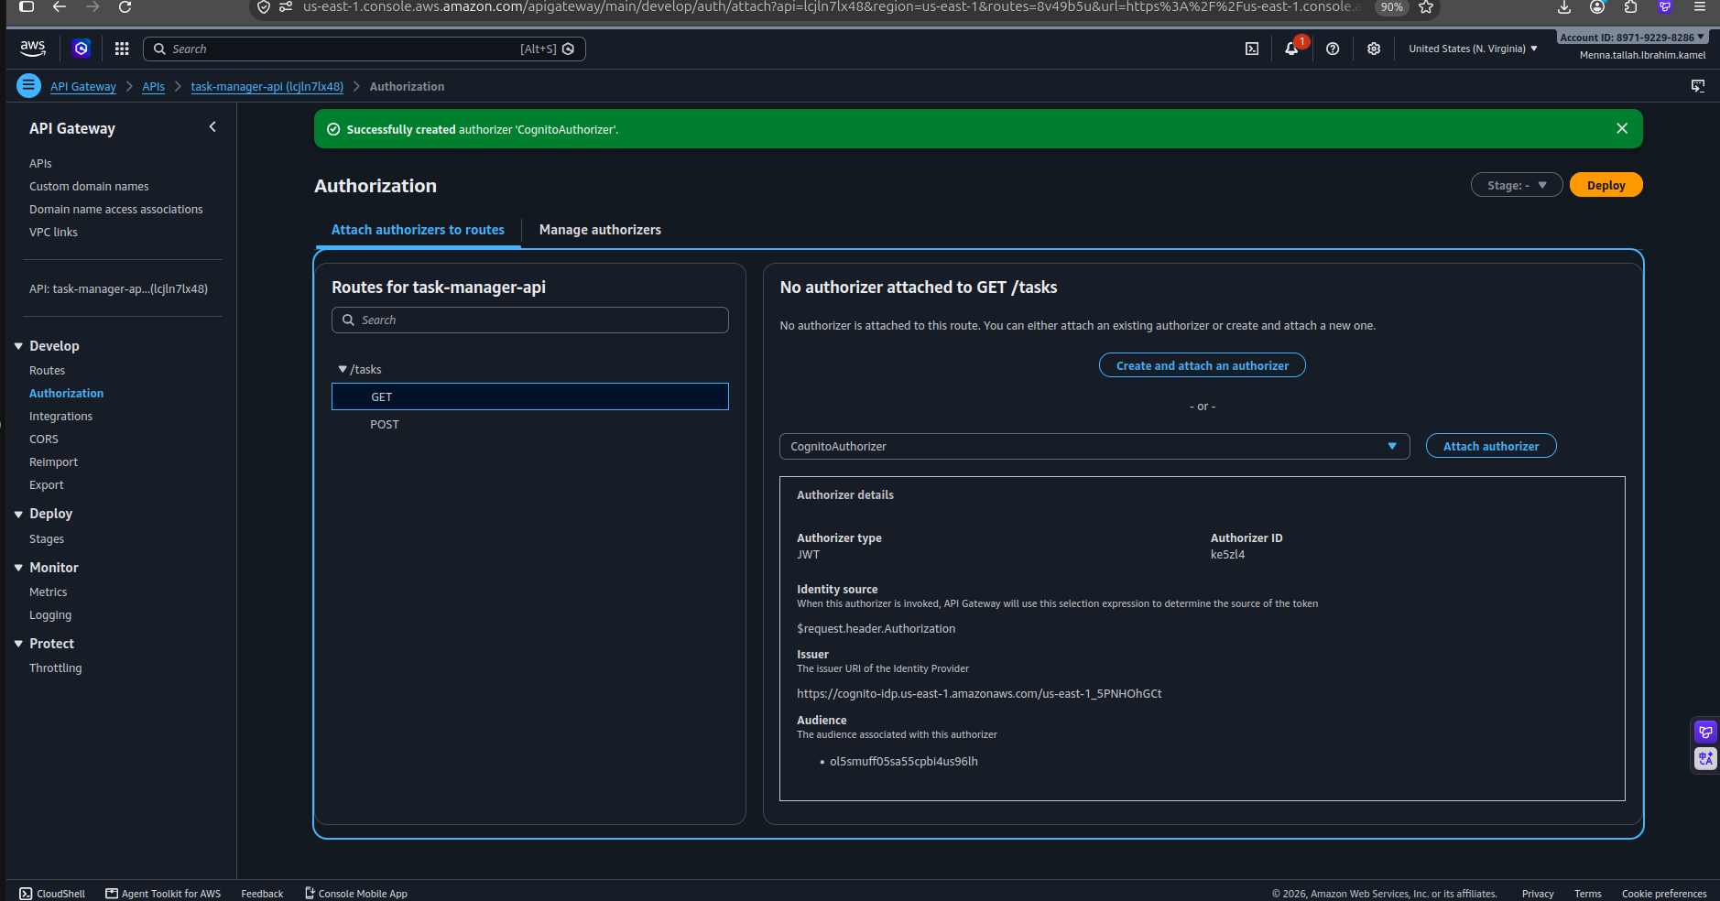
Figure 27: Attaching CognitoAuthorizer to the GET /tasks route
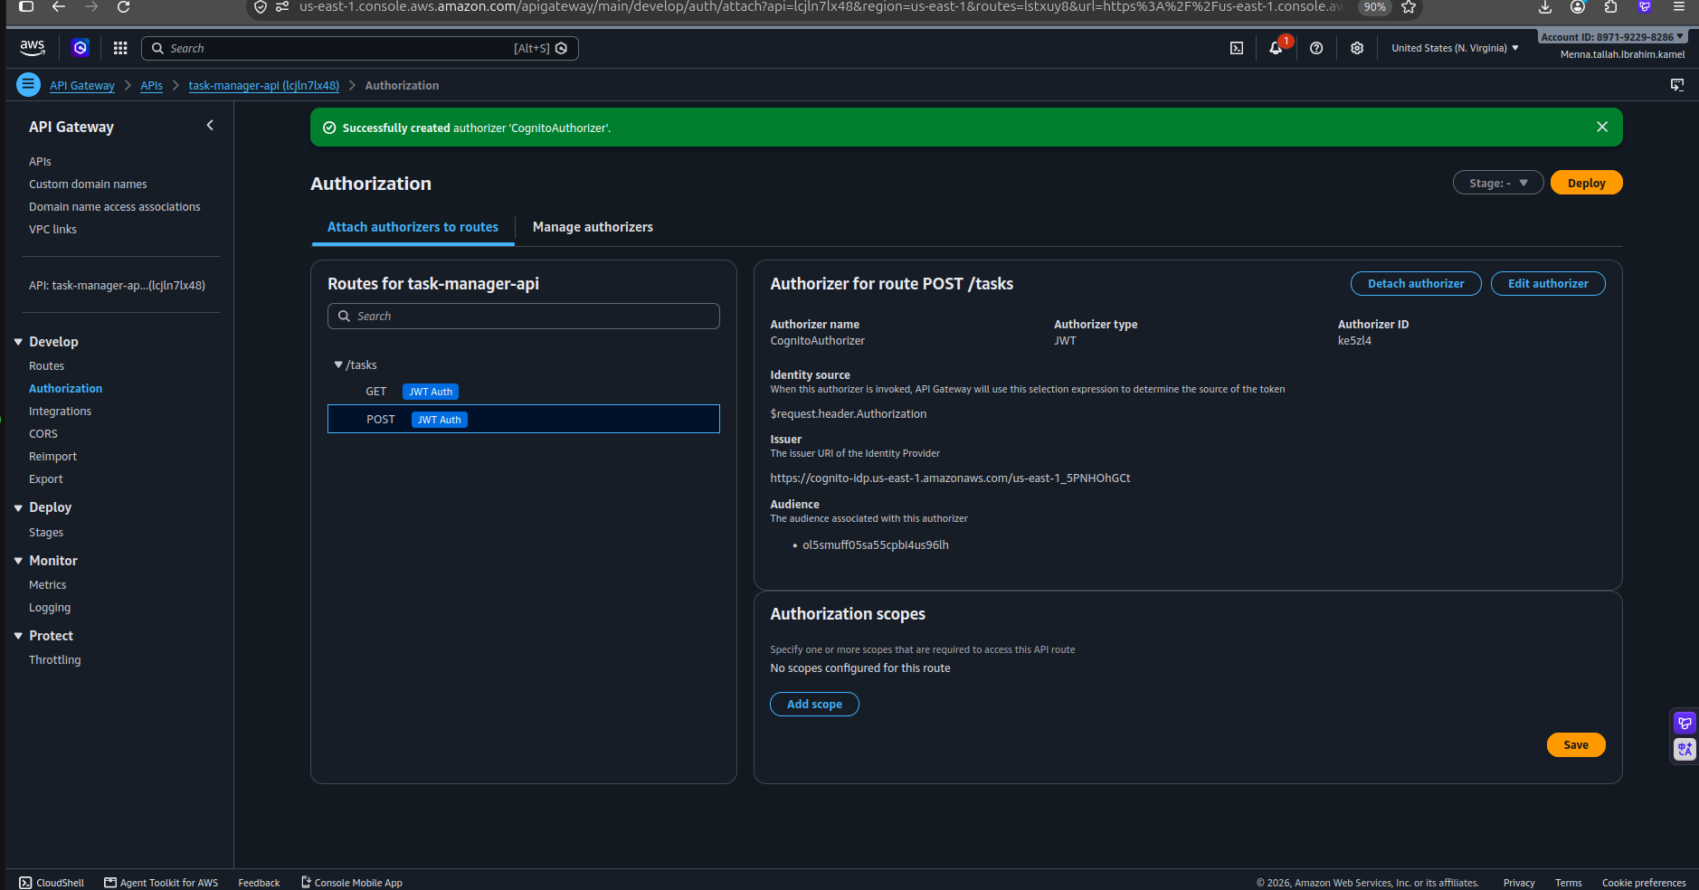
Figure 28: POST /tasks protected by CognitoAuthorizer (JWT Auth) with issuer and audience
An unauthenticated request to GET /tasks now returns the response below, which confirms that API Gateway is protecting the API.
curl https://lcjln7lx48.execute-api.us-east-1.amazonaws.com/tasks
{"message":"Unauthorized"}

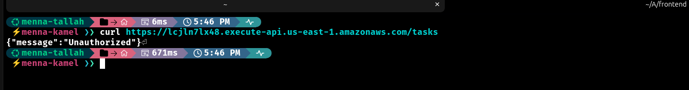
Figure 29: Unauthenticated request returns {"message":"Unauthorized"}
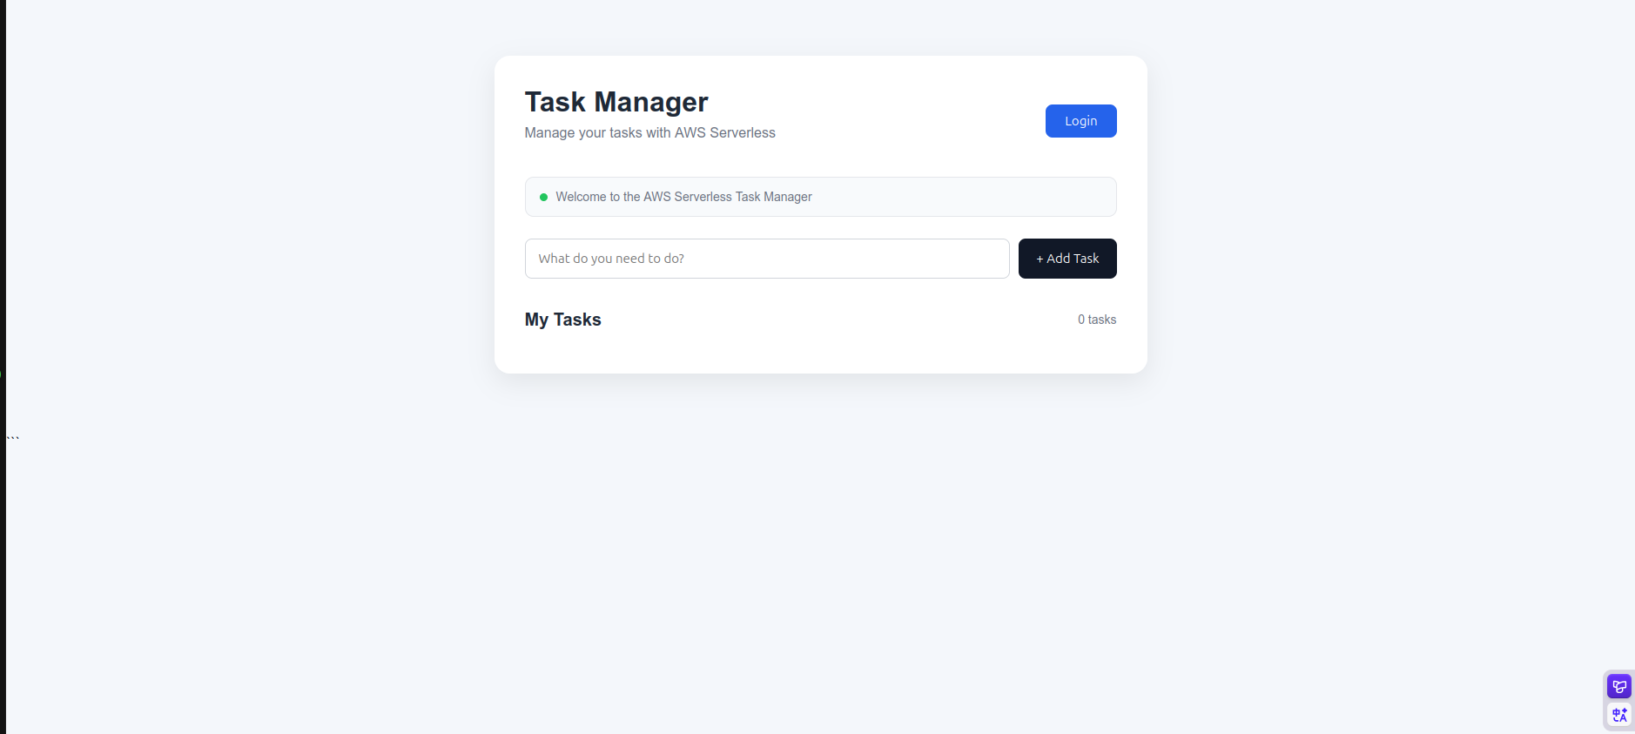
Figure 30: Task Manager frontend with a Login button (not signed in)
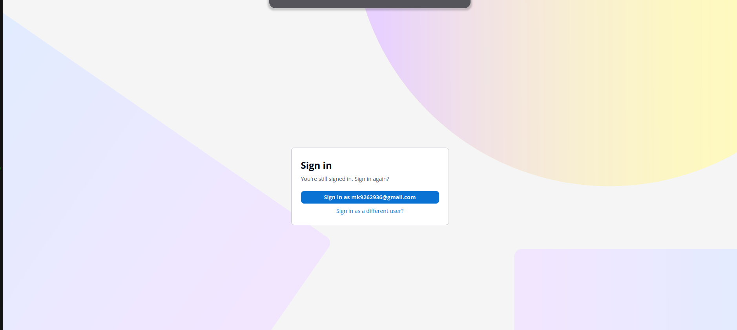
Figure 31: Cognito Managed Login recognizes the existing session

8. Step 7: Multi-User Data Isolation
The Lambda function reads the authenticated user's Cognito sub claim and uses it as the unique user identifier (userId).
requestContext
--> authorizer
--> jwt
--> claims
--> sub (used as userId)

Each new task stores three attributes: taskId (UUID), title and userId. For a GET request, Lambda returns only the tasks whose userId matches the authenticated user.
{
"taskId": "UUID",
"title": "Learn Terraform",
"userId": "Cognito-user-sub"
}

User A --> Cognito --> JWT --> Lambda --> userId = User A
--> only User A's tasks

User B --> Cognito --> JWT --> Lambda --> userId = User B
--> only User B's tasks

This was tested by signing out and signing in with a second user: each user sees only their own tasks.

9. Step 8: Route 53 and the Custom Domain
Before this step, users reached the application on the Amplify domain main.d1pgn8um2fjyka.amplifyapp.com. A custom domain gives the application a professional URL.
Important: Route 53 does not host the frontend. It only resolves the domain name (DNS) and directs traffic to Amplify, which continues to host the frontend.

9.1 Route 53 hosted zone
Setting | Value
Domain | gbgcafe.click
Type | Public hosted zone
Hosted zone ID | Z09376353SECKY64YLB1Y

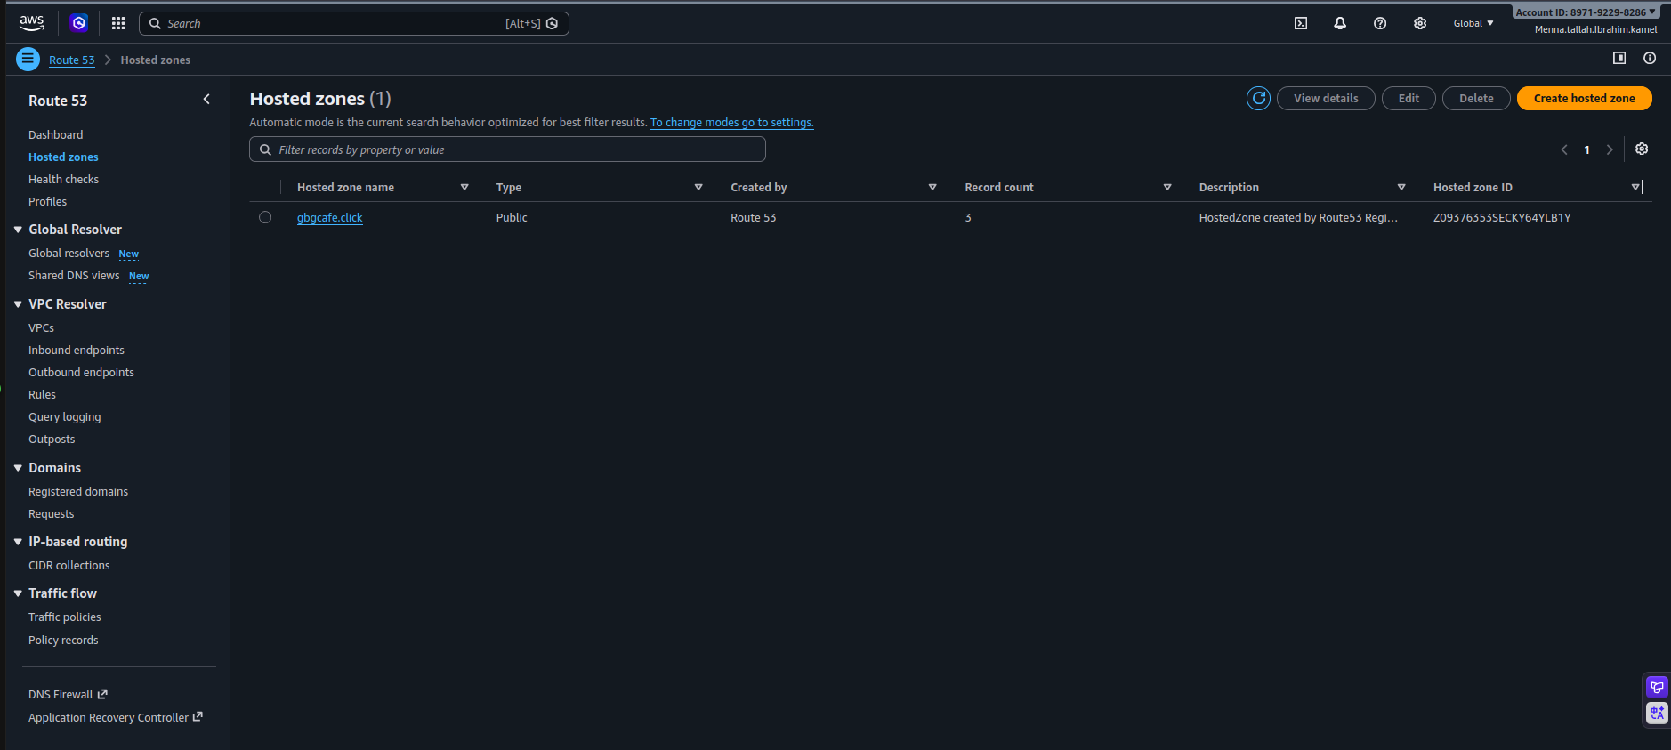
Figure 32: Route 53 > Hosted zones: public hosted zone gbgcafe.click

9.2 Amplify custom domain
Setting | Value
Root domain | gbgcafe.click
Subdomain | www.gbgcafe.click (branch main)
Root redirect | gbgcafe.click redirects to https://www.gbgcafe.click
SSL certificate | Managed by Amplify
Final status | Available

User --> www.gbgcafe.click --> Route 53 (DNS) --> Amplify Hosting --> Frontend

gbgcafe.click --> redirect --> www.gbgcafe.click

9.3 Update the Cognito URLs
After the custom domain was added, the callback and sign-out URLs were updated so that the login and logout flows return to https://www.gbgcafe.click/.
Setting | Value
Callback URLs | https://main.d1pgn8um2fjyka.amplifyapp.com/ and https://www.gbgcafe.click/
Default redirect URL | https://www.gbgcafe.click/
Allowed sign-out URL | Updated to support the custom domain


Figure 33: Allowed sign-out URL (before the update, Amplify domain)
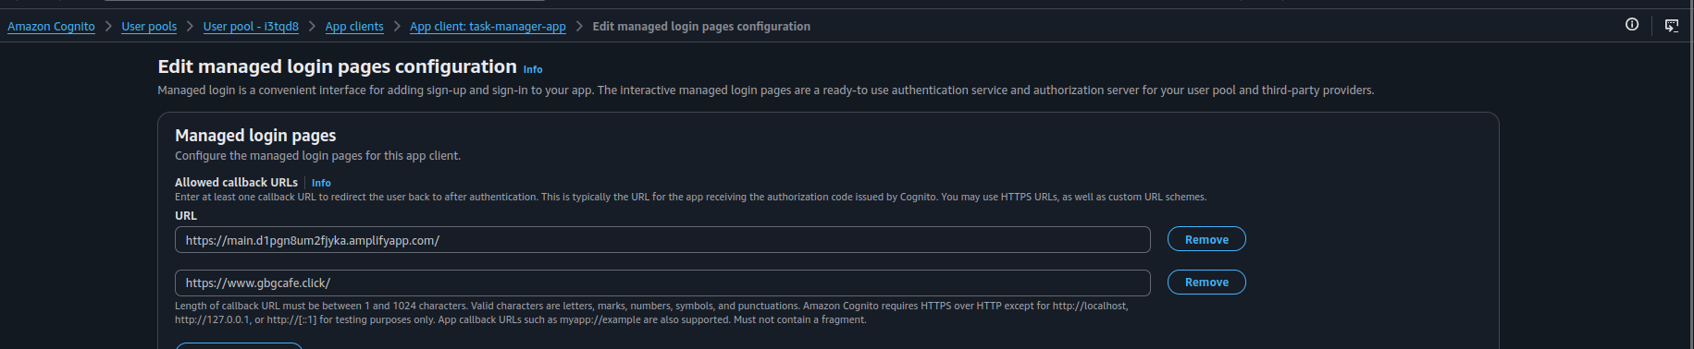
Figure 34: Allowed callback URLs now include https://www.gbgcafe.click/

9.4 Update the API Gateway CORS configuration
The frontend calls API Gateway from the browser, so CORS must allow the frontend origin. After switching to the custom domain, the application showed Failed to add task because CORS still allowed only the old Amplify origin. Changing the allowed origin fixed the problem and the POST request worked.
Setting | Before | After
Access-Control-Allow-Origin | https://main.d1pgn8um2fjyka.amplifyapp.com | https://www.gbgcafe.click
Allow-Headers | authorization, content-type | authorization, content-type
Allow-Methods | GET, POST, OPTIONS | GET, POST, OPTIONS
Allow-Credentials | No | No

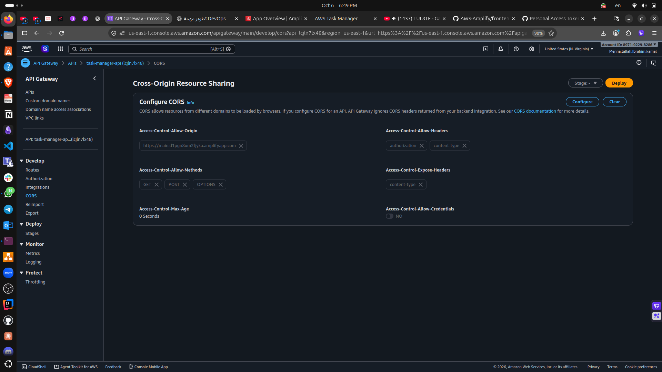
Figure 35: CORS before the change: allowed origin is the Amplify default domain
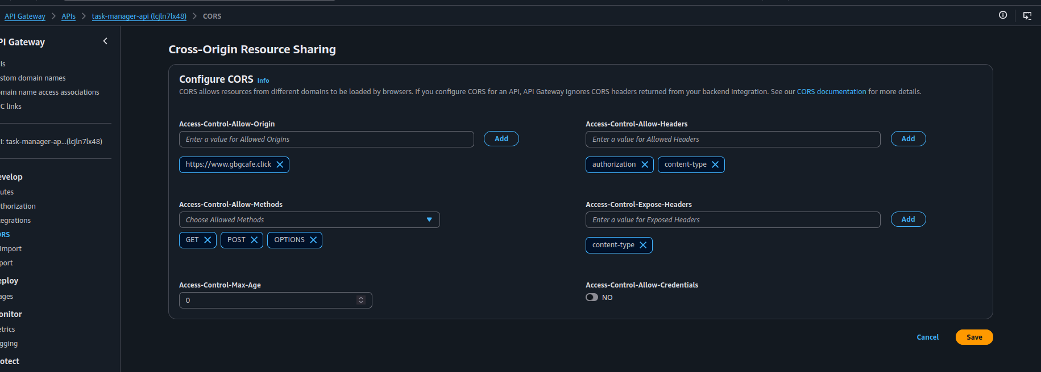
Figure 36: CORS after the change: allowed origin is https://www.gbgcafe.click

9.5 Logout flow
The logout removes the local access_token and id_token, then redirects the user to the Cognito logout endpoint, which returns to https://www.gbgcafe.click.
Click Sign Out --> remove tokens --> Cognito logout endpoint
--> redirect to www.gbgcafe.click

10. Step 9: Monitoring and Logging with CloudWatch
Lambda / API Gateway / DynamoDB
|
v
CloudWatch
+------+------+
| |
Metrics Logs
+------+------+
v
Dashboard: TaskManager-Monitoring

10.1 Lambda metrics
The dashboard TaskManager-Monitoring has a Lambda widget for task-manager-api with a 5-minute period.
Metric | What it shows
Invocations | How many times the function was invoked (application activity)
Errors | Executions that ended with an error; an increase may indicate application or infrastructure problems
Duration | Execution time; a sudden increase can indicate slow DynamoDB operations or performance problems
Throttles | Invocations that were throttled; may indicate that concurrency limits were reached
ConcurrentExecutions | Number of executions running at the same time (traffic and concurrency)

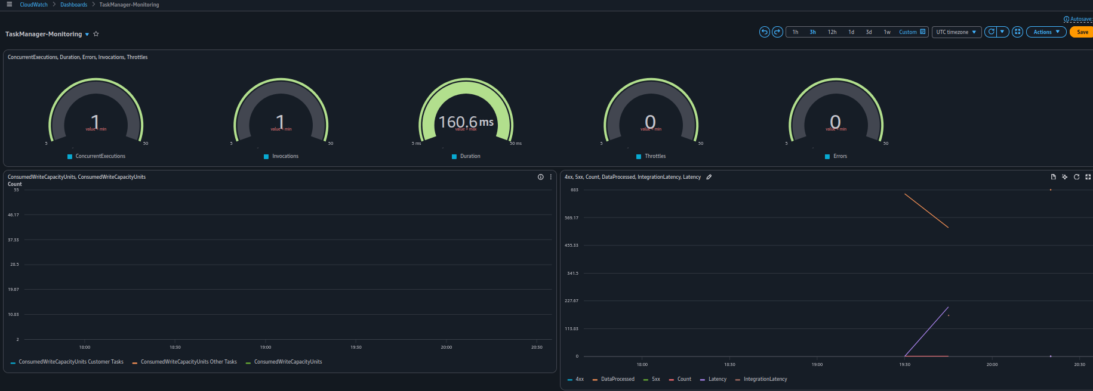
Figure 37: CloudWatch dashboard TaskManager-Monitoring with Lambda, DynamoDB and API Gateway widgets

10.2 API Gateway and DynamoDB metrics
Service | Important metrics
API Gateway | Count (requests), 4XXError (client errors such as 401, 403, 404), 5XXError (server errors such as 500, 502, 503), Latency (total processing time), IntegrationLatency (time spent in the Lambda integration)
DynamoDB | ConsumedReadCapacityUnits, ConsumedWriteCapacityUnits, ReadThrottleEvents, WriteThrottleEvents (the table uses on-demand capacity)

10.3 CloudWatch Logs and application logging
Lambda logs are written to the log group /aws/lambda/task-manager-api. Each execution produces START, application logs, END and REPORT lines. Python logging was added to the function:
logger = logging.getLogger()
logger.setLevel(logging.INFO)

logger.exception("Error while processing request") # stack trace

Example application log lines: HTTP Method: POST, Creating new task, Creating task: <task-id> and Task successfully stored in DynamoDB.
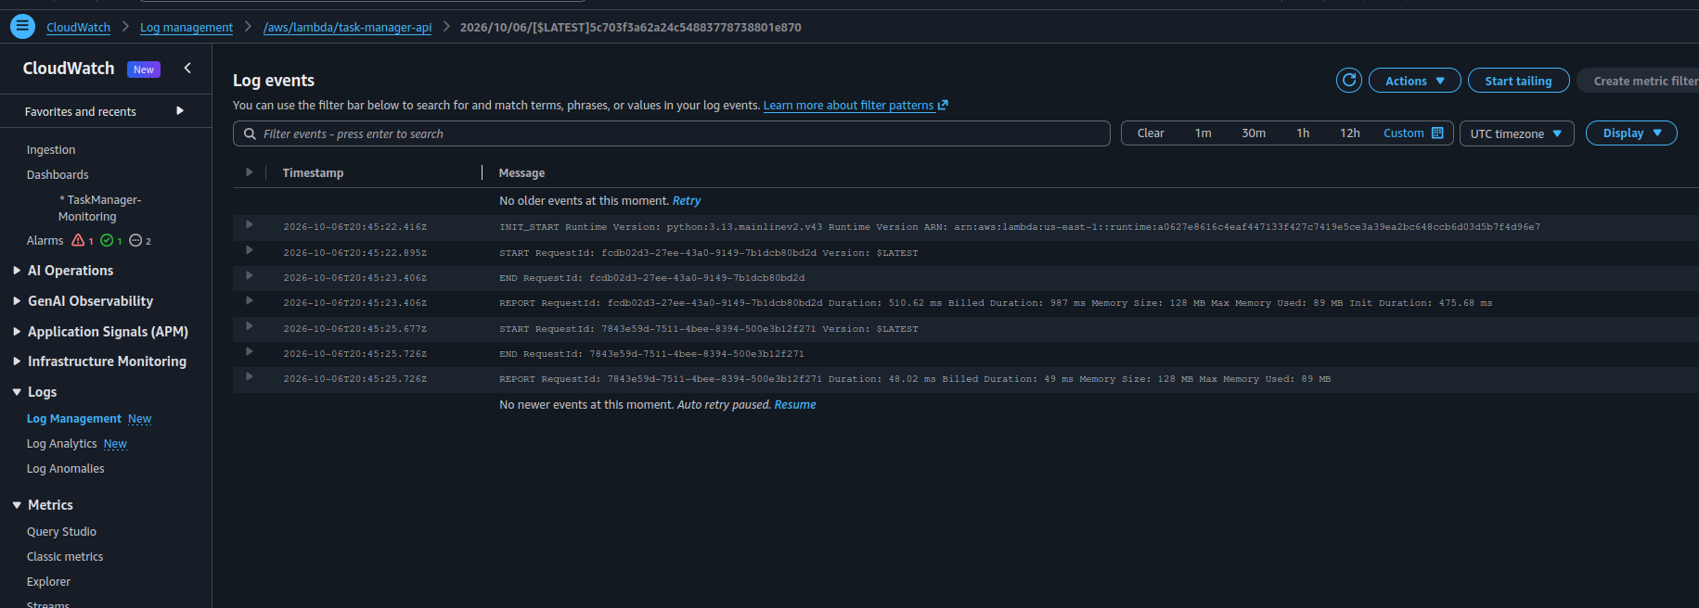
Figure 38: CloudWatch Logs: log events of /aws/lambda/task-manager-api
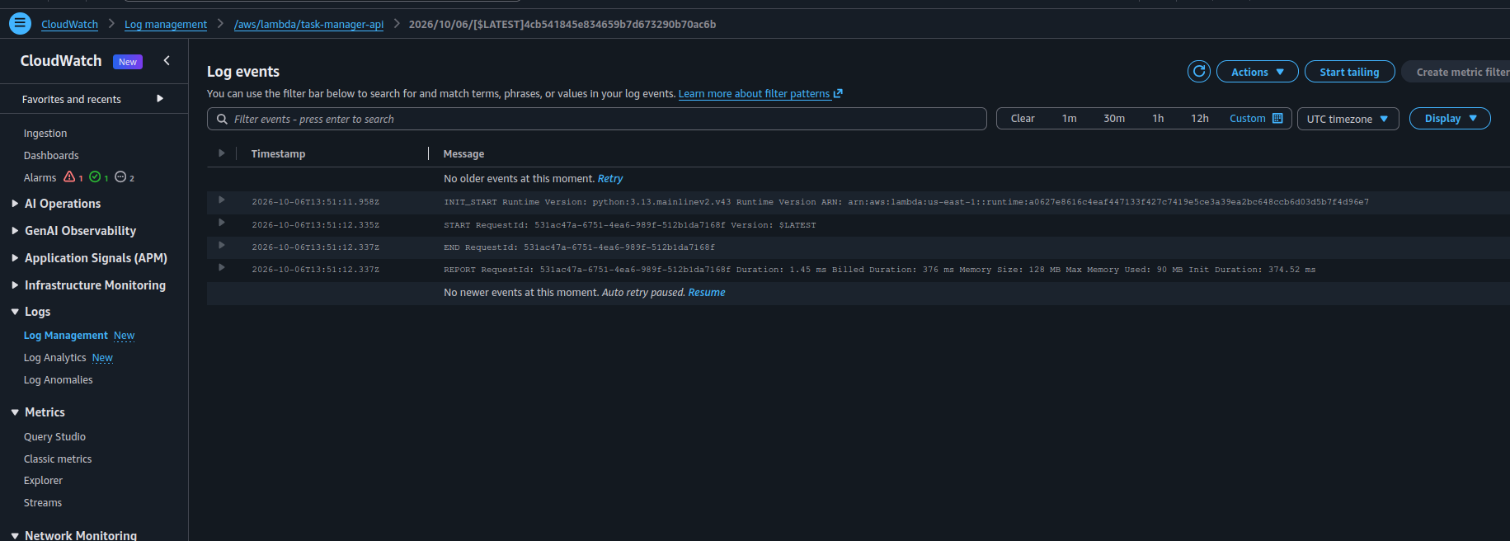
Figure 39: Log events of a later execution (START, END and REPORT lines)

10.4 Monitoring test
The monitoring was tested with real application requests: open the application, log in, add tasks, refresh the application, open the CloudWatch dashboard and refresh the metrics. Add Task generates POST /tasks and loading the tasks generates GET /tasks; both pass through API Gateway and Lambda to DynamoDB and appear in CloudWatch.

10.5 Amplify monitoring
Amplify Hosting provides its own monitoring sections: Metrics (requests, data transfer, 4xx and 5xx errors, time to first byte), Alarms, Access logs and Build notifications. Access logs help investigate frontend requests (for example a 404 for a missing resource), and the build logs show why a deployment failed.
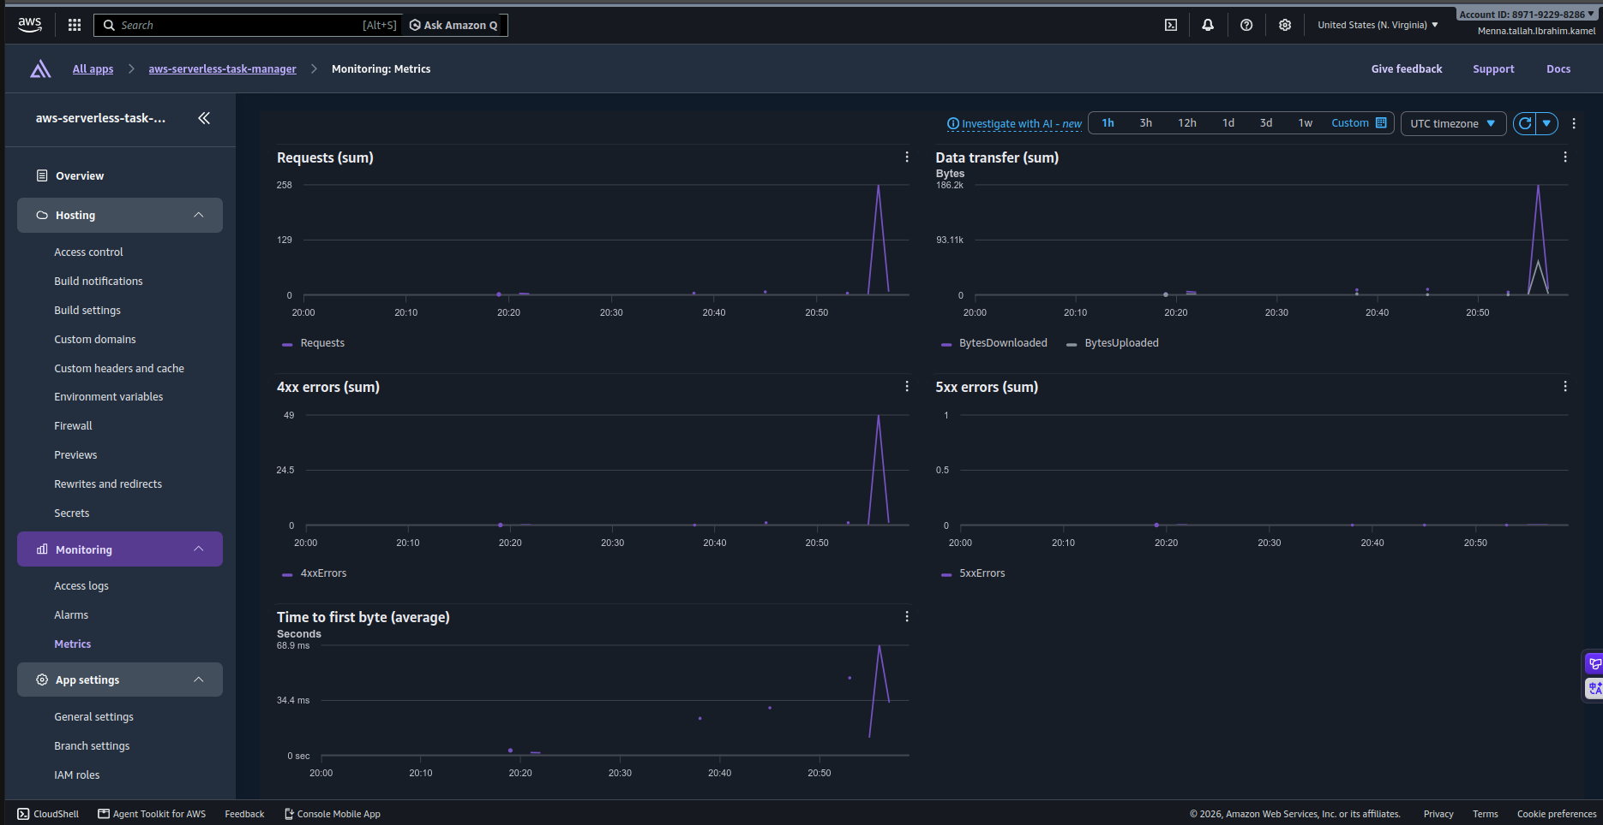
Figure 40: Amplify > Monitoring > Metrics: requests, data transfer, 4xx and 5xx errors
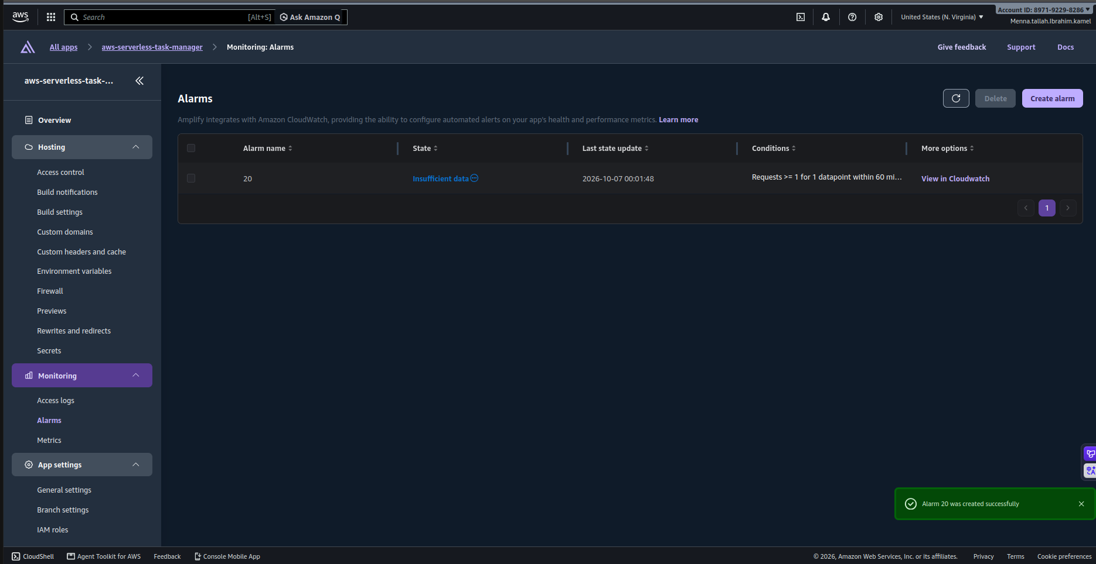
Figure 41: Amplify > Monitoring > Alarms: alarm created successfully

11. Failure Testing and Troubleshooting
A controlled Lambda test event was used to test error logging. The following invalid event was provided:
{
"requestContext": {}
}

The function tried to read requestContext.http.method, which was missing, and raised an exception. The exception was logged with logger.exception(), so CloudWatch Logs shows the stack trace.
Request --> API Gateway --> Lambda --> Exception
|-- CloudWatch Logs (stack trace)
|-- CloudWatch Metrics (Errors)
Identify root cause --> Fix code --> Deploy new version

Test result summary
# | Test | Expected result | Result
1 | Unauthenticated GET /tasks | {"message":"Unauthorized"} | Pass
2 | Sign up, email verification and login | User is Confirmed and signed in | Pass
3 | Add a task (POST /tasks) | HTTP 201 and the task is displayed | Pass (after the CORS fix)
4 | Load tasks (GET /tasks) | Only the user's own tasks are returned | Pass
5 | Second user (data isolation) | User B does not see User A's tasks | Pass
6 | Custom domain and root redirect | gbgcafe.click redirects to www.gbgcafe.click | Pass
7 | Monitoring test | Requests appear in the CloudWatch dashboard | Pass
8 | Failure test | Stack trace appears in CloudWatch Logs | Pass

12. End-to-End Flows and Security

12.1 Add a task (POST)
User clicks "Add Task"
--> Frontend: POST /tasks, Authorization: Bearer <JWT>
--> API Gateway: validate the JWT with the Cognito JWT authorizer
--> Lambda: extract the user "sub"
--> DynamoDB: PutItem
--> Lambda: HTTP 201 --> API Gateway --> Frontend --> task displayed

12.2 Load tasks (GET)
Frontend: GET /tasks
--> API Gateway + JWT authorizer
--> Lambda: extract userId
--> DynamoDB: retrieve the user's tasks
--> API Gateway --> Frontend --> display tasks

12.3 Security layers
- Cognito authenticates the user and issues the JWT.
- The API Gateway JWT authorizer rejects requests without a valid token.
- Lambda filters data by the userId taken from the token.
- The frontend never accesses DynamoDB directly; all access goes through API Gateway and Lambda.
- The Lambda role should be reduced to least privilege for production.

13. Lessons Learned
- Authentication and authorization are different. Cognito authenticates the user; API Gateway authorizes access to protected routes using the JWT.
- Route 53 does not host the website. It provides DNS resolution; Amplify hosts the frontend.
- CORS must match the actual frontend origin. Moving from the Amplify domain to www.gbgcafe.click required updating API Gateway CORS.
- Metrics and logs have different purposes. Metrics answer how much, how often and how long; logs answer what exactly happened, where and why.
- Monitoring is more useful when tested. Generate traffic, observe metrics, generate a failure, inspect logs, find the root cause, fix and redeploy.

14. Final Result and Checklist
The completed project is a serverless application with a custom domain, authentication, a protected API, a serverless backend, a NoSQL database, multi-user isolation, CI/CD, monitoring, logging and troubleshooting. The final user-facing URL is https://www.gbgcafe.click.
Check | Done
HTML/CSS/JS frontend deployed on Amplify Hosting with GitHub integration and automatic deployment | [x]
Cognito user pool, registration, email verification, login, JWT authentication and logout | [x]
Lambda function, API Gateway HTTP API, GET and POST /tasks, JWT authorizer | [x]
DynamoDB table Tasks with multi-user isolation | [x]
Route 53 hosted zone, Amplify custom domain, SSL certificate, root redirect and www domain | [x]
Cognito callback and logout URLs and API Gateway CORS updated | [x]
CloudWatch dashboard, Lambda metrics and logs, application logging | [x]
API Gateway, DynamoDB and Amplify monitoring sections | [x]
Monitoring test and failure / troubleshooting test | [x]

Appendix A: Screenshot Checklist
Use this table to confirm that every figure contains the correct screenshot.
Figure | What it shows | Done
1 | Amplify > Create new app: repository mennakamel25/AWS-Amplify, branch main and monorepo root frontend | [x]
2 | Amplify app settings: app name, build command and output directory | [x]
3 | Advanced settings: environment variable AMPLIFY_MONOREPO_APP_ROOT = frontend | [x]
4 | DynamoDB > Create table: table name Tasks and partition key taskId (String) | [x]
5 | Default table settings with On-demand capacity mode | [x]
6 | IAM > Create role: role name TaskManagerLambdaRole with the Lambda trust policy | [x]
7 | TaskManagerLambdaRole with both permission policies attached | [x]
8 | Lambda > Create function: task-manager-api with the custom execution role TaskManagerLambdaRole | [x]
9 | Lambda Test tab: creating a test event | [x]
10 | Lambda test result: execution succeeded with the response and log output | [x]
11 | DynamoDB > Explore items: the task created by the Lambda test appears in the Tasks table | [x]
12 | API Gateway > Create HTTP API with the Lambda integration (payload version 2.0) | [x]
13 | Routes for task-manager-api: GET /tasks and POST /tasks | [x]
14 | Integrations: each route is attached to the Lambda function (payload format 2.0) | [x]
15 | Browser: GET /tasks returns the stored tasks as JSON | [x]
16 | Terminal: POST /tasks creates a task | [x]
17 | Cognito: application type SPA, sign-in with Email, self-registration and required attribute email | [x]
18 | Initial return URL: the Amplify default domain | [x]
19 | App client task-manager-app: client ID, token expiration and Managed login pages configuration | [x]
20 | Cognito Managed Login: Sign in page | [x]
21 | Sign up page: email, password rules and confirm password | [x]
22 | Verification email containing the confirmation code | [x]
23 | Confirm your account page | [x]
24 | Cognito > Users: the new user with Email verified = Yes and status Confirmed | [x]
25 | Frontend after the first login on the Amplify domain | [x]
26 | API Gateway > Authorization: authorizer CognitoAuthorizer created | [x]
27 | Attaching CognitoAuthorizer to the GET /tasks route | [x]
28 | POST /tasks protected by CognitoAuthorizer (JWT Auth) with issuer and audience | [x]
29 | Unauthenticated request returns {"message":"Unauthorized"} | [x]
30 | Task Manager frontend with a Login button (not signed in) | [x]
31 | Cognito Managed Login recognizes the existing session | [x]
32 | Route 53 > Hosted zones: public hosted zone gbgcafe.click | [x]
33 | Allowed sign-out URL (before the update, Amplify domain) | [x]
34 | Allowed callback URLs now include https://www.gbgcafe.click/ | [x]
35 | CORS before the change: allowed origin is the Amplify default domain | [x]
36 | CORS after the change: allowed origin is https://www.gbgcafe.click | [x]
37 | CloudWatch dashboard TaskManager-Monitoring with Lambda, DynamoDB and API Gateway widgets | [x]
38 | CloudWatch Logs: log events of /aws/lambda/task-manager-api | [x]
39 | Log events of a later execution (START, END and REPORT lines) | [x]
40 | Amplify > Monitoring > Metrics: requests, data transfer, 4xx and 5xx errors | [x]
41 | Amplify > Monitoring > Alarms: alarm created successfully | [x]

