
Task 4: Shared, Hybrid, and Replicated Storage on AWS
CloudMart storage project: Amazon EFS, S3 Files, S3 Cross-Region Replication and S3 File Gateway
Item | Details
Project | CloudMart Storage Project (Flask web application on shared storage)
Storage services | Amazon EFS, S3 Files, S3 Cross-Region Replication (CRR), AWS Storage Gateway (S3 File Gateway)
Compute | Two EC2 Linux clients (task4-client-a and task4-client-b) and one File Gateway appliance (task4-filegw)
Network | VPC task4-vpc (10.0.0.0/16) with two subnets
Region | us-east-1
Document version | 1.0
Status | Draft
Prepared by | Menna Kamel
Date | 2026-10-11

Document Version and Change Log
Version | Date | Author | Description of change
1.0 | 2026-10-11 | Menna Kamel | Initial release: network, EFS, S3 Files, S3 CRR, S3 File Gateway, persistent NFS mounts, CloudMart application, troubleshooting and validation checklist

1. Project Overview and Architecture
This project demonstrates four storage solutions on Amazon Web Services:
- Amazon EFS: shared file storage for multiple EC2 instances.
- S3 Files (S3-backed mount): access to S3-backed data through a filesystem-style interface.
- Amazon S3 Cross-Region Replication (CRR): replication of objects between S3 buckets in different Regions.
- AWS Storage Gateway, S3 File Gateway: connects Linux EC2 instances to Amazon S3 through an NFS file share.
The project also includes a Flask web application called CloudMart, which lets users upload, view and download files using the different storage backends.

1.1 Objectives
- Understand the differences between file storage and object storage.
- Configure AWS networking with a VPC and subnets.
- Connect multiple EC2 instances to shared storage (EFS, S3 Files, NFS).
- Implement S3 Cross-Region Replication.
- Configure an S3 File Gateway and mount its NFS share on two EC2 instances.
- Integrate the storage services with a Flask application running as a systemd service.
- Troubleshoot connectivity, permissions and application issues, and verify that files reach their intended storage.

1.2 Shared storage architecture
CloudMart user --> Web browser --> EC2 Client B (Flask app, systemd)

+-----------------+------------------+
| | |
v v v
Amazon EFS S3 Files mount S3 File Gateway
/mnt/efs /mnt/s3files /mnt/cloudmart-share
|
v
AWS Storage Gateway
|
v
Amazon S3 bucket

- EC2 Client A (Subnet A): connects to the shared storage and creates and reads files to verify shared access.
- EC2 Client B (Subnet B): connects to the shared storage and hosts the CloudMart Flask application.
- Amazon EFS: a shared network filesystem that several instances can access at the same time.
- S3 File Gateway: exposes an NFS share and stores the file data in an S3 bucket, so Linux applications use a filesystem interface instead of S3 APIs.

1.3 S3 Cross-Region Replication architecture
S3 source bucket (Region A)
|
| Cross-Region Replication (asynchronous)
v
S3 destination bucket (Region B)

1.4 Environment and resources
Resource | Value
Region | us-east-1
VPC | task4-vpc (vpc-0588ea80fff9a94e4), CIDR 10.0.0.0/16
Subnet A | task4-subnet-a, 10.0.1.0/24 (subnet-096b627afed723144)
Subnet B | task4-subnet-b, 10.0.2.0/24 (subnet-0d6f75e3be9ea1849)

EC2 instance | Private IP | Purpose
task4-client-a | 10.0.1.201 | Storage client in Subnet A
task4-client-b | 10.0.2.56 | Storage client and application server
task4-filegw | 10.0.2.34 | S3 File Gateway appliance

Storage | Mount point
Amazon EFS | /mnt/efs
S3 Files (S3-backed mount) | /mnt/s3files
S3 File Gateway | /mnt/cloudmart-share

2. Part One: Configure the AWS Network

2.1 VPC and subnets
A VPC provides the isolated network in which the EC2 clients and storage resources communicate. The CIDR 10.0.0.0/16 gives a private address range for the lab.
- Open VPC > Create VPC, choose VPC only, and enter the name task4-vpc and IPv4 CIDR 10.0.0.0/16.
- Create task4-subnet-a with CIDR 10.0.1.0/24 in task4-vpc (Client A is placed here).
- Create task4-subnet-b with CIDR 10.0.2.0/24 (Client B and the File Gateway appliance are placed here).
Note: the VPC already exists in the current environment. Do not create another VPC if you continue the existing lab.
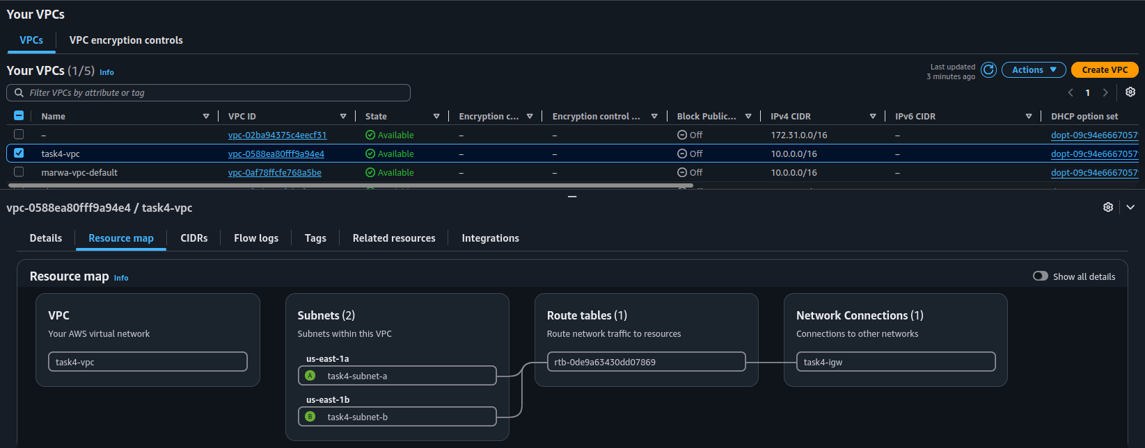
Figure 1: VPC resource map: task4-vpc with task4-subnet-a, task4-subnet-b, the route table and the internet gateway

2.2 Routing
Open VPC > Route Tables. The route table contains the local route (10.0.0.0/16 to local). If the lab needs internet access, the public subnet route table also contains 0.0.0.0/0 to the Internet Gateway. An Internet Gateway route alone does not make an instance publicly reachable: public IP assignment, subnet routing and security-group rules must also allow it.
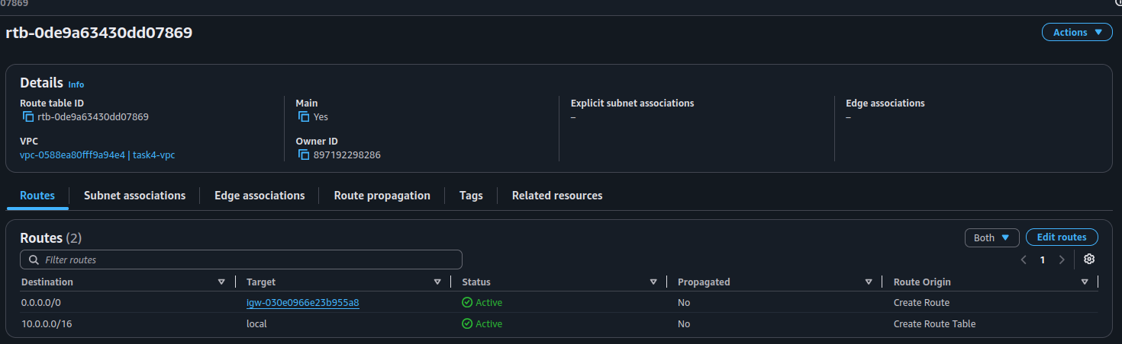
Figure 2: Route table of task4-vpc with the local route and the 0.0.0.0/0 route to the internet gateway
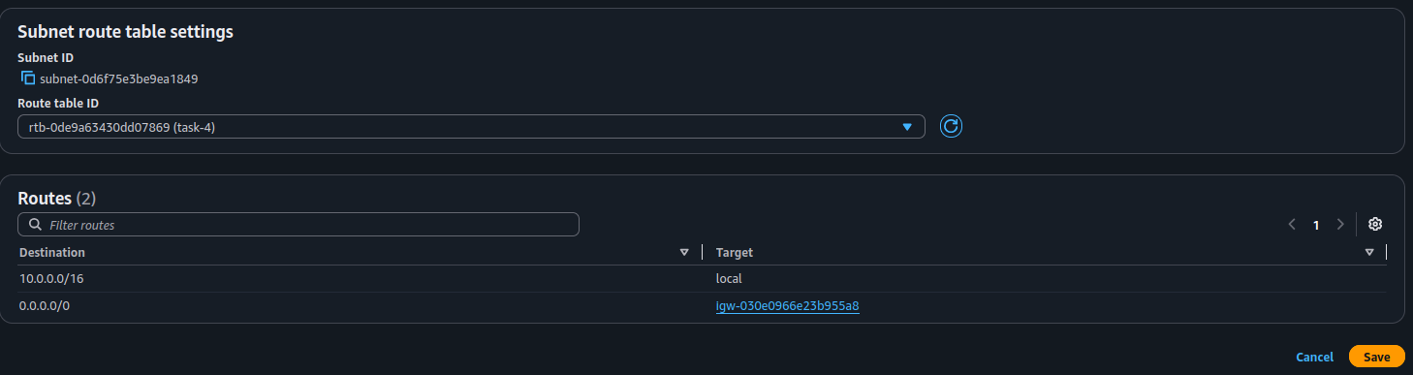
Figure 3: Associating the route table with a subnet

2.3 Security groups
Security groups control traffic to and from the EC2 instances and the storage resources. Restrict SSH and application access to trusted source addresses wherever possible.
Security group | Port | Purpose
Client security group | TCP 22 | SSH administration
Client security group | TCP 5000 | CloudMart web application (Flask)
EFS mount-target group | TCP 2049 | NFS from the client security group only
S3 Files group | TCP 2049 | NFS from the client security group
File Gateway group | TCP 2049, 111, 20048 | NFS, RPC port mapper and mount-related RPC traffic (exact ports depend on the NFS version)

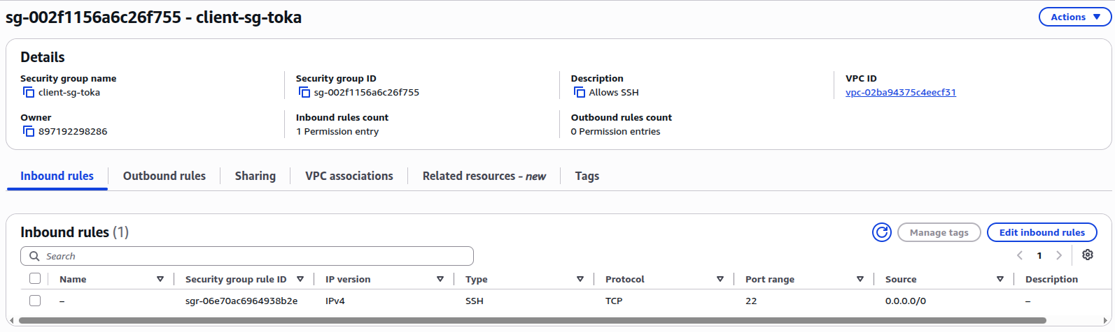
Figure 4: Client security group: inbound SSH (TCP 22)
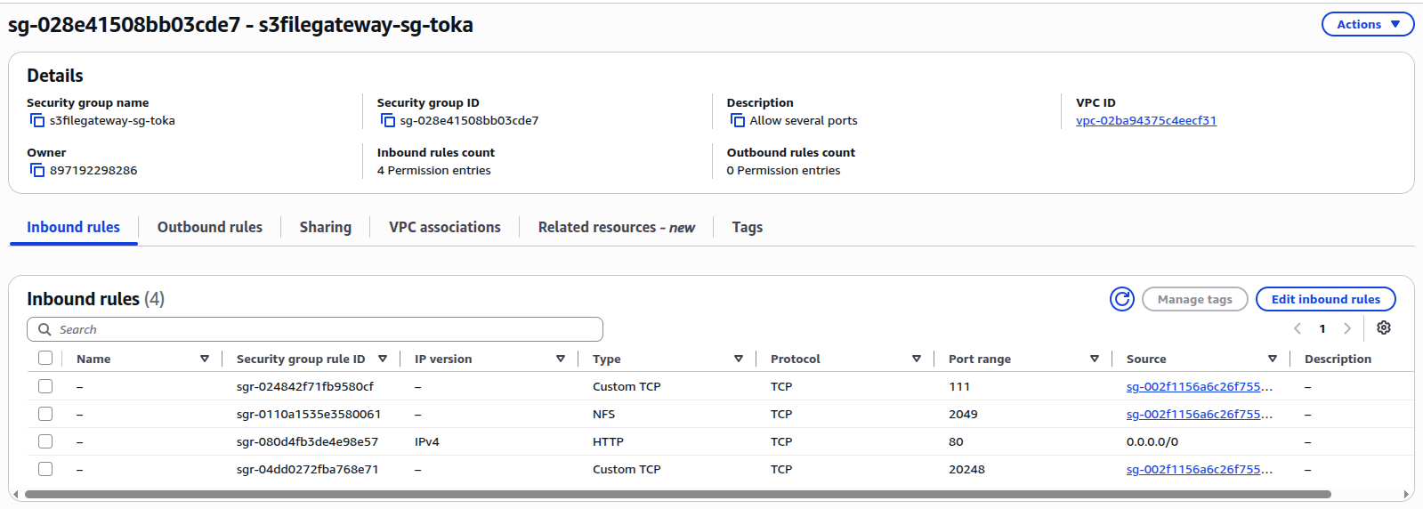
Figure 5: File Gateway security group: TCP 111, 2049, 80 (activation) and 20048
Security warning: do not expose NFS ports to the public internet. The lab used a temporary TCP 80 rule for Gateway activation; review and remove that rule when the approved activation workflow no longer needs it.

3. Part Two: Amazon EFS
Amazon Elastic File System (EFS) is a managed network filesystem. Several EC2 instances can mount the same filesystem, so a file created on Client A is readable on Client B.
EC2 Client A ----\
\
---> Amazon EFS
/
EC2 Client B ----/

3.1 Create the EFS filesystem
- Open Amazon EFS > Create file system and choose the project VPC.
- Configure the mount targets (one per Availability Zone, using the EFS mount-target security group).
- Enable encryption at rest, create the filesystem and record the filesystem ID (fs-xxxxxxxxxxxxxxxxx).
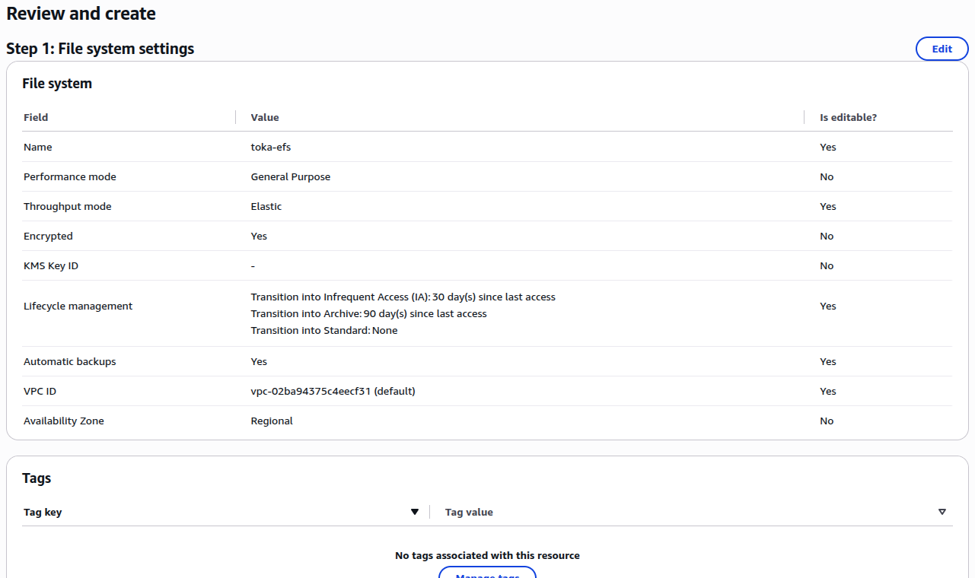
Figure 6: Amazon EFS review page: file system settings
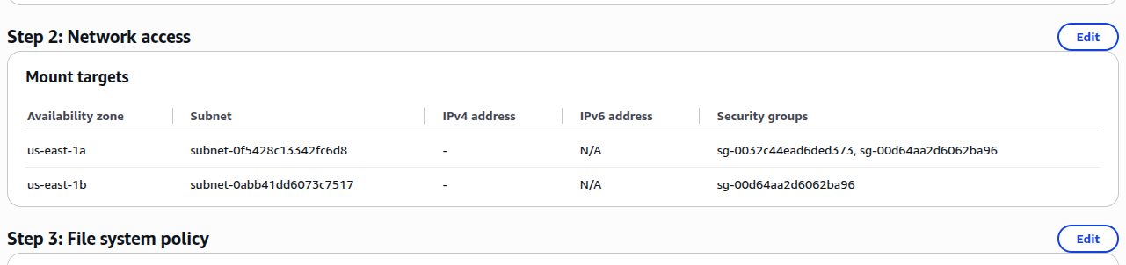
Figure 7: Amazon EFS mount targets and their security groups

3.2 EFS security
The mount-target security group must allow inbound NFS on TCP 2049 from the EC2 client security group. Do not use 0.0.0.0/0 for this rule.
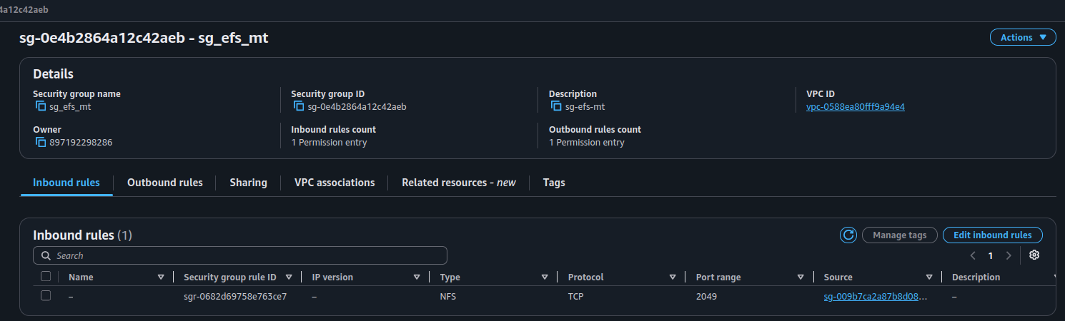
Figure 8: EFS mount-target security group: inbound NFS (TCP 2049) from the client security group
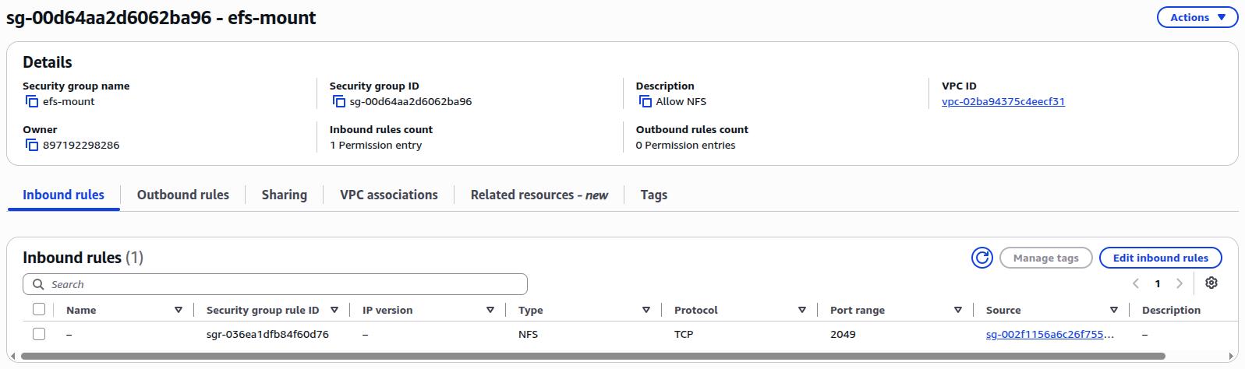
Figure 9: Security group efs-mount: inbound NFS (TCP 2049)

3.3 Install the EFS utilities and mount EFS
On Client A and Client B install the EFS mount helper and create the mount directory:
sudo dnf install -y amazon-efs-utils
sudo mkdir -p /mnt/efs

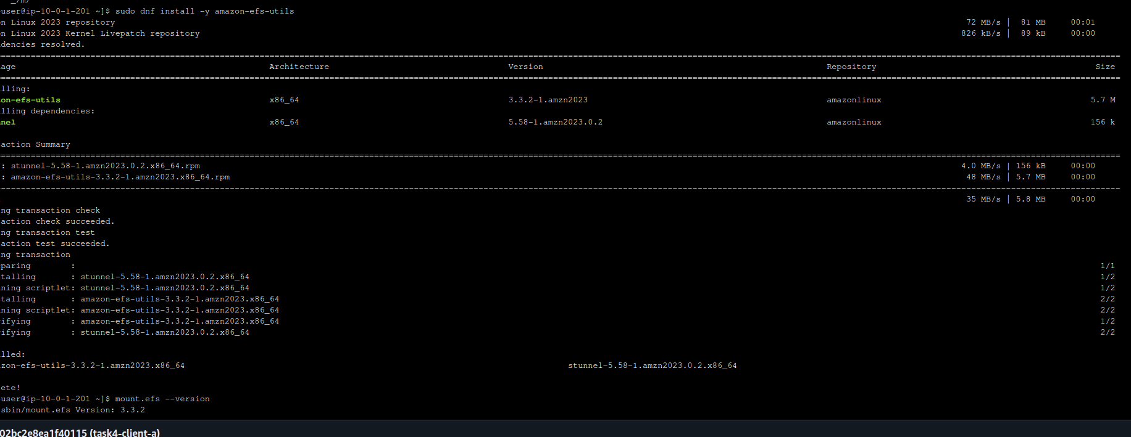
Figure 10: Installing amazon-efs-utils on Client A (task4-client-a)
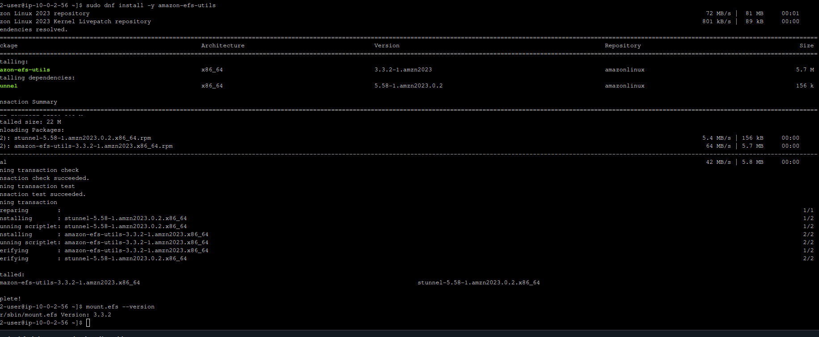
Figure 11: Installing amazon-efs-utils on Client B (task4-client-b)
Mount the filesystem (replace <EFS_ID> with your filesystem ID) and verify it:
sudo mount -t efs -o tls <EFS_ID>:/ /mnt/efs
findmnt /mnt/efs
df -hT /mnt/efs

3.4 Test shared access
- On Client A: echo "Hello from EC2 Client A" | sudo tee /mnt/efs/client-a.txt
- On Client B: cat /mnt/efs/client-a.txt
- On Client B create client-b.txt the same way and read it on Client A.
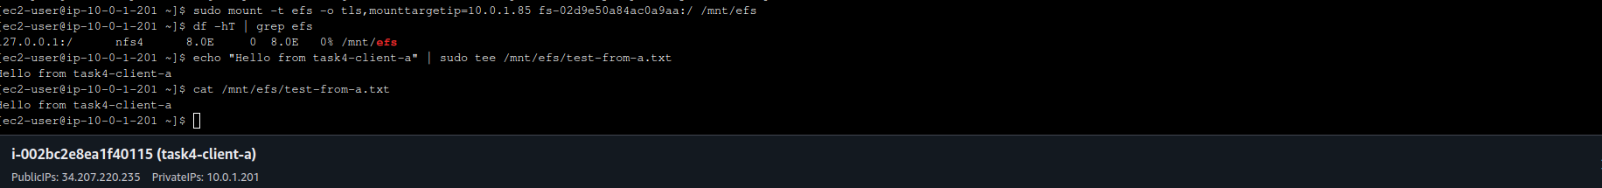
Figure 12: Client A mounts EFS and creates a test file
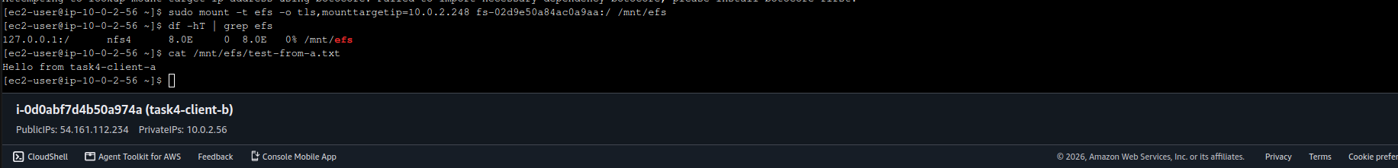
Figure 13: Client B reads the file created on Client A
Expected result: both clients can read the files created by the other client, which demonstrates shared filesystem access.

3.5 Automatic mounting with /etc/fstab
After manual mounting works, back up the file, add the EFS entry and validate it before any reboot:
sudo cp /etc/fstab /etc/fstab.backup
sudo findmnt --verify --verbose
sudo mount -a
findmnt /mnt/efs

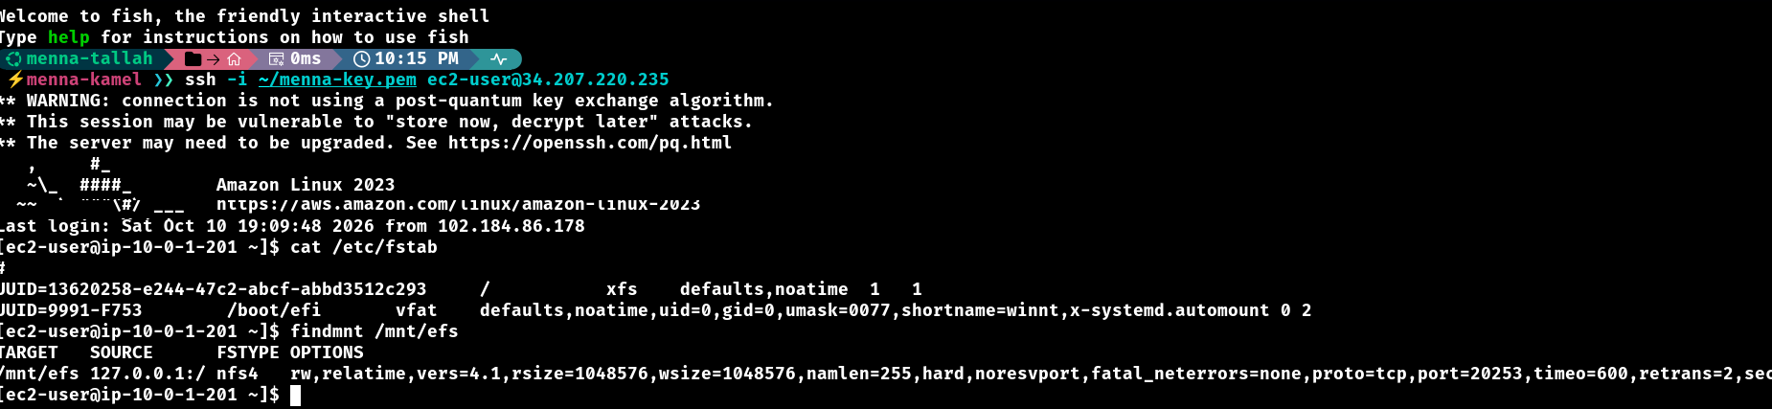
Figure 14: Client A: /etc/fstab and findmnt /mnt/efs showing the EFS mount (TLS)
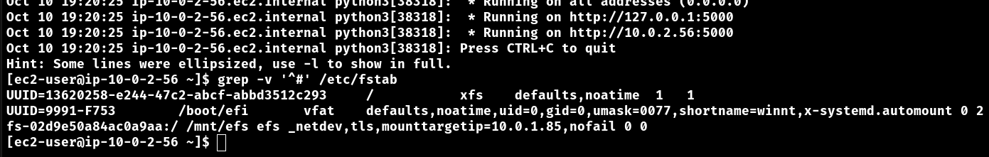
Figure 15: Client B: EFS entry in /etc/fstab

4. Part Three: S3 Files (S3-Backed Mount)
Amazon S3 is object storage, not a traditional filesystem, and a normal bucket cannot be mounted over NFS. S3 Files provides a filesystem-style interface to the bucket. The mount point used in this project is /mnt/s3files.

4.1 IAM roles and permissions
S3 Files needs a role that the file system service can assume, and the EC2 instances need permission to use the file system.
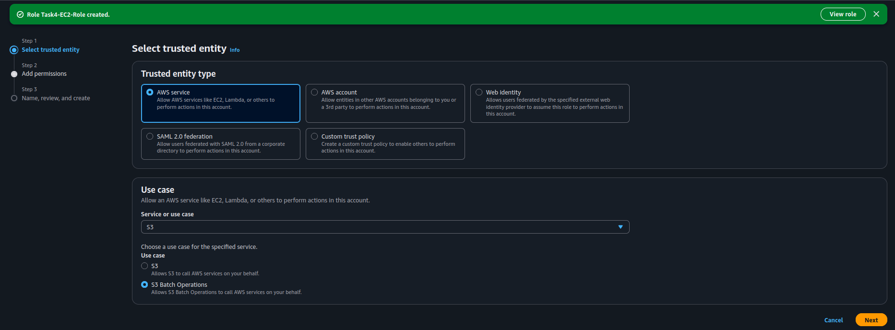
Figure 16: IAM: creating the role for the storage resources (role created successfully)
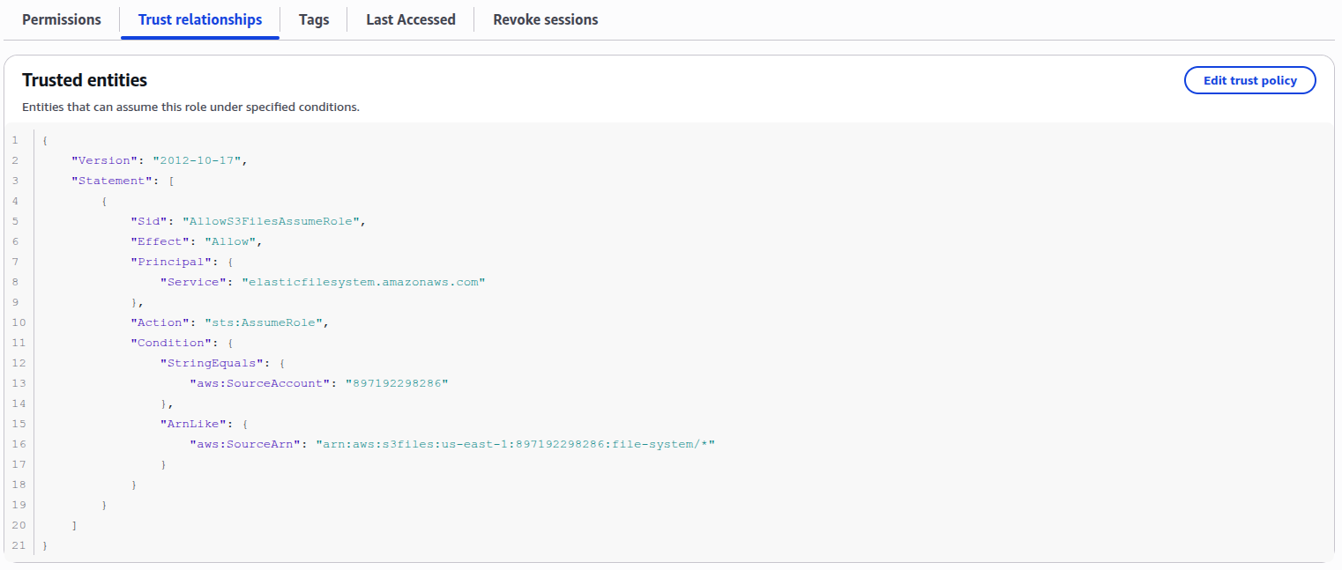
Figure 17: Trust relationship of the S3 Files role (service principal elasticfilesystem.amazonaws.com)
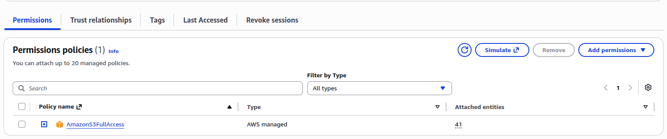
Figure 18: Permissions of the S3 Files role: AmazonS3FullAccess
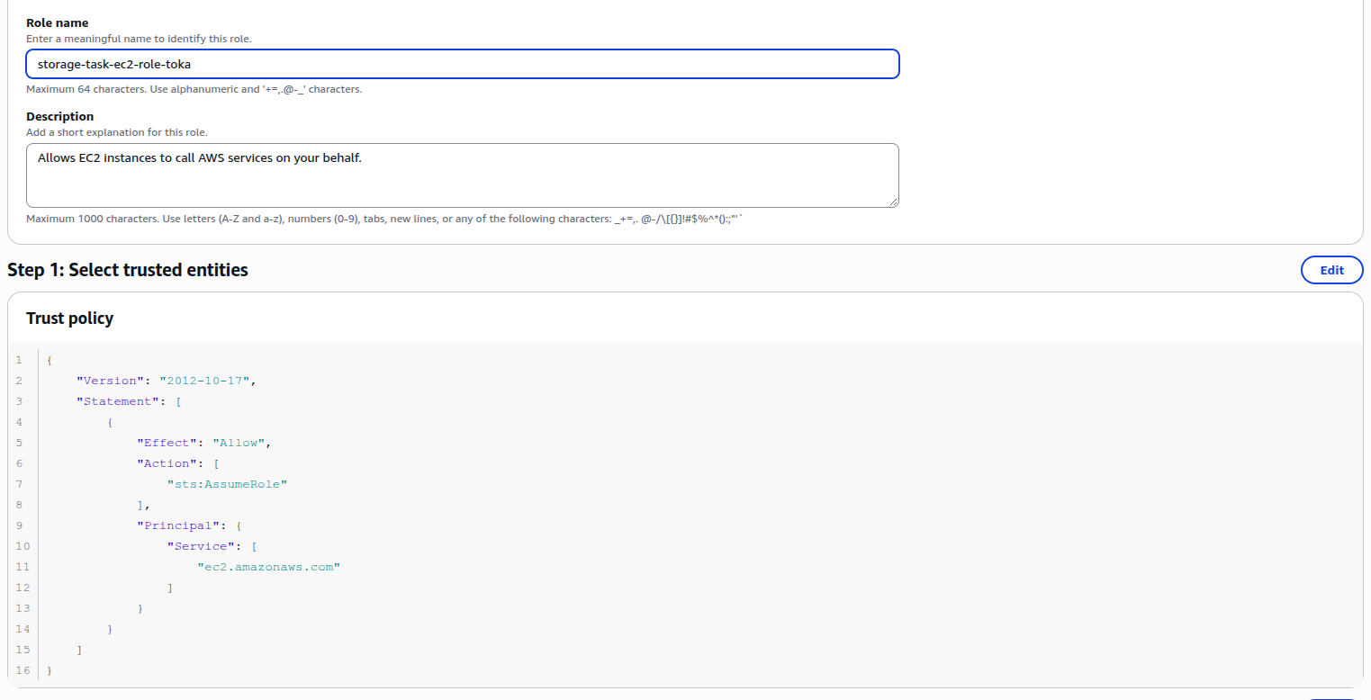
Figure 19: Trust policy of the EC2 instance role (service principal ec2.amazonaws.com)
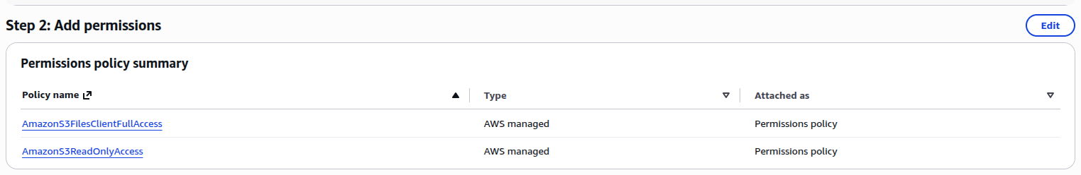
Figure 20: Permissions of the EC2 instance role: AmazonS3FilesClientFullAccess and AmazonS3ReadOnlyAccess

4.2 Create the S3 Files file system
The file system is created from the AWS CLI (CloudShell) for the S3 bucket and role. The CLI returns the file system ID and ARN.
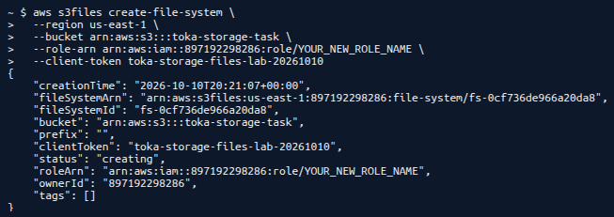
Figure 21: CloudShell: aws s3files create-file-system returns the file system ARN and ID

4.3 Attach the file system to the EC2 instance and mount it
In the console choose Attach to an EC2 instance, select the instance and the local mount path /mnt/s3files. The console shows the mount instructions.
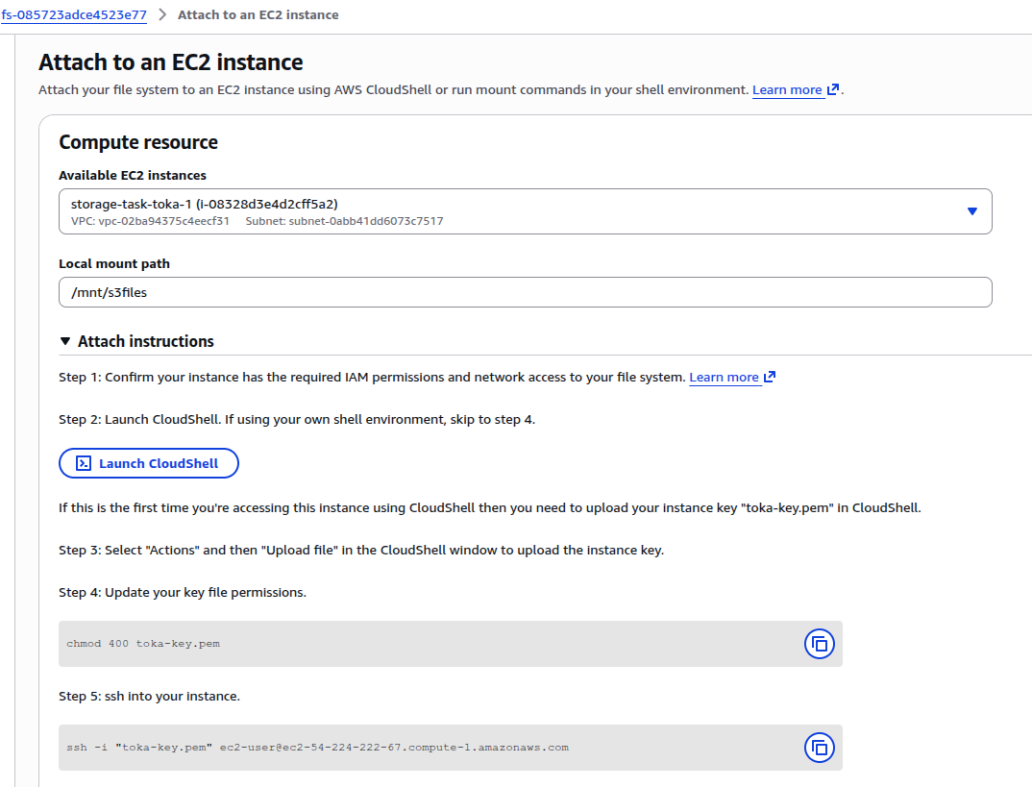
Figure 22: Attach to an EC2 instance: compute resource and local mount path /mnt/s3files
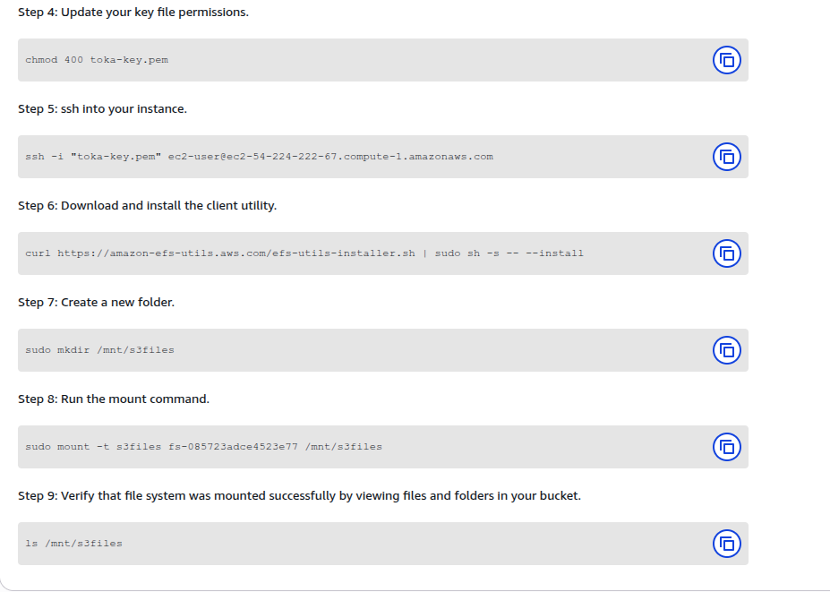
Figure 23: Attach instructions: install the client utility, create the folder and run the mount command
sudo mkdir -p /mnt/s3files
sudo mount -t s3files <FILE_SYSTEM_ID> /mnt/s3files
findmnt /mnt/s3files
df -hT /mnt/s3files

Figure 24: findmnt /mnt/s3files shows the mounted S3 Files file system
Security group: the S3 Files mount target uses its own security group that allows NFS (TCP 2049) from the client security group.
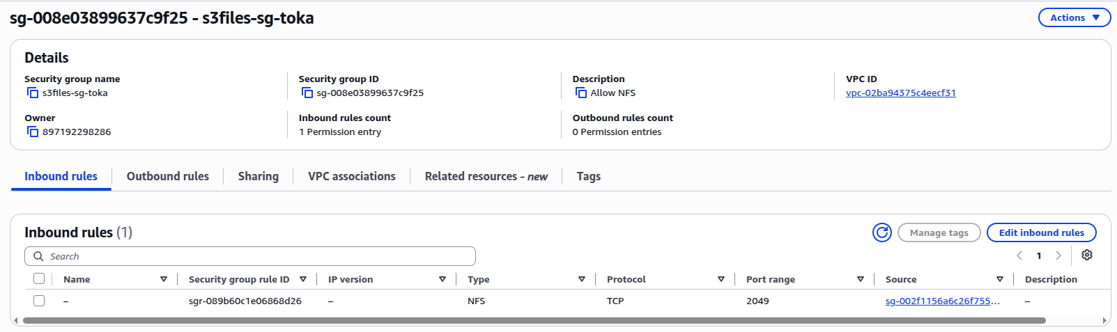
Figure 25: S3 Files security group: inbound NFS (TCP 2049)

4.4 Test the mount and verify the object in S3
Create the upload directory and a test file, then confirm that it appears in the bucket. If you receive Permission denied, inspect the permission model of the service; chmod or sudo cannot override permissions enforced by a remote storage service.
sudo mkdir -p /mnt/s3files/uploads
echo "Hello from EC2 via S3 Files" | sudo tee /mnt/s3files/ec2-to-s3-test.txt
ls /mnt/s3files

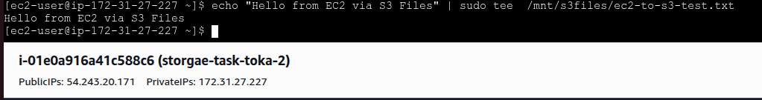
Figure 26: Writing a test file through /mnt/s3files
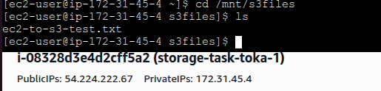
Figure 27: Listing /mnt/s3files from the second client: the file is visible
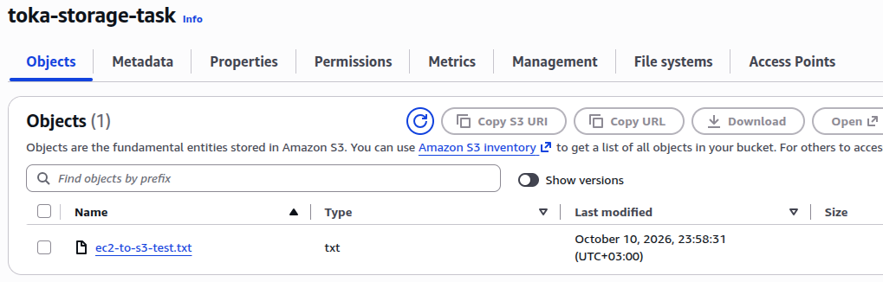
Figure 28: The test file appears as an object in the S3 bucket
The reverse direction also works: a file uploaded to the bucket from the S3 console shows up under the mount.
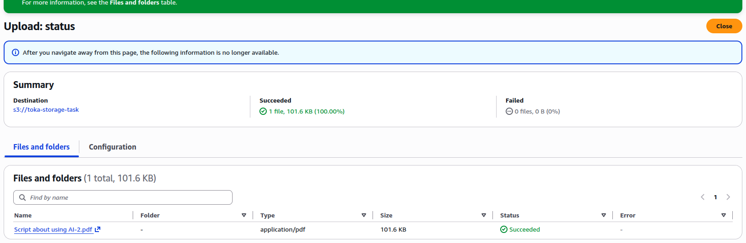
Figure 29: Uploading a file to the bucket from the S3 console
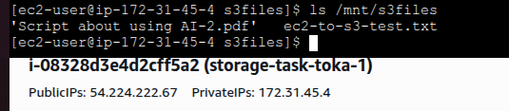
Figure 30: The uploaded file and the test file are both visible under /mnt/s3files
Expected result: the file can be written and read through the mount, and its storage-side representation can be verified in S3.

5. Part Four: S3 Cross-Region Replication (CRR)
CRR automatically copies eligible objects from a source bucket to a destination bucket in a different Region. It is useful for regional redundancy and disaster recovery. Replication is asynchronous, so an object might not appear immediately in the destination.

5.1 Create the buckets
Setting | Value
Source bucket | cloudmart-source-menna-897192298286-us-east-1-an (us-east-1)
Destination bucket | cloudmart-dr-menna-897192298286-eu-west-2-an (Europe, London, eu-west-2)
Block Public Access | Enabled on both buckets
Bucket versioning | Enabled on both buckets (required for replication)

5.2 Configure the replication rule
- Open the source bucket, then Management > Replication rules > Create replication rule.
- Rule name: cloudmart-crr-rule, status Enabled, scope Apply to all objects in the bucket.
- Destination: choose the destination bucket in this account.
- IAM role: choose the existing role approved for the lab, then save.
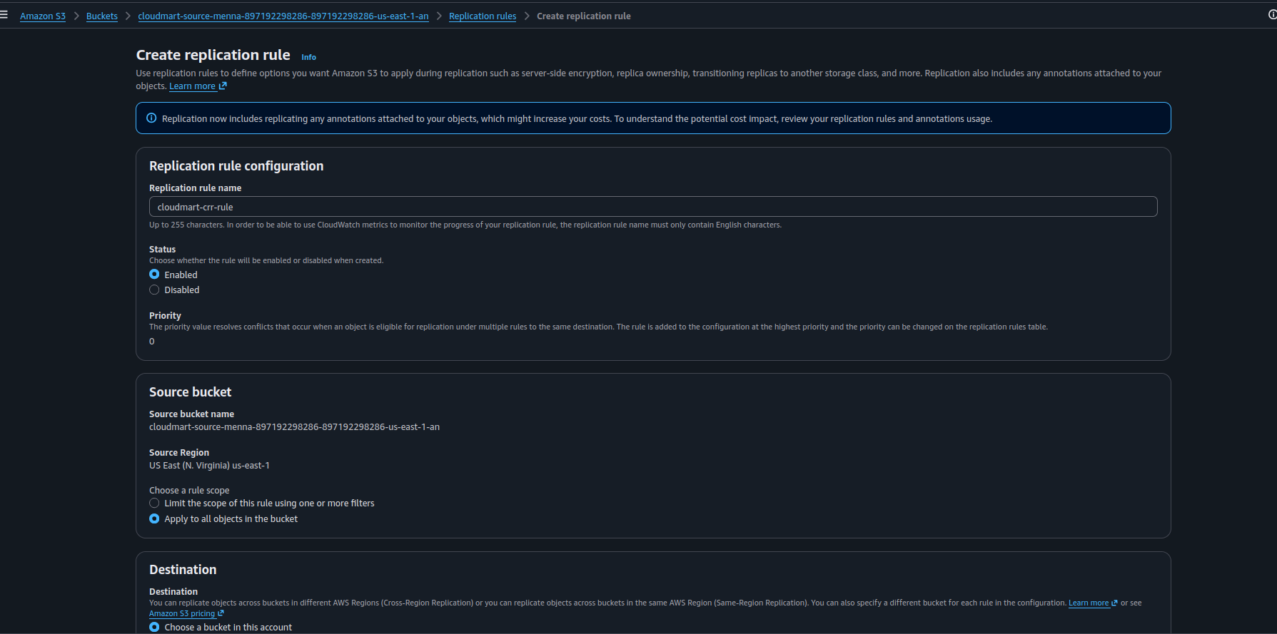
Figure 31: Create replication rule: name cloudmart-crr-rule, status Enabled, source bucket and scope
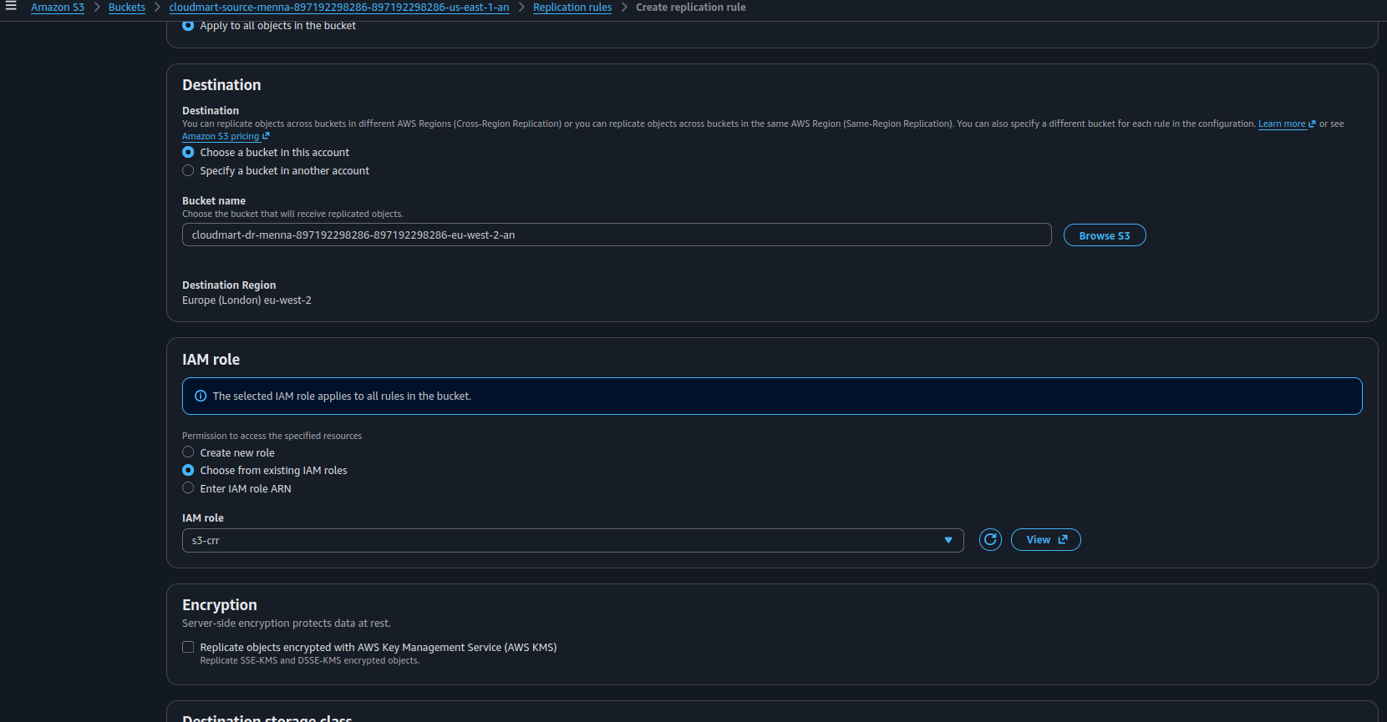
Figure 32: Replication destination bucket (eu-west-2) and the IAM role
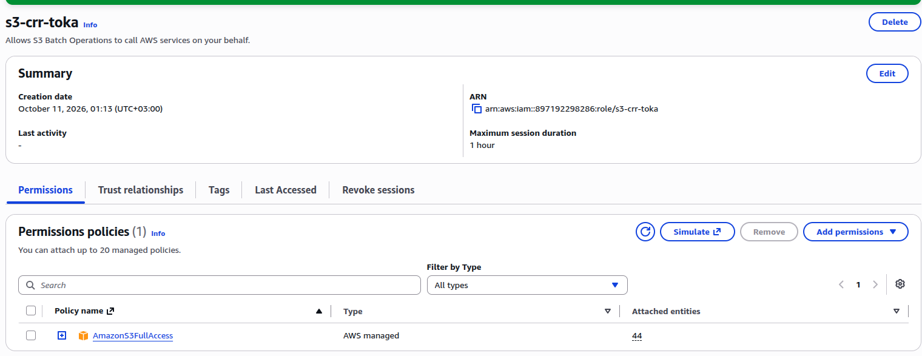
Figure 33: IAM role used for replication and its permissions policy
IAM permissions: if the assignment prohibits creating or changing IAM policies, do not work around a permission error. Ask the instructor to provide or authorize the required role.

5.3 Test and verify replication
Upload a new object to the source bucket (for example crr-test.txt), open the object and check its replication status, then open the destination bucket and confirm that the object appears.
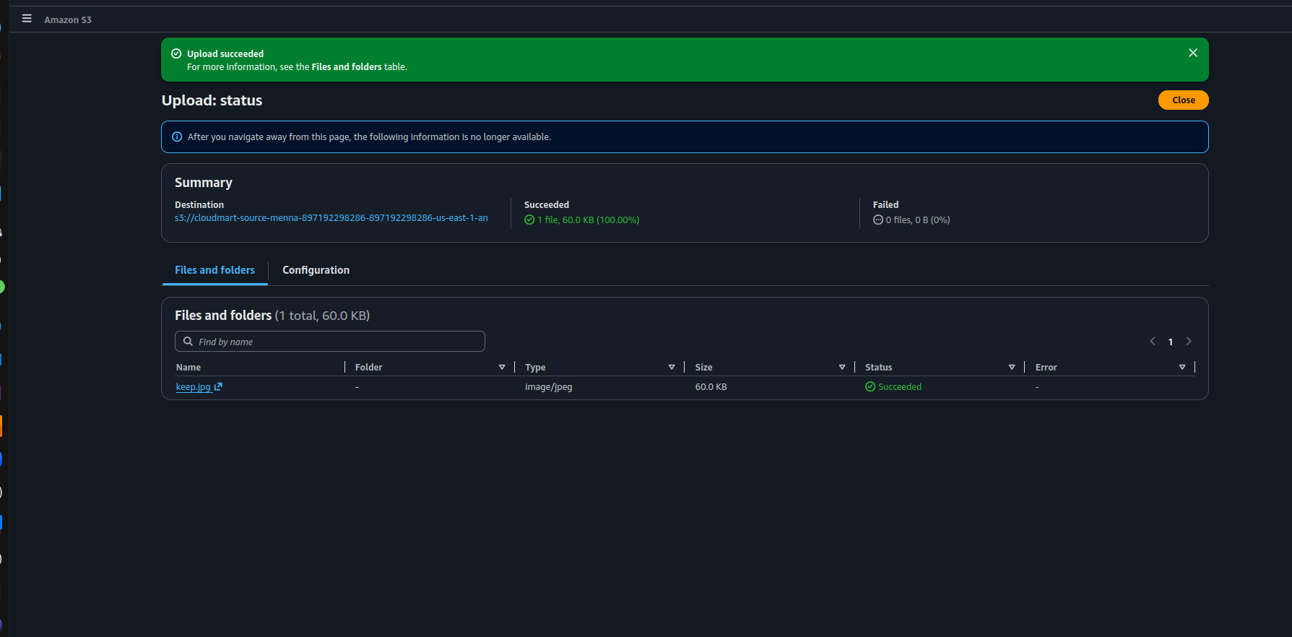
Figure 34: Upload to the source bucket succeeded
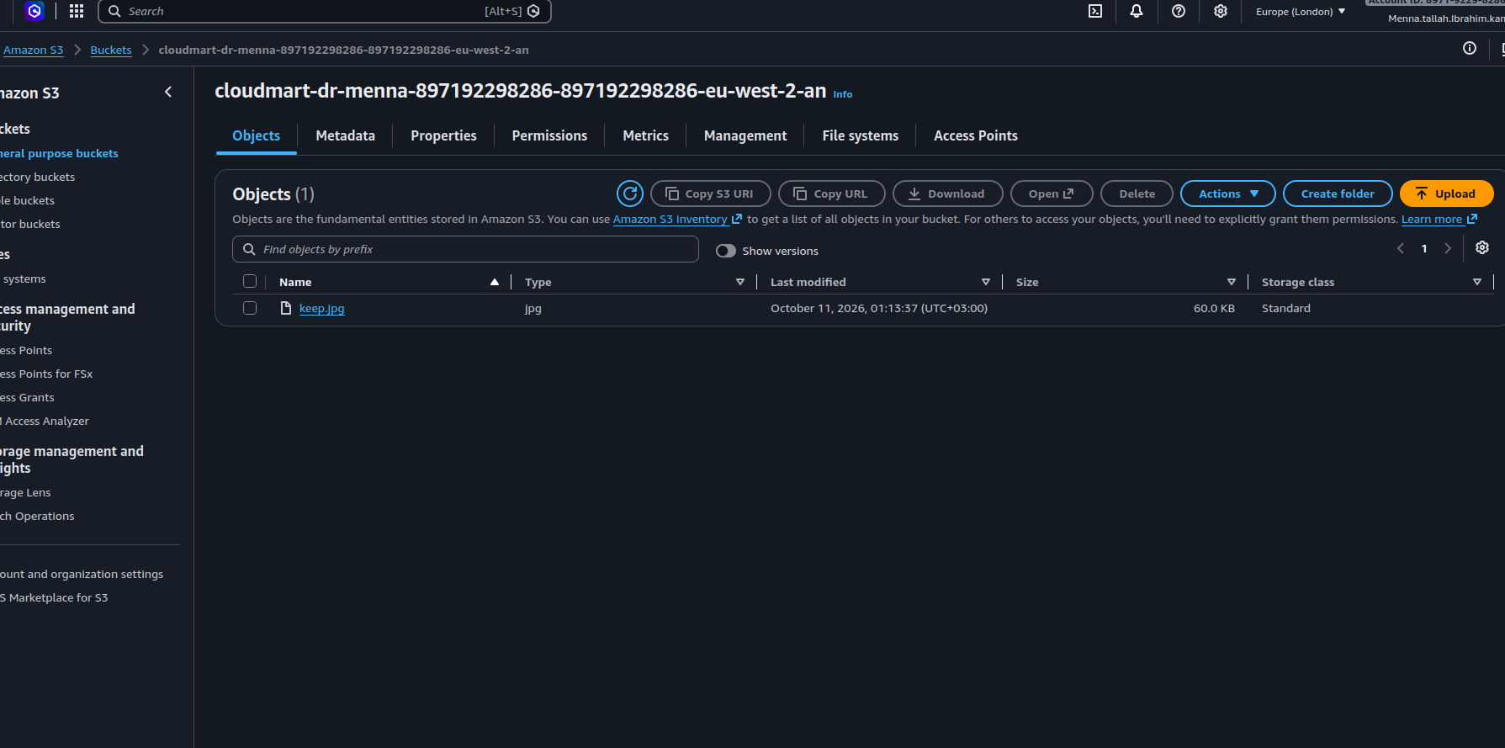
Figure 35: The replicated object appears in the destination bucket in the other Region
Important: a basic replication rule does not necessarily replicate objects that existed before the rule was enabled. Existing objects may require S3 Batch Replication.

6. Part Five: S3 File Gateway
S3 File Gateway provides file-based access to Amazon S3. Applications use NFS, while Storage Gateway manages the objects in S3.
EC2 Linux client
| NFS
v
S3 File Gateway
| AWS Storage Gateway
v
Amazon S3 bucket

Client path: /mnt/cloudmart-share/example.txt

6.1 Create the gateway
Open AWS Storage Gateway > Create gateway and choose Amazon S3 File Gateway as the gateway type, Amazon EC2 as the host platform, and the default settings (150 GiB cache disk).
Setting | Value
Gateway name | task4-filegw
Gateway ID | sgw-D3885ABB
Private IP | 10.0.2.34
Region | us-east-1
Cache disk | 150 GiB (/dev/nvme1n1)

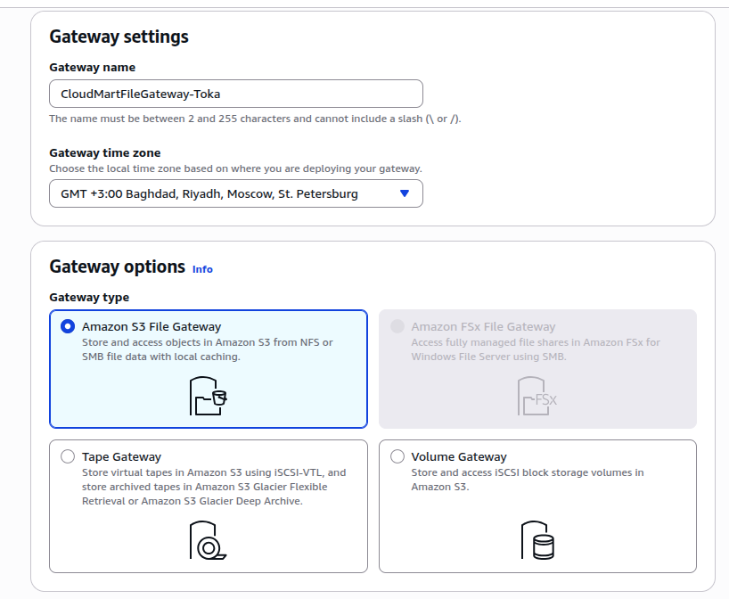
Figure 36: Gateway settings: name, time zone and gateway type Amazon S3 File Gateway
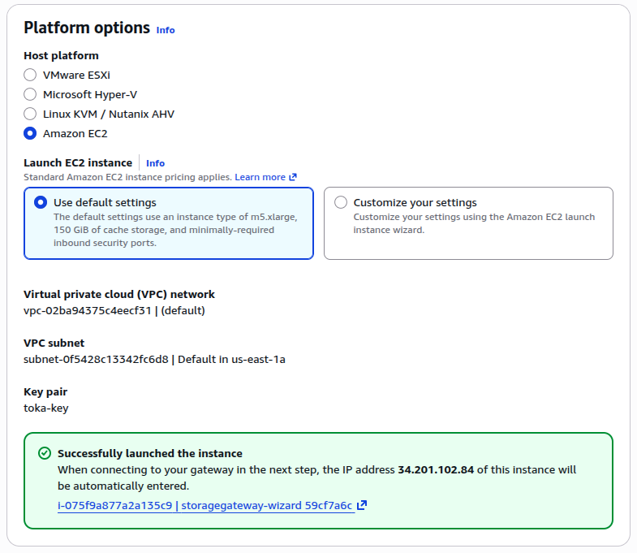
Figure 37: Platform options: Amazon EC2 with default settings and the launched instance
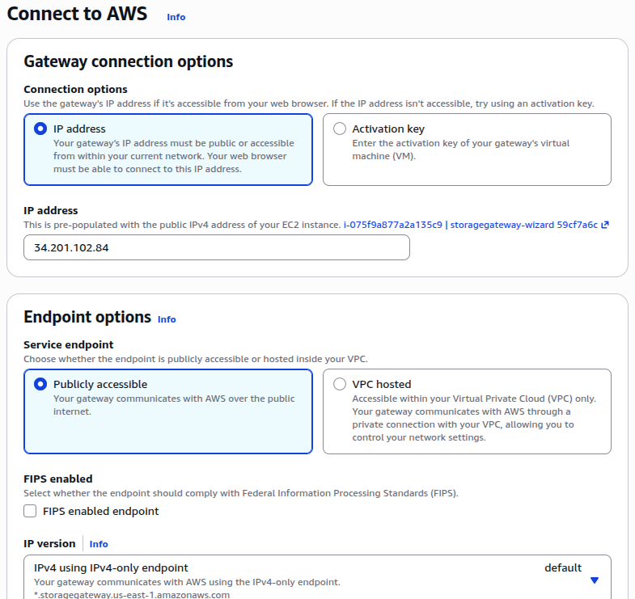
Figure 38: Connect to AWS: gateway connection and endpoint options
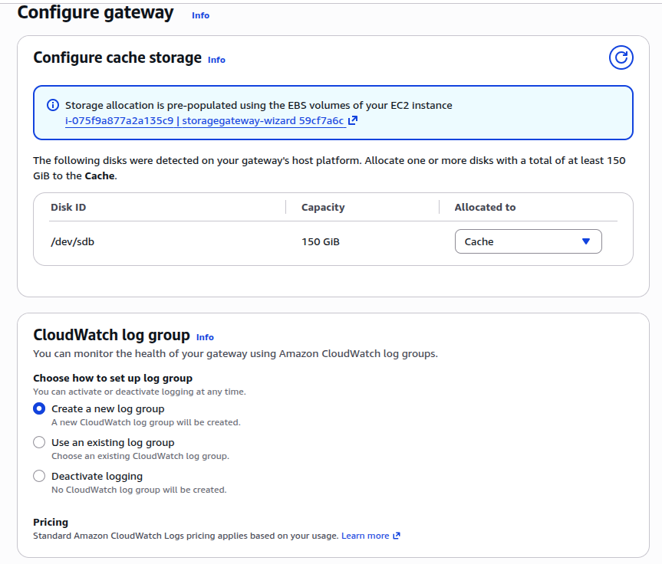
Figure 39: Configure cache storage: the 150 GiB disk allocated to Cache
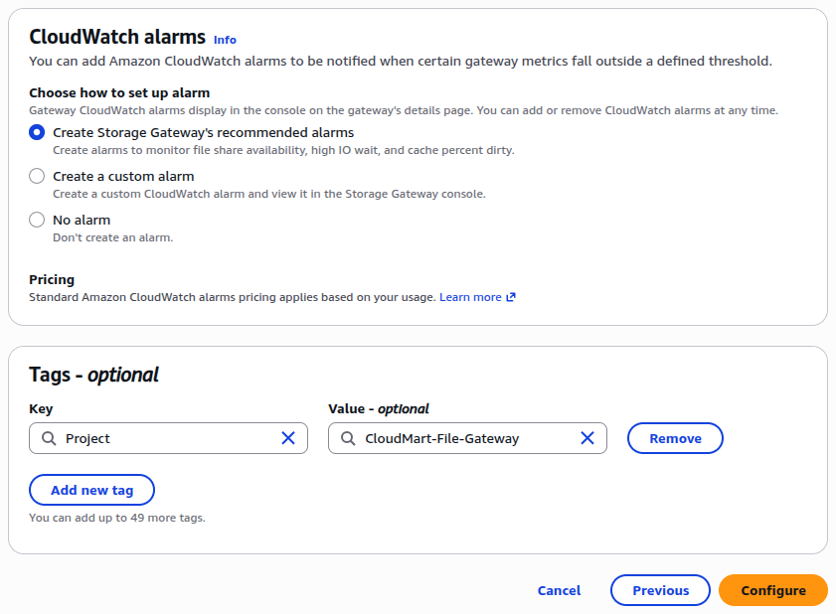
Figure 40: CloudWatch alarms and tags, then Configure
Cache disk: do not format the appliance's disk from the EC2 operating system unless AWS documentation explicitly requires it.

6.2 Create the NFS file share
The Gateway needs an IAM role that Storage Gateway can assume to write to the S3 bucket. Then create the NFS file share for the bucket.
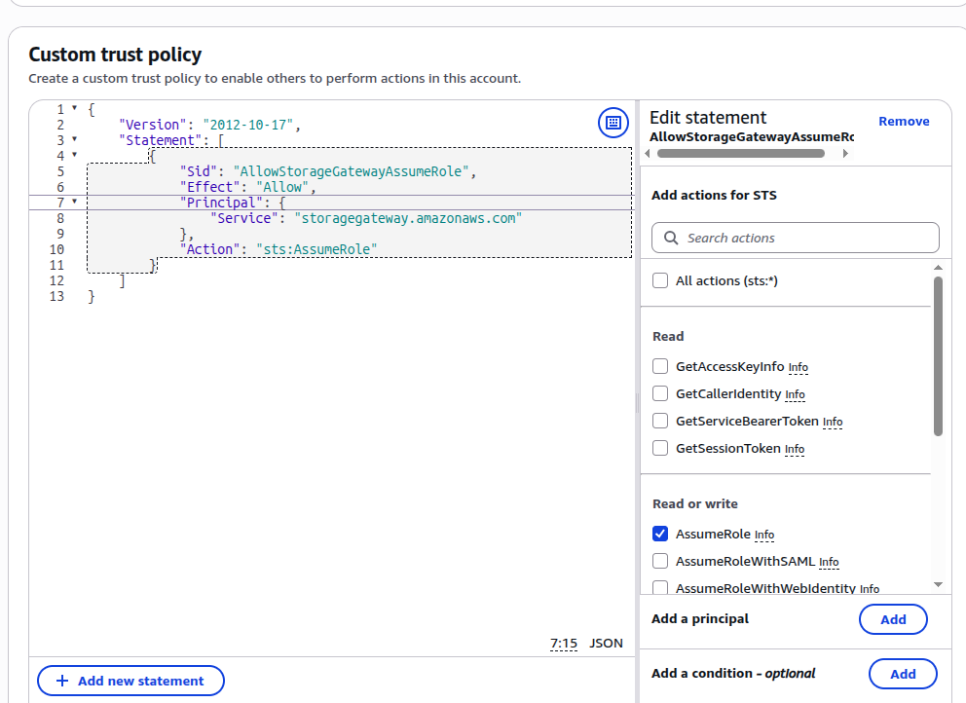
Figure 41: Custom trust policy: Storage Gateway (storagegateway.amazonaws.com) can assume the role
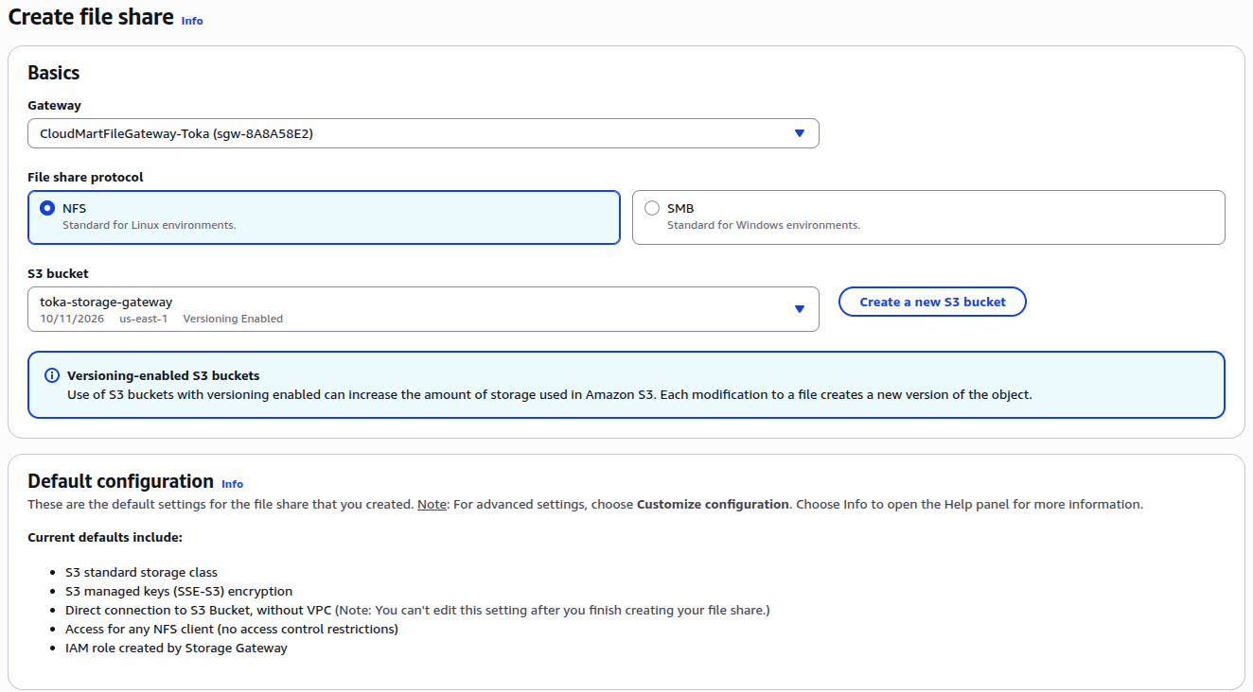
Figure 42: Create file share: gateway, NFS protocol and the S3 bucket
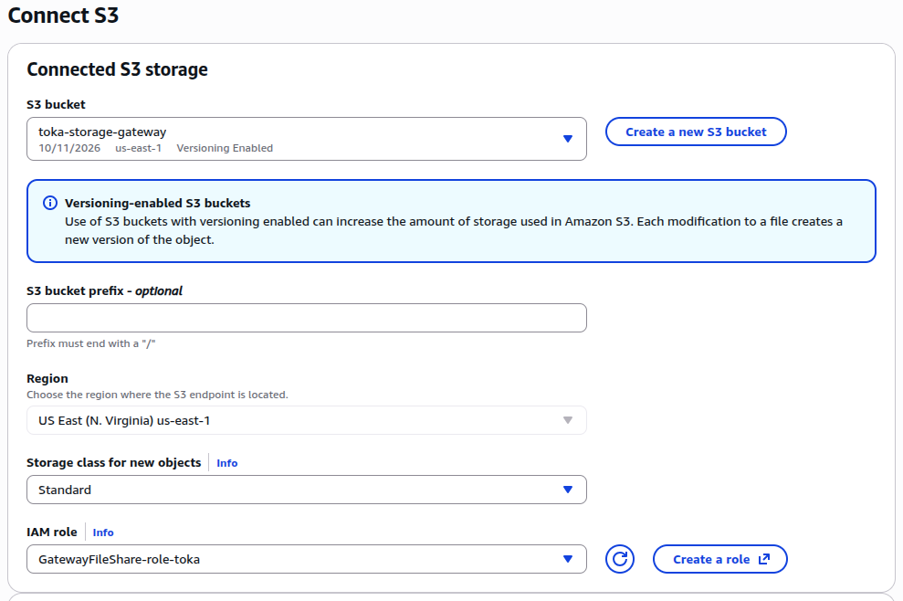
Figure 43: Connect S3: bucket, storage class and IAM role
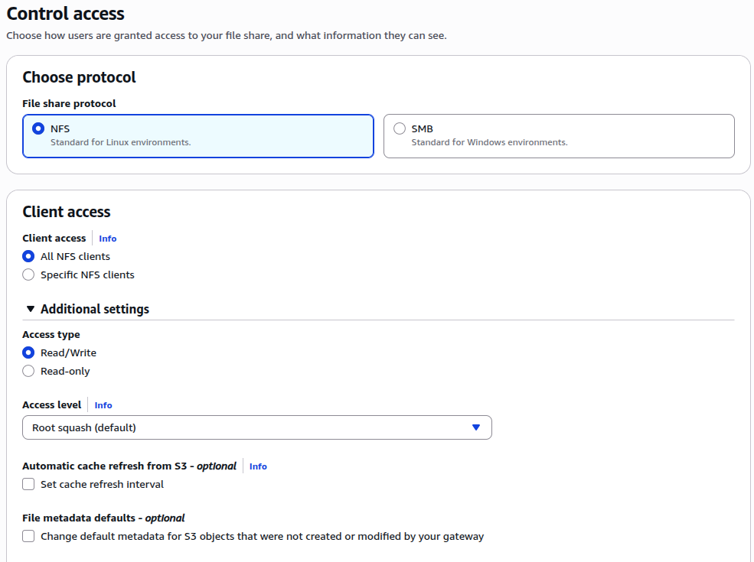
Figure 44: Control access: NFS, read/write access and root squash
Setting | Value
File share ID | share-D8BC4EB2
Export path | /menna-cloudmart-share
S3 bucket | cloudmart-file-gateway-menna-897192298286-us-east-1-an
Read only | false
Squash | RootSquash
Object ACL | private
Status | AVAILABLE
Allowed clients | 10.0.1.201/32 and 10.0.2.56/32

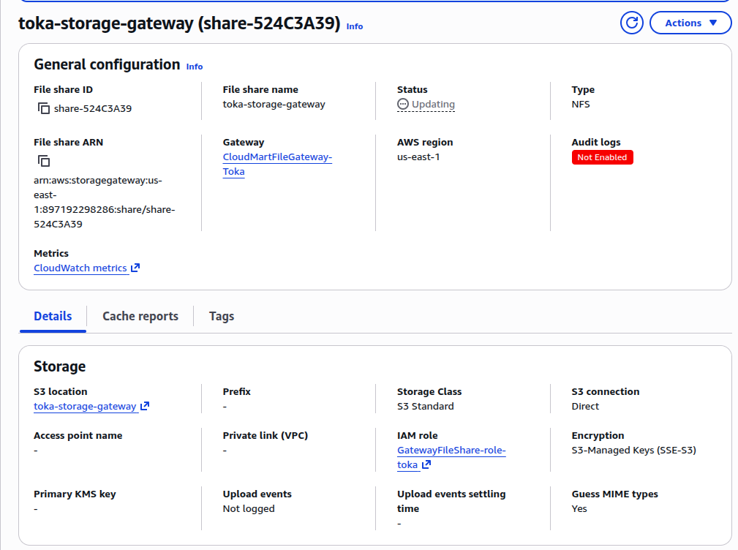
Figure 45: File share details: status, S3 location, IAM role and storage class
Verify the share with the AWS CLI. The expected status is AVAILABLE.
aws storagegateway describe-nfs-file-shares \
--file-share-arn \
arn:aws:storagegateway:us-east-1:897192298286:share/share-D8BC4EB2 \
--region us-east-1 --output json

6.3 Mount the NFS share on both clients
On Client A and Client B install the NFS utilities, create the mount point and mount the share from the Gateway private IP:
sudo dnf install -y nfs-utils
rpm -q nfs-utils
sudo mkdir -p /mnt/cloudmart-share

sudo mount -t nfs -o nolock,hard \
10.0.2.34:/menna-cloudmart-share \
/mnt/cloudmart-share

findmnt /mnt/cloudmart-share

The expected source is 10.0.2.34:/menna-cloudmart-share with filesystem type nfs4.
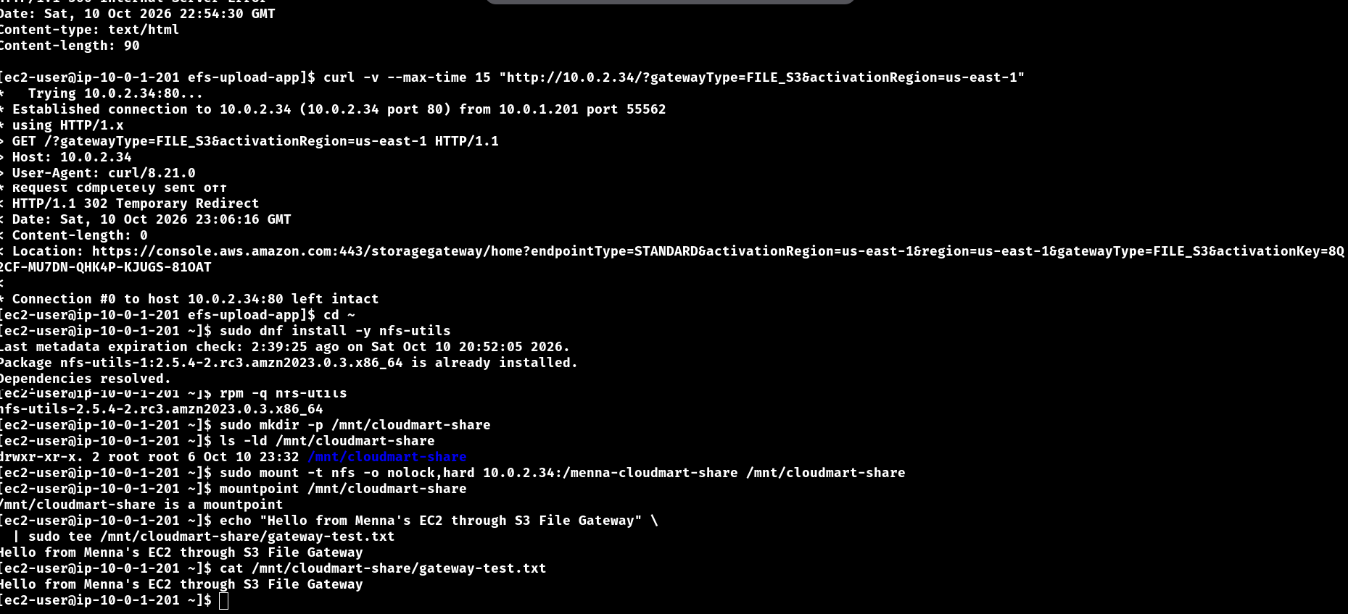
Figure 46: Client A: nfs-utils installed, NFS share mounted and the first test file written

6.4 Test shared read/write access
- On Client A create gateway-test.txt in /mnt/cloudmart-share and read it.
- On Client B read gateway-test.txt (it must be visible).
- On Client B create gateway-test-from-client-b.txt and read it on Client A.
echo "Hello from Menna's EC2 through S3 File Gateway" \
| sudo tee /mnt/cloudmart-share/gateway-test.txt
cat /mnt/cloudmart-share/gateway-test.txt

6.5 Verify the files in S3
aws s3 ls s3://cloudmart-file-gateway-menna-897192298286-us-east-1-an/ \
--recursive --region us-east-1

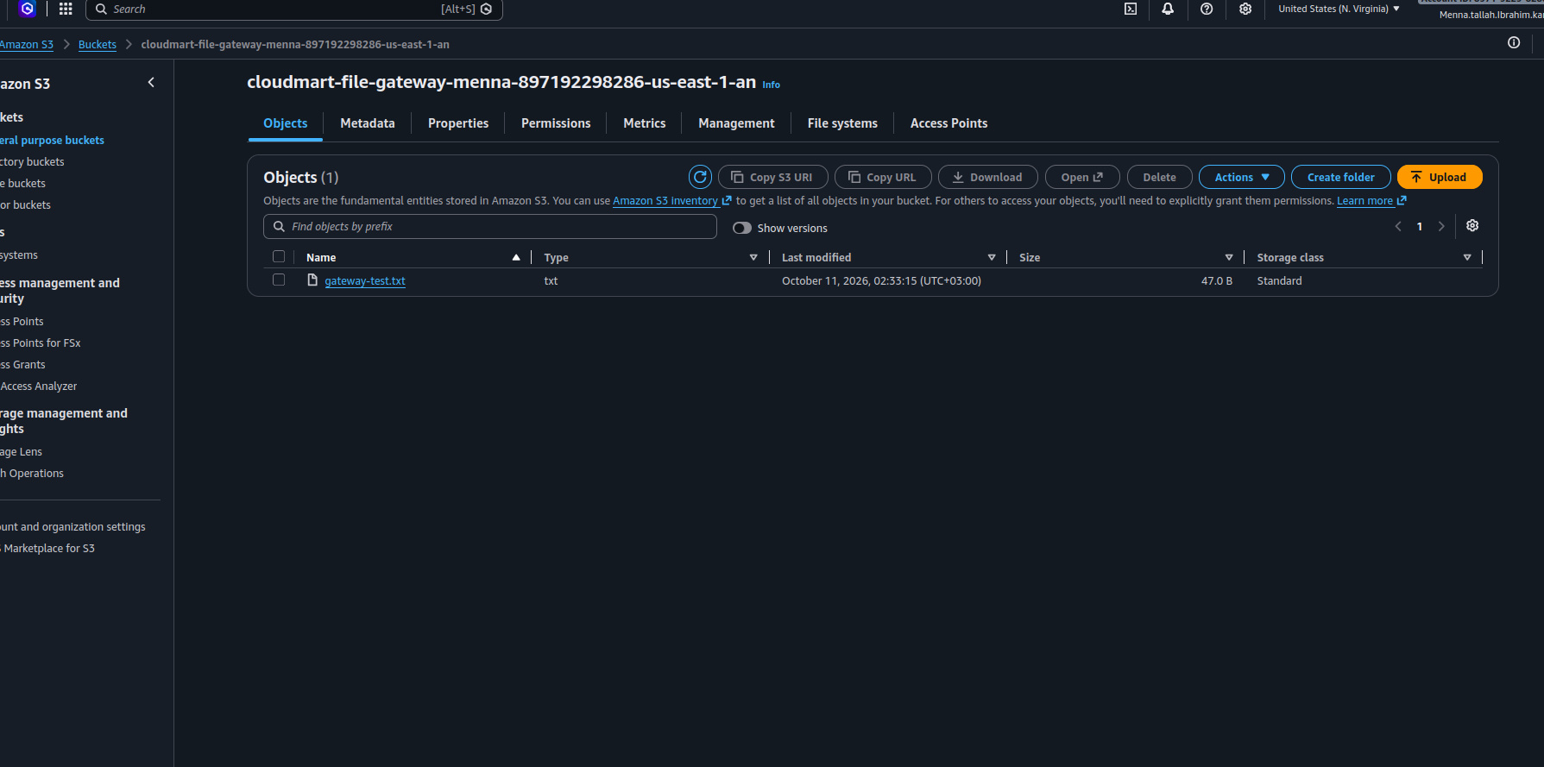
Figure 47: The file created through the Gateway appears as an object in the S3 bucket
Why may the object take time to appear? Storage Gateway uploads file changes to S3 asynchronously. A successful NFS write does not guarantee that the object is immediately visible in the S3 console.

7. Automatic NFS Mounting
A manual mount must be recreated after an EC2 reboot unless it is persistent. On both clients, back up /etc/fstab and add the entry below.
sudo cp /etc/fstab /etc/fstab.backup

10.0.2.34:/menna-cloudmart-share /mnt/cloudmart-share nfs \
_netdev,nofail,nolock,hard,timeo=600,retrans=2 0 0

Option | Meaning
_netdev | Treats the mount as network-dependent
nofail | A missing mount is not a fatal boot dependency
nolock | Disables NFS locking for this mount
hard | Retries NFS operations instead of failing immediately
timeo=600 | NFS RPC timeout parameter
retrans=2 | Number of retries before further recovery

Validate the configuration, then test after a reboot. Warnings from unrelated entries should be investigated separately; do not delete the EFS or S3 Files entries without checking them.
sudo findmnt --verify --verbose
sudo mount -a
findmnt /mnt/cloudmart-share

sudo reboot # then, after reconnecting:
findmnt /mnt/cloudmart-share
cat /mnt/cloudmart-share/gateway-test.txt

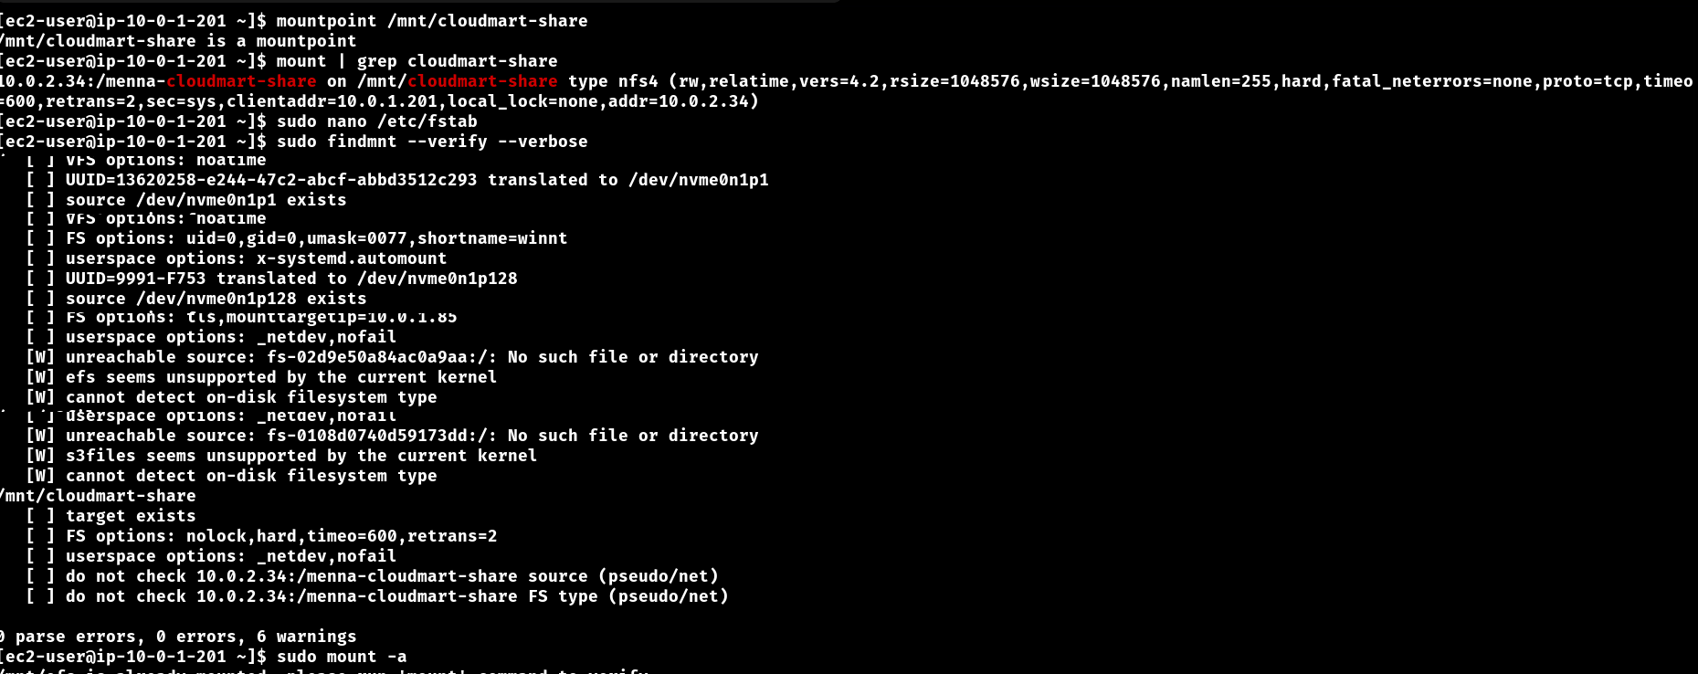
Figure 48: findmnt --verify and the mounted NFS share (/mnt/cloudmart-share) on the client
Completion criterion: the mount is present after the reboot and the shared file remains readable on both clients.

8. CloudMart Flask Application
CloudMart is a Flask application with a web interface for the storage backends. It shows the configured storage options, checks whether each mount is available, uploads files, lists stored files, opens or downloads them, and enforces an upload size limit (20 MB).
Item | Value
Server | Client B (/home/ec2-user/efs-upload-app/)
Main file | /home/ec2-user/efs-upload-app/app.py
Service name | efs-upload-app.service
Mount points used | /mnt/efs, /mnt/s3files, /mnt/cloudmart-share

8.1 Configure the File Gateway storage entry
In app.py the Gateway entry must point to the real NFS mount. Using an incorrect path such as /mnt/filegateway would make the application look at a different directory.
"gateway": {
"name": "Amazon S3 File Gateway",
"mount": "/mnt/cloudmart-share",
"folder": "/mnt/cloudmart-share/uploads",
"description": "Access S3 through an NFS file share",
},

sudo mkdir -p /mnt/cloudmart-share/uploads
ls -ld /mnt/cloudmart-share/uploads
findmnt /mnt/cloudmart-share

8.2 Validate and restart the service
cd ~/efs-upload-app
python3 -m py_compile app.py # no output = syntax is valid

sudo systemctl restart efs-upload-app.service
sudo systemctl status efs-upload-app.service --no-pager -l

The compile check does not prove that the application can write to the storage directory; that needs a separate test. The expected state is Active: active (running). If the service fails, inspect the logs:
sudo journalctl -u efs-upload-app.service -n 100 --no-pager
sudo journalctl -u efs-upload-app.service -f
sudo systemctl show efs-upload-app.service -p User -p Group -p ExecStart

8.3 Open the web interface
Open the EC2 instance address on the configured application port (allowed in the EC2 security group), select a storage backend, choose a small test file and upload it.
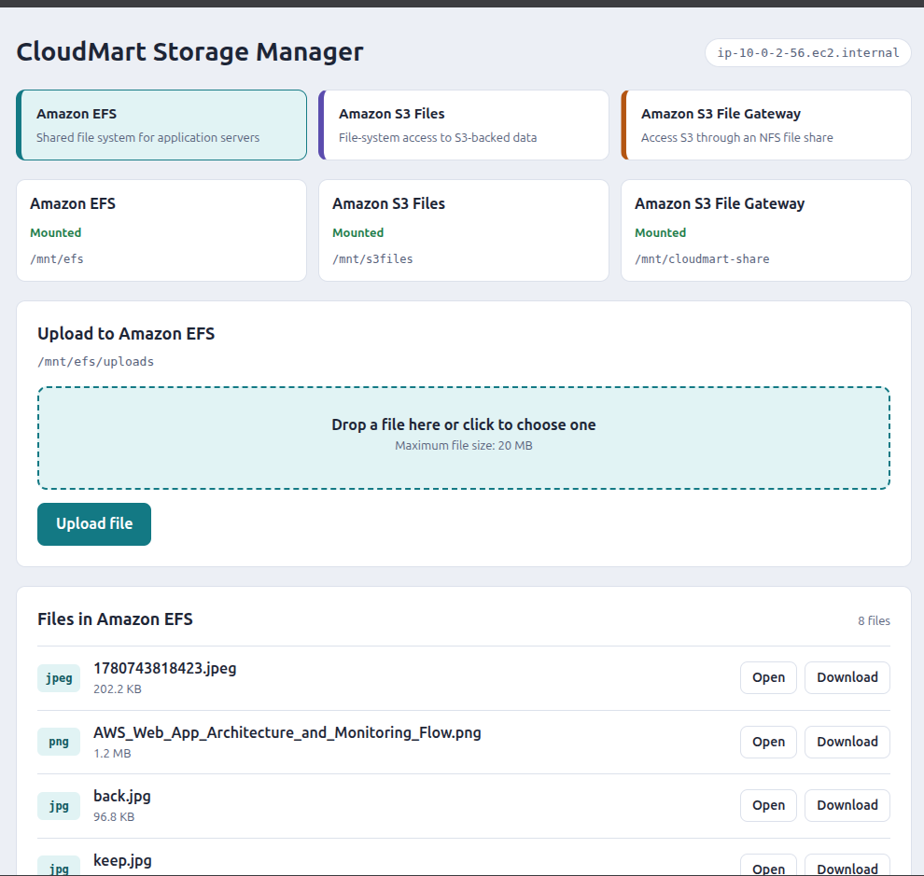
Figure 49: CloudMart on Client B: Amazon EFS selected (upload directory /mnt/efs/uploads)
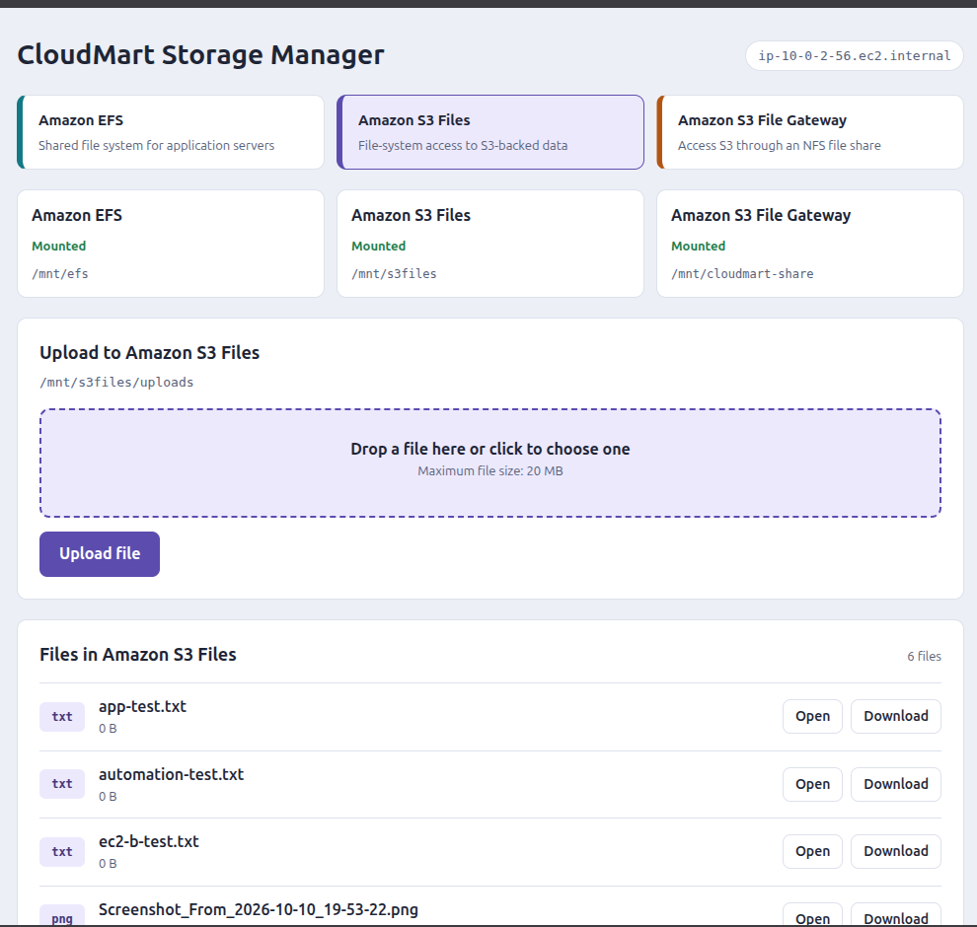
Figure 50: CloudMart on Client B: Amazon S3 Files selected (/mnt/s3files/uploads)
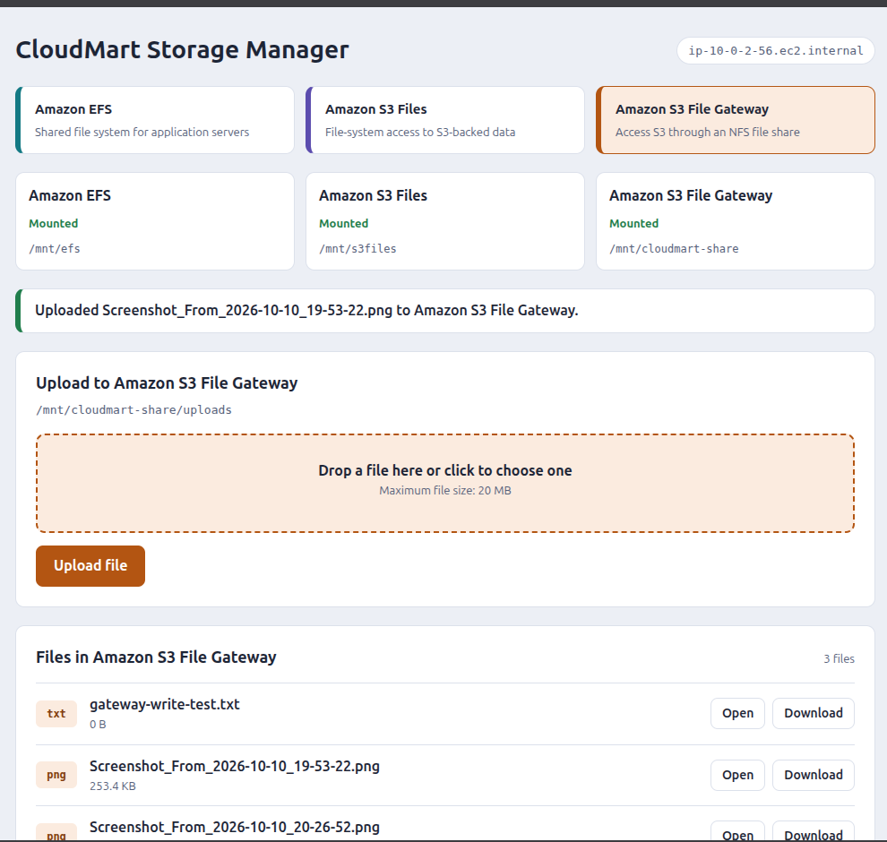
Figure 51: CloudMart on Client B: Amazon S3 File Gateway upload succeeded (/mnt/cloudmart-share/uploads)
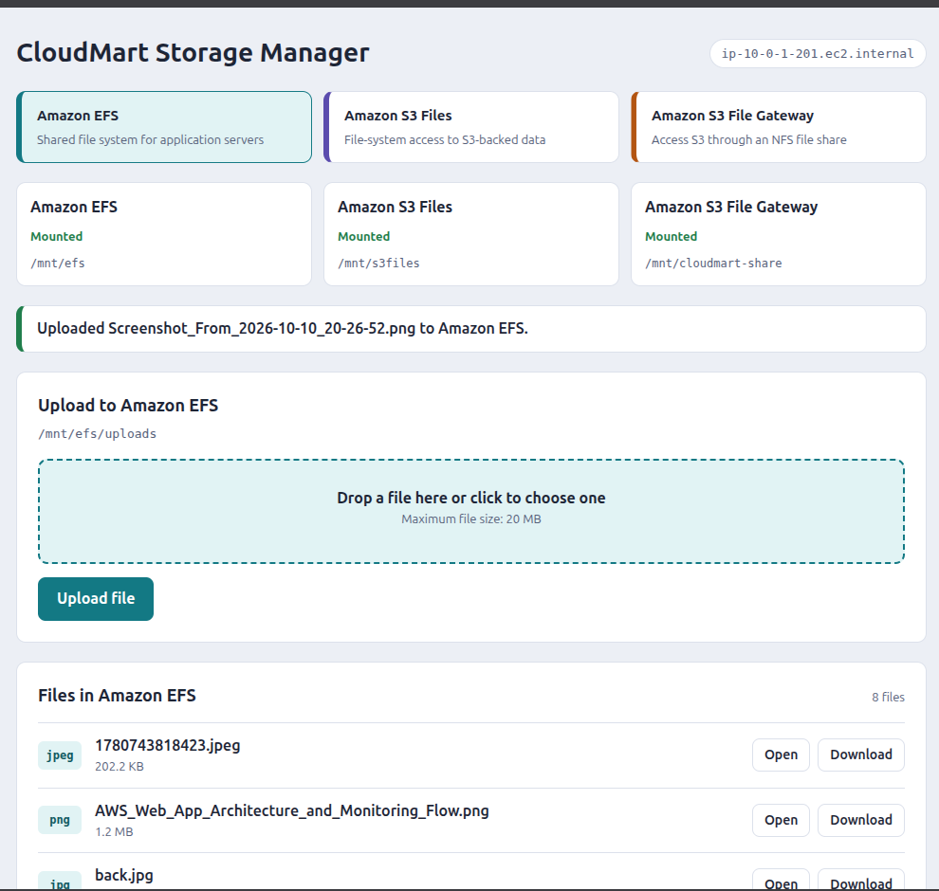
Figure 52: CloudMart on Client A: file uploaded to Amazon EFS
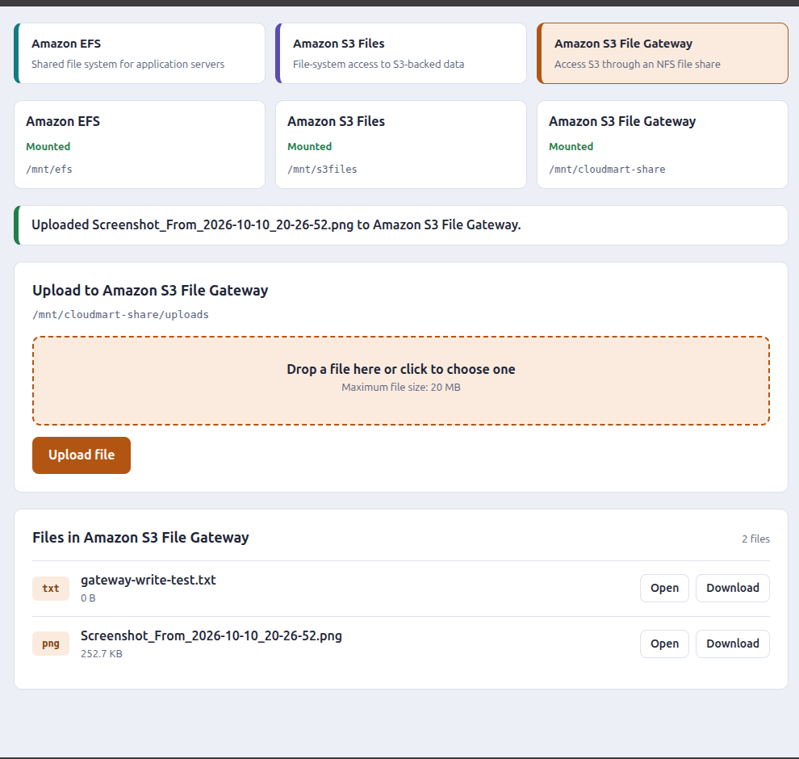
Figure 53: CloudMart: the Gateway storage lists the uploaded files
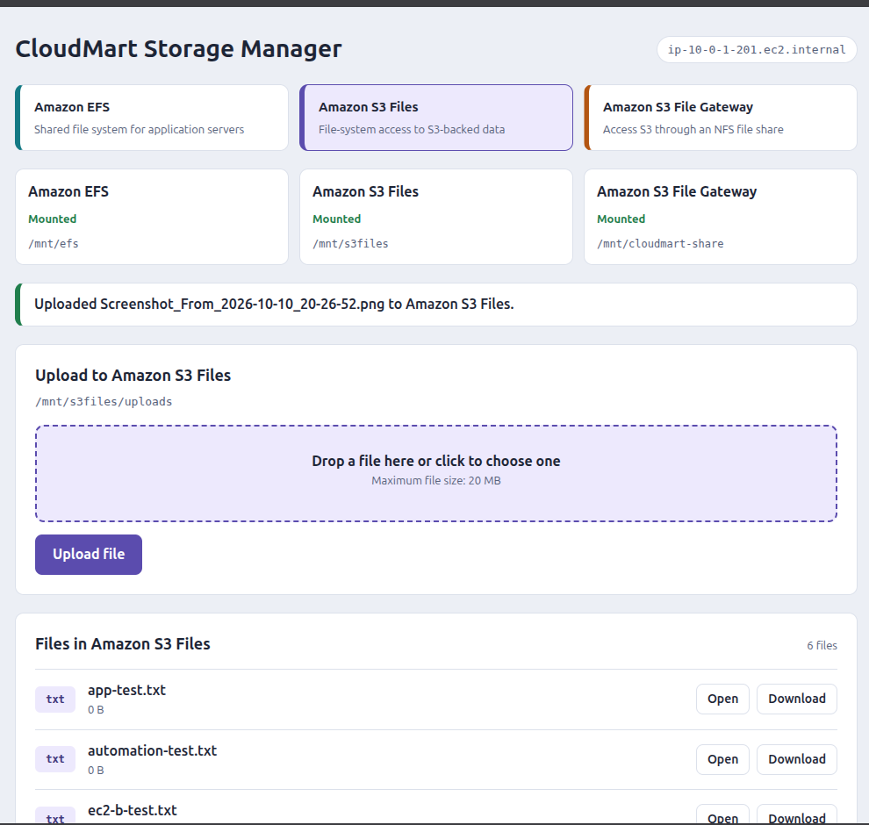
Figure 54: CloudMart: the S3 Files storage lists the uploaded files

9. Troubleshoot File Gateway Permissions
The NFS mount can work while directory permissions still block application uploads. Work through the checks below.

9.1 Inspect the mount and the upload directory
findmnt /mnt/cloudmart-share
ls -ldn /mnt/cloudmart-share
ls -ldn /mnt/cloudmart-share/uploads

The lab showed an NFSv4.2 mount with rw. The numeric owner 65534 normally corresponds to nobody. The recorded modes were 777 for /mnt/cloudmart-share and 755 for /mnt/cloudmart-share/uploads. Mode 755 lets only the owner write, so ec2-user may be unable to create files inside uploads.

9.2 Understand root squash
The share uses RootSquash: requests made as root on the client are mapped to an anonymous identity on the server side. That is why this command may fail with Operation not permitted:
sudo chmod -R 777 /mnt/cloudmart-share

This is not necessarily a syntax problem; the remote filesystem may not allow the metadata change.

9.3 Test the real write permission
Run the test as the same user that runs Flask (do not use sudo if the service runs as ec2-user):
touch /mnt/cloudmart-share/uploads/app-write-test.txt

If it fails with Permission denied, the web upload will fail as well. Being able to create a file in the share root does not prove that the uploads directory is writable by the Flask process.

9.4 Do not change permissions blindly
- Inspect the directory owner and mode.
- Confirm the File Gateway permission configuration.
- Determine how the NFS share maps client identities.
- Use the permission-management method supported by the share.
- Retest with the same identity that runs Flask.

10. End-to-End CloudMart Upload Test
- Restart the service on Client B and check that it is active (running).
- Open CloudMart, select the Gateway storage, upload a small file (for example cloudmart-test.txt) and confirm that the application reports success.
- On Client B run ls -lah /mnt/cloudmart-share/uploads and cat the uploaded file.
- On Client A run the same two commands: the file must be visible through the same NFS share.
- From CloudShell run aws s3 ls on the bucket; allow time for the asynchronous upload.
# | Expected result
1 | The file appears in the CloudMart interface.
2 | The file exists in /mnt/cloudmart-share/uploads on Client B.
3 | The file is visible through the same mount on Client A.
4 | The file eventually appears as an object in the backing S3 bucket.

If the browser upload fails, inspect the Flask service logs before changing permissions.

11. Troubleshooting Guide
Problem | What to check
NFS mount fails | ping -c 4 10.0.2.34 (ICMP may be blocked, so a failed ping alone does not prove NFS is down); Gateway state, private IP, VPC and subnet placement, NFS security-group rules, the share's allowed client list, and the NFS export path.
Mount exists but the app says storage is unavailable | findmnt /mnt/cloudmart-share and confirm that the application uses the same mount path.
Permission denied | id, ls -ldn on the share and uploads, and the service user (systemctl show ... -p User -p Group). rw means the filesystem is mounted read/write, not that every user can write everywhere.
Flask service fails to start | python3 -m py_compile ~/efs-upload-app/app.py, restart and status of the service, then journalctl -u efs-upload-app.service -n 100.
File visible through NFS but not in S3 | Wait for the asynchronous upload and run aws s3 ls again; if the object is still missing, check the Gateway health and upload errors.
CRR object is missing | Versioning on both buckets, rule enabled, object matches the rule scope, correct destination bucket and Region, replication status of the object, replication IAM role, and whether the object was uploaded before the rule existed.

12. Final Validation Checklist
Do not mark a row as complete until the test succeeds.
Component | Validation | Expected result
VPC | EC2 placement | Clients and Gateway use the intended VPC
EFS | Mount on Client A and Client B | /mnt/efs is mounted on both
EFS | Shared file test | Both clients can access the test files
S3 Files | Mount check | /mnt/s3files is mounted
S3 Files | File test | Write/read and storage-side verification succeed
CRR | Versioning | Enabled on both buckets
CRR | Replication rule | Rule is enabled
CRR | Replication test | Source object appears in the destination
File Gateway | Gateway state | RUNNING
File Gateway | File share state | AVAILABLE
File Gateway | Client A and Client B mounts | /mnt/cloudmart-share is mounted on both
File Gateway | Shared access | Both clients read each other's files
File Gateway | S3 verification | Gateway-created objects appear in S3
Persistent mount | Reboot test | The mount returns after reboot
CloudMart | Service state | active (running)
CloudMart | Web upload | Upload succeeds
CloudMart | Cross-client check | Uploaded file appears on Client A
CloudMart | S3 check | Uploaded object appears in S3

Before publishing: hide credentials and sensitive account information (key file names, public IP addresses and account IDs) in the screenshots.

Appendix A: List of Figures
Figure | Description
1 | VPC resource map: task4-vpc with task4-subnet-a, task4-subnet-b, the route table and the internet gateway
2 | Route table of task4-vpc with the local route and the 0.0.0.0/0 route to the internet gateway
3 | Associating the route table with a subnet
4 | Client security group: inbound SSH (TCP 22)
5 | File Gateway security group: TCP 111, 2049, 80 (activation) and 20048
6 | Amazon EFS review page: file system settings
7 | Amazon EFS mount targets and their security groups
8 | EFS mount-target security group: inbound NFS (TCP 2049) from the client security group
9 | Security group efs-mount: inbound NFS (TCP 2049)
10 | Installing amazon-efs-utils on Client A (task4-client-a)
11 | Installing amazon-efs-utils on Client B (task4-client-b)
12 | Client A mounts EFS and creates a test file
13 | Client B reads the file created on Client A
14 | Client A: /etc/fstab and findmnt /mnt/efs showing the EFS mount (TLS)
15 | Client B: EFS entry in /etc/fstab
16 | IAM: creating the role for the storage resources (role created successfully)
17 | Trust relationship of the S3 Files role (service principal elasticfilesystem.amazonaws.com)
18 | Permissions of the S3 Files role: AmazonS3FullAccess
19 | Trust policy of the EC2 instance role (service principal ec2.amazonaws.com)
20 | Permissions of the EC2 instance role: AmazonS3FilesClientFullAccess and AmazonS3ReadOnlyAccess
21 | CloudShell: aws s3files create-file-system returns the file system ARN and ID
22 | Attach to an EC2 instance: compute resource and local mount path /mnt/s3files
23 | Attach instructions: install the client utility, create the folder and run the mount command
24 | findmnt /mnt/s3files shows the mounted S3 Files file system
25 | S3 Files security group: inbound NFS (TCP 2049)
26 | Writing a test file through /mnt/s3files
27 | Listing /mnt/s3files from the second client: the file is visible
28 | The test file appears as an object in the S3 bucket
29 | Uploading a file to the bucket from the S3 console
30 | The uploaded file and the test file are both visible under /mnt/s3files
31 | Create replication rule: name cloudmart-crr-rule, status Enabled, source bucket and scope
32 | Replication destination bucket (eu-west-2) and the IAM role
33 | IAM role used for replication and its permissions policy
34 | Upload to the source bucket succeeded
35 | The replicated object appears in the destination bucket in the other Region
36 | Gateway settings: name, time zone and gateway type Amazon S3 File Gateway
37 | Platform options: Amazon EC2 with default settings and the launched instance
38 | Connect to AWS: gateway connection and endpoint options
39 | Configure cache storage: the 150 GiB disk allocated to Cache
40 | CloudWatch alarms and tags, then Configure
41 | Custom trust policy: Storage Gateway (storagegateway.amazonaws.com) can assume the role
42 | Create file share: gateway, NFS protocol and the S3 bucket
43 | Connect S3: bucket, storage class and IAM role
44 | Control access: NFS, read/write access and root squash
45 | File share details: status, S3 location, IAM role and storage class
46 | Client A: nfs-utils installed, NFS share mounted and the first test file written
47 | The file created through the Gateway appears as an object in the S3 bucket
48 | findmnt --verify and the mounted NFS share (/mnt/cloudmart-share) on the client
49 | CloudMart on Client B: Amazon EFS selected (upload directory /mnt/efs/uploads)
50 | CloudMart on Client B: Amazon S3 Files selected (/mnt/s3files/uploads)
51 | CloudMart on Client B: Amazon S3 File Gateway upload succeeded (/mnt/cloudmart-share/uploads)
52 | CloudMart on Client A: file uploaded to Amazon EFS
53 | CloudMart: the Gateway storage lists the uploaded files
54 | CloudMart: the S3 Files storage lists the uploaded files

