
Managing EC2 Instances Securely Using AWS Systems Manager
Task 2 - Part 2: Session Manager and Run Command, with no SSH access and no key pair
Item | Details
Services | AWS Systems Manager (Session Manager, Run Command, Fleet Manager), Amazon EC2, AWS IAM
Instance OS | Amazon Linux 2023 (SSM Agent preinstalled)
Workload | Apache HTTP Server (httpd) installed remotely with Run Command
Access method | AWS Management Console only (no CLI, no SSH, no port 22, no key pair)
Document version | 1.0
Status | Draft
Prepared by | __________________
Date | __________________
Document Version and Change Log
Version | Date | Author | Description of change
1.0 | 2026-10-04 |  | Initial release: IAM role, EC2 launch without key pair, Session Manager, Run Command, Apache verification, tests, troubleshooting and cleanup

1. Overview and Architecture
An organization wants to improve how it manages EC2 instances by removing the need for SSH access and key pair management. In this task the team uses AWS Systems Manager to connect to and manage an EC2 instance securely from the AWS Management Console. Session Manager provides the remote shell, and Run Command installs and starts an Apache web server. No CLI is used and port 22 is never opened.
Component | Purpose
IAM role and instance profile | Grants the instance permission to talk to Systems Manager (managed policy AmazonSSMManagedInstanceCore)
EC2 instance | Amazon Linux 2023, launched without a key pair, in a public subnet with a public IPv4 address
Security group | Allows inbound HTTP (port 80) only. No inbound SSH rule
SSM Agent | Preinstalled on Amazon Linux 2023. Connects outbound over HTTPS (443) to Systems Manager
Session Manager | Opens a browser-based shell on the instance without SSH, key pairs or a bastion host
Run Command | Runs the AWS-RunShellScript document to install and start Apache (httpd)

Architecture
Administrator (browser, IAM permissions)
|
v HTTPS
AWS Systems Manager (Session Manager / Run Command)
^
| outbound HTTPS 443 only (initiated by SSM Agent)
|
EC2 instance (AL2023, public subnet, IAM profile, no key pair)
| Apache httpd :80
v
Internet users --> EC2 public IPV4 (Security group: inbound TCP 80 only)

Why this is more secure: the instance opens no management port. The SSM Agent calls out to Systems Manager, and every session and command is authorized by IAM and recorded (Session history, Run Command history and AWS CloudTrail). There are no key files to store, share or rotate.

Prerequisites
- AWS account with permissions for IAM, EC2 and Systems Manager (for example AdministratorAccess in a lab account).
- A Region with a default VPC (or a VPC with a public subnet that routes to an internet gateway). The instance needs outbound internet access so the SSM Agent can reach Systems Manager.
- A modern web browser. No SSH client, PEM file or AWS CLI is required.

2. Step 1: Create an IAM Role for Systems Manager Access
- Open the IAM console, choose Roles, then Create role.
- For Trusted entity type select AWS service. For Use case select EC2, then click Next.
- In Add permissions, search for and select the managed policy AmazonSSMManagedInstanceCore. Click Next.
- Enter the Role name Team2-EC2-SSM-Role and an optional description such as "Allows EC2 instances to be managed by Systems Manager".
- Review the trust policy and permissions, then click Create role.
- Open the new role and confirm that AmazonSSMManagedInstanceCore is listed under Permissions.
Note: when you create a role for EC2 in the console, AWS automatically creates an instance profile with the same name. The instance profile is what you attach to the EC2 instance in Step 2.
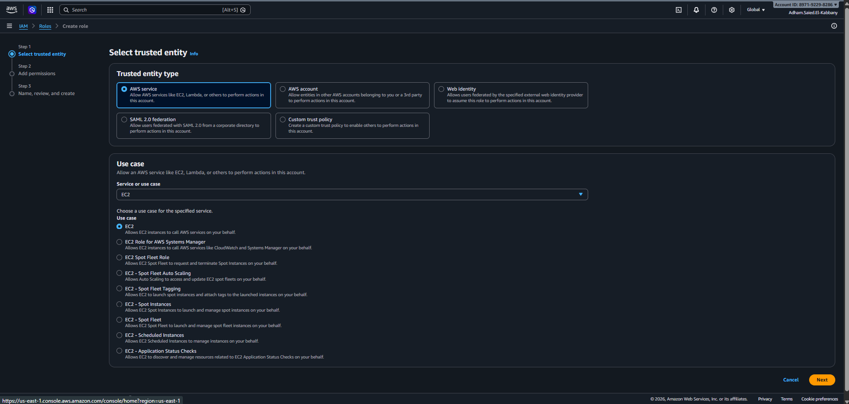
Figure 2: IAM > Roles > Create role: Trusted entity type "AWS service" and use case "EC2"
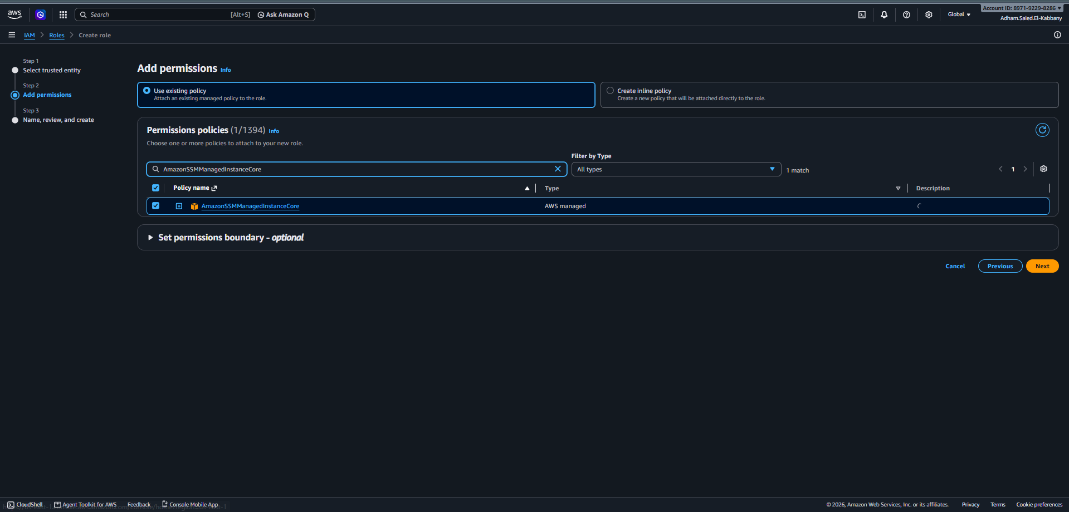
Figure 3: Add permissions page with AmazonSSMManagedInstanceCore selected
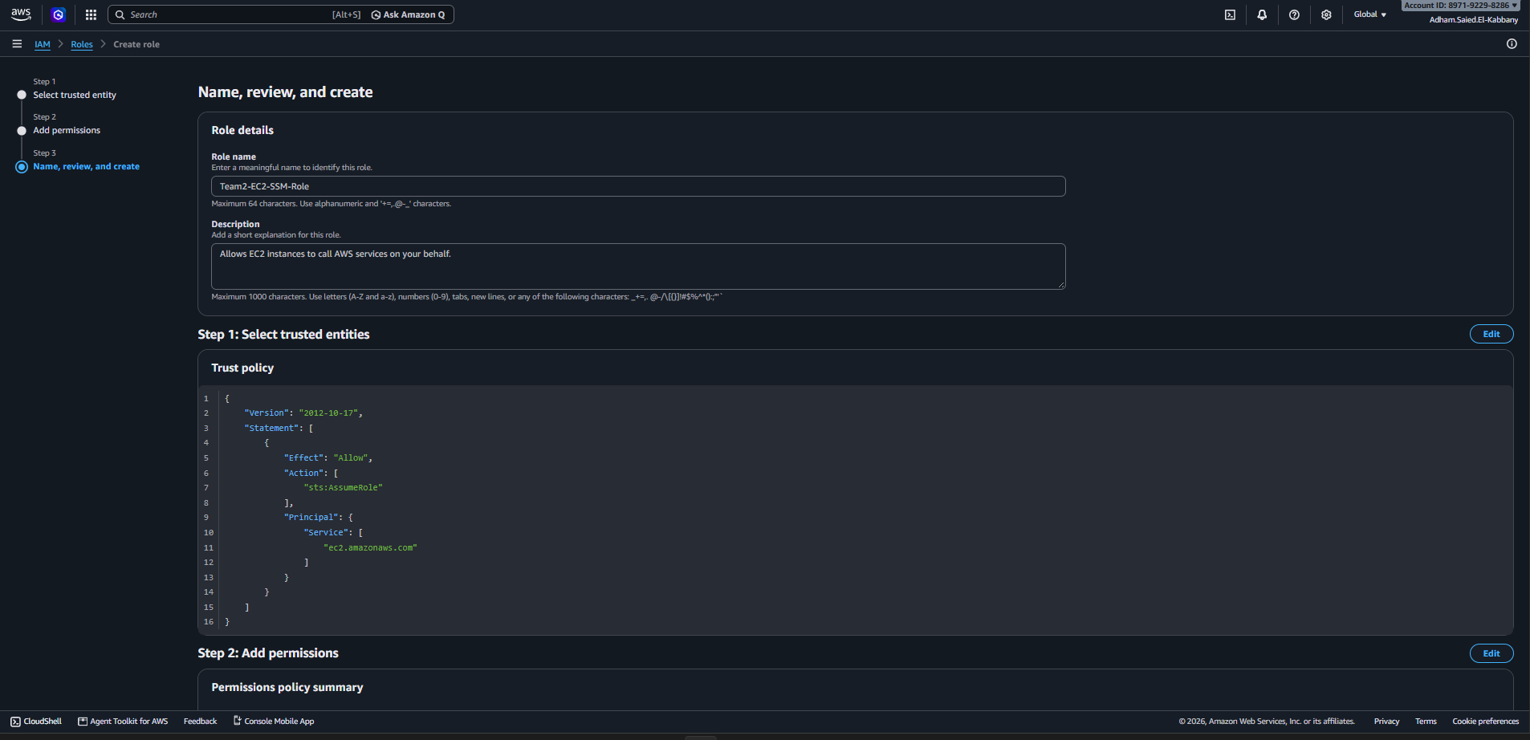
Figure 4: Name, review and create page showing the role name Team2-EC2-SSM-Role
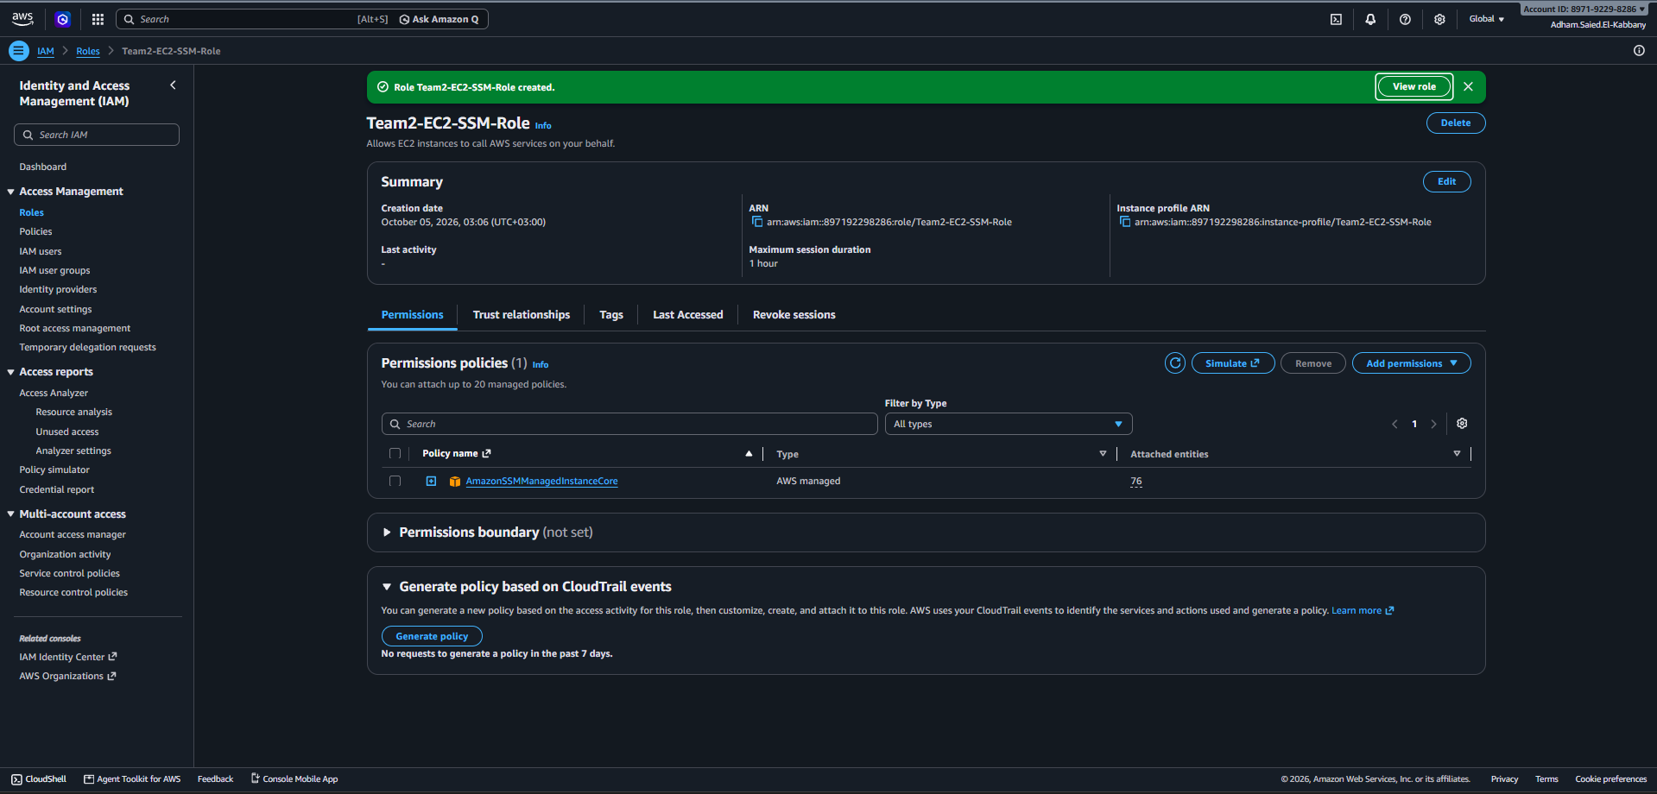
Figure 5: Role summary page showing AmazonSSMManagedInstanceCore attached

3. Step 2: Launch an EC2 Instance Without an SSH Key Pair
- Open the EC2 console and click Launch instance.
- Name: team2-ssm-apache-server.
- Application and OS Images: choose Amazon Linux 2023 AMI (64-bit x86).
- Instance type: t3.micro (or the free-tier eligible type shown in your Region).
- Key pair (login): select Proceed without a key pair (Not recommended). Access is provided by Systems Manager instead.
- Network settings: click Edit. Select the default VPC and a public subnet. Set Auto-assign public IP to Enable.
- Firewall (security groups): choose Create security group, name it ssm-web-sg, and keep only one inbound rule: HTTP, TCP 80, source 0.0.0.0/0. Delete the default SSH (port 22) rule.
- Expand Advanced details. For IAM instance profile select EC2-SSM-Role.
- Leave the storage defaults and click Launch instance.
- Open Instances and wait until Instance state is Running and Status check shows 2/2 checks passed.

Launch settings summary
Setting | Value
Name | team2-ssm-apache-server
AMI | Amazon Linux 2023
Instance type | t3.micro
Key pair | None (Proceed without a key pair)
Subnet / Public IP | Public subnet / Auto-assign public IP: Enable
Security group | ssm-web-sg: inbound TCP 80 from 0.0.0.0/0. No port 22
Outbound rules | Default (all traffic allowed), so the SSM Agent can reach Systems Manager on 443
IAM instance profile | Team2-EC2-SSM-Role

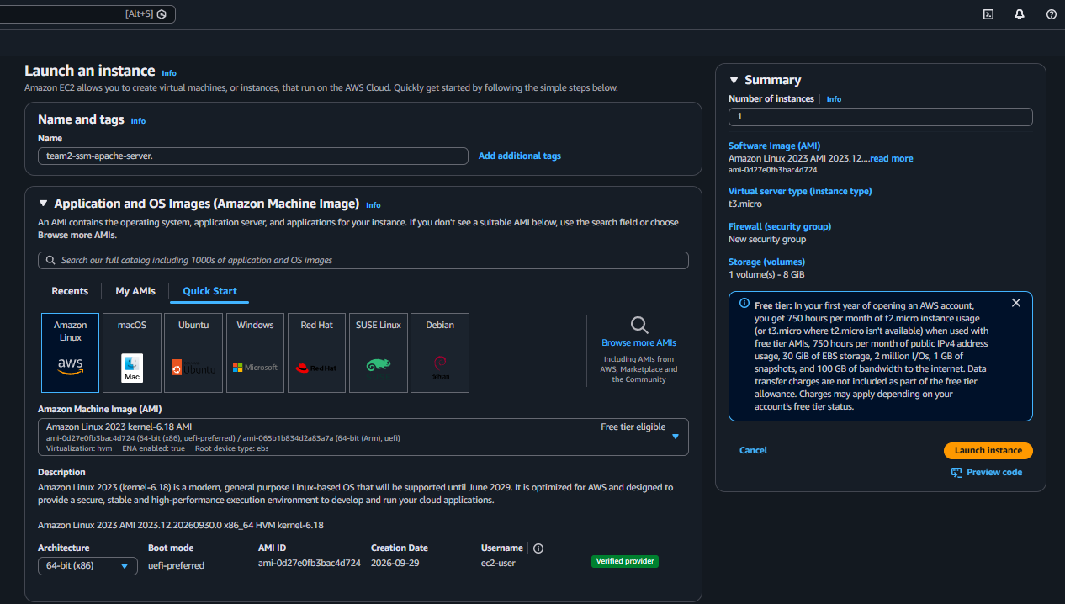
Figure 6: Launch instance page: name and Amazon Linux 2023 AMI selected
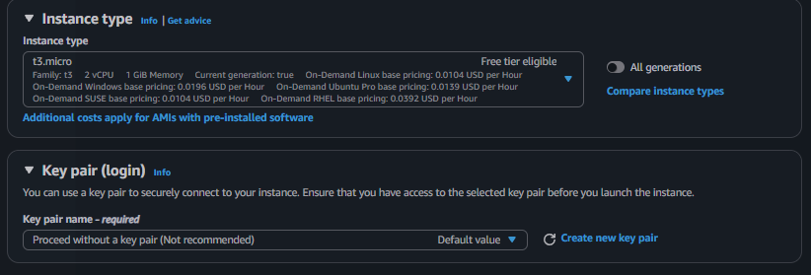
Figure 7: Instance type and Key pair section set to "Proceed without a key pair"
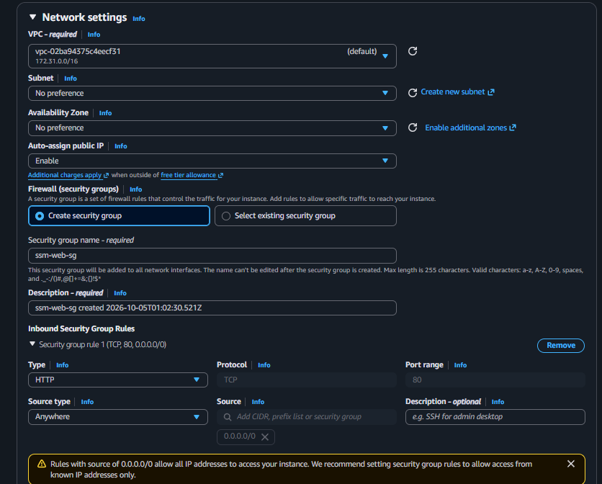
Figure 8: Network settings: public subnet, auto-assign public IP enabled, security group with only HTTP (port 80)
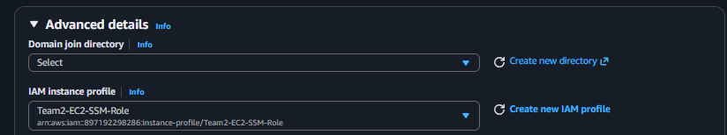
Figure 9: Advanced details: IAM instance profile EC2-SSM-Role selected
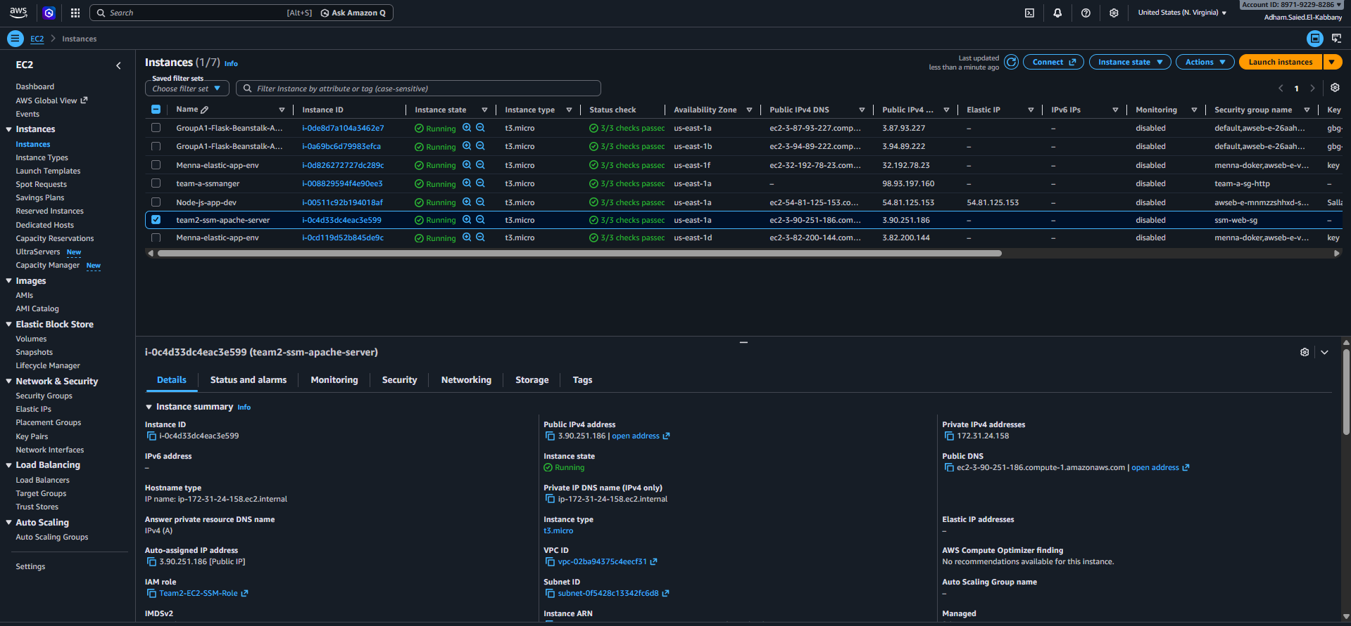
Figure 10: Instances list showing ssm-apache-server Running with 2/2 checks passed
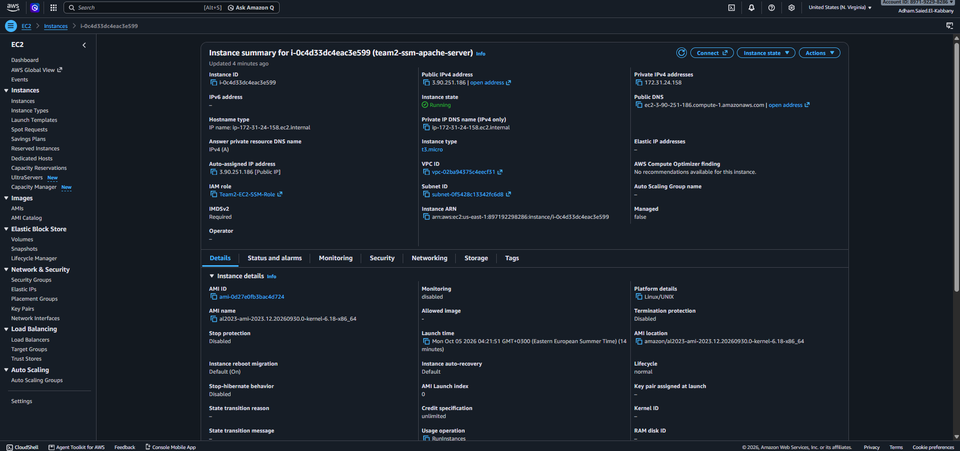
Figure 11: Instance details showing Key pair name empty and IAM role Team2-EC2-SSM-Role attached

4. Step 3: Access the Instance Using Session Manager

4.1 Confirm the instance is a managed node
- Open Systems Manager in the console and choose Fleet Manager (under Node Tools).
- Find team2-ssm-apache-server in the managed nodes list. Ping status must be Online. This can take 2 to 5 minutes after launch.
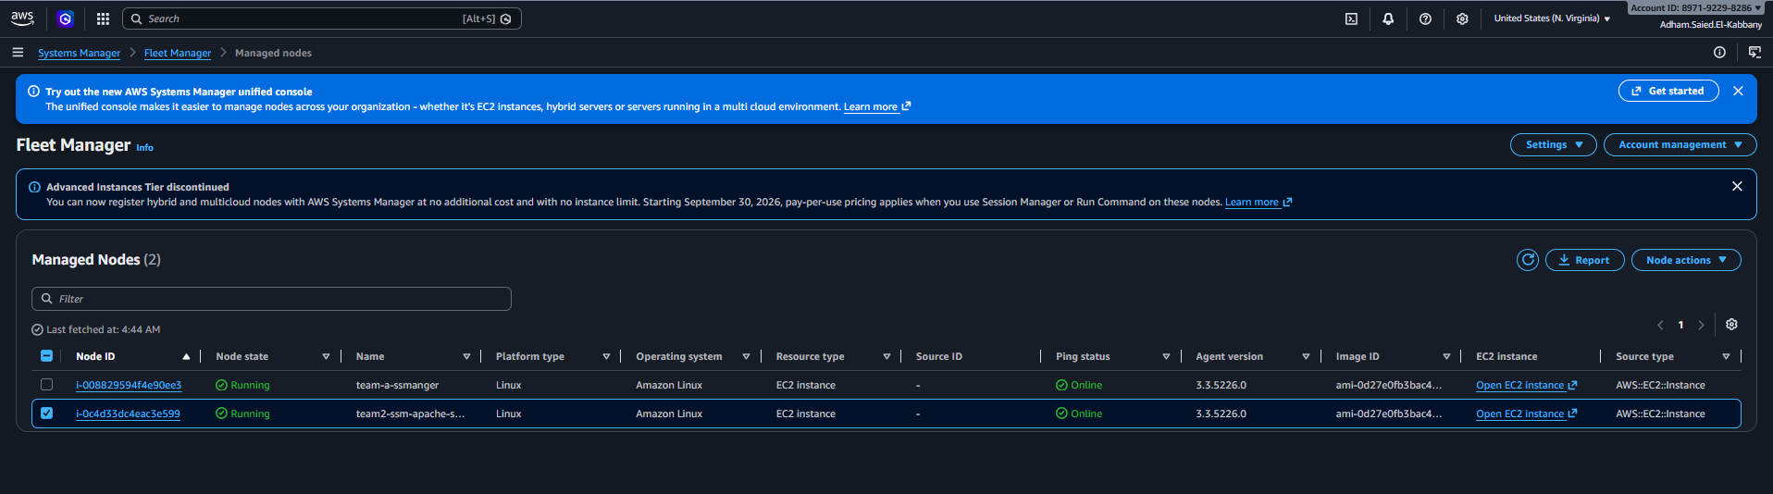
Figure 12: Systems Manager > Fleet Manager showing team2-ssm-apache-server with Ping status Online

4.2 Start a session
- In Systems Manager choose Session Manager, then Start session.
- Select team2-ssm-apache-server and click Start session. (Alternative: EC2 > select the instance > Connect > Session Manager tab > Connect.)
- A browser-based terminal opens. Run the commands below to inspect the instance.
whoami
cat /etc/os-release
systemctl status amazon-ssm-agent --no-pager

Expected: the user is ssm-user, the OS is Amazon Linux 2023, and the SSM Agent service is active (running). Click Terminate when finished.
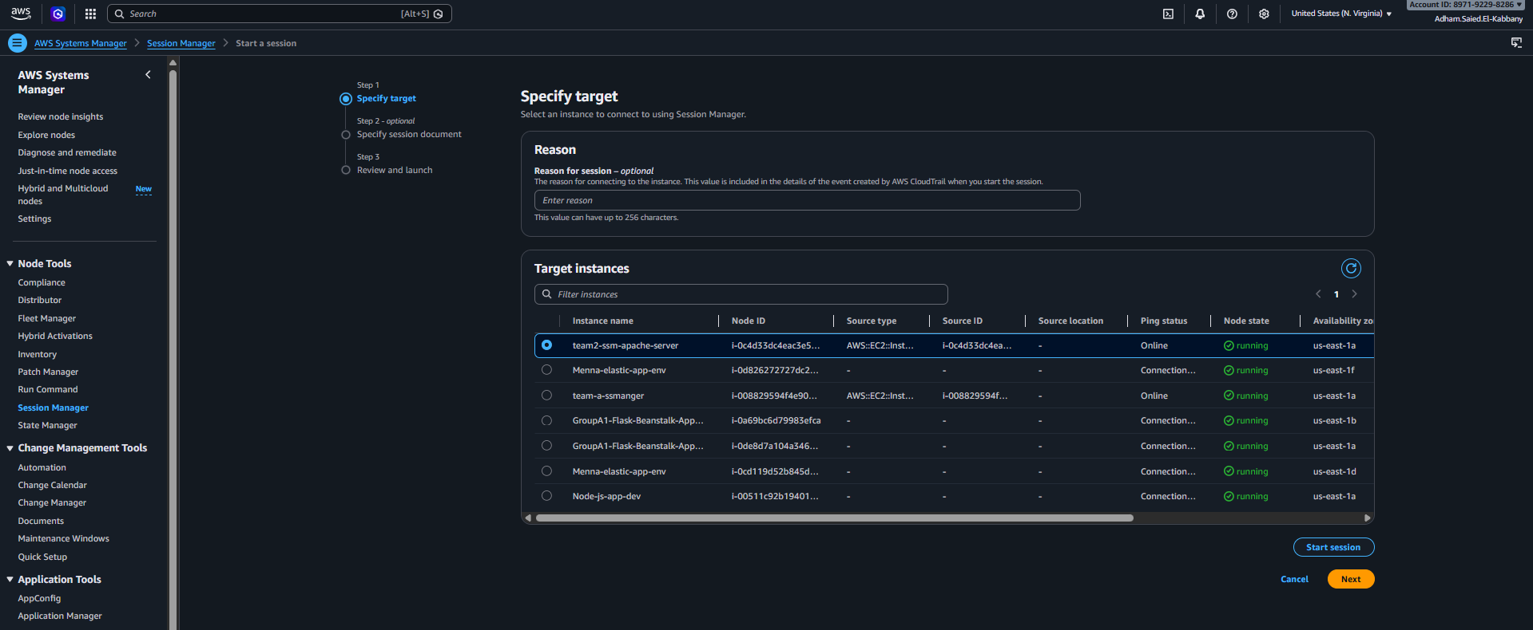
Figure 13: Systems Manager > Session Manager > Start session with the instance selected
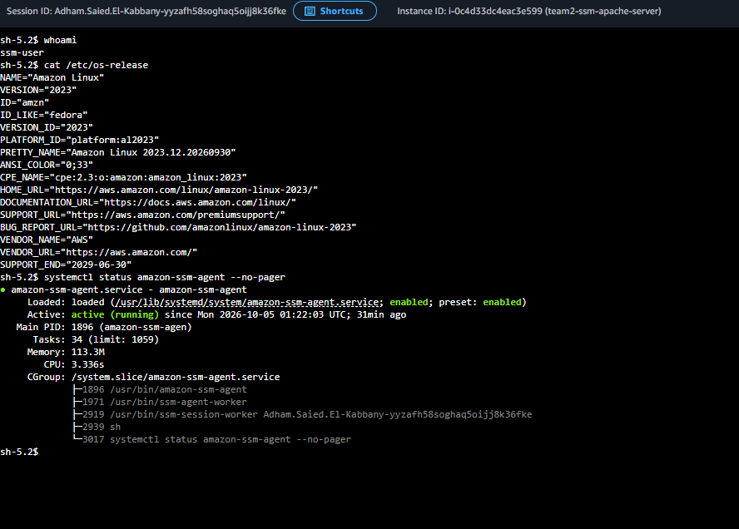
Figure 14: Browser shell session showing whoami, os-release and amazon-ssm-agent status

5. Step 4: Run Commands Using Systems Manager (Install Apache)
- In Systems Manager choose Run Command, then Run command.
- In Command document search for and select AWS-RunShellScript (Platform: Linux).
- In Command parameters, paste the script below into the Commands box.
- In Targets choose Choose instances manually and select team2-ssm-apache-server.
- Leave Execution timeout at the default. Output options (S3 / CloudWatch Logs) are optional and can stay disabled for this lab.
- Click Run. On the command detail page click the refresh icon until Overall status is Success.
- Select the Instance ID, then View output, to read the output of the script.
Commands
#!/bin/bash
dnf install -y httpd
systemctl enable httpd
systemctl start httpd
systemctl status httpd --no-pager

Optional custom page: the default Apache welcome page is shown only while /var/www/html has no index.html. If you later want your own page, run a second command such as echo "<h1>Apache installed with Run Command</h1>" > /var/www/html/index.html. Do this only after the default page has been verified and captured.
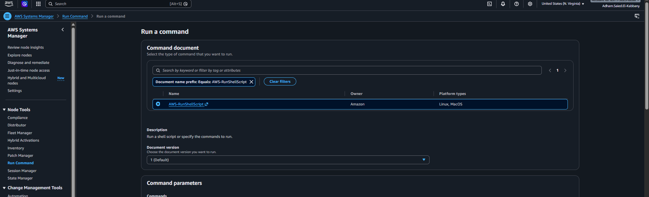
Figure 15: Run Command: AWS-RunShellScript document selected
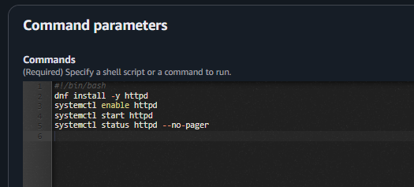
Figure 16: Command parameters box containing the Apache install script
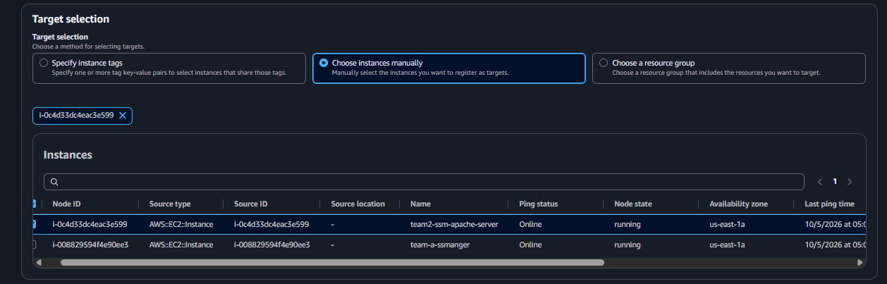
Figure 17: Targets section with ssm-apache-server selected
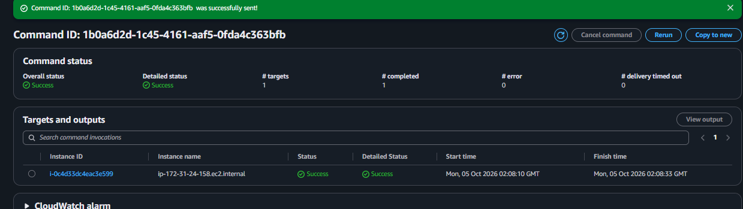
Figure 18: Command detail page with Overall status Success
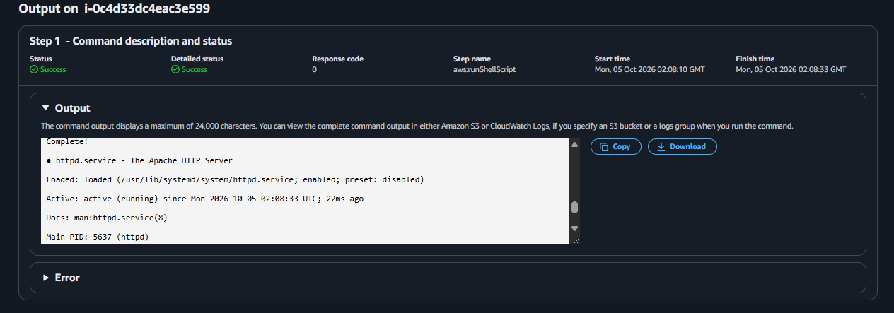
Figure 19: Command output showing httpd installed and active (running)

6. Step 5: Verify the Web Server
- In the EC2 console select the instance and copy its Public IPv4 address.
- Open a new browser tab and go to http://ec2-3-90-251-186.compute-1.amazonaws.com. Use http, not https, because only port 80 is open.
- The Apache default welcome (test) page is displayed. The exact wording depends on the Apache version, for example "It works!" or "Test Page for the Apache HTTP Server".
- Optional: in Session Manager run the commands below to confirm Apache answers locally.
systemctl status httpd --no-pager
curl -I http://localhost

The default page can be served with status 403 together with the test page body. This is normal and still confirms Apache is running.
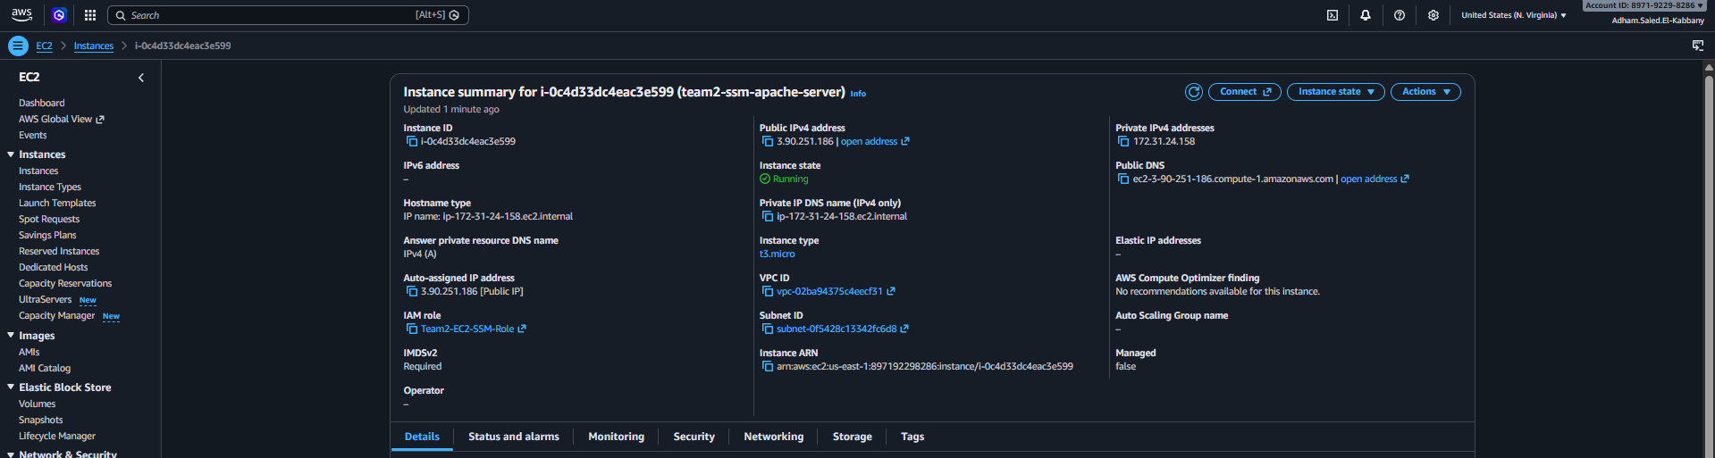
Figure 20: EC2 instance details showing the Public IPv4 address
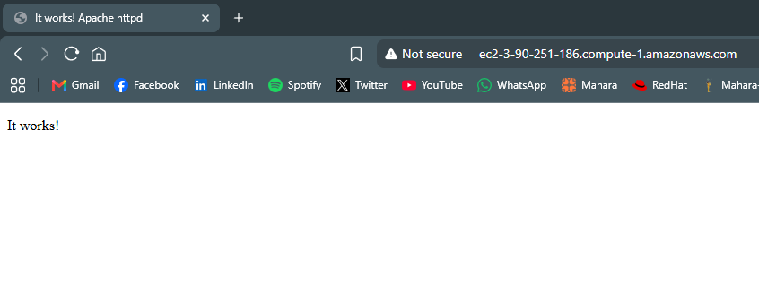
Figure 21: Browser showing the Apache welcome page at http:// ec2-3-90-251-186.compute-1.amazonaws.com
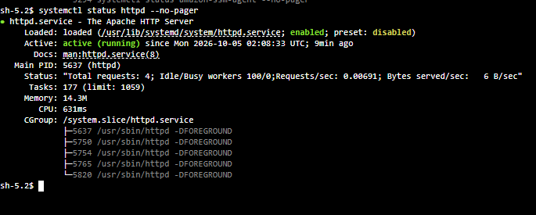
Figure 22: Session Manager terminal showing systemctl status httpd as active (running)

7. Scenario Testing
# | Test | Command / Action | Expected result
1 | No key pair | EC2 > instance details > Key pair name | Key pair name is empty
2 | No port 22 | EC2 > Security tab > Inbound rules | Only TCP 80 is listed
3 | Managed node | Systems Manager > Fleet Manager | Instance is listed with Ping status Online
4 | Session Manager | Start session, then run whoami | Shell opens in the browser; user is ssm-user
5 | Run Command | Run AWS-RunShellScript with the Apache script | Overall status Success
6 | Apache service | In a session: systemctl status httpd --no-pager | active (running)
7 | Web page | Open http://ec2-3-90-251-186.compute-1.amazonaws.comin a browser | Apache welcome page is displayed
8 | SSH is blocked | nc -vz -w 5 ec2-3-90-251-186.compute-1.amazonaws.com22 | Connection times out (port 22 is closed)
9 | Audit trail | Session Manager > Session history; Run Command > Command history | Session and command are listed with user, time and status

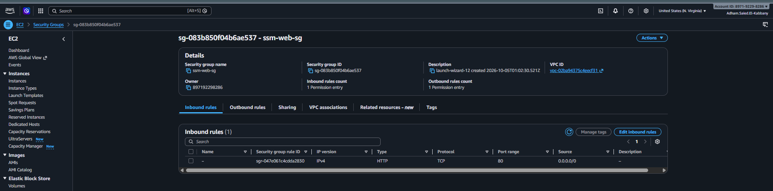
Figure 23: Security group inbound rules showing only HTTP (no SSH)
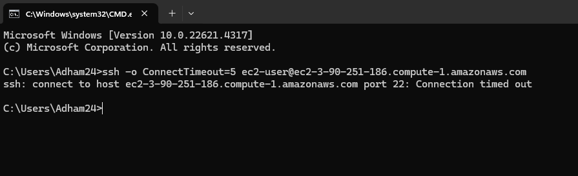
Figure 24: Terminal output of the port 22 test timing out
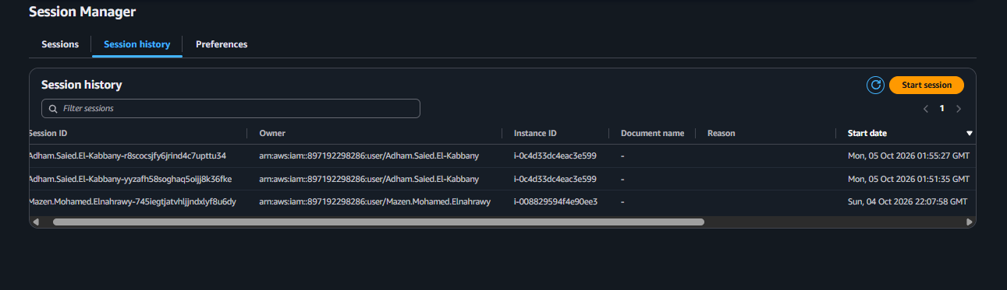
Figure 25: Session Manager > Session history listing the session
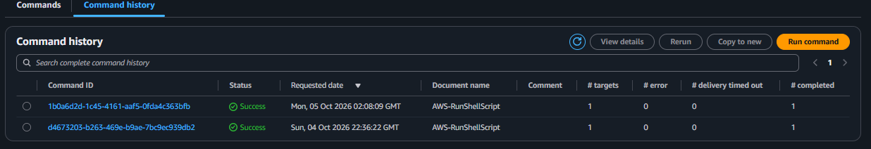
Figure 26: Run Command > Command history listing the Apache command

8. Troubleshooting
Symptom | Likely cause and fix
Instance not shown in Fleet Manager / Session Manager | The IAM instance profile is missing or lacks AmazonSSMManagedInstanceCore. Fix with EC2 > Actions > Security > Modify IAM role. Wait a few minutes or reboot the instance.
Ping status Connection lost or never Online | The instance has no outbound path to Systems Manager. Check that it has a public IP in a public subnet with an internet gateway route, and that outbound 443 is allowed. For private subnets create VPC endpoints for ssm, ssmmessages and ec2messages.
Start session is disabled or fails with AccessDenied | Your own IAM user or role lacks ssm:StartSession (and related) permissions. Ask an administrator to grant them.
Run Command stays Pending or TimedOut | The instance is not Online in Fleet Manager. Fix connectivity first, then run the command again.
Run Command status Failed | Open View output and read the error stream. A dnf error usually means no internet access or a typing mistake in the script.
Browser cannot open the page | The security group has no inbound TCP 80 rule, you used https instead of http, the instance has no public IP, or Apache is not running. Check each in that order.
Page shows 403 Forbidden | This is the default Apache test page behavior when no index.html exists. It confirms Apache is running.
Role attached but still not managed | Wait 5 to 10 minutes after attaching the role, or restart the SSM Agent from a session: sudo systemctl restart amazon-ssm-agent.

9. Security Recommendations and Cleanup

Recommendations
- Restrict the HTTP source in the security group to known IP ranges instead of 0.0.0.0/0 when the site is not public.
- Enable Session Manager logging to Amazon S3 or CloudWatch Logs for a full record of session activity.
- Limit who can start sessions with IAM policies, for example by resource tag or by instance.
- Keep instances in private subnets and use VPC endpoints (ssm, ssmmessages, ec2messages) when internet access is not required.
- Use Patch Manager and State Manager to keep instances patched and consistent.

Cleanup (avoid charges)
- EC2 > select ssm-apache-server > Instance state > Terminate instance.
- Delete the security group ssm-web-sg after the instance has terminated.
- IAM > Roles > delete EC2-SSM-Role (this also removes the instance profile).
- Delete any S3 buckets or CloudWatch log groups you created for session or command logs.

Appendix A: Screenshot Checklist
Use this table to confirm that every screenshot placeholder has been filled.
Figure | What to capture | Done
1 | VPC console showing the default VPC and a public subnet with a route to an internet gateway | [ ]
2 | IAM > Roles > Create role: Trusted entity type "AWS service" and use case "EC2" | [ ]
3 | Add permissions page with AmazonSSMManagedInstanceCore selected | [ ]
4 | Name, review and create page showing the role name EC2-SSM-Role | [ ]
5 | Role summary page showing AmazonSSMManagedInstanceCore attached | [ ]
6 | Launch instance page: name and Amazon Linux 2023 AMI selected | [ ]
7 | Instance type and Key pair section set to "Proceed without a key pair" | [ ]
8 | Network settings: public subnet, auto-assign public IP enabled, security group with only HTTP (port 80) | [ ]
9 | Advanced details: IAM instance profile EC2-SSM-Role selected | [ ]
10 | Instances list showing ssm-apache-server Running with 2/2 checks passed | [ ]
11 | Instance details showing Key pair name empty and IAM role EC2-SSM-Role attached | [ ]
12 | Systems Manager > Fleet Manager showing ssm-apache-server with Ping status Online | [ ]
13 | Systems Manager > Session Manager > Start session with the instance selected | [ ]
14 | Browser shell session showing whoami, os-release and amazon-ssm-agent status | [ ]
15 | Run Command: AWS-RunShellScript document selected | [ ]
16 | Command parameters box containing the Apache install script | [ ]
17 | Targets section with ssm-apache-server selected | [ ]
18 | Command detail page with Overall status Success | [ ]
19 | Command output showing httpd installed and active (running) | [ ]
20 | EC2 instance details showing the Public IPv4 address | [ ]
21 | Browser showing the Apache welcome page at http:// ec2-3-90-251-186.compute-1.amazonaws.com | [ ]
22 | Session Manager terminal showing systemctl status httpd as active (running) | [ ]
23 | Security group inbound rules showing only HTTP (no SSH) | [ ]
24 | Terminal output of the port 22 test timing out | [ ]
25 | Session Manager > Session history listing the session | [ ]
26 | Run Command > Command history listing the Apache command | [ ]

