
CloudMart Backup, Restore, and Disaster Recovery on AWS
AWS Backup, EC2, EBS and EFS across Virginia and London, with a Python storage dashboard
Item | Details
Project | CloudMart Backup, Restore, and Disaster Recovery on AWS
Source Region | US East (N. Virginia), us-east-1
Recovery Region | Europe (London), eu-west-2
Main services | Amazon EC2, Amazon EBS, Amazon EFS, AWS Backup, Apache HTTP Server, Python, Linux, SHA-256
Backup design | Primary vault in us-east-1, DR vault in eu-west-2, daily rule with 7-day retention and a copy to London
Document version | 1.0
Status | Draft
Prepared by | Menna Kamel
Date | 2026-10-13

Document Version and Change Log
Version | Date | Author | Description of change
1.0 | 2026-10-13 | Menna Kamel | Initial release: source environment, AWS Backup plan and vaults, recovery in London, EBS and EFS restore, SHA-256 validation, storage dashboard and results

1. Project Overview
The objective of this project was to practice AWS backup and disaster recovery by preparing a source environment in the Virginia Region and a separate recovery environment in the London Region.
The project involved EC2 instances, EBS volumes and EFS file systems. After preparing the recovery environment, I verified the mounted storage, inspected the recovered files and checked file integrity with SHA-256 checksums. Finally, I built a storage dashboard on the London EC2 instance using Python and Apache HTTP Server. The dashboard runs independently in London and shows only the storage information available in that environment.

1.1 Objectives
- Understand AWS Backup and disaster recovery concepts.
- Work with EC2 instances across two AWS Regions.
- Configure and mount EBS volumes.
- Configure EFS mount targets and NFS connectivity.
- Restore storage resources in a separate Region.
- Verify recovered files with SHA-256 checksums.
- Build a simple web dashboard that displays storage information.
- Configure automatic dashboard updates with systemd.
- Access the dashboard through the EC2 public DNS.

1.2 Architecture
US East (N. Virginia) us-east-1 Europe (London) eu-west-2
------------------------------ -----------------------------
EC2 menna-backup-task5 EC2 menna-restore-key-access
|- EBS /mnt/cloudmart-data |- EBS /mnt/cloudmart-data
|- EFS /mnt/cloudmart-efs |- EFS /mnt/cloudmart-efs
| |
v v
AWS Backup Python + Apache dashboard
cloudmart-primary-vault (EBS and EFS files, SHA-256)
|
| copy of the recovery points
+-----------------------------> cloudmart-dr-vault

Property | Source (Virginia) | Recovery (London)
Region | us-east-1 | eu-west-2
EC2 instance | menna-backup-task5 | menna-restore-key-access
Instance ID | i-0d444df9ed740e8ed | i-00a5063f2f5db154c
Private IP | 10.0.1.180 | 10.0.1.113
Backup vault | cloudmart-primary-vault | cloudmart-dr-vault
EBS mount | /mnt/cloudmart-data | /mnt/cloudmart-data
EFS mount | /mnt/cloudmart-efs | /mnt/cloudmart-efs

2. Source Environment in Virginia

2.1 Source EC2 instance
Property | Value
Region | us-east-1
Instance name | menna-backup-task5
Instance ID | i-0d444df9ed740e8ed
Private IP | 10.0.1.180
VPC ID | vpc-0588ea80fff9a94e4
Security group | sg-009b7ca2a87b8d08e

I connected to the instance and inspected its storage with df -hT (mounted filesystems) and lsblk (attached block devices). These commands identify the root filesystem and the additional EBS data volume. I also created a small set of test files to have data to back up and verify.
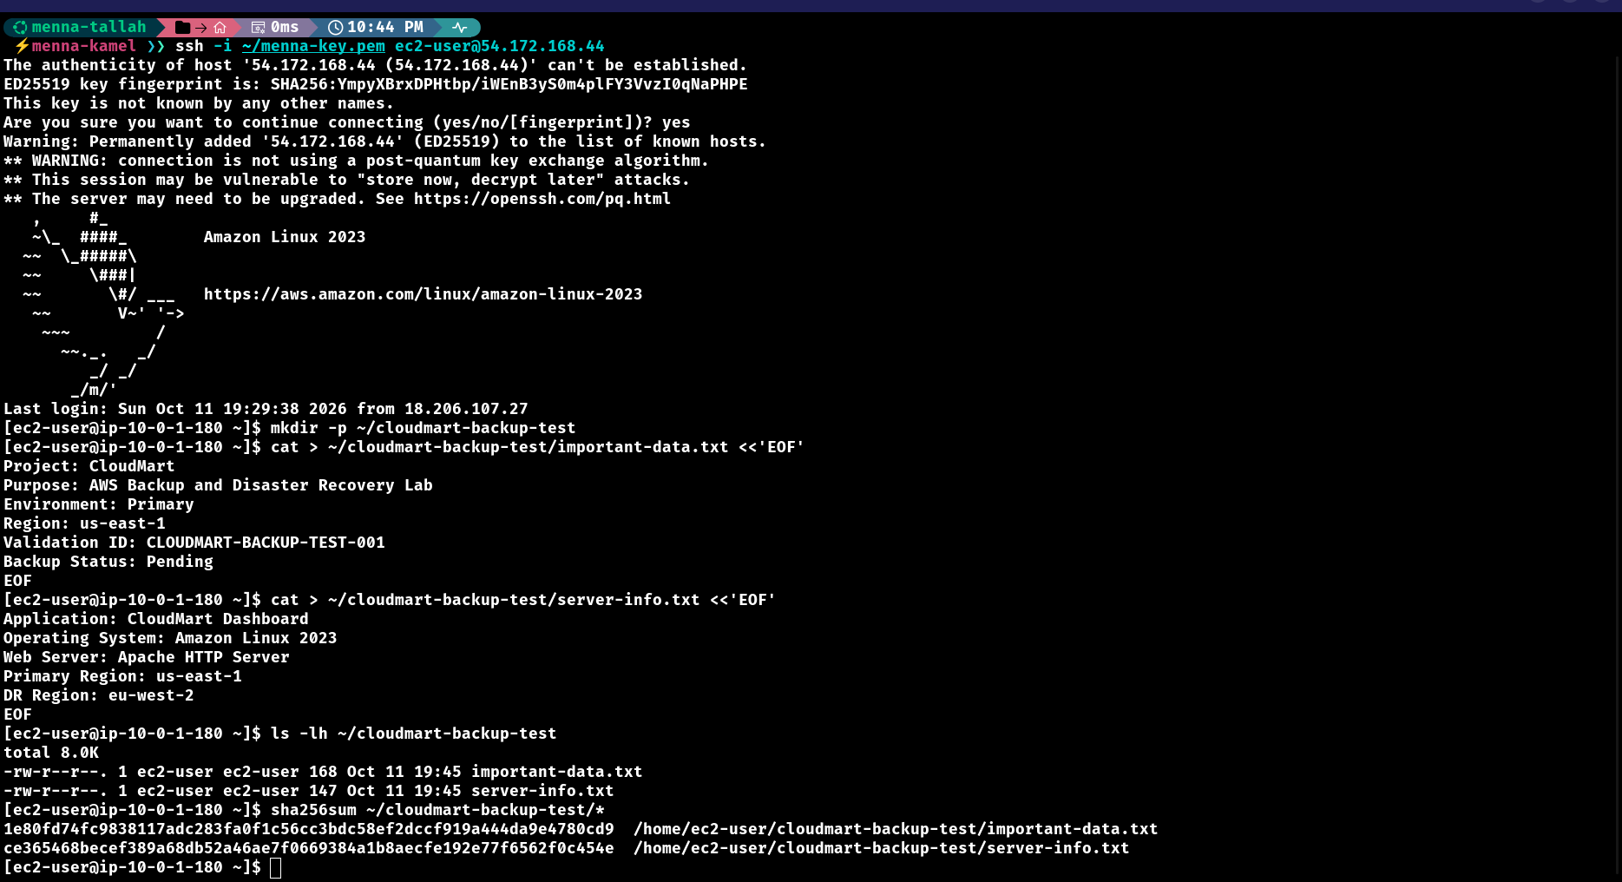
Figure 1: Source EC2 instance: SSH session and the test files created for the backup (important-data.txt and server-info.txt)

2.2 EBS data volume
The source instance has a separate EBS data volume, created in the same Availability Zone as the instance and attached to it.
Property | Value
Linux device | /dev/xvdf
Filesystem | XFS
Size | 10 GiB
Mount point | /mnt/cloudmart-data

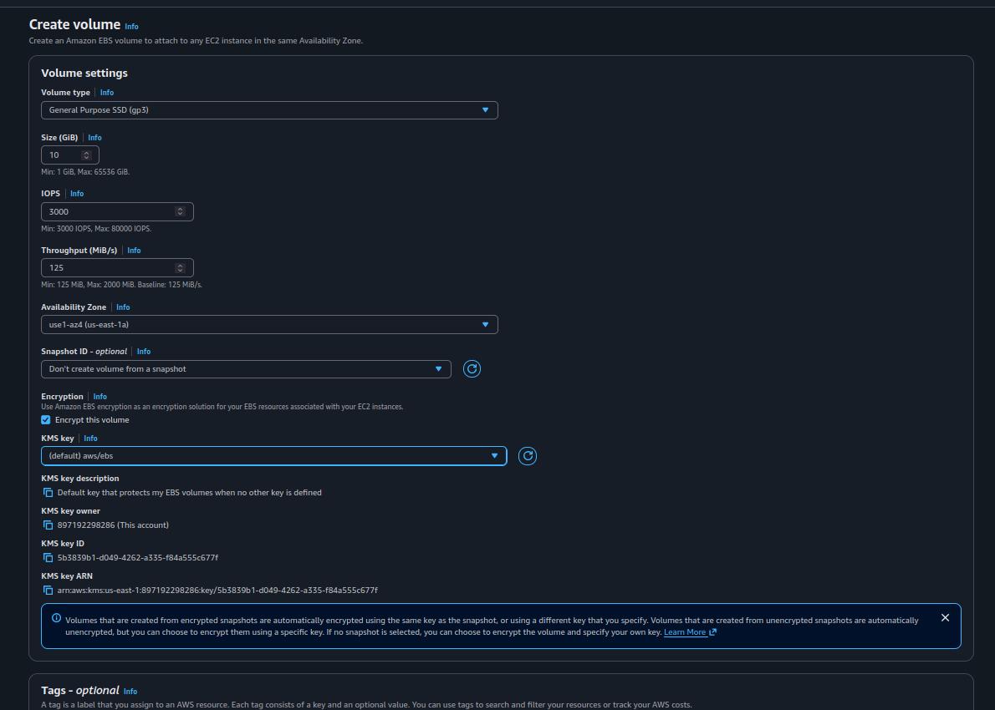
Figure 2: EC2 > Create volume: General Purpose SSD (gp3), 10 GiB, encryption enabled
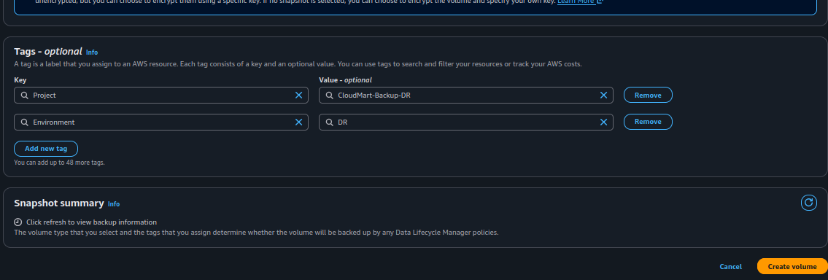
Figure 3: Volume tags (Project and Environment) before choosing Create volume
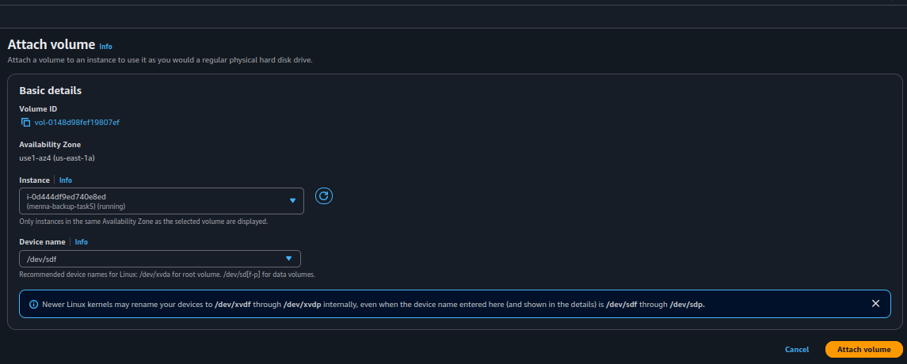
Figure 4: Attach volume: the volume is attached to the source instance
The volume was formatted with XFS, mounted, and made persistent through /etc/fstab:
sudo mkfs.xfs /dev/xvdf
sudo mkdir -p /mnt/cloudmart-data
sudo mount /dev/xvdf /mnt/cloudmart-data
df -hT /mnt/cloudmart-data
sudo find /mnt/cloudmart-data -type f
# /mnt/cloudmart-data/important-data.txt

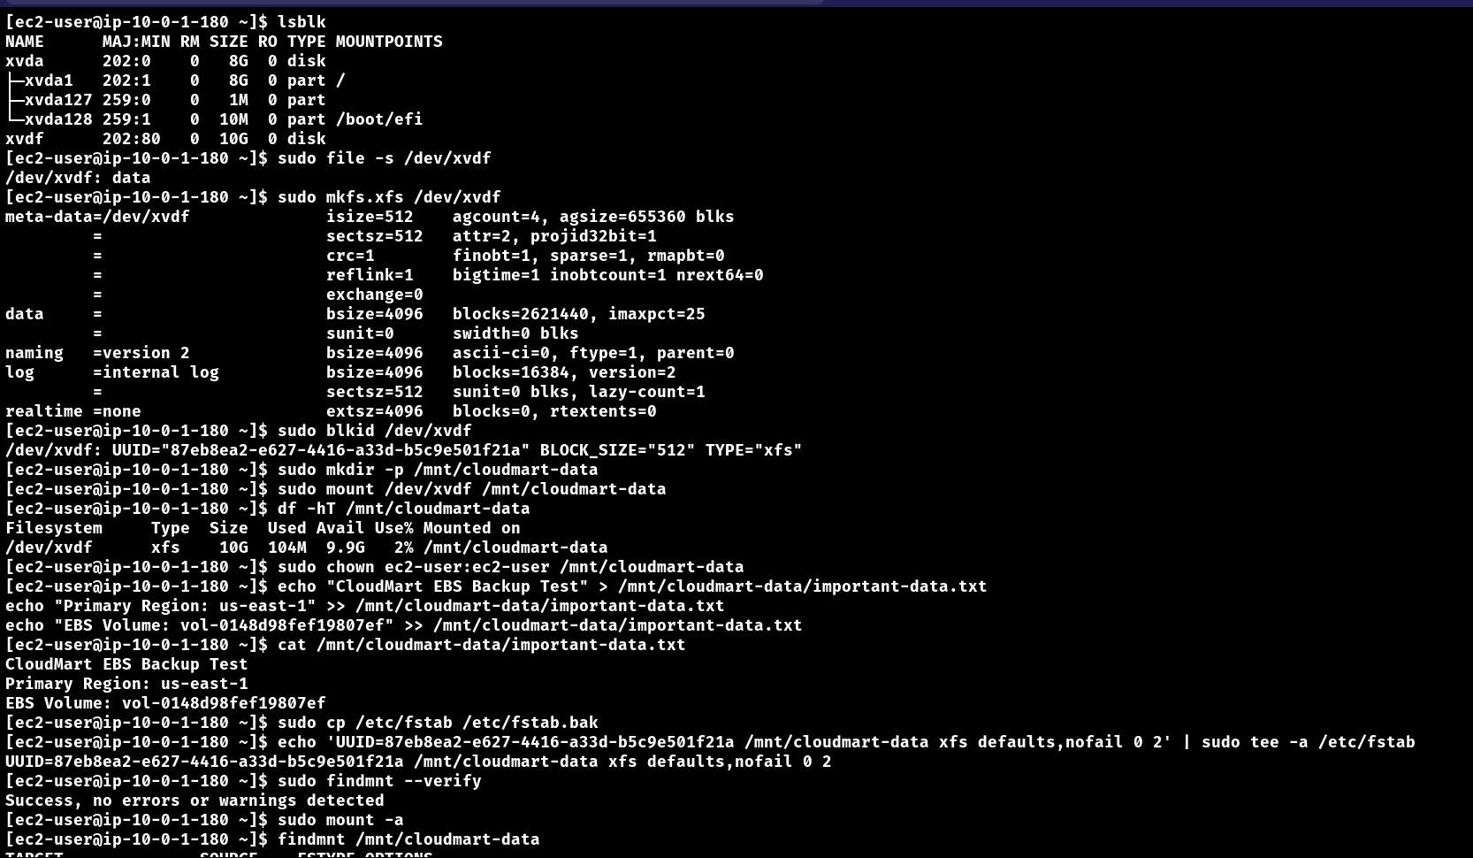
Figure 5: Formatting, mounting and verifying the EBS volume, then writing important-data.txt
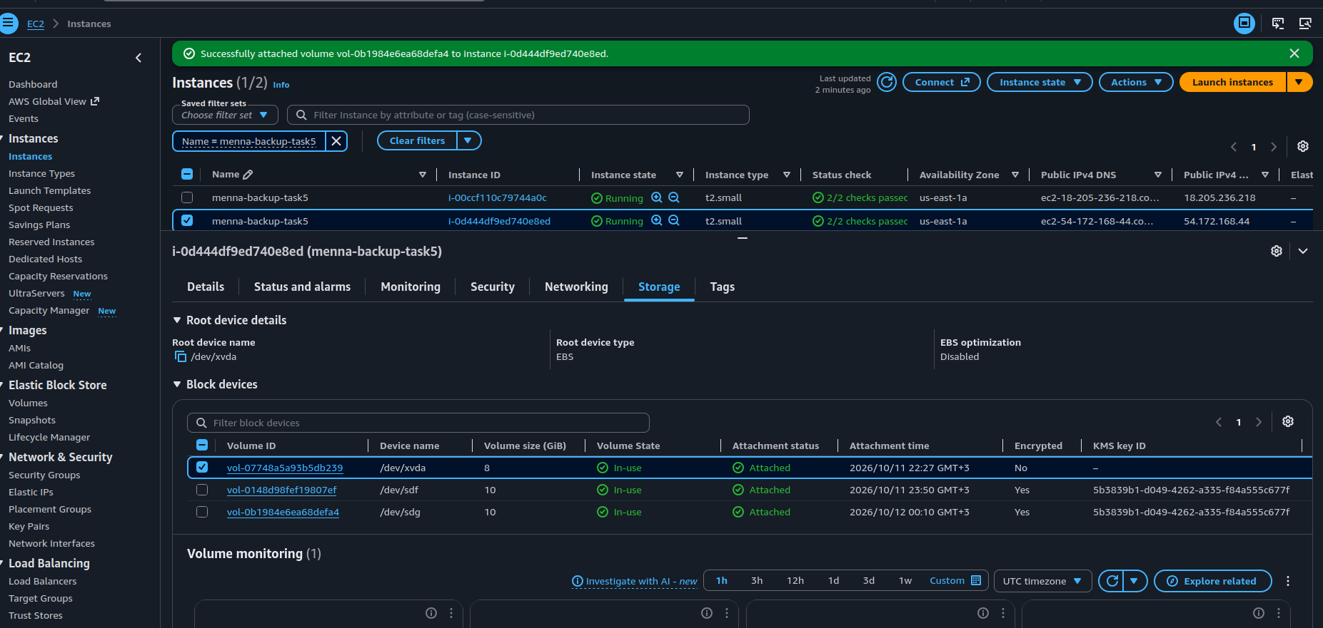
Figure 6: Source instance storage: root volume and the attached EBS data volumes

2.3 Original EBS file checksum
I calculated the SHA-256 checksum of the source file and kept it as the reference for validating the recovered file in London:
sudo sha256sum /mnt/cloudmart-data/important-data.txt

006eef3fc88f639cf00ac32349e374b8b84ebd9e1843bd4c8b46091aab51aa14

Figure 7: findmnt and the SHA-256 checksum of important-data.txt on the source volume

2.4 Source EFS file system
Property | Value
EFS name | task4-efs-menna
EFS ID | fs-02d9e50a84ac0a9aa
Region | us-east-1
Mount point | /mnt/cloudmart-efs
EFS security group | sg-0e4b2864a12c42aeb
Mount target IPs | 10.0.1.85 and 10.0.2.248 (two Availability Zones)

Network access. The security group of the EFS mount targets needs an inbound rule of type NFS (TCP 2049) from the source EC2 security group sg-009b7ca2a87b8d08e. I tested the connection to a mount target:
nc -zv 10.0.1.85 2049 # the connection succeeded: NFS port reachable

Install the utilities and mount EFS:
sudo dnf install -y amazon-efs-utils
sudo mkdir -p /mnt/cloudmart-efs
sudo mount -t efs -o tls fs-02d9e50a84ac0a9aa:/ /mnt/cloudmart-efs
df -hT

Inspect the files stored in EFS and calculate their checksums as a reference:
sudo find /mnt/cloudmart-efs -type f
sudo find /mnt/cloudmart-efs -type f \
-exec sha256sum {} \; | sort

# | File on the source EFS
1 | uploads/back.jpg
2 | uploads/Screenshot_From_2026-10-10_19-53-22.png
3 | uploads/keep.jpg
4 | uploads/1780743818423.jpeg
5 | uploads/test-from-b.txt
6 | uploads/Screenshot_From_2026-10-10_22-23-35.png
7 | uploads/Screenshot_From_2026-10-10_20-26-52.png
8 | uploads/AWS_Web_App_Architecture_and_Monitoring_Flow.png
9 | test-from-a.txt

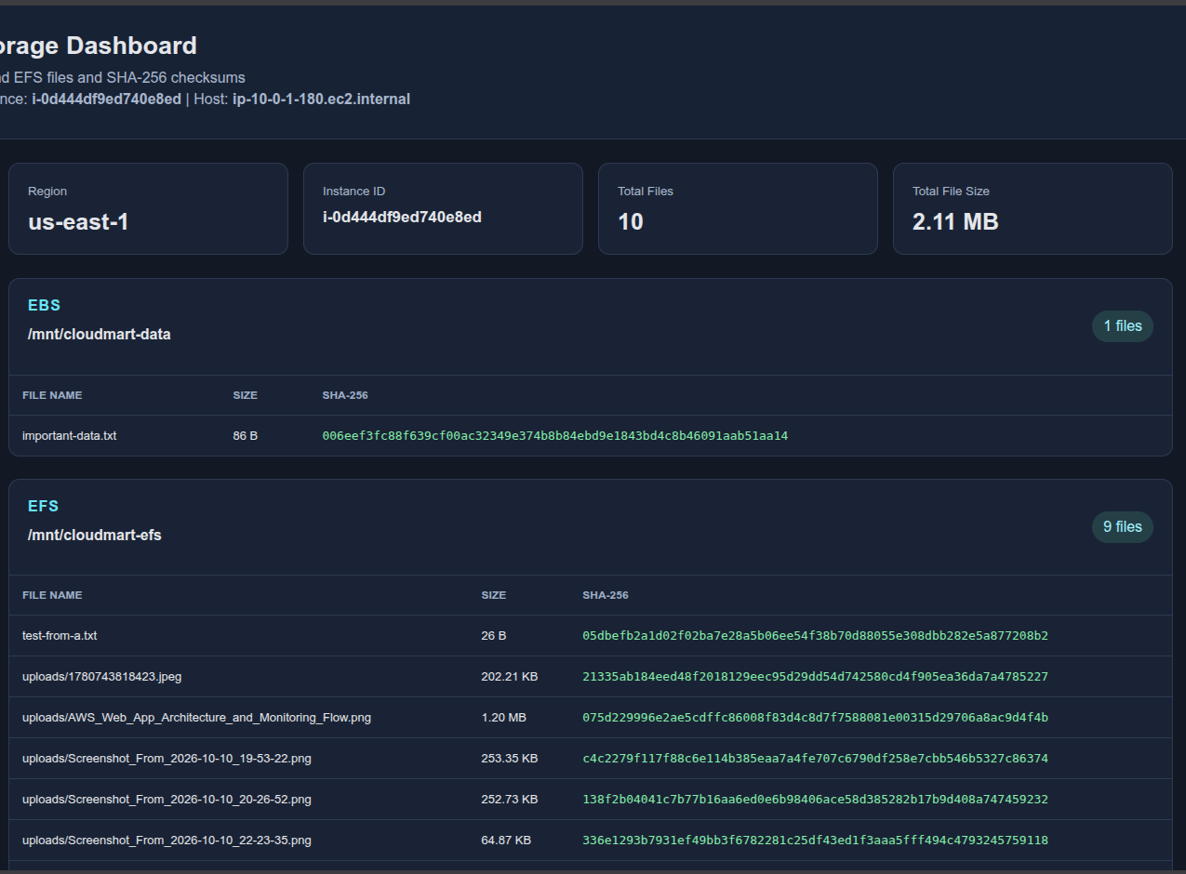
Figure 8: Dashboard of the Virginia instance: region, instance ID, EBS file and EFS files with their SHA-256 checksums

3. AWS Backup Configuration
AWS Backup protects the EC2 instance, the EBS volume and the EFS file system. Backups are stored in a vault in the source Region, and a copy is sent to a vault in the recovery Region.
Naming: the task brief used the names academy-backup-plan, daily-backup-rule and academy-backup-vault. In the console the resources were created with the names below (cloudmart-...), so this document uses the names that were verified in the console.

3.1 Backup vaults
Vault | Region | Purpose
cloudmart-primary-vault | us-east-1 (Virginia) | Primary backups of the source resources
cloudmart-dr-vault | eu-west-2 (London) | Copies of the recovery points for disaster recovery

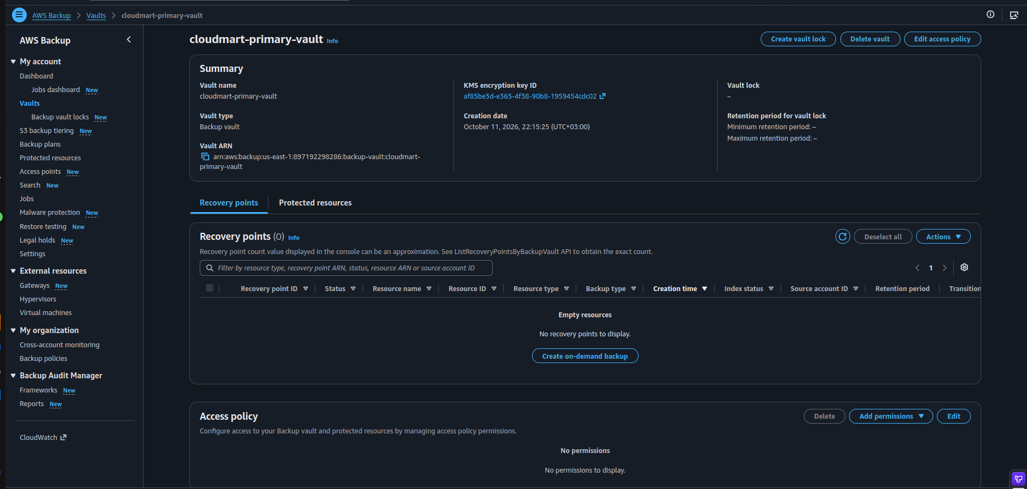
Figure 9: AWS Backup > Vaults: cloudmart-primary-vault in us-east-1 (no recovery points yet)
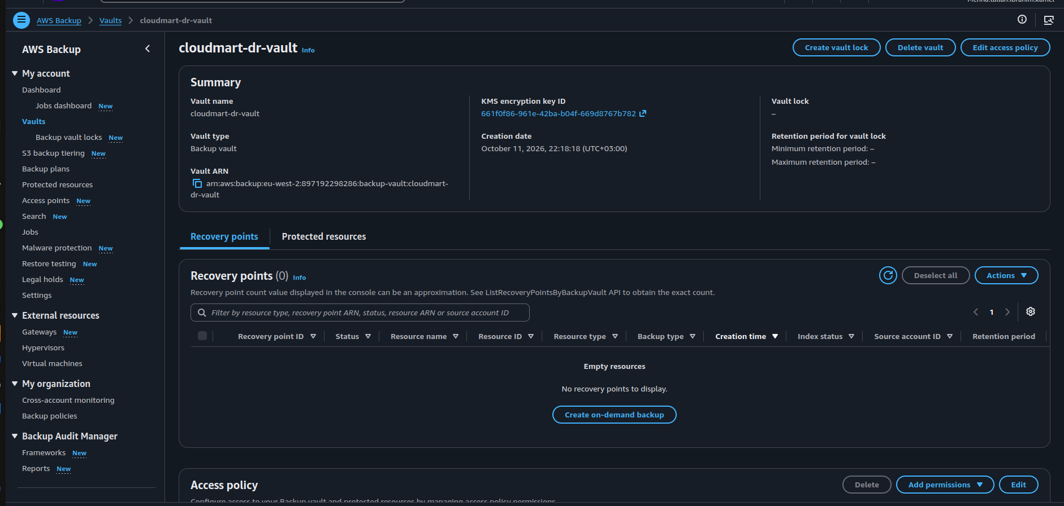
Figure 10: AWS Backup > Vaults: cloudmart-dr-vault in Europe (London)

3.2 Backup plan and rule
Setting | Value
Backup plan | cloudmart-daily-backup-plan (built as a new plan)
Backup rule | cloudmart-daily-rule
Backup vault | cloudmart-primary-vault
Frequency | Daily
Retention period | 7 days
Copy to destination | Europe (London), vault cloudmart-dr-vault, same retention settings as the rule
Plan tag | Project = CloudMart-Backup-DR

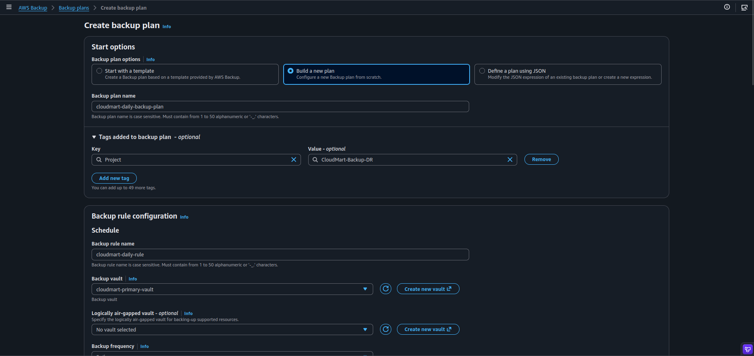
Figure 11: Create backup plan: plan name, tag and the rule name cloudmart-daily-rule
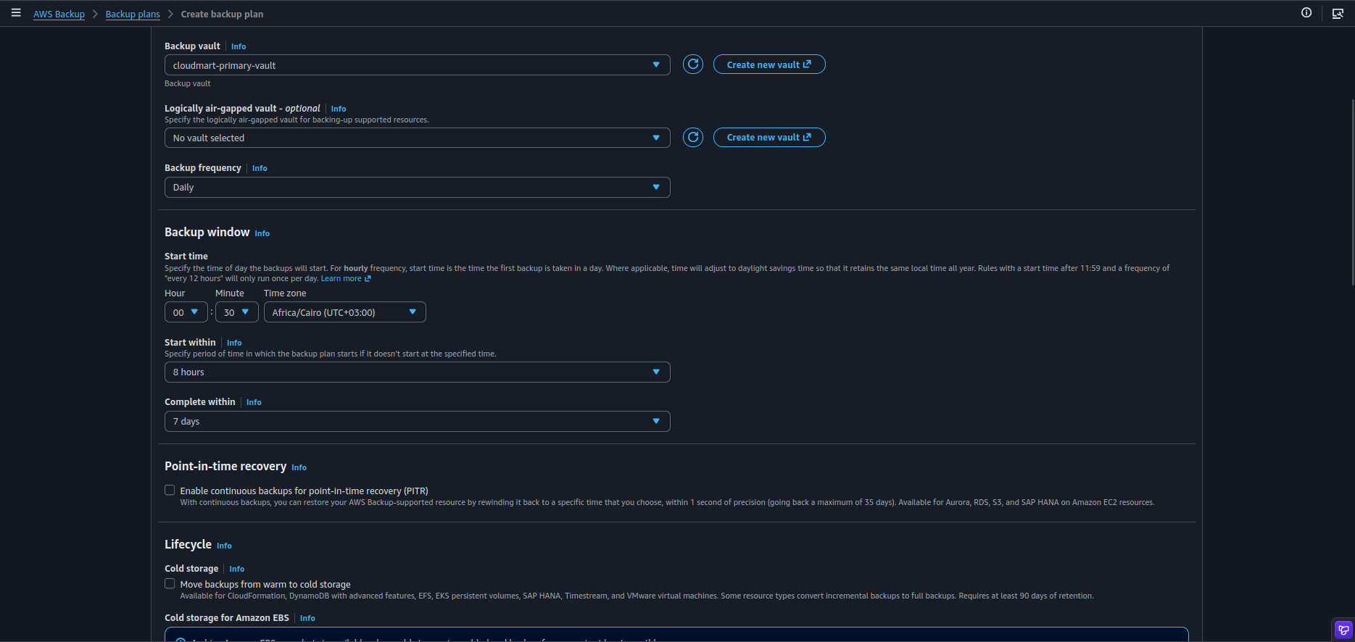
Figure 12: Backup rule: vault cloudmart-primary-vault, daily frequency and backup window
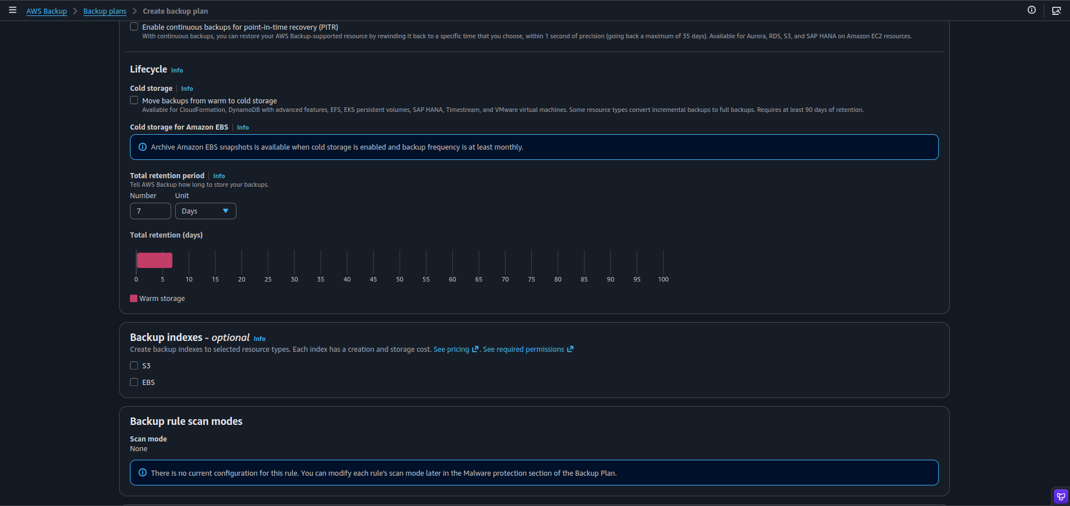
Figure 13: Lifecycle: total retention period of 7 days
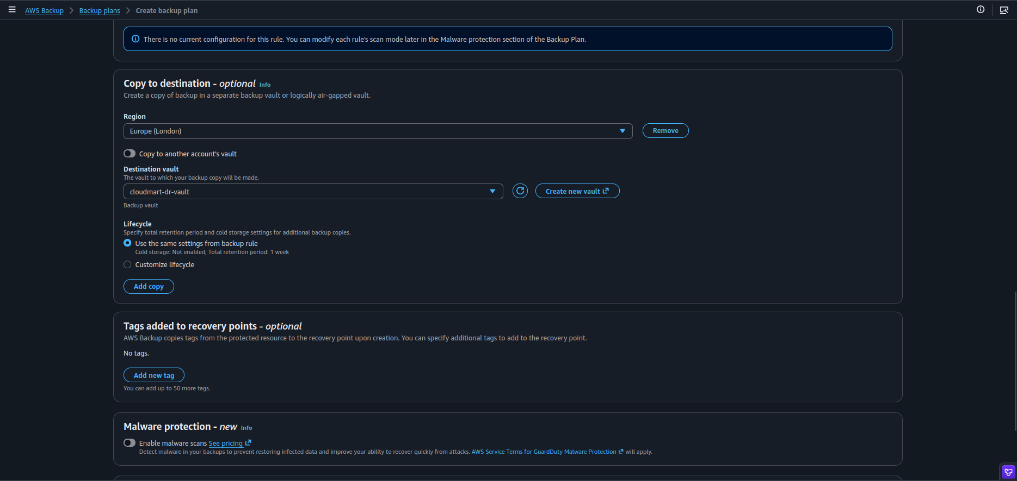
Figure 14: Copy to destination: Europe (London) and the vault cloudmart-dr-vault

3.3 Resource assignment
The EC2 instance was assigned to the plan with the resource assignment cloudmart-ec2-assignment, using the default AWS Backup role (no IAM policies were created or modified). The EBS volume and the EFS file system were protected with on-demand backups (see section 3.4).
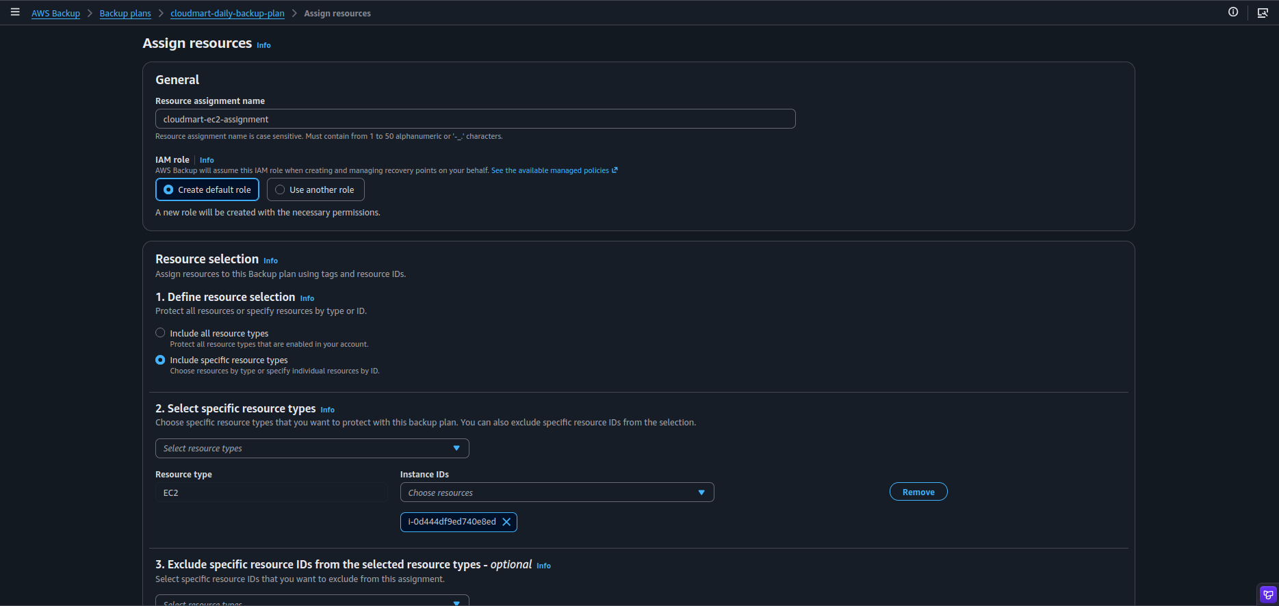
Figure 15: Assign resources: assignment name, IAM role and the resource type EC2
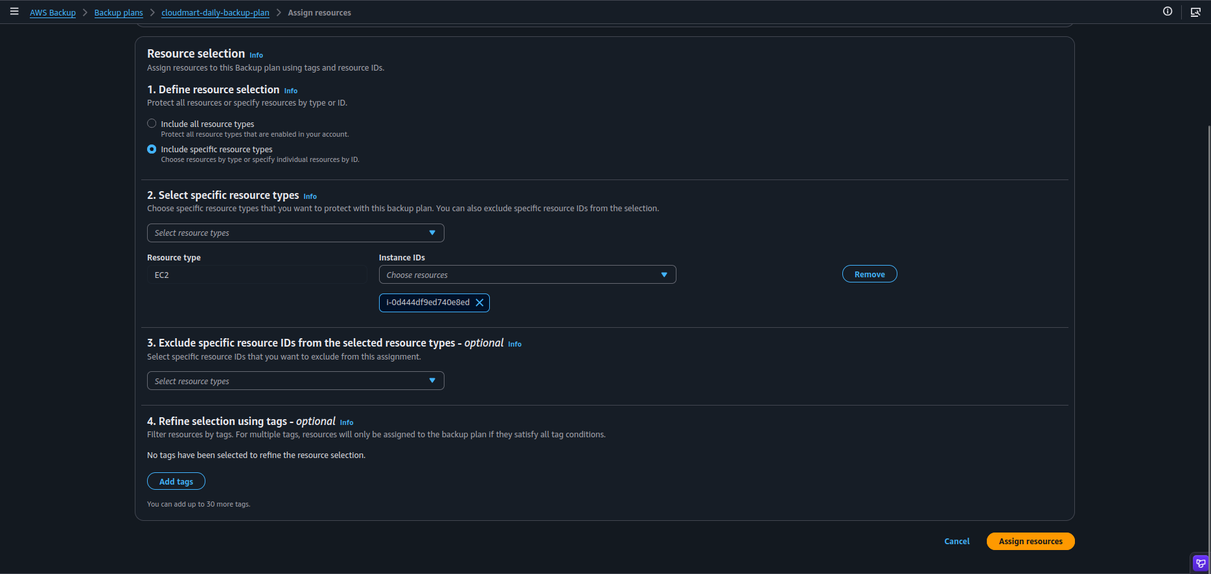
Figure 16: The source instance is selected and the assignment is created with Assign resources

3.4 Backup jobs and recovery points
For each resource the important details are the resource ID, the job status, the recovery point and the destination vault.
Resource | Backup | Status shown in the console
EC2 instance | Image (AMI) recovery point | Completed, 8 GiB, retention 7 days
EBS volume | Snapshot, manual backup of the data volume | Completed in the primary vault
EFS file system | On-demand backup of task4-efs-menna | Completed in the primary vault
Copy to London | EC2 image, EBS snapshot and EFS backup | All three recovery points present in cloudmart-dr-vault

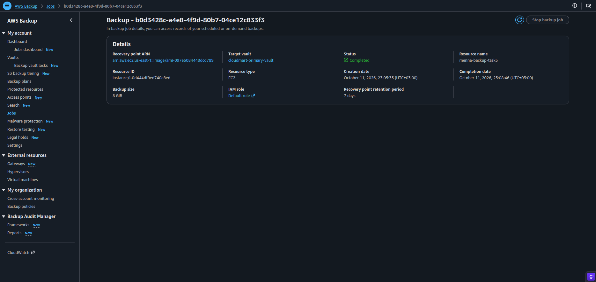
Figure 17: EC2 backup job: status Completed with the recovery point and the primary vault
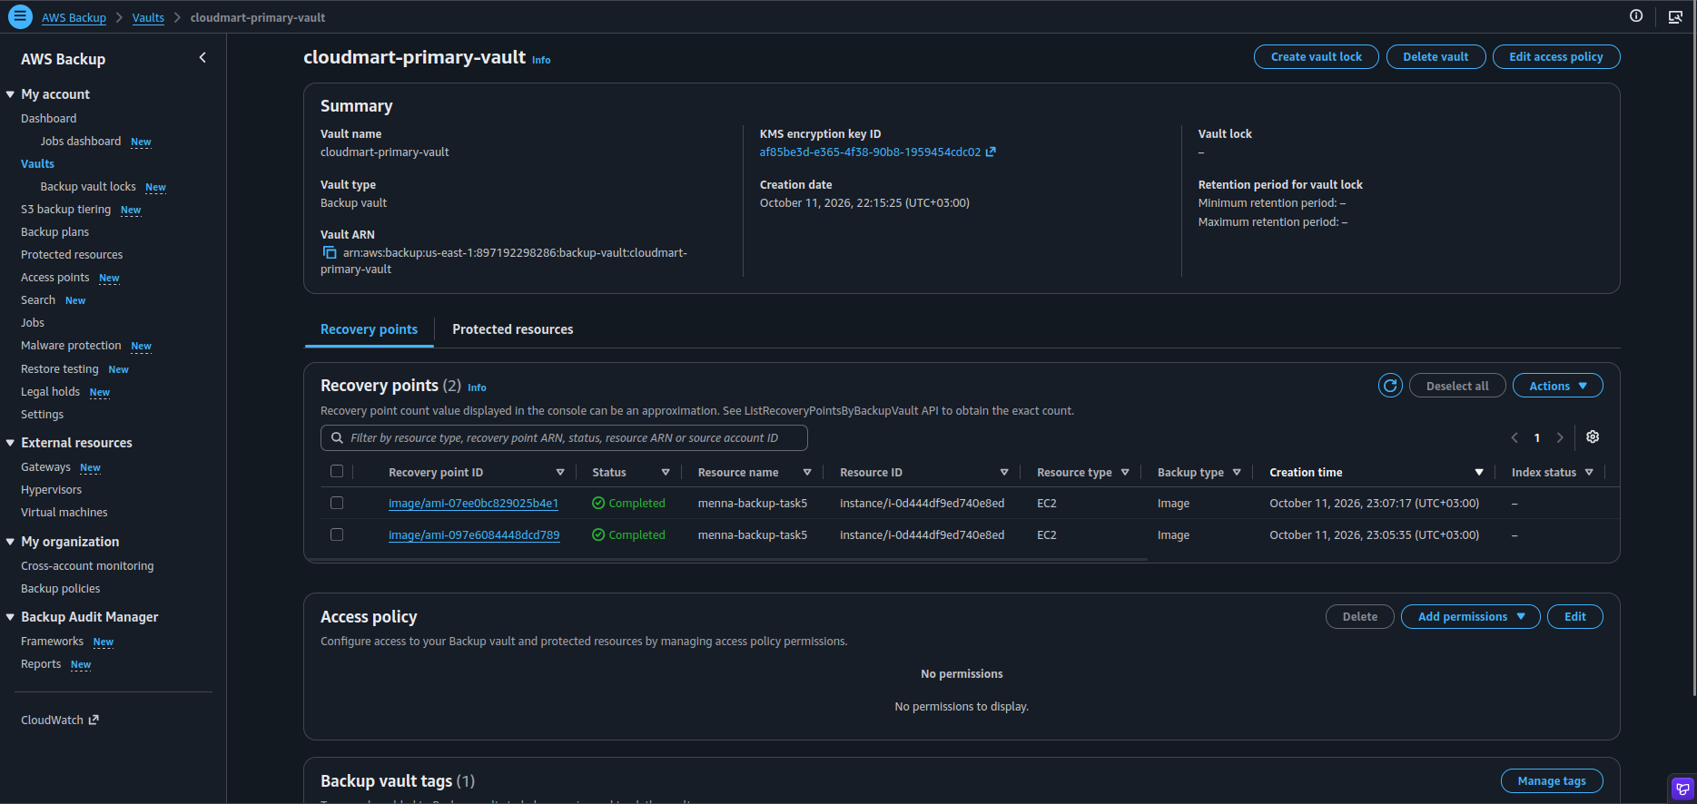
Figure 18: cloudmart-primary-vault: EC2 recovery points (Completed)
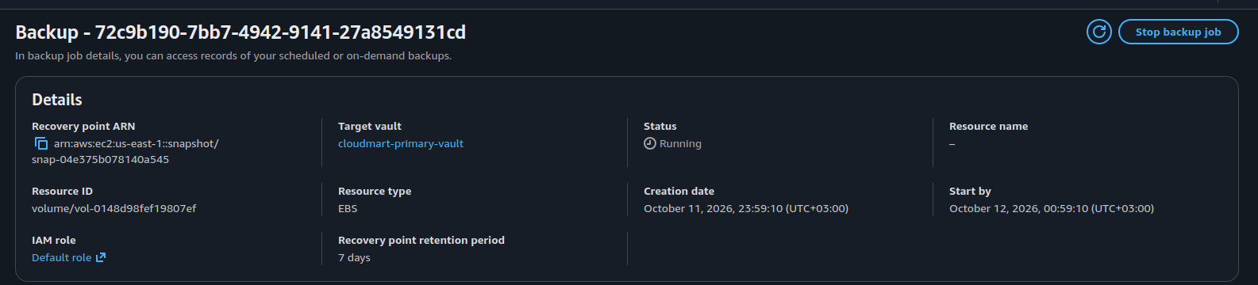
Figure 19: EBS backup job in progress for the data volume
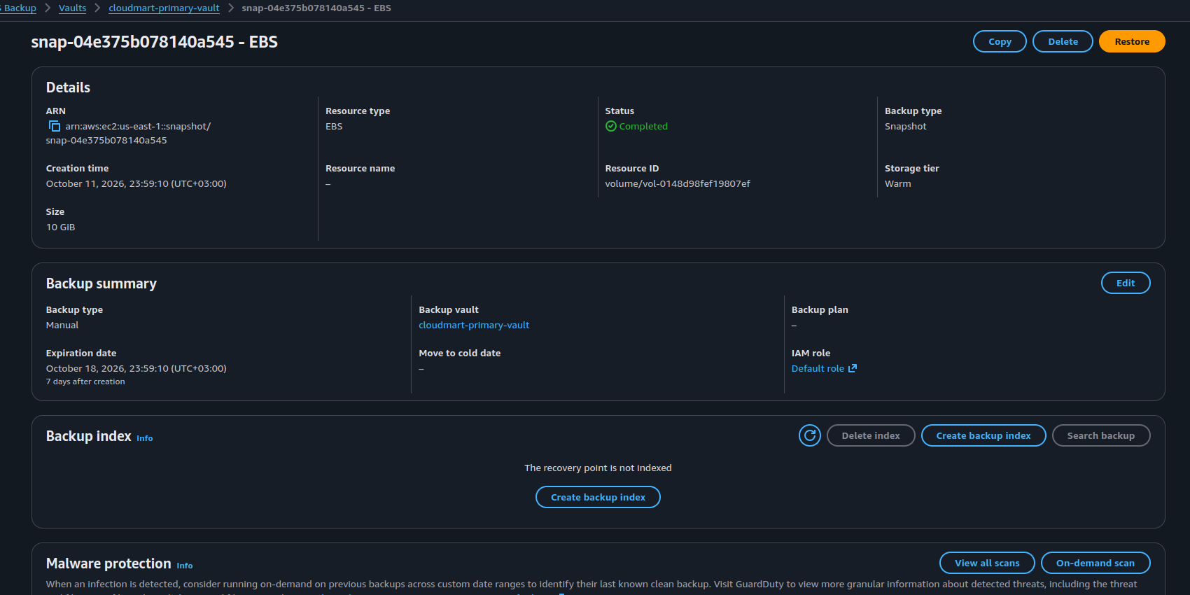
Figure 20: EBS snapshot recovery point: status Completed, storage tier Warm
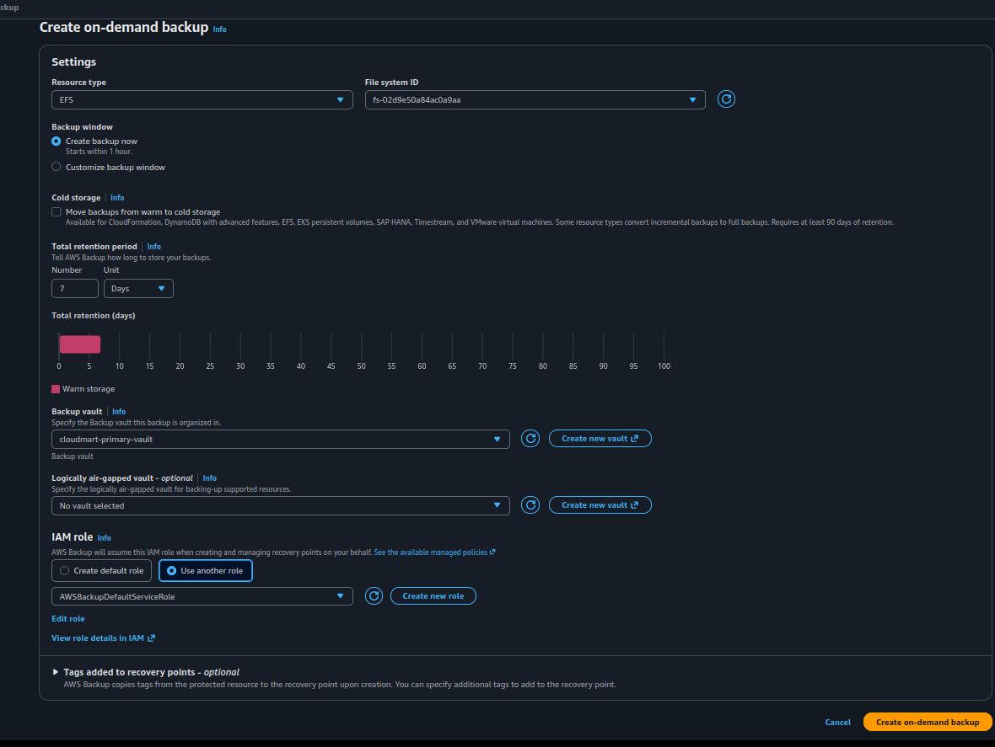
Figure 21: On-demand backup of the EFS file system with the AWS Backup role and 7-day retention
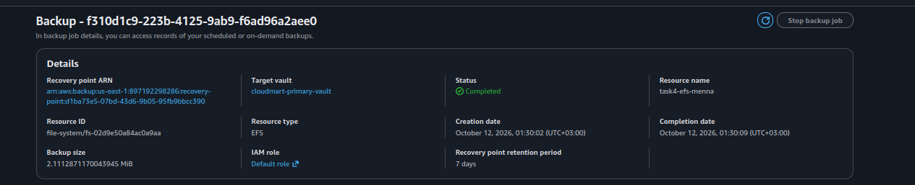
Figure 22: EFS backup job: status Completed
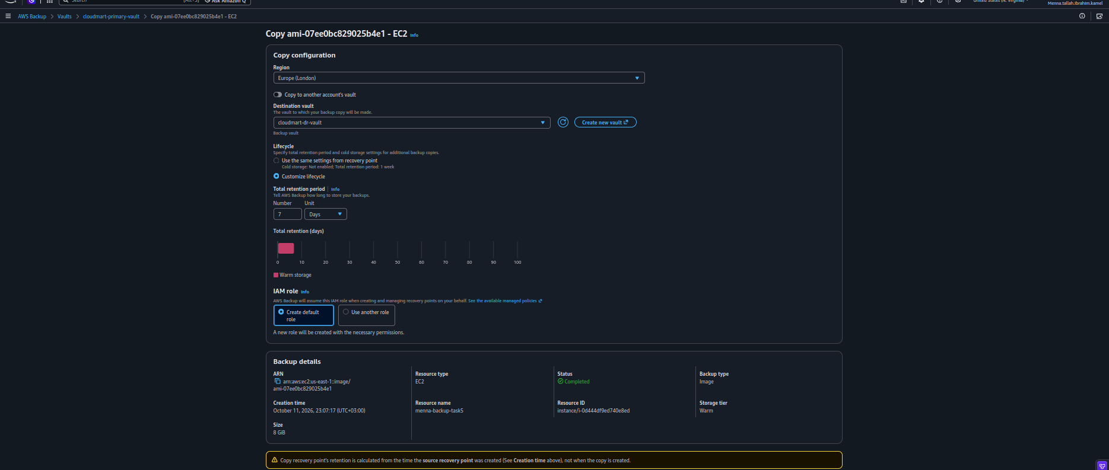
Figure 23: Copy of the EC2 recovery point to the London Region (copy configuration)
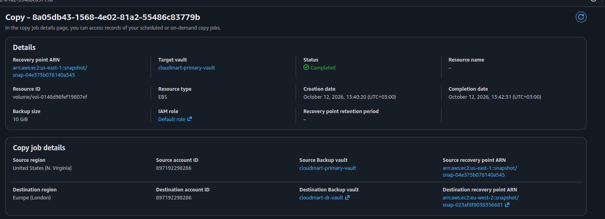
Figure 24: Copy job of the EBS snapshot to cloudmart-dr-vault: status Completed
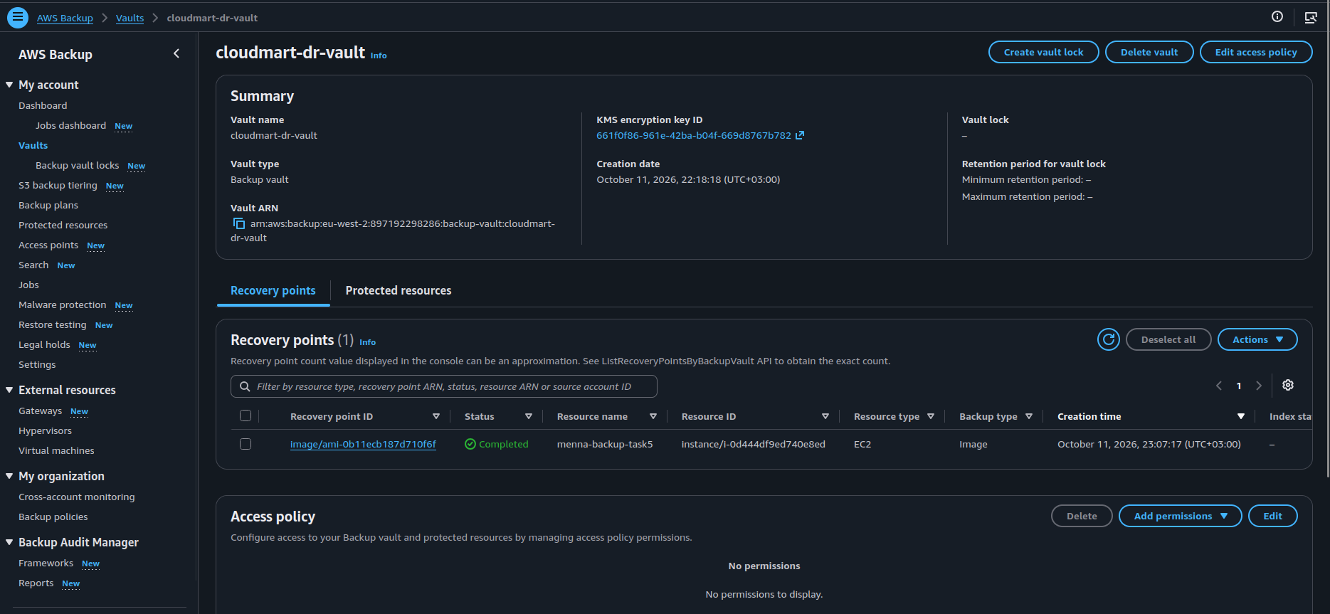
Figure 25: cloudmart-dr-vault: the EC2 recovery point copied to London
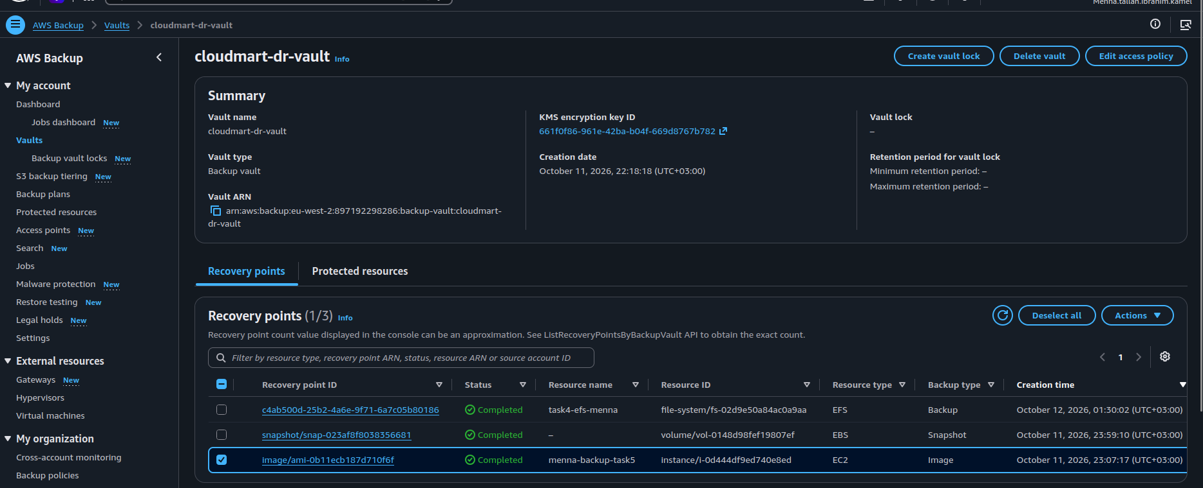
Figure 26: cloudmart-dr-vault: EFS backup, EBS snapshot and EC2 image recovery points (Completed)
Scope: these screenshots cover EC2, EBS and EFS. S3 recovery points are not part of the captured evidence and should be checked separately in the AWS Backup console.

4. Recovery Environment in London

4.1 Recovery EC2 instance
Property | Value
Region | eu-west-2
Instance name | menna-restore-key-access
Instance ID | i-00a5063f2f5db154c
Private IP | 10.0.1.113
Security group | sg-0f87fca347d966402
IAM role | menna-restore-ssm-role

The London instance is kept separate from the Virginia instance. This allows me to inspect the recovered storage without depending on the source instance for the dashboard. The recovery VPC is menna-restore.
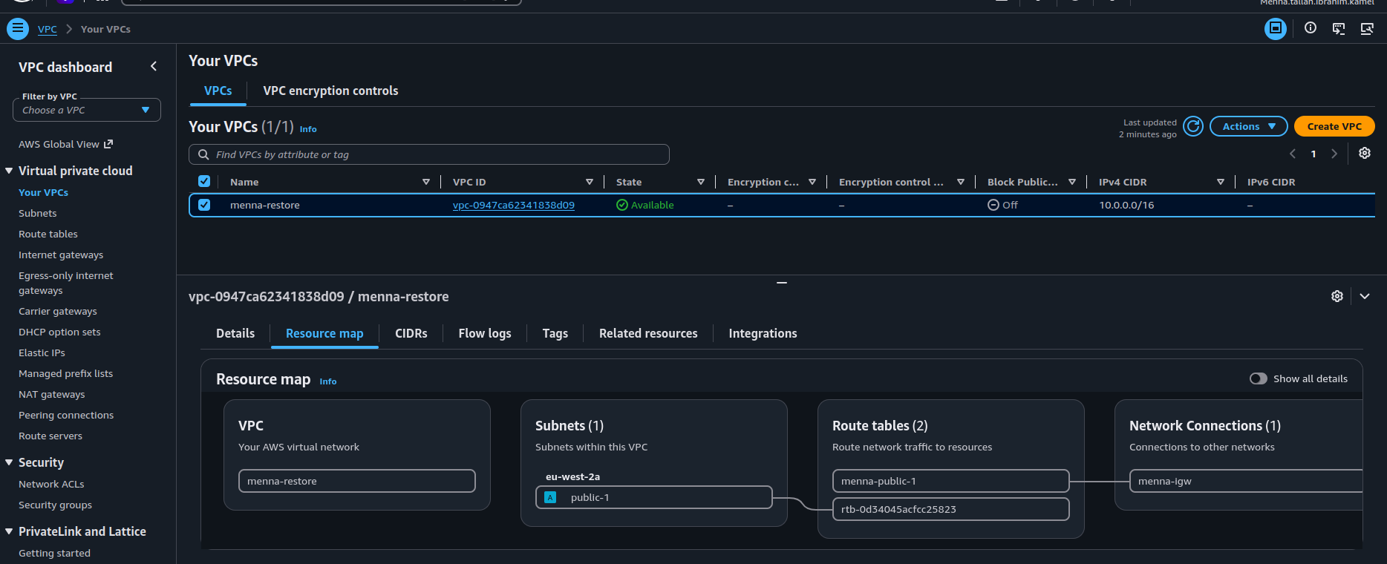
Figure 27: London VPC menna-restore: subnet, route tables and internet gateway
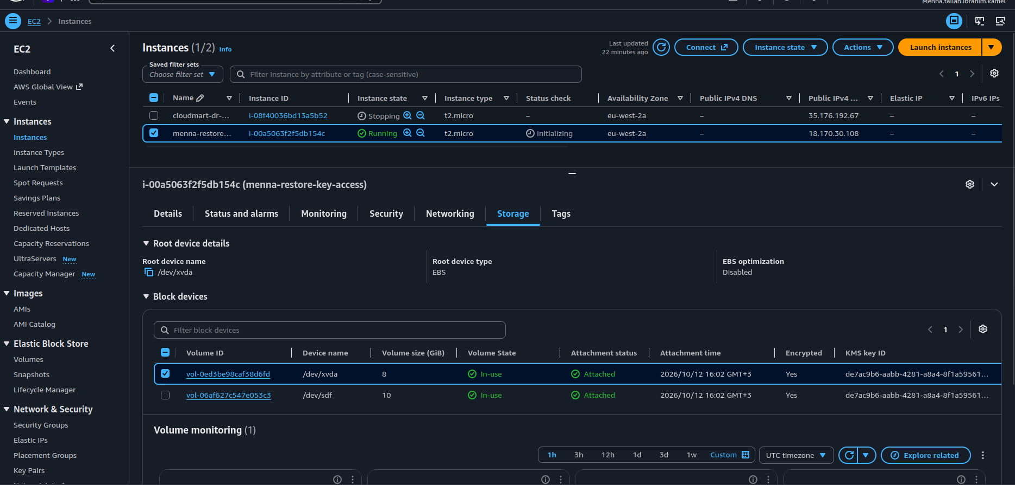
Figure 28: London recovery instance menna-restore-key-access with its root and data volumes

4.2 Verify the London storage
On the London instance I ran df -hT. The output confirmed the three storage locations:
/dev/xvda1 xfs 8.0G ... /
/dev/xvdf xfs 10G ... /mnt/cloudmart-data
127.0.0.1:/ nfs4 8.0E ... /mnt/cloudmart-efs

- The root filesystem is mounted.
- The separate EBS data volume is mounted at /mnt/cloudmart-data.
- The EFS file system is mounted at /mnt/cloudmart-efs. The entry 127.0.0.1:/ is normal when the EFS mount helper uses its local TLS proxy.

4.3 Restore test of the EC2 recovery point
To validate the EC2 recovery point I restored it into a new instance. The restore job completed and created a new instance with a new instance ID. On the restored instance the test files and the Apache service were present.
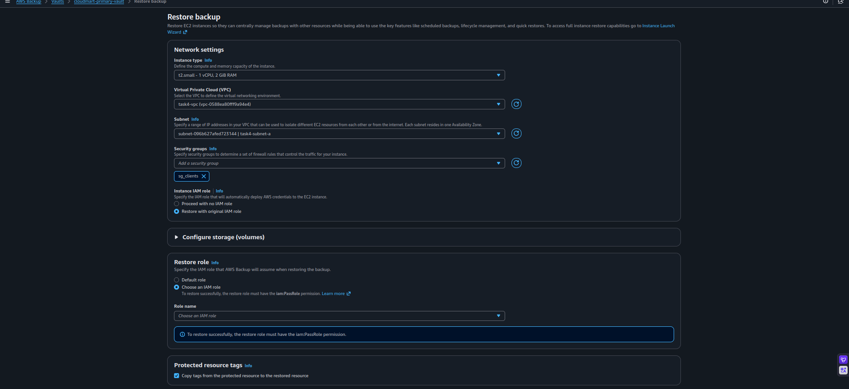
Figure 29: Restore backup: network settings for the new instance (instance type, VPC, subnet and security group)
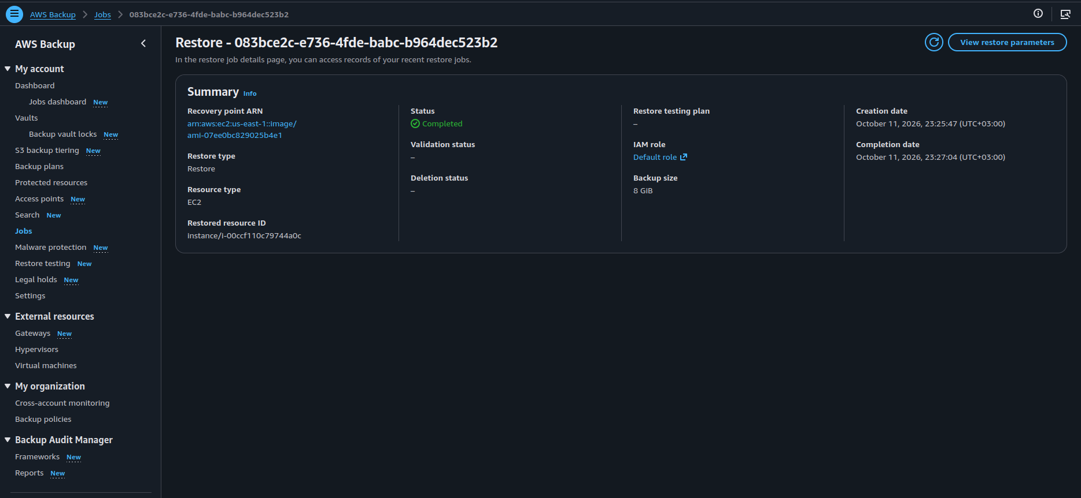
Figure 30: Restore job: status Completed with the restored resource ID
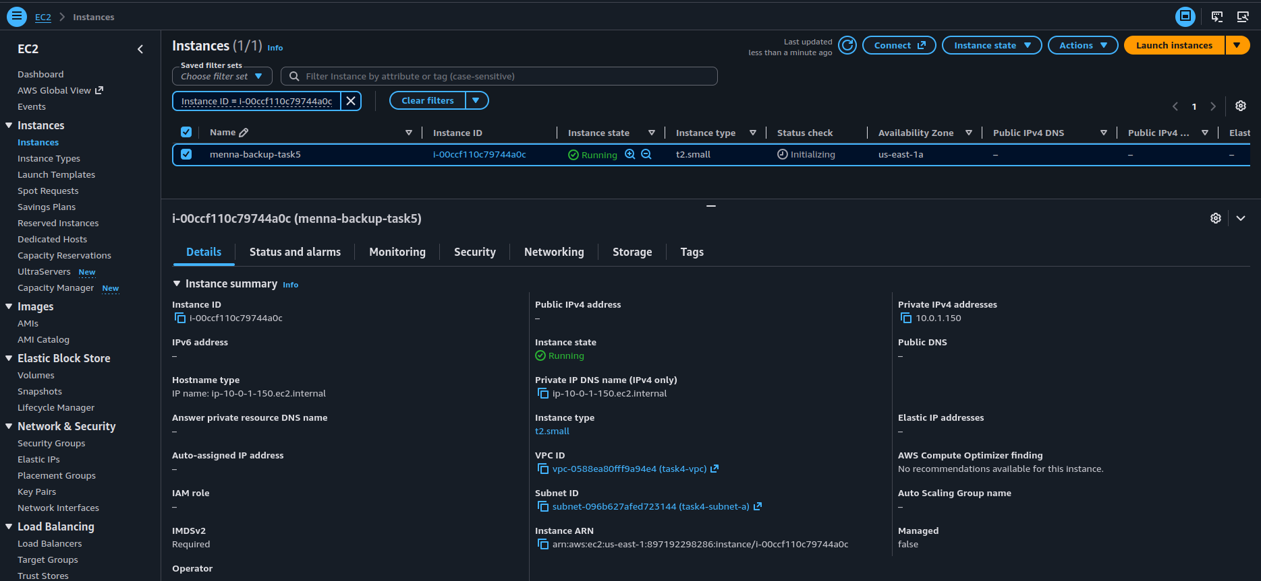
Figure 31: The restored EC2 instance is running (new instance ID, private IP 10.0.1.150)
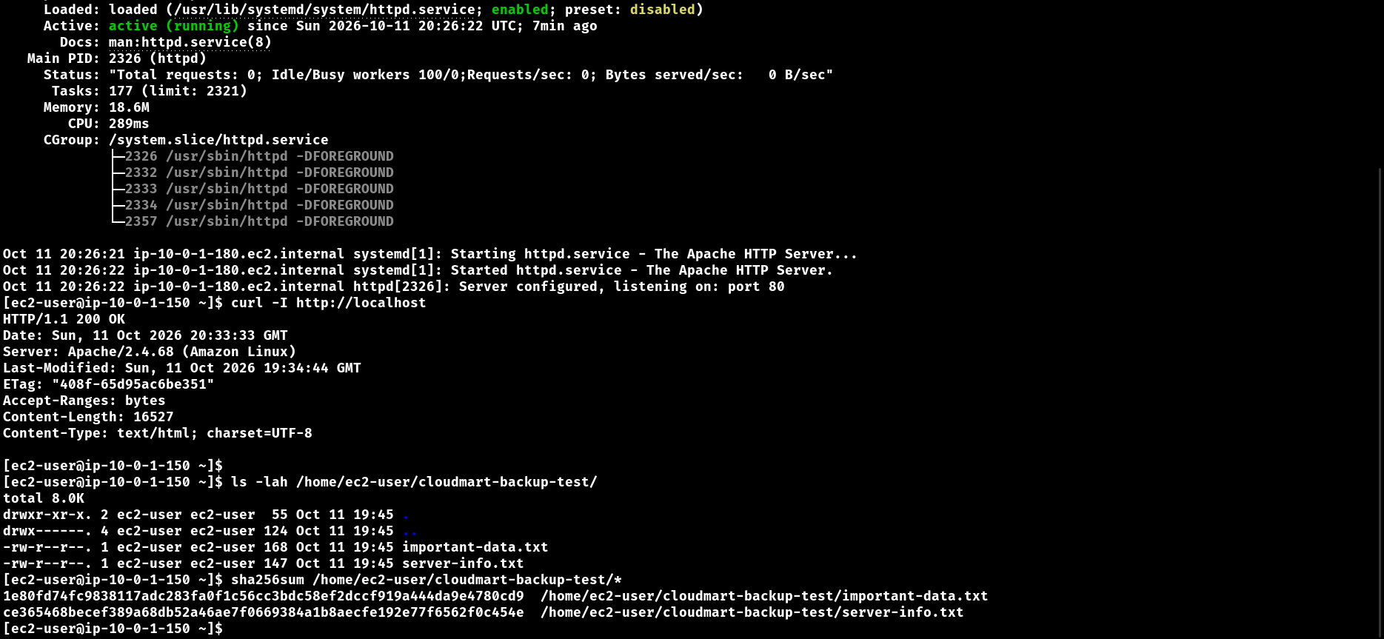
Figure 32: Restored instance: Apache is running, curl returns HTTP 200 and the test file checksums are listed
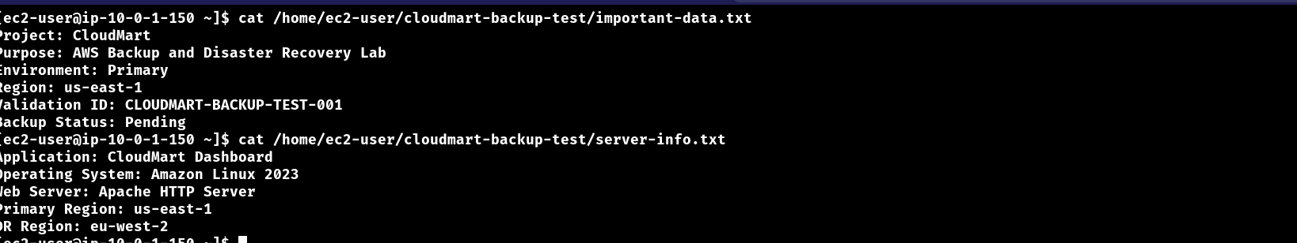
Figure 33: Restored instance: the contents of important-data.txt and server-info.txt

4.4 Cross-Region EC2 restore: KMS error
A restore of the EC2 recovery point into the London Region was also attempted. AWS Backup reported the job as failed with a KMS key error:
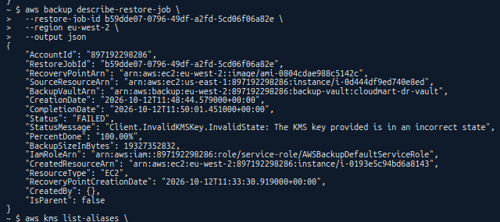
Figure 34: aws backup describe-restore-job (eu-west-2): Status FAILED, Client.InvalidKMSKey.InvalidState
Troubleshooting: the error means that the KMS key used for the restored volumes was in an incorrect state. Check the state and the permissions of the KMS key selected for the restore (the AWS-managed or customer key in eu-west-2) and retry. In this lab the recovery instance in London is the separate instance menna-restore-key-access, which is the environment used for the EBS and EFS validation below.

5. Restore and Mount EBS
The EBS data volume was recovered from the snapshot recovery point and attached to an instance in the recovery environment. The London instance has a separate 10 GiB XFS data volume mounted at /mnt/cloudmart-data.
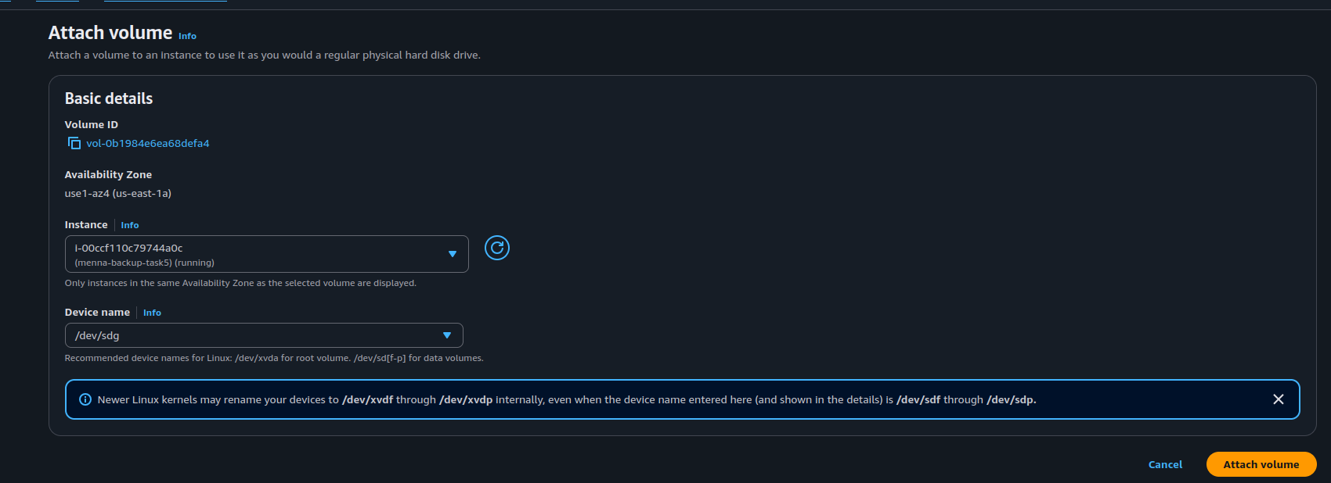
Figure 35: Attach volume: the restored volume is attached to the recovery instance
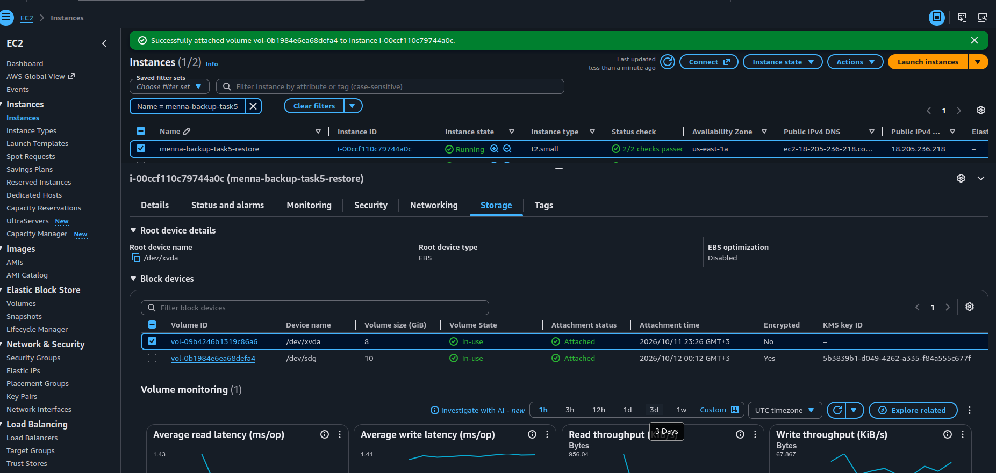
Figure 36: Recovery instance storage: the restored 10 GiB data volume is In-use and Attached
I mounted the recovered volume read-only to inspect it without changing it, and listed its files:
sudo mkdir -p /mnt/restore-check
sudo file -s /dev/xvdg # SGI XFS filesystem data
sudo mount -o ro /dev/xvdg /mnt/restore-check
findmnt /mnt/restore-check
sudo find /mnt/cloudmart-data -type f
# /mnt/cloudmart-data/important-data.txt

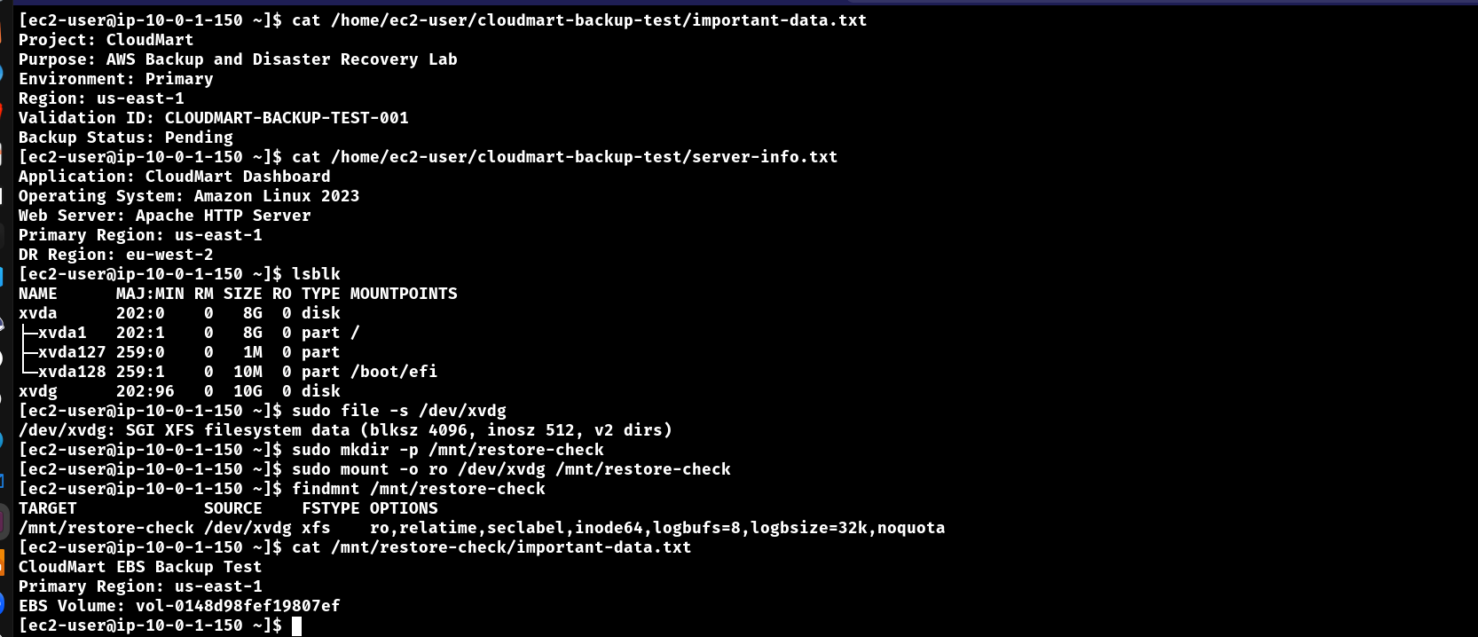
Figure 37: Recovery instance: lsblk, file -s, read-only mount of the restored volume and its contents

5.1 Validate EBS data integrity
I calculated the SHA-256 checksum of the recovered file:
sudo sha256sum /mnt/cloudmart-data/important-data.txt

006eef3fc88f639cf00ac32349e374b8b84ebd9e1843bd4c8b46091aab51aa14

Figure 38: SHA-256 checksum of important-data.txt on the recovered volume
Environment | SHA-256 of important-data.txt
Virginia (source) | 006eef3fc88f639cf00ac32349e374b8b84ebd9e1843bd4c8b46091aab51aa14
Recovery | 006eef3fc88f639cf00ac32349e374b8b84ebd9e1843bd4c8b46091aab51aa14
Result | MATCH

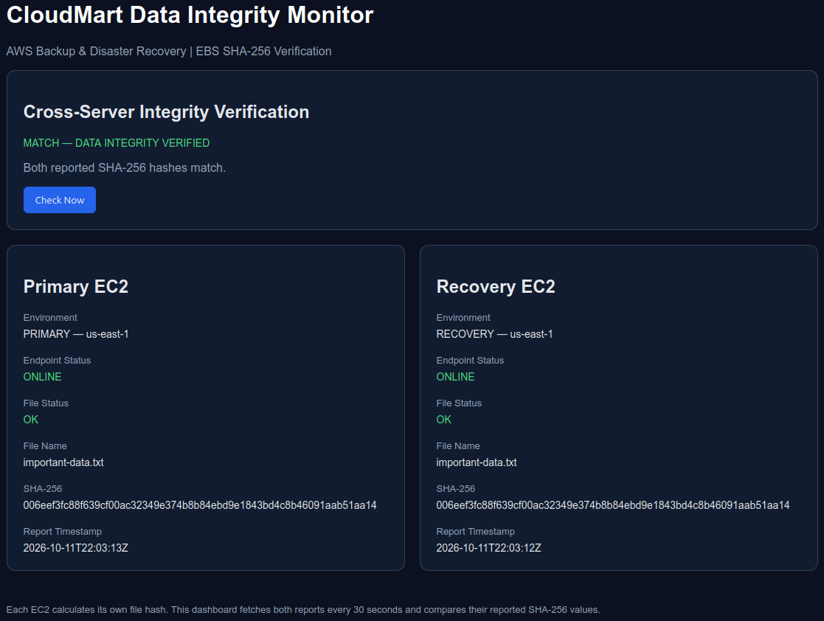
Figure 39: CloudMart Data Integrity Monitor: both servers report the same SHA-256 (MATCH, data integrity verified)
Result: the SHA-256 checksum of important-data.txt matched between the source and recovery environments. This confirms that the contents of this particular file were identical. It does not, by itself, prove that every file or every resource was recovered correctly.

6. Restore and Mount EFS in London

6.1 Restore the EFS recovery point
The EFS recovery point was restored from cloudmart-dr-vault into a new file system in London. The restore job first shows Pending and then Completed, with the restored resource ID.
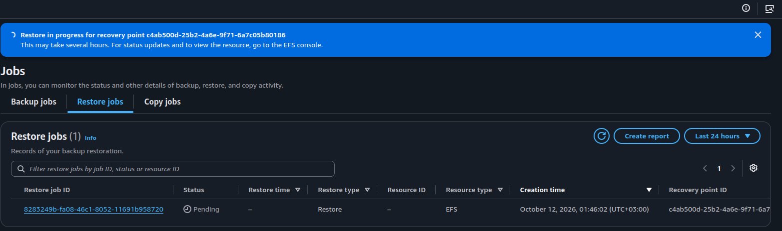
Figure 40: AWS Backup > Restore jobs: restore of the EFS recovery point is in progress (Pending)
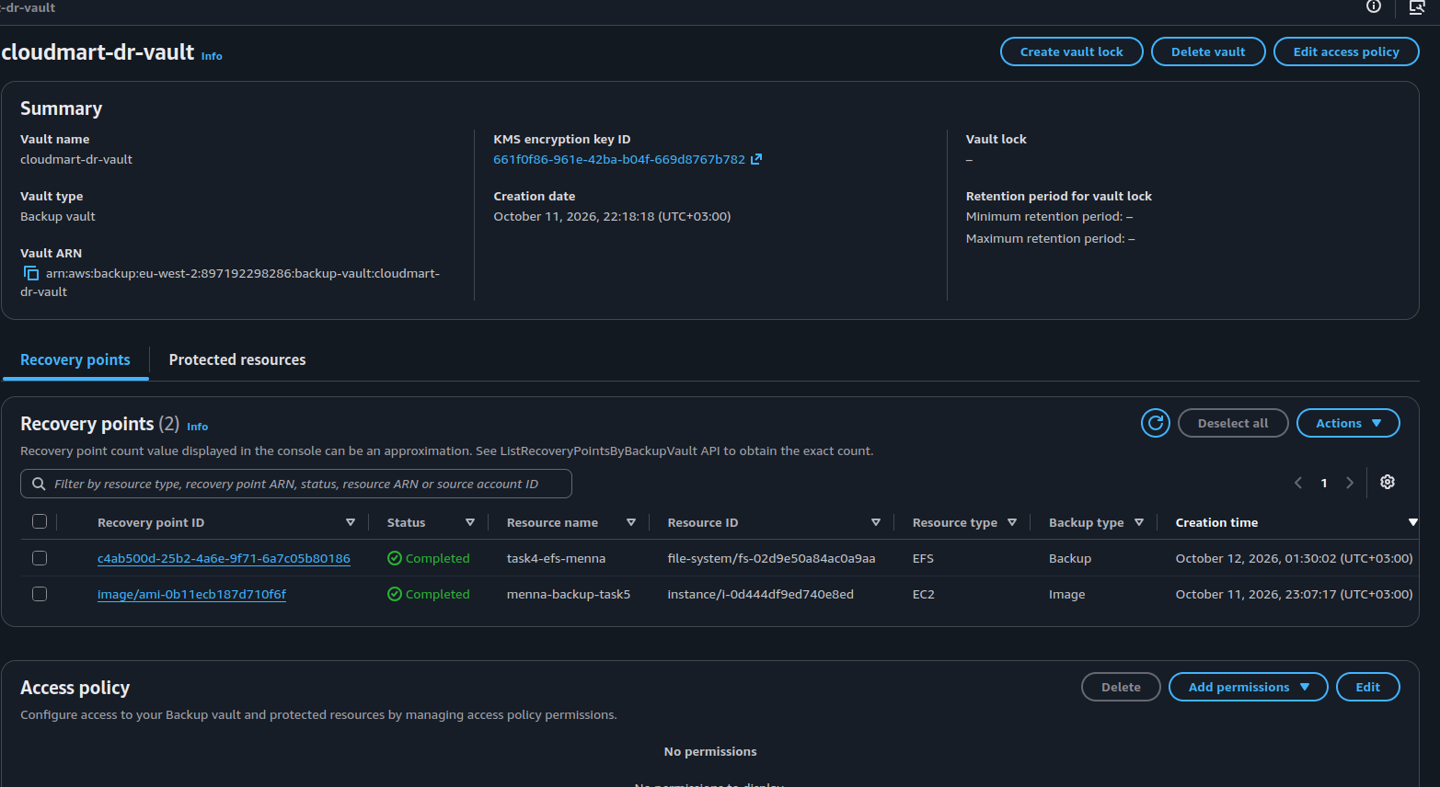
Figure 41: cloudmart-dr-vault: the EFS recovery point used for the restore
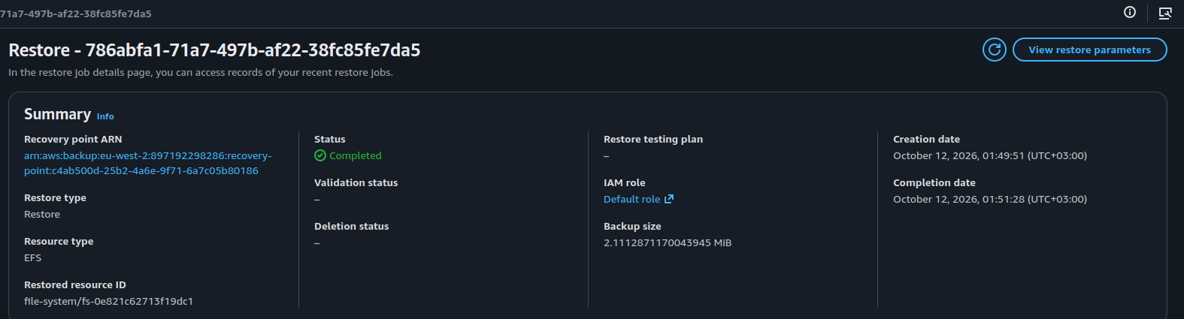
Figure 42: Restore job: status Completed and the restored EFS file system ID
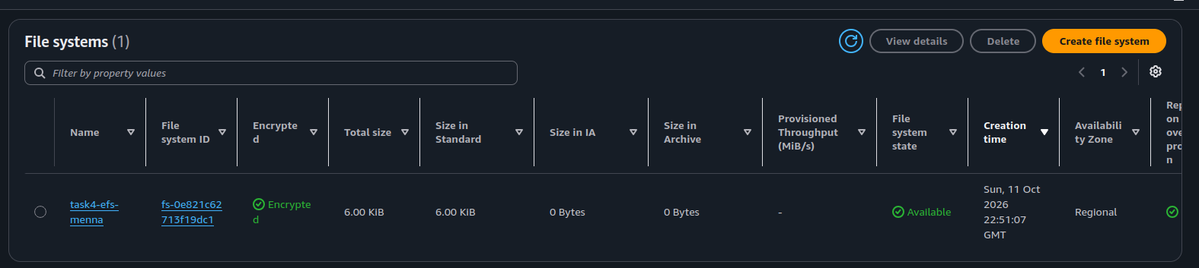
Figure 43: Amazon EFS in London: the restored file system is Available and encrypted

6.2 Recovered EFS configuration
Property | Value
Region | eu-west-2
EFS ID | fs-0e821c62713f19dc1
Mount target IP | 10.0.1.201
Mount target ID | fsmt-09b811fa151ddedfb
Mount target security group | sg-0f297f268b0f14c07
Mount point | /mnt/cloudmart-efs

6.3 EFS security group access
The EFS mount-target security group must allow NFS traffic from the London EC2 security group:
Setting | Value
Type | NFS
Protocol | TCP
Port | 2049
Source | sg-0f87fca347d966402

6.4 Mount the recovered EFS
sudo mkdir -p /mnt/cloudmart-efs

sudo mount -t efs \
-o tls,mounttargetip=10.0.1.201 \
fs-0e821c62713f19dc1:/ \
/mnt/cloudmart-efs

df -hT

6.5 Inspect the recovered files
The recovered files include the same nine files as the source EFS. AWS Backup restores them beneath a restore directory similar to aws-backup-restore_2026-10-11T22-51-28-425947719Z/, and a aws-backup-lost+found_... directory also appears.
sudo find /mnt/cloudmart-efs -type f

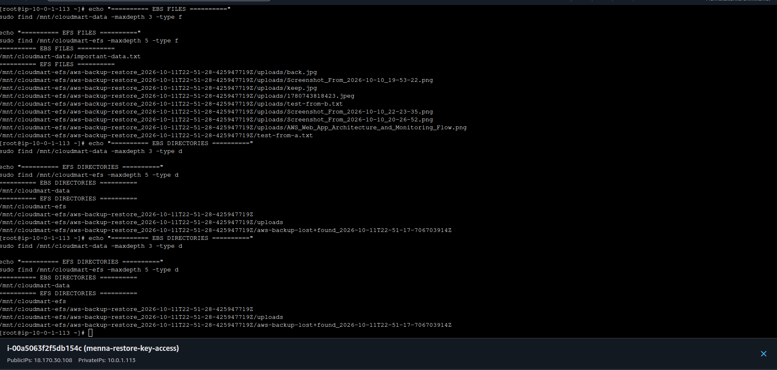
Figure 44: London instance: files on EBS and EFS and the aws-backup-restore directory structure
Important: the restore directory prefix is generated during the restore, so its name should not be hard-coded into future scripts.

7. London Storage Dashboard

7.1 Requirements
After verifying the recovered storage I created a simple web dashboard on the London EC2 instance. It displays only the information available on that instance and does not communicate with Virginia.
- Display the AWS Region, the EC2 instance ID and the hostname.
- List the files found on the EBS volume and on the EFS file system.
- Show the size of each file and calculate its SHA-256 checksum.
- Display the total number of files and their combined size.
- Refresh the webpage automatically.

7.2 Install and start Apache
sudo systemctl enable --now httpd
sudo systemctl status httpd --no-pager

Apache serves the dashboard from /var/www/html/index.html.

7.3 Python dashboard script
The script is /usr/local/bin/storage-dashboard.py. It uses only the Python standard library: hashlib (SHA-256), pathlib (files), html (escaping), socket (hostname) and datetime (generation time). It inspects two storage locations and uses the instance information below:
STORAGES = {
"EBS": "/mnt/cloudmart-data",
"EFS": "/mnt/cloudmart-efs",
}

REGION = "eu-west-2"
INSTANCE_ID = "i-00a5063f2f5db154c"

For every file the script gets the path relative to the mount point, reads the file in binary mode, calculates the SHA-256 checksum, gets the size, and adds the result to the HTML table, which is written to /var/www/html/index.html.
sudo chmod +x /usr/local/bin/storage-dashboard.py
sudo /usr/bin/python3 /usr/local/bin/storage-dashboard.py
sudo ls -lh /var/www/html/index.html

To confirm that the page contains the title and the expected files:
sudo grep -E \
'London Storage Dashboard|important-data.txt|test-from-a.txt|back.jpg' \
/var/www/html/index.html

The output included the page title, important-data.txt from EBS and the EFS files test-from-a.txt and uploads/back.jpg (shown with the restore-directory prefix), which confirms that the page lists files from both storage locations.

7.4 Automatic updates with systemd
A systemd service regenerates the dashboard every 30 seconds. The service file is /etc/systemd/system/storage-dashboard.service:
[Unit]
Description=London Storage Dashboard

[Service]
Type=simple
ExecStart=/bin/bash -c 'while true; do \
/usr/bin/python3 /usr/local/bin/storage-dashboard.py; \
sleep 30; done'
Restart=always
RestartSec=5

[Install]
WantedBy=multi-user.target

sudo systemctl daemon-reload
sudo systemctl enable --now storage-dashboard
sudo systemctl status storage-dashboard --no-pager

The webpage also uses a 30-second HTML refresh interval, so the browser reloads the generated page periodically.
Note: the dashboard is a lightweight lab implementation. It scans files and calculates checksums repeatedly, so a production implementation would normally use a more efficient update strategy for large storage volumes.

8. Validate the Dashboard

8.1 Test Apache locally
curl -I http://localhost

HTTP/1.1 200 OK
Server: Apache/2.4.68 (Amazon Linux)
Content-Type: text/html; charset=UTF-8

8.2 Open the dashboard through the public DNS
The dashboard was opened through the public DNS name of the London EC2 instance rather than through localhost:
http://ec2-18-170-30-108.eu-west-2.compute.amazonaws.com/

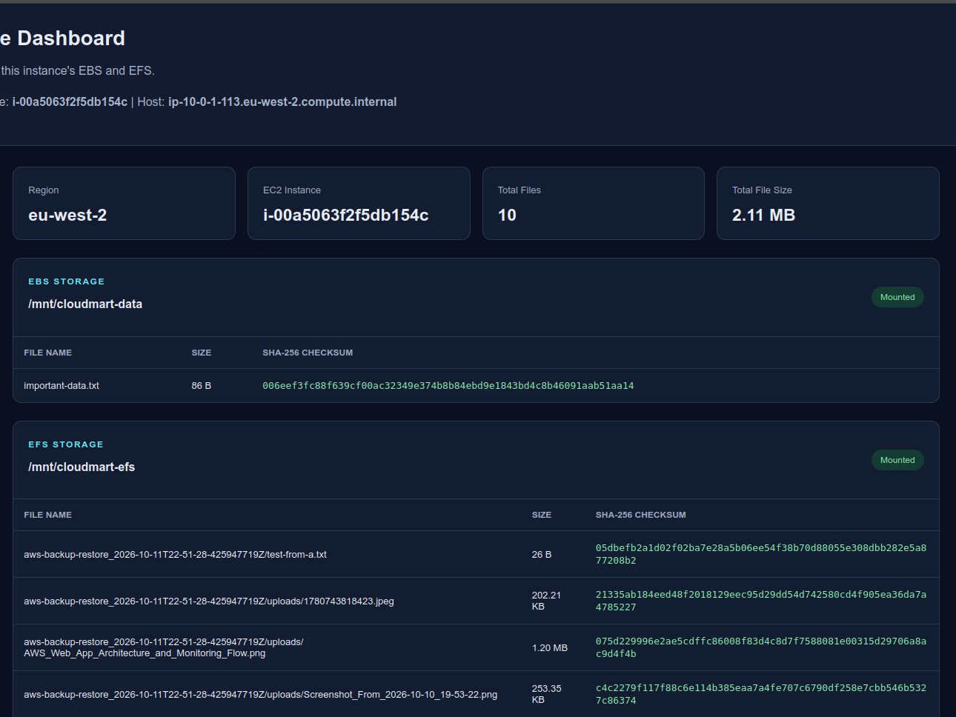
Figure 45: London Storage Dashboard: region, instance, total files and size, EBS and EFS files with SHA-256
Check the address: always check the public DNS name in the EC2 console, because it can change if the instance receives a different public IPv4 address. For external access the EC2 security group must allow HTTP on TCP port 80 and the instance must have public network routing.

9. Final Results
Component | Result
Virginia source EC2 | Identified and accessed
Virginia EBS | Mounted at /mnt/cloudmart-data
Virginia EFS | Mounted at /mnt/cloudmart-efs; NFS port 2049 reachable
AWS Backup | Plan with daily rule, 7-day retention and a copy to London; EC2, EBS and EFS recovery points Completed
London recovery EC2 | Identified and accessed
London EBS | Mounted at /mnt/cloudmart-data
London EFS | Restored and mounted at /mnt/cloudmart-efs
EBS file integrity | SHA-256 matched for important-data.txt
Apache | Served the dashboard successfully
Dashboard HTML | Generated at /var/www/html/index.html
systemd service | Configured for automatic updates
Local HTTP test | Returned HTTP/1.1 200 OK
Public DNS access | Dashboard opened using the London public DNS
Cross-Region EC2 restore | Failed with a KMS key state error (see section 4.4)

10. Conclusion
In this project I worked with AWS backup and recovery concepts across the Virginia and London Regions. I verified the source EC2 instance, its EBS data volume and its EFS file system, configured AWS Backup with a daily rule, a 7-day retention and a copy to a DR vault in London, and then worked with the separate recovery environment: I mounted the recovered storage, inspected the recovered files and validated the contents of an important EBS file with SHA-256.
Finally, I developed a Python-based storage dashboard hosted by Apache on the London EC2 instance. It displays the local EBS and EFS files, their sizes and SHA-256 checksums and basic instance information. A systemd service regenerates the page automatically, and Apache returned HTTP 200.
Scope note: EC2, EBS and EFS backups, the EBS and EFS restores, the checksum validation of the specified EBS file and the London dashboard are confirmed by the lab outputs. S3 recovery and the cross-Region EC2 restore (KMS error) should be completed and verified in the AWS console before declaring every requirement of the overall assignment complete.

Appendix A: List of Figures
Figure | Description
1 | Source EC2 instance: SSH session and the test files created for the backup (important-data.txt and server-info.txt)
2 | EC2 > Create volume: General Purpose SSD (gp3), 10 GiB, encryption enabled
3 | Volume tags (Project and Environment) before choosing Create volume
4 | Attach volume: the volume is attached to the source instance
5 | Formatting, mounting and verifying the EBS volume, then writing important-data.txt
6 | Source instance storage: root volume and the attached EBS data volumes
7 | findmnt and the SHA-256 checksum of important-data.txt on the source volume
8 | Dashboard of the Virginia instance: region, instance ID, EBS file and EFS files with their SHA-256 checksums
9 | AWS Backup > Vaults: cloudmart-primary-vault in us-east-1 (no recovery points yet)
10 | AWS Backup > Vaults: cloudmart-dr-vault in Europe (London)
11 | Create backup plan: plan name, tag and the rule name cloudmart-daily-rule
12 | Backup rule: vault cloudmart-primary-vault, daily frequency and backup window
13 | Lifecycle: total retention period of 7 days
14 | Copy to destination: Europe (London) and the vault cloudmart-dr-vault
15 | Assign resources: assignment name, IAM role and the resource type EC2
16 | The source instance is selected and the assignment is created with Assign resources
17 | EC2 backup job: status Completed with the recovery point and the primary vault
18 | cloudmart-primary-vault: EC2 recovery points (Completed)
19 | EBS backup job in progress for the data volume
20 | EBS snapshot recovery point: status Completed, storage tier Warm
21 | On-demand backup of the EFS file system with the AWS Backup role and 7-day retention
22 | EFS backup job: status Completed
23 | Copy of the EC2 recovery point to the London Region (copy configuration)
24 | Copy job of the EBS snapshot to cloudmart-dr-vault: status Completed
25 | cloudmart-dr-vault: the EC2 recovery point copied to London
26 | cloudmart-dr-vault: EFS backup, EBS snapshot and EC2 image recovery points (Completed)
27 | London VPC menna-restore: subnet, route tables and internet gateway
28 | London recovery instance menna-restore-key-access with its root and data volumes
29 | Restore backup: network settings for the new instance (instance type, VPC, subnet and security group)
30 | Restore job: status Completed with the restored resource ID
31 | The restored EC2 instance is running (new instance ID, private IP 10.0.1.150)
32 | Restored instance: Apache is running, curl returns HTTP 200 and the test file checksums are listed
33 | Restored instance: the contents of important-data.txt and server-info.txt
34 | aws backup describe-restore-job (eu-west-2): Status FAILED, Client.InvalidKMSKey.InvalidState
35 | Attach volume: the restored volume is attached to the recovery instance
36 | Recovery instance storage: the restored 10 GiB data volume is In-use and Attached
37 | Recovery instance: lsblk, file -s, read-only mount of the restored volume and its contents
38 | SHA-256 checksum of important-data.txt on the recovered volume
39 | CloudMart Data Integrity Monitor: both servers report the same SHA-256 (MATCH, data integrity verified)
40 | AWS Backup > Restore jobs: restore of the EFS recovery point is in progress (Pending)
41 | cloudmart-dr-vault: the EFS recovery point used for the restore
42 | Restore job: status Completed and the restored EFS file system ID
43 | Amazon EFS in London: the restored file system is Available and encrypted
44 | London instance: files on EBS and EFS and the aws-backup-restore directory structure
45 | London Storage Dashboard: region, instance, total files and size, EBS and EFS files with SHA-256

