1. How many DaemonSets are created in the cluster in all namespaces?

One.

1. what DaemonSets exist on the kube-system namespace?

kube-proxy

1. What is the image used by the POD deployed by the kube-proxy

DaemonSet

registry.k8s.io/kube-proxy:v1.31.0

1. Deploy a DaemonSet for FluentD Logging. Use the given specifications.

Name: elasticsearch

Namespace: kube-system

Image: k8s.gcr.io/fluentd-elasticsearch:1.20

This image doesn’t work, and I use one instead of it

fluent/fluentd-kubernetes-daemonset:v1-debian-elasticsearch

1. Deploy a pod named nginx-pod using the nginx:alpine image with the labels set to tier=backend.
2. Deploy a test pod using the nginx:alpine image.
3. Create a service backend-service to expose the backend application within the cluster on port 80.
4. Try to curl the backend-service from the test pod. What is the response?

9- Create a deployment named web-app using the image nginx with 2 replicas

kubectl get deployments

NAME READY UP-TO-DATE AVAILABLE AGE

web-app 2/2 2 2 59s

1. Expose the web-app as service web-app-service application on port 80 and nodeport 30082 on the nodes on the cluster
2. access the web app from the node

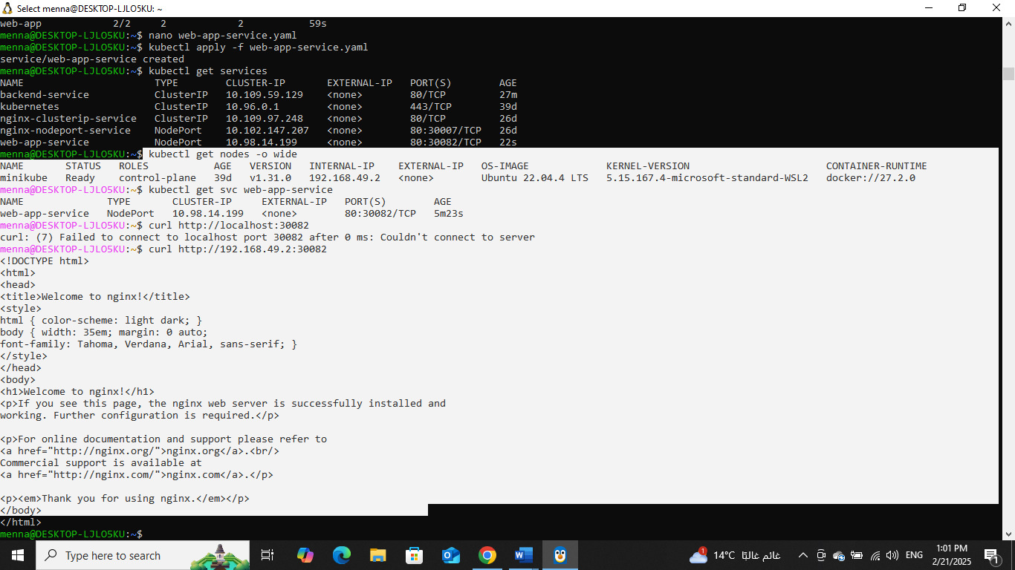

1. How many static pods exist in this cluster in all namespaces?

Four

13-On which nodes are the static pods created currently?

master