Language and Compilers
Dr. Khaled Morsy
Sheet (1)

- Define the terms (compiler, interpreter, Lexical analyzer, syntax analyzer, semantic analyzer)
Compiler:
A compiler is a program that can read a program in one language (the source language) and translate it into an equivalent program in another language (the target language). It also reports the errors that it detects during the translation process.

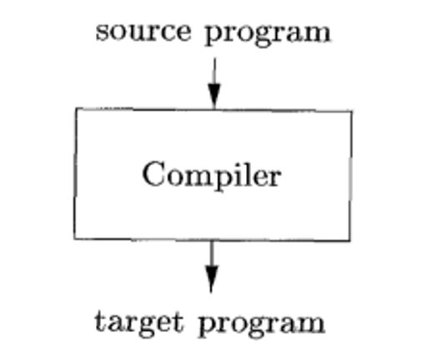
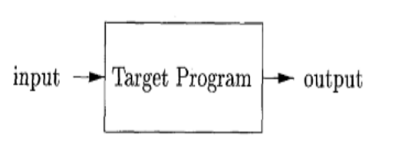

Interpreter:
An interpreter is another common kind of language processor. Instead of producing a target program as a translation, an interpreter appears to directly execute the operations specified in the source program on inputs supplied by the user
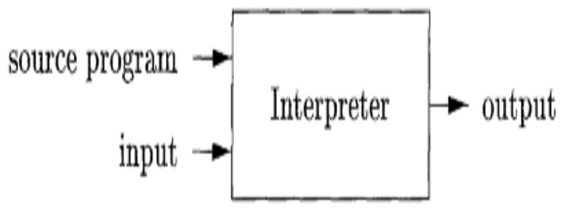

Lexical Analyzer:
Reads the stream of characters making up the source program and groups the characters into a meaningful sequences called lexemes. For each lexeme, the lexical analyzer produces as output a token of the form <token_name, attribute-value>.
Syntax analyzer:
The second phase of the compiler is syntax analysis or parsing. The parser uses the first components of the tokens produced by the lexical analyzer to create a tree-like intermediate representation that depicts the grammatical structure of the token stream
Semantic analyzer:
The semantic analyzer uses the syntax tree and the information in the symbol table to check the source program for semantic consistency with the language definition.
It also gathers type information and saves it in either the syntax tree or the symbol table, for subsequent use during intermediate-code generation.

.

- Illustrate using figure the phases of compiler.
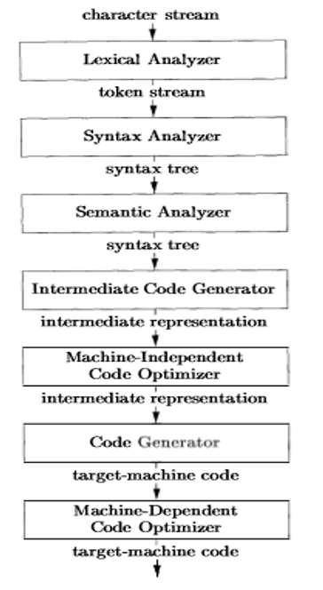

- Describe the feature that distinguish Java language processor from other language translators.

Java language processor has a special feature that combine both of the compiler and interpreter.
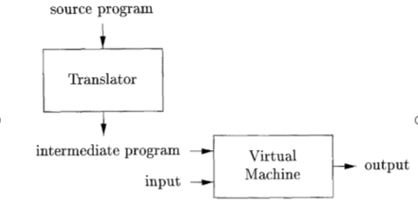

- Given the sentence:
Tax = (Salary – Deduction) * Percentage
Show using figure the phases of compiler and how this expression can be translated from source sentence into intermediate code (hint: follow exactly the example given with the description of compiler phases)

