

Child Health Analysis Report
Cameroon Demographic and Health Survey 2018

Author: Momeni Gilles
Date: January 2026
Data Sources: Tables_DIAR.xls, Tables_ARI_FV.xls, Tables_Size.xls

Executive Summary
This report presents a comprehensive analysis of child health indicators in Cameroon based on the 2018 Demographic and Health Survey (DHS). The analysis focuses on childhood morbidity (diarrhea, fever, and acute respiratory infections), treatment-seeking behaviors, and feeding practices during illness.

Key Findings
Indicator | Prevalence | Treatment Seeking
Diarrhea | 11.9% | 51.6%
Fever | 15.4% | 61.0%
ARI Symptoms | 1.0% | 59.2%

1. Childhood Morbidity Overview

1.1 Prevalence of Childhood Illnesses
Among children under 5 years of age in Cameroon, the two-week prevalence rates were:
- Fever: 15.4% - the most common childhood illness
- Diarrhea: 11.9% - affecting approximately 1 in 8 children
- ARI Symptoms: 1.0% - relatively rare but potentially severe
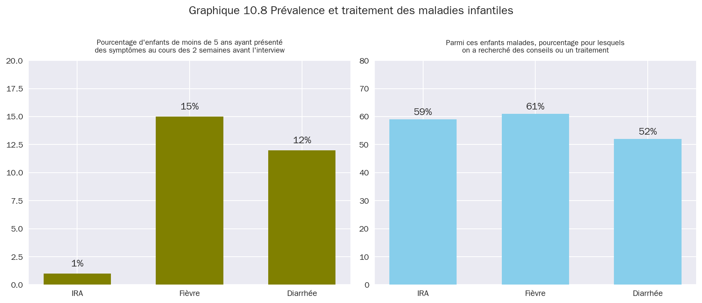 Graphique 10.8: Prévalence et traitement des maladies infantiles

1.2 Treatment-Seeking Behavior
Treatment-seeking rates varied by illness type: - Fever: 61.0% sought treatment (highest rate) - ARI: 59.2% sought treatment - Diarrhea: 51.6% sought treatment (lowest rate)
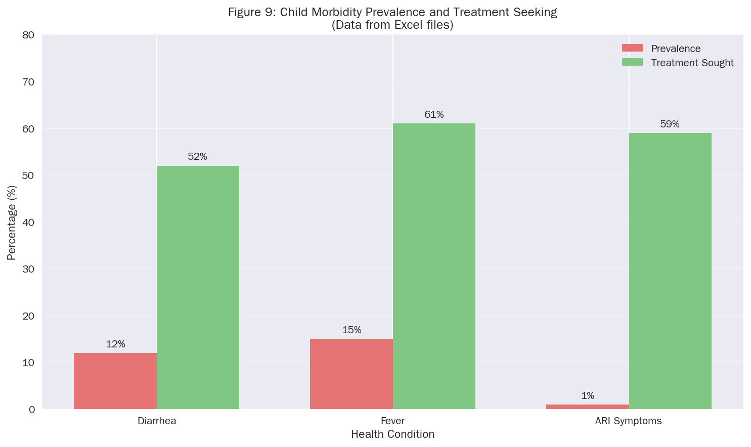 Figure 9: Child Morbidity Prevalence and Treatment Seeking

2. Diarrhea Deep Dive

2.1 Age-Specific Prevalence
Diarrhea prevalence follows a characteristic age pattern, peaking in the 6-23 month age range:
Age Group | Prevalence
<6 months | 5.0%
6-11 months | 20.4%
12-23 months | 21.1%
24-35 months | 13.4%
36-47 months | 7.7%
48-59 months | 4.9%
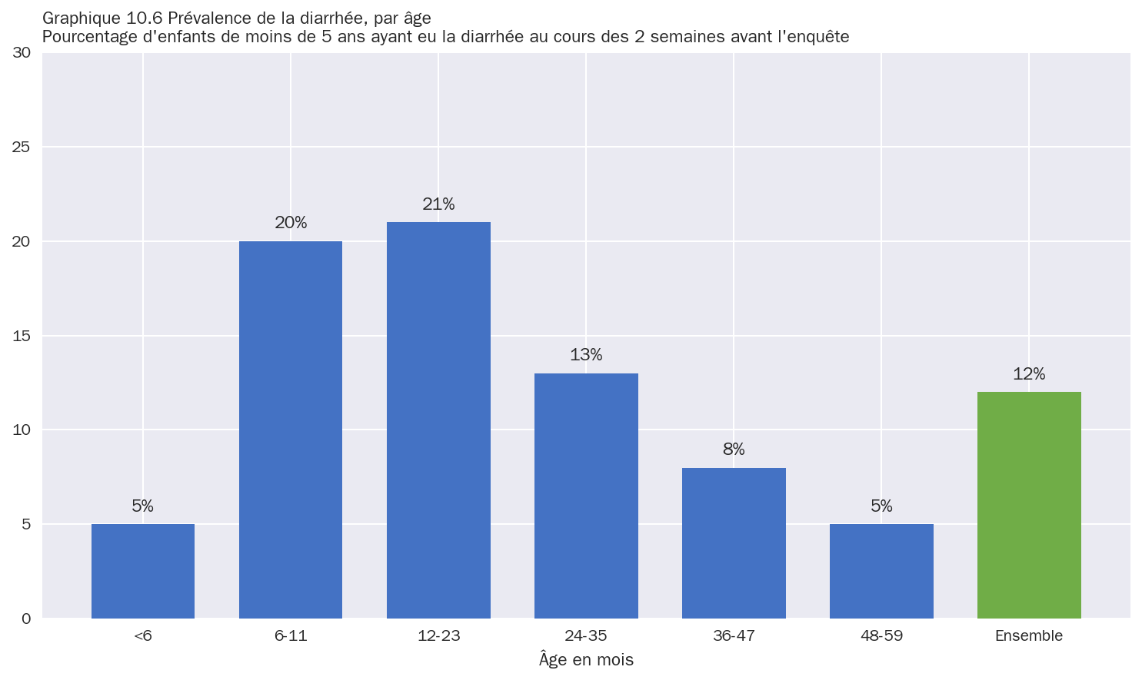 Graphique 10.6: Prévalence de la diarrhée par âge

2.2 Treatment Patterns
Various treatments were used for childhood diarrhea:
Treatment | Percentage
TRO (Oral Rehydration Therapy) | 44.6%
ORS or increased fluids | 42.0%
ORS (sachet) | 17.9%
Zinc | 20.6%
ORS and Zinc (combined) | 7.7%
No treatment | 23.4%
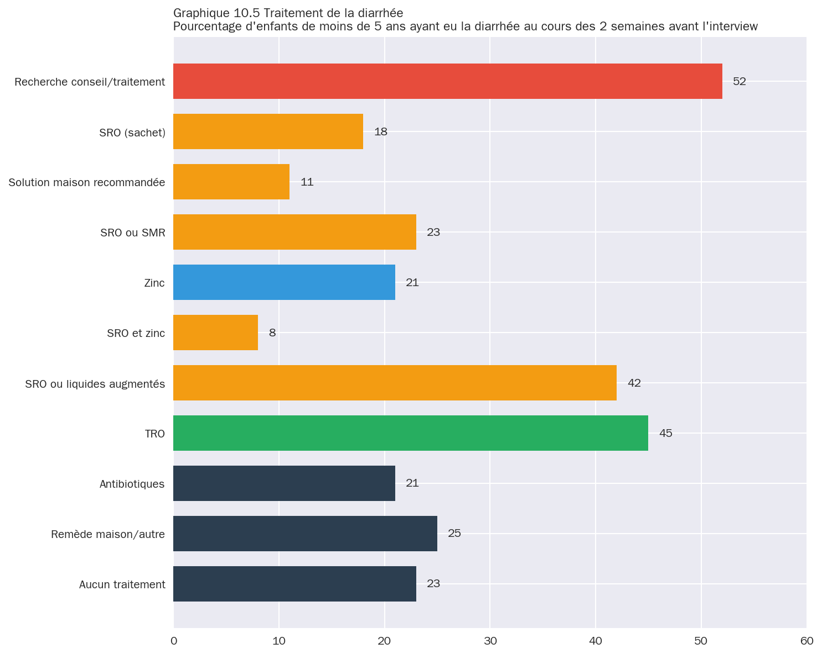 Graphique 10.5: Traitement de la diarrhée

3. Socio-Economic Determinants

3.1 ORS Use by Wealth Quintile
Access to ORS treatment shows a clear wealth gradient:
Wealth Quintile | ORS Rate
Poorest | 9.2%
Poorer | 12.5%
Middle | 19.3%
Richer | 21.8%
Richest | 29.9%
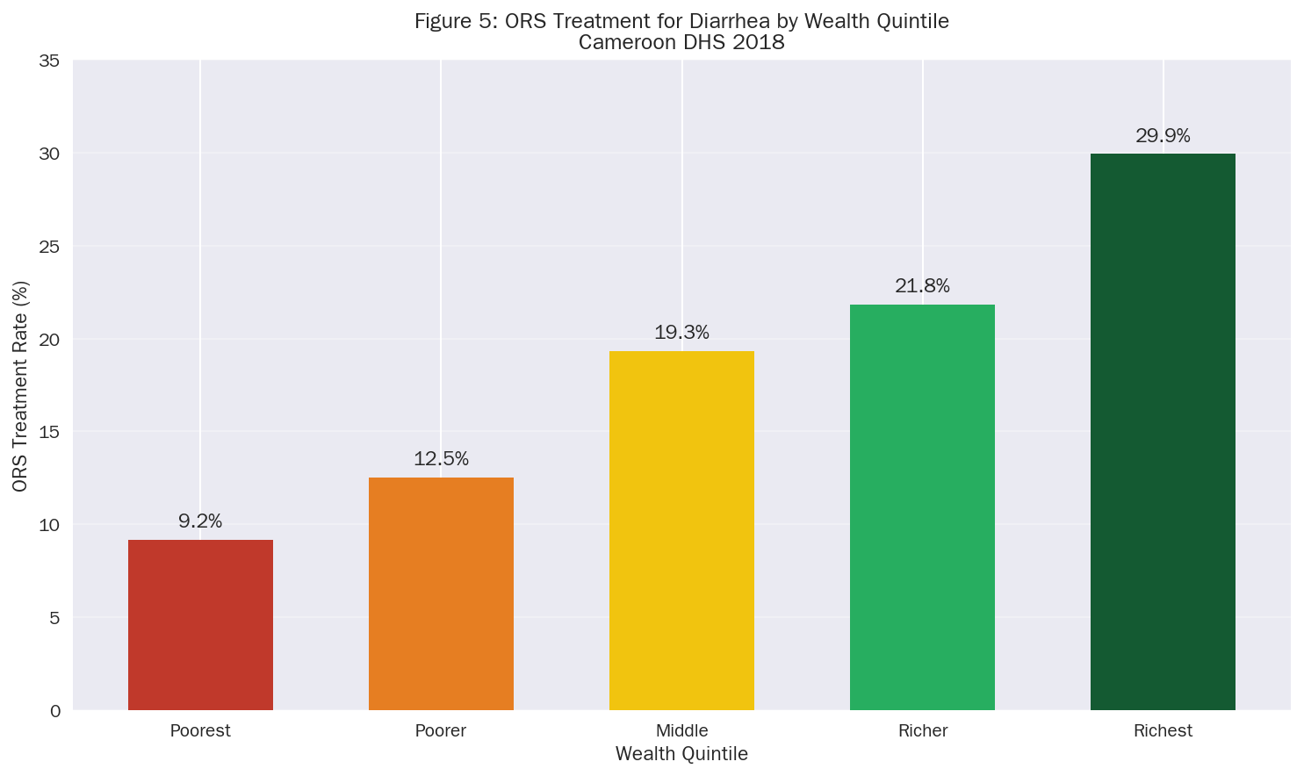
Figure 5: ORS Treatment for Diarrhea by Wealth Quintile

3.2 Care-Seeking by Mother’s Education
Education Level | Care-Seeking Rate
No Education | 51.1%
Primary | 63.7%
Secondary | 65.6%
Higher | 63.9%
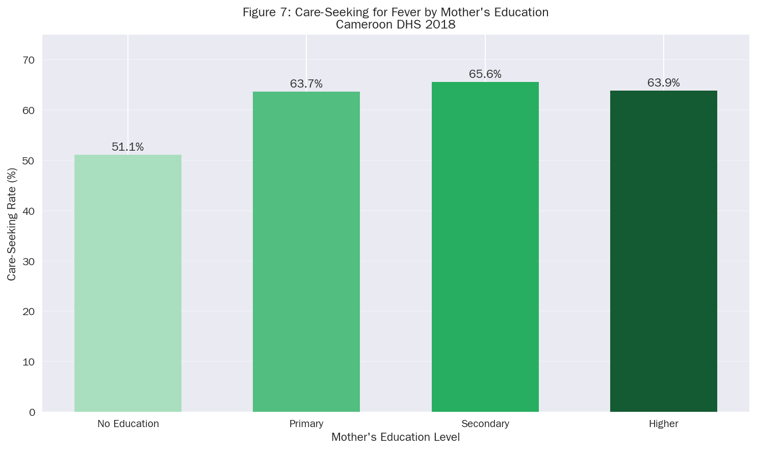 Figure 7: Care-Seeking for Fever by Mother’s Education

4. Feeding Practices During Illness

4.1 Fluid and Food Intake During Diarrhea
WHO recommends increasing fluids and maintaining food intake during diarrhea:
Liquids given: - More: 32.3% - Same: 30.1% - Less: 25.2% - None: 2.5%
Food given: - More: 10.3% - Same: 33.7% - Less: 39.6% - None: 3.9%
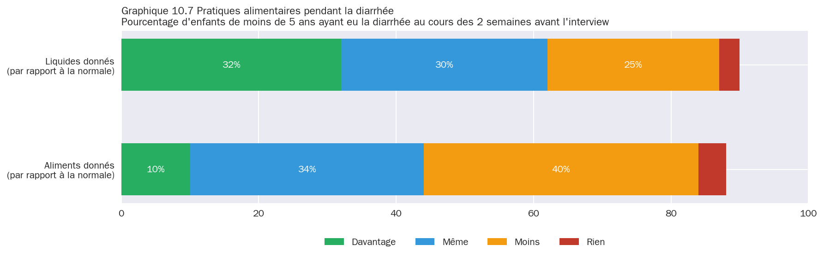 Graphique 10.7: Pratiques alimentaires pendant la diarrhée
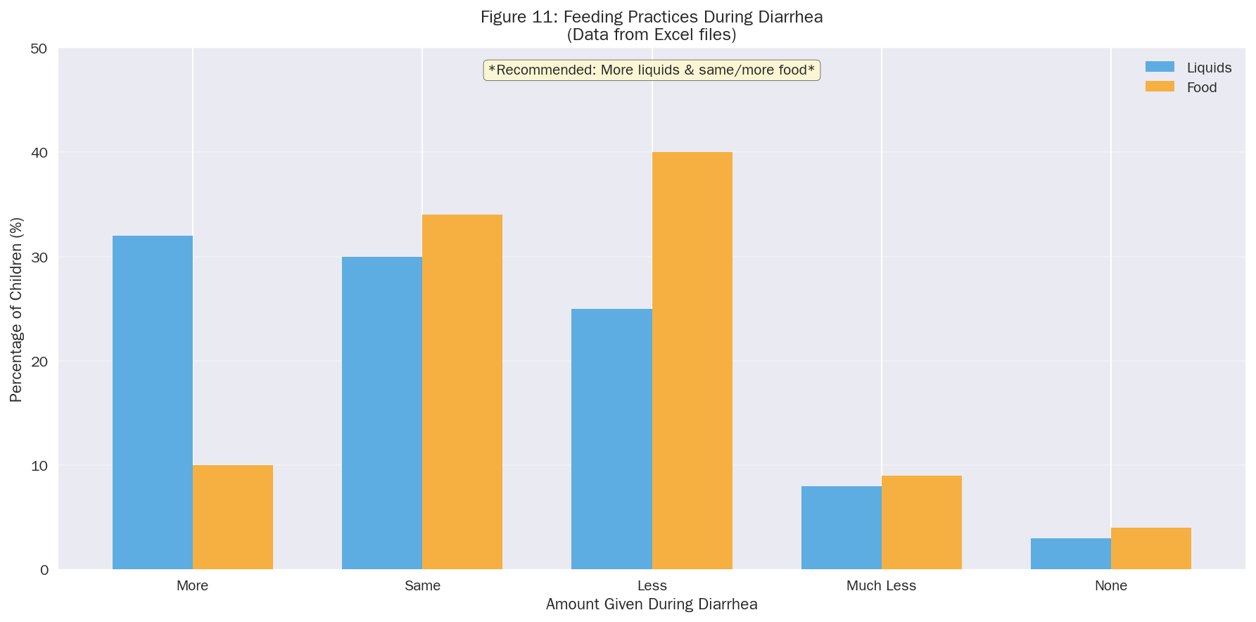 Figure 11: Feeding Practices During Diarrhea

5. Regional Analysis
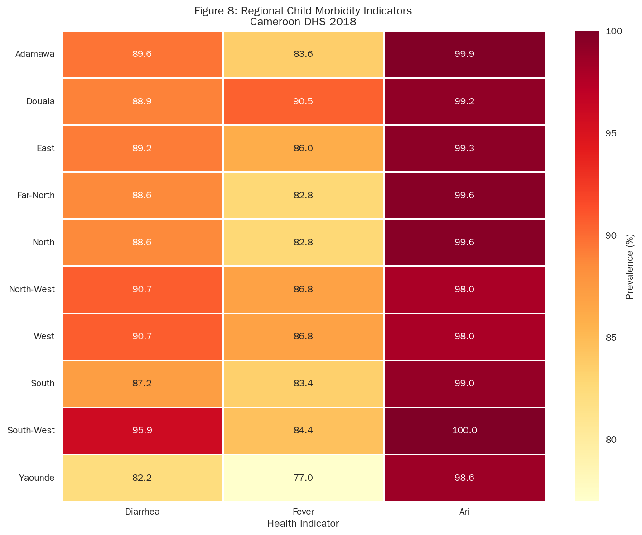
Figure 8: Regional Child Morbidity Indicators

6. Conclusions and Recommendations

Key Findings:
- Fever is the most prevalent childhood illness (15.4%)
- Diarrhea peaks in children aged 6-23 months (21.1%)
- ORS treatment shows significant wealth disparities (9.2% poorest vs 29.9% richest)
- Combined ORS+Zinc use remains low at 7.7%

Recommendations:
- Target diarrhea prevention for 6-23 month age group
- Improve ORS access in poorest wealth quintiles
- Promote combined ORS+Zinc treatment
- Educate caregivers on feeding practices during illness

Data Sources
All data extracted from: - Tables_DIAR.xls - Diarrhea prevalence and treatment - Tables_ARI_FV.xls - ARI and Fever data - Tables_Size.xls - Birth weight data

References
- Institut National de la Statistique (INS) and ICF. 2020. Enquete Demographique et de Sante du Cameroun 2018. Yaounde, Cameroun, and Rockville, Maryland, USA: INS and ICF.
- World Health Organization. 2020. Children: improving survival and well-being. WHO Fact Sheets.
- UNICEF. 2019. Levels and Trends in Child Mortality. UN Inter-agency Group for Child Mortality Estimation.
- The DHS Program. Guide to DHS Statistics. ICF International.
- World Health Organization. 2016. Integrated Management of Childhood Illness (IMCI). Geneva: WHO.

Appendix: Statistical Tables

A.1 Sample Characteristics
The analysis utilized pre-tabulated summary statistics from the DHS 2018 standard tables, covering: - Children aged 0-59 months for morbidity indicators - Recent births for birth weight analysis

A.2 Data Quality Notes
- All percentages are based on weighted estimates
- Missing data were excluded from analysis
- Regional classifications follow DHS standard definitions

Analysis conducted following DHS Chapter 10 (Child Health) methodology

