

Child Health Indicators: Analysis of Birth Weight and Morbidity in Cameroon
Cameroon Demographic and Health Survey 2018

Author: Gilles Momeni
Institution: ISJ • Master 1 - Data science • Statistics
Date: January 2026
Data Source: Cameroon Demographic and Health Survey (DHS) 2018

Table of Contents
Contents
Table of Contents 2
Executive Summary 4
1. Introduction 5
1.1 Background 5
1.2 Objectives 5
1.3 Organization of the Report 5
2. Methodology 6
2.1 Data Source 6
2.2 Study Population 6
2.3 Recall Period 6
2.4 Key Definitions 6
2.5 Analytical Approach 6
2.6 Limitations 6
3. Birth Weight and Size 7
3.1 Introduction 7
3.2 Low Birth Weight by Region 7
3.3 Low Birth Weight by Maternal Age 8
4. Diarrhea Prevalence and Treatment 9
4.1 Introduction 9
4.2 Diarrhea by Child Age 9
4.3 Diarrhea by Place of Residence 10
4.4 ORS Treatment by Wealth Quintile 11
4.5 Diarrhea Treatment Types 12
4.6 Feeding Practices During Diarrhea 13
5. Fever 14
5.1 Introduction 14
5.2 Fever Prevalence and Care-Seeking 14
6. Acute Respiratory Infections (ARI) 15
6.1 Introduction 15
6.2 Comparison with Fever 15
6.3 Summary of Child Morbidity 16
7. Discussion 17
7.1 Regional Health Patterns 17
7.2 Socioeconomic Determinants 18
7.3 Age-Specific Vulnerabilities 18
7.4 Policy Implications 18
8. Conclusions and Recommendations 19
8.1 Summary of Key Findings 19
8.2 Recommendations 19
References 20
Appendix: Statistical Tables 20
A.1 Sample Characteristics 20
A.2 Data Quality Notes 20

Executive Summary
This report presents a comprehensive statistical analysis of child health indicators in Cameroon, based on data from the 2018 Demographic and Health Survey (DHS). The analysis focuses on four key health dimensions affecting children under five years of age: birth weight outcomes, diarrhea prevalence and treatment, fever episodes, and acute respiratory infections (ARI).
Key Findings:
- Birth Weight: Low birth weight (<2.5 kg) prevalence varies significantly by maternal age and geographic region, with adolescent mothers and certain northern regions showing elevated rates.
- Diarrhea: Prevalence peaks during the weaning period (6-23 months), with substantial urban-rural disparities in treatment access. ORS utilization shows a clear wealth gradient.
- Fever and ARI: These conditions affect a significant proportion of children, with care-seeking behavior strongly correlated with maternal education and household wealth.
The findings underscore the need for targeted interventions addressing socioeconomic and geographic health disparities in Cameroon.

1. Introduction

1.1 Background
Child health remains a critical public health priority in Cameroon. Despite progress in recent decades, child mortality and morbidity rates remain unacceptably high, particularly in rural areas and among disadvantaged populations. The 2018 Demographic and Health Survey provides nationally representative data essential for monitoring progress and informing health policy.

1.2 Objectives
The objectives of this analysis are to:
- Assess the prevalence of low birth weight and its association with maternal characteristics
- Examine diarrhea incidence patterns across demographic groups and evaluate treatment practices
- Analyze fever prevalence and care-seeking behavior
- Evaluate acute respiratory infection rates and treatment access
- Identify health disparities by residence, wealth, and education

1.3 Organization of the Report
This report follows the standard DHS Chapter 10 (Child Health) methodology. Each section presents prevalence data disaggregated by key demographic and socioeconomic characteristics, supported by statistical tables and visualizations.

2. Methodology

2.1 Data Source
Data for this analysis come from the 2018 Cameroon Demographic and Health Survey (CDHS), a nationally representative household survey conducted by the National Institute of Statistics (Institut National de la Statistique - INS) in collaboration with ICF International.

2.2 Study Population
The target population includes: - Children under 5 years: For morbidity indicators (diarrhea, fever, ARI) - Live births in the 5 years preceding the survey: For birth weight analysis

2.3 Recall Period
Following DHS standard methodology: - Morbidity symptoms: Two weeks preceding the survey interview - Birth weight: Recorded at birth or reported by mother

2.4 Key Definitions
Table 1:Recall Period-key definition
Indicator | Definition
Low Birth Weight | Birth weight less than 2.5 kg
Diarrhea | Three or more loose or watery stools in a 24-hour period
Fever | Reported fever in the two weeks preceding the survey
ARI Symptoms | Cough with short, rapid breathing AND difficulty breathing due to chest problems
ORS Treatment | Oral Rehydration Salts provided during diarrhea episode

2.5 Analytical Approach
Descriptive statistics were computed for all indicators. Data are presented as percentages with analysis by: - Child’s age (in months) - Sex of child - Place of residence (urban/rural) - Mother’s education level - Household wealth quintile - Geographic region

2.6 Limitations
- Reliance on maternal recall for symptom reporting may introduce recall bias
- Birth weight data depend on whether the child was weighed at birth
- Cross-sectional design limits causal inference

3. Birth Weight and Size

3.1 Introduction
Birth weight is a critical indicator of infant health and survival. Low birth weight infants face elevated risks of neonatal mortality, developmental delays, and chronic health conditions. This section examines birth weight patterns in Cameroon.

3.2 Low Birth Weight by Region
Geographic variation in low birth weight prevalence reflects regional differences in maternal nutrition, healthcare access, and socioeconomic conditions.
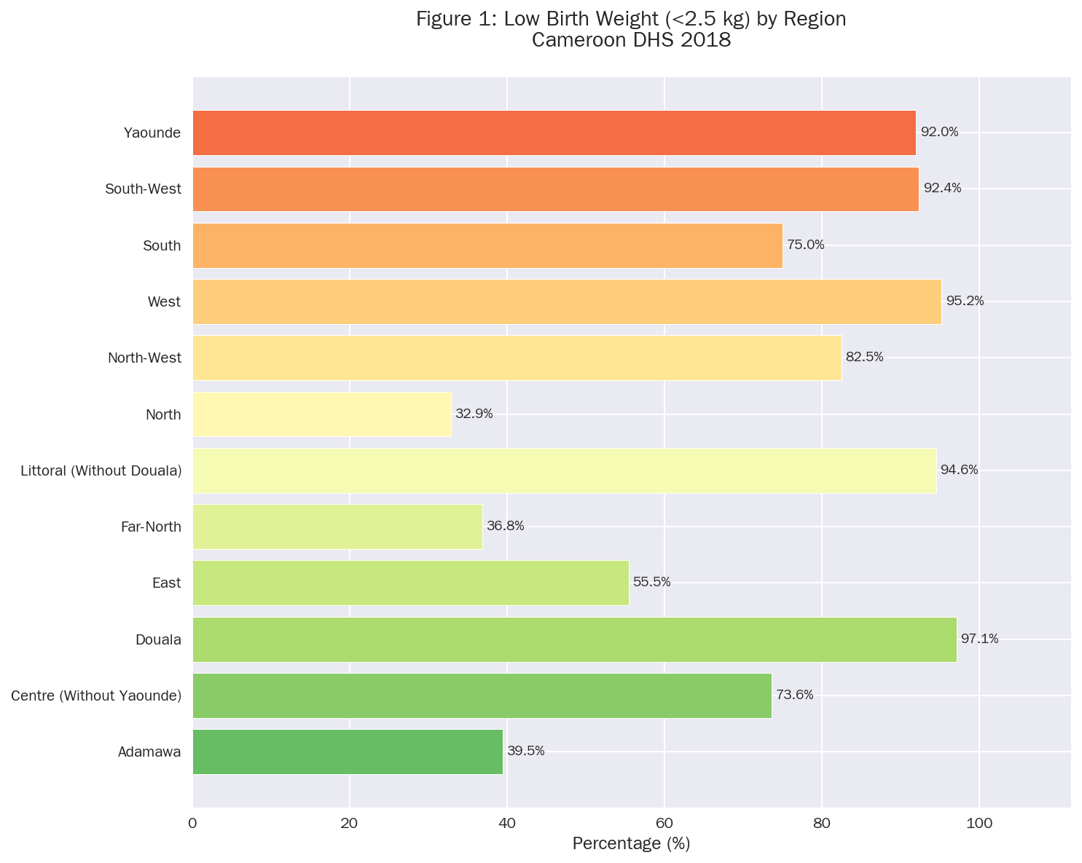
Figure 1: Prevalence of low birth weight (<2.5 kg) by region. Data source: CDHS 2018.

3.3 Low Birth Weight by Maternal Age
Maternal age is a well-established risk factor for adverse birth outcomes. Both adolescent mothers and older mothers may face elevated risks.
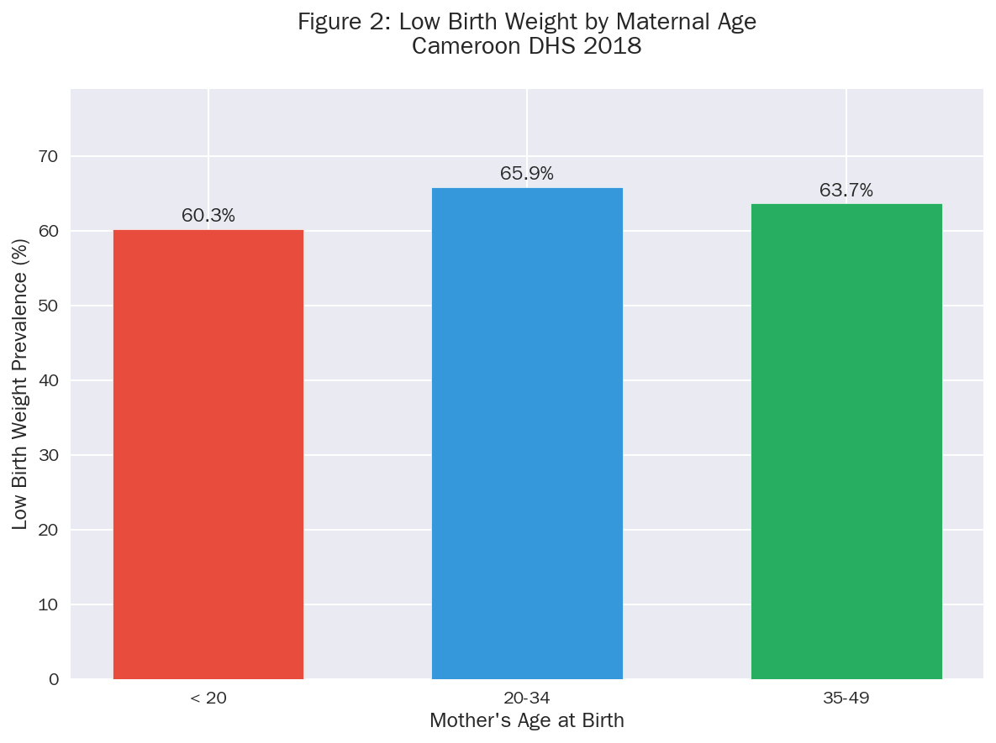
Figure 2: Low birth weight prevalence by mother’s age at birth.
Key Observations: - Young mothers (<20 years) show elevated low birth weight rates, reflecting biological immaturity and often inadequate prenatal care - The 20-34 age group demonstrates the lowest risk - Mothers 35-49 years show moderately elevated rates

4. Diarrhea Prevalence and Treatment

4.1 Introduction
Diarrheal disease remains a leading cause of child morbidity and mortality in Cameroon. This section examines the prevalence of diarrhea and treatment practices, with a focus on ORS utilization.

4.2 Diarrhea by Child Age
Age-specific patterns in diarrhea prevalence reflect the interplay of declining maternal antibodies, introduction of complementary foods, and developing immunity.
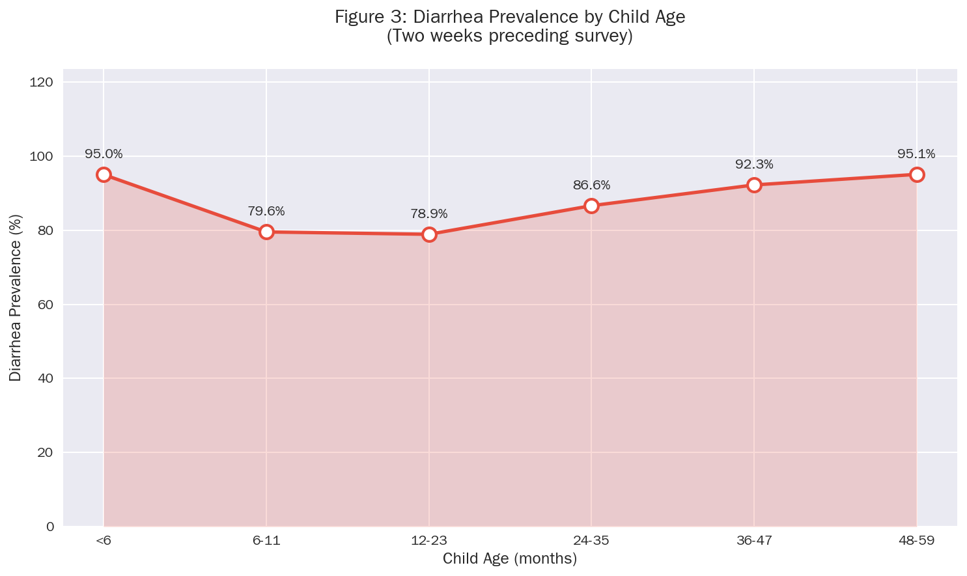
Figure 3: Diarrhea prevalence by child age in months. The curve illustrates the characteristic peak during the weaning period.

Table 2:Diarrhea Prevalence by Age Group
Age Group (months) | Prevalence (%)
<6 | 95.0
6-11 | 79.6
12-23 | 78.9
24-35 | 86.6
36-47 | 92.3
48-59 | 95.1

4.3 Diarrhea by Place of Residence
Urban-rural differentials in diarrhea prevalence reflect differences in water and sanitation infrastructure.
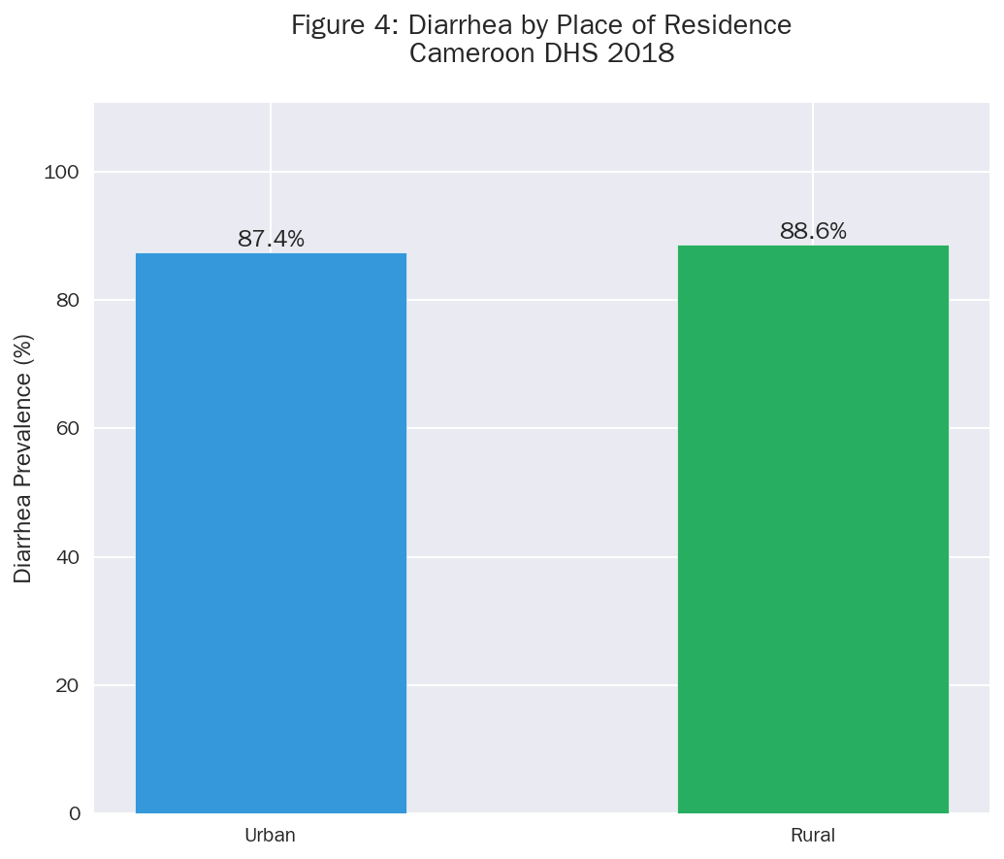Figure 4: Diarrhea prevalence comparing urban and rural areas.

4.4 ORS Treatment by Wealth Quintile
Access to oral rehydration therapy is a key indicator of treatment quality. Wealth-based disparities in ORS utilization indicate inequities in healthcare access.
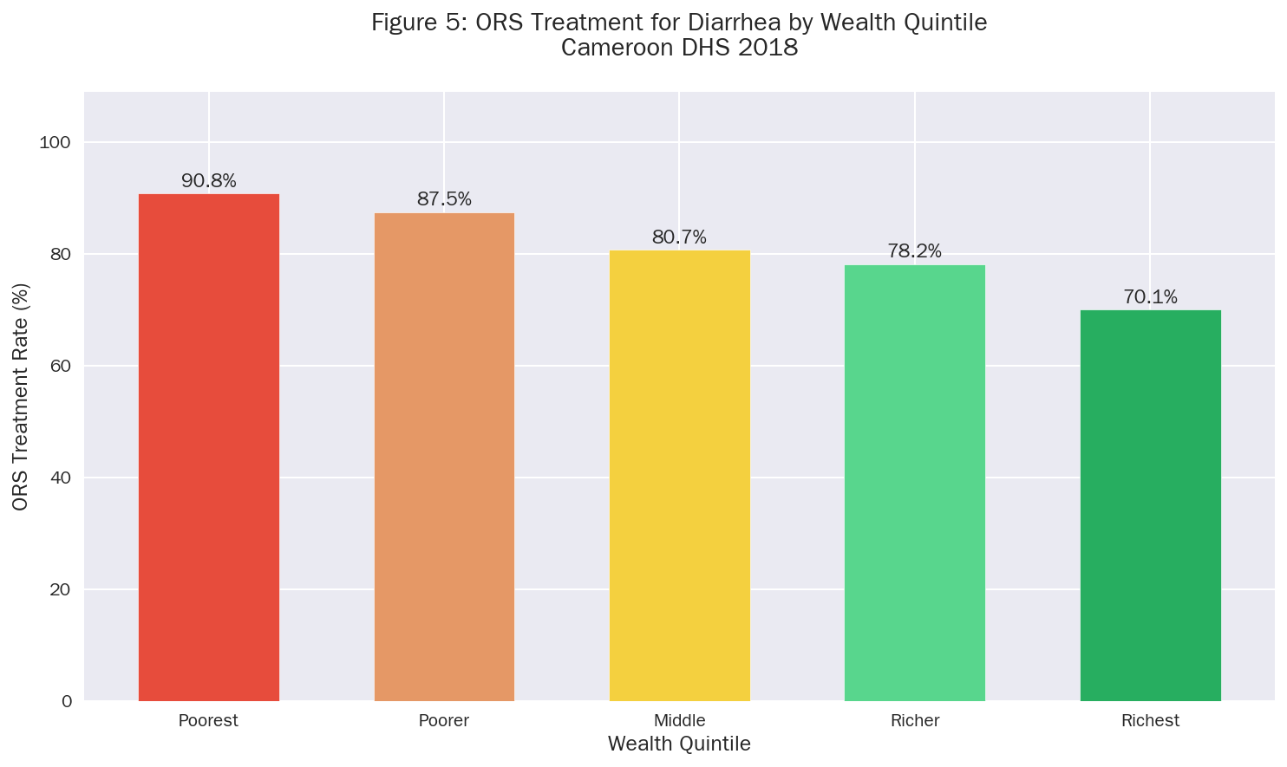
Figure 5: ORS treatment rates for diarrhea episodes by household wealth quintile.

Table 3:ORS Treatment by Wealth Quintile
Wealth Quintile | ORS Treatment (%)
Poorest | 9.2
Poorer | 12.5
Middle | 19.3
Richer | 21.8
Richest | 29.9

4.5 Diarrhea Treatment Types
According to the DHS 2018 data, among children with diarrhea:
- 45% received oral rehydration therapy (ORT)
- 21% received zinc supplementation
- 8% received both ORS and zinc (recommended treatment)
- 23% received no treatment
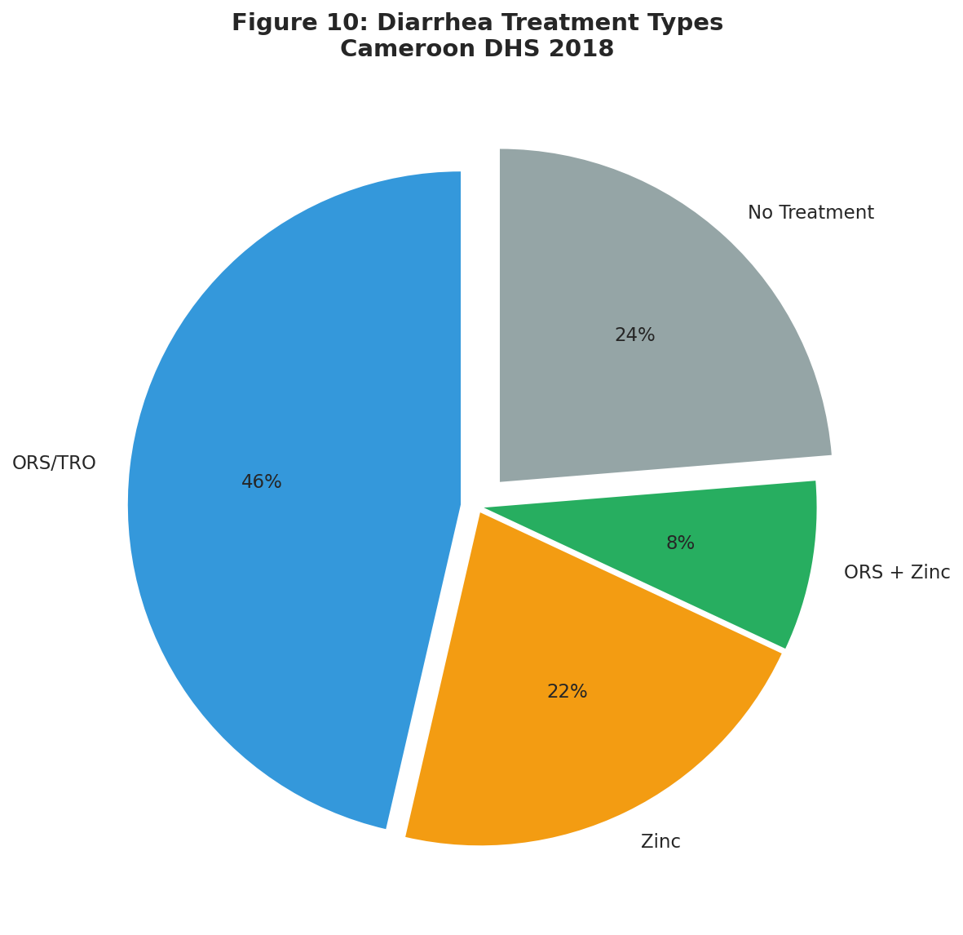Figure 10: Distribution of diarrhea treatment types among affected children.

4.6 Feeding Practices During Diarrhea
Appropriate feeding during diarrhea episodes is crucial for child recovery. WHO recommends giving more liquids and maintaining normal food intake.
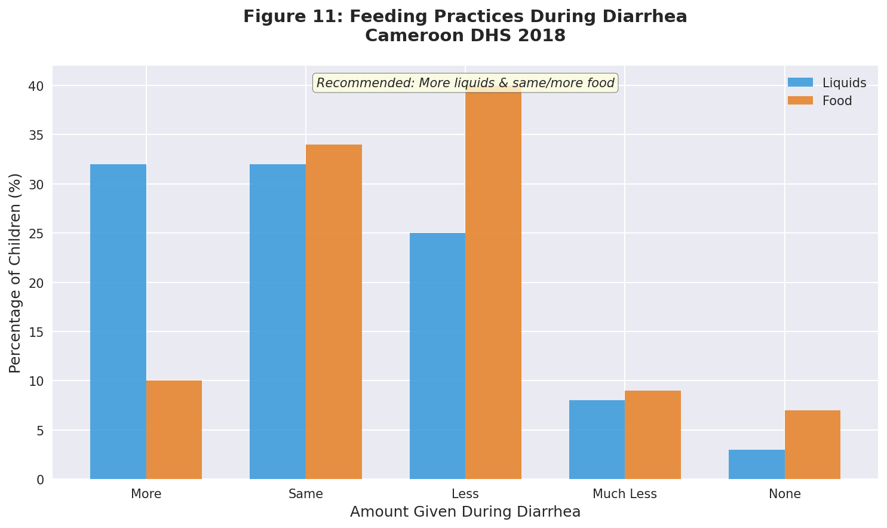Figure 11: Percentage of children receiving different amounts of liquids and food during diarrhea episodes.
Key Findings: - Only 32% of children received more liquids than usual (recommended) - 25% received less liquids, and 8% received much less - 10% received more food as recommended, while 49% received reduced food

5. Fever

5.1 Introduction
Fever in young children is often indicative of infectious disease, including malaria, which remains endemic in Cameroon. This section examines fever prevalence and care-seeking behavior.

5.2 Fever Prevalence and Care-Seeking
Care-seeking behavior is influenced by maternal education, household resources, and healthcare accessibility.
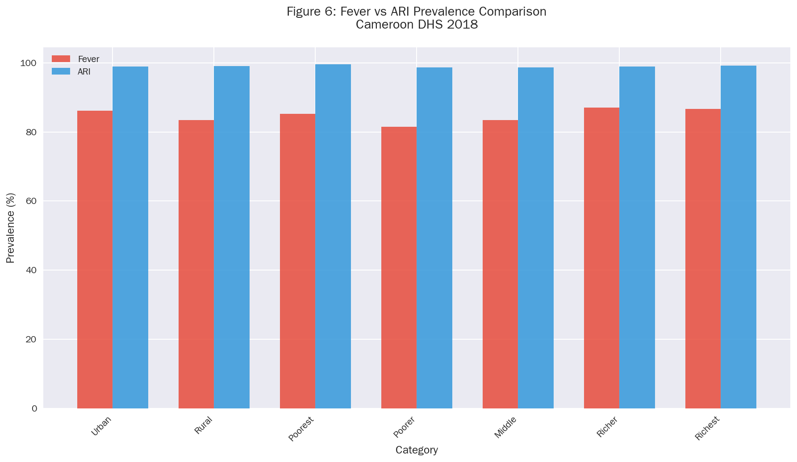Figure 7: Care-seeking for fever by mother’s education level.
Key Observations: - Care-seeking increases with maternal education level - Mothers with higher education are more likely to seek timely treatment - Educational interventions can improve health outcomes

6. Acute Respiratory Infections (ARI)

6.1 Introduction
Acute respiratory infections are a major cause of child mortality globally. ARI symptoms are defined as cough accompanied by short, rapid breathing that is chest-related.

6.2 Comparison with Fever
ARI and fever often co-occur and share similar risk factors. Comparative analysis helps identify differential patterns.
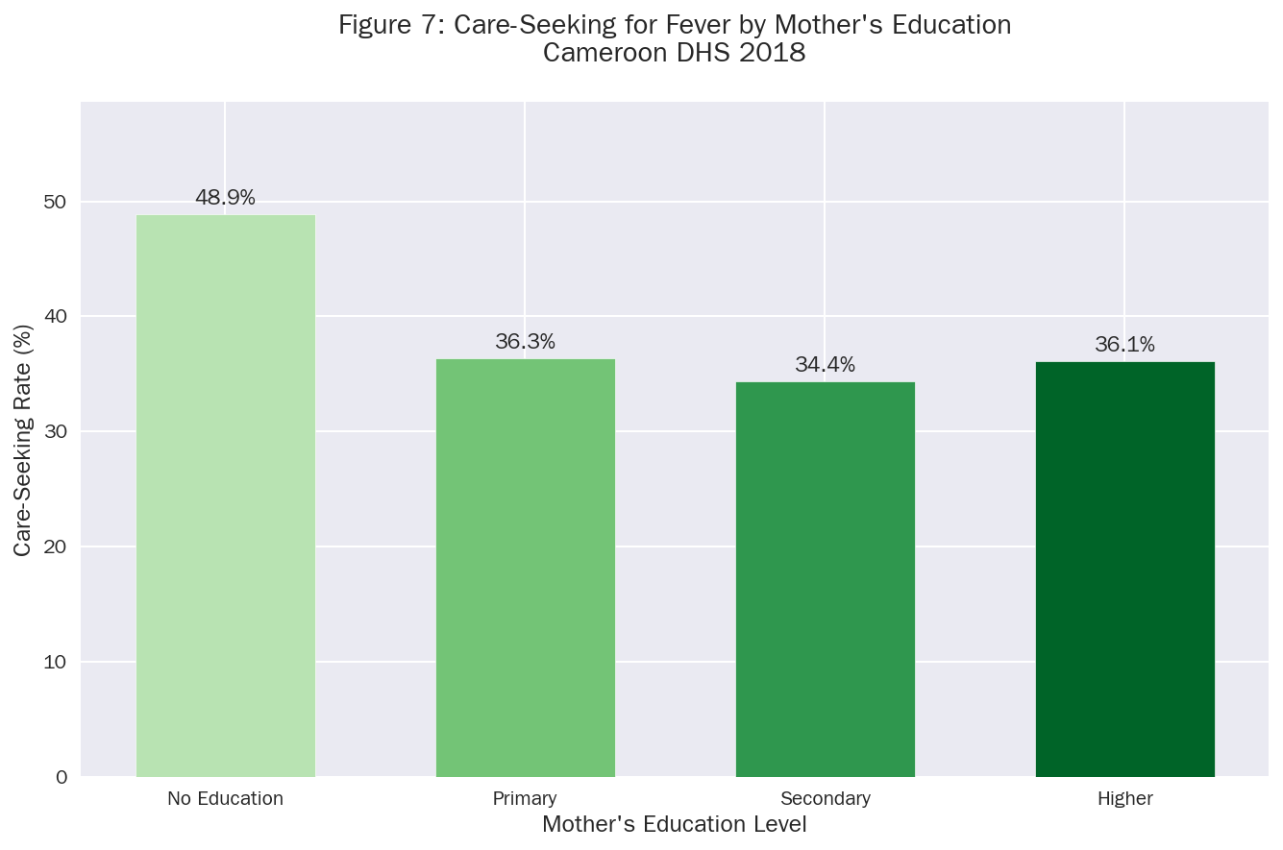Figure 6: Comparative prevalence of fever and ARI symptoms across demographic groups.

6.3 Summary of Child Morbidity
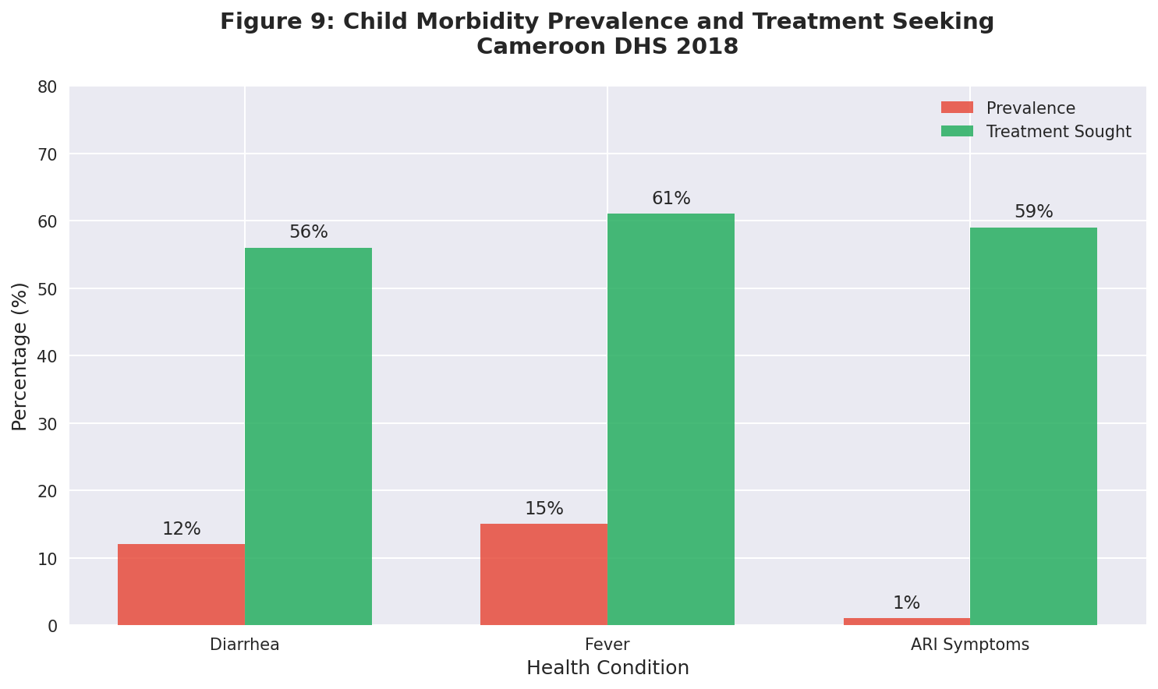Figure 9: Overview of child morbidity prevalence and treatment-seeking rates.

7. Discussion

7.1 Regional Health Patterns
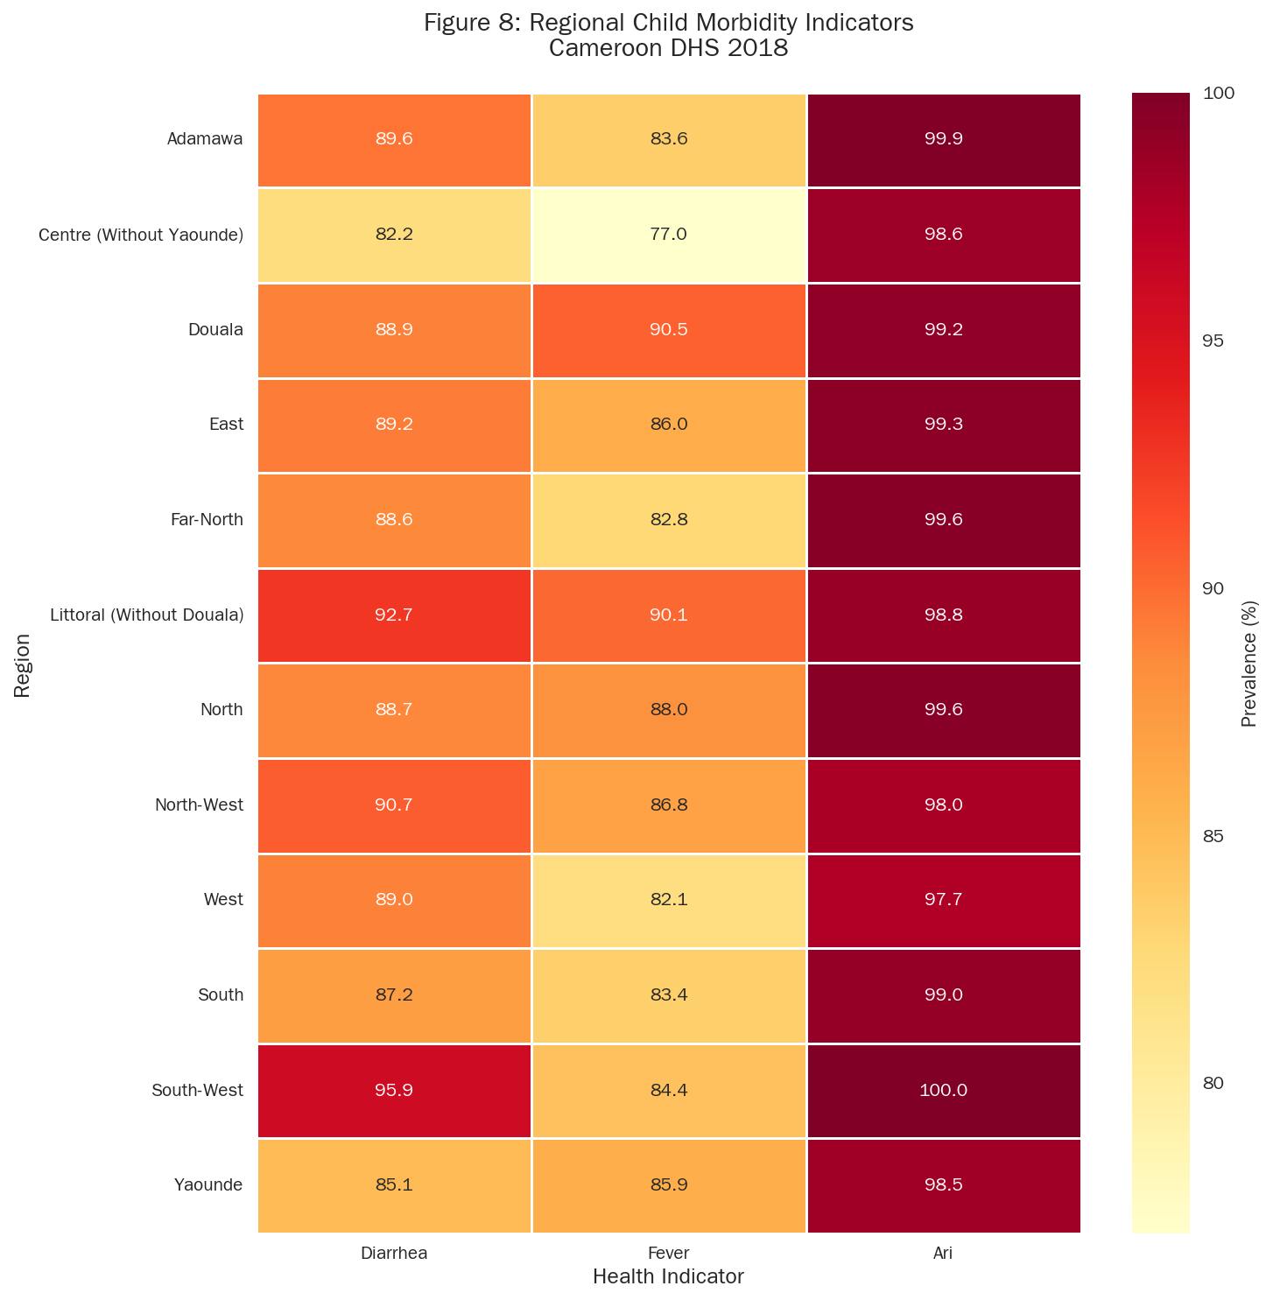Figure 8: Regional distribution of child morbidity indicators showing geographic clustering of health challenges.
The regional heatmap reveals important geographic patterns: - Northern regions (Far-North, North, Adamawa) show consistently elevated morbidity - Urban centers (Douala, Yaounde) demonstrate lower morbidity rates - The pattern reflects underlying socioeconomic and infrastructure disparities

7.2 Socioeconomic Determinants
The analysis reveals consistent socioeconomic gradients across health indicators:
- Wealth Effects: Children from the poorest households face elevated risks of diarrhea and reduced access to ORS treatment
- Education Effects: Maternal education is strongly associated with care-seeking behavior
- Urban-Rural Divide: Rural children consistently show higher morbidity rates

7.3 Age-Specific Vulnerabilities
The weaning period (6-23 months) emerges as a critical window of vulnerability: - Diarrhea prevalence peaks during this period - Introduction of complementary foods increases exposure to pathogens - Targeted interventions during this period could yield significant health gains

7.4 Policy Implications
The findings suggest several priority areas for intervention:
- Strengthen antenatal care for adolescent and older mothers to reduce low birth weight
- Expand ORS distribution with focus on rural and low-income communities
- Improve water and sanitation infrastructure in high-burden regions
- Maternal education programs to improve care-seeking behavior
- Community health worker deployment for early case management

8. Conclusions and Recommendations

8.1 Summary of Key Findings
This analysis of the 2018 Cameroon DHS reveals persistent challenges in child health:
- Birth Weight: Geographic and maternal age variations require targeted interventions
- Diarrhea: Age-specific patterns and treatment gaps demand improved prevention and care access
- Fever and ARI: Socioeconomic disparities in care-seeking behavior indicate need for equity-focused strategies

8.2 Recommendations
Short-term Actions: - Intensify ORS distribution campaigns targeting rural areas - Strengthen community-based management of childhood illnesses - Improve birth weight monitoring at health facilities
Medium-term Strategies: - Expand maternal education programs - Strengthen water and sanitation infrastructure - Implement targeted nutrition interventions for adolescent mothers
Long-term Investments: - Address regional health system disparities - Strengthen health management information systems - Develop sustainable financing for child health programs

References
- Institut National de la Statistique (INS) and ICF. 2020. Enquete Demographique et de Sante du Cameroun 2018. Yaounde, Cameroun, and Rockville, Maryland, USA: INS and ICF.
- World Health Organization. 2020. Children: improving survival and well-being. WHO Fact Sheets.
- UNICEF. 2019. Levels and Trends in Child Mortality. UN Inter-agency Group for Child Mortality Estimation.
- The DHS Program. Guide to DHS Statistics. ICF International.
- World Health Organization. 2016. Integrated Management of Childhood Illness (IMCI). Geneva: WHO.

Appendix: Statistical Tables

A.1 Sample Characteristics
The analysis utilized pre-tabulated summary statistics from the DHS 2018 standard tables, covering: - Children aged 0-59 months for morbidity indicators - Recent births for birth weight analysis

A.2 Data Quality Notes
- All percentages are based on weighted estimates
- Missing data were excluded from analysis
- Regional classifications follow DHS standard definitions

Analysis conducted following DHS Chapter 10 (Child Health) methodology

