LoadTesting Playbook documentation:
Here is how this playbook tends to work in ansible. You start with a project file that would be the parent name in git. If I had a github the project name would be called “Ansible project. There are two folders that are very important in ansible in order to run a playbook. They are hosts and playbooks they are shown below. We are going to look at the contents of hosts first.
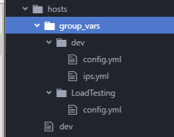
The contents of hosts would have group_vars, these are the variables that would be dedicated to the hosts. In that folder we have the dev file, dev folder , and load testing. Lets look at the dev.yml file.
[dev:children]
LoadTesting
[LoadTesting]
LoadTesting.testing.com server_id=101
The code in the dev file simply finds the server that you are trying to call in the host file. When you run the playbook you would have to call on hosts/dev or hosts/prod for this example I kept dev available.
In the dev folder there are two files that are in there. Config.yml and ips.yml. Ips.yml have all the ips that you are going to use for the server. This file tends to be connected to a dns role, but I left it here it show what that would look like. The dev will not call on this file unless a DNS role is in place. The other file is the config file. This has all of the small configurations the server would call on. Here is what it looks like.
env: dev
environment_full: development
env_branch_name: develop
env_web: dev.
env_web_expanded: dev.
env_prefix: dev-
domain_name: dev-testing.com
smtp_server: 127.0.0.1
alert_emails: webops-alerts@testing.com
cron_emails: "{{ alert_emails }}"
enable_real_ip: true
# calculation= 1 child per 150MB of memory due to max RSS per process and other processes
dns_forwarders:
#- for project purposes we dont have a dns forwarder we are going to focus solely on load testing
dns_master_ipv4: 8.8.8.8
dns_slave_ipv4: 1.1.1.1
internal_ca_certificates:
- filename: LoadTestingGlobalCA
certificate: "{{ loadtesting.ca }}"
Some of the code it will have is some ways to name the development environment for automation reasons some people name stuff differently everywhere this is a way to combat this issue. This is also where most of the global variables for all servers are located for uniformity.
With that in mind you can assume that the config file for the LoadTesting folder is code for the scope of only the LoadTesting servers.
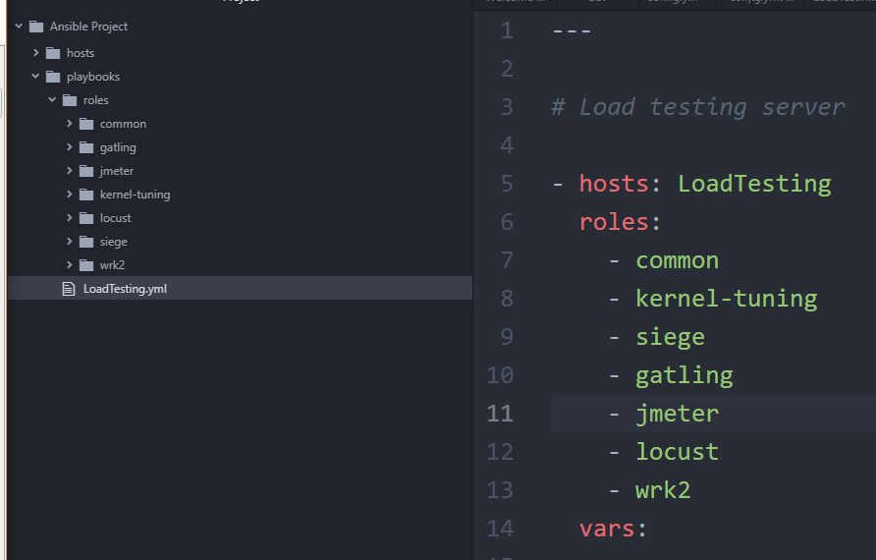
Now lets look at whats in the playbooks folder, you can see there is a lot of roles that can be created for one load testing server. These roles are separate so you can recycle them in different servers if the company grows or find different uses in some of what each role has to offer.
The common role is designed to have all the basic system parameters and packages offered in the system. To maintain the same set of packages throughout the system at all times. Its designed to hit all the servers that would be classified in the host/dev role.
Kernal-tuning in linux allows you to dynamically change some parameters on the fly, to ensure that the kernal in linux can work in the way intended by the user. One big perk is that it can allow changes to persist after reboots. So its important to keep that role.
The siege tool is one of the roles added to the load testing server. This tool is an open source tool that provides regression and benchmark testing, it can stress tests URLs for memory using GET and POST requests. An example to this load testing would be shown here:
https://local.LoadTesting.com:8443/loadtest/checkout_onepage/saveMethod POST method=guest

This line will go to this website and POST the guest method on the web page to see if checkout can work on the web page. The task playbook shows essentially what linux tasks need to be deployed to the server using ansible.
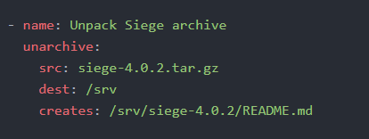
When we dig deeper in the code we find this function. This function unpacks Siege archive which is in the files folder and puts it in the /srv folder in the server. Then it will create the README file from there. There are other functions used to install applications and other useful functions such as configure the Siege build and so on.
The gatling tool is another role that's imperative to load testing web pages. Its written in scala which is a high level javascript programming language. One of the more interesting lines in this code is how it installs. In line 12 it installs by getting it straight from the maven repo and places it in the srv folder. From there it will create the LICENCE file and then add permissions to it. Because its a remote source you have to specify it in the repo by writing.
remote_src: yes
This indicates to ansible that its remote and will allocate this knowledge accordingly. The scala file has a lot of good test examples on how this runs in the system. The code is built by importing some libraries that are needed then creating a load testing class. You then add a base url and make sure some of the tests you would like to ignore are blacklisted. If you want to test very specific things on the site you use the whitelist of this application. The other parameters are what headers you would like to accept, encoding, language and web browser types that you allow for this test. Lets dive in as to what a test would look like.
.pause(1)
.exec(http("product2")
.get("https://" + uri2 + ":443/men/site/white.html")
.headers(headers_0))
The code here will show that it is pausing for 1 second and the executing the product2 of this file, which they will get by accessing uri2 which would be: "dev.LoadTesting.com" and then add the second part of that. So product2 would be: https://dev.LoadTesting.com:443/men/site/white.html and it is looking for the header Map("Upgrade-Insecure-Requests" -> "1") . This code as a whole is executing this site while testing if the insecure request is set to true through a GET request. It basically allows you to test the code without making the source code insecure, and it sends a signal to the server that it wants to have an encrypted and authenticated response rather than a non-encrypted one.
Jmeter is the next role on the list and that's a tool from apache to scale load testing on demand. The tasks do an install and then pulls the jmeter binary and adds permission to it. The files shown here is basically a lot of tests that we would use for the checkout process and so on for automation it will automatically test certain pages for load in terms of what page it needs to be added, this would be in the jmeter.jmx file. In the jmix.properties file you provide all the parameters needed to complete the test properly.
Locust is a very strong python load tester for web pages it is the same thing as jmeter the difference is that it can the same test 30x more memory efficient since it doesn't spin up a GUI and the code is all handled via git. Since you also need to install python you have to add this under the tasks.
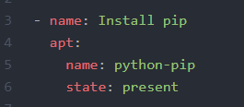
For redhat instead of apt you change that to yum and it should work on ansible red hat. This basically installs pip which is used for python in linux.
Wrk2 is another load testing application for web sites, instead of the other applications it uses Lua instead of javascript or python. It runs like nmap or other software. Since I dont have code on hand of what it would look like I pulled some straight from the git repository to give a good idea of what it would look like.
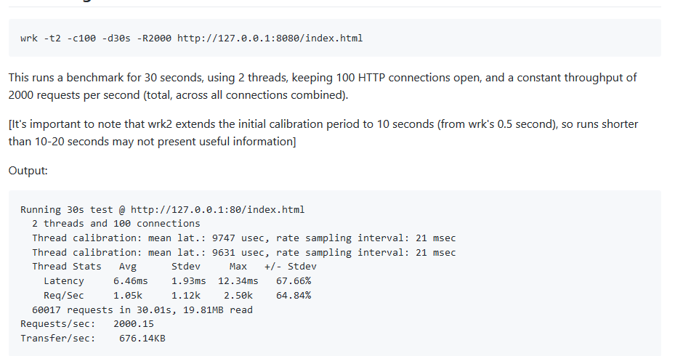
Fig 1: Credit https://github.com/giltene/wrk2
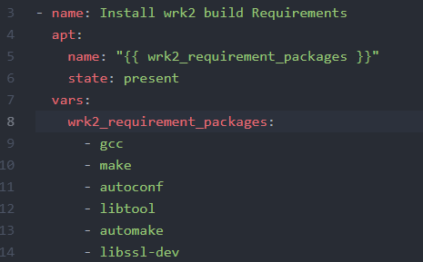
One of the interesting modules in this play book would be how we install a bunch of applications using variables. This is shown below.
This code basically says that it will install what ever is under the variable shown below, this would be make,gcc,autoconf and so on. This will go to that part of variables and install them separately.
Hope you enjoyed this crash course on creating a load testing server in ansible. Let me know if you need any questions or help setting one yourself. If anything is unclear feel free to contact me on my email: mariaenokian1@gmail.com or my phone number 267-243-6722.

