



**Linux Basics exam**

Write all answers here in this document. Use screenshots to support your answers. **Screenshot must include the commands you used**. For example, a simple **ls** from a directory is not adequate. If screenshot won’t cover your answer or is missing some essential parts, you may add written answer as well in addition to screenshot.

Return the exam document before 11:30AM to the teachers email in **PDF format**.

Maximum amount of points from the exam is 60 points. Question specific maximum points are marked after each question.

1. Create directory structure presented in the image below. [2p]

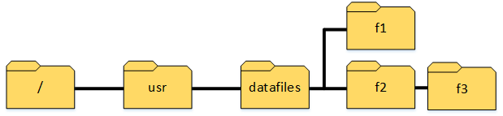

1. Create two groups: *validators* and *confirmers*. [2p]
2. Create user *laura* with home directory and set bash as a default shell. Set new password of your choice for user *laura*. [3p]
3. Set *validators* as owner group for directory f2 so that changes will be inherited to child objects. [3p]
4. Give write permissions for *validators* for f2 directory so that changes will be inherited to child objects. [2p]
5. Set *confirmers* as owner group for directory f1 and set directory permissions using numeric format so that only group has permissions to directory. Group must have all permissions. [3p]
6. Add user *laura* to groups *validators* and *confirmers* so that *confirmers* will be user’s primary group. [3p]
7. Switch to user *laura* so that the whole environment is changed (**the following exercises will be done with user laura**). [3p]
8. Create directory *restored* to *laura*’s home directory using absolute path. Create two new files inside *restored* directory using relative path: *backup_1.txt* and *backup_2.txt*. Redirect the output of command *ls –la /tmp* to the end of the *backup_2.txt* file. [4p]
9. Copy the directory *restored* to previously created directory *f1*. [2p]
10. Download the package from the link below and move the package to directory *f3* with a new name *downloaded_data.tar.gz*. [3p] <http://student.labranet.jamk.fi/~hantt/exam/examdata.tar.gz>
11. Extract *downloaded_data.tar.gz* package using only one command. Move *data1.txt* file from extracted directory to user’s home directory. Print the content of the file *data1.txt* to the command line. [3p]
12. Search a string *franela* with apt package management tool and redirect the output of the command to the file called *apt-search-results.txt* inside the directory *f2* using absolute path. [3p]
13. List the content of laura’s home directory using long listing format. Show only objects modified during this month. [4p]
14. **Return to your previous user**. Find files with file name including the string *cloud* from */var/log* directory using administrative privileges. [3p]
15. Create a new permanent alias for all users, which prints the content of user’s home directory. Verify that alias works on user *laura*. **Important:** command must work regardless where you run it in the file system! [5p]
16. Delete *datafiles* directory using one command. [2p]
17. Use systemd to write the following message into the file called *one-day-event.txt* in your user’s home directory: “***This message has been recorded in the 24th of Nov 2021***” (hint: echo command). This event will only occur once in 24.11.2021 at 6.30 PM. [5p]
18. Install *mariadb-server*, check the status of the service after the installation, stop the service if it is running and lastly disable unit from the boot. **Important:** If you receive the following error, please remove the ***mysql-common*** package from your system before the installation: ***mariadb-server : Depends: mariadb-server-10.3 (>= …)*** [5p]