**Experiment: 5**

PART A

(PART A: TO BE REFERRED BY STUDENTS)

**Aim:** Programming using nested loops

**Learning Outcomes:** The learner would be able to

1. Understand the syntax of nested loop
2. Use nested to solve problems by writing programs

**Theory:**

**Nested Loop (loop inside loop**)**:**

* A loop within another loop is known as nested loop.
* Combinations of any loops are possible.

**Syntax:-**

|  |  |  |
| --- | --- | --- |
| **Nested For**  for (initialization; condition; update)  {  for (initialization; condition; update)  {  // body of inner loop  }  // body of outer loop  } | **Nested While**  while (condition)  {  while (condition)  {  // body of inner loop  }  // body of outer loop  } | **Nested Do While**  do  {  do  {  // body of inner loop  }while (condition);  // body of outer loop  }while (condition); |

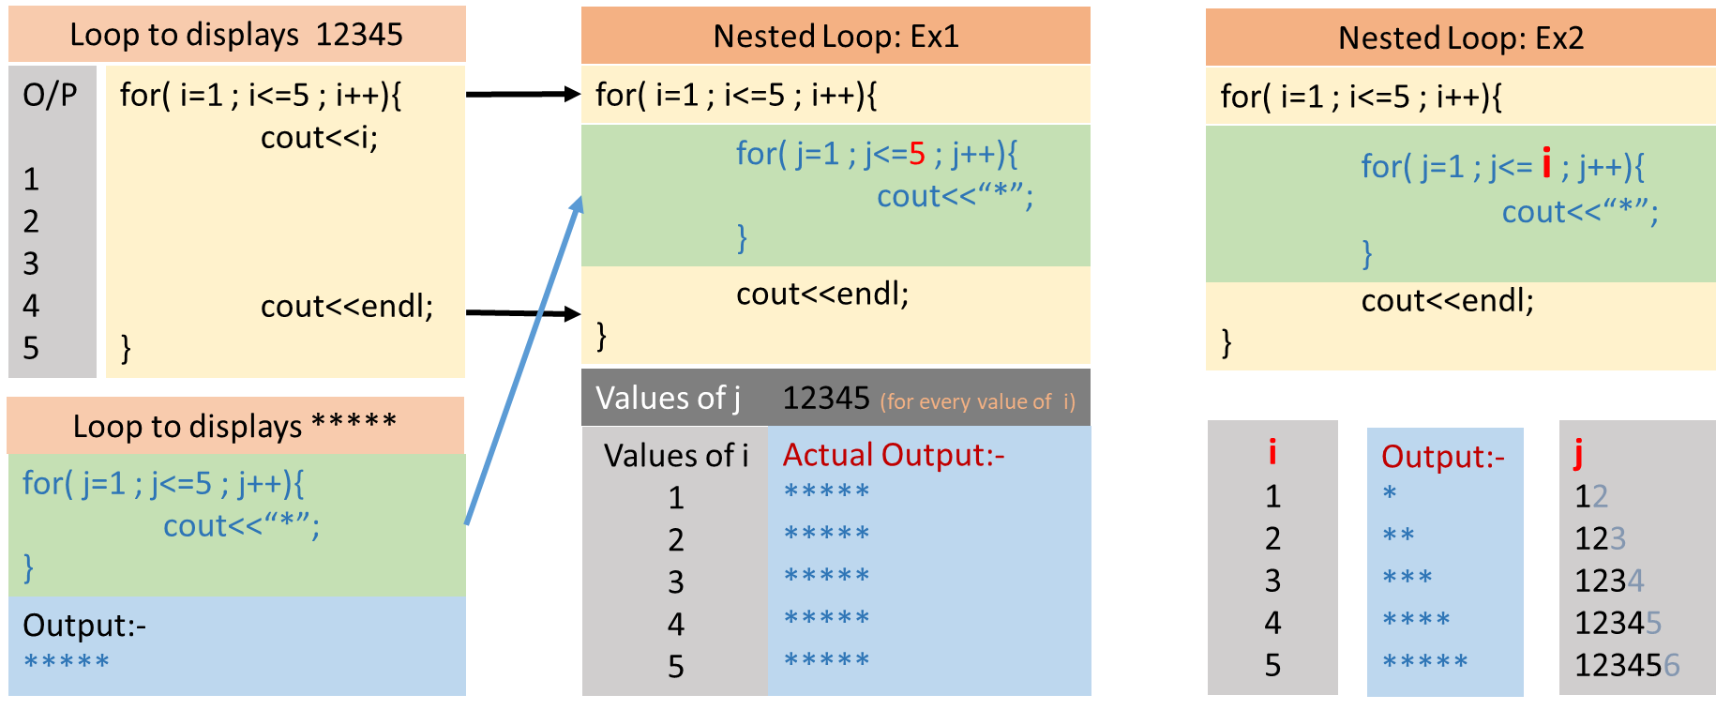

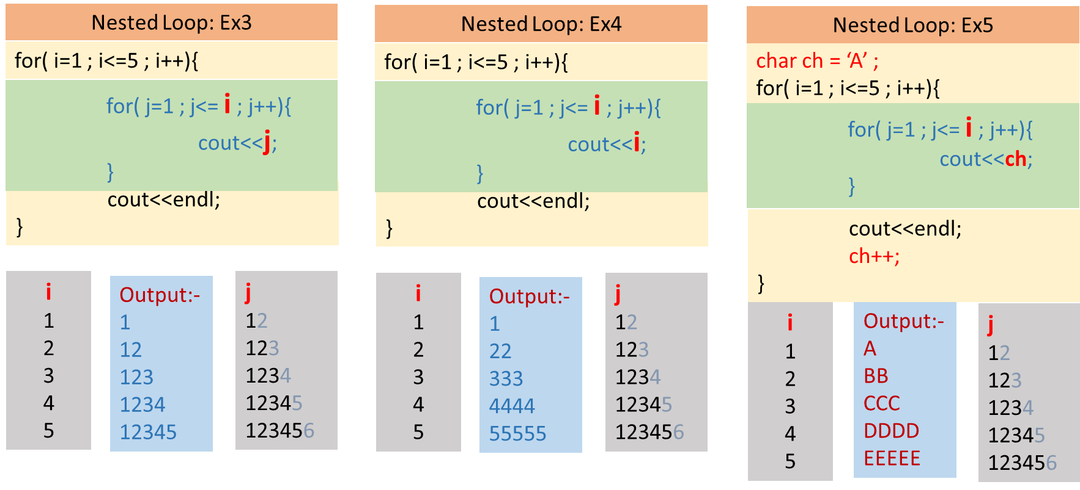

**Instructions: - All the students are informed to write all executed code in a workbook in the following sequence and format.**

* + - 1. Problem Statement
      2. Input and Output
      3. Test Cases
      4. Flowchart
      5. Program (with color codes)

1. Red – Directives
2. Blue – Keywords, constants values
3. Green – Comments, messages
4. Black – {variables, functions, class, object} name, operators, punctuation
   * + 1. Trace Table (additional columns may require in some concepts)

|  |  |  |  |  |  |
| --- | --- | --- | --- | --- | --- |
| Var-1 | Var-2 | …. | Var-n | Condition | Output |
|  |  |  |  |  |  |
|  |  |  |  |  |  |

**Tasks:**

|  |  |  |  |  |  |  |
| --- | --- | --- | --- | --- | --- | --- |
| Sr. No. | Problem Statement | I/O | Test Cases | Flow chart | Program- with color codes | Trace Table |
| 1 | Write a program to print following pattern using nested loop.  A  BC  DEF  GHIJ  KLMNO | ✓ |  | ✓ | ✓ | ✓ |
| 2 | Write a program to print following pattern using nested loop.  *****  ****  ***  **  * | ✓ |  | ✓ | ✓ | ✓ |
| 3 | Write a program to print following pattern using nested loop, read number of lines to be displayed from user.  *  **  ***  ****  ***** | ✓ |  |  | ✓ |  |
| 4 | Write a program to print following pattern using nested loop.  $  $ $  $ $ $ | ✓ |  |  | ✓ |  |
| 5 | Write a program to print following pattern using nested loop.  1  1 2  1 2 3  3 2 1  2 1  1 | ✓ |  |  | ✓ |  |
| 6 | Write a C++ program to print Armstrong numbers between N1 to N2, where N2>N1. | ✓ | ✓ |  | ✓ |  |
| 7 | Write a C++ program to print prime numbers between N1 to N2, where N2>N1. | ✓ | ✓ | ✓ | ✓ | ✓ |
| 8 | WAP to generate all combinations of 1, 2 & 3 using for loop. | ✓ | ✓ |  | ✓ |  |