**Experiment: 6**

PART A

(PART A: TO BE REFERRED BY STUDENTS)

**Aim:** Programming using 1D Array & 2D array

**2,3,4,5,6**

**Learning Outcomes:** The learner would be able to

1. Understand the syntax of array declaration, initialization
2. Traversing the arrays (1D or 2D)
3. Implement programs using arrays (1D or 2D)
4. Use appropriate array (1D, 2D or Multi-dimensional) depending on the problem statements

**Theory:**

**Programming constructs 1 – D and 2 - D arrays**

* It is group of logically related data, stored in contiguous blocks of memory under common name.
* An Array is homogeneous or similar type of data under common name.
* Data items or elements of arrays are separated by subscript or index.
* Array is an indirect pointer.
* C++ Supports following arrays.
  + One Dimensional Arrays
  + Two or Multi-Dimensional Arrays.
* One-dimensional arrays are represented as set of values in one row.
* Multi-dimensional arrays are views as table-containing data i.e. rows & columns.

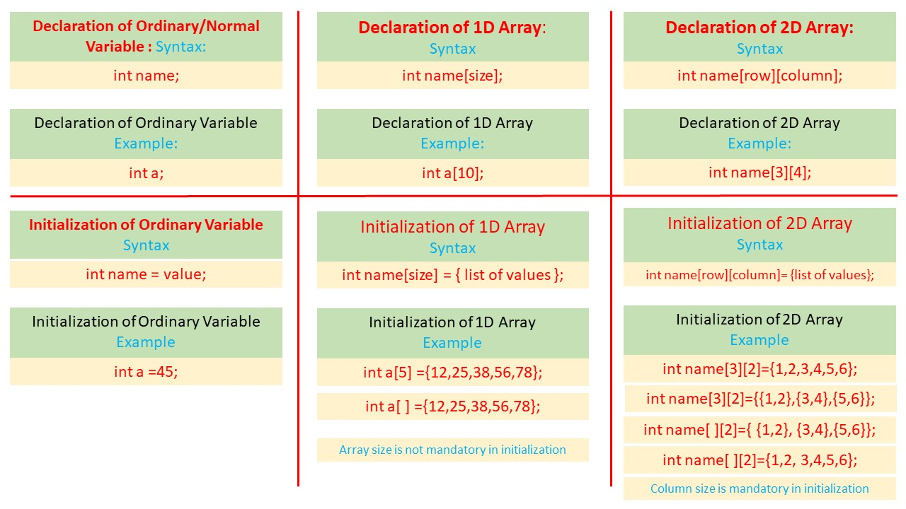

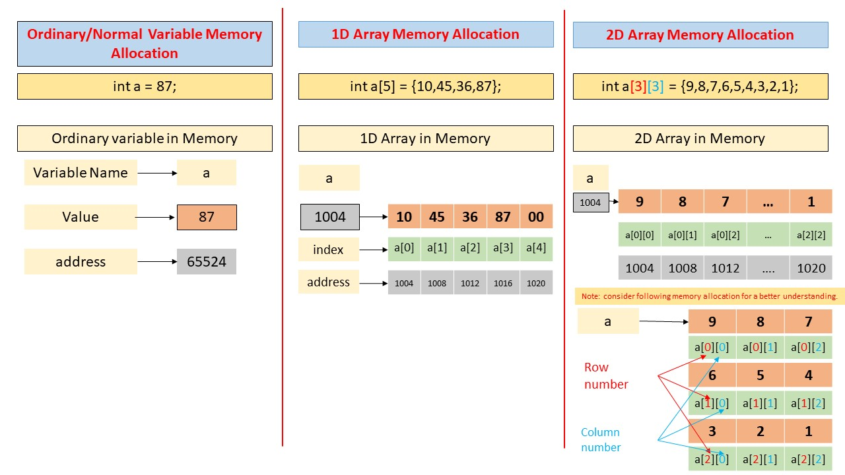

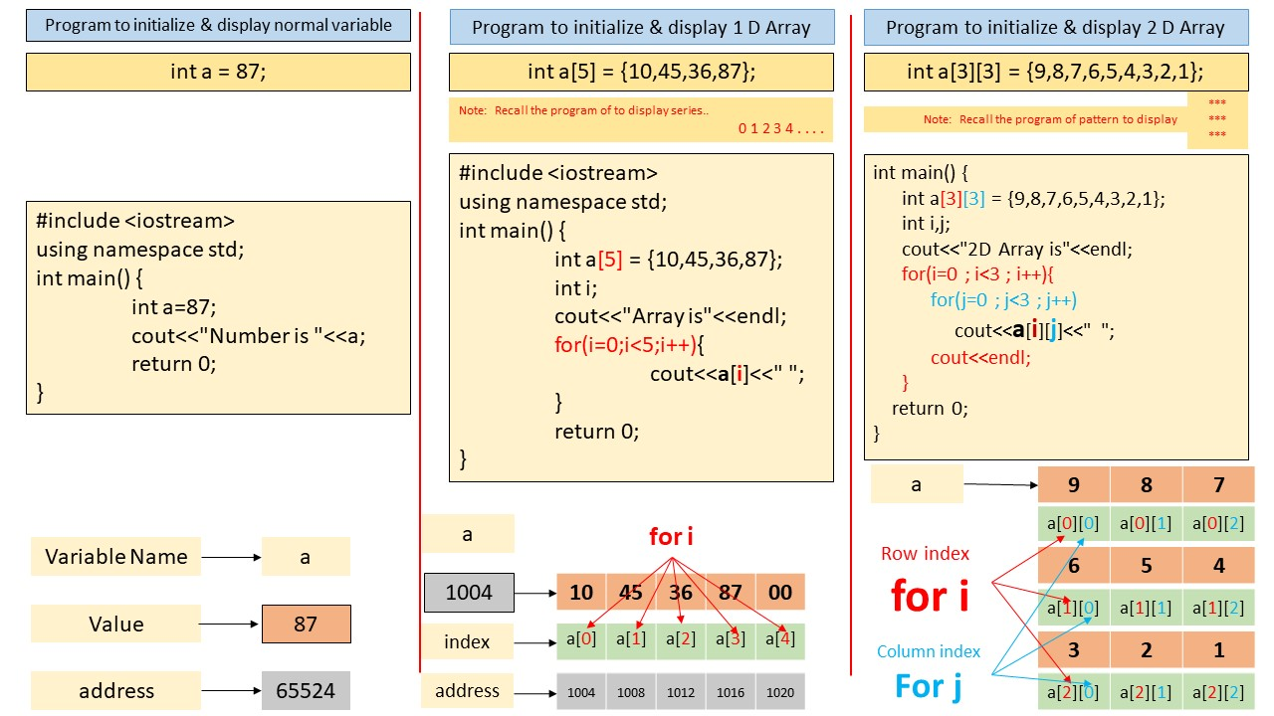  
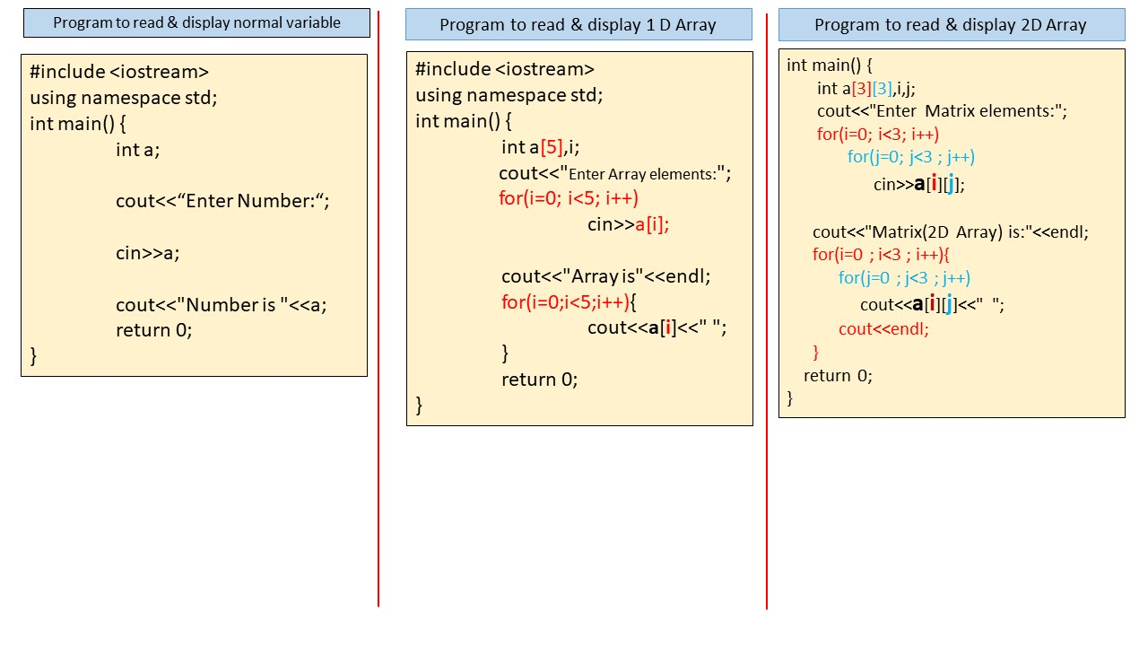

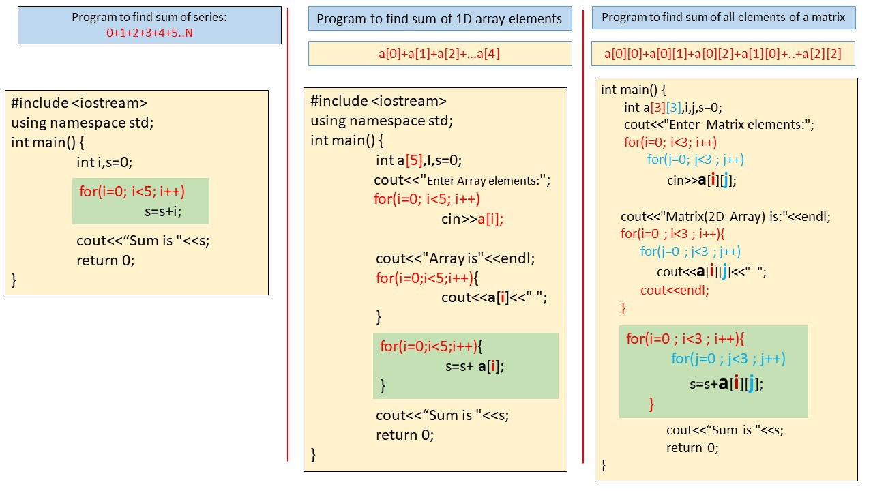

**Tasks:**

|  |  |  |  |  |  |  |
| --- | --- | --- | --- | --- | --- | --- |
| Sr. No. | Problem Statement | I/O | Test Cases | Flow chart | Program- with color codes | Trace Table |
| 1 | Write a program to multiply each element of an array by 5 and display the resultant array. | ✓ | ✓ | ✓ | ✓ | ✓ |
| 2 | Write a program to find and display odd & even numbers from an array (1D) separately. | ✓ | ✓ |  | ✓ |  |
| 3 | Write a program to copy one 1D array into another 1D array and display copied array. | ✓ | ✓ |  | ✓ |  |
| 4 | Implement a program to reverse elements of 1D array and display it. | ✓ | ✓ |  | ✓ |  |
| 5 | Develop a program to perform sum of elements of matrix (2D array) of order MXN. | ✓ | ✓ | ✓ | ✓ |  |
| 6 | Develop a program to find sum of elements of lower triangular matrix of order MxN. | ✓ | ✓ |  | ✓ |  |
| 7 | Write a program to perform addition of two matrix (2D array) and display the resultant matrix. | ✓ | ✓ |  | ✓ |  |
| 8 | Implement a program to find the largest element 3X3 matrix. | ✓ | ✓ |  | ✓ | ✓ |

**Practice Questions:-**

1. Write a program to find sum of odd & sum of even numbers from array separately.
2. WAP to copy one array into another array in reverse order.
3. WAP to delete an element from an array.
4. WAP to find Sum of diagonal elements of MxN matrix.
5. WAP to find Sum of elements of upper triangular of MxN matrix.
6. WAP to find Matrix multiplication [of order mXn and pXq].