Lab-2:Agile Backlog Creation & Sprint Simulation in Jira

Customizable Subscription Box Scheduler

Name: Rhea Menon
SRN: PES1UG24AM222
Jira Space: UAPI board (menonrhea2005.atlassian.net)

1. Project Overview
This submission documents the Agile backlog and Sprint 1 simulation built in Jira for the Customizable Subscription Box Scheduler (Problem Statement #35), rather than the teacher's worked Coffee Kiosk example. The backlog was derived directly from the five functional requirements (FR-001–FR-005) and two non-functional requirements (NFR-001, NFR-002) defined in the Lab 1 Requirements Table, and organized into four epics and seven user stories covering subscriber preferences, billing, payment security, and fulfillment.
Section 2 presents the full Epic and User Story table. Section 3 documents backlog prioritization and story-point estimation. Section 4 documents Sprint 1 planning. Section 5 documents the sprint report / burndown chart access. Section 6 is the group reflection.

2. Epics & User Stories
The table below lists all 4 epics and 7 user stories created for this scenario, in the same Epic → Description → User Stories format used in the reference handout.
Epic 1 — Subscriber Preference & Delivery Customization
Allow subscribers to personalize their box preferences and manage upcoming deliveries before fulfillment locks in.
User Story | As a... | I want to... | So that...
UAPI-9 (5 pts, High) | Subscriber | to set and update preference tags (e.g., dietary, genre, roast type) | my monthly box is auto-curated to match my preferences.
UAPI-10 (8 pts, High) | Subscriber | to swap items in my monthly box up to 48 hours before my billing renewal date | I can customize my delivery to match my current taste before it locks in for fulfillment.
Epic 2 — Billing Cycle & Payment Management
Manage the subscriber's recurring billing cycle — including automated charges, cycle skipping, and promotional discounts — so payments process accurately and predictably every month.
User Story | As a... | I want to... | So that...

UAPI-11 (5 pts, Medium) | Subscriber | to skip a single upcoming billing cycle without cancelling my subscription, submitted at least 48 hours before renewal | I can pause deliveries for a month I don't need a box without losing my subscription.
UAPI-12 (8 pts, High) | Subscriber | the system to automatically charge my saved payment method on the billing renewal date | my subscription continues without manual effort.
UAPI-13 (3 pts, Low) | Subscriber | to apply a valid promotional discount code during checkout or renewal | I can reduce my subscription cost whenever a promo offer is available.

Epic 3 — Payment Security & Validation
Ensure all subscriber payment data is validated, encrypted, and processed in full compliance with PCI-DSS standards to protect financial information.
User Story | As a... | I want to... | So that...
UAPI-14 (8 pts, High) | Subscriber | my payment details validated and encrypted (PCI-DSS compliant) whenever a charge is processed | my financial data stays protected at rest and in transit.

Epic 4 — Fulfillment Operations
Enable the Fulfillment Lead to generate and export accurate, scalable shipping manifests for all confirmed subscriber boxes ahead of the shipping date.
User Story | As a... | I want to... | So that...
UAPI-15 (13 pts, High) | Fulfillment Lead | to generate and export a fulfillment manifest (box contents and shipping labels) for all confirmed subscriber boxes, scaling to 10,000 boxes in under 1 minute | I can pack and ship orders accurately and on schedule.

3. Backlog Setup, Epics & Prioritization
The Scrum space ("UAPI board") was configured with Epic, Story, Bug, and Task work types and a To Do / In Progress / Done workflow.

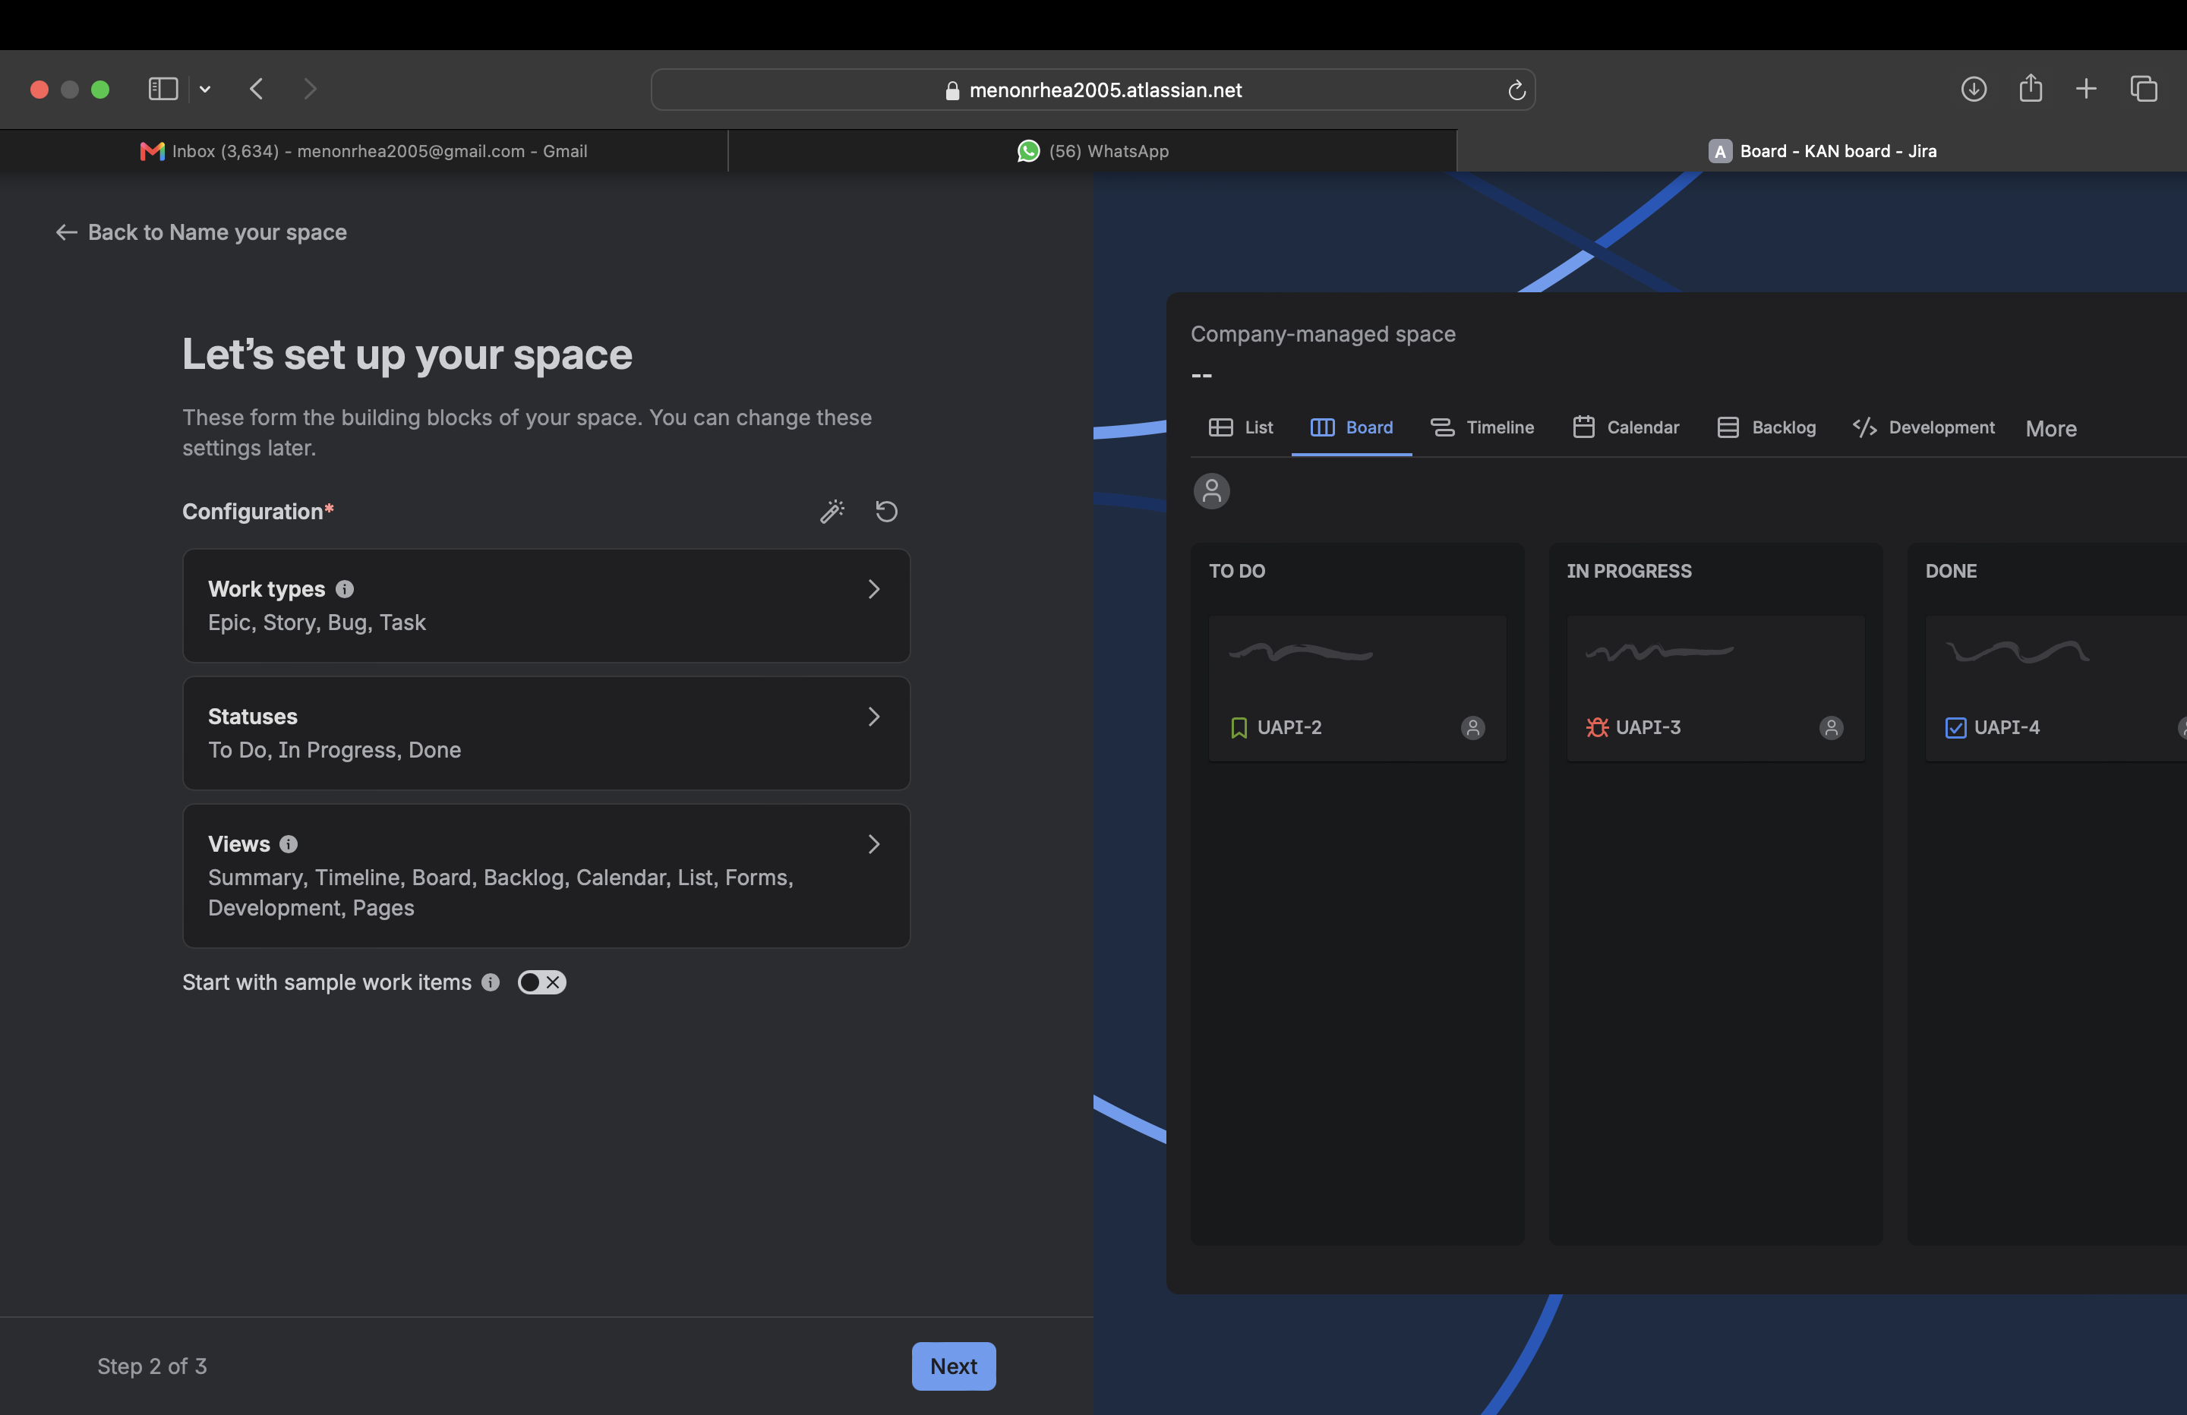

All 4 epics were created and each of the 7 stories was linked to its correct parent epic via the Parent field.

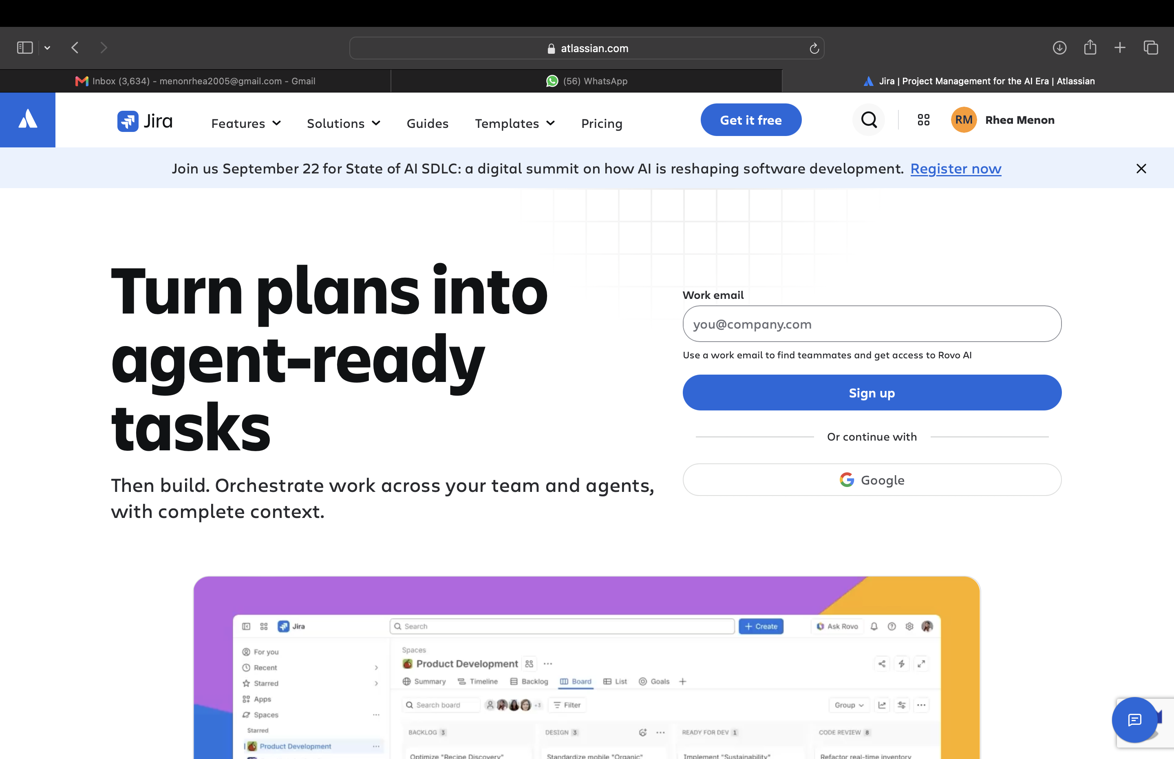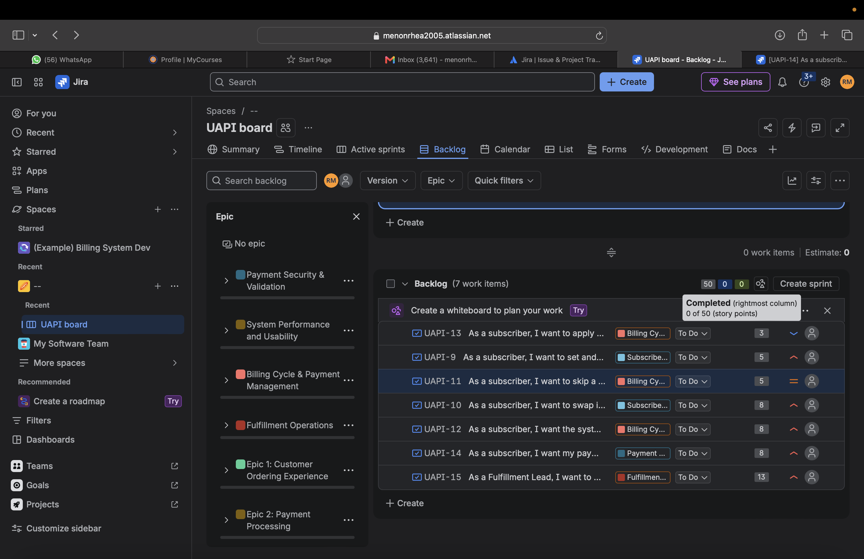

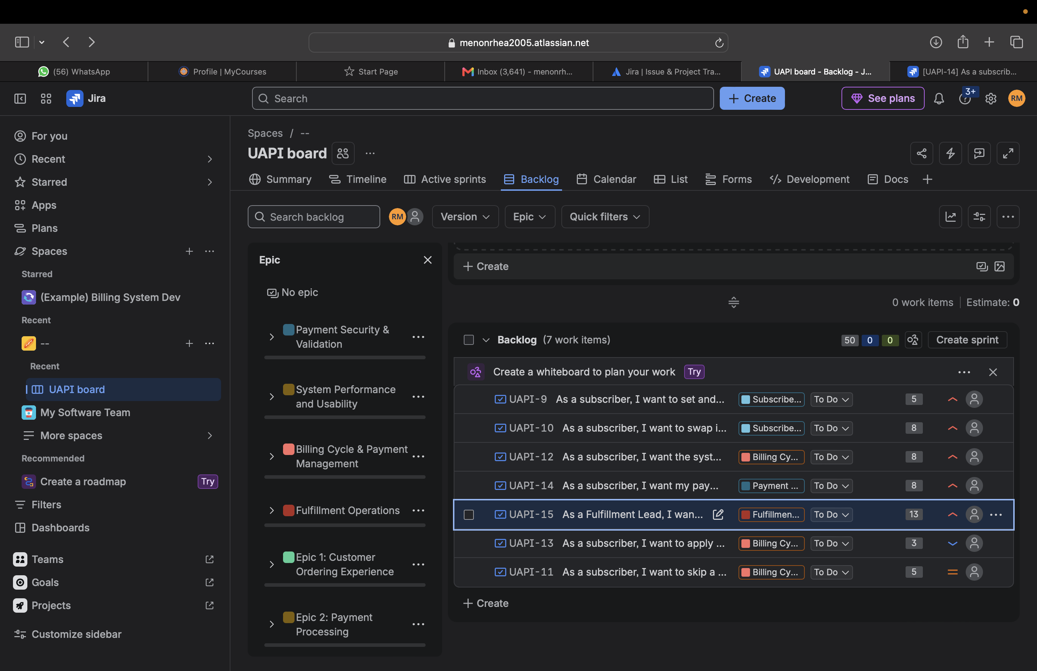

4. Sprint 1 Planning & Execution
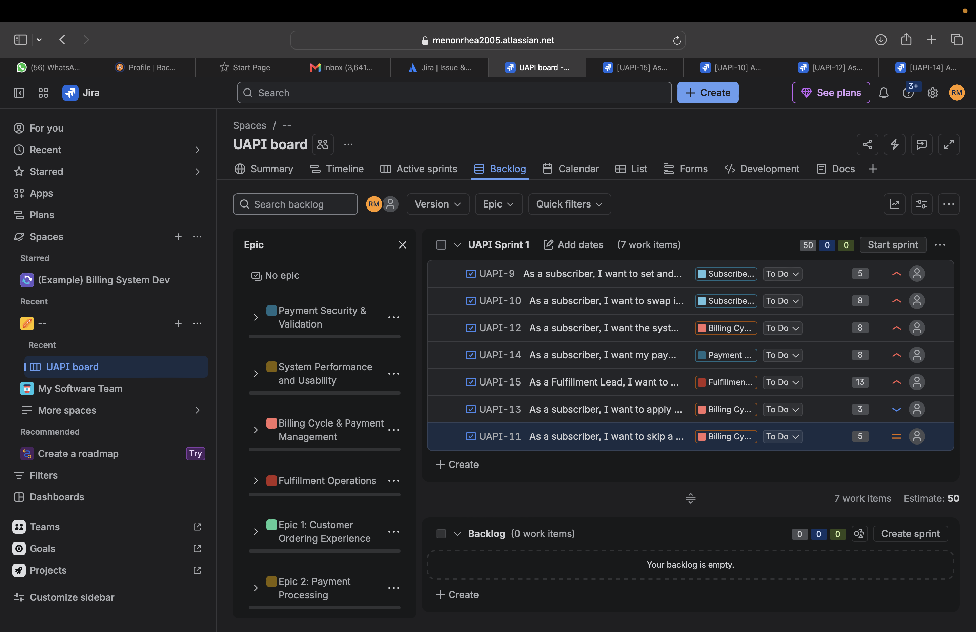

5. Sprint Report & Burndown Chart
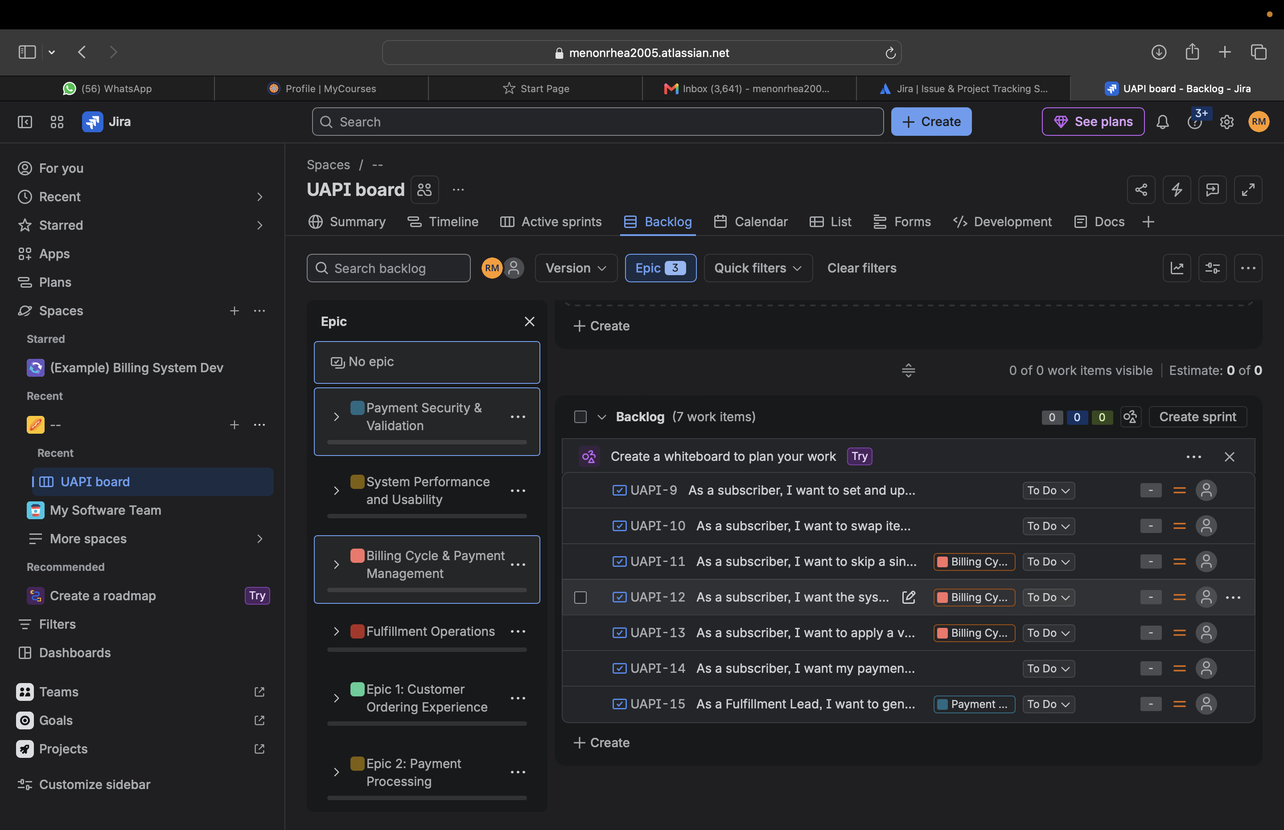

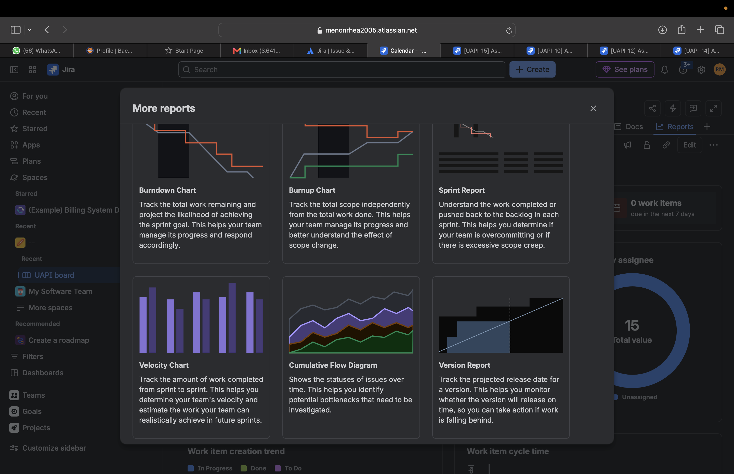

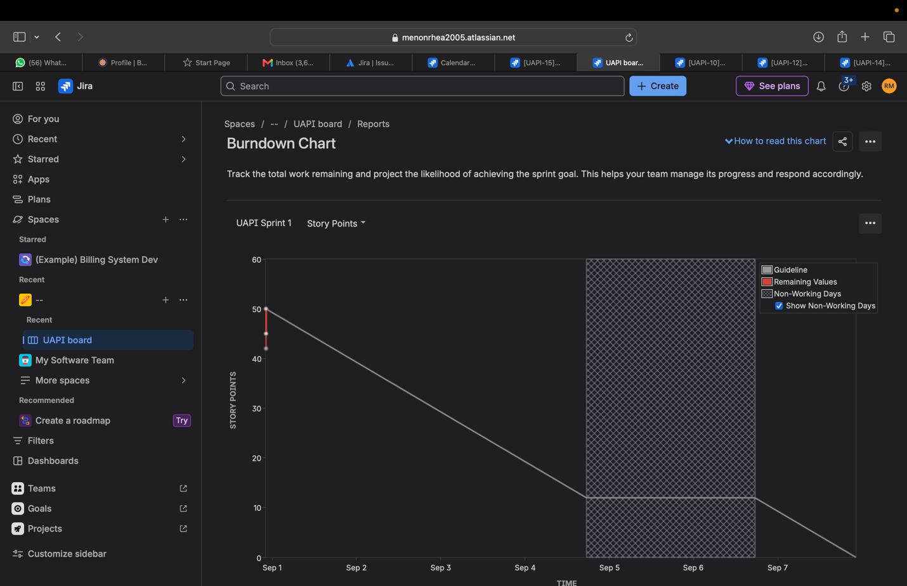

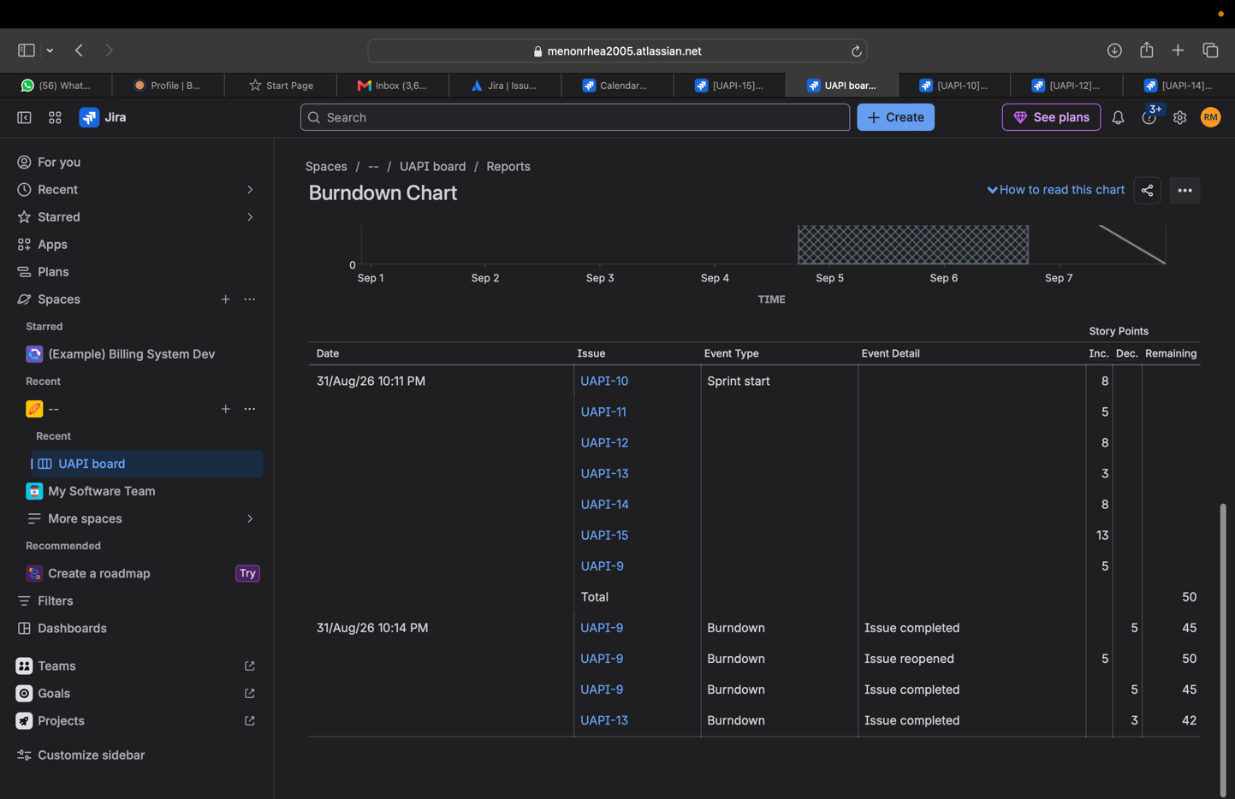

6. Group Reflection
Since I used my own Lab 1 requirements instead of the coffee kiosk example, the biggest adjustment was figuring out how to turn FR-001 through FR-005 into epics that actually made sense together. I almost made each functional requirement its own epic at first, but that got messy fast — grouping billing, security, and fulfillment separately ended up working a lot better once I saw how the stories naturally clustered.
Story points were probably the trickiest part of the whole thing. My first pass had almost everything set to 5 because I didn't really have a reference point yet. Once I started comparing stories directly against each other, like noticing that automatically charging a saved payment method (UAPI-12) needed way more thought than just applying a promo code (UAPI-13), the numbers started making more sense. I also ran into an issue where Jira reset one of my story's points back to blank without me touching it, so I got in the habit of double-checking every field before trusting the sprint total.
Prioritizing the backlog made it pretty obvious which features the app can't function without. Payment security and automatic billing were easy High priority picks since the subscription model just doesn't work without them, while the promo code story was an easy Low since it's optional. Moving all seven stories into Sprint 1 and starting it gave me a decent feel for what an actual sprint kickoff looks like, even on this small a scale.
If I did this again with a bigger team, I'd probably break UAPI-15 down into smaller stories since 13 points is a lot to track as one card, and I'd double-check that every field (epic link, points, priority) actually saved before moving on to the next story. Small stuff like that is easy to miss until the sprint numbers don't add up and you have to go back and find out why.

