# Login page will get the users from the data base

1. **I have to choose a user**
2. **Then if the user is chosen or correct I**

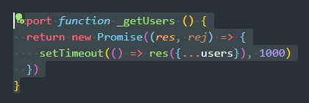**a- will pass to the home page.  
b- if no user I will be sent back to the login page and asked to login first.**

That’s why I need the following:

1. Know how to choose a user from the database.(get users)
2. Know where to redirect the user(fake blank page with one word as a text.)
3. Make a state for the currentUser and pass it to all the components….
4. If current user then I will be able to interact with the component if no current user or current user is empty then I will be redirected back to the login page.
5. How will I implement this by redux.