NAME: Galoran John Haru B. DATE: Dec. 16. 2023.

COURSE &BLK:BSCOM-E SCORE:__________

PROGRAMMING LOGIC AND DESIGN

FINAL EXAMINATION

Direction: Using online C++ compiler Screenshot your simulation and paste your code. **No Cheating. (Cheating Automatic zero)**

1. Create a C++ program to solve the average of four numbers(5points)

Example : the user input numbers(3,3,5,5) the program output will be 4.

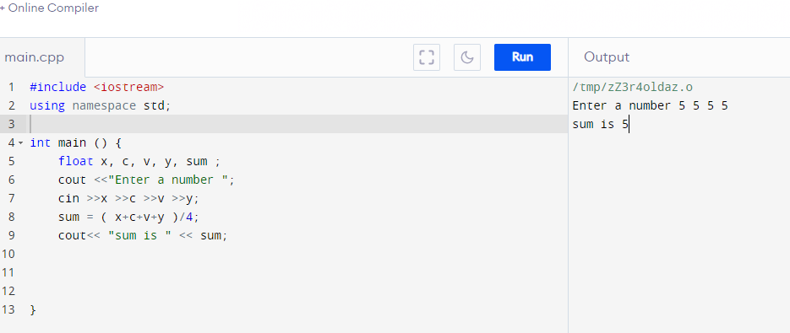

#include <iostream>

using namespace std;

int main () {

float x, c, v, y, sum ;

cout <<"Enter a number ";

cin >>x >>c >>v >>y;

sum = ( x+c+v+y )/4;

cout<< "sum is " << sum;

}

1. Create a C++ program to find the LCM of four numbers(15 points)

Example : the user input numbers(10,12,8,4) the program output will be 120.

1. Create a C++ program that converts the decimal number into binary number(20 points)

Example : the user input numbers(7) the program output will be 111.

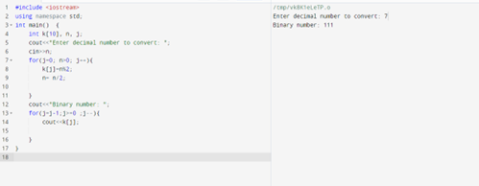

#include <iostream>

using namespace std;

int main() {

int k[10], n, j;

cout<<"Enter decimal number to convert: ";

cin>>n;

for(j=0; n>0; j++){

k[j]=n%2;

n= n/2;

}

cout<<"Binary number: ";

for(j=j-1;j>=0 ;j--){

cout<<k[j];

}

}

1. Create a C++ program to enter a decimal number and the program separate and display the digit.

(30 points)

Example: the user enter a number (3425)

Output:

3

4

2

5

