INTRODUCTION

Written by Nicholas D. Mensah

Western Governors University

Study.com

Computer Science 115: Programming in Java

3/18/2022

Author Note

Funded by the Mensah Family

Abstract

In this article I qualitatively explore the foundations of Java, a compiled programming language. As a novice Java Programmer, I design this basic average grading app. 1) this app will be geared toward students, professors, and parents to track the progress of an individual’s grades. 2) Through this average quiz grading app, I touch on the theories of Arrays, Array List, Conditional Statements, for loops, Do… while… Loops, Swing, Java utility packages, Class, and Method formatting. While constructing the Average Quiz Grade App the Java language demonstrates this light weight language through error debugging. I have added a concept of how the app would look without the functionality. It will serve as an outline and the app can be tested in the terminal.

Keywords: Java, Debugging, Class, Method

INTRODUCTION

# According to Oracle, “Java is the #1 programming language and development platform” as shown in table 1. After programming with JavaScript for a couple months, I was up for a challenge, and Java was that challenge. Java, is a very verbose and somewhat light weight language to write. For example, Java is a compiled and very declarative language, but with practice this language can serve as foundation toward a stronger foundation and many other programming languages. Through this test/quiz grading App, I will dive deeper into this language through exploration, of Data types, Class and method declarations, loops and arrays. With diving deeper into Java, I hope to solve this challenge of obtaining the final class average and final letter grade. I will take an Algorithmic approach, being that we as programmers are just writing logic for the computer so it can clearly produce our results. Therefore, we will develop a program that will help individuals obtain a final letter grade and average score with Java.

As stated by Matt McClintock “Knowing how to write, compile and execute code is a skill” and this developing a program project has encouraged me develop my knowledge as a programmer in in Java. *My Developing a Programming Java* was executed and complied through the Integrated development environment (IDE) with used a JDK and java development extensions. Then, we start writing with a class titled App. The class App extended JFrame so if needed I could utilize the various methods and components to eventually produce a proper graphical user interface. Since, the program only calls for the program to be executed through the terminal, I will prompt the user to submit 10 grades and the program will store and reproduce these grades along with a final grade and an average score.

The logic is the meat of this program and will be implemented through George Bools conditional statement theories. I will utilize loops to in a way to keep the program automated and limit the lines of code. I will make use of the do... while... loop due to it executing once so that even if the user does not want to use the program and exits with the numbers 999, they will be prompted at least once to “please enter your final 10 test scores or 999 to exit:”. In addition to the do… while loop…, I used the for loop being that we specified that we would obtain then score at max. Therefore, with the utilization of for loop, do while loops and conditional statement I will obtain the information needed through the importation of the SCANNER class from the util package.

## PROBLEM STATEMENT

Debugging allows an individual to be a stronger developer, because once you suffer through bugs you will be able to spot then in the future. Through, the knowledge of Robert C. Martin from The *Clean Coder* I try to implement “Test Driven Development” to minimize debugging. The task, would be to gain a user’s 10 ten test scores, compute the average, compare the average to a set of predefined results and boom you have the results that are requested, but only if it was so easy. One of the main enigmas that I came across was trying to get through the issue of the mismatch error. To elaborate, oracle states that a mismatch error is “Thrown by a Scanner to indicate that the token retrieved does not match the pattern for the expected type, or that the token is out of range for the expected Thrown by a Scanner to indicate that the token retrieved does not match the pattern for the expected type, or that the token is out of range for the expected type. type.” Next, a problem would have risen by with the do while loop going through an infinite loop, not clearly stating the condition make the statement true. Another, issue that I have been tasked with exiting the program if the user enters 999. For example, if the user no longer wanted to continue, they would still get a grade for the exams entered at that moment. Another task that I have would be to obtain the total from the array list.

### Solution

To solve the mismatch error, I utilizes the using a String to begin with being that I could catch if the user enters a none integer as well as making it simpler for the try catch exception handler. I started as a string and used the parseInt (). To convert a string into an integer as demonstrated in figure 1. By starting as a string, I could verify if the element was a string or if it was properly converted to an Integer. The solution for exiting the program if 999 was entered would be to check whether the user wanted to continue after being prompted to enter an integer to capture scores in the array list. In order, to obtain and total the elements from the array list I would utilize another for loop and increment the total by each time the array list is loop through. By obtaining the total now we are able to get the average by diving the total by the array. Size () or in our case 10 since 10 will be the total amount of scores obtained.

#### PERFORMANCE EVALUATION

Developing in Java has been a success it preforms the task that it was designed to accomplish. The program will prompt the user to submit 10 or less scores, then the program goes through the java engine places the results in an array list. From the array list the elements are cycled through with a for loop and arithmetically summed to obtain a total, then the average is stored wrapper Integer variable named avgScore which is using the naming convention which is camel case. Next, the average is calculated, then the average is printed in the terminal to test before proceeding. Subsequently, the average score goes through conditional statement which goes through a grading scale from zero to 100. The grades of A-F will be stored in an Array due to the array having a fixed size compared to the Array List. The letter grades are accessed from the array through indexing. For example, letterGrade [0] will access and “A” were as letterGrade [4] result in an” F”. Consequently, when an invalid score is given the conditional statement will trigger the user to produce a Valid Score. For example, if a user where to input an invalid integer which results in a irrational number then the condition will trigger the final else condition to produce a Valid score. At the end of the program, you will have your average score, and letter grade with the list of scores entered for you to have assurances as shown in figure 2.

##### CONCLUSION

Therefore, developing a Java program will leave any programmer or anyone interested in a challenge with pure satisfaction. The program has accomplished its end goals as shown in *fiqure2* (Mensah,2022). The program will produce the average scores, a grade, and a list of score. The program will allow the user to exit if the user enters 999. I attempted to produce clean and concise code. Finally, the debugging of the code was minimized by trying to catch errors before writing a line of code. With the try catch exception I attempted to throw a wide enough net that will catch errors and will prevent to code from overflowing. Thanks for this opportunity and I hope you enjoy. Any suggestions will greatly be appreciated. The gui is there to show what I will be working on in the future.

References

Practical Application for Java: Using the Scanner Class. (2017, December 26). Retrieved from https://study.com/academy/lesson/practical-application-for-java-using-the-scanner-class.html.

Programming in Java - Assignment: Developing a Java Program. (2018, October 16). Retrieved

from <https://study.com/academy/lesson/programming-in-java-assignment-developing-a-java-program.html>.

Static vs. Non-Static Methods in Java. (2017, December 8). Retrieved from <https://study.com/academy/lesson/static-vs-non-static-methods-in-java.html>.

What is a JFrame Class in Java? - Uses & Examples. (2018, March 9). Retrieved from <https://study.com/academy/lesson/what-is-a-jframe-class-in-java-uses-examples.html>.

Oracle Java: OraclePro Consulting & Services. (2022, March18). Retrieved from <https://www.oraclepro.com/products/oracle-java/>

Martin, R. C. (2020). *The clean coder: A code of conduct for professional programmers*. Ren min you dian chu ban she.

InputMismatchException (java platform SE 7). (2020, June 24). Retrieved March 18, 2022, from https://docs.oracle.com/javase/7/docs/api/java/util/InputMismatchException.html

*The most popular programming languages - 1965/2022 - new update*. Statistics and Data. (2022, January 9). Retrieved March 18, 2022, from https://statisticsanddata.org/data/the-most-popular-programming-languages-1965-2022-new-update/#:~:text=Java%20moved%20from%20second%20place,also%20in%20the%20top%2010.

Tables

Table 1

Oracle stated Java was #1

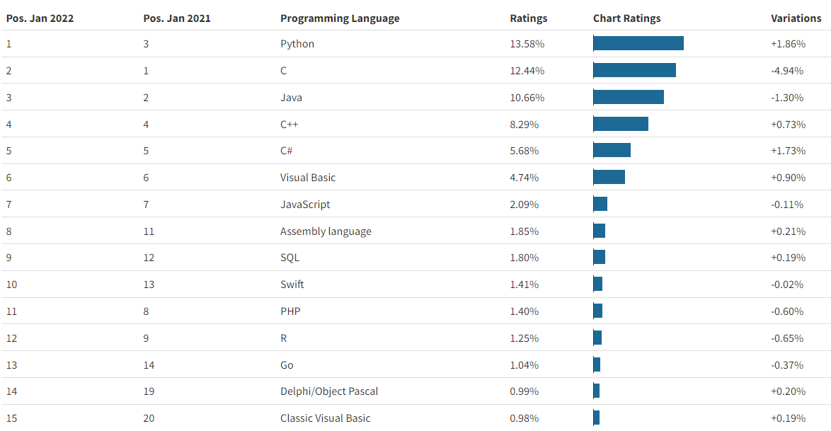

Note: As of 1 January 2022, the most popular programming language is Python. Python has a rating of 13.58%. This is an increase of +1.86 compared to January 2021. Thanks to this change, Python has moved from third position to first. In second place is C, which has a rating of 12.44%, a decrease of 4.94% compared to the previous year. Because of this change, C moved from first to second place. In third position is Java with 10.66% ratings and a change of -1.30%. Java moved from second place in 2021 to third place in January 2022. C++, C#, Visual Basic, JavaScript, Assembly Language, SQL and SQL in tenth position with 1.80% are also in the top 10.

Class InputMismatchException

Figure 1. This is the solution for the mismatch error thrown by Scanner “public class ****InputMismatchException****

extends [NoSuchElementException](https://docs.oracle.com/javase/7/docs/api/java/util/NoSuchElementException.html)

Thrown by a Scanner to indicate that the token retrieved does not match the pattern for the expected type, or that the token is out of range for the expected type.”

Conditional Statement Results

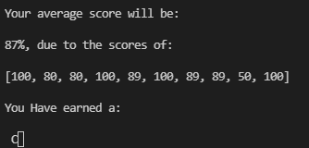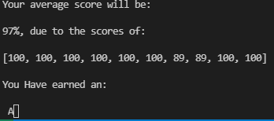

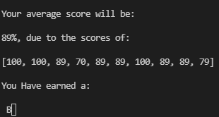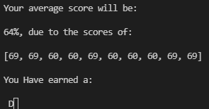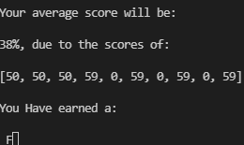 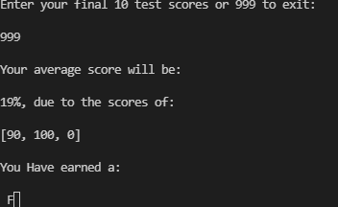

*Figure 2. shows the results of the conditional after debugging and testing the program*