|  |  |
| --- | --- |
|  |  |
|  | Machine Learning |
|  |  |
|  |  |
|  | **Lab 1: Decision Trees**  LinusGroß  DanielMensah |
|  |  |

|  |
| --- |
|  |

# Assignment 0

*Each one of the datasets has properties which makes them hard to learn. Motivate which of the three problems is most difficult for a decision tree algorithm to learn.*

With the known true concept, the easiest to learn is probably the set MONK-1 because it just depends on 3 attributes and having a conjunction as a connection. However, the property *a*1 = *a*2 is more difficult to test, because there are 3 possibilities for this equation to be true. With the property *a*5 = 1 there is a very easy equation to check which can terminate the tree quite early.

The set MONK-2 is the most difficult for a decision tree algorithm to learn because all six attributes have to be considered. Thus, the tree needs to have all six attributes for a decent decision.

The MONK-3 set depends like set MONK-1 on 3 attributes, but the tree will at least have a depth of 2 attributes. Furthermore, the attribute *a*5 is considered in both equation and especially in the inequality, which means all 3 other branches, where the inequality is true, must be continued.

# Assignment 1

*The file dtree.py defines a function entropy which calculates the entropy of a dataset. Import this file along with the monks datasets and use it to calculate the entropy of the training datasets.*

The following table shows the entropy of the monk training datasets. MONK-1 has the highest entropy, which makes it the most unpredictable dataset. However, the entropy of the other datasets is just slightly lower.

|  |  |
| --- | --- |
| Dataset | Entropy |
| Monk-1 | 1 |
| Monk-2 | 0,957117 |
| Monk-3 | 0,999806 |

# Assignment 2

*Explain the entropy for a uniform distribution and a non-uniform distribution, present some example distributions with high and low entropy.*

Looking at the formula for the entropy

$$E\left(S\right)=-\sum_{i}{p_{i}⋅\log_{2}{(p_{i})}}$$

we have to consider the negative sum of the function $f\left(x\right)=x⋅\log_{2}{(x)}$ with *x* equal to the different probabilities *pi*.

The following graph show the function *f(x)* for $0≤x≤1$. If the probability *x* is near to 0 or 1 the entropy tends to 0. This makes sense, since a high and respectively a low probability leads to a great predictability and thus to a low entropy.

For a uniform distribution, every of the *n* events has the same probability $p_{i}=p=1/n$ and the formula for the entropy simplifies to:

$$E\left(S\right)=-\sum_{i=1}^{n}{p_{i}⋅\log_{2}\left(p_{i}\right)}$$

$$E\left(S\right)=-\sum_{i=1}^{n}{\frac{\log_{2}\left(\frac{1}{n}\right)}{n}}=-\log_{2}\left(\frac{1}{n}\right)$$

As the following graph shows, the entropy follows a logarithmical growth for a uniform distribution. The entropy reaches to quite high values, since a single event gets very unpredictable when the total amount of events *n* rises.

For example, rolling a dice has a uniform distribution with *n = 2* and leads to an entropy of approximately 2,585.

On the other hand, non-uniform distributions can lead to much lower entropies. Considering, that some events are more likely than other events in these distributions, the predictability is much higher in contrast to a uniform distribution, which however leads to a lower entropy.

As a example we consider a manipulated dice with the following probability distribution:

|  |  |  |
| --- | --- | --- |
| Event | Non-uniform distribution | Uniform distribution |
| 1 | 5% | 16,67% |
| 2 | 5% | 16,67% |
| 3 | 5% | 16,67% |
| 4 | 5% | 16,67% |
| 5 | 5% | 16,67% |
| 6 | 75% | 16,67% |
| Entropy | 1,3917 | 2,585 |

On the right graph we see, that the event 6 is much more likely in comparison to the uniform distribution. Using the entropy-formula we will get the entropy 1,39 for the manipulated non-uniform distribution, which is way lower than the entropy of the uniform dice (2,585).

So you can say that generally that uniform distributions maximize the entropy while non-uniform distributions on the other hand have always a lower entropy.

# Assignment 3

*Use the function averageGain to calculate the expected information gain corresponding to each of the six attributes. Based on the results, which attribute should be used for splitting the examples at the root node?*

The following table shows the information gain for each attribute at the root node. A value corresponds to a high information gain, which means we lower the entropy as much as possible by asking for the give value.

|  |  |  |  |  |  |  |
| --- | --- | --- | --- | --- | --- | --- |
| Dataset | *a*1 | *a*2 | *a*3 | *a*4 | *a*5 | *a*6 |
| MONK-1 | 0.0752726 | 0.0058384 | 0.0047075 | 0.026311 | 0.2870307 | 0.00075786 |
| MONK-2 | 0.003756177 | 0.002458499 | 0.00105614 | 0.015664247 | 0.01727717 | 0.006247622 |
| MONK-3 | 0.007120868 | 0.2937361735 | 0.000831114 | 0.002891817 | 0.2559117246 | 0.00707702607 |

With the give true concepts, it makes sense to take *a*5 as the first attribute in MONK-1. In MONK-2 all attributes need to be considered and it seems like *a*5 is the best attribute. The true concept behind MONK-3 suggests that *a*5 is the best attribute to ask for first, thus it is used in both equations. Yet the algorithms suggest *a*2 as the best attribute to ask, because it has only 3 values it can take in contrast to *a*5, which can take 4 different values.

# Assignment 4

*For splitting we choose the attribute that maximizes the information gain, Eq.3. Looking at Eq.3 how does the entropy of the subsets, Sk, look like when the information gain is maximized? How can we motivate using the information gain as a heuristic for picking an attribute for splitting? Think about reduction in entropy after the split and what the entropy implies.*

Maximizing the information gain means that we want to lower the entropy as much as possible. This means, that the term

$$\sum_{kϵvalues(A)}{\frac{\left|S_{k}\right|}{\left|S\right|}Entropy(S_{k})}$$

should be as low as possible. This implies that the sum of the weighted entropy of the given subset is as low as possible, which means it is very predictable. Consequently, the information gain is high, if the entropy of a subset is very low, we gain much information about the total set and are able to reduce the entropy of the remaining set as much as possible.

# Assignment 5

*Build the full decision trees for all three Monk datasets using buildTree.*

Monk-1:

As expected for the case of *a*5 = 1 the tree terminates quickly. But however, the algorithm decides to check the important attributes *a*1 and *a*2 mostly on the end of the tree, which leads to more nodes than needed

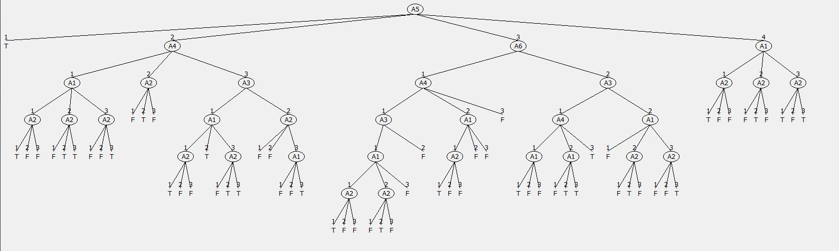

Monk-2:

Since all six attributes need to be checked the tree grows as expected very large and doesn’t even fit the screen. Thus, this is the hardest problem for the decision tree.

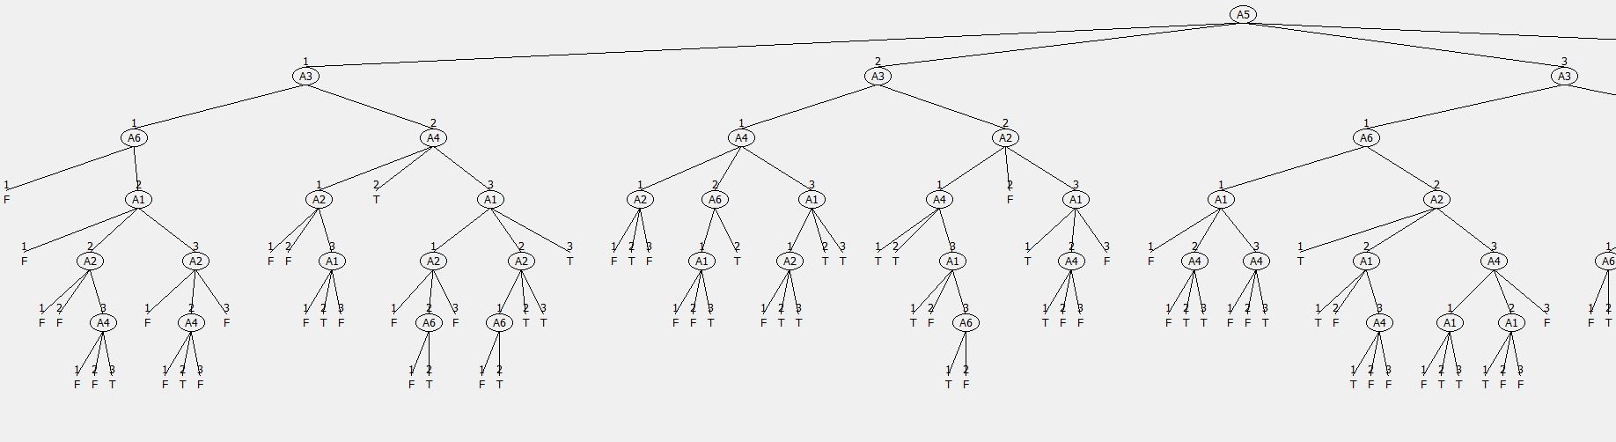

Monk-3:

For the Monk-3 dataset the algorithm grew the smallest tree. This is due to the true concept, which was quite easy for the algorithm to detect.

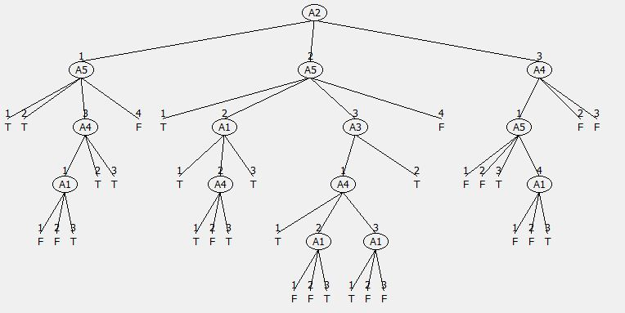

*Compute the train and test set errors for the three Monk datasets for the full trees. Were your assumptions about the datasets correct? Explain the results you get for the training and test datasets.*

The following table shows the errors of the different datasets, with the respective training and test dataset.

|  |  |  |  |
| --- | --- | --- | --- |
|  | *E*Train | *Right classificationTest* | *E*Test |
| Monk-1 | 0 | 0,828704 | 0,171296 |
| Monk-2 | 0 | 0,692129 | 0,307871 |
| Monk-3 | 0 | 0,94444 | 0,055556 |

All training sets have the maximal accuracy of 1. The Monk-3 dataset has 5% additional noise (misclassification on the training set), hence it is not surprising that the accuracy is nevertheless by 1 because we check our false tree on the “false” dataset. It is mseeming contradictory at first, but after detailed thinking about it, it makes total sense.

At the test dataset the Monk-2 set has as expected the highest error. This is due to the fact, that all 6 attributes have to be considered to make the right decision. The tree however has some branches that terminate after 2 nodes, so not all attributes are considered and it comes to misclassification.

The 3rd Monk dataset has the best result. The reason for this is the easy true concept behind this set, which leads to the smallest decision tree with many early terminating branches. The 5% error comes from the misclassification in the training set.

As discussed before, the first Monk dataset has a tree which is build up way too large. The true concept just looks at 3 attributes, but the tree uses way more to classify the data. This could be a reason for the error of approximately 20%.

# Assignment 6

*Explain pruning from a bias variance trade-off perspective.*

An optimal decision tree would have no bias and a low variance. The higher the complexity the model has, the higher is the variance. This means, the deeper our tree is, the higher is the variance. A consequence of a high variance is the highly dependence of the training data. But a deep tree also indicates a smaller bias, since we do use all the attributes to specify a sample to a given class. This means, by pruning the tree we minimize the variance by the cost of the bias.

# Assignment 7

*Evaluate the effect pruning has on the test error for the monk1 and monk3 datasets, in particular determine the optimal partition into training and pruning by optimizing the parameter fraction. Plot the classiffcation error on the test sets as a function of the parameter fraction.*

The goal is to minimize the classification error by maximizing the amount of the correct assigned samples to the classes. By using reduced error pruning we cut the tree at several nodes to improve classification of the decision tree. For this the training data is separated randomly into a training set and a validation set. The validation set is used to decide whether the pruned performs better or worse than the unpruned tree.

The following graphic shows the mean of the classification error over the fraction for splitting the data.

On the graph we can see the effects of the pruning. In general, we lose some score in the classification for the smaller trees. For the MONK-3 set the pruning varies the classification score in the range of 4%, but a higher score than with the full tree can be achieved. This is due to the reason, that the full MONK-3 tree is already quite small and delivers a very good result.

On the MONK-1 set the pruning has a huge effect. The classification score can gain up to 4% in comparison with the full tree. Furthermore, the complexity of the big tree is drastically reduced. The graph shows also the effect of the division of the training data into new training and validation data. A higher fraction corresponds to a higher a percentage of the new training data. It makes sense to keep the validation data smaller than the training data, since a decent grown tree from training data is more essential than a huge validation of the pruning.

The following table show the calculated mean, standard deviation, standard error and the confidence interval by using the student-t distribution with a 95% confidence interval

|  |  |  |  |  |  |  |  |
| --- | --- | --- | --- | --- | --- | --- | --- |
|  | fraction | | | | | |  |
|  | 0,3 | 0,4 | 0,5 | 0,6 | 0,7 | 0,8 |  |
| mean | 0,7712 | 0,7973 | 0,8195 | 0,8398 | 0,8514 | 0,8605 | MONK-1 |
| standard deviation | 0,04195564 | 0,04017762 | 0,04611075 | 0,04800408 | 0,0487415 | 0,049281097 |
| standard error | 0,00132742 | 0,00127116 | 0,00145888 | 0,00151878 | 0,00154211 | 0,001559185 |
| confidence interval (half) | 0,00260485 | 0,00249446 | 0,00286282 | 0,00298037 | 0,00302615 | 0,003059653 |
|  |  |  |  |  |  |  |  |
| mean | 0,9156 | 0,9395 | 0,9543 | 0,9565 | 0,9585 | 0,9521 | MONK-3 |
| standard deviation | 0,0568633 | 0,04371987 | 0,03474082 | 0,03127266 | 0,02877312 | 0,032359949 |
| standard error | 0,00179908 | 0,00138324 | 0,00109915 | 0,00098942 | 0,00091034 | 0,001023823 |
| confidence interval (half) | 0,0035304 | 0,00271438 | 0,00215691 | 0,00194159 | 0,0017864 | 0,002009091 |
|  |  |  |  |  |  | N | 1000 |
|  |  |  |  |  |  | t(crit) for 95% | 1,96234146 |