UNIVERSITY OF SKILLS TRAINING AND
ENTREPRENEURIAL DEVELOPMENT (USTED)
Faculty of Applied Sciences and Mathematics Education
Department of Information Technology Education

ICT233: Web Technologies and Design
Group Assignment — 2025/2026 First Semester

USTED CLINIC
Online Healthcare Website Project

GROUP 3
Submission Date: Friday, April 10, 2026

Group 3 Members
S/N | Index Number | Role
1 | 5240210021 | ASARE BOADI KELVIN
2 | 5240210022 | FAROUK ABDUL SHAFIU
3 | 5240210023 | AIDOO ZIPPORAH
4 | 5240210024 | SAMUEL MENSAH OPOKU
5 | 5240210026 | BADU BRIGHT
6 | 5240210027 | OWUSU ASIEDU EPHRAIM
7 | 5240210028 | PHILIP DARBO MENSAH
8 | 5240210029 | AWUDU ADIZA
9 | 5240210030 | AUGUSTINE DORGLO

Project Background

1.1 Introduction
USTED Clinic also functions as a university-affiliated healthcare facility, providing essential medical services to students and staff within the university community. The clinic plays a vital role in promoting student health and well-being by offering accessible and timely care, including routine check-ups, emergency attention, and preventive services. In addition to supporting medical education and research, the clinic ensures that students receive proper healthcare, enabling them to maintain their academic performance and overall quality of life

1.2 Business Processes
The core business processes of Usted Clinic include the following:
- Patient Registration: New patients register with personal and health insurance details either in person or online.
- Appointment Scheduling: Patients book appointments with specific doctors or departments based on availability.
- Consultation Management: Doctors review patient records, conduct consultations, and prescribe treatments.
- Laboratory & Diagnostics: Patients are referred for tests; results are shared digitally or in person.
- Pharmacy & Prescription: Prescribed medications are dispensed from the clinic pharmacy.
- Billing & Payments: Patients settle bills through cash, mobile money, or health insurance.
- Feedback & Follow-up: Patient feedback is collected post-visit to improve service quality.

1.3 Why a Website is Needed
Despite the increasing demand for healthcare services in Kumasi- Tanoso, Usted Clinic currently relies entirely on physical walk-ins and telephone calls to manage appointments and patient inquiries. This creates several challenges:
- Long patient queues and waiting times due to unmanaged appointment flow.
- Limited accessibility of clinic information (opening hours, services, doctor availability) outside business hours.
- Difficulty for patients in remote areas or with mobility limitations to access the clinic.
- Lack of a centralized channel for collecting and responding to patient feedback.
- No digital presence, reducing the clinic's visibility to new potential patients.

A dedicated clinic website will address these challenges by providing:
- A 24/7 accessible platform where patients can learn about services, view doctor profiles, and book appointments online.
- A structured appointment booking form with JavaScript validation to reduce scheduling errors.
- A contact and feedback page enabling two-way communication between patients and clinic staff.
- A responsive, mobile-friendly design ensuring accessibility across smartphones, tablets, and desktops — reflecting the reality that most Ghanaian internet users access the web via mobile devices.
- An SEO-optimized, well-structured codebase that improves the clinic's discoverability on search engines.

1.4 Project Scope
The website will be built using HTML5, CSS3, and JavaScript only — no external frameworks or backend systems. It will consist of a minimum of four (4) interlinked pages:
- Home Page (index.html): Overview of the clinic, hero section, services summary, and call-to-action.
- Services Page (services.html): Detailed listing of all medical services offered with descriptions.
- Appointments Page (appointments.html): Online appointment booking form with client-side JS validation.
- Contact Page (contact.html): Contact information, location map placeholder, and patient feedback form.

1.5 Target Audience
The primary target audience includes students within the university as well as members of the surrounding community in the Kumasi metropolitan area and nearby regions. This includes young adults, families, and elderly individuals who seek accessible and reliable healthcare services. The website is designed to meet the needs of students by providing convenient access to medical information and services, while also supporting the broader community with essential healthcare resources. Additionally, it serves healthcare workers and health insurance scheme administrators who may interact with the clinic for referrals and service coordination.

1.6 Acceptance Criteria Alignment
The project has been designed in alignment with the acceptance criteria provided in the assignment brief, addressing all nine quality dimensions: Functionality, Usability, Performance, Security, Content, Design, Accessibility, Testing, Maintenance, and User Feedback.

1.7 Site Map

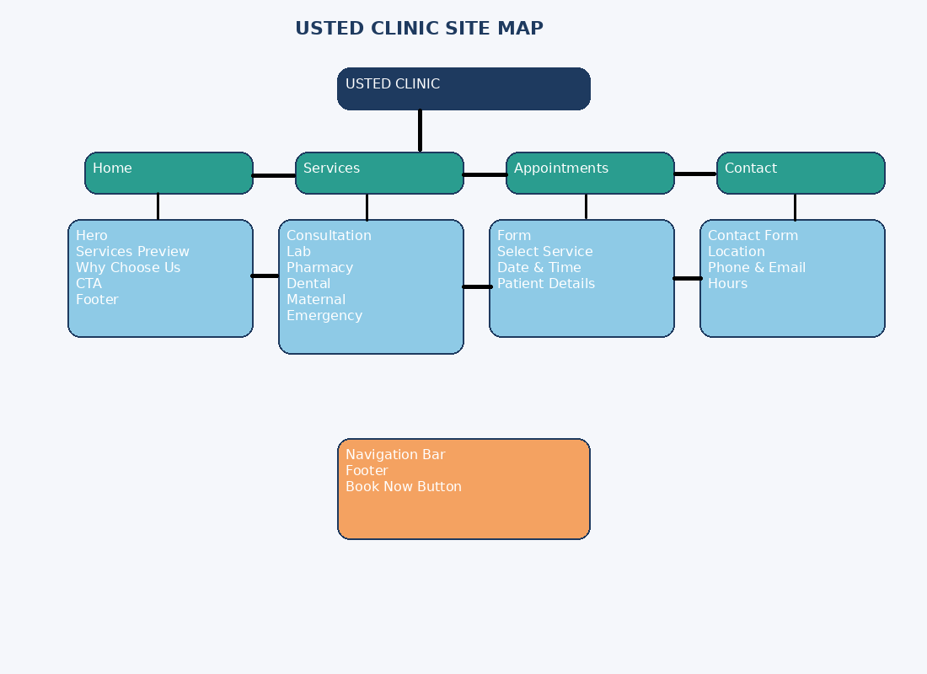
│
├── Home (index.html)
│ ├── Hero Section
│ ├── Services Preview
│ ├── Why Choose Us
│ ├── Call-To-Action (CTA)
│ └── Footer
│
├── Services (services.html)
│ ├── General Consultations
│ ├── Laboratory & Diagnostics
│ ├── Pharmacy
│ ├── Dental Care
│ ├── Maternal & Child Health
│ └── Emergency Care
│
├── Appointments (appointments.html)
│ ├── Book Appointment Form
│ ├── Select Service
│ ├── Date & Time Selection
│ └── Patient Details
│
├── Contact (contact.html)
│ ├── Contact Form
│ ├── Clinic Location
│ ├── Phone & Email Info
│ └── Opening Hours
│
└── Global Components
├── Navigation Bar
├── Footer
└── Call-to-Action Buttons (Book Now)

1.7 WIRE FRAME

HOME PAGE

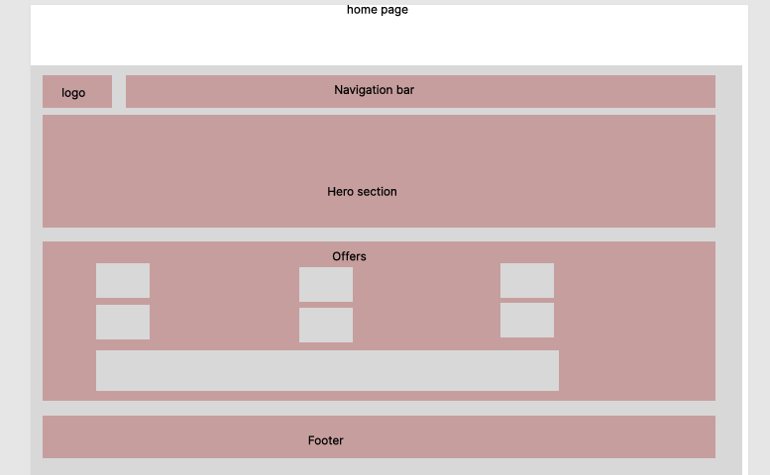

SERVICE
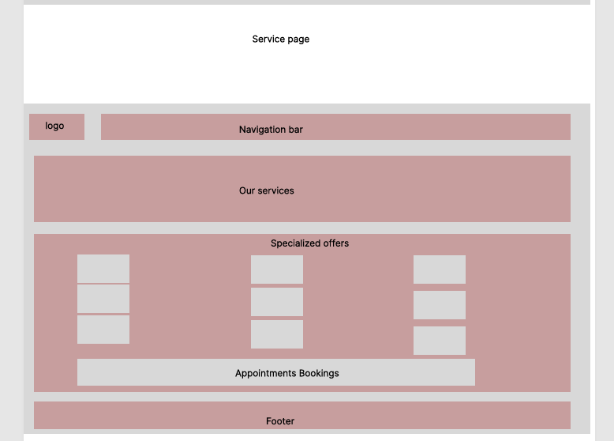

APPOINTMENT
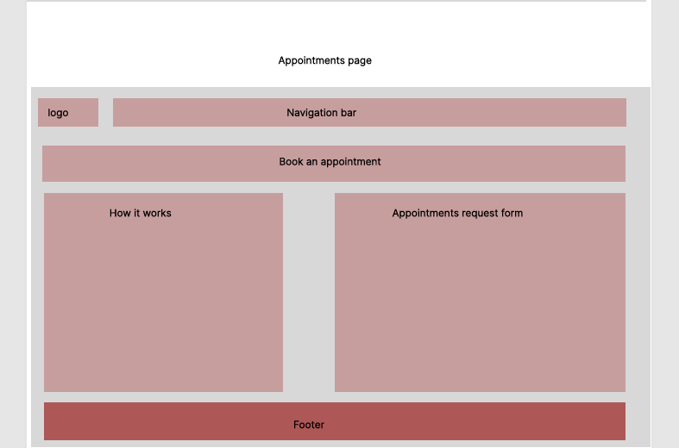

CONTACTS
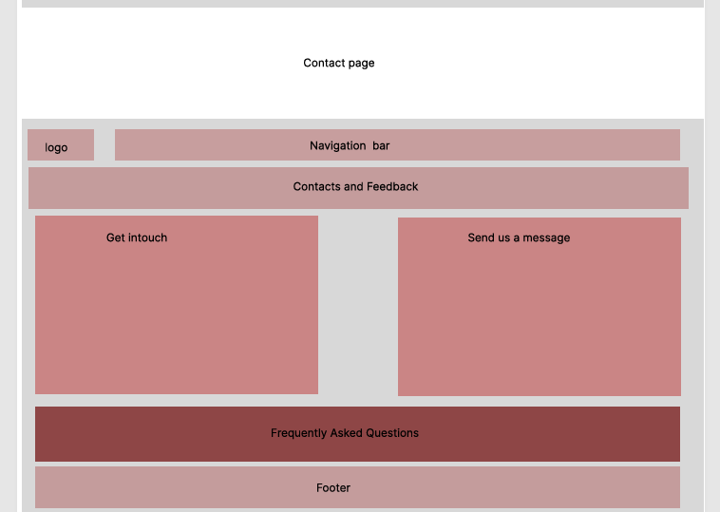

BOOKING

