**TASKS FOR WEEK 1 TRAINING:**

1. **Download and install SQL Server 2019 Version**
2. **Download and import AdventureWorks2019 (both OLTP and DW versions)**
3. **Watch the following list of videos and learn every concept explained.**

**Note:** Watch the following videos and practice every line of code explained in the videos. Make sure that you are creating the same objects and running the same code logic displayed in the videos. Always ask “WHY” and don’t proceed to the next video if you are not satisfied with the explanation. You can research the same material from any resource of your own choice.

1. [**Connecting to SQL Server**](https://www.youtube.com/watch?v=ZNObiptSMSI&list=PL08903FB7ACA1C2FB&index=1)
2. [**Creating, altering and dropping a database**](https://www.youtube.com/watch?v=TuxuHHacIWU&list=PL08903FB7ACA1C2FB&index=2)
3. [**Creating and working with tables**](https://www.youtube.com/watch?v=JLeaM8pK8dE&list=PL08903FB7ACA1C2FB&index=3)
4. [**Default Constraint**](https://www.youtube.com/watch?v=dwSqHhMl32Y&list=PL08903FB7ACA1C2FB&index=4)
5. [**Cascading referential integrity**](https://www.youtube.com/watch?v=ETepOVi7Xk8&list=PL08903FB7ACA1C2FB&index=5)
6. [**Check Constraint**](https://www.youtube.com/watch?v=9Zj5ODhv0b0&list=PL08903FB7ACA1C2FB&index=6)
7. [**Identity column**](https://www.youtube.com/watch?v=aOkFE6NLGCQ&list=PL08903FB7ACA1C2FB&index=7)
8. [**Get last generated id in sql server**](https://www.youtube.com/watch?v=n1iwngG_zNY&list=PL08903FB7ACA1C2FB&index=8)
9. [**Unique key constraint in SQL Server**](https://www.youtube.com/watch?v=oqrsfatxTYE&list=PL08903FB7ACA1C2FB&index=9)
10. [**SQL Select statement**](https://www.youtube.com/watch?v=R9pXnHIFj_8&list=PL08903FB7ACA1C2FB&index=10)
11. [**Writing re-runnable sql server scripts**](https://www.youtube.com/watch?v=TsbMvs0Zqu0&list=PL08903FB7ACA1C2FB&index=66)
12. **Complete the following 2 Homework tasks.**

(Go to the next pages to find the homework tasks)

**Homework Task 1:**

1. Create database called HR
2. Create 3 tables with given name and fill them with the values from the Figure below. When you create Skill table, set its Skill_ID column as an identity column starting from 100 and increasing by 10.

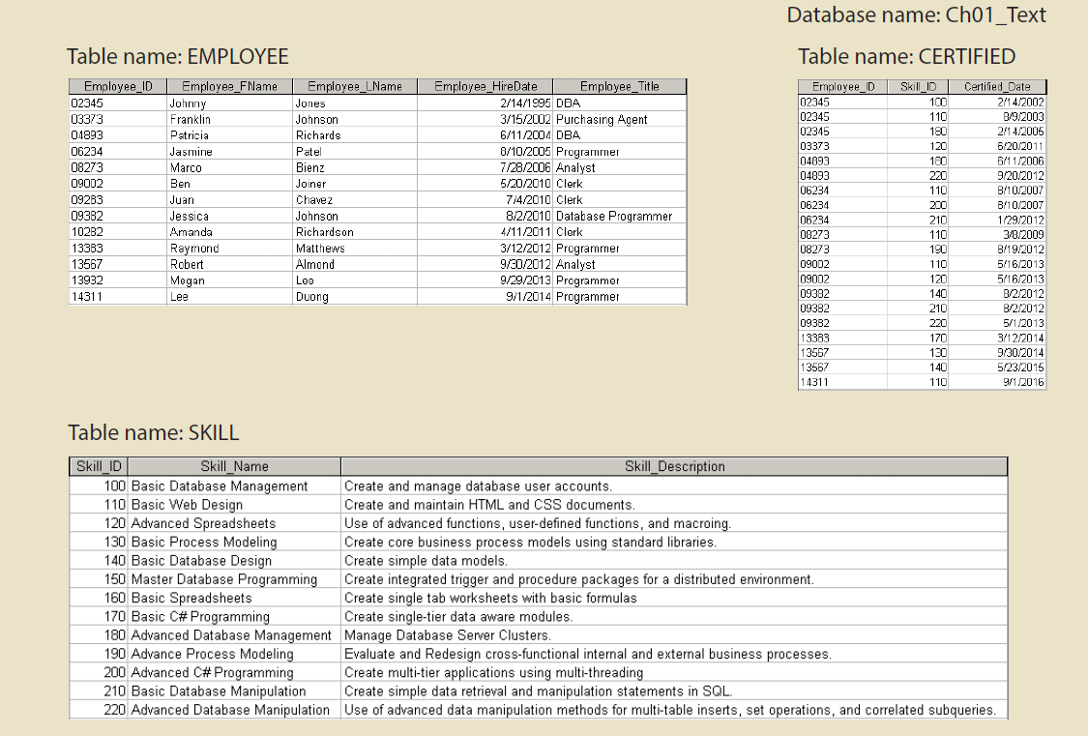

1. Create required foreign key constraints for the tables.
2. Create Check constraint on Certified table to make sure the values of Skill_ID column can only be between 100 and 220
3. Create Default Constraint on Employee table’s Employee_Title column with the value ‘Unknown’

**Homework Task 2:**

1. Create database called Store.
2. Create 3 tables with names from the figure below and insert their values given in the figure and apply sequence to auto generate Employee table’s EMP_CODE column values.
3. Make Employee table’s Store_code column’s default value = 3.
4. Create needed foreign keys between tables.
5. Create Check constraint on Store table’s store_ytd_sales column to make sure it only accepts positive values.

