# Dice Generator

The user should be able to choose different dice, such as a D6 or a D10 (number

of faces).

The user should be able to roll their chosen dice to see the random outcome.

## User Stories / functionalities

1. Choose dice type
   * As a player, I want to choose between a D6(6 faces dice) and a D10(10-faces dice), so that I can roll the kind of dice i need.
2. Roll the dice
   * As a player, I want to tap a “Roll” Button, so that I can get a random result.
3. See the result
   * As a player, I want to see the rolled number clearly on the screen, so that I immediately know what I have rolled.
4. Roll again quickly
   * As a player, I want to roll again without reselecting the dice, so that I can roll multiple times faster.
5. Default dice
   * As a new user, I want the app to start with a default dice selected (eg. D6), so that I can roll right away without selection.
6. Error handling
   * As a player, I want the app to prevent rolling if no dice is selected, so that I don’t get confused result.

## Storyboard

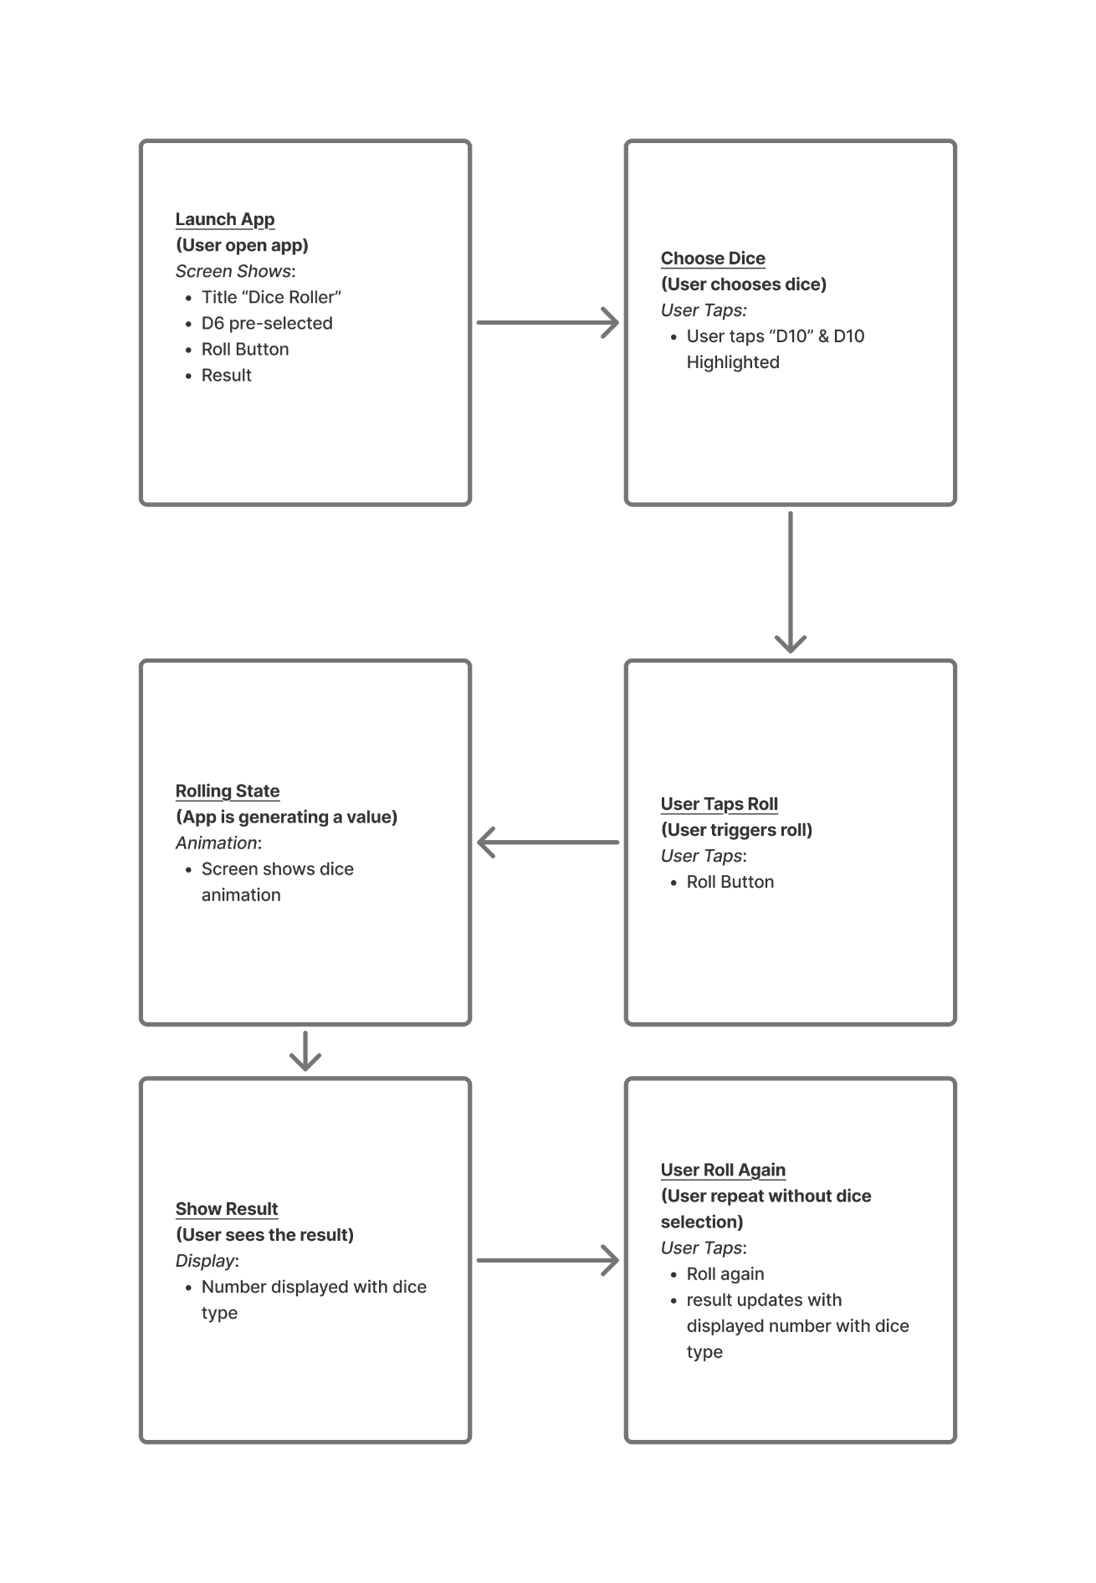

1. **Open App:** (User Open App)
   * Screen shows title: "Dice Roller"
   * D6 is pre-selected (highlighted)
   * Big "Roll" button
   * Result area.
2. **Choose Dice:** (User Choose dice)
   * User taps “D10”
   * Now D10 is highlighted, D6 is unselected
3. **User Taps Roll:** (User triggers the roll)
   * User tap “Roll” button
4. **Rolling State:** (App is generating a value)
   * Screen shows dice animation (Rolling… or dice icon).
5. **Show Result:** (User Sees the result)
   * Number displayed
   * Under it a dice type
6. **User Roll Again:** (User repeat without dice selection)
   * User raps “Roll” again
   * Result updated with displayed number with dice type