Capstone Project

JetStock
(Inventory and Product Management Application)

Introduction
A lightweight inventory manager for small businesses to track products, stock, categories, suppliers, and restock needs in one place.

Purpose
JetStock is a web application designed to help small businesses manage their products and inventory in one place. It will allow users to add products, organise them into categories, update stock quantities, identify low-stock items, and search inventory quickly.

Problem statement
Many small businesses still manage their stocks manually using notebooks, spreadsheets, or WhatsApp messages. This makes it difficult to keep product information accurate, tracking stock levels in real time, and identify low-stock items before they become a problem.

Existing inventory tools often target larger businesses and can be too complex, expensive, or cluttered for small operations. As a result, small business owner relies on manual methods which is inefficient that waste time and increase chance of stock errors.

Why the problem matters
This problem is valuable to address because poor inventory control can lead to:
- Stock shortages
- Over ordering
- Inaccurate product records
- Slower business operations
- Time lost for searching product information
- Poor organisation of product, category and supplier information
A simpler inventory tool focused on small businesses can improve day-to-day efficiency and decision-making.

Current state
Many small business owners still use monolithic ways:
- Track products manually in spreadsheets or notebooks
- Update stock occasionally
- Don’t have central dashboard
- Misses low-stocked items
- Spend too much time searching product information

Desired state
With JetStock, the user should be able to:
- Store product information in one system
- Organise product more accurately
- Update stock levels easily
- Quickly find products
- Identify low-stock items from a dashboard
- Maintain more accurate inventory records

Industry/ domain
JetStock sits in the inventory and operations domain. Many existing systems are designed for bigger operations, while JetStock aims to be simpler and more usable for smaller ones especially relevant for:
- Small retailers
- Resellers
- Clothing sellers
- Home businesses
- Boutique product businesses

Stakeholders

Primary stakeholders
- Small business owner/ admin: They need a clear view of stock, products, and low-stock items.
- Staff/Inventory user: They need a quick way to add, edit and update inventory without confusion.

Secondary stakeholders
- Customer of the business: They benefit indirectly when products are available and inventory is manged accurately.
- Developer/maintainers: They need readable code and maintainable structure.

Value proposition
JetStock provides a lightweight and practical inventory management solution for small businesses that do not need a large enterprise software. It focuses on simplicity, visibility, and quick stock control.

Project scope

In scope
- Product management
- Category management
- Stock movements updates
- Low-stock (Inventory) detection/visibility
- Search and filter for products
- Dashboard summary
- CRUD operations with database
- Client-server architecture
- Unit/API testing
- Login/authentication

Out of scope
- Product barcode scanning
- Payment system
- Advanced analytics & Forecasting
- Email/SMS notification
- Full sales/invoice system
- Bulk import/export
- Mobile app
- Supplier portal

MVP features

Core features
- Registration/Login/auth
- Add/Edit/View/Delete product
- Add/Edit/View/Delete category
- Update stock quantity (Stock movements)
- View low-stock products (Inventory)
- Search product by name/SKU
- Filter products
- Dashboard with summary

Extended features
- CSV export
- Image upload
- Customer order managements
- Pagination
- Theme modes
- Role-based access
- Charts and analytics

Non-functional Requirements
- The application should be responsive and usable on desktop and tablet.
- The interface should be simple and easy to navigate.
- The backend should follow MVC structure for maintainability.
- API responses should be clear and handle errors properly.
- Data must persist reliably in MySQL.
- The app should support future deployment on AWS.
- Sensitive configuration should be stored in environment variables.

Product Description

Architecture Plan (Tech Stack)

Frontend
- React
- HTML
- JavaScript
- CSS

Backend
- Node.js
- Express

Database
- MySql
- Redis Cache

Testing
- Jest Framework (Unit Testing)
- Postman (API testing)

Deployment
- Frontend: Netlify or Vercel
- Backend: Render/Railway/ EC2
- Database: Mysql

Structure (MVC)
- Routes
- Controllers
- Models
- Services
- Middleware

Version Control
- Git + GitHub

Architecture Diagram

System Architecture
Jetstock follow a clien-server architecture. The frontend is built using React and Material UI, and communicates with the backend through Axios-based HTTP requests. The backend is developed with Node.js and Express using MVC architecture to separates routes, controllers, business logic, and database interaction. MySql is used as the relational database to store products, categories, suppliers, inventory and stock movement records.

Include a diagram of the building blocks of the design including users and how they interact with the product.

User Stories
# | User Story Title | User Story Description | Priority | Additional Notes
1 | signup | As a user, I want to register an account so I can securely access the system. | High | Email, password
2 | login | As a user, I want to log in so I can manage products and stock. | High | Auth: JWT/Session
3 | Add product | As s user, I want to add a product so I can store its information in the system. | High | Name, SKU, category, supplier, quantity, price
4 | View Products | As a user, I want to view all products so I can monitor my inventory. | High | List by: name, category, supplier, Qty, edit/delete
5 | Edit Product | As a user, I want to edit product details, so product information stays accurate. | High | Update details
6 | Delete product | As a user, I want to delete a product so I can remove outdated inventory records. | High | Alert before delete
7 | Add Category | As a user, I want to create categories so I can organise products. | High
8 | Filter products | As a user, I want to filter products by category so I can find items more easily. | Medium
9 | Search products | As a user, I want to search products by name or SKU so I can find them quickly. | Medium
10 | Add/Remove Stock | As a user, I want to adjust stock quantity, so inventory levels stay correct. | High | Increase/decrease Qty
11 | View Low Stock | As a user, I want to identify low-stock products, so I know what to restock | High | Threshold logic
12 | View Dashboard | As a user, I want a dashboard summary so I can quickly understand inventory status, | Medium | Total products, low stock

User Flow
Draw.io Link: https://drive.google.com/file/d/1MXYz-eideYcytwEZzE_zcrA1COw-gLBQ/view?usp=sharing
User Registration/Login 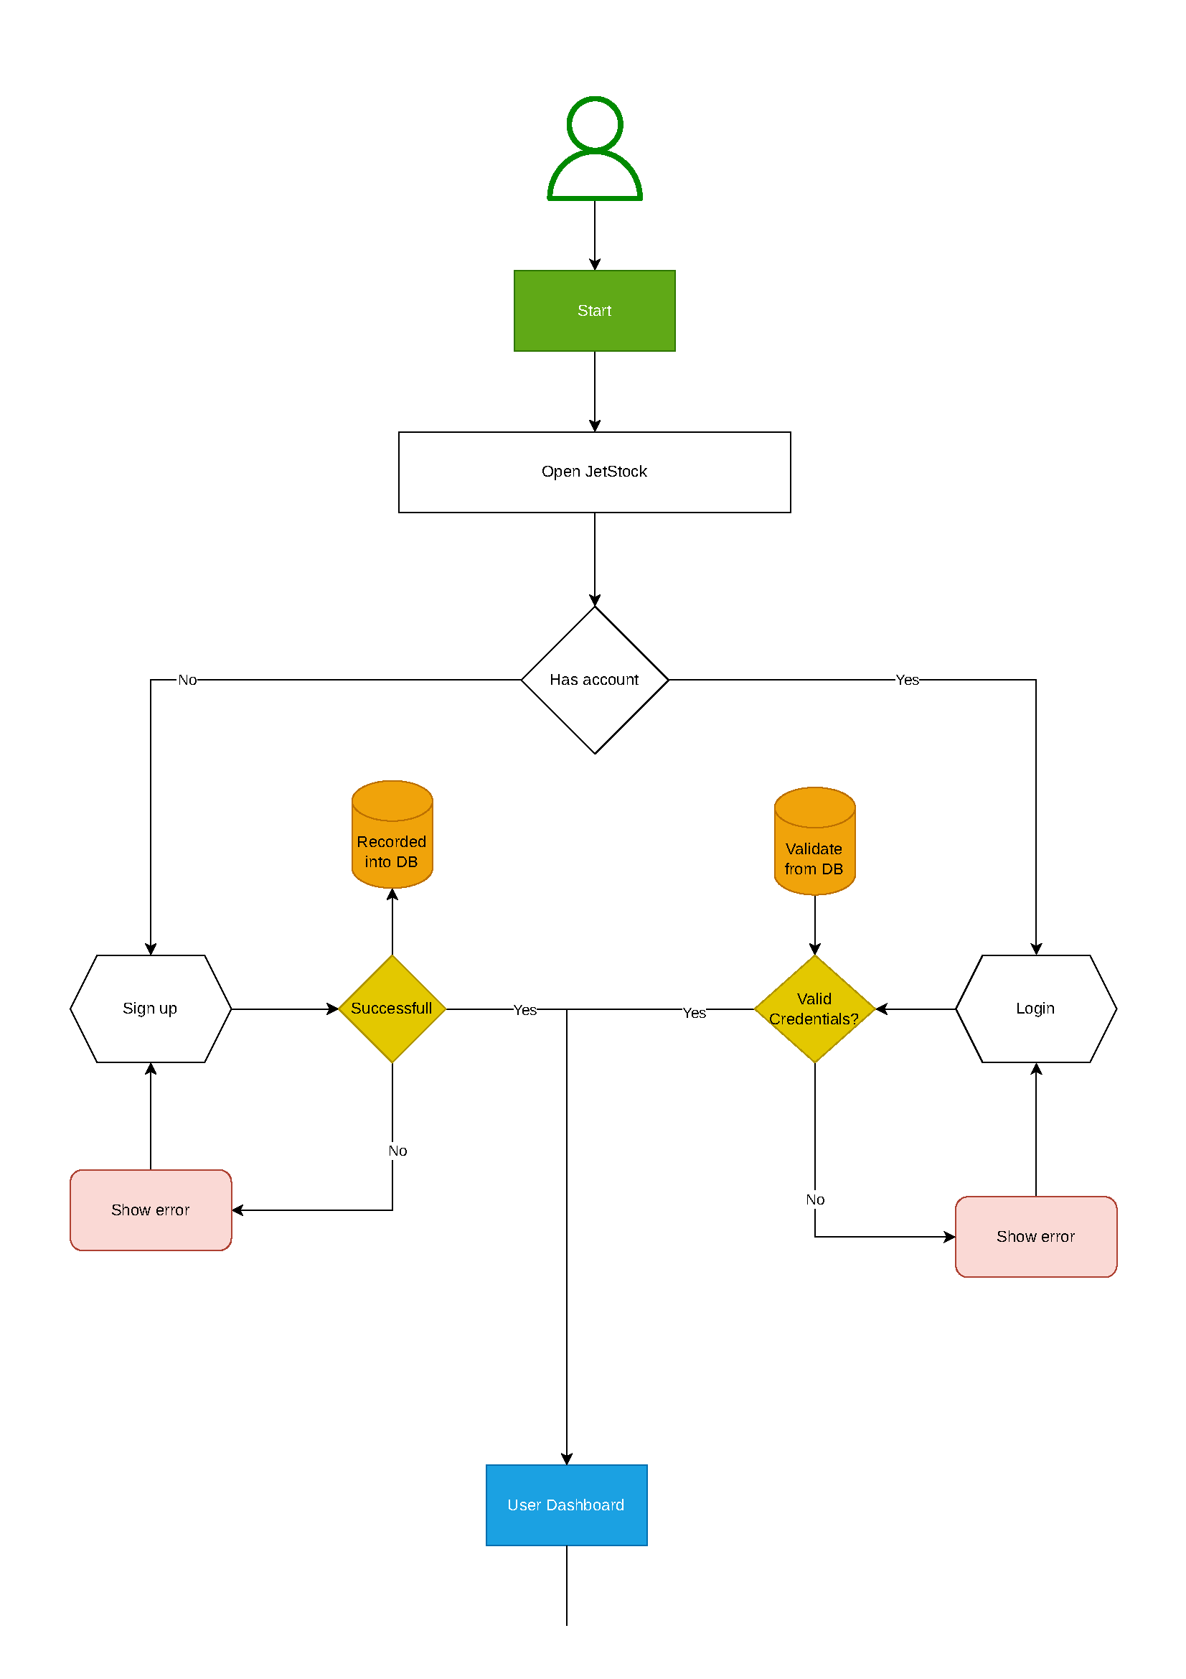

User Product/Category/Supplier Management
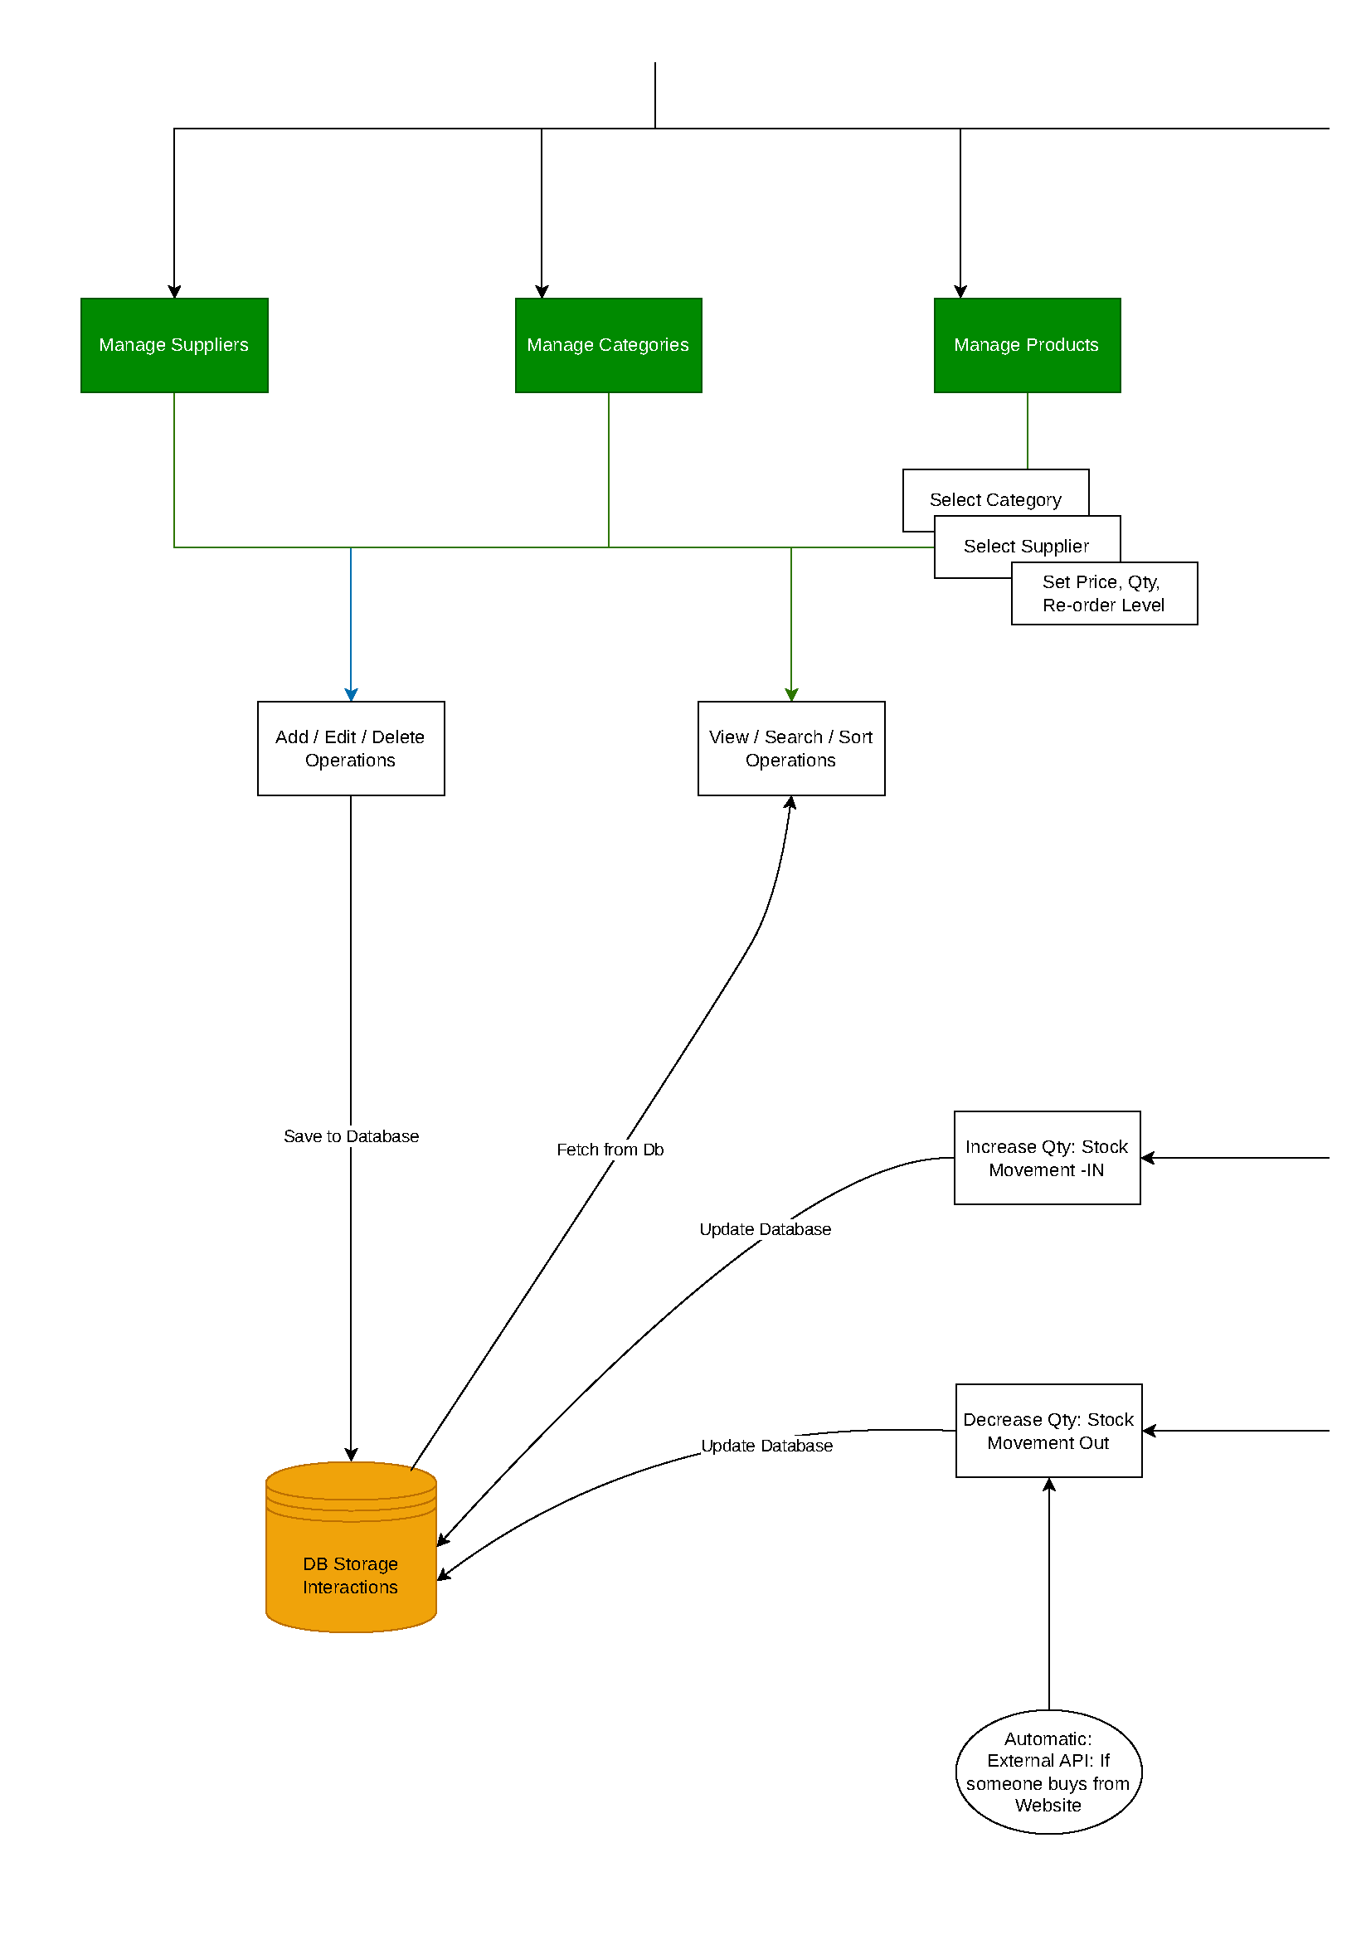

Inventory Management
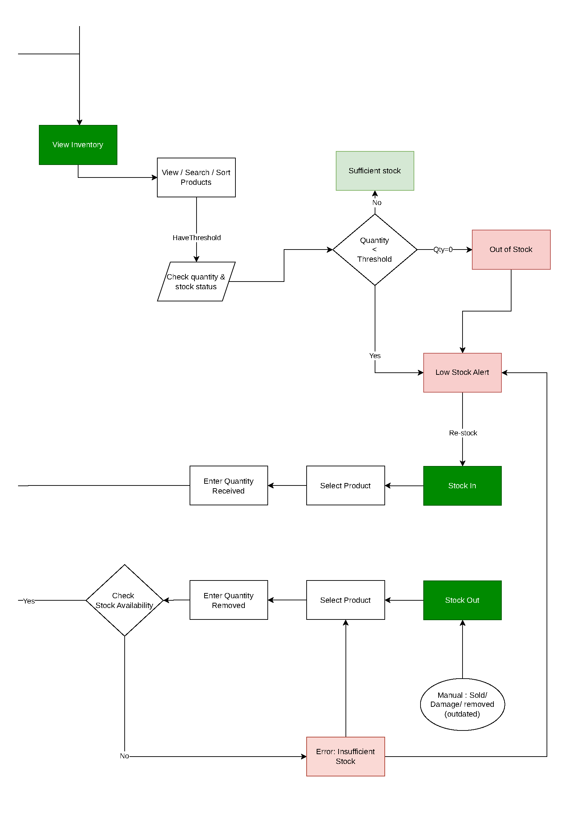

Reporting
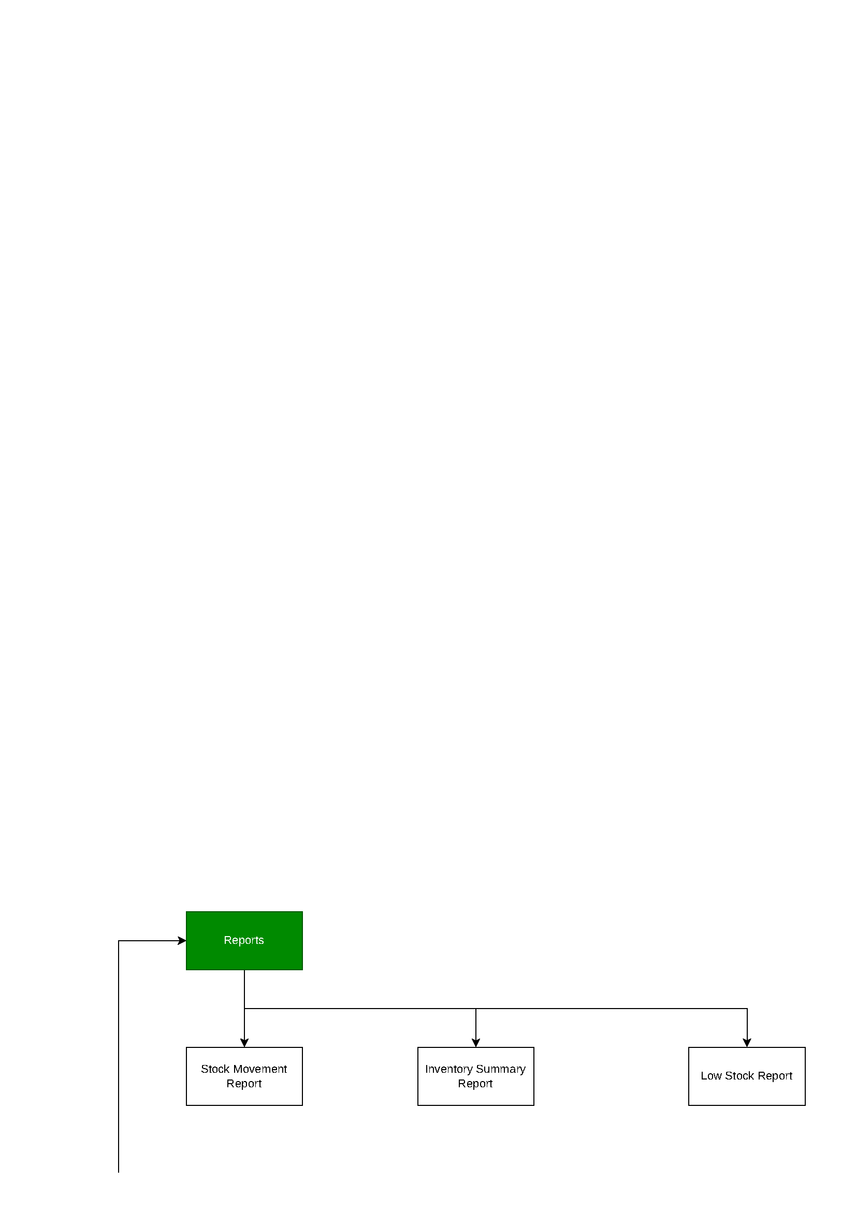

Database Model: ERD diagram

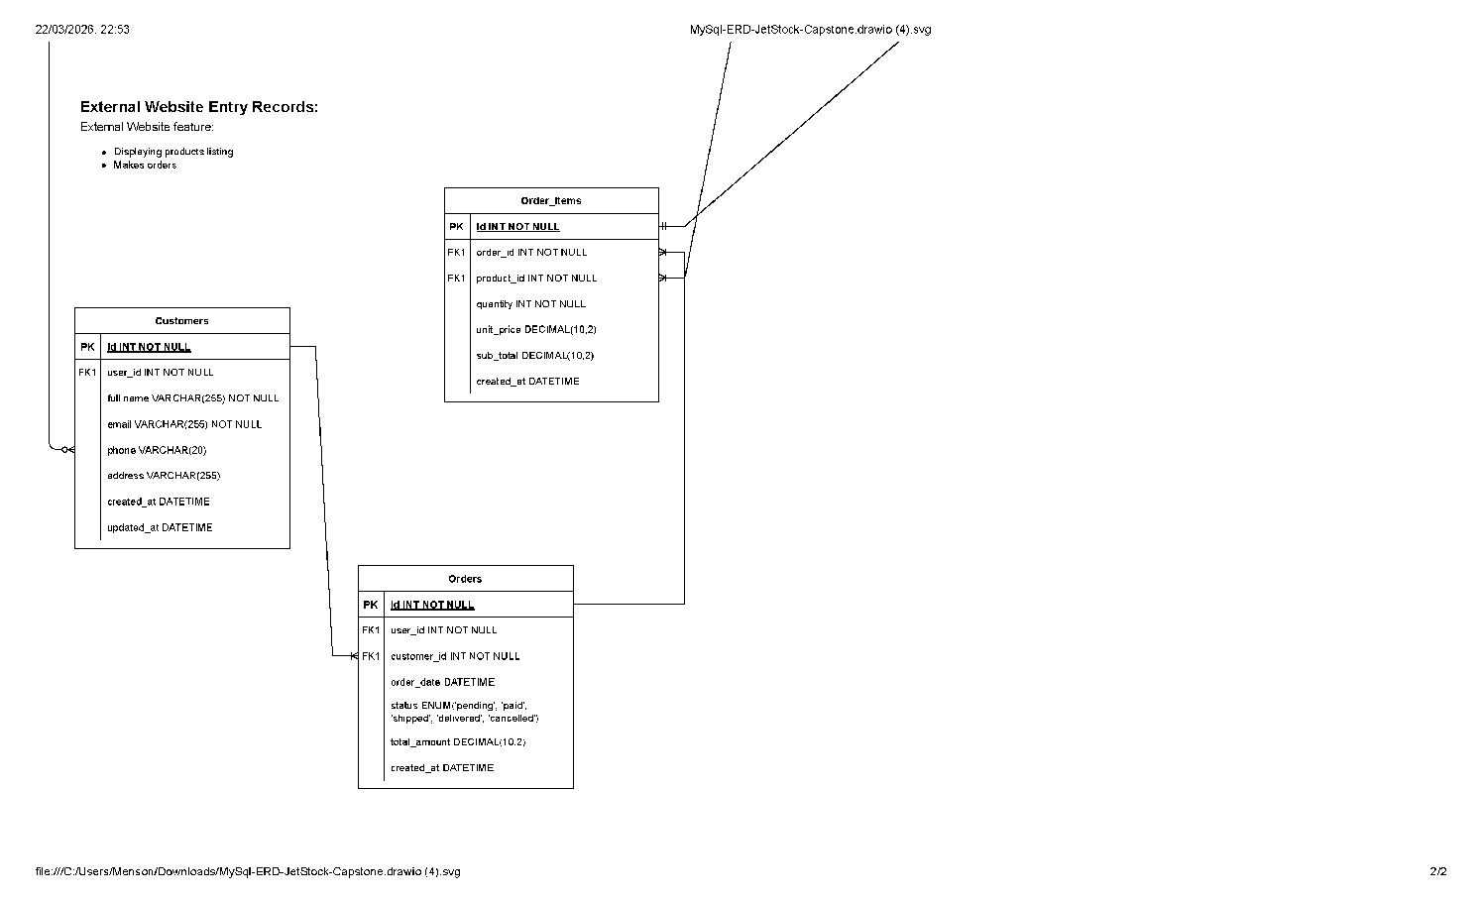
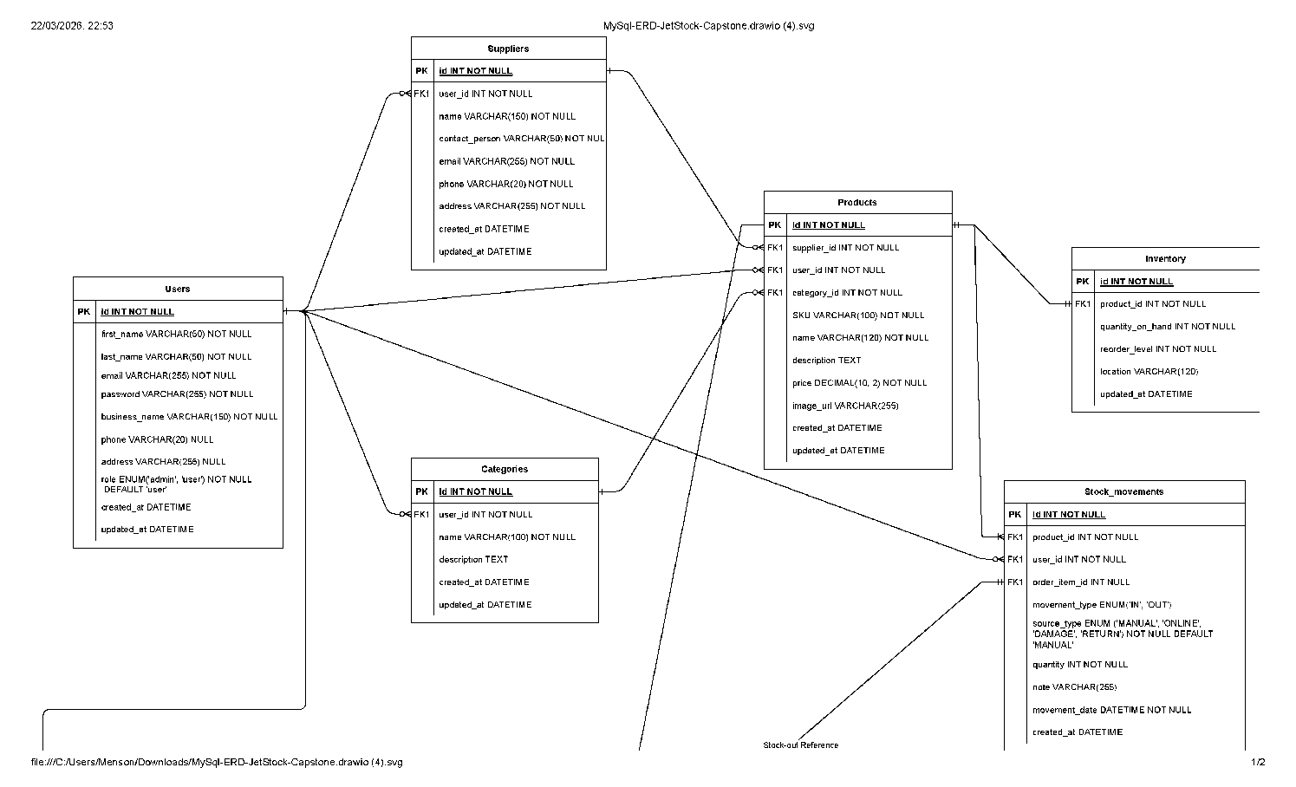
https://drive.google.com/file/d/1HupjjxbfYEgbygMS7iAcHn4O365Hqnl0/view?usp=sharing

Wireframe Design
Figma Link: https://www.figma.com/proto/BI3GKjDIRTp2sso2760ZbR/JetStock-Capston?node-id=0-1&t=uJu1PHDUC1vpBGlW-1
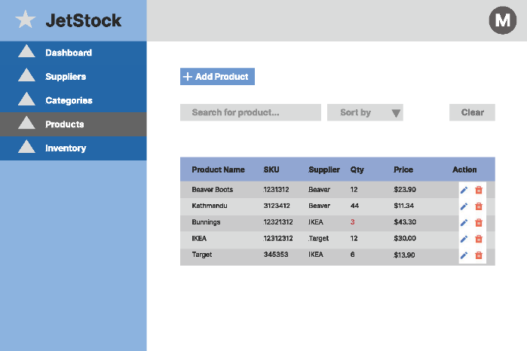
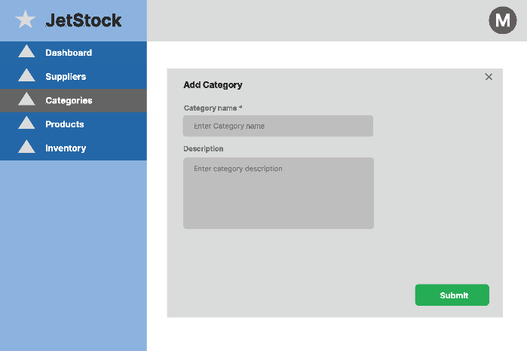
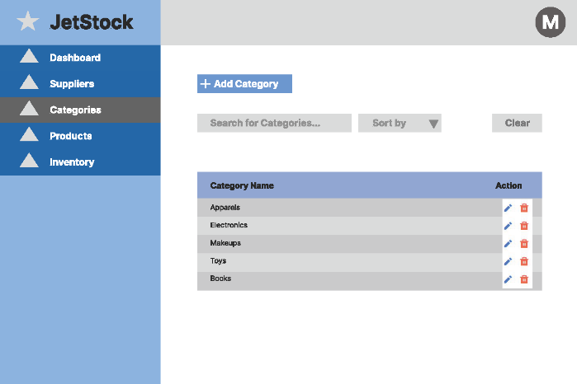
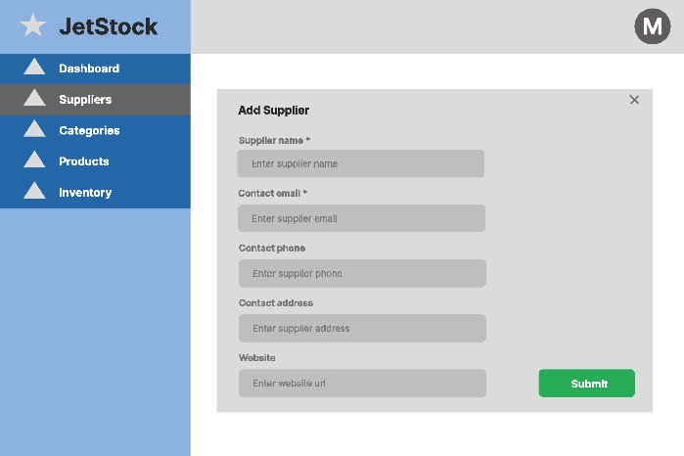
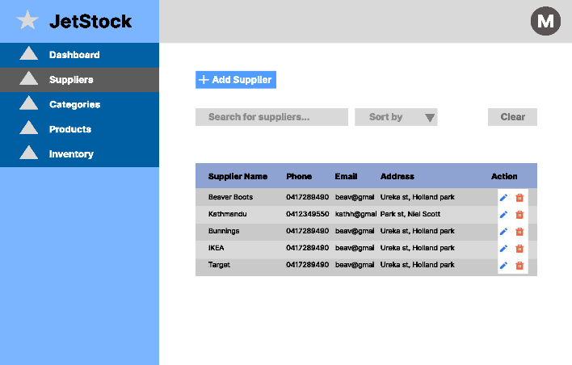
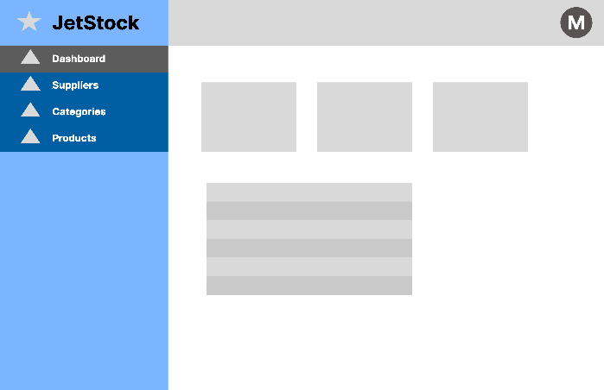
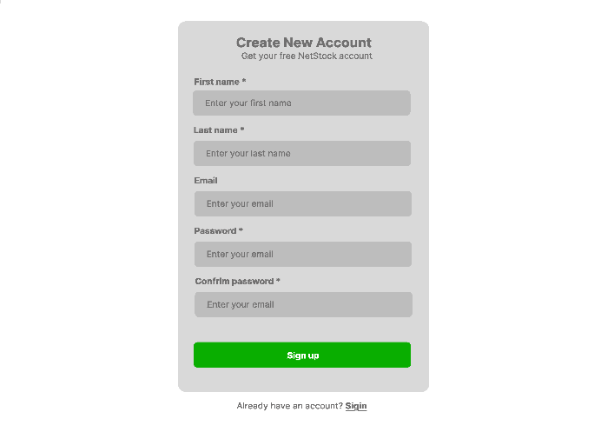
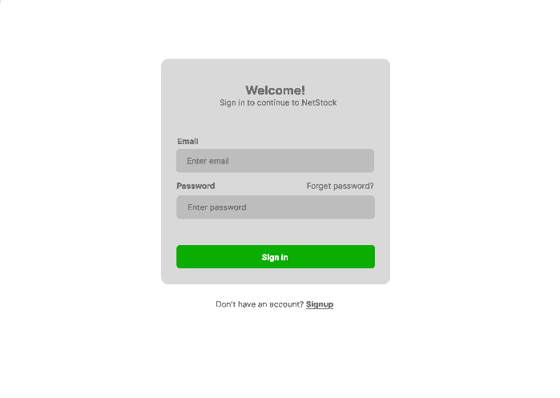

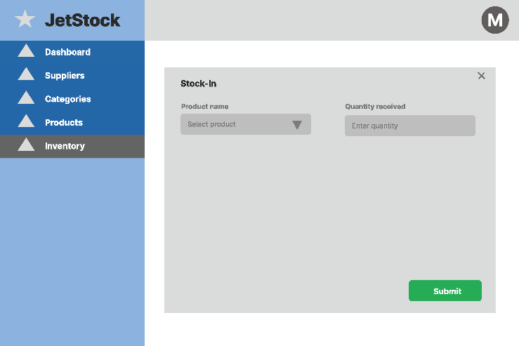
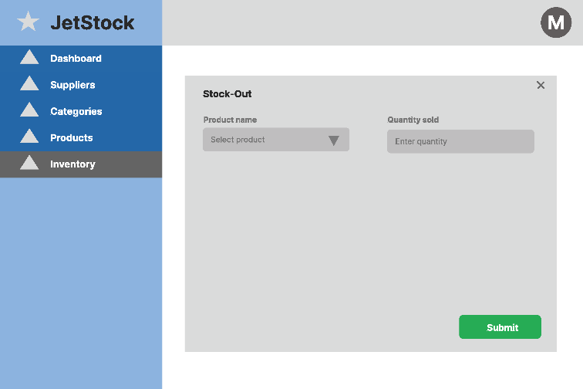
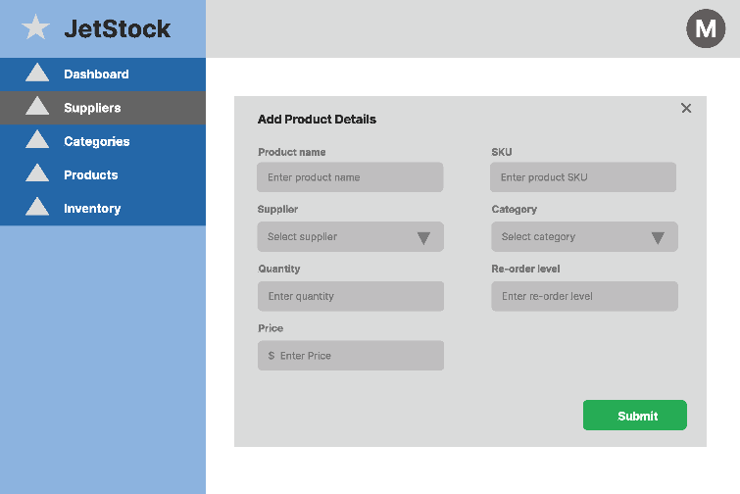
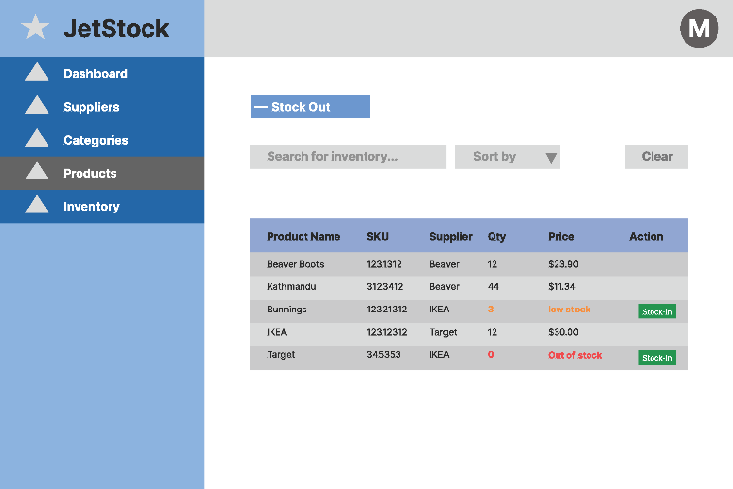

Project Planning
Include a Gantt chart or screenshot of a Trello board showing key milestones (with dates) to complete the project.

Testing Strategy
- What were steps undertaken to achieve product quality?
- How was each feature of the application tested?
- How did you handle edge cases?

Implementation
- What were the considerations for deploying the software?

End-to-end solution
- How well did the software meet its objectives?

References
- Where is the code used in the project? (link to GitHub)
- What are the resources used in the project? (libraries, APIs, databases, tools, etc)

