JetStock
Inventory & Product Management Application
─────────────────────────────────────
Capstone Project Documentation
Software Engineering Program
April 2026

1. Introduction
JetStock is a lightweight inventory management web application designed for small businesses to track products, stock, categories, suppliers, and restock needs — all in one place.

1.1 Purpose
JetStock is a web application designed to help small businesses manage their products and inventory in one place. It allows users to add products, organise them into categories, update stock quantities, identify low-stock items, and search inventory quickly.

1.2 Problem Statement
Many small businesses still manage their stock manually using notebooks, spreadsheets, or WhatsApp messages. This makes it difficult to keep product information accurate, track stock levels in real time, and identify low-stock items before they become a problem.
Existing inventory tools often target larger businesses and can be too complex, expensive, or cluttered for small operations. As a result, small business owners rely on manual methods which are inefficient, waste time, and increase the chance of stock errors.

Why the Problem Matters
Poor inventory control can lead to:
- Stock shortages
- Over-ordering
- Inaccurate product records
- Slower business operations
- Time lost searching for product information
- Poor organisation of product, category and supplier information
A simpler inventory tool focused on small businesses can significantly improve day-to-day efficiency and decision-making.

1.3 Current State
Many small business owners still rely on traditional approaches:
- Tracking products manually in spreadsheets or notebooks
- Updating stock only occasionally
- No central dashboard for visibility
- Missing low-stocked items until it is too late
- Spending too much time searching for product information

1.4 Desired State
With JetStock, users are able to:
- Store all product information in one system
- Organise products more accurately by category and supplier
- Update stock levels easily through stock movements
- Quickly find products through search and filter
- Identify low-stock items directly from a dashboard
- Maintain more accurate and reliable inventory records

1.5 Industry / Domain
JetStock sits in the inventory and operations management domain. Many existing systems are designed for large enterprises, while JetStock aims to be simpler and more accessible for smaller operations — particularly relevant for:
- Small retailers
- Resellers
- Clothing and fashion sellers
- Home-based businesses
- Boutique product businesses

1.6 Stakeholders

Primary Stakeholders
- Small business owner / admin — Needs a clear view of stock, products, and low-stock items for decision-making.
- Staff / Inventory user — Needs a quick way to add, edit, and update inventory without confusion.

Secondary Stakeholders
- Customers of the business — Benefit indirectly when products are available and inventory is managed accurately.
- Developers / Maintainers — Need readable code and a maintainable structure for future enhancements.

1.7 Value Proposition
JetStock provides a lightweight and practical inventory management solution for small businesses that do not need large enterprise software. It focuses on simplicity, visibility, and quick stock control — reducing the time and effort required to manage daily inventory operations.

1.8 Project Scope

In Scope
- Product management (CRUD)
- Category management (CRUD)
- Supplier management (CRUD)
- Stock movement updates (Stock In / Stock Out)
- Low-stock detection and visibility (Inventory)
- Search and filter for products
- Dashboard summary
- Customer and order management
- Client-server architecture
- Unit and API testing
- Login and authentication

Out of Scope
- Product barcode scanning
- Payment processing system
- Advanced analytics and forecasting
- Email / SMS notifications
- Full sales and invoice system
- Bulk import / export
- Mobile app
- Supplier portal

1.9 MVP Features

Core Features
- Registration / Login / Authentication
- Add / Edit / View / Delete product
- Add / Edit / View / Delete category
- Add / Edit / View / Delete supplier
- Update stock quantity (stock movements)
- View low-stock products (Inventory)
- Search product by name / SKU
- Filter products
- Dashboard with summary statistics

Extended Features
- CSV export
- Image upload
- Customer order management
- Pagination
- Theme modes
- Role-based access control
- Charts and analytics

1.10 Non-Functional Requirements
- The application is responsive and usable on desktop and tablet.
- The interface is simple and easy to navigate.
- The backend follows MVC structure for maintainability.
- API responses are clear and handle errors properly.
- Data persists reliably in MySQL.
- The application supports future deployment on AWS.
- Sensitive configuration is stored in environment variables.

2. Product Description

2.1 Technology Stack
Layer | Technologies
Frontend | React, HTML5, CSS3, JavaScript (ES6)
Backend | Node.js, Express.js
Database | MySQL, Redis (Cache)
Testing | Jest (Unit Testing), Postman (API Testing)
Deployment | Frontend: AWS EC2 | Backend: AWS EC2 | DB: Redis MySQL
Architecture | MVC — Routes, Controllers, Models, Services, Middleware
Version Control | Git + GitHub

2.2 System Architecture
JetStock follows a client-server architecture. The frontend is built using React and communicates with the backend through Axios-based HTTP requests. The backend is developed with Node.js and Express using MVC architecture to separate routes, controllers, business logic, and database interaction. MySQL is used as the relational database to store products, categories, suppliers, inventory, and stock movement records.
The system is composed of two client interfaces: JetStock (the React-based admin interface) and JetStore (a plain HTML/CSS/JS external storefront). Both communicate with a shared Node.js server, which queries and receives data from a MySQL database.
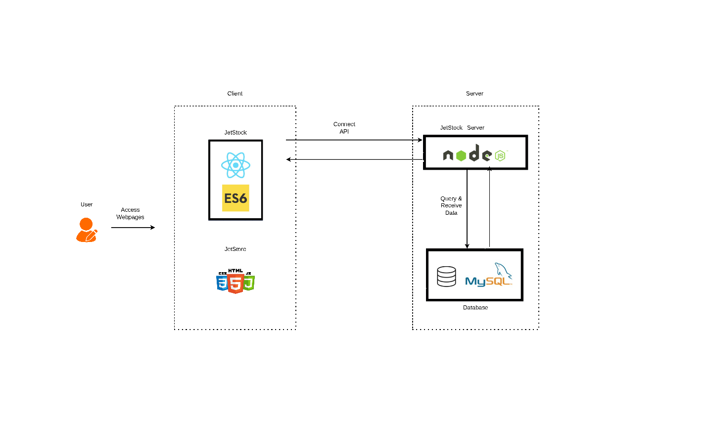

2.3 Database Design (ERD)
The JetStock database consists of nine core tables designed to support full inventory lifecycle management:
Table | Description
Users | Stores business owner and staff accounts with role-based access (admin / user)
Products | Core product records including SKU, name, price, supplier, and category references
Categories | Product classification groups created and managed per user
Suppliers | Supplier contact details linked to user accounts
Inventory | Tracks quantity on hand and reorder level per product
Stock_movements | Logs every stock IN/OUT movement with source type (MANUAL, ONLINE, DAMAGE, RETURN)
Customers | Customer records for order management
Orders | Customer orders with status tracking (pending, paid, shipped, delivered, cancelled)
Order_items | Line items within each order, including quantity, unit price, and subtotal

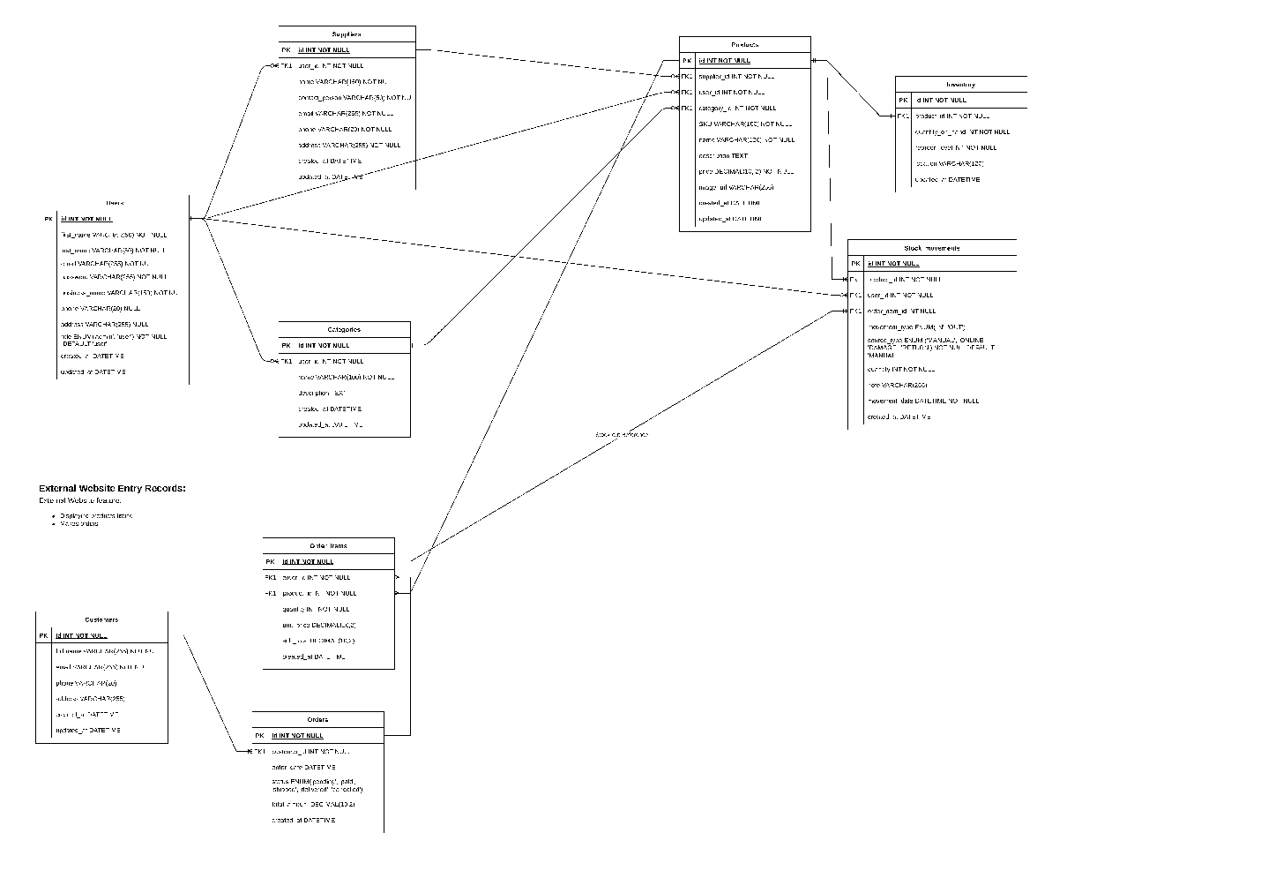

2.4 User Stories
# | Title | Description | Priority | Notes
1 | Sign Up | As a user, I want to register an account so I can securely access the system. | High | Email, password
2 | Login | As a user, I want to log in so I can manage products and stock. | High | JWT / Session auth
3 | Add Product | As a user, I want to add a product so I can store its information in the system. | High | Name, SKU, category, supplier, qty, price
4 | View Products | As a user, I want to view all products so I can monitor my inventory. | High | List by name, category, supplier, Qty
5 | Edit Product | As a user, I want to edit product details so product information stays accurate. | High | Update all details
6 | Delete Product | As a user, I want to delete a product to remove outdated records. | High | Alert before delete
7 | Add Category | As a user, I want to create categories so I can organise products. | High
8 | Filter Products | As a user, I want to filter products by category so I can find items more easily. | Medium
9 | Search Products | As a user, I want to search products by name or SKU so I can find them quickly. | Medium
10 | Stock Movement | As a user, I want to adjust stock quantity so inventory levels stay correct. | High | Increase / decrease qty
11 | Low Stock View | As a user, I want to identify low-stock products so I know what to restock. | High | Threshold logic
12 | Dashboard | As a user, I want a dashboard summary so I can quickly understand inventory status. | Medium | Total products, low stock count
13 | Manage Suppliers | As a user, I want to add and manage supplier details to keep contact info up to date. | High | CRUD operations
14 | Customer Orders | As a user, I want to create and track customer orders. | Medium | Order status tracking

2.5 User Flow
The user flow covers five key interaction paths through the application:
- Registration & Login — New users create an account, existing users log in with validation.
- Product / Category / Supplier Management — Users add, edit, view, and delete records with full CRUD operations.
- Inventory Management — Users perform stock in / stock out operations, with automatic quantity updates and low-stock alerts.
- Order Management — Users create customer orders, add order items, and track order status.
- Reports — Users view inventory summary, stock movement history, and low-stock reports.
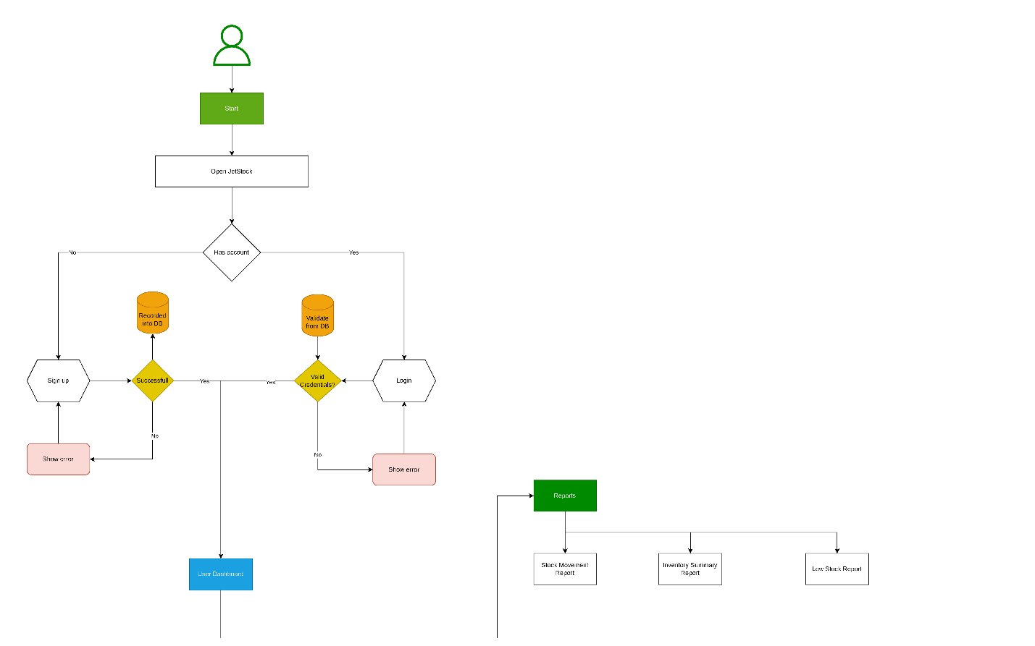
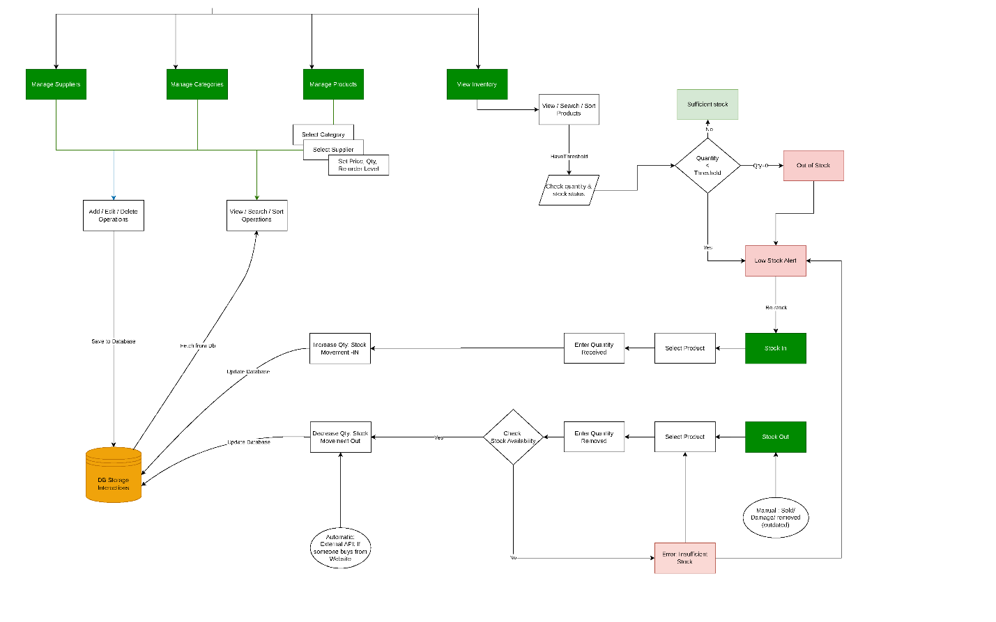

2.6 Wireframe Design
The application wireframes were designed in Figma to map out the user interface before development. Key screens include:
- Login / Sign Up screens with input validation
- Dashboard with summary statistics
- Suppliers listing page with search, sort, and action buttons
- Categories listing page
- Products listing page with quantity colour-coding (red for low stock, grey for out of stock)
- Add/Edit forms for Suppliers, Categories, and Products
- Inventory page with Stock In and Stock Out actions
Figma Prototype: https://www.figma.com/proto/BI3GKjDIRTp2sso2760ZbR/JetStock-Capston
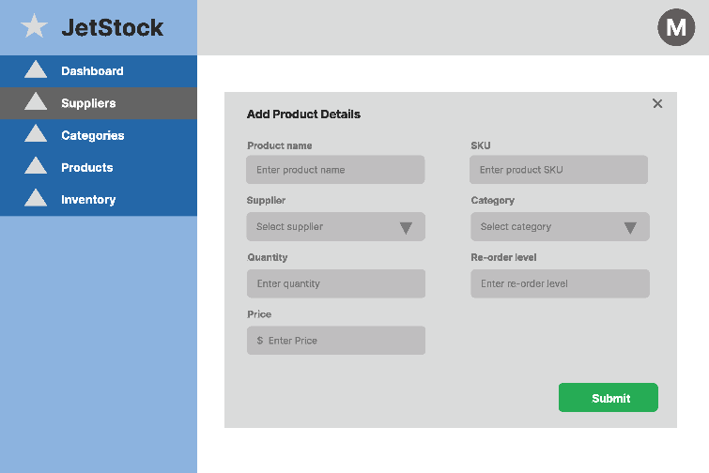
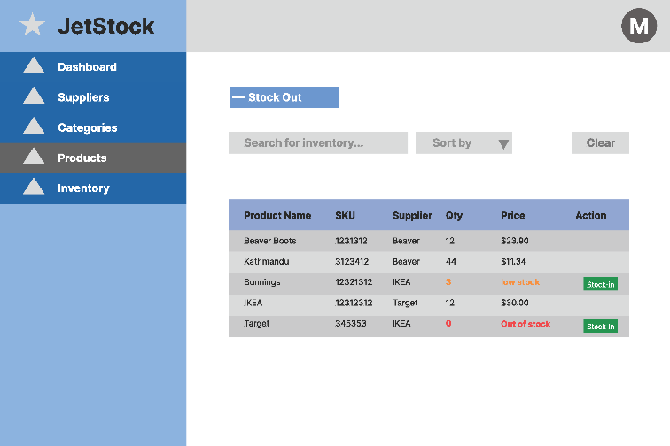
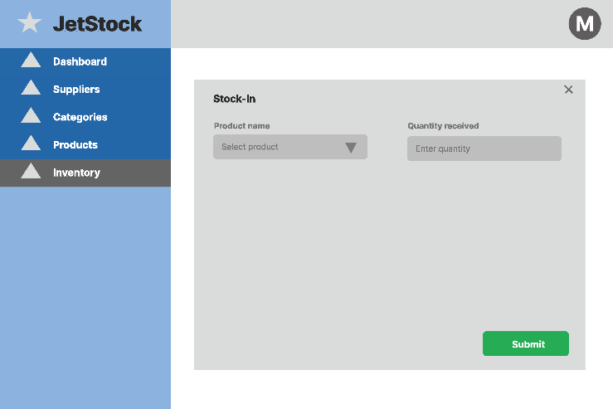
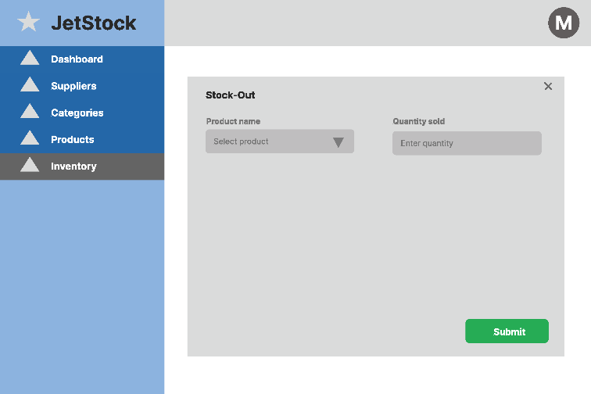

3. Project Planning
The JetStock project was planned and executed over approximately three weeks, from 13 March 2026 to 31 March 2026. All tasks were tracked using a project management tool with Gantt chart view, and every milestone was marked as complete.
3.1 Key Milestones
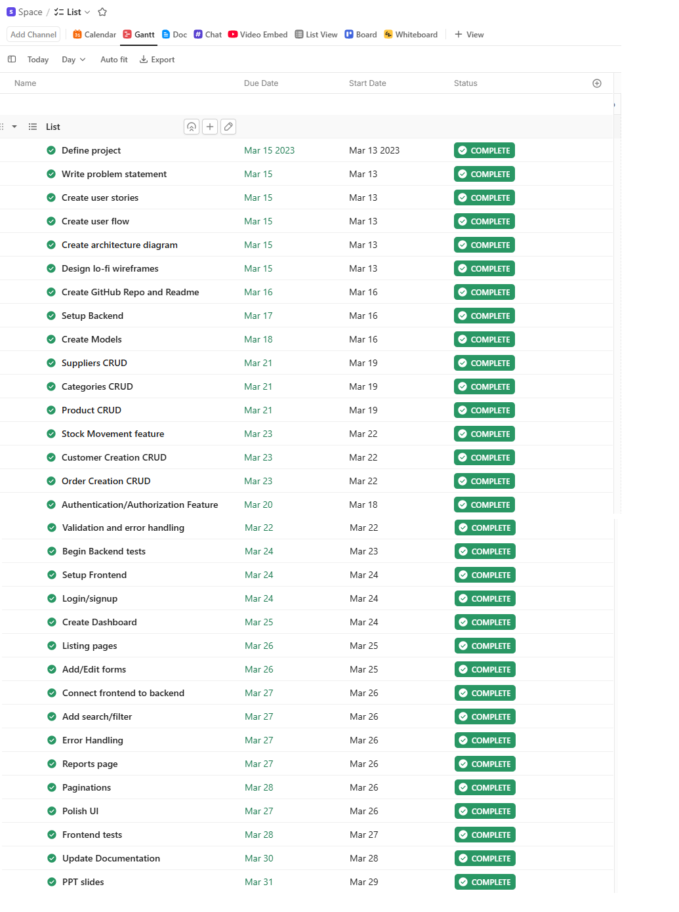
All planned tasks were completed on schedule, demonstrating effective time management and adherence to the project plan.

4. Testing Strategy
JetStock was tested using a combination of unit testing, API testing, and manual UI testing to ensure product quality and reliability.

4.1 Backend Unit Testing (Jest)
Jest was used to write unit tests for core backend logic. Tests were structured around controllers and service functions to validate business logic in isolation.
- Tested CRUD operations for Products, Categories, Suppliers, and Inventory
- Tested stock movement calculations (quantity increases and decreases)
- Tested authentication middleware (JWT token validation)
- Tested input validation and error handling responses

4.2 API Testing (Postman)
All REST API endpoints were tested using Postman to verify correct request/response behaviour:
- GET, POST, PUT, DELETE endpoints verified for all resources
- Tested valid and invalid request bodies to confirm validation responses
- Tested authentication headers to confirm protected routes reject unauthorised requests
- Verified HTTP status codes: 200 OK, 201 Created, 400 Bad Request, 401 Unauthorised, 404 Not Found, 500 Server Error

4.3 Edge Cases
The following edge cases were identified and handled during development:
- Stock Out with quantity exceeding available stock — returns an error: 'Insufficient stock'
- Duplicate product SKU — returns a validation error
- Deleting a category that has associated products — handled with appropriate error messaging
- Login with incorrect credentials — returns 401 with a descriptive error
- Empty search results — frontend displays a 'No results found' message
- Out-of-stock products on the Inventory page — displayed with 'Out of Stock' label
- Low-stock items — highlighted visually in red on the Products and Inventory pages

4.4 Manual UI Testing
Each frontend feature was manually tested through the browser to confirm correct rendering, state updates, and user interactions:
- Login / Registration flow tested with valid and invalid inputs
- All CRUD forms validated for required fields and error messages
- Dashboard summary cards verified to reflect real-time database counts
- Search and filter functionality confirmed to return correct filtered results
- Pagination tested across product and supplier listings
- Stock In and Stock Out operations confirmed to update inventory quantities correctly

5. Implementation

5.1 Development Approach
JetStock was built using an iterative development approach, progressing from backend setup to frontend integration. Development followed the MVC (Model-View-Controller) pattern, keeping business logic, routing, and data access clearly separated for maintainability.

5.2 Backend Implementation
The backend was developed with Node.js and Express. The following structure was adopted:
- Routes — Define API endpoints for each resource
- Controllers — Handle request logic and call appropriate services
- Models — Interact directly with the MySQL database using queries
- Services — Contain reusable business logic
- Middleware — Handle authentication (JWT), error handling, and input validation
Sequelize ORM was considered but raw MySQL queries were used for greater control and transparency during development.

5.3 Frontend Implementation
The frontend was built using React with functional components and hooks (useState, useEffect). Axios was used for all HTTP requests to the backend API. Key frontend considerations:
- Context API used for managing authentication state globally
- React Router used for client-side navigation between pages
- Protected routes implemented to restrict access to authenticated users
- Reusable components created for tables, forms, and modals
- Error boundaries and loading states included for better user experience

5.4 Database Implementation
MySQL was used as the relational database. The schema was designed to support the full inventory lifecycle, with foreign key relationships enforcing data integrity across tables. Key design decisions:
- Products linked to Suppliers, Categories, and Users via foreign keys
- Stock movements table records every inventory change with movement type and source
- Inventory table maintains the current quantity on hand and reorder level per product
- Orders and Order_items support external storefront (JetStore) integration

5.5 Deployment Considerations
The following deployment approach was planned for JetStock:
- Frontend deployed to AWS EC2 for react application
- Backend deployed to AWS EC2 for the Node.js server
- MySQL database to AWS Redis Mysql
- Environment variables used for all sensitive configuration (database credentials, JWT secret)
- CORS configured on the backend to allow requests from the deployed frontend domain

6. End-to-End Solution

6.1 How Well Did the Software Meet Its Objectives?
JetStock successfully delivered on all core MVP objectives defined at the start of the project. The following outcomes were achieved:
Objective | Outcome
Provide a central place to manage products | Product CRUD fully implemented with search and filter
Organise products by category and supplier | Category and Supplier CRUD completed
Track real-time stock levels | Stock In / Stock Out implemented with inventory updates
Identify low-stock items proactively | Low-stock highlighting on Inventory and Products pages
Provide a dashboard summary | Dashboard with real-time product and inventory stats
Secure access with authentication | JWT-based authentication with protected routes
Support customer order management | Customer and Order CRUD implemented
Expose an API for the external storefront | JetStore external site connects via the same backend API

6.2 Challenges and Learnings
During the project, several challenges were encountered and resolved:
- Managing stock quantity consistency — Resolved by centralising all stock changes through the stock_movements table and computing quantity changes atomically.
- JWT authentication and protected routes — Required careful middleware design on both the backend (token validation) and frontend (route guarding).
- Connecting two client interfaces (JetStock and JetStore) to one API — Managed through CORS configuration and shared endpoints.
- Balancing scope within the timeline — The project scope was clearly defined upfront, allowing the team to prioritise high-value features and avoid scope creep.

6.3 Future Improvements
The following enhancements are planned for future iterations:
- Barcode scanning for faster stock in / out operations
- Email / SMS notifications for low-stock alerts
- Advanced analytics and stock forecasting
- Bulk CSV import / export for products
- Mobile-responsive PWA or native mobile app
- Role-based access control with team management

7. References

7.1 Source Code
The complete source code for JetStock is available on GitHub:
- GitHub Repository: https://github.com/[your-username]/jetstock
- The repository includes a Readme file with setup instructions, environment variable configuration, and API documentation.

7.2 Technologies and Libraries
Resource | Type | Purpose
React | Frontend Framework | UI component library
Node.js | Runtime Environment | Backend JavaScript runtime
Express.js | Backend Framework | REST API server
MySQL | Database | Relational data storage
Redis | Cache | Session and query caching
JWT (jsonwebtoken) | Library | Authentication tokens
Axios | Library | HTTP requests from frontend
Jest | Testing Framework | Unit testing
Postman | API Testing Tool | Endpoint testing
Sequelize / MySQL2 | ORM / Driver | Database queries
React Router | Library | Frontend routing
dotenv | Library | Environment variable management
bcrypt | Library | Password hashing
Draw.io | Design Tool | Architecture and user flow diagrams
Figma | Design Tool | Wireframe and UI design
Git + GitHub | Version Control | Source code management
AWS EC2 | Deployment | Frontend hosting
AWS EC2 | Deployment | Backend hosting

7.3 External Resources
- React Documentation — https://react.dev
- Express.js Documentation — https://expressjs.com
- MySQL Documentation — https://dev.mysql.com/doc
- Jest Documentation — https://jestjs.io
- Node.js Documentation — https://nodejs.org/en/docs

