**Dynamics of Human-environmental interactions**

**1. Home**

Welcome to the Dynamics of Human-environmental Interactionslab at the University of Massachusetts in Boston! Our group is interested in understanding how human behavior relates to the sustainability of socio-ecological systems. Understanding the complexity of human-environment interactions requires significant collaboration between both scientists from other environmental fields (economists, sociologists, ecologists, agronomists, marine scientists) and the humans that are interacting with the environment (fishers, farmers, land-owners and the general public). We think that It is this collaboration that makes environmental research interesting and will help us better understand the nature of current environmental problems and help us devise more sustainable solutions for the future.

Recent News

Former Lab member Mary Pleasant starts position at Oregon State University as professional faculty in the [Department of Applied Economics](http://appliedecon.oregonstate.edu/staff)!

New version of online participatory modeling software Mental Modeler s now available with online scenario capabilities: http://www.mentalmodeler.org/scenario/

Check out our new paper in *Global Environmental Change* about how local ecological conditions influence farmer understanding and how understanding influences behavior/decisions.

<http://www.journals.elsevier.com/global-environmental-change/>

Check out our [new paper in *Ecological Economics*](http://onlinelibrary.wiley.com/doi/10.1111/cobi.12316/abstract) published with a ninth –grade public school classroom

(See NOAA coverage here: <http://nefsc.noaa.gov/news/features/njstudents/>)

Check out our [new paper in *Conservation Biology*](http://onlinelibrary.wiley.com/doi/10.1111/cobi.12316/abstract) about the ‘hidden drivers’ of the bushmeat trade in Tanzania

Check out our [new paper in the new journal *Ecosystem Services*](http://www.sciencedirect.com/science/article/pii/S2212041614000266) about managing cultural ecosystem services

**2. People**

Dr. Steven Gray, Principal Investigator

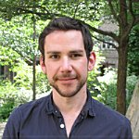

Steven Gray is an assistant professor of human ecology at the School for the Environment at the University of Massachusetts Boston. Prior to this position he was an assistant professor at the University of Hawaii (UH) in the Department of Natural Resources and Lead of the Social Science Division at the Water Research Resource Center at UH. His research focuses on developing decision-support software to help communities, resource managers, and other decision-makers to understand, and to adapt to, the social impacts of climate and other environmental changes. Currently his lab is working on a participatory modeling software called [Mental Modeler](http://www.mentalmodeler.com), which he, his students, and colleagues are applying in a variety of environmental planning and research contexts including marine spatial planning in Ireland, coastal hazard planning in the Pacific Islands, conservation agricultural planning in Nepaland India, understanding the bushmeat trade dynamics for conservation planning in Tanzania, and modeling landowner decision-making in relation to wildfire risks the Northeast US.

2. Graduate Students

Current

Alex Metzger (PhD, UMass)

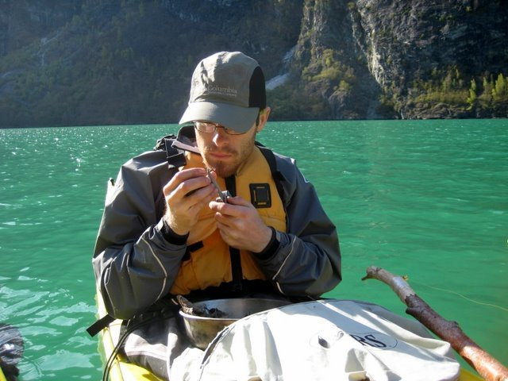

Alex's background in urban sustainability and resource flow analysis, sustainable forest management, and land conservation has led to his interest in stakeholder involvement with common pool resources. His current research focusses on analyzing the interplay among mental models, social networks, and resource management decision-making in order to understand the underlying factors that determine successful management strategies.

He earned his B.S. in Conservation Biology from the SUNY College of Environmental Science and Forestry, M.S. in Natural Resources from North Carolina State University, and M.S. in Forest Ecology from the University of Helsinki, Finland. He has also worked in both the government and non-profit sectors in positions related to natural resource conservation, environmental research, and land management.

Maxwell Martin (MS, UMass)

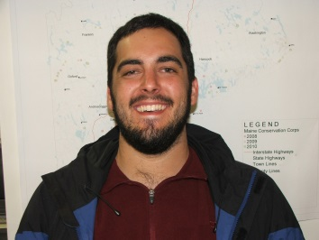

Max’s interests are in studying both the methods and theory of how to best integrate social and environmental science datasets to adequately describe social-ecological interaction for sustainability. Max is currently working on an internationally funded (NSF) Belmont Forum project to evaluate farmer decision-making in India.

Before moving to UMB Max was an undergrad in Pennsylvania, studying at a small but “life-changing” college - Juniata - with a B.S. in Human Ecology (which he designed himself) in 2013. Since then Max has been working with the Maine Conservation Corps building and rehabilitating trails in the great state of Maine.

Noelani Punawai (PhD, UHawaii)

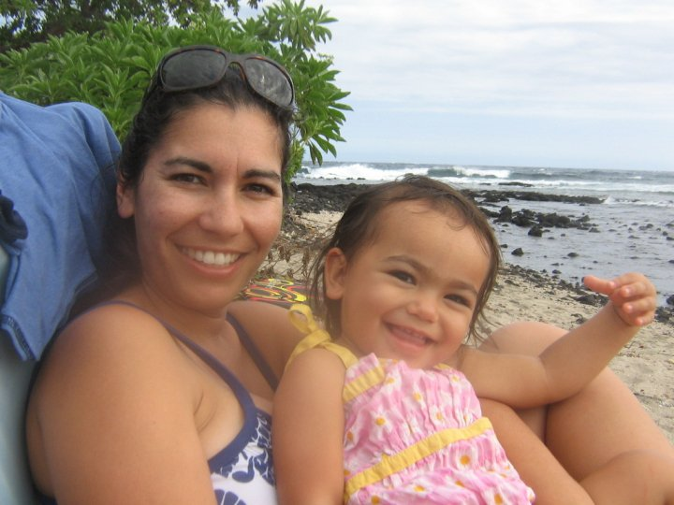

Born and raised in rural Puna on Hawai'i Island, Noe is passionate about protecting our islands, and specifically the ocean or seascape. Her work focuses on understanding the subjective meanings of the seascape and using this knowledge to inform management.

Noe is a mother of 3 making her dedication to conservation and education of our youth a force in her life. Working at the University of Hawaii at Hilo for the Pacific Islands Program for Exploring Science, she connects students to careers and research in Hawaii and empowers them to take control of  our  collective  future. Noe is academically trained in marine (BA UH Hilo) and environmental science (MSc. WSU) and is working on her PhD in the Natural Resources and Environmental Management program at UH Manoa*.*

B. Former lab Members

Jackie Chan-Halbrednt (PhD, UHawaii)

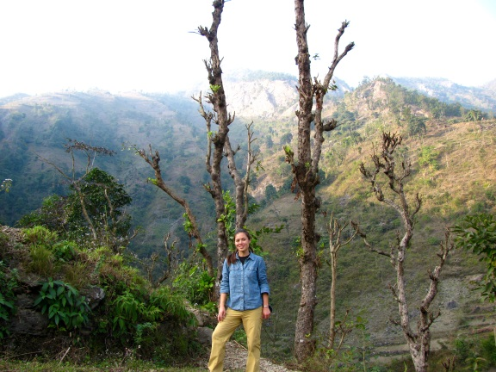

Jackie is interested in the individual (mental models), family (household), and social (community) implications of international agricultural development. Her dissertation research was funded by USAID and evaluated the different human dimensions of conservation agriculture. This research has been featured in leading journals like Global Environmental Change and in development relevant publications like Mountain Research and Development. Jackie recently traded the beautiful shores of Hawaii for the bucolic yet cosmopolitan scenery of Wageningen in the Netherlands. She continues collaborating with our group as part of the NSF Belmont Form Project working with rural farmers in India.

Molly Miller (MS, 2014)

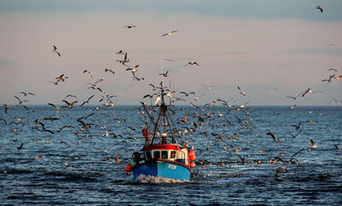

A native of Massachusetts, Molly decided to take some time off from the New England winters to spend a few years in Hawaii. While at the University of Hawaii, Molly’s research focused on evaluating the degree of fishermen participation in NOAA’s cooperative research program in to understand (1) how fishermen participation in science changed since the program was started in 2000 and (2) the outcomes associated with scientists/fishermen collaboration.

Before heading to Hawaii, Molly received a BS in Biology from Vassar College in New York and since graduating, has returned to the beautiful and unforgiving coastline of Maine.

Angela Nyaki (MS, 2013)

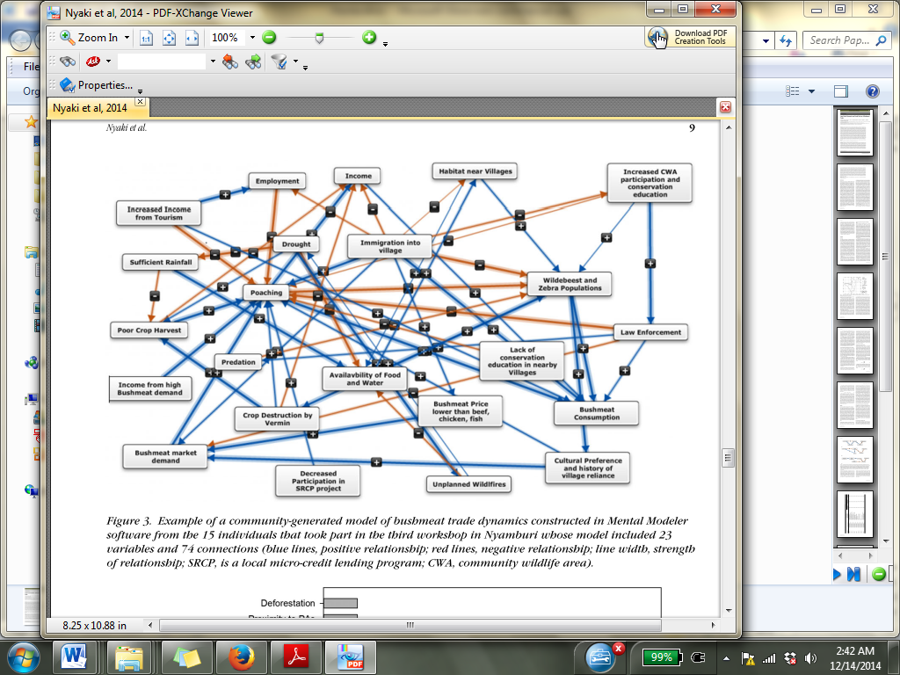

Angela joined the group in 2011 as a graduate student and Ford Foundation Fellow at the University of Hawaii in the Department of Natural Resources and Environmental Management. Before joining the lab, Angela was a wildlife officer with the Tanzania National Park Service working in the Serengeti. Angela‘s research interest are in collaborative management of wildlife resources and with funding from the Frankfurt Zoological Society engaged in participatory modeling with the illegal hunters in the park to better understand the drivers of illegal poaching from the community perspective.

Mary Pleasant (MS, 2013)

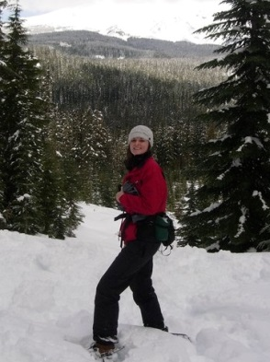

Mary's primary goal is to facilitate sustainable management of natural resources through engaging local community in conservation, and studying their effects on and interaction with the environment. Understanding how humans interact with the natural world requires an interdisciplinary approach of both the social and natural sciences, using a mix of quantitative and qualitative methods.

Mary holds a B.S. is in Wildlife Biology from Humboldt State University, and M.S. in Natural Resources and Environmental Management from the University of Hawaii at Manoa. Professionally, she has worked for the Bureau of Land Management and California State Parks in natural resource management. In addition, while at the University of Hawaii, she was both a research assistant studying ecosystem services and project coordinator for an international development project in the Philippines that provided under-served youth access to agricultural entrepreneurship training and resources. She is now professional faculty in the Department of Applied Economics at Oregon State University.

**3. Publications**

**Books**

Gray, S., M. Palissio, R. Jordan and S. Gray (Eds.) *Participatory modeling for adaptation:*

*Theory, methods, and applications.* Springer Publishing, New York City (under contract, for summer 2015)

**Refereed/Peer Reviewed**

(graduate student/advisee co-author underlined; undergraduate co-author noted with asterisk*)

Note: 10 additional journal manuscripts in review or revision as of 8/1/14

**2015**

Henly-Shepard, S., Gray, S., and Cox, L. 2015. Facilitating community adaptation through

participatory modeling and social learning.. *Environmental Science and Policy.* 45:109-122.

Barnes-Mauthe, M. Gray, S., Arita, S., Lynham, J., P. Leung, What determines social network

capital in a social-ecological system? (in press) *Environmental Management*

Hmelo-Silver, C., Liu, L., Gray, S., Jordan, R. 2015. Using representational tools to learn about

complex systems (in press) *Journal of Research in Science Teaching*

***\*Cover Article for January 2015***

**2014**

Halbrendt, J., S. Gray, S., Radovich, T., Crow, S., Kimura, A. 2014.Differences in farmer and

expert beliefs and the perceived impacts of conservation agriculture. *Global Environmental Change.* 28: 50-62.

Nayaki, A., Gray, S., Lepczyk, J. Skibins, D. Rentsch. 2014. Understanding the hidden drivers

and local-scale dynamics of the bushmeat trade through participatory modeling *Conservation Biology* 28(5) 1403-1414.

Halbrendt, J., Gray, S., Radovich, T., and Kimura, A., Reed, B., and Tammang, B. 2014

Implications of conservation agriculture for men's and women's workloads among marginalized farmers in the Central Middle Hills of Nepal. *Mountain Research and Development*. 34(3) 214-222.

Punawai, N., Canale, L., Haws, M., Potemra, J., and Gray, S. 2014. Development of a

GIS-based tool for aquaculture siting. *International Journal of Geo-Information.* 3:800-816.

Gray, S., Gray S., and Zanre, E. 2014. Fuzzy Cognitive Maps as representations of mental

models and group beliefs: theoretical and technical issues. In *Fuzzy Cognitive maps for Applied Sciences and Engineering –From fundamentals to extensions and learning algorithms* Ed: Elpiniki I. Papageorgiou. Springer Publishing. pp 29-48.

Gray, S., D. Mellor, D, RC Jordan, and G. Newman. 2014. Modeling with citizen scientists.

*Proceedings of the International Environmental Modelling and Software Society*

*(iEMSs)* 7th Intl. Congress on Env. Modelling and Software, San Diego, CA, USA, Daniel P. Ames, Nigel W.T. Quinn and Andrea E. Rizzoli (Eds.)  
<http://www.iemss.org/society/index.php/iemss-2014-proceedings>

Gray, S., Gagnon, A.,Gray, S., Mahony, C., Muir, D., Falaleeva, M. 2014. Are local coastal

managers detecting the problem? Assessing stakeholder perception of climate vulnerability using Fuzzy Cognitive Mapping. *Ocean and Coastal Management.* 94:74-89.

Pleasant, M, Gray, S., Lepcyzk, C. Fernandez*, A., Hunter*, N., and D. Ford* 2014. Managing

cultural ecosystem services: Local management yields large-scale benefits. *Ecosystem Services.* 8: 141-147.

Nicosia K, S. Daaram, B. Edelman, L. Gedrich, E. He, S. McNeilly, V. Sheno, A. Velagapudi,

W. Wu ,L. Zhang, A. Barvalia, V. Bokka, B. Chan, J. Chiu, S. Dhulipalla, V. Hernandez, J. Jeon, P. Kanukollu, P. Kravets, A. Mantha, C. Miranda,V. Nigam, M. Patel, S. Praveen,T. Sang, S. Upadhyay, T. Varma,C. Xu, B. Yalamanchi, M. Zharova, A. Zheng ,R. Verma, J. Vasslides, J. Manderson, R.C. Jordan, and S.A. Gray. 2014. Determining the willingness to pay for ecosystem service restoration in a degraded coastal watershed: A ninth grade investigation. *Ecological Economics*.104: 145–151.

**2013**

Jordan, R.C., Brooks, W., Gray, S., Delisi, J., and A. Berkowitz. 2013. Rising to the challenge of

‘broader impacts’ *Frontiers in Ecology and the Environment* 11(5) 234-235.

Barnes-Mauthe, M., S. Arita, S. D. Allen, S. A. Gray and P. Leung. 2013. The influence of   
 ethnic diversity on social network structure in a common-pool resource system:

Implications for collaborative management. *Ecology and Society* 18 (1): 23. [online]

URL: <http://www.ecologyandsociety.org/vol18/iss1/art23/>

Gray, S. Gray, S., Cox, L., and Henly-Shepard, S. 2013. Mental modeler: A fuzzy-logic

cognitive mapping modeling tool for adaptive environmental management. *Proceedings of the 46th International Conference on Complex Systems*. 963-973.

Jordan, R.C., C. Hmelo-Silver, L. Liu, and S. Gray. 2013. Using a complex system ontology

to foster ecosystem learning. *Applied Environmental Education and Communication* 12(1) 55-64.

Sinha, S., Gray, S., Hmelo-Silver, C.E., Jordan, R.C., Eberbach, C., Goel, A., and S. Rugabar

2013. Conceptual representations for transfer A case study tracing back and looking forward. *Frontlines in Learning Research* 1(1) 3-24.

Jordan, R.C., DeLisi, J., Brooks, W., Gray, S., Alvarado, A., Berkowitz, A. 2013. A

collaborative model of science teacher professional development. *International Journal of*

*Modern Education Forum* 2(2) 31-41.

Jordan, R.C., Gray, S., Brooks, W., Hemlo-Silver, C.E., Honwad, S. 2013. Process-based

thinking in ecological science. *Natural Sciences Education* 42(1): 68-74

**2012**

Gray, S., Nicosia, K.; and Jordan, R. C. 2012. Lessons learned from citizen science in the

classroom. *Democracy and Education*, 21(1) 14.

Gray, S., R. Shwom, R. C. Jordan 2012. Understanding factors that influence stakeholder trust

of natural resource science and institutions *Environmental Management* 49, 663-674.

Gray, S., Chan, A.*, Clark, D.* and R.C. Jordan. 2012. Modeling the integration of stakeholder

knowledge in social-ecological system decision-making: Benefits and limitations to knowledge diversity. *Ecological Modeling* 229,88-96.

Jordan, R.C., Ehrenfeld, J., Gray, S., Brooks, W. & C.E. Hmelo-Silver. 2012 Cognitive

considerations in citizen science. Eds: R. Bonnie J. Dickenson. In *Citizen Science:*

*Public Participation in Environmental Research*. Cornell University Press

Kohut, J. Palarama, L., Bochenek, E., Jenson, O., Manderson, J. Oliver, M., Gray, S., and C.

Roebuck 2012. Using ocean observing systems and local ecological knowledge to nowcast butterfish bycatch events in the Mid-Atlantic Bight longfin squid fishery. *Oceans*, 1-6

Palarama, L., Manderson, J., Kohut, J., Oliver, M., Gray, S. and Goff, J. 2012 Improving habitat

models by incorporating pelagic measurements by coastal ocean observatories. *Marine Ecology Progress Series* 447, 15-30.

**2011**

Jordan, R.C., S. Gray, D. Howe, W. Brooks, and J. Ehrenfeld. 2011. Knowledge gain and

behavior change in citizen-science programs. *Conservation Biology.* (25) 1148-1154.

Vattam, S., Goel, A., Rugaber, S., Hmelo-Silver, C., Jordan, R., Gray, S., Sinha, S., 2011

Understanding complex natural systems by articulating Structure-Behavior-Function models. *Educational Technology and Society* 14(1) 66-81.

**2010**

Gray, S.and R.C. Jordan. 2010. Ecosystem-based angling: Incorporating recreational fishermen

into ecosystem-based management. *Human Dimensions of Wildlife.* 15(4) 233-246.

Gray, S.,M. Ives, J. P. Scandol, and R.C. Jordan. 2010. Categorizing the risks in fisheries

management. *Fisheries Management and Ecology.* 17(6) 501-512.

Sinha, S., Gray, S., Hmelo-Silver, C.E., Jordan, R.C., Honwad, S. 2010, Appropriating

conceptual representations: A case of transfer among middle school science teachers *Proceedings of the 9th International Conference of the Learning Sciences*.(1) 834-841.

**2009**

Gray, S. Ives, M., Scandol, J., and Jordan, R 2009. Classifying the risk in fisheries management

in Australia and the U.S. Atlantic coast. In: *Scandol JP, Ives MC and Lockett MM*

*Development of national guidelines to improve the application of risk-based methods in the scope, implementation and interpretation of stock assessments for data-poor species.* Finalreport to the Fisheries Research & Development Corporation for Project No. 2007/016.3Industry & Investment NSW Final Report Series No. 115. Cronulla Fisheries Research Centreof Excellence, NSW, Australia pp 164-179.

Jordan, R.C., S. Gray, C. Hmelo-Silver, M. Demeter, and L. Lui. 2009. An assessment of

students' understanding of ecosystem concepts: Conflating ecological systems and cycles. *Applied Environmental Education and Communication.* 8(1) 40-48.

**2008**

Gray, S., C. E. Hmelo-Silver, L. Liu, R.C. Jordan, H. Jeong. 2008. Learning with ecosystem.

models. *Proceedings of the 8th International Conference of the Learning Sciences*. 1: 289-296.

Jordan, R.C., S. Gray, and R. Golan-Duncan. 2008. Teachers and scholarship: Self-definition of

teachers in the scientific enterprise. *Education and Society,* 26(3) 33-44.

Hmelo-Silver, C. R. C. Jordan, L. Lui, S. Gray**,** M. Demeter, S. Rugaber, S.Varrtam, and A.

Goel. 2008. Focusing on function: Thinking below the surface of complex natural systems *Science Scope*, 31: 27-35

Jordan, R.C., S. Gray, M. Demeter, L. Lui, and C. Hmelo-Silver. 2008. Quick fix: Don’t forget

behavior in systems thinking! *American Biology Teacher*, 70: 329-330.

**4. Research**

Our research concentrates on understanding how individuals and groups make decisions about complex social-ecological systems, with a focus on issues related to public participation, knowledge inequality, and the role that values and scientific modeling play in characterizing environmental and social change. This work draws from a range of disciplines (e.g., cognitive psychology, systems sciences, planning, ecology, and computer science) and has been supported by NSF, NOAA, USEPA, BLM, USDA, the Leibniz Institute (Germany) and the Australian Academy of Sciences.

**Current Research Funding**

2014-2016 **Department of the Interior (Bureau of Land Management)**

Policy Scenarios for fire-adapted communities: understanding stakeholder risk-perceptions

2014-2016 **NOAA Sea Grant**

Forecasting climate change impacts on coastal ecosystem services in Hawaii through integration of ecological and social models

2014-2015 **NSF (Belmont Forum)**

Agriculture, food security & climate change: Sustainable management of agro-ecological resources for tribal societies

2012-2016 **NSF Cyberlearning**

Sustaining ecological community through citizen science and online collaboration

**Selected Past Research Funding**

2013-2014 **USGS Water Resources Research Institute Programs**

Forecastingclimate change impacts on watershed-based ecosystem services in Hawaii

2012-2014 **USDA**

Mental Modeler: Developing a software tool to support community-based decision-making

2012-2014 **Leibniz-Institute of Freshwater Ecology and Inland Fisheries**

Freshwater Understanding the relationship between natural resource decision-maker mental models and sustainable natural resource management in freshwater recreational fisheries

2011-2012 **NOAA Cooperative Research, Conservation Engineering**

Evaluation of broad and fine scale models of butterfish biomass applied to by-catch reduction in the longfin inshore squid fishery in the Mid-Atlantic Bight

2010-2012 **NOAA Cooperative Research, Conservation Engineering**

Integrating habitat models and stakeholder knowledge into commercial fishing to reduce by-catch

2008 **NSF Office of International Science and Engineering**

Improving the management of data-poor fisheries: Evaluating risk and uncertainty in fisheries management in Australia and the United States

**5. Teaching**

I enjoy teaching and student mentorship because it offers me an opportunity to refine my own knowledge while introducing students to new concepts, ways of reasoning, and methods to measure and understand the complexity of our external world. Additionally, I find it very rewarding when students are able to communicate this reasoning and understanding to others, both personally and through academic presentations and writing. This enjoyment might be best exemplified by the diversity of my teaching and mentorship experiences with students. In terms of mentorship, I have worked with undergraduate students from a variety of fields including environmental policy and planning, biology, education, mathematics, and natural resource management. I developed and taught courses in environmental and natural resource policy, environmental politics, social-ecological research methods, modeling, statistics and applied calculus, conflict resolution, and a series of research methods and quantitative analysis courses. Examples of these courses can be found below.

EEOS 122: Introduction to Natural Resource Policy

EEOS 476: Capstone

EEOS 603: Coasts and Communities I (co-taught)

EEOS 604: Coasts and Communities II (co-taught)

NREM 302: Environmental and Natural Resource Policy

NREM 203: Applied Calculus for the Life and Social Sciences

Recent News: Podcasts from the EEOS 476 are now available and VERY exciting! Listen to our students profile SFE faculty below.

[to be added]

**6. Software**

Mental Modeler*: A Participatory Modeling Tool for Communities and Researchers*

Participatory modeling has grown in popularity in recent years with the acknowledgement that stakeholder knowledge is an essential component in effective environmental decision-making. Including stakeholders in model building and model analysis allows decision-makers to understand important conceptual components in the system under management, build trust and common understanding between often diverse and competing groups, and reduce uncertainty by mining information that might not be a part of scientific assessment performed by experts alone. Although the benefits of participatory modeling are somewhat clear, scientific modeling software used routinely by experts is often too complicated for many novice users.

For the last four years, I have been developing open-source participatory-modeling software called *Mental Modeler* ([www.mentalmodeler.org](http://www.mentalmodeler.org)) that utilizes a fuzzy-logic cognitive mapping (FCM) approach and allows environmental stakeholders opportunities to develop semi-quantitative models of social-ecological systems. This software is designed with two goals in mind. The first is to afford stakeholders and other decision-makers an opportunity to understand the perceived structure of a managed system as well as how the system may react under a range of social and environmental scenarios. This appropriation uses the software as a collaborative learning tool which standardizes knowledge across types (local ecological, traditional ecological, scientific, etc.), allows real-time understanding of potential outcomes of future scenarios, and can create meta-models of stakeholder knowledge.

The second goal of the software is to popularize and facilitate “mental modeling” as a social-science method by collecting and quantitatively comparing the beliefs of individual stakeholders and to characterizing community-level knowledge about environmental or social issues. This appropriation allows the knowledge of different stakeholders to be quantitatively compared using network measures and can be used to understand conditions under which the predicted outcomes associated with different environmental policy or change scenarios are shared or divergent across stakeholder groups. The following examples illustrate how this approach has been used in a range of studies