UNIVERSITY OF BRASILIA

GAMA FACULTY

AEROSPACE ENGINEERING

MINI-PROJECT

Topic: Idealized Fuselage

Executer: Luiz Georg, 15/0041390

Application date: October 3rd, 2021

BRASILIA
2020

INTRODUCTION

In order to study and analyse more complex structural shapes composed of smaller elements, such as fuselages and wings made with stringers and panels, one can make model simplifications. A good, simplified model behaves, ideally, very similarly to the actual structure under specific conditions, such that it can be used as a good approximation for real life application. More complicated models, of course, offer higher accuracy, at the cost of more calculations and more complicated analysis.
For structures used in aerospace, a common structure is a closed, thin skin strengthened by stringers. In such structures, we can idealize the stringers as concentrations of area that resist direct stresses, called booms, and thin skin that resists shear stresses.
In this Project, a fuselage of such type will be studied, showing how to develop the idealized model and how to use it to obtain structurally meaningful results.

PROBLEM

Table 1 Problem values (Option 0)
Description | Symbol | Unit | Dimension
Diameter of fuselage | D | mm | 880
Bending moment | M_{x} | kN∙m | 235
Shear Load | F | kN | 120
Distance of shear load application | d | mm | 170
Number of stringers | z | - | 16
Skin thickness | t | mm | 0.8
Width of z-section | w | mm | 26
Height of z-section | h | mm | 30
Thickness of z-section | t_{z} | mm | 2

The fuselage under study has circular section, strengthened by 16 equally spaced stringers on the inside. The stringers are Z profile beams with geometry shown in Figure 1, while the fuselage cross section under analysis is shown in Figure 2. The values of each dimension are tabulated in Table 1, and fully specify the problem geometry

Figure 1 Dimensions of stringers
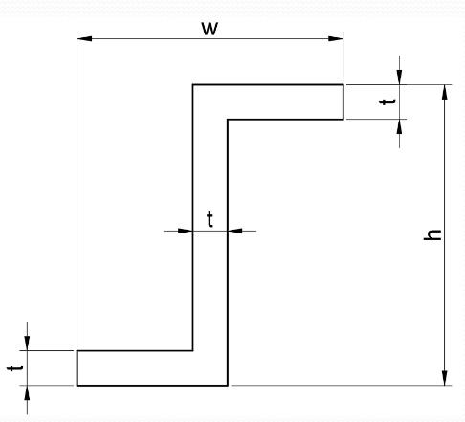

Figure 2 Fuselage cross-section
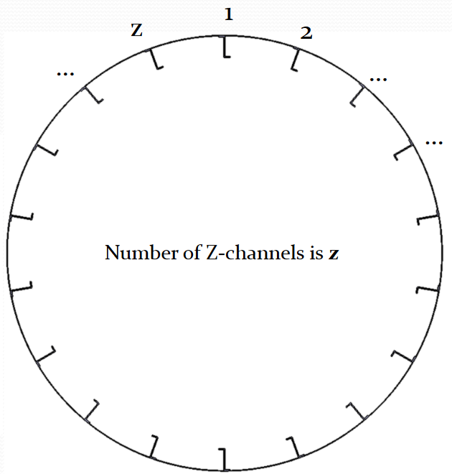

The fuselage is under 2 loads. A bending moment Mx, applied in a vertical plane as shown in Figure 3, causes direct stresses that will be resisted by the stringers. At the same time, a vertical shear force applied away from the centre of symmetry, as shown in Figure 4, creates shear stresses that are resisted by the skin. The effect of the stringers resisting shear force is negligible, while we will idealize the skin as thin panels that resist only shear stresses and booms that resist only direct stresses, so the effect of each load can be analysed separately. As with the geometry, the actual values of the loads are tabulated in Table 1.

Figure 3 Bending load
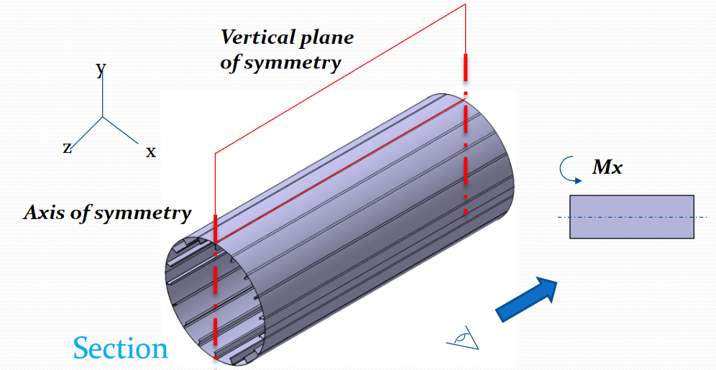

Figure 4 Shear load
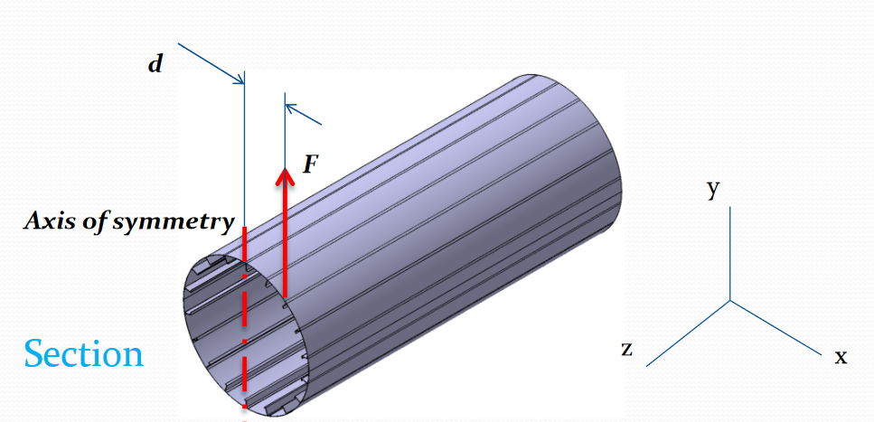

SOLUTION

- Structural idealization
To solve the problem, we first need to apply some simplifications. The stringers are small compared to the overall fuselage section, so direct tensions are mostly constant along each. They also don`t contribute to resist shear stresses, so they will be idealized as booms (points with area) that only resist direct stresses. The area of each stringer is easily calculated from Figure 1 as $A= wt+ht-t^{2}=108 {mm}^{2}$, and this area will be applied at the point each stringer touches the fuselage.
The skin resists mostly shear stresses, but it still has some area that resists direct stresses. To further simplify our model, we will replace the skin with a thin skin that carries shear flow, and booms at each end that resist direct stresses. The direct stress along the actual skin has a non-constant distribution, but for the case of bending moments in the vertical plane we can estimate that distribution to create equivalent booms that correctly represent the minimum and maximum direct stresses under this load. To do this, we will consider each section between stringers as approximately flat and place the equivalent booms on top of the booms we created for the stringers, effectively summing their areas. In this way, following the numbering convention used in Figure 2, the area of each boom relative to the skin can be calculated as:

$$A_{n}={\frac{1}{6}t}_{z}\frac{Dπ}{16}\left(4+\frac{σ_{n-1}}{σ_{n}}+\frac{σ_{n+1}}{σ_{n}}\right)$$

$$A_{n}={\frac{1}{6}t}_{z}\frac{Dπ}{16}\left(4+\frac{cos⁡((n-1)π/8)}{cos⁡(nπ/8)}+\frac{cos⁡((n+1)π/8)}{cos⁡(nπ/8)}\right)$$

In these equations, $σ_{n}$ represents the direct stress at the point we are placing the nth boom, and we know that the distribution of bending moments is directly proportional to the distance from the centroid, perpendicular to the bending axis. We calculate the distance ratio using the radial symmetry of the problem. It’s important to note that the area for the booms across the bending axis cannot be calculated using this formula, but since they are across the neutral axis, they resist no stress from the bending load and therefore their area is not needed.
Solving the equation for each boom, we find that the area of each boom (including the stringer and panel idealizations) is equal to 242.7 mm² for every boom.

- Stress distribution calculation
With our idealized structure, we can calculate the stresses across each element. Since the idealized skin does not resist direct stresses and the booms don’t resist shear stress, we can calculate the stresses for each load separately.
Starting with the bending load, we again use the fact that the bending stress is proportional to the distance from the centroid in the direction perpendicular to the bending moment. We know, from basic knowledge in solid mechanics, that such a moment in a symmetrical section is characterized by the equation:

$$σ_{z}=\frac{M_{x}y_{c}}{I_{xx}}$$

We can calculate the perpendicular distance from the centroid $y_{c}$ using the same method we used in the stress ratios for the boom areas, and the moment of inertia around the x axis, for our concentrated area booms, is:

$$I_{xx}=\sum{A_{n}{y_{c}}^{2}}$$

$$I_{xx}=3.759×{10}^{8} {\text{mm}}^{\text{4}}$$

Going back, we solve the equation for direct stress for the bending load and find the stresses shown in Table 2. It is worth noting that, as expected with this type of load, the stress distribution is symmetric across the Cy axis and anti-symmetric across the Cx axis.

Table 2 Direct stresses over each boom
Boom | $σ_{z}$ [MPa] |  | Boom | $σ_{z}$ [MPa]
1 | 275.1 |  | 9 | -275.1
2 | 254.1 |  | 10 | -254.1
3 | 194.5 |  | 11 | -194.5
4 | 105.3 |  | 12 | -105.3
5 | 0 |  | 13 | 0
6 | -105.3 |  | 14 | 105.3
7 | -194.5 |  | 15 | 194.5
8 | -254.1 |  | 16 | 254.1

For the shear stress distribution, we can move the shear load to the shear center and calculate an equivalent torsion moment applied in the anti-clockwise direction. Then, we can calculate the effects of each of those loads separately and add them by superposition. For symmetric shapes, the shear centre is always located in the axis of symmetry. Therefore, for our cross-section, it coincides with the centre of area. Therefore, the applied torsion moment around the centroid is $T=Fd=20.4 \text{kN}\text{∙m}$.
Then, since we have an idealized thin panel (0 thickness), the shear flow distribution relative to the shear force can be calculated as a sum instead of an integral:

$$q_{F,n}=-\frac{F}{I_{xx}}\sum_{1}^{n}{A_{i}}y_{i}+q_{F,0}$$

In this equation, $q_{F,n}$ represents the shear flow after boom $n$ and before boom $n+1$, oriented in the anti-clockwise direction. The first term on the right is the open section shear flow $q_{b,n}$, while $q_{F,0}$ is a constant that appears when we have a closed section and can be calculated using the anti-symmetry across Cy ($q_{F,1}+q_{F,16}=0$).

$$q_{F,0}=\frac{-\left(q_{b,1}+q_{b,16}\right)}{2}$$

$$q_{s,0}=17.05 \text{N/mm}$$

The shear flow relative to torsion is constant for our circular section and equals $q_{T}=T/2A$, where $A$ is the area enclosed by the fuselage section. Therefore, $q_{T}=16.77 \text{N/mm}$. Finally, calculating $q_{b,n}$ for each panel, we have $q_{s,n}=q_{b,n}+q_{F,0}+q_{T}$. The results are tabulated in Table 3 and the distribution is shown graphically in Figure 5.

Table 3 Shear flow distribution across the fuselage
Panel | $q_{s}$ [N/mm] |  | Panel | $q_{s}$ [N/mm]
1,2 | 33.82 |  | 16,1 | -0.275
2,3 | 65.31 |  | 15,16 | -31.77
3,4 | 89.42 |  | 14,15 | -55.88
4,5 | 102.5 |  | 13,14 | -68.92
5,6 | 102.5 |  | 12,13 | -68.92
6,7 | 89.42 |  | 11,12 | -55.88
7,8 | 65.31 |  | 10,11 | -31.77
8,9 | 33.82 |  | 9,10 | -0.275

Figure 5 Shear flow distribution across the fuselage, in N/mm
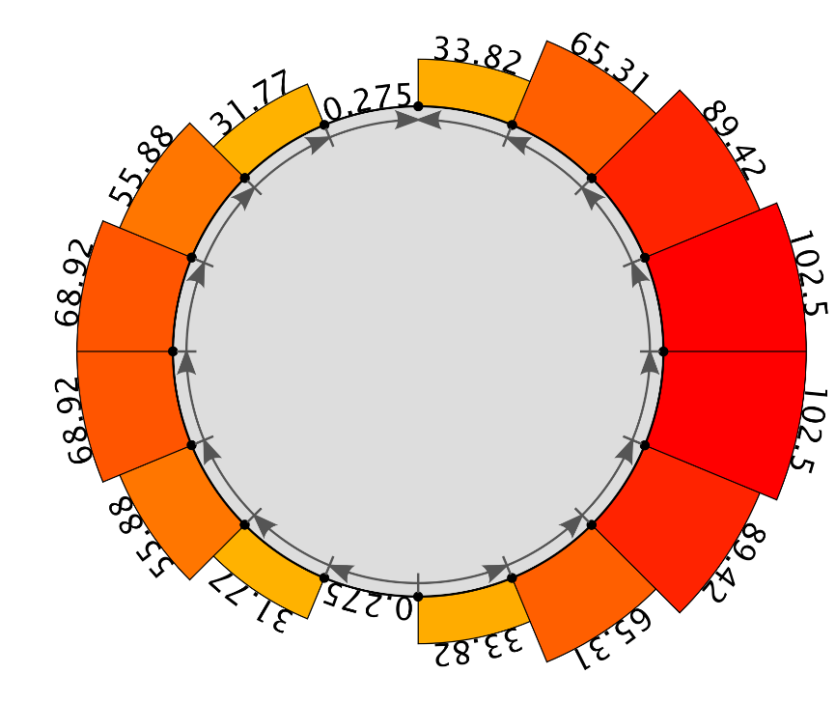

CONCLUSIONS

The idealized model of panels and booms is a useful design tool for thin walled structures. Though a simplified model, it lets one calculate the maximum stresses under specific conditions without resorting to complicated calculations and allows for fast development and design space exploration. Though the distribution includes discontinuities and area accumulations, it gives a confident result for the main results when designing maximum and minimum stresses.
If we knew the material of the fuselage, the values calculated here could be used with a structural criterion to determine if the structure is adequately dimensioned.
On the other hand, The simplifications used here include a single, isotropic material for the skin and the stringers, which is not realistic for modern day aerospace industry.

LITERATURE

MEGSON, T. H. G. Aircraft Structures for Engineering Students. 4th ed. Oxford, UK: Butterworth-Heinemann, 2007.

