Sprint Planning Document (Sprint 2)

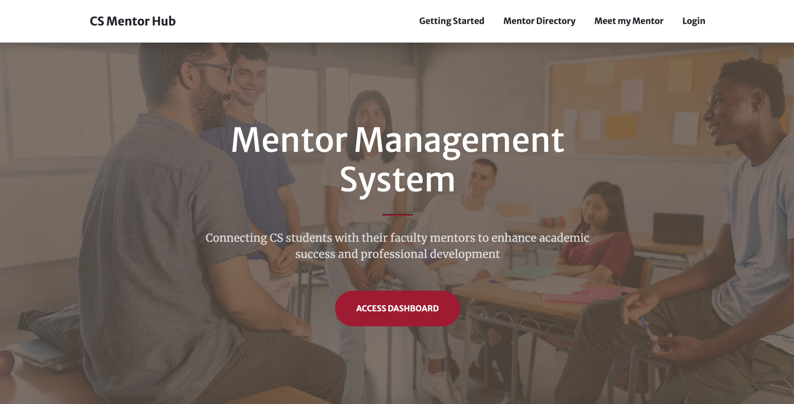

**Sprint Goal Backlog (Sprint 2)**

February 25 - March 14, 2025

{Andrew Hahn, Hannah Hazelwood, Gregory Nothnagel, Manjila Singh}

**High-level Project Overview**

**Project Mission:**

* The Mentor Management Project aims to support a mentorship program for freshmen in the Computer Science Department. Through this program, students can receive academic, professional, and personal development.

**Problems We Are Solving:**

* There is currently no infrastructure for a mentorship program.
* Materials and information are decentralized, causing a lot of extra work to manually send emails and review form responses.
* There are many students in the department compared to the number of faculty. This means there is a large time burden on those facilitating the mentorship program.
* Freshmen struggle to adjust to college life and need extra support.

**Project Overview (High-Level Features):**

* **Mentor Management Website:**
  + **Sign-in/up:** Users should be able to sign in with crimson email address to Microsoft.
  + **Meet My Mentor:** Page should display a student’s mentor and all necessary information about that mentor.
  + **Mentor Directory:** Users should be able to see a list of all mentors. Students can request to change their mentor.
  + **Home Page/Get Started**: This page should give basic instructions to students about the mentorship process.
  + **Logging a Meeting:** After a meeting, a mentee should be able to add a log for the meeting to track it. It should include various information about the student and the meeting. The mentor should be able to see these logs and add notes for any of their mentee’s meeting logs.
  + **All Students:** This page will be in the mentor view and will show all the students and their information.
  + **My Students:** This page will be in the mentor view and will show the students that belong to a mentor. A mentor can view meeting log responses here and add meeting notes of their own.
  + **Meeting Scheduler:** A student should be able to schedule a meeting with their mentor. Both students and mentors should be able to see all of their upcoming mentorship meetings.
  + **Tracking Students:** Users should be able to track a student from freshman to senior year. A student should be able to see their meeting history. A mentor should be able to see all of their students’ meeting histories. An admin should be able to see all the students’ meeting histories.
* **Admin Dashboard**
  + CRUD Dashboard for admin and student workers to manage students, mentors and mentorships.
* **Backend Services**
  + **Realtime Database**: Data for students, mentors, mentorships, meetings, interest forms etc.
  + **Hosting:** Host the web app on the cloud. Should be able to deploy and run the project through Docker.
  + **Authentication:** Use OAuth to connect to Microsoft (crimson emails) for authentication.

**Sprint 2 Planning**

**Sprint 2 Goals:**

1. **Allow mentor to see a list of all of their mentees.**
2. **Allow only users in the database to access the website.**
3. **Allow students to send request to change their mentors.**
4. **Fix X-Frame/X-Content vulnerabilities.**
5. **Create and detect mentor and mentee view when a user logs in.**
6. **Allow student to fill out a meeting form that pre-fills some fields with student information.**
7. **Let mentor update a meeting log instance to add mentor notes.**
8. **Allow admin to batch import data into database using excel file in Django admin panel.**
9. **Host website on cloud.**

**Sprint 2 Deliverables:**

* **Allow mentor to see a list of all of their mentees:**
  + **Assigned:** {Andy Hahn}
  + Create a My Students tab to display a list of all assigned mentees with their information and meeting logs.
* **Allow only users in the database to access the website:**
  + **Assigned:** {Andy Hahn}
  + Restrict access to only users listed in the database
  + Check whether a user is present in the database before allowing them to log in.
* **Allow students to send request to change their mentors:**
  + **Assigned:** {Gregory Nothnagel}
  + Add an option for logged in students to request a mentor change which sends an email to Dr. Anderson.
* **Fix X-Frame/X-Content vulnerabilities:**
  + **Assigned:** {Hannah Hazelwood, Manjila Singh, Gregory Nothnagel}
  + Address security vulnerabilities by implementing proper HTTP headers.
* **Create and detect mentor and mentee view when a user logs in:**
  + **Assigned:** {Andy Hanh}
  + Every time a user logs in, differentiate between mentors and mentees and show the view accordingly.
* **Allow student to fill out a meeting form that pre-fills some fields with student information:**
  + **Assigned:** {Hannah Hazelwood}
  + Create a meeting log form that a mentee can fill out. This will keep track of any mentor meetings. Mentors should be able to see these meeting logs.
  + Simplify the process of filling out meeting log form by automatically populating known student information (name, email, major, minor, preferred name).
  + Follow any necessary cyber concerns related to form inputs.
* **Let mentor update a meeting log instance to add mentor notes:**
  + **Assigned:** {Hannah Hazelwood}
  + Allow mentors to add or edit meeting notes after a student submits a meeting log.
* **Allow admin to batch import data into database using excel file in Django admin panel:**
  + **Assigned:** {Manjila Singh}
  + Admins should be able to upload excel files to add or update student and mentorships through the Django admin panel.
* **Host website on cloud:**
  + **Assigned:** {Gregory Nothnagel}
  + Deploy the website to a cloud server which is now available at <https://34.170.92.44:3000/>