Sprint Planning Document (Sprint 3)

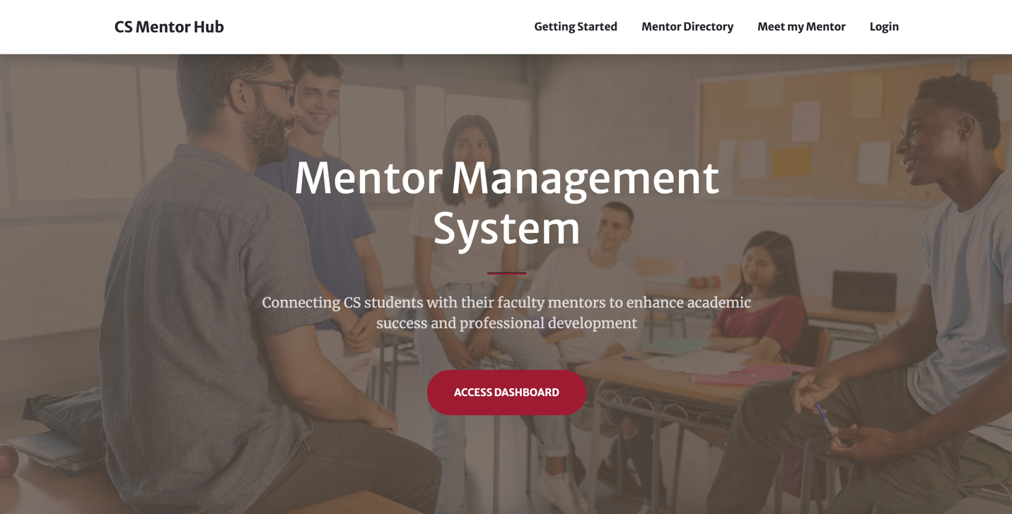

**Sprint Goal Backlog (Sprint 3)**

March 15 – April 22, 2025

{Andrew Hahn, Hannah Hazelwood, Gregory Nothnagel, Manjila Singh}

**High-level Project Overview**

**Project Mission:**

* The Mentor Management Project aims to support a mentorship program for freshmen in the Computer Science Department. Through this program, students can receive academic, professional, and personal development.

**Problems We Are Solving:**

* There is currently no infrastructure for a mentorship program.
* Materials and information are decentralized, causing a lot of extra work to manually send emails and review form responses.
* There are many students in the department compared to the number of faculty. This means there is a large time burden on those facilitating the mentorship program.
* Freshmen struggle to adjust to college life and need extra support.

**Project Overview (High-Level Features):**

* **Mentor Management Website:**
  + **Sign-in/up:** Users should be able to sign in with crimson email address to Microsoft.
  + **Meet My Mentor:** Page should display a student’s mentor and all necessary information about that mentor.
  + **Mentor Directory:** Users should be able to see a list of all mentors. Students can request to change their mentor.
  + **Home Page/Get Started**: This page should give basic instructions to students about the mentorship process.
  + **Logging a Meeting:** After a meeting, a mentee should be able to add a log for the meeting to track it. It should include various information about the student and the meeting. The mentor should be able to see these logs and add notes for any of their mentee’s meeting logs.
  + **All Students:** This page will be in the mentor view and will show all the students and their information.
  + **My Students:** This page will be in the mentor view and will show the students that belong to a mentor. A mentor can view meeting log responses here and add meeting notes of their own.
  + **Meeting Scheduler:** A student should be able to schedule a meeting with their mentor. Both students and mentors should be able to see all of their upcoming mentorship meetings.
  + **Tracking Students:** Users should be able to track a student from freshman to senior year. A student should be able to see their meeting history. A mentor should be able to see all of their students’ meeting histories. An admin should be able to see all the students’ meeting histories.
* **Admin Dashboard**
  + CRUD Dashboard for admin and student workers to manage students, mentors and mentorships.
* **Backend Services**
  + **Realtime Database**: Data for students, mentors, mentorships, meetings etc.
  + **Hosting:** Host the web app on the cloud. Should be able to deploy and run the project through Docker.
  + **Authentication:** Use OAuth to connect to Microsoft (crimson emails) for authentication.

**Sprint 3 Planning**

**Sprint 3 Goals:**

1. **Implement Login Attempts.**
2. **Automate Hosting Process.**
3. **Look into database bugs (mentorship, mentor).**
4. **Ensure proper documentation and Project Website completion.**
5. **Deploy to Dr. Anderson’s server**
6. **Fix: user logged in as student can see mentor tabs.**
7. **New admin credentials and put into env variables.**
8. **Discuss merging mentorship table into student table as a student attribute.**
9. **Mentor profile page.**
10. **Confirmation for changing mentors.**
11. **Add MC Summary attribute to meeting log modals.**
12. **Add input limits on new input fields.**
13. **Change student profile to look like mentor profile.**
14. **Batch updates to student attributes/mentor assignments.**
15. **Add cohorts to student table.**
16. **Finalize UI.**
17. **Add student workers as admins.**

**Sprint 3 Deliverables:**

* **Implement Login Attempts:**
  + **Assigned:** {Hannah Hazelwood}
  + Add login attempts to the admin dashboard login page to address cybersecurity concerns.
  + Research Django Axes to implement login attempts
* **Automate Hosting Process:**
  + **Assigned:** {Gregory Nothnagel}
  + Make deployment more user friendly, add environmental variables for IP related URLs.
  + Merge cloud branch into main branch.
* **Look into database bugs (mentorship, mentor):**
  + **Assigned:** {Manjila Singh}
  + Last sprint we uncovered a few database bugs, investigate what’s causing them.
  + Add some error handling to the CSV upload to help prevent unintended behavior in database.
* **Ensure proper documentation and Project Website completion:**
  + **Assigned:** {Hannah Hazelwood, Manjila Singh, Gregory Nothnagel, Andy Hahn}
  + Complete all necessary documentation, including information on how to install, how to use features, how to modify application, and FAQs.
  + Add all information, documentation, and deliverables to the project website.
  + Make videos for documentation and add to the project website.
* **Deploy to Dr. Anderson’s server:**
  + **Assigned:** {Manjila Singh, Gregory Nothnagel, Andy Hahn}
  + Deploy website to new server. Make any necessary changes to make the application work on this server.
  + New server is at <https://10.8.0.56:8000/admin> and <https://10.8.0.56:3000>
* **Fix: user logged in as student can see mentor tabs:**
  + **Assigned:** {Andy Hanh}
  + Current bug lets a student/mentor see the opposite role’s pages by typing in the correct URL.
  + Restrict viewing to certain roles and add an unauthorized view.
* **New admin credentials and put into env variables:**
  + **Assigned:** {Gregory Nothnagel}
  + Change admin login credentials for cybersecurity concerns.
  + Take login credentials out of source code and instead use references an .env file that will be hidden on the server. Now the person deploying can set their own passwords on deployment.
  + Also add other database passwords into .env file.
* **Discuss merging mentorship table into student table as a student attribute:**
  + **Assigned:** {Hannah Hazelwood, Gregory Nothnagel, Manjila Singh, Andy Hahn}
  + The current database has mentorship table separate from student. Technically, a student can only have one mentor, so this table could be integrated into the student table.
  + Discuss if changing this table is worth having to change all of the code that references it with the time remaining in the semester.
* **Mentor profile page:**
  + **Assigned:** {Andy Hahn}
  + A mentor should have a profile page where they can edit their office, research areas of interest, and office hours.
  + Do not let mentors edit their name or email.
* **Confirmation for changing mentors:**
  + **Assigned:** {Gregory Nothnagel}
  + Add in a confirmation screen letting students know they must approve the mentor request with their desired mentor before emailing Dr. Anderson.
* **Add MC Summary attribute to meeting log modals:**
  + **Assigned:** {Hannah Hazelwood}
  + Modify the meeting log modal to include the new interest summary attribute.
* **Add input limits on new input fields:**
  + **Assigned:** {Hannah Hazelwood}
  + All text input fields should have input limits for cybersecurity purposes.
  + Add limits to profile pages and forms.
* **Change student profile to look like mentor profile:**
  + **Assigned:** {Andy Hahn}
  + Update the student profile page to match the new mentor profile page.
* **Batch updates to student attributes/mentor assignments:**
  + **Assigned:** {Hannah Hazelwood, Gregory Nothnagel, Manjila Singh, Andy Hahn}
  + Admins should have the ability to make batch updates to student attributes or mentor assignments.
* **Add cohorts to student table:**
  + **Assigned:** {Hannah Hazelwood, Gregory Nothnagel, Manjila Singh, Andy Hahn}
  + The student table should include a field that references the student’s cohort.
* **Finalize UI:**
  + **Assigned:** {Manjila Singh}
  + Make all necessary edits to each of the pages on the front-end, ensuring a consistent and appealing UI.
* **Add student workers as admins:**
  + **Assigned:** {Hannah Hazelwood, Gregory Nothnagel, Manjila Singh, Andy Hahn}
  + Add student workers as additional users in the admin dashboard.
  + Assess if student workers should have any restrictions in the admin dashboard. If so, implement those restrictions.