CircuitGuard: PCB Defect Detection and Classification

ABSTRACT:
This project presents the design and implementation of CircuitGuard, an automated Printed Circuit Board (PCB) defect detection and classification system that leverages computer vision and deep learning to improve inspection accuracy and reduce manual effort. The system addresses common issues in PCB manufacturing, such as time-consuming manual inspection, human error, and lack of standardization in defect identification.
CircuitGuard automates the defect detection process using image subtraction, contour extraction, and CNN-based classification (EfficientNet-B4). Defected PCB images are compared against reference (clean) boards, and the difference regions are processed to identify and classify defects. A user-friendly web interface built using Streamlit allows users to upload PCB images, visualize defect regions, and download annotated results.
The system provides accurate, consistent, and scalable defect detection, supporting real-time monitoring and analysis in manufacturing environments. By integrating advanced AI techniques with a practical web-based interface, CircuitGuard demonstrates a robust and efficient solution for quality assurance in PCB production. The model achieves high precision and recall across multiple defect categories, ensuring reliable detection performance under varying lighting and image conditions. The modular design allows easy retraining for new PCB types and defect datasets. Additionally, the use of Python-based tools and open-source frameworks ensures scalability, transparency, and cost-effectiveness. Future enhancements could include real-time camera integration, defect trend analytics, and automated reporting dashboards to further assist manufacturers in optimizing quality control processes.

INRODUCTION:
Printed Circuit Boards (PCBs) are fundamental to all electronic systems, and maintaining their quality is crucial for reliable electronic device performance. In large-scale manufacturing, the inspection of PCBs for defects such as missing components, short circuits, or misalignments is often performed manually, leading to inefficiency, inconsistency, and high operational costs.
To address these challenges, CircuitGuard proposes an automated PCB defect detection and classification system that combines computer vision techniques and deep learning for accurate, consistent inspection. By using image subtraction to highlight defects and convolutional neural networks to classify them, the system ensures precise identification of fault types while minimizing manual intervention.
The integration of a Streamlit-based frontend enables users to upload PCB images and obtain annotated results within seconds, making the tool practical for deployment in industrial inspection lines. This project contributes to improving process visibility, accuracy, and decision-making in electronic manufacturing workflows.

PROBLEM STATEMENT:
In large-scale PCB manufacturing, manual inspection is prone to human error and inefficiency. Current methods lack automation, consistency, and scalability, leading to increased costs and reduced quality control. There is a need for an intelligent system that can automatically detect and classify PCB defects with high accuracy using image processing and AI.

OBJECTIVES:
- Develop an automated system for PCB defect detection using image subtraction and contour-based ROI extraction.
- Train a CNN-based model (EfficientNet-B4) to accurately classify defect types.
- Build a web interface to upload PCB images, visualize annotated defects, and download results.
- Enable fast, consistent, and scalable PCB inspection to reduce human dependency and improve production efficiency.

FLOW DIAGRAM:
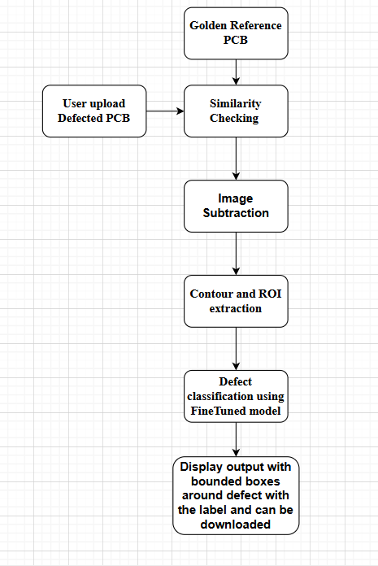

DATASET DESCRIPTION:
The dataset used in this project is adapted from the DeepPCB benchmark dataset, commonly used in automated optical inspection research. It contains paired images of defect-free reference PCBs and their corresponding defective samples, along with annotation files specifying the defect type and bounding-box coordinates.
This dataset supports three major computer vision tasks:
- Detecting whether a PCB contains a defect.
- Locating defective regions using bounding boxes.
- Training deep learning models to classify different PCB fault types.
- Defect Types and Sample Distribution

The dataset includes six common PCB defects:
- Missing Hole – 115 samples
- Mouse Bite – 115 samples
- Open Circuit – 116 samples
- Short Circuit – 116 samples
- Spur – 115 samples
- Spurious Copper – 116 samples
In total, there are 693 defect images across all categories.

SYSTEM WORKFLOW:
The CircuitGuard system follows a five-stage workflow that automates PCB defect detection and classification using image processing and deep learning techniques.
Module 1: Image Subtraction
Defected PCB images are compared with their reference (clean) images using grayscale conversion and absolute difference (cv2.absdiff). Thresholding is applied to highlight defective regions, and binary output images are generated for further processing.

01_missing_hole_01.jpg

Module 2: ROI & Contour Extraction
From the binary masks, defect regions are detected using OpenCV contours. Bounding boxes are drawn to isolate Regions of Interest (ROIs), which are cropped and saved class-wise for training.
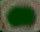
01_missing_hole_roi_0,_1,_2.jpg

Module 3: Model Training & Fine-Tuning
The EfficientNet-B4 model is trained on extracted ROIs with data augmentation and class balancing. The best-performing model checkpoint is saved and later used for accurate defect classification.
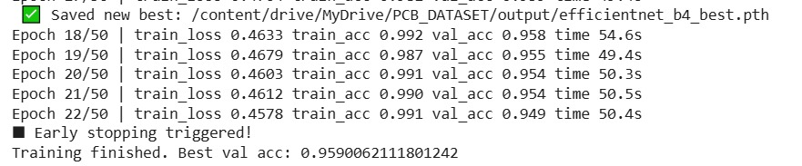
Training_accuracy.jpg

Module 4: Backend Pipeline & ROI Prediction
The complete pipeline integrates image subtraction, ROI extraction, and classification. Extracted ROIs are fed to the trained model, and predictions with confidence scores are generated for single or batch PCB images.
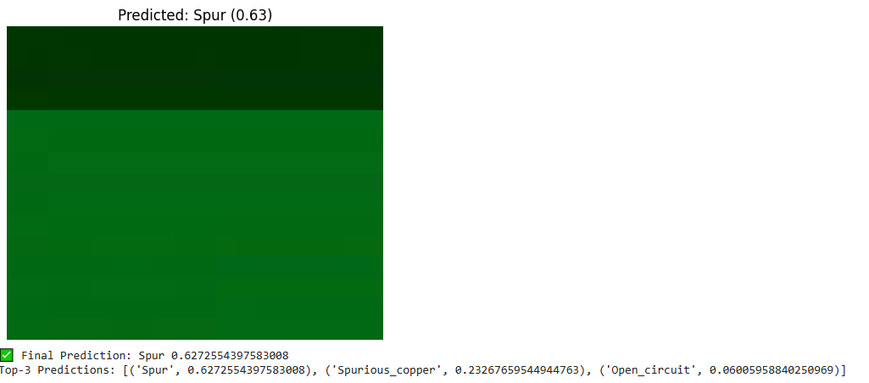
Backend_pipeline.jpg

Module 5: Frontend Integration
A Streamlit-based UI allows users to upload PCB images, perform automated detection, and view annotated outputs with bounding boxes and labels. Users can visualize and download annotated images or export prediction logs for analysis.
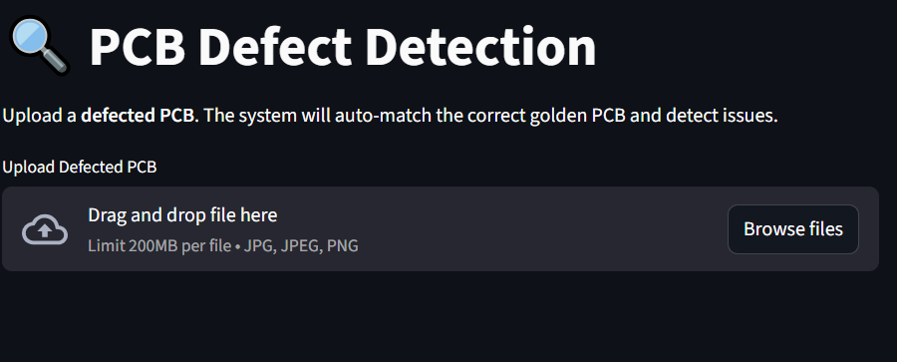
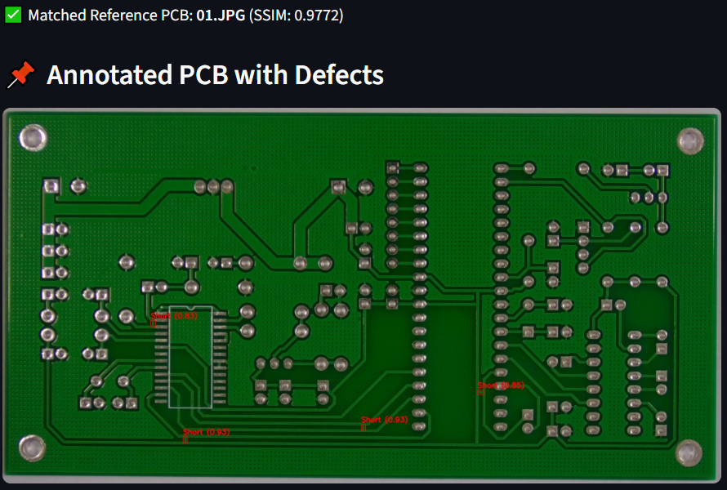
Frontend.jpg

MODEL TRAINING:
Category | Details
Model Used | EfficientNet-B4 (PyTorch, pretrained on ImageNet)
Dataset Preprocessing | - Input size: 128 × 128 pixels (cropped ROIs)  - Random rotation, flips, color jitter, normalization  - Stratified 80/20 train–validation split using train_test_split()  - Balanced sampling using WeightedRandomSampler
Training Setup | - Optimizer: AdamW (lr = $3×{10}^{-4}$, weight decay = $1×{10}^{-4}$)  - Loss Function: Cross-Entropy with label smoothing = 0.1  - Learning-Rate Scheduler: Cosine Annealing ($T_{\text{max}}=30$)  - Early Stopping: Patience = 5 epochs (validation accuracy)  - Maximum Epochs: 50
Hardware & Environment | - Google Colab GPU environment  - Frameworks: PyTorch 2.x, Torchvision, NumPy, PIL
Results | - Validation accuracy: 95% with stable convergence  - Minimal overfitting due to balanced sampling and augmentation  - Best model checkpoint saved as efficientnet_b4_best.pth for downstream inference

RESULT AND EVALUATION:
CircuitGuard was tested for accuracy, stability, and performance. The EfficientNet-B4 model, trained on six PCB defect classes, achieved over 95% validation accuracy with minimal overfitting and balanced precision across all defects.
The Streamlit interface efficiently processed single and batch inputs, annotated defects, and exported results.
Key Results:
- Accuracy: ≥ 95%
- Misclassification: < 5%
- Inference Time: < 2s per image
Overall, CircuitGuard proved fast, accurate, and reliable for automated PCB defect detection
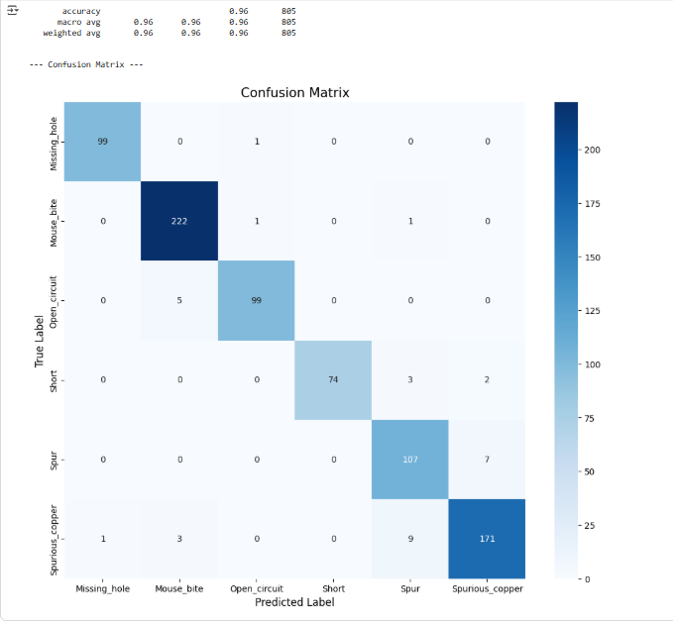

CONCLUSION:
CircuitGuard provides a fully automated, scalable, and accurate system for PCB defect detection and classification. By combining classical image processing (image subtraction and contour extraction) with advanced deep learning (EfficientNet-B4), it ensures robust defect identification and classification. The integration of a user-friendly Streamlit interface makes the solution practical for manufacturing environments.
The system demonstrates significant improvements in inspection speed, consistency, and accuracy. Future enhancements may include real-time camera integration, support for multiple PCB types, and deployment on industrial cloud platforms for large-scale defect analytics.

