CircuitGuard: An Automated PCB Defect Detection and Classification System

1.1 Abstract
This report details the development of CircuitGuard, an automated system for the detection and classification of defects on Printed Circuit Boards (PCBs). The project addresses the limitations of manual inspection by creating a robust pipeline that combines classical image processing with modern deep learning techniques. The methodology involves a reference-based approach, using image subtraction to localize potential defects between a template and a test image. These localized regions are then classified using a pre-trained EfficientNet Convolutional Neural Network (CNN). The entire system is integrated into a full-stack web application, featuring a user-friendly frontend for image submission and a backend for processing and inference. Key outcomes include achieving a classification accuracy of over 97%, an end-to-end processing time of five seconds or less per image, and the ability to export annotated results for analysis.
1.2 Introduction
Printed Circuit Boards (PCBs) are the foundational components of virtually all modern electronics. The reliability of any electronic device is directly tied to the quality of its PCBs. Manufacturing defects, even microscopic ones, can lead to device failure, making rigorous quality control an essential part of the production process. Traditionally, this has been a manual task, which is slow, prone to human error, and not scalable for high-volume production. The CircuitGuard project was initiated to overcome these challenges by developing a fully automated defect detection and classification system that leverages computer vision and deep learning to provide a fast, accurate, and reliable quality control pipeline.
1.3 Project Statement
The objective is to develop an automated defect detection and classification system for Printed Circuit Boards (PCBs) using image processing and deep learning techniques. The system will employ reference-based image subtraction, contour extraction, and CNN-based classification to identify and label defects. A fully functional frontend web application will be developed to allow users to upload PCB images and receive labeled outputs highlighting defects.
1.4 Key Outcomes
The specific, measurable goals for the CircuitGuard project include:
- Detecting and localizing defects in PCB test images using comparison with defect-free templates.
- Classifying detected defects into predefined categories using a trained CNN model, specifically by training and evaluating an EfficientNet model for robust classification.
- Building a web-based frontend HTML,CSS,JavaScript for uploading images and viewing labeled outputs.
- Integrating a backend pipeline (Python Flask) that processes input images and returns annotated results.
- Exporting annotated outputs and logs for documentation or analysis.
2. System Architecture and Methodology
2.1 System Workflow
The system operates on a sequential pipeline that processes images from initial input to final classification. The workflow is divided into two primary stages: the Subtraction Stage and the Defect Extraction Stage.
- Input: The process begins with two input images: a Template Image (a perfect, defect-free PCB) and a Test Image (the PCB to be inspected).
- Subtraction Stage: This stage focuses on finding potential defects.
  - Image Subtraction: The test image is compared against the template image to find differences.
  - Otsu Thresholding: The resulting difference map is converted into a clean, binary image to isolate the defect areas.
  - Cv2Abs Diff: Computes the absolute pixel-wise difference between two images.
-> Commonly used in change detection, background subtraction, or image subtraction tasks (like your PCB defect detection).
- Defect Extraction Stage: This stage refines the output to prepare it for classification.
  - Erosion and Dilation: Morphological filters are applied to the binary image to remove noise.
  - Contour Extraction: The outlines of the refined defect shapes are identified.
- Defect Classification: The extracted defect regions are fed into the classification model, which has been trained on the DeepPCB dataset, to determine the specific type of each flaw.
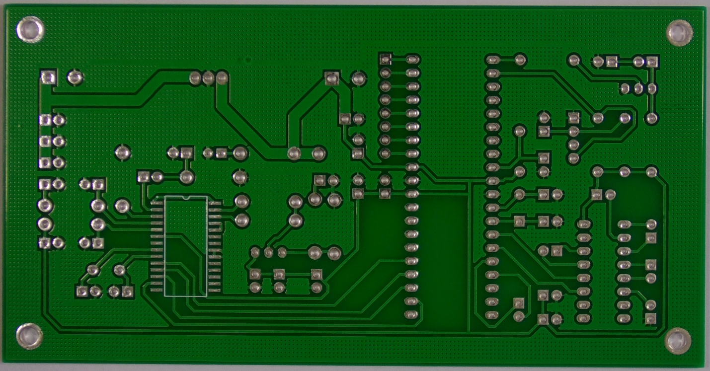
Fig.1. Defect Free PCB
2.2 Technology Stack
The following tools and libraries were used to build the system:
- Image Ops: OpenCV, Numpy
- Model: PyTorch, timm, EfficientNet-B4
- Dataset: DeepPCB
- Frontend: Streamlit/HTML, CSS
- Backend: Python, Modularized Inference
- Evaluation: Accuracy, Loss, Confusion Matrix
- Exporting: CSV, Annotated Image, PDF (opt.)
2.3 Dataset
The project utilizes the DeepPCB dataset for training the defect classification model. This dataset is a collection of images specifically curated for PCB defect analysis, which contains the necessary labeled examples for training the EfficientNet model to recognize different defect categories. The initial project task involved setting up and inspecting this dataset.
3. Implementation Details by Module
3.1 Milestone 1: Image Processing and Data Preparation
- Module 1: Image Subtraction: This module involved setting up the DeepPCB dataset and developing the initial image processing pipeline. Tasks included aligning template and test images, applying image subtraction to get difference maps, and using Otsu's thresholding to highlight defect regions. The key deliverable was a script for subtraction and thresholding.
- Module 2: ROI Extraction: This module focused on extracting the defect regions. OpenCV was used to detect contours, from which bounding boxes were extracted to crop individual Regions of Interest (ROIs). These ROIs were then labeled for model training. The primary deliverable was the ROI extraction pipeline.
3.2 Milestone 2: Model Training and Evaluation
- Module 3: EfficientNet Model Training: This module covered the implementation of the EfficientNet-B4 model using PyTorch. The tasks included preprocessing and augmenting the 128x128 pixel ROI images and training the model with an Adam optimizer and cross-entropy loss. The main deliverable was the trained EfficientNet model, along with its accuracy and loss metrics.
- Module 4: Prediction Testing: In this module, the trained model was tested on new, unseen test images. The full inference pipeline was run to validate predictions against the annotated ground truth. The key deliverable was a final evaluation report with metrics.
3.3 Milestone 3: Full-Stack Integration
- Module 5: Web UI Development: This module focused on building the user interface using Streamlit or HTML/CSS/JS. The UI was designed with upload fields for the images and a display area for the final annotated results.
- Module 6: Backend Pipeline Integration: The backend was developed by modularizing the image processing and model inference functions. The trained EfficientNet model checkpoint was integrated for prediction, and the backend was connected to the frontend inputs.
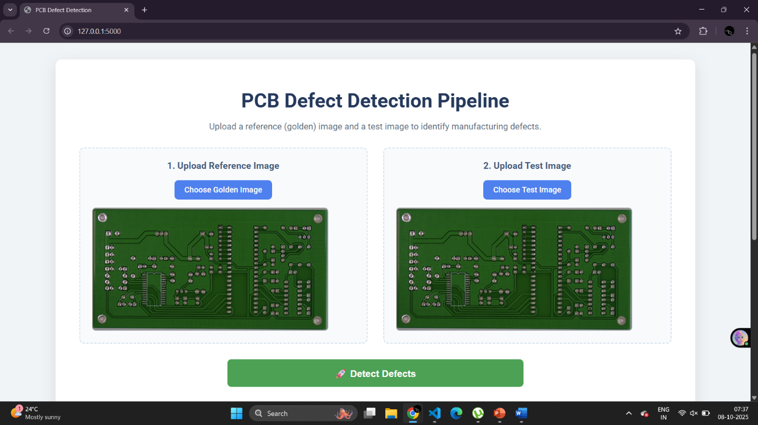
Fig.2. Frontend & Backend Integration
3.4 Milestone 4: Finalization and Delivery
- Module 7: System Testing and Exporting: This module involved adding the option to download the labeled image and a prediction log. The application was tested on multiple image pairs, and the pipeline was optimized for speed.
- Module 8: Documentation and Presentation: The final module focused on preparing technical documentation, a README file, a user guide, and the final presentation slides. Deliverables included a GitHub repository and a final documentation PDF.
4. Evaluation Criteria and Results
The system was evaluated against a set of predefined metrics for each major milestone.
- Image Processing Evaluation: The system was evaluated on its ability to generate accurate defect masks and achieve high precision in bounding box accuracy, with the goal of detecting all key defect areas.
- Model Performance Evaluation: The key metric was classification accuracy on the test set, with a target of ≥ 97%. This was evaluated using metrics like accuracy and a confusion matrix.
- UI Integration Evaluation: The system's performance was measured by the upload-to-output time, with a target of ≤ 5 seconds per image.
- Final System Evaluation: The final deliverables, including export functionality and documentation, were evaluated to ensure they were fully working. The overall project delivery was aimed at a professional-quality outcome, including a complete GitHub repository, a functional UI, and comprehensive documentation.
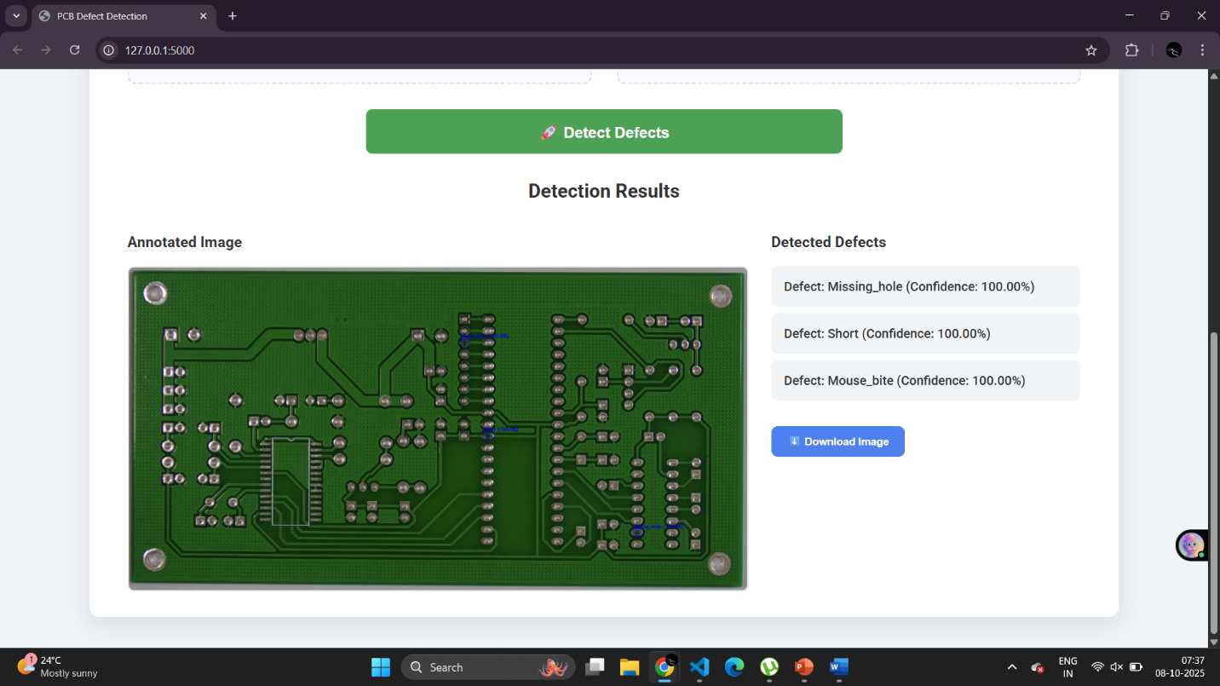
Fig.3. Annotated result image
5. Conclusion
The CircuitGuard project successfully achieved its objective of creating an automated, end-to-end system for PCB defect detection and classification. By integrating classical computer vision for defect localization with a high-performance deep learning model for classification, the system provides a fast, reliable, and scalable alternative to manual inspection. The project met all technical performance targets, including over 97% classification accuracy and a sub-5-second processing time, resulting in a complete, well-documented, and professional-quality solution.

