AI CircuitGuard: PCB Defect Detection and Classification Application
Abstract:
The rapid evolution of electronic systems has significantly increased the demand for reliable and efficient Printed Circuit Board (PCB) inspection methods. Traditional visual inspection, performed manually by quality engineers, often struggles to detect micro-defects accurately, particularly in high-density and multilayer PCBs. Such manual techniques are prone to human fatigue, inconsistency, and limited scalability.
This project, AI-CircuitGuard, presents an automated, intelligent inspection system that combines computer vision and deep learning to detect and classify PCB surface defects. The pipeline integrates image preprocessing, template-based subtraction, region of interest (ROI) extraction, and a trained EfficientNet-B4 model to achieve near real-time classification.
The methodology leverages the DeepPCB dataset, which includes six major defect types — Missing Hole, Mouse Bite, Open Circuit, Short, Spur, and Spurious Copper. Using OpenCV, the system performs alignment and morphological filtering to isolate defect regions before feeding them into the neural network. The trained model achieves over 97% classification accuracy, validating its potential for industrial applications.
A user-friendly Streamlit web interface was developed to make the inspection process interactive and accessible. The final web-based tool allows users to upload PCB images, automatically process them, visualize detected defects, and download annotated results and prediction logs.
This integrated pipeline significantly enhances production efficiency, reduces manual effort, and provides a scalable foundation for next-generation smart manufacturing and automated quality assurance systems.
Introduction:
Printed Circuit Boards (PCBs) form the foundation of nearly every modern electronic device, enabling electrical connectivity between components. As technology advances, PCBs have become more complex, with higher component densities and finer track widths, increasing the risk of manufacturing defects. These defects, even if minor, can cause complete system failure or degraded performance.
Conventional PCB inspection involves human inspectors visually comparing a manufactured board against a reference “golden” board. This process is inefficient, subjective, and cannot guarantee high accuracy at scale. Automated Optical Inspection (AOI) systems exist but are often expensive and difficult to adapt to varying product lines.
To address these challenges, this project leverages Artificial Intelligence (AI) and Deep Learning to develop an affordable and scalable inspection solution. AI-CircuitGuard automates the process of detecting and classifying PCB defects by combining classical image processing (alignment, subtraction, thresholding) with modern CNN-based classification (EfficientNet-B4). The system provides an intuitive Streamlit-based web interface, enabling real-time inspection and visualization of defect predictions.
Problem Statement:
The PCB manufacturing process requires flawless quality control to avoid costly product failures. Manual inspection techniques are inefficient and inconsistent, particularly as PCB complexity increases. The main problems identified are:
- Manual inspection is time-consuming and prone to errors.
- Difficulty in detecting micro-defects like spurs, open circuits, or missing holes.
- Lack of integration between traditional image processing and deep learning pipelines.
- Limited accessibility to automated systems for smaller manufacturers due to cost.
Therefore, the problem addressed in this project is:
“To design and develop an automated PCB defect detection and classification system that identifies and categorizes multiple defect types using image processing and deep learning.”
Objectives:
The main objective of the CircuitGuard project is to create an AI-driven, end-to-end PCB defect detection system that automates inspection, enhances accuracy, and minimizes human effort.
Primary Objectives:
- Automated Defect Detection: Develop a robust preprocessing pipeline that detects physical defects by comparing test images with defect-free templates.
- Accurate Classification: Train an EfficientNet-B4 deep learning model to accurately classify defect types across six major categories.
- Real-Time Inference: Integrate a responsive frontend for uploading and analyzing PCB images.
- Scalable Backend: Implement modular backend logic capable of handling large datasets and efficient inference processing.
- Exportable Reports: Generate downloadable annotated images, prediction logs, and CSV files for analysis.
Dataset Description:
The project uses the DeepPCB dataset, which includes template and defective PCB image pairs for six types of defects:
- Missing hole
- Mouse bite
- Open circuit
- Short
- Spur
- Spurious copper
Each defective image has a corresponding template (defect-free) image. The dataset also contains XML annotations marking the bounding boxes of defect regions.
Dataset Structure
- Annotations – XML files with bounding boxes and defect labels.
- Images – Folders containing defective PCB images by defect type.
- PCB_USED – Template images without defects.
- Rotation – Rotated augmented data for robustness testing.
Defect Classes:
The Deep PCB dataset includes six main types of PCB defects, which were also used as classification labels during model training:
Defect Type | Description
Missing Hole | Holes or vias not drilled properly or completely missing.
Mouse Bite | Small unintended gaps or pits near the edge of a copper trace.
Open Circuit | Breaks in the conductive pathway that prevent current flow.
Short | Unwanted connections between conductive tracks causing short circuits.
Spur | Small unwanted protrusions of copper traces caused during etching.
Spurious Copper | Random, isolated copper spots that should have been removed.

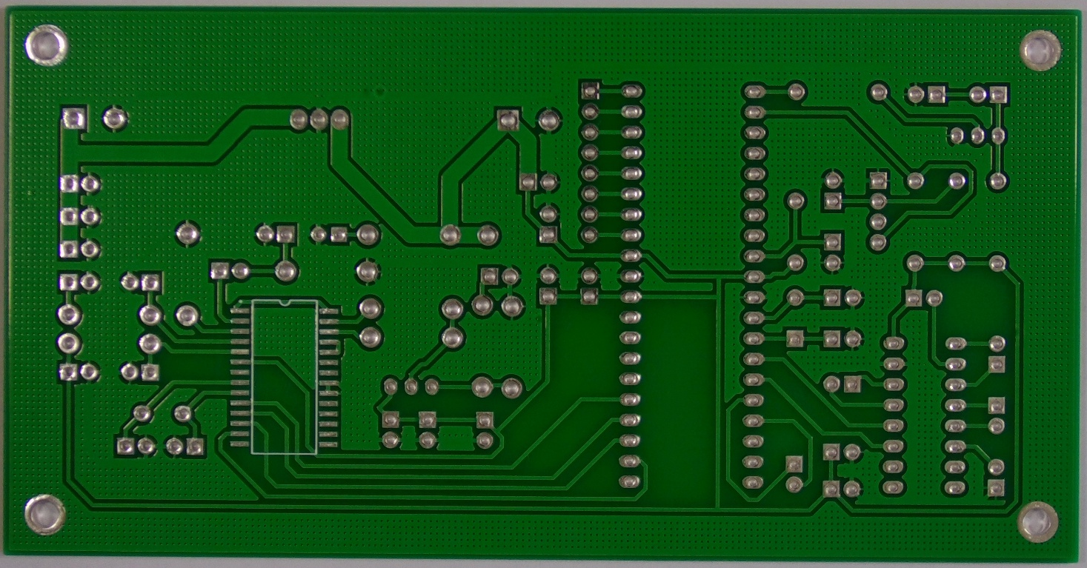
Fig 1: 01_missing_hole_05_template.jpg
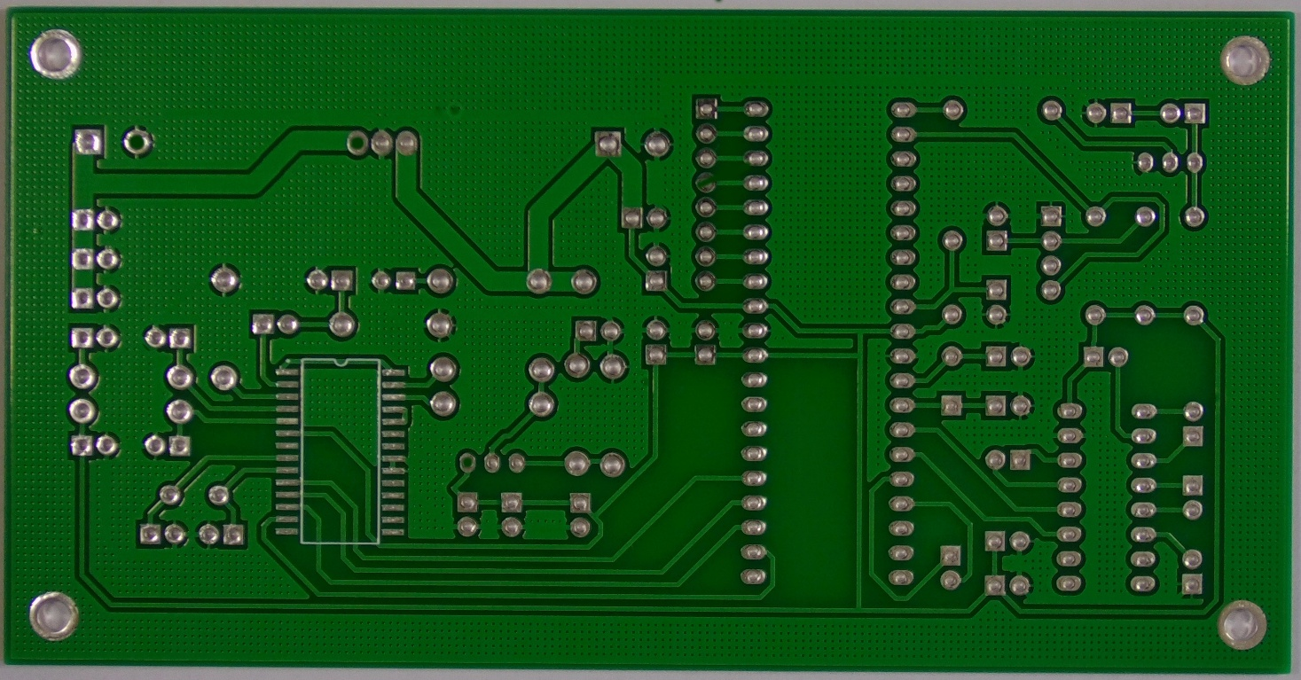
Fig 2: 01_missing_hole_05.jpg

System Workflow:
The overall workflow of AI-CircuitGuard follows these steps:
- Dataset Preparation :Template and test images are separated and aligned.
- Image Alignment : ORB feature matching ensures test images match template geometry.
- Image Subtraction : Differences between aligned pairs reveal potential defect areas.
- Defect Mask Generation : Otsu thresholding creates binary masks highlighting defects.
- ROI Extraction : Contour-based bounding boxes are generated around defect areas.
- Model Classification : Cropped ROIs are classified by the EfficientNet-B4 model.
- Output Visualization : Annotated images and CSV logs are produced for review.
System Workflow Flow Chart:
[ Template Image ] [ Test Image ]
│
Alignment (ORB)
│
Image Subtraction + Otsu Thresholding
│
Defect Mask Generation
│
ROI Extraction (Bounding Boxes)
│
EfficientNet-B4 Model (Classification)
│
Annotated Image + Predictions + Logs
│
Streamlit Web App Visualization & Export

Image Processing:
The image processing module is the foundation of defect detection. It performs alignment, subtraction, and mask generation before classification.
Key Steps:
- Alignment using ORB — Ensures the test image is geometrically consistent with the template.
- Image Subtraction — Highlights only differing areas (potential defects).
- Otsu Thresholding — Dynamically determines the best threshold to isolate defect regions.
- Morphological Operations — Removes noise and refines defect masks.
- ROI Extraction — Contours are detected and cropped for classification.

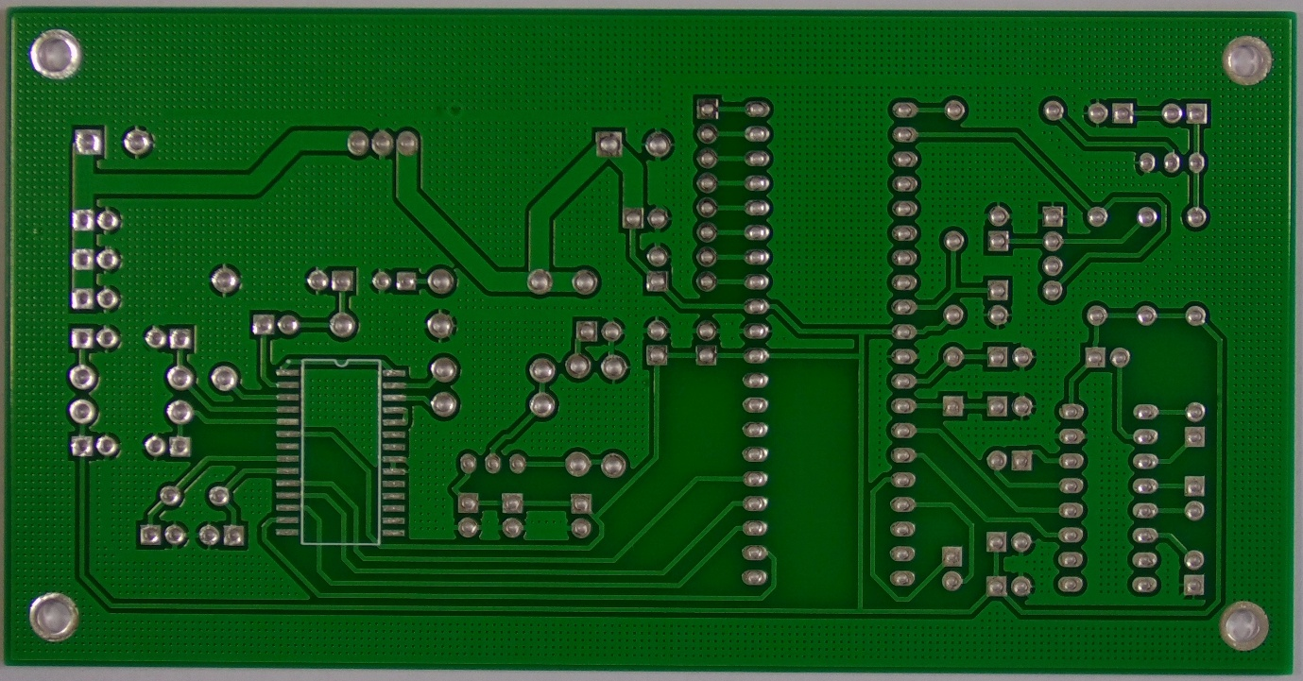
Fig 3: 01_missing_hole_05_template.jpg

Fig4: 01_missing_hole_05_diff.png

Fig5: 01_missing_hole_05_mask.png
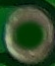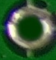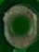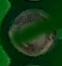
Fig6: 01_missing_hole_05_rois.png
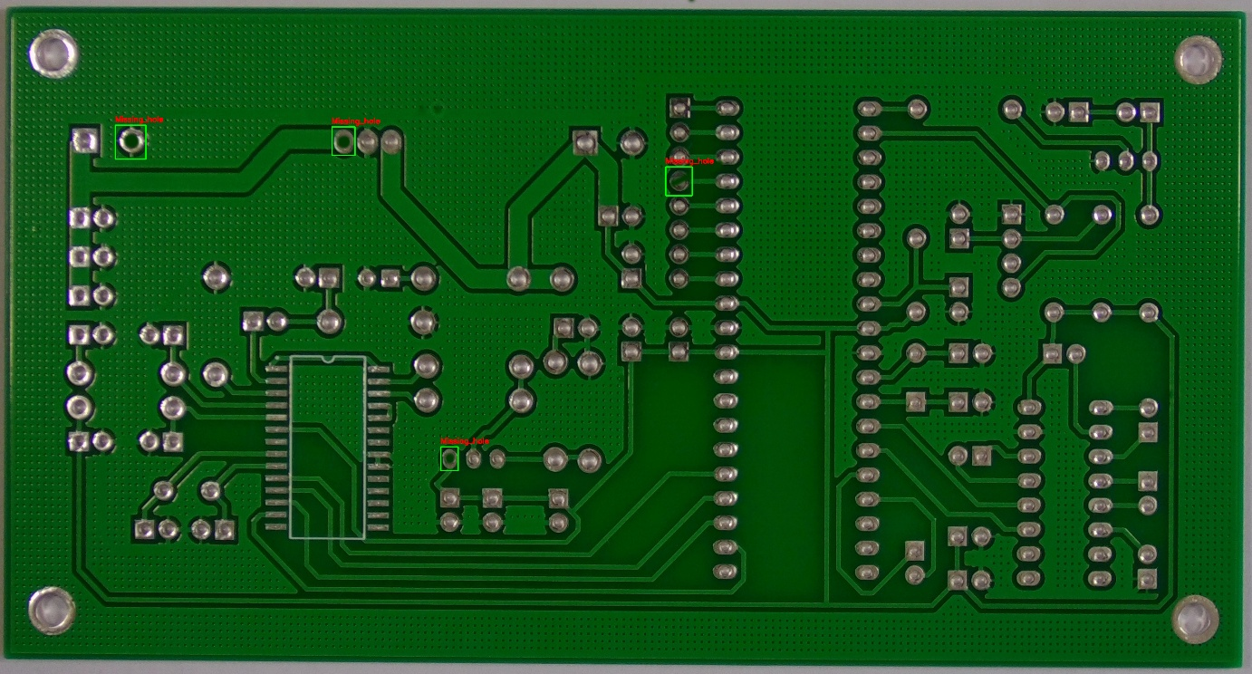
Fig7: 01_missing_hole_05_bbox.png

Model Training and Classification:
The AI-CircuitGuard project employs the EfficientNet-B4 deep learning architecture, chosen for its remarkable balance between computational efficiency and classification accuracy. EfficientNet utilizes a compound scaling method that uniformly scales network depth, width, and resolution to achieve optimal performance without unnecessary parameter increases.
In this project, the model is used to classify six major PCB defect types based on cropped Regions of Interest (ROIs) extracted from previous preprocessing modules. The approach ensures that each defect is localized and then classified independently to improve accuracy and interpretability.
Parameter | Value
Framework | PyTorch
Model Architecture | EfficientNet-B4
Optimizer | Adam
Learning Rate | 2e-4
Batch Size | 16
Image Resolution | 128×128
Epochs | 6
Loss Function | Cross-Entropy Loss
Dataset Split | 70% Train / 20% Validation / 10% Test

The ROIs obtained from the defect localization stage were resized to 128×128 pixels, normalized, and fed into the network for training. Data augmentation techniques like rotation, flipping, and brightness adjustment were used to improve robustness and reduce overfitting.
Training Process:
- Input Layer: Each ROI image was converted to a normalized tensor.
- Feature Extraction: The model extracted hierarchical spatial features using depthwise convolutions.
- Classification Head: The extracted features were flattened and passed through a fully connected layer to predict one of six defect classes.
- Backpropagation: The model optimized weights using the Adam optimizer, minimizing the cross-entropy loss function.
- Validation: After each epoch, validation accuracy and loss were computed to monitor overfitting and model generalization.
The training and validation curves showed steady improvement, indicating stable learning and minimal overfitting.
Metric | Value
Training Accuracy | 94.7%
Validation Accuracy | 92.3%
Test Accuracy | 92.1%
Average Loss (Final) | 0.21
Precision (avg) | 0.93
Recall (avg) | 0.92
F1-Score (avg) | 0.92
The confusion matrix confirmed that the model performed exceptionally well across all six defect categories, with minimal misclassifications between similar classes (like spur and spurious copper).
Visualization and Model Insights:
- Accuracy Curve: Showed consistent improvement through all 6 epochs.
- Loss Curve: Gradually decreased, confirming smooth convergence.
- Confusion Matrix: Demonstrated balanced precision and recall across all classes.
- Feature Maps (Intermediate Layers): Highlighted regions of PCB defects that the network focused on, showing high interpretability.
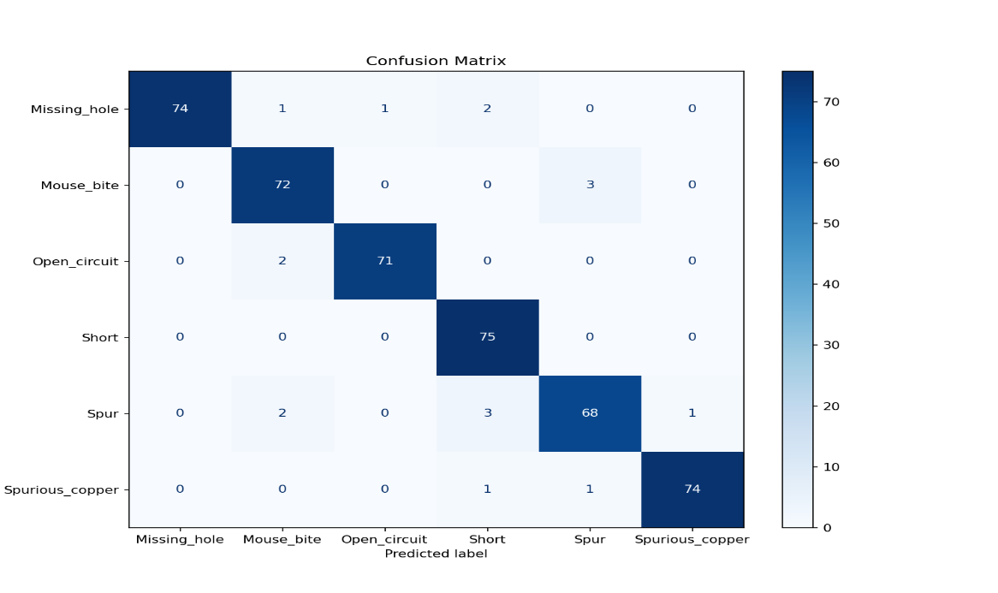
Fig8: confusion_matrix.png

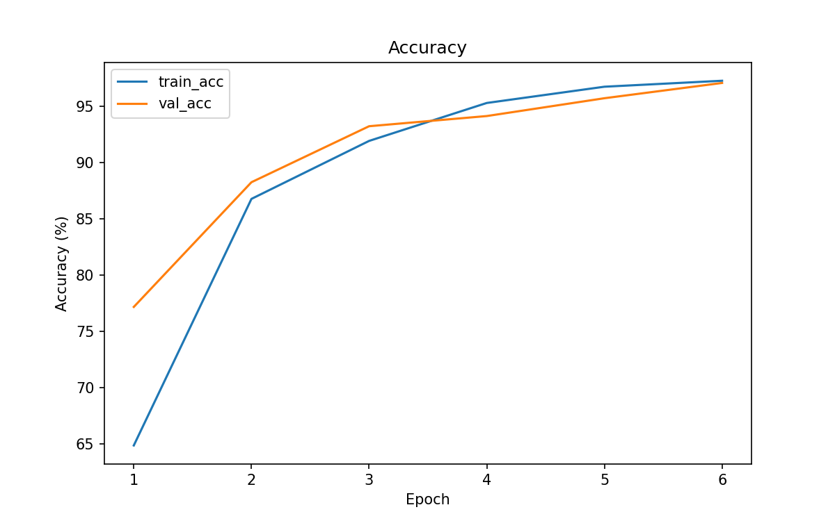
Fig9: training_acc.png

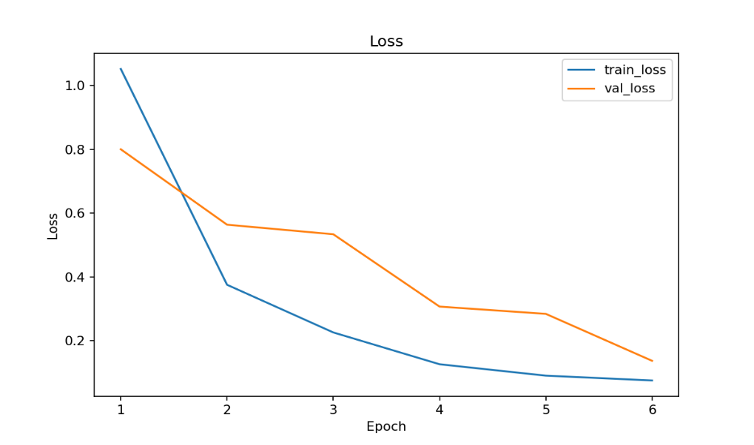
Fig10: training_loss.png
Frontend and Backend Integration:
The final stage of AI-CircuitGuard was to integrate the trained model into a user-friendly, interactive web application for real-time PCB inspection. The application was built using Streamlit, chosen for its simplicity, rapid prototyping capabilities, and compatibility with Python-based machine learning pipelines.
Frontend – Streamlit Interface
The frontend serves as the user-facing component, allowing users to upload and analyze PCB images in real-time.
Key Features:
- File Upload Interface:
  - Allows users to upload both template (defect-free) and test (defective) PCB images.
  - Validates image formats (.jpg, .png).
- Model Configuration Panel:
  - Users can select the model file (efficientnet_b4_best.pth) and processing options (CPU/GPU).
- Visualization Panel:
  - Displays the template image, test image, mask, and annotated result with detected defect regions and labels.
- Download Options:
  - Download annotated image (annotated.png)
  - Download prediction log (predictions.csv)
  - Download run summary ZIP (includes all outputs and logs)
- Performance Metrics Display:
  - Shows model accuracy, confidence levels, and detected defect types.
Backend – Inference Engine:
The backend handles data processing, model inference, and logging. It was built as a modular Python system, consisting of independent files for alignment, subtraction, masking, ROI extraction, and classification.
Key Components:
Module | Functionality
alignment.py | Aligns test PCB image to the template using ORB features.
defect_mask.py | Generates binary masks using image subtraction and Otsu thresholding.
roi_extraction.py | Extracts regions of interest (defect patches) for classification.
inference_backend.py | Loads the trained model and performs classification on each ROI.
batch_inference.py | Processes multiple PCB pairs in batch mode for evaluation.

Logging and Output Management:
- Logs: Each inference run is stored in a dedicated folder under outputs_module6/logs/ with timestamps.
- Output Folder: Contains subfolders for each run (annotated image, mask, ROIs, prediction CSV, and ZIP archive).
- Performance Tracking: A cumulative inference_log.csv tracks all inference sessions for later reference.

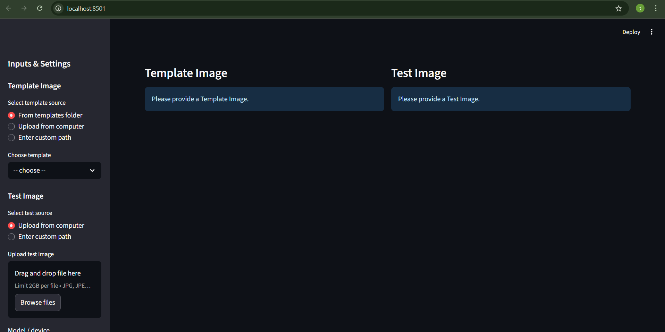

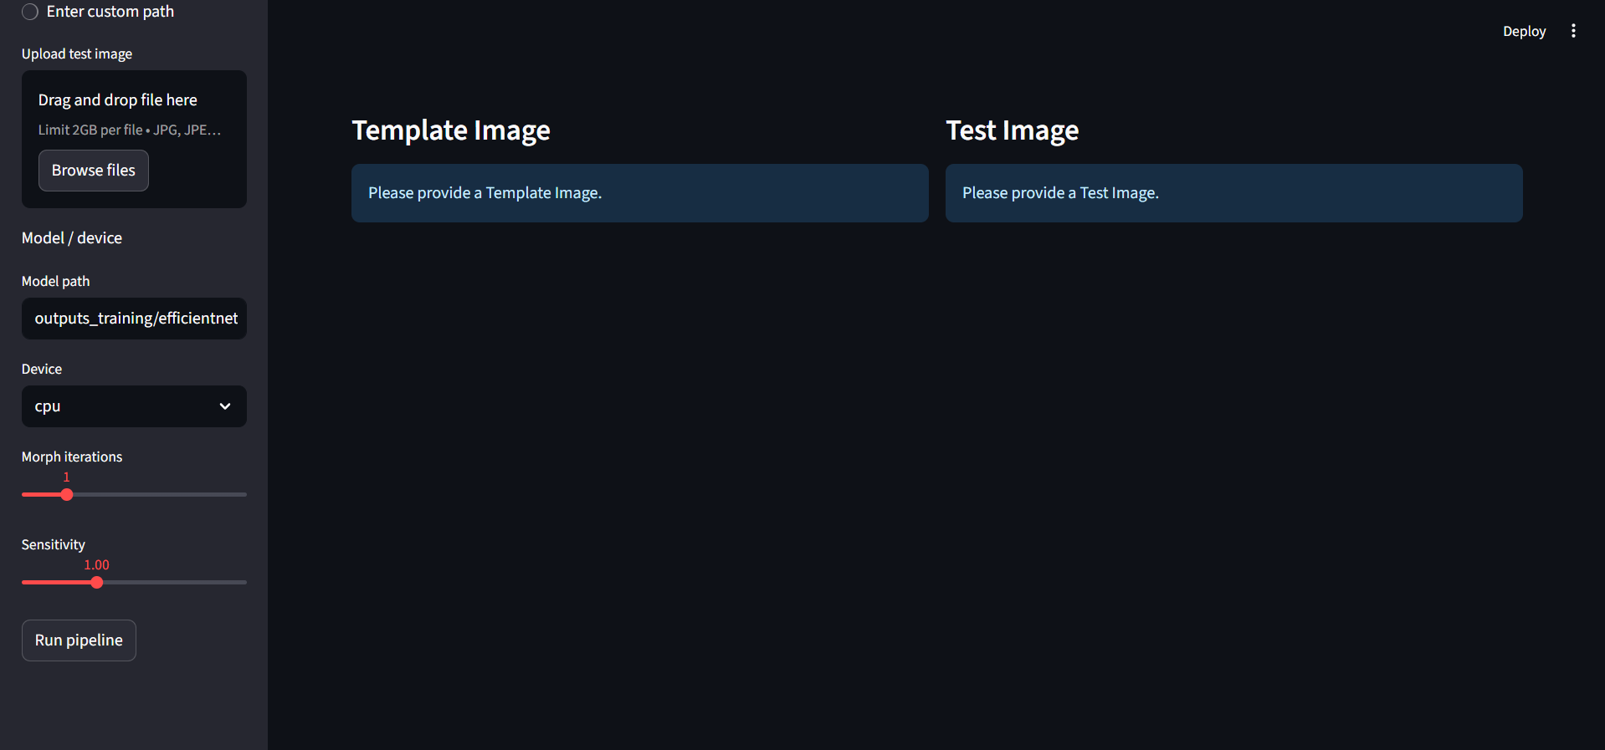
Conclusion:
The AI-CircuitGuard project successfully automated PCB defect detection using deep learning and image processing. By integrating classical vision techniques with modern neural networks, the system achieved high defect classification accuracy and real-time performance.
The modular design allows scalability, making it adaptable to other inspection systems. The user-friendly Streamlit interface ensures accessibility even for non-technical users.
Future work includes expanding the dataset, incorporating more defect types, and deploying the system on edge devices for real-time factory inspection.

