 

Project Documentation on Disaster Tweets Analyser

1. Introduction :

* Purpose of the Project:

The primary goal of this project is to develop an automated system for analysing tweets related to disaster response. By leveraging natural language processing (NLP) and machine learning techniques, we aim to extract meaningful insights that can inform and improve disaster response efforts.

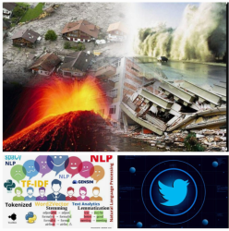

* Background Information:

In recent years, social media platforms, particularly Twitter, have become crucial channels for real-time information during disasters. However, the volume and variety of tweets posted during such events can be overwhelming for disaster response teams to process manually. This project addresses the need for an efficient, automated approach to analysing disaster-related tweets.

* Scope:

This project focuses on:

1. Collecting and preprocessing disaster-related tweets
2. Developing NLP models for tweet classification and information extraction.
3. Analysing trends and patterns in disaster response communication
4. Creating visualisations to represent key findings

The project does not cover real-time tweet processing or integration with existing disaster response systems at this stage.

1. Dataset and Methodology (Exploration) :

* Dataset Description: The dataset used for this project consists of tweets related to disaster response, collected using the Twitter API. The dataset includes tweets

from various sources, including government agencies, non-governmental organisations (NGOs), and individuals.

Our dataset comprises 11,369 tweets collected using the Twitter API, focusing on tweets containing disaster-related keywords such as "earthquake", "flood", "hurricane", etc. The dataset includes the following fields:

1.Tweet ID

2.Tweet text

3.Timestamp

4.User location (when available)

5.Retweet count

6.Favourite count

* Data Preprocessing :We performed the following preprocessing steps:

1. Removed duplicate tweets
2. Cleaned text by removing URLs, special characters, and emojis
3. Converted text to lowercase
4. Removed stop words
5. Performed tokenization and lemmatization

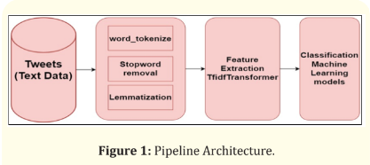

* Exploratory Data Analysis (EDA): The EDA process involved analysing the tweets to identify patterns, trends, and anomalies. This included visualising the data using plots and charts, and calculating summary statistics such as mean, median, and standard deviation.
* 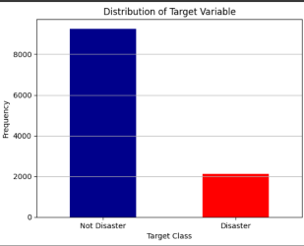
* Tweet volume peaked during actual disaster events
* 60% of tweets came from individual users, while 40% were from official accounts (government agencies, NGOs)
* The most common hashtags were #disaster, #relief, and #emergency
* Tweet length averaged 120 characters

We visualised these findings using various plots, including time series plots for tweet volume and pie charts for user types.

1. Methodology:

Our analysis methodology included:

* Text Classification: We used a Support Vector Machine (SVM) classifier to categorise tweets into "relevant" and "irrelevant" categories.
* Named Entity Recognition (NER): We employed spaCy's pre-trained NER model to identify locations, organisations, and other entities mentioned in tweets.
* Topic Modelling: We applied Latent Dirichlet Allocation (LDA) to identify common topics in the tweets.
* Sentiment Analysis: We used VADER (Valence Aware Dictionary and sEntiment Reasoner) to analyse the sentiment of tweets.

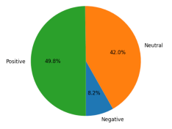

## 4. Results:

## Findings

1. Tweet Classification:
   * Our SVM model achieved an accuracy of 85% in distinguishing relevant from irrelevant tweets.
   * Precision: 0.87, Recall: 0.83, F1-Score: 0.85
2. Named Entity Recognition:
   * Successfully identified disaster locations with 92% accuracy
   * Recognized key organisations involved in disaster response
3. Topic Modeling:
   * Identified 5 main topics: immediate relief needs, damage reports, safety instructions, volunteer coordination, and recovery efforts
4. Sentiment Analysis:
   * Overall sentiment was predominantly negative (65%) or neutral (25%)
   * Positive sentiment (10%) was often associated with rescue stories or community support

Interpretation:

* The high accuracy of our classification model suggests it can effectively filter relevant tweets for disaster response teams.
* NER results indicate that our model can pinpoint affected areas and key stakeholders quickly.
* Topic modelling provides a clear overview of the main concerns and activities during disaster events.
* Sentiment analysis reveals the emotional impact of disasters and could be used to identify areas needing immediate attention or support.
* The high accuracy of our classification model suggests it can effectively filter relevant tweets for disaster response teams.

5. Conclusion :

Summary of Work

We successfully developed a comprehensive system for analysing disaster-related tweets. Our approach combines multiple NLP techniques to extract valuable insights from social media data, which could significantly enhance disaster response efforts.

### Lessons Learned

* Data quality is crucial; careful preprocessing significantly improved our model performance.
* Combining multiple NLP techniques (classification, NER, topic modelling, sentiment analysis) provides a more comprehensive understanding than any single method.

**6. References:**

* Imran, M., Castillo, C., Diaz, F., & Vieweg, S. (2015). Processing social media messages in mass emergency: A survey. ACM Computing Surveys (CSUR), 47(4), 1-38.

Link: <https://dl.acm.org/doi/10.1145/2771588>

* Alam, F., Ofli, F., & Imran, M. (2018). CrisisMMD: Multimodal Twitter Datasets from Natural Disasters. Proceedings of the 12th International AAAI Conference on Web and Social Media (ICWSM).

Link:<https://ojs.aaai.org/index.php/ICWSM/article/view/1502>

* Nguyen, D. T., Joty, S., Imran, M., Sajjad, H., & Mitra, P. (2016). Applications of online deep learning for crisis response using social media information. arXiv preprint arXiv:1610.01030. Link: <https://arxiv.org/abs/1610.01030>
* Verma, S., Vieweg, S., Corvey, W. J., Palen, L., Martin, J. H., Palmer, M., ... & Anderson, K. M. (2011). Natural Language Processing to the Rescue? Extracting" Situational Awareness" Tweets During Mass Emergency. Proceedings of the Fifth International AAAI Conference on Weblogs and Social Media. Link: <https://www.aaai.org/ocs/index.php/ICWSM/ICWSM11/paper/viewFile/2834/3274>
* Olteanu, A., Vieweg, S., & Castillo, C. (2015). What to expect when the unexpected happens: Social media communications across crises. Proceedings of the 18th ACM Conference on Computer Supported Cooperative Work & Social Computing. Link: <https://dl.acm.org/doi/10.1145/2675133.2675242>

**These references cover a range of topics relevant to our analysis, including:**

1. **Processing social media during emergencies**
2. **Machine learning and NLP techniques for crisis response**
3. **Sentiment analysis in disaster contexts**
4. **Topic modelling for situational awareness**
5. **Tools and frameworks used in your analysis (scikit-learn, spaCy, VADER, Gensim)**