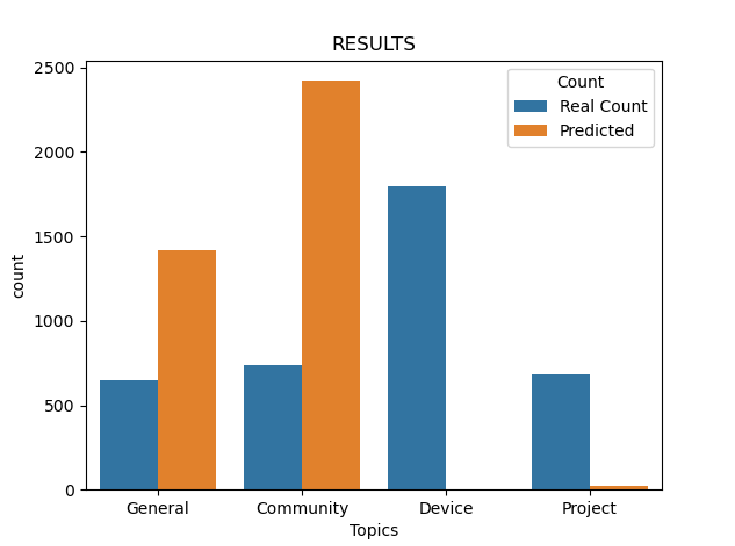V1:

V2:

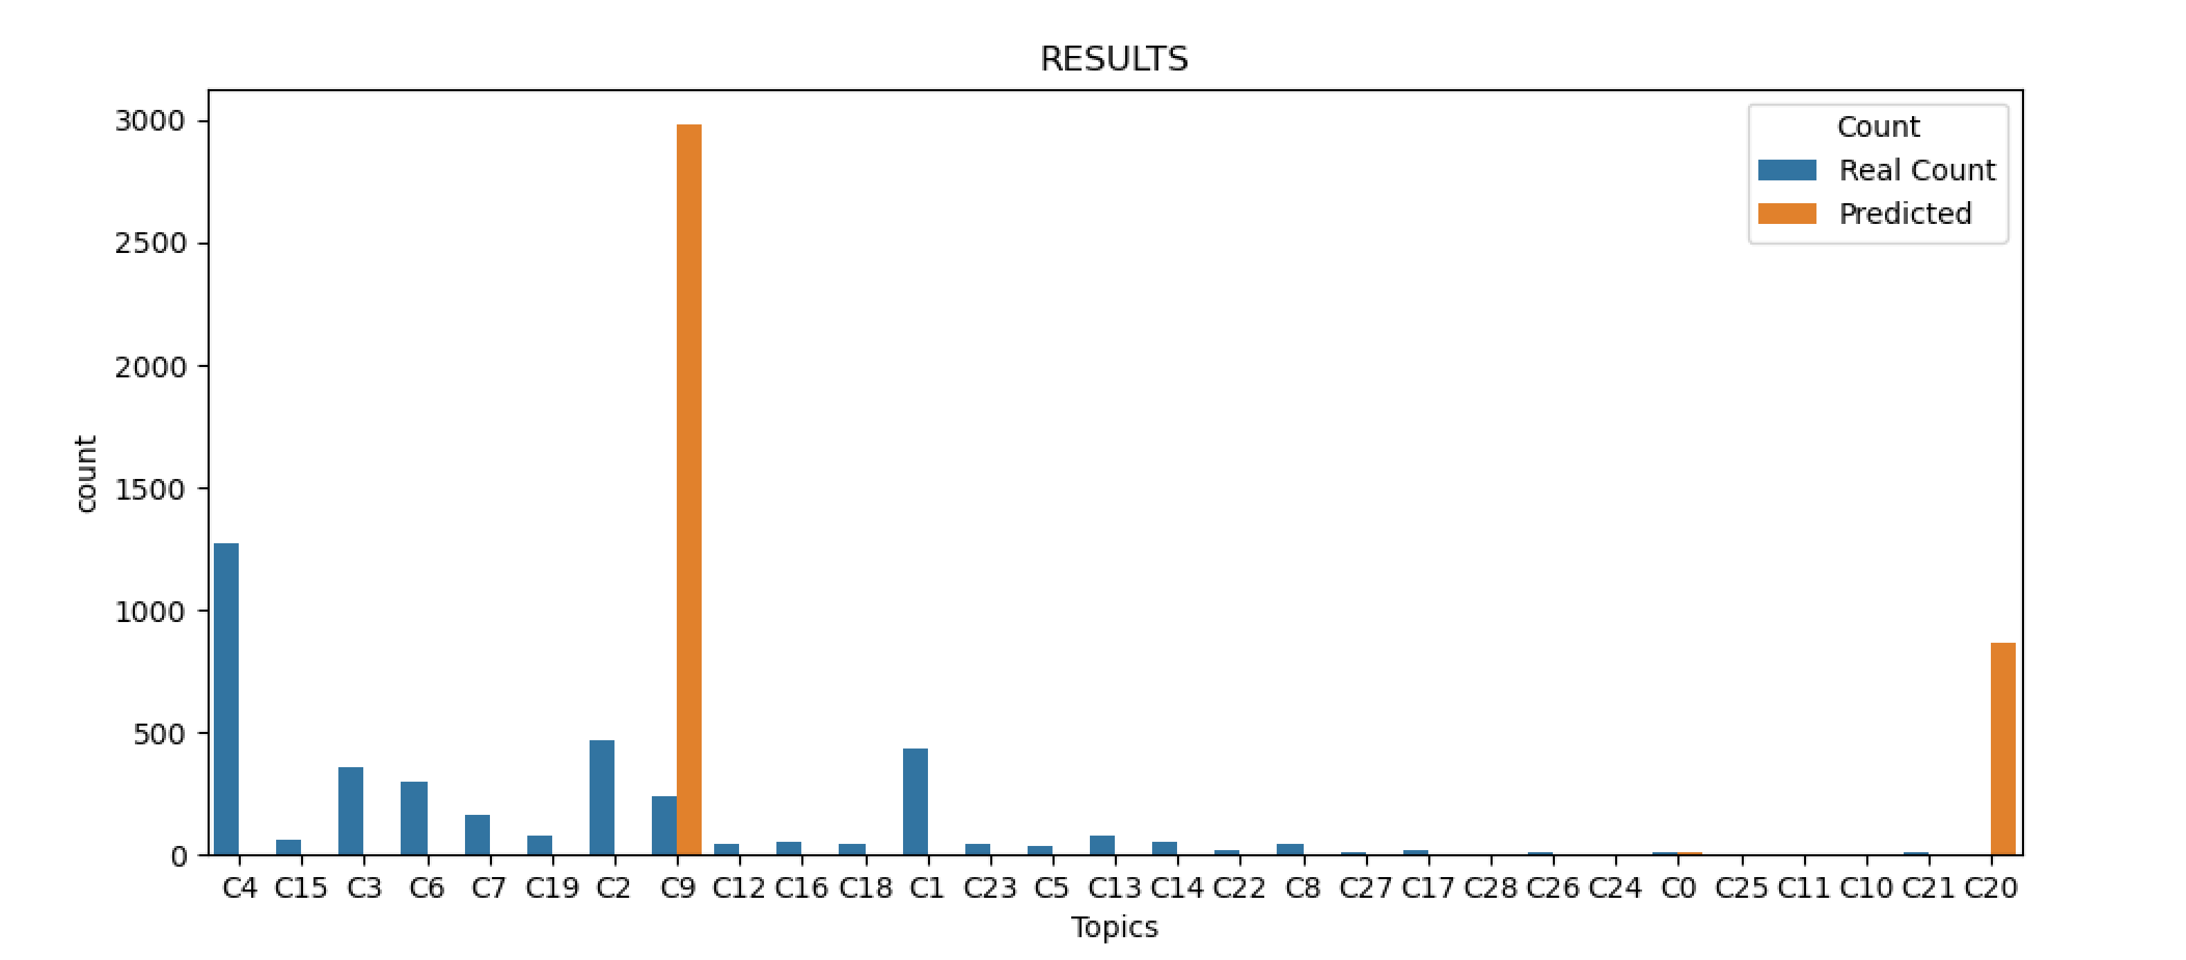

{'Groups & Events': 0, 'Community Created Device Types': 1, 'Connected Things': 2, 'Projects & Stories': 3, 'Devices & Integrations': 4, 'Announcements': 5, 'Community Created SmartApps': 6, 'SmartApps & Automations': 7, 'Writing SmartApps': 8, 'General Discussion': 9, 'Mobile Tips & Tricks': 10, 'Hub Firmware Release Notes': 11, 'webCoRE': 12, 'Writing Device Types': 13, 'Apps & Clients': 14, 'SmartThings (Samsung Connect)': 15, 'Deals': 16, 'Android': 17, 'How-To': 18, 'FAQ': 19, 'Capability Type Suggestions': 20, 'Meta': 21, 'Features & Feedback': 22, 'Automation Ideas': 23, 'Hub Firmware Beta': 24, 'Wiki': 25, 'Device Ideas': 26, 'Ideas and Suggestions': 27, 'iOS': 28, 'Windows': 29, 'Beta Programs': 30, 'Rules API': 31, 'Device Integrations': 32}

V3:

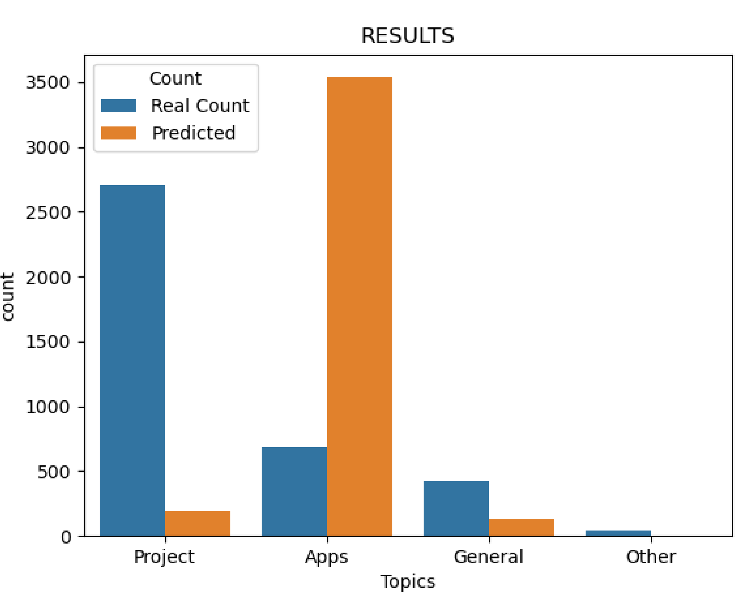

V4:

