INFSCI 2725_DATA ANALYTICS_Assignment3

Fengxi Liu Jinrong Liu

**Model1 House Votes PC:**

**Q1: Overall classification accuracy**



**Q2: Sensitivity and specificity of two parties**

Firstly, we get a confusion matrix from the result of validation as follows:

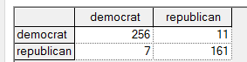

We can get conclusions from this matrix:





**Q3: Positive and negative predict value of the two parties:**

We can also get this from the confusion matrix





Q4: Calibration curve

Algorithm: Binning Selected Bin count is : 10 (default)

We can draw the two Calibration curves of two parties:

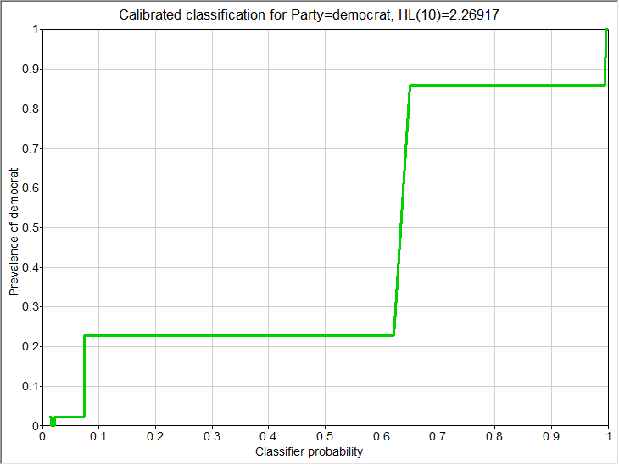

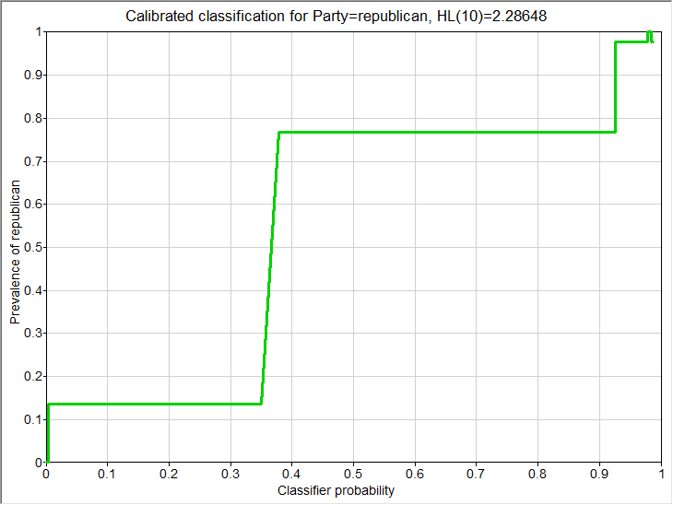

**Model2 House Votes Naïve**

**Q1: Overall classification accuracy**



**Q2: Sensitivity and specificity of two parties**



We can get conclusions from this matrix:





**Q3: Positive and negative predict value of the two parties**

We can also get this from the confusion matrix:





**Q4: Calibration curve**

**Democrat:**

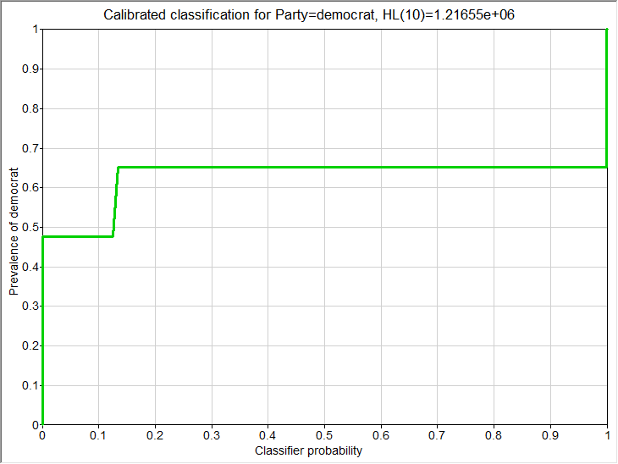

**Republican:**

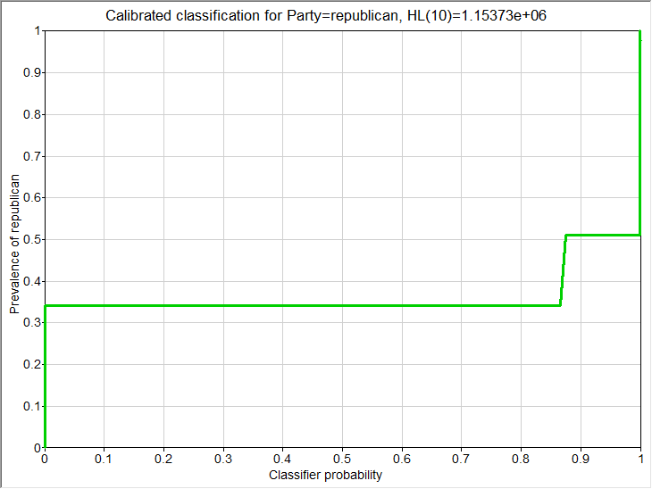

**Model3 House-Votes-Manual:**

**Q1: Overall classification accuracy**



**Q2: Sensitivity and specificity of two parties**

We can get conclusions from this matrix:

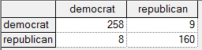





**Q3: Positive and negative predict value of the two parties:**

We can also get this from the confusion matrix





**Q4: Calibration curve**

Algorithm: Binning Selected Bin count is : 10 (default)

We can draw the two Calibration curves of two parties:

**Demo:**

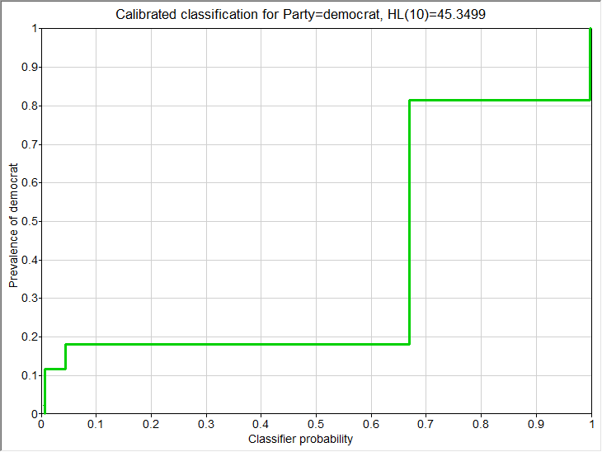

**Repub:**

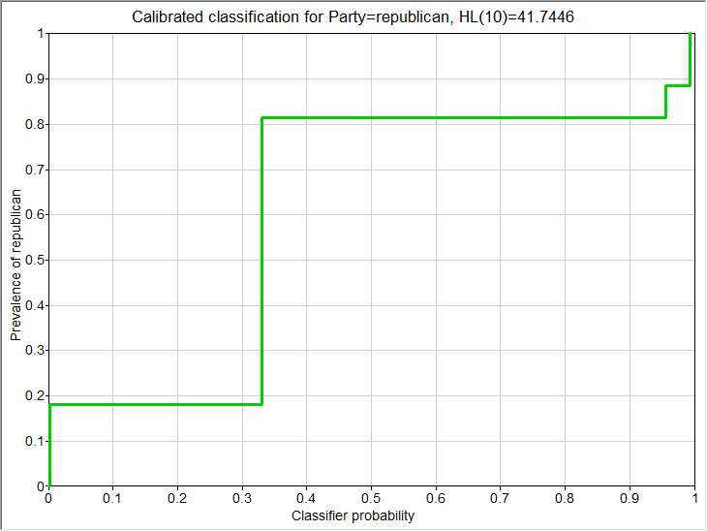

**Observations:**

From the value of sensitivity and specificity as well as the positive and negative predict value of each model, we can see that PC model and Manual model work better than Naïve model.