Assignment 3

Fengxi Liu Jinrong Liu

1. **Answers to the questions**

**Q1: Overall classification accuracy**



Q2: Sensitivity and specificity of two parties

Firstly, we get a confusion matrix from the result of validation as follows:

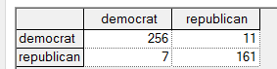

We can get conclusions from this matrix:





Q3: Positive and negative predict value of the two parties:

We can also get this from the confusion matrix





Q4: Calibration curve

Algorithm: Binning Selected Bin count is : 10 (default)

We can draw the two Calibration curves of two parties:

