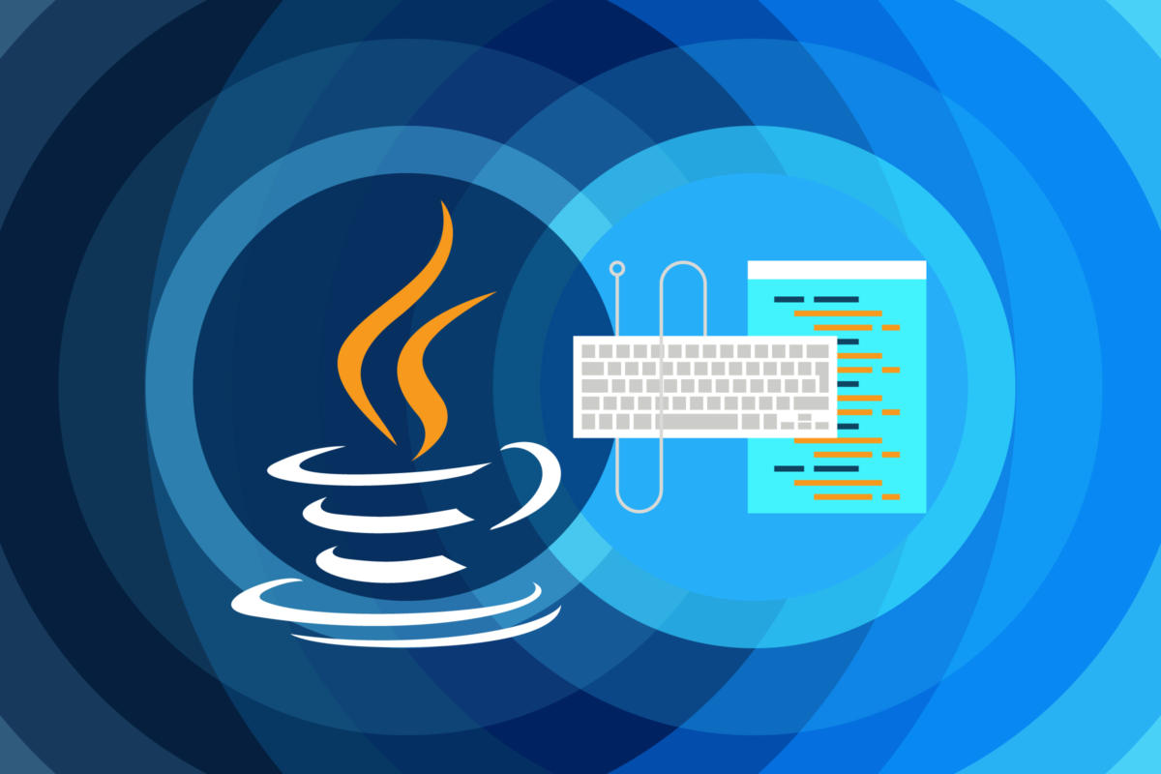

Programming with JAVA

ITJA211

**Student**: Menzi Hlope

**Number:** CGMSXBYZ5

# Overview & Purpose

Last year for the Java assignment I did a beautiful intro, cited James Gosling and his journey struggling with C++ all the way to him inventing JAVA.

This year though I shall not dwell much on the history but will focus on submitting a working program. Maybe not production ready but the programs do answer the required questions.

I know in doing a program, I need to mitigate for Cross Site Request Forgery, integrate some form of Email Confirmation and some form of Secure Password Reset amongst other things.

I humbly give thanks to the fact that you’ll look at this assignment with mercy and Love.

# Question 1

# Simple: James Gosling created Java to be easy to use, write, compile, debug, and learn than other programming languages. It is easier than C++ especially since JAVA does automated memory management.

# Object-Oriented: OOP uses concepts like class, object, inheritance, encapsulation, abstraction, polymorphism, etc. which enables the creation of reusable code.

# Platform-Independent: Java allows the developer to write programs for any Hardware and Operating System allowing you to move code from one machine to machine.

# Distributed: Java allows the program to be used in a distributed manned theerefore allowing the code to be easily scaled up.

# Secure: Java was built from the ground up with Security in mind because the Java Virtual Machine has a unique identifier that identifies the bytecode and verifies it before running it.

# Allocation: Java uses the LIFO (Last In First Out) paradigm allowing data to be stored and retrieved easily.

# Multithreaded: Java programs allow several tasks to run simultaneously within.

# Rich APIs: Java has a lot of APIs for application development for example the mySQL API that allows me to connect to the database I created for question 2.

# Resource Availability: Java has tons of free documentation online which quickly gets you up and started in coding you dream.

# Question 1.2

1. The code written allows you to access the database via the login.

**Username**: John

**Password**: Hlope

# Question 2

1. When the user clicks on the ‘Add record’ button, all the information entered into the textboxes is added to the database. Once the record has been added, a message box must be displayed to inform the user of the success of the transaction.
2. When the user enters the name and surname of a customer and clicks on the ‘Search for Record’ button, the telephone number and address of that particular customer is retrieved from the database and displayed in the appropriate text boxes. Once the record has been retrieved, a message box should inform the user that they can change the values in one of the text boxes and update the record of that employee by clicking on the ‘Update the Records’ button.
3. When the user clicks on the ‘Update the Records’ button, the details of the particular employee is updated in the database. A message box informs the user if the update has been successful.