Lab 4

Ana Menzies

24/03/2022

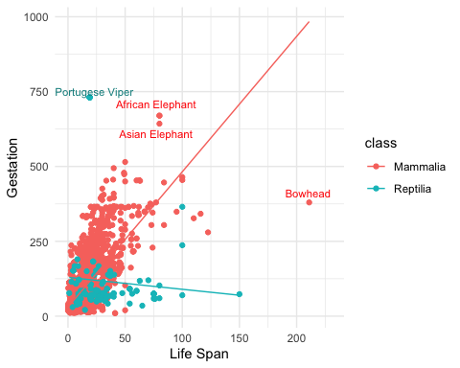

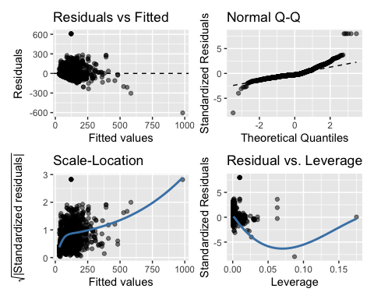

The residual vs fitted plot shows that while most of the residuals do not have structure/pattern, there are several observations that have large residuals, indicating that there are points of high leverage in the data. The normal QQ plot also shows that there is deviation of a few residuals on on the tails from the 45 degree line. These indicate a heavy tailed distribution - with longer tails than normal distribution, where a few observations of very high or low values sit. This again suggests points of high leverage/outliers in the data. The scale-location plot highlights that the constant-variance assumption is not met, as the line is not roughly horizontal, but trends up with fitted values. This means that the average magnitude of the standardised residuals changes as a function of the fitted values. However, this effect seems to be created by a few points of high leverage. The residual vs leverage plot confirms that there are points of high leverage in this model aka outliers, and deleting them would change our model a lot. These residual plots suggests that we are breaking some of our assumptions of a linear model of equal variance and normality of residuals due to outliers in the data. These outliers should be investigated for further analysis