Projekt Modul Web ProgrammingGulasch-2-Go

# 

# Introduction

The web shop Gulasch-2-Go is a web shop for a food-delivery service in Bern that delivers Goulash with side dishes and beverages

Clients should be able to order from a set of products and .be able to select an combine of main dishes and side dishes according to their choice. They should also be able to select a few options for the main dishes like “more onions” or “make it hotter”.

Clients should have the possibility to order with or without a login.

## Use cases

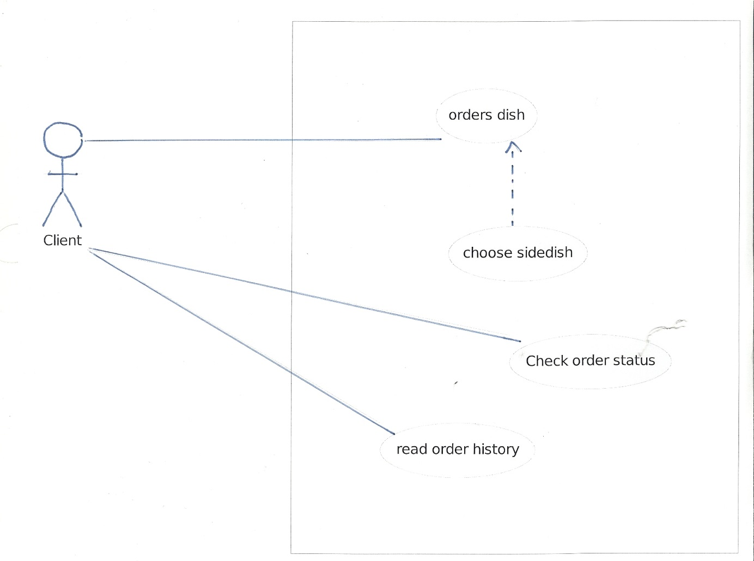

# Requirements

### Supported web browsers

Gulasch-2-Go must at least work in Mozilla Firefox and Google Chorme

### Language.

The web site must be in German and French. Additional languages should be possible

### Database

All the Data should be in a Database. This DB should store the product, orders, customer. All oder should be assigned to a user .If the client orders without login, the order will be assigned to a dummy user.

### Security

Clients can create a login. This login and the personal data should be secure from intruders. Users will not have to create a login

##### Information

The Customer should see opening hours and the location of the company. The location will be shown in Google Maps.

##### Payment

Clients will have to pay cash on delivery, so there is no need for a payment system in the web shop.

# Design of Website

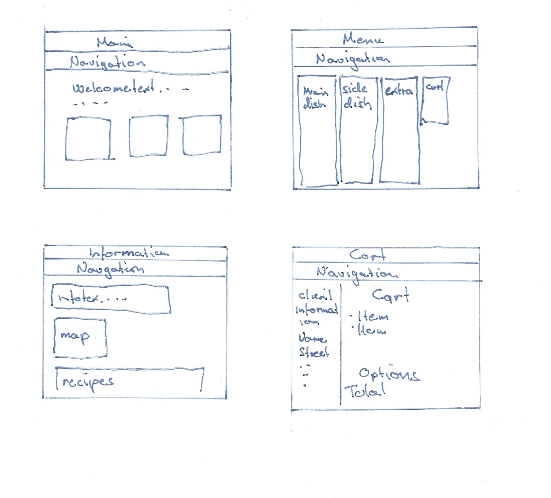

OOPHP classes:  
 Shop item  
 Product list  
 Shoppingcart

# Design of the DB

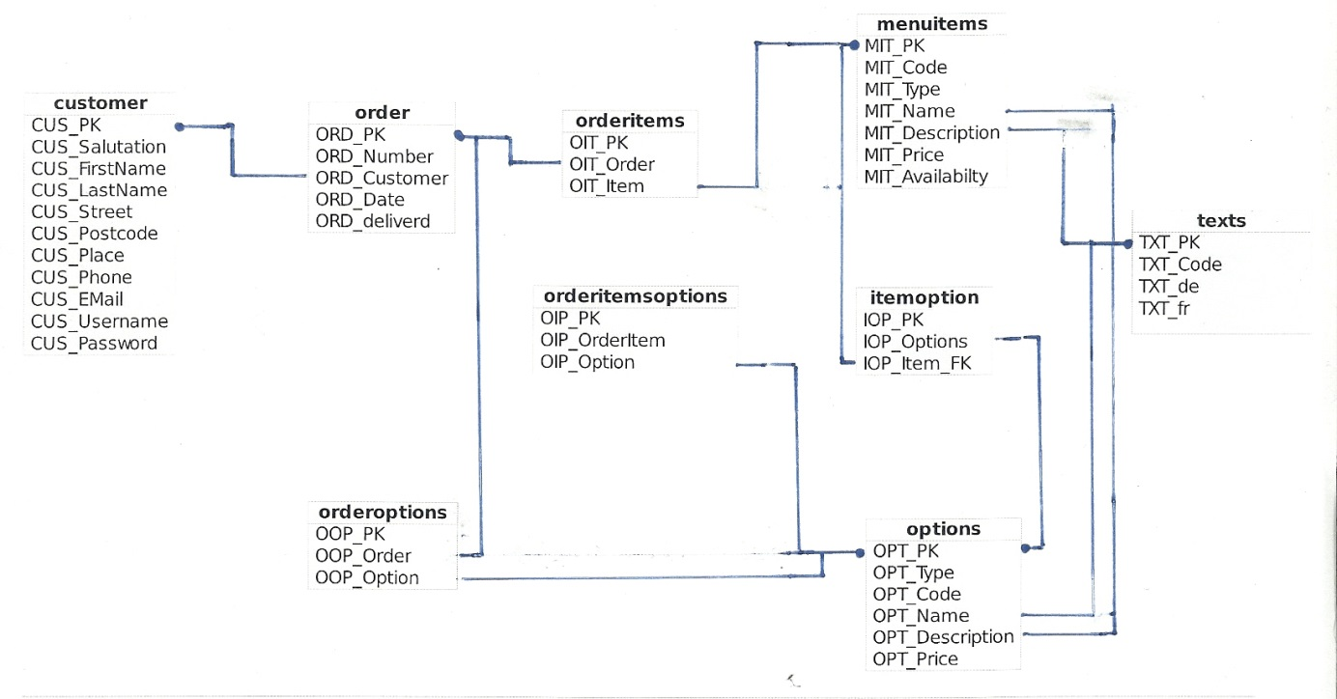

# System evolution

-History of a client’s orders  
-Repeat order from history  
-Page with some Recipes