**LAB 2**

**Q1. (6 mark)**

Write a console application that includes **Product** and **Program** classes.

The **Product** class contains:

* Three **public properties**: **ID** (string); **Name** (string) and **Price** (float).
* The public override function **ToString()** to return string that present all information about the Product: ID, Name, Price of Products.

**Program** class contains:

* Four public method:
  + **Add(IList<Product> list)** to add a product object to the last position of the collection list.
  + **Display(IList<Product> list)** to display a list of products as described in the output.
  + **Sort(IList<Product> list)** to sort products by name, if the name is the same sort by product price descending. Then display product list as described in the output.
  + **Search(IList<Product> list)** to search for products with the product name starting with the search value. Display product list as described in the output. If no products are found, display "**Product not exist!**".
* Main method with a collection **list** type **IList<Product>** initialized and assigned initial elements.

The output should be the same as below:

1. Display function: **(2 mark)**

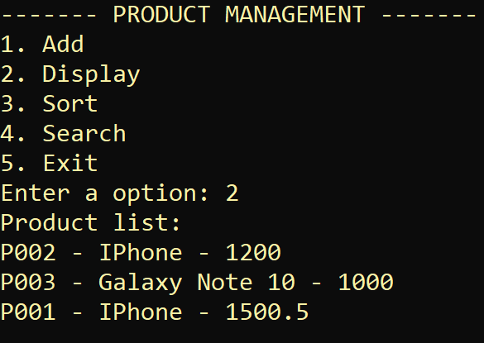

1. Add function: **(1 mark)**

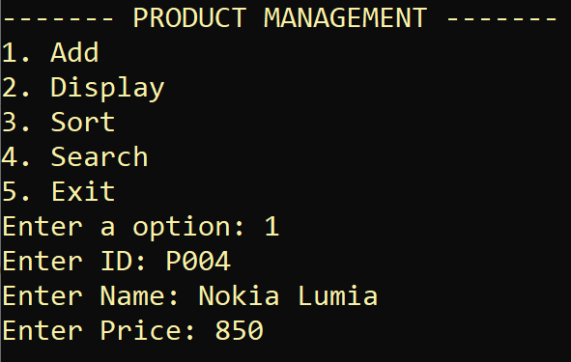

1. Sort function: **(1 mark)**

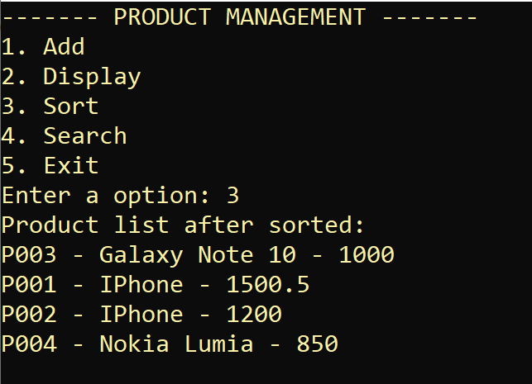

1. Search function: **(2 mark)**

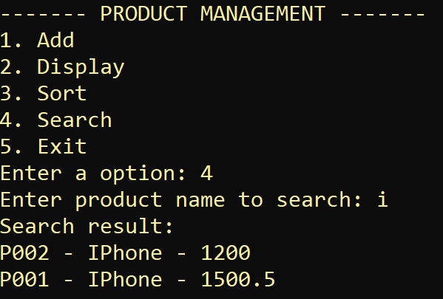 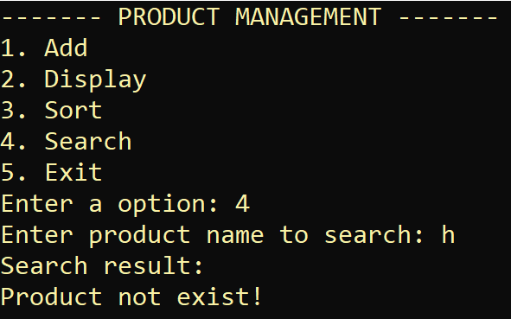

**Q2. (4 mark)**

You are asked to write a console application which allow user manage his/her Payment. Your tasks include several of following steps:

1. You should create an interface named ITax , which define [ float ComputeTax() ] method, this is an abstract method (no-code method). (**1 mark**)
2. Your Payment class will inherited ITax. Payment contains only one attribute named [ float Amount ]. Your task is to override the ComputeTax () method such that : tax = 10% of Amount; (**1 mark**)
3. Create an event to notify user when the Amount be edited; (**2 mark**)

Hint:

The main function of your application should look like following (it is not necessary to have exactly the same code, but this is good enough to test your application):

static void Main(string[] args)

{

Payment payment = new Payment() { amount = 1000 };

payment.AmountChanged += notifyAmountChanged; // your handling function

payment.Amount = 990;

Console.WriteLine( “Tax:” + payment. ComputeTax ());

}

You application should display like following:

