Section: Create Campaign
Module : Setup Campaign for health and educational facilities


Setup campaign for health and educational facilities
“In this module we show you how to setup new campaign using specific types and tags for collecting wanted data.”
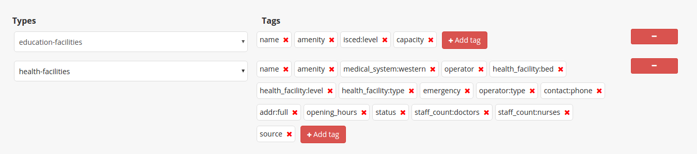
Types and tags is needed to specified what data that will be overviewed on campaign. Types is for feature of data that needs collected and tags is what attribute that needs to be overviewed.

You try:
Goal: Set up campaign for health and educational facilities.

* Login to field campaigner and go to “Create New Campaign” in top navigation.

* Fill general information for new campaign. On types section for now just add types health and educational facilities.
* On Campaign AOI, let's try find yout hometown by clicking magnifying glass icon on the map and search your hometown and draw polygon.
* Don’t forget to submit your changes if you are satisfied.

Check your results:
- Go to detail of campaign. Could you see “education-facilities” and “health-facilities” tab on the left of map?
- Click on graph icon on the right of “health-facilities”, could you see data on the map and also on the overview below it?
Name | Value
Area of Interest | Data of health and educational.
Type | 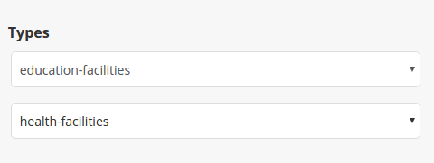
Draw | The campaign AOI, finish your polygon by clicking again on your start point.
Validate | 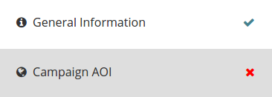  Validate with looking tick for each tab.
Submit | Submit changes with  



More about
Types is used to determined what typeof output data is needed for campaign. Tags is used overviewed attribute data. If data that collected doesn't has tags that we determined in types/tag input, it will show errors on Attribute Completeness Errors on the detail campaign.

Check your knowledge:
- Mark all the correct statements:
- When we select new type, the tags that generated is default one.
- By clicking on tags, it will tell that I don't need this tag to be checked on this campaign.
- I can add as many types as I want.

- I want to check cafe around my hometown that should be has name in it and easy to look on detail. What should I do?
- Create campaign that has AOI is around my town. Add new type “cafe”.
- Create campaign that has AOI is around my town. Add new type “cafe” and delete other tags than “name”.
- Create campaign. Add new type “cafe”.


Further reading:

