**Guidelines**

***Setup Environment, framework***

Giving vision for software architecture

Language used:

* Front-end: HTML, CSS, JQUERY
* Back-end: PHP
* Database: SQL

Code environment: Visual Studio Code

* Framework:
* Front-end: Bootstrap 3
* Back-end: Laravel 5.2 (Because client use GoDaddy hosting and PHP 5.6. So, we choose Laravel 5.2 for this project)

Other software needed to install:

* Composer to run Laravel
* Node.js to run Laravel

**INSTALLATION**

**Note:** This setup for Mac OS

For the PC user, you should go to their website and install manually with setup file. No need to install homebrew.

**Install Homebrew**

/usr/bin/ruby -e "$(curl -fsSL https://raw.githubusercontent.com/Homebrew/install/master/install)"

**Install Composer**

brew install composer

composer --version

**Install PHP**

brew install php72

php --version

**Install Node.js**

Go to [Node.js Homepage](https://nodejs.org/en/) and download **TLS version**

**Setup**

Step 1:

Create a new project with this one to get the file .env example. Change the red nam_of_project below to the name you like. E.g CampIzza

composer create-project --prefer-dist laravel/laravel name_of_project "5.2.*"

After this, cd to this project.

cd <name_of_project>

Then rename the file env.example

mv .env.example .env

* Clone your project from our Github.
* Open Visual Studio Code
* Open project directory
* Open Terminal and enter commands

Mysql -u root -p

* Enter MySQL password for confirm that you has installed MySQL and can access it
* Open “**.env**” file from root project directory

P/S: Please check your file if you already have the file **.env** or not

It is an important file to see Laravel website when you run website from your localhost.

* Enter your database password into DB_PASSWORD
* Open new tab/window Terminal and enter below commands

**Install packages** from package.json

npm install

**Install packages** from composer.json

composer install

**Create directory** public/imgages

Create this folder, in the future, all website image will put to here.

**Create directory** public/css

Create this folder, in the future, all CSS files will put to here.

**Create directory** public/js

Create this folder, in the future, all JavaScript files will put to here.

**Note**: I have customized Laravel folder structure for easy development. You just need to know it.

## **AFTER SETTING UP EVERYTHING:**

To run the localhost:8000 server

**Php artisan serve**

You will use this one every time you want to run the website.

## **HOW IT WORKS**

## **Architecture**

Laravel uses MVC architecture (Model - View - Controller)

[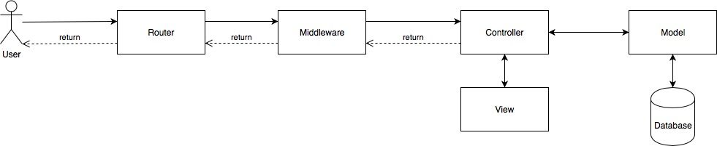](https://github.com/meow-at-vincent/CampIzza/blob/master/Documents/resources/high-level-architecture/MVC-architecture.jpg)

With MVC Architecture, you must focus on 4 points

* Router
* Controller
* View
* Model

## **Folder Structure**

I list some important directories

CampIzza

|___app

| |___Http

| | |___Controllers

| | |___routes.php

| |___User.php

| |___Role.php

|___database

| |___migrations

| |___seeds

|___public

|___|___js

|___|___css

|___|___img

|___resources

|___|___views

Explain it:

| **Directory** | **Description** |
| --- | --- |
| app/Http/Controllers/ | Controller (m-v-C) |
| app/Http/routes.php | Router |
| app/*.php | Model (M-v-c) |
| database/migrations | Create table schema |
| database/seeds | Create sample data |
| resources/ | View (m-V-c) |

## **Development**

# Close Terminal after run

php artisan migrate:refresh --seed

# Open Terminal #1

php artisan serve

## **References**

* <https://laravel.com/docs/5.2>
  + <https://laravel.com/docs/5.2/migrations>
  + <https://laravel.com/docs/5.2/routing>
  + <https://laravel.com/docs/5.2/controllers>
  + <https://laravel.com/docs/5.2/blade>
  + <https://laravel.com/docs/5.2/eloquent>
* <https://laravel-mix.com/docs/2.1/installation>
* <http://bootstrapdocs.com/v3.0.0/docs/getting-started/>