This document exist to explain the practical interview assessment on 30/Jan/2020.

Before everything, make sure the dot net core SDK is installed and runnable.

You may download the dotnetcore sdk here:

<https://dotnet.microsoft.com/download/dotnet-core/2.2>

You can confirm it’s working by executing deonet –version in your console.

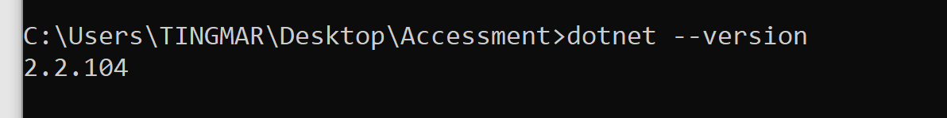

1. To Build ,go to (cd, change directory) the %Root%\Scenario\Src\ execute dotnet build {\*.csproj file}

You may see an MoneyChanger.Martin.Sun.dll file is built, this is going to be the file for execution later.

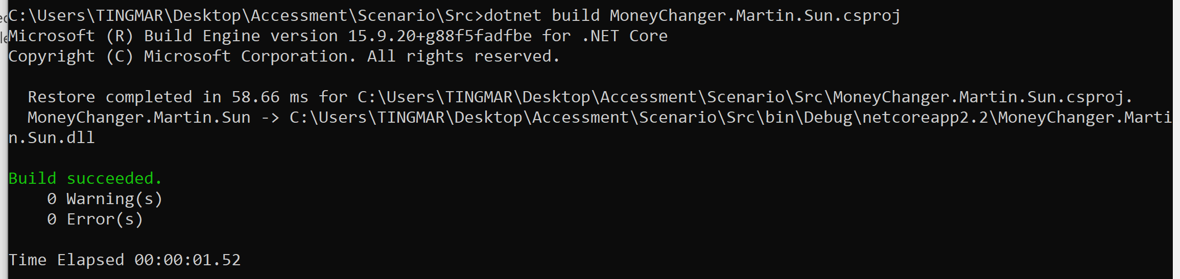

Note:

If you have restore failed message, please try to white list <https://nuget.org> in your internal proxy, or connect to a public network instead.

if you want to configure nuget to use your proxy, please refer to here

<https://stackoverflow.com/questions/9232160/nuget-behind-a-proxy>

1. To run the program, go to (cd, change directory) the %Root%\Scenario\Src\bin\Debug\netcoreapp2.2

Or any other directory the out put happen to build the dll into.

Then, run dotnet MoneyChanger.Martin.Sun.dll

(yes, jusr dotnet dah dll)

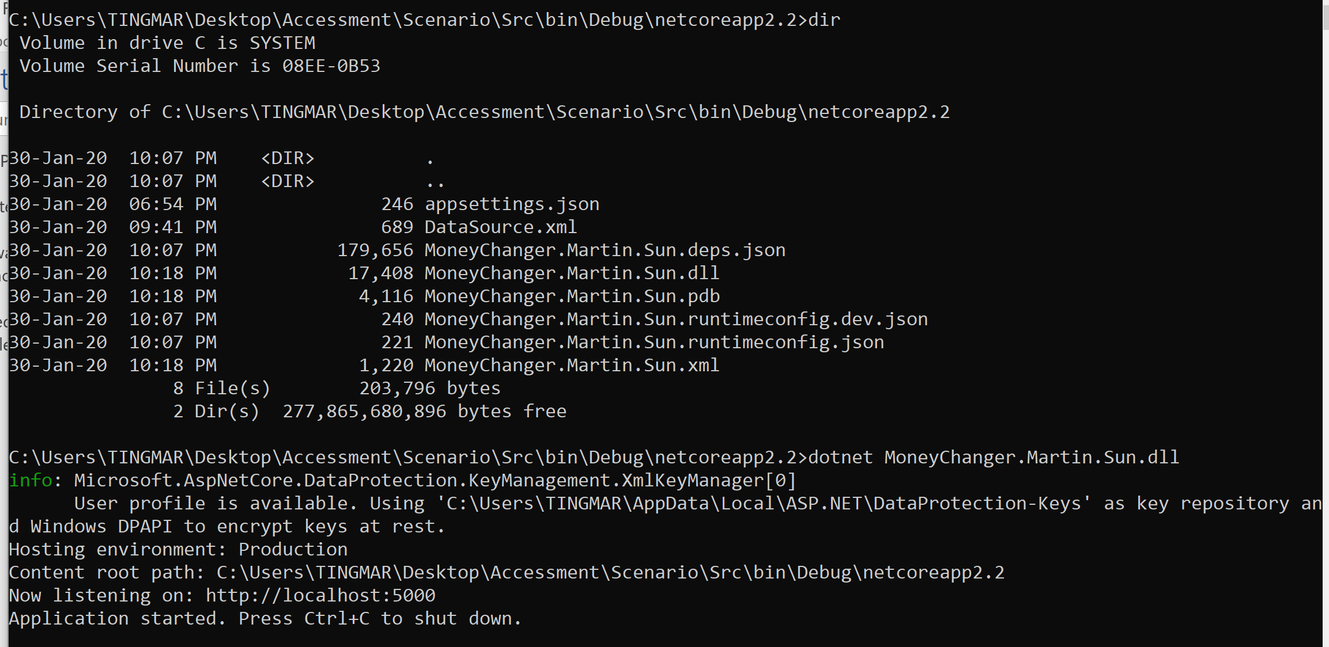

You will see the service is now listening on 5000, please open your browser and navigate to <http://localhost:5000/swagger/index.html>

