Use Case Diagram :
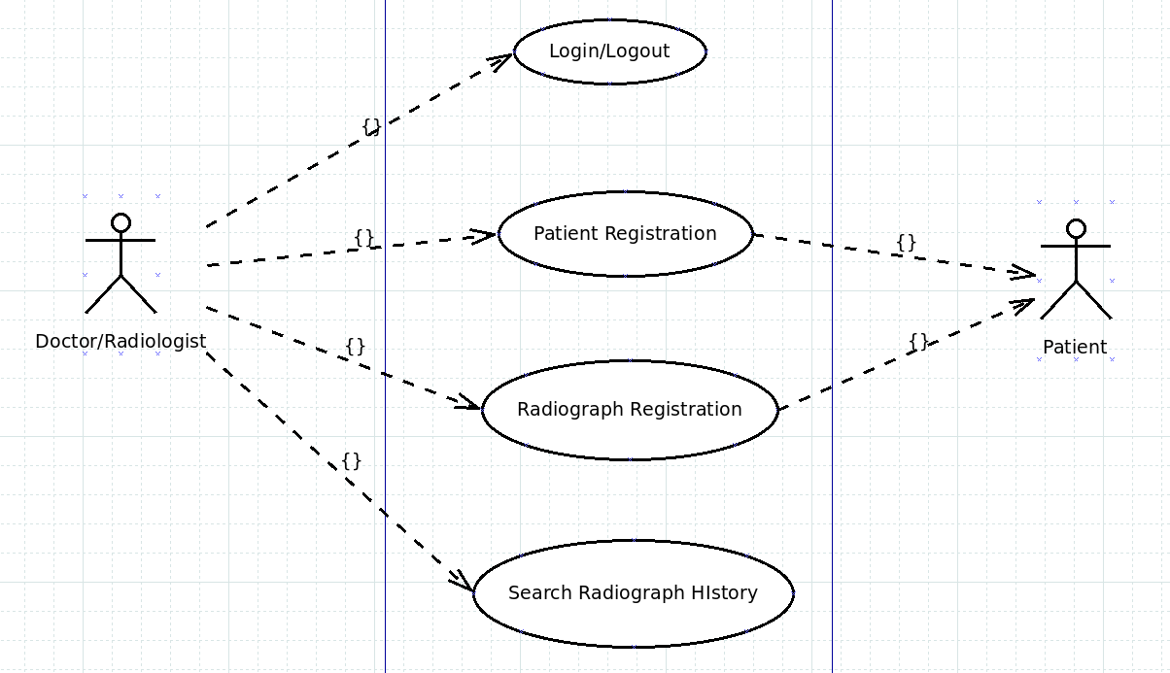
Figure : use case diagram

Entity Relationship Diagram :

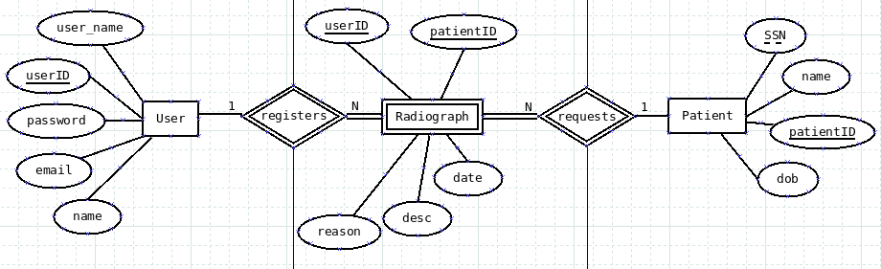

Figure : ERD

Database Diagram :
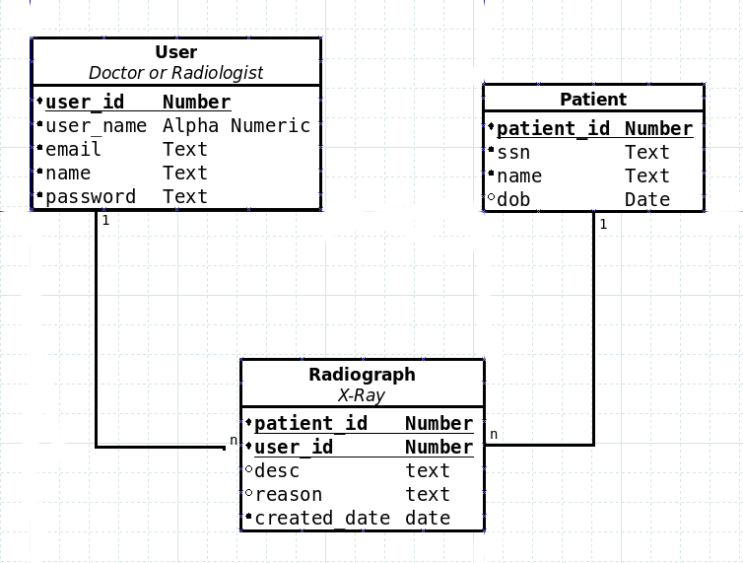
Figure : Database diagram

