Project Handover Document

Project

X-Ray Radiographs Management System
for Medical Centre

Developed by Muhammad Raheem
Java Developer

Dated : October 20, 2016

Diagrams

Use Case Diagram :
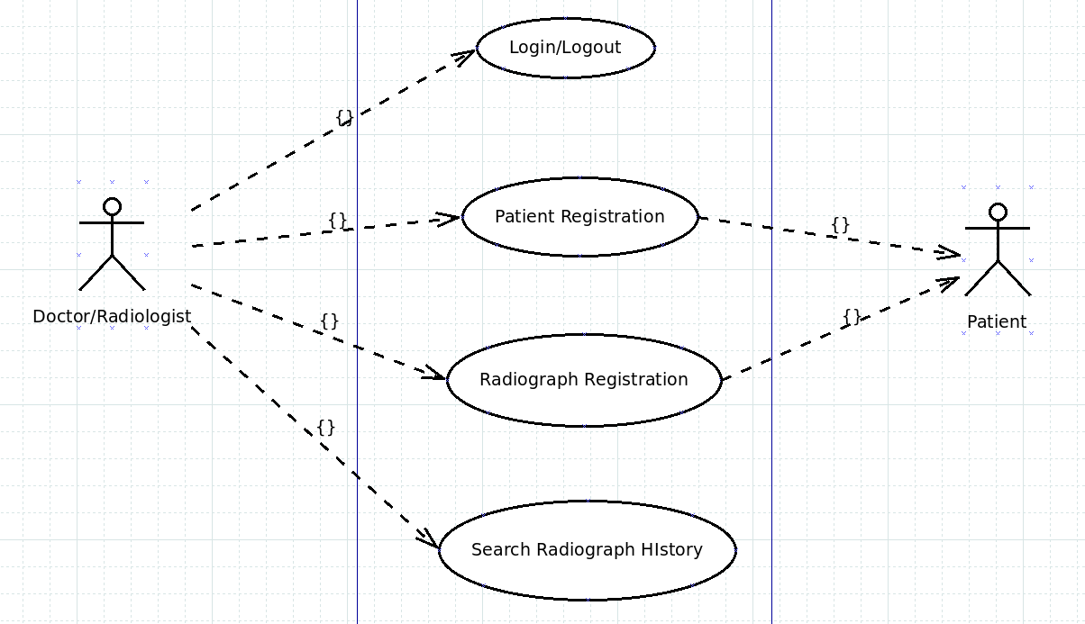
Figure : use case diagram

Entity Relationship Diagram :

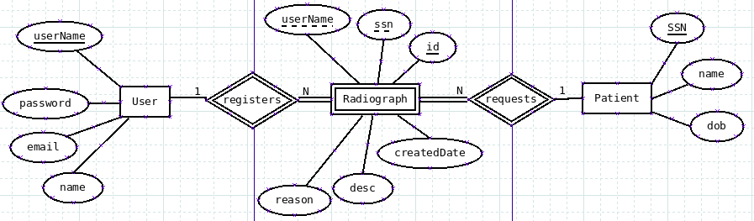

Figure : ERD

Database Diagram :

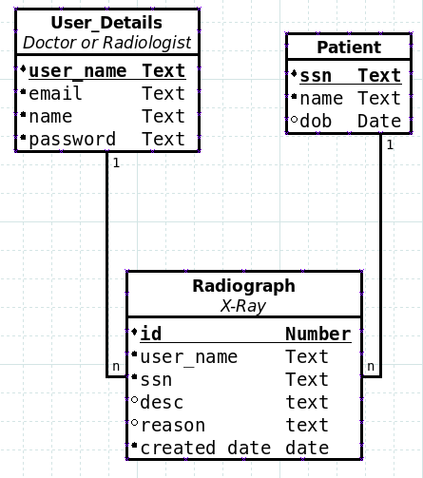

Figure : Database diagram

Tools and Technologies

Java8 :
Almost latest version of java has been used to build the application, although no advanced feature such as Lambdas and Streams are used due to simplicity of the application. The exact version and environment details are as follows,
openjdk version "1.8.0_91"
OpenJDK Runtime Environment (build 1.8.0_91-8u91-b14-3ubuntu1~16.04.1-b14)
OpenJDK 64-Bit Server VM (build 25.91-b14, mixed mode)

Maven :
Maven is used to manage the project dependencies automatically. Another purpose is to automate the build management process. It automatically handles the compilation, testing, war file creation etc.

MySql Database :
Open source production grade relational database management system. Looks to be an overkill for such a small application but its a good database with wide community support at various forums and blogs. This helps a lot in development process.

Spring MVC :
It decouples the application front end from backend and request/response management. JSP with HTML and JSTL along with Spring tag library is used to handle the view. The model consists of service and data access layers. Spring dispatcher controller provides Controller facility. Its very easy to configure and provide support for annotations and xml based configurtion. It seamlessly integrates with the data access layers. Spring has elegant framework architecture providing off the shelf components such as mvc which could be used alone. Spring MVC also provides good support for validation as well as internationalization and localization.

JSP :
with HTML, JSTL and Spring tag library is used to render the UI of the application.

Spring Data JPA :
Provides an abstration layer on top of Spring Data JPA common, simplifying the commonly used interfaces. Provides built in crud support, helping to avoid grunt code. These interfaces also helps us separate the implementation from DBMS. That means we can easily change underlying data store by simple configuration changes in the provided xml configuration file. Spring Data JPA also provides support for rich query languages such as HQL and Hibernate Criteria which are based on object model. In addition, we can always fall back to traditional native SQL if complexity arises. This elegant framework also helps in unit and integration testing of the system.

Hibernate with HQL :
This is the data provider used as JPA implementation which is seamlessly integrated to Spring Data JPA through datasource configuration.

Others :
Log4j logger
Apache Tomcat application server
GitHub
Git
Eclipse IDE
Linux OS
Testing with Junit, Mockito, Spring Test Framework and DBUtil : to be used.

Project Setup

Application properties
application properties such as database configuration can be configured in the application.properties file under resources directory of the project. The properties are as follows,
#Database Configuration
db.driver=com.mysql.jdbc.Driver
db.username=testuser
db.password=password
db.url=jdbc:mysql://localhost/medicaldb

#Hibernate Configuration
hibernate.dialect=org.hibernate.dialect.MySQLInnoDBDialect
#hibernate.hbm2ddl.auto=create-drop
hibernate.ejb.naming_strategy=org.hibernate.cfg.ImprovedNamingStrategy
hibernate.format_sql=true
hibernate.show_sql=true

Database
A database schema should be created by any name with a user, configurable in the properties file of the application.
The database scripts are provided in the resources folder of the project as well as separately in the project package by the name of db_scripts.txt. In the project, the subfolder named db under resources folder contains two file. The ddl.sql(Data Definition Language) file contains tables creation scripts and dml.sql(Data Manipulation Language) file contains scripts to user accounts. See the scripts below,
DDL scripts :
CREATE TABLE user_details
(
user_name VARCHAR(100) NOT NULL,
email VARCHAR(100) NOT NULL,
name VARCHAR(200) NOT NULL,
password VARCHAR(100) NOT NULL,
PRIMARY KEY (user_name),
CONSTRAINT unique_user_details_email UNIQUE (email)
);

CREATE TABLE patient
(
ssn VARCHAR(25) NOT NULL,
name VARCHAR(200) NOT NULL,
dob DATE,
PRIMARY KEY (ssn)
);

CREATE TABLE radiograph
(
id int(10) unsigned NOT NULL AUTO_INCREMENT,
user_name VARCHAR(100) NOT NULL,
ssn VARCHAR(25) NOT NULL,
reason VARCHAR(500) NOT NULL,
description VARCHAR(500) NOT NULL,
created_date TIMESTAMP DEFAULT CURRENT_TIMESTAMP,
PRIMARY KEY (id),
FOREIGN KEY (user_name) REFERENCES user_details(user_name),
FOREIGN KEY (ssn) REFERENCES patient(ssn)
);

DML Scripts :
insert into user_details values("raheem", "rahimpk123@yahoo.com", "Muhammad Raheem", "raheem123");
insert into user_details values("eric", "eric@yahoo.com", "Dr Eric Larsson", "eric123");

Logger Log4j
To configure the logger, change the log file path in the log4j.xml file under resources directory of the project.

Users Login info
Currently, the provided db script creates two users.
1) username = raheem password = raheem123
2) username = eric password = eric123
The two users, in addition to any other user created, can login to the system.

GitHub

Repository : https://github.com/rahimbuneri/medical.git

Build Process

Got to project root directory radiographs and fire up the following command,
> mvn clean package
and voila, you have the war file radiographs.war ready in the subdirectory named target to be shifted to the webapps folder of tomcat or any other application server.

URL
http://localhost:8080/radiographs

Host Name = localhost. Could be 127.0.0.1 or any other configured IP.
Port No = 8080 default port for Apache Tomcat. Any Servlet container would work.
Root Context = radiographs
The default page is login page.

Application Flow

Login to the system : After successful login, the user is directed to the home page.

Radiographs listing page is home page for the user where all options are provided such as create patient and see list of patients. The radiographs listing shows only those records which are created by the logged in user/doctor.

Add patient

Register Radiograph by selecting patient having name in the drop down list.

Patients list page

Logout : the user is redirected to login page.

Features

Forms validation implemented in patient and radiograph pages.

Concurrent users are supported although was not required. This is done through transactions in the service layer.

Application flow by providing rich set of links/menus on each page.

User Authentication through login and logout.

Internationalization and localization support. Currently, only English is supported but the application is configured to fully support any language. We just need to put the translations in properties file.

User engagement through immediate feedback for example success message after creating an object such as patient or radiograph record. Detailed error messages are also provided for validation error. For unknown errors such as 404 and 500, respective error pages are configured. In addition, good redirection between pages are provided to support good usability of the application.

Detailed Logging provided in separate file for each step in the application so that any loss of information could be recovered and errors in production could be analyzed.

Detailed code comments and both class and method levels and clean code with an eye for future extension such as search facility. In addition, the could is structured in simple modular way so that it could be easily followed.

Limitations and Future improvements

Basic Front end.

Basic User management. Currently, userName is kept in session after successful login and removed at logout. That means, any link can be directly accessed but radiographs will not be shown as no user information exitsts in session due to logout. The solution would be to put an interceptor or filter which will allow static resources(html, css, js and images) to be served without requiring authentication but redirect any unauthenticated/logged out user/copy paste link to login page.

Sorting and pagination is not supported. Could easily be added when required.

Basic validation for patient form and radiograph pages are implemented.
Name : Not Empty(only spaces included) and Max limit 100 characters
Social Security ID : Not Empty, Max limit 25 characters
Reason : Not Empty, Limit 500 characters
Description : Not Empty, Limit 500 characters

Insufficient Automated Testing
Unit tests for controllers
Integration tests for controllers
Unit tests for Data access layer
Integration tests for Data access layer

Multiple build environments setup such as test. Basic support is included but requires full configuration.

Embedded application server such as Jetty could be used for testing instead of tomcat, with embedded database.

