Modeling left ventricular diastolic dysfunction and cardiopulmonary fitness in hypertrophic cardiomyopathy

Mark E. Pepin,^{1,2,3 *} Diona Gjermeni, Jack O’Sullivan,^{1,2} Jonathan Hu, Gracia Fahed, Everton J. Santana, Sanjay Malunjkar,^{1,2} Jeffrey W. Christle,^{1,2} Matthew Wheeler,^{1,2} Eldrin F. Lewis,^{1,2} Euan Ashley,^{1,2} and Francois Haddad^{1,2}

- Stanford Cardiovascular Institute, Stanford University School of Medicine, Stanford, CA, USA
- Department of Medicine, Division of Cardiovascular Medicine, Stanford University School of Medicine, Stanford, CA, USA
- Cardiovascular Initiative, Broad Institute of Harvard and MIT, Boston, MA, USA

Short Running Title: Diastolic dysfunction in HCM
Total Character Count: 17,704 (Total)
Number of Figures: [Central Illustration, ~2-3 main Figures]
Number of Tables: [Patient demographics, stats table, etc]
Keywords: Diastolic dysfunction, hypertrophic cardiomyopathy, cardiopulmonary fitness

*Correspondence:
Mark E. Pepin, MD, PhD, MS, FESC
Division of Cardiovascular Medicine, Department of Medicine
Stanford University School of Medicine
Tel: 857-381-3060
E-mail: pepinme@gmail.com
Abstract [202/250 words]
Background. Left ventricular Diastolic dysfunction (DD) is a physiologic hallmark of hypertrophic cardiomyopathy (HCM), yet the correlation between resting echocardiographic indices and functional capacity remains controversial. The 2025 ASE guidelines proposed an updated hierarchical framework to improve its hemodynamic stratification, yet its utility in predicting cardiopulmonary fitness in HCM is unproven. Objectives. To characterize the association between the ASE 2025 diastolic diagnostic framework and objective cardiopulmonary fitness among individuals with HCM. Methods. We evaluated patients diagnosed with HCM (LVEF ≥ 55%) who underwent comprehensive echocardiography and serial cardiopulmonary exercise testing (CPET). LVDD was graded using the 2025 ASE algorithm, integrating E/e', Ar-A duration difference, peak tricuspid regurgitation velocity, and left atrial maximum volume index. The primary endpoint was the association between LVDD grade and peak oxygen consumption (VO₂). Secondary endpoints included VE/VCO₂ slope and heart failure-related outcomes. Nonlinearity was assessed using ***. Results. [NEED RESULTS]. Conclusions. In HCM, resting DD exhibits a modest nonlinear association with cardiopulmonary fitness. These data support that, while the ASE 2025 framework improves hemodynamic classification, resting metrics provide only modest predictive value for functional capacity. These findings underscore the complex, dynamic nature of exercise intolerance in HCM that extends beyond the noninvasive proxies of resting diastolic function.
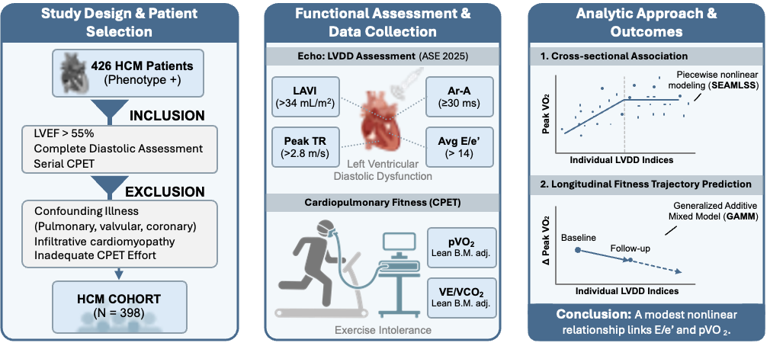
Abbreviations. ARIC = Atherosclerosis Risk in Communities Study; ASE = American Society of Echocardiography; BMI = body mass index; CAD = coronary artery disease; HFpEF = heart failure with preserved ejection fraction; LARS = left atrial reservoir strain; LAV = left atrial volume; LAVI = left atrial volume index; LVEF = left ventricular ejection fraction; LVDD = left ventricular diastolic dysfunction; PBHS = Project Baseline Health Study; TRV = tricuspid regurgitation velocity.
Figure 1: Conceptual summary. This retrospective longitudinal analysis investigates the hemodynamic determinants of exercise intolerance in non-obstructive hypertrophic cardiomyopathy (HCM). ASE = American Society of Echocardiography; CPET = cardiopulmonary exercise testing; HCM = hypertrophic cardiomyopathy; VO₂ = oxygen consumption.

Introduction
Hypertrophic cardiomyopathy (HCM) represents the most common inherited cardiovascular condition and is characterized by a chronic, progressive decline in exercise tolerance that culminates in heart failure with preserved ejection fraction (HFpEF).^{1,2} Clinical trials of HCM therapies often employ comprehensive cardiopulmonary exercise testing (CPET) given its quantifiable prognostic bearing.^{3,4} However, the associated expense, complexity, and geographic constraints remain barriers to its wider implementation.
The origins of cardiopulmonary fitness among HCM patients are multifactorial and encompass both altered structural morphology and tissue mechanics. Alongside preclinical decrements in functional capacity, genetic HCM carriers exhibit left ventricular diastolic dysfunction (LVDD),⁵ implicating its central role in its clinical manifestations. Specifically, genotype-positive carriers exhibit increased myocardial stiffness and delayed relaxation,^{6–8} coinciding with worsened diastolic hemodynamics.^{9,10} Nevertheless, while preliminary studies support the ability of LVDD characterization to predict the presence of genotypic HCM, conflicting reports question its utility as a true predictor of cardiopulmonary fitness.
Echocardiographic assessment of LVDD in HCM relies on Doppler-derived surrogates that provide indirect estimates of mean left atrial pressure.¹¹ These measurements, however, are frequently confounded by dynamic loading conditions and coincident valvular abnormalities, resulting in only modest correlations with invasive hemodynamics and functional capacity.^{12,13} Earlier algorithmic approaches to diastolic classification compounded these limitations, often yielding indeterminate categorization among HCM patients that had failed to capture the continuous spectrum of LVDD that dictates exercise intolerance.¹⁴
In response, the American Society of Echocardiography recently provided updated guidelines to better define LVDD in patients with HCM by limiting "indeterminate" cases and lessening reliance on preload-dependent measurements.^{13,15} This updated guidance proposes the use of E/e' (>14), Ar-A duration difference (≥30 ms), left atrial maximum volume index (>34 mL/m²), and peak tricuspid regurgitation velocity (>2.8 m/s) that together exhibit a robust inverse correlation with invasive LV filling pressures.^{16–19} Subsequent multi-center studies support the implementation of this new guidance for HFpEF, citing improved sensitivity for detecting elevated filling pressures relative to the previous framework.²⁰ Larger cohort analyses, including the Atherosclerosis Risk in Communities (ARIC) study, offer age-stratified references to establish the prognostic relevance of diastolic function for incident heart failure complications and mortality.²¹ However, its utility as a relevant proxy of functional capacity has not been shown among individuals with HCM.
Therefore, the current study aims to characterize the relationship between LVDD – as defined by the ASE 2025 guidelines – and cardiopulmonary fitness among individuals with HCM. Here, we describe a continuous association between individual LVDD indices and peak VO₂ using flexible nonlinear regression modeling. Lastly, we leverage serial endpoints of cardiopulmonary fitness to test whether the utility of LVDD modeling predicts a longitudinal trajectory of fitness.
Methods
Ethical approval. The study protocol was reviewed and approved by the Stanford University Institutional Review Board (IRB, XXXX). Informed consent was obtained from all participants whose data were curated for inclusion in the current analysis. All patient data and samples were de-identified to maintain privacy and confidentiality.
Study population and patient selection. We performed a retrospective analysis of a longitudinal cohort of patients with phenotypically manifested HCM (Table 1). To limit the physiologic confounding of clinical comorbidities, inclusion was restricted to patients with a left ventricular ejection fraction (LVEF) ≥ 55% and the absence of significant left ventricular outflow tract (LVOT) obstruction (resting and provoked peak gradients < 30 mmHg). We also excluded patients with known infiltrative cardiomyopathy (e.g., cardiac amyloidosis), moderate-to-severe valvular heart disease, severe coronary artery disease (defined as having undergone prior percutaneous intervention or surgical bypass), or primary pulmonary pathology including pulmonary hypertension or interstitial lung disease. To ensure the validity of our functional assessments, patients were excluded if they possessed comorbid muscular or neurologic conditions precluding maximal effort during exercise testing. Patients with incomplete echocardiographic diastolic analysis required for guideline-based classification were also excluded.
Diastolic assessment via transthoracic echocardiography. Comprehensive trans-transthoracic echocardiography was performed using a standardized clinical protocol, as has been previously described.²² Post hoc diastolic functional analysis was classified using the 2025 American Society of Echocardiography (ASE) recommendations,¹⁵ which details four primary diagnostic features for HCM: average E/e′ ratio (> 14), pulmonary venous Ar-A duration difference (≥ 30 ms), peak tricuspid regurgitation velocity (> 2.8 m/s), and left atrial maximum volume index (> 34 mL/m²). Additional echocardiographic variables included mitral inflow velocities (E and A), septal and lateral e′ velocities, isovolumic relaxation time (IVRT), posterior wall thickness, septal wall thickness, LVOT gradient, and left ventricular ejection fraction (LVEF).
Cardiopulmonary exercise testing (CPET). Symptom-limited cardiopulmonary exercise testing was performed using a standardized ramp protocol on a treadmill with continuous electrocardiographic (ECG) and breath-by-breath gas exchange monitoring in accordance with standardized protocol.²³ Tests were considered adequate if the respiratory exchange ratio (RER) was ≥ 1.04. Peak oxygen consumption (peak VO₂) was defined as the highest 20 second averaged value during the final stage of exercise and expressed both as an absolute value and as percent predicted using age and sex adjusted reference equations derived from NHANES data.²⁴ Secondary CPET parameters included metabolic equivalents (METs) achieved, ventilatory efficiency quantified by the VE/VCO₂ slope, and heart rate recovery (HRR) measured at one minute after terminating exercise.
Modeling the relationship between diastolic dysfunction and fitness. To characterize the continuous relationship between diastolic indices and cardiopulmonary fitness (i.e. Peak VO₂), we utilized a Semiparametric Additive Model for Location, Scale, and Shape (SEAMLSS) within the GAMLSS framework, as previously described.²⁵ While standard reference equations often employ the LMS method (Box-Cox transformation),²⁶ our approach relies on a global power parameter λ to distort severity grading in the central physiologic range when correcting for tail skewness (the "butterfly effect").
Derivation of the Stable Relative Metric. The primary relative deviation was defined as the log-transformed ratio of observed (y) to predicted (μ) values, as follows:
$$u\left(x\right)=\ln\left(\frac{y}{μ\left(x\right)}\right)$$
Longitudinal Prediction. Serial CPET data were analyzed using mixed-effects modeling to determine if baseline diastolic Z-scores – derived from the SEAMLSS framework – predicted the trajectory of Peak VO₂ decline over time. To characterize this longitudinal trajectory, we employed a Generalized Additive Mixed Model (GAMM) rather than standard linear mixed models to account for potential nonlinearity in fitness decline.²⁷ The GAMM framework extends the mixed-effects model by replacing the linear slope of time with a penalized nonparametric regression spline allowing the data to determine the shape of the trajectory without imposing a rigid linear assumption. The model specification included a random intercept and random smoother for each subject to account for within-patient correlation and individual heterogeneity in decline patterns. To test the prognostic value of diastolic function, we evaluated the tensor product interaction between the continuous time smooth and the baseline SEAMLSS-derived LVDD Z-score, as previously described. This interaction term explicitly tests whether the nonlinear trajectory of Peak VO$_2$ significantly diverges as a function of baseline diastolic severity. Model fit was assessed using the Akaike Information Criterion (AIC), with the nonlinear GAMM demonstrating superior fit compared to nested linear alternatives.
To adjust for the skewness inherent within physiologic measurements while avoiding the accompanying global distortion, we used a semiparametric piecewise-linear mapping (SEAMLSS) rather than a global Box-Cox power transformation, as previously stated. Briefly, while the Box-Cox method (LMS) is a useful standard for deriving reference equations,^{26,28} its global curvature can conflate values within the normal range when correcting for extreme tails. We mathematically validated that, for the mild skewness observed in this cohort our piecewise approach converges with the Box-Cox transformation while preserving a stable, linear interpretation of severity (log-percent predicted) in the clinically primary diagnostic window (Supplemental Figure SX).

Results
- Patient characteristics.
- Number of patients included
- Comorbidities (see above)
- Characterizing the association between diastolic dysfunction and cardiopulmonary fitness.
- DD and peak VO₂
- DD and VE/CO₂ slope
- Other direct comparators?
- Modeling the nonlinear correlation between left ventricular diastolic dysfunction and cardiopulmonary fitness.
- Longitudinal association between diastolic dysfunction and cardiopulmonary fitness.
- Serial analysis of DD and Peak VO₂
- Serial analysis of DD and VE/VCO₂ slope

Discussion

- Main takeaways: TBD
- Context: The gold standard assessment for phenotypic profiling of HFpEF, including nonobstructive HCM, involves invasive measurement of left ventricular filling pressure at rest and during peak exercise. However, noninvasive tools are preferred given the limited access to facilities capable of providing these assessments.
- Meaning of diastolic parameters:

Current diastolic assessment necessitates a multiparametric integration of indices reflecting active relaxation, passive stiffness, and chronic remodeling to overcome the limitations of any single variable. Early validation using simultaneous micromanometry established that while mitral inflow patterns (E, A, and deceleration time) accurately reflect the acute trans-mitral pressure gradient, they remain confounded by their strong dependence on preload (Appleton et al.). To isolate intrinsic myocardial relaxation (τ) from loading conditions, tissue Doppler imaging of the mitral annulus (e') was developed, demonstrating relative load-independence in human physiologic models. Consequently, the E/e' ratio has emerged as the most robust non-invasive surrogate for mean left atrial pressure (PCWP), providing a validated hemodynamic correlate across a spectrum of ejection fractions (Nagueh et al.); Ommen et al.). These acute hemodynamic snapshots are contextualized by the left atrial volume index (LAVI), which serves as the morphologic "barometer" of chronic diastolic burden and cumulative wall stress (Tsang et al.), while pulmonary venous flow analysis—specifically the temporal difference between venous and mitral A-wave reversal—offers distinct insight into LVEDP independent of mean LAP (Rossvoll & Hatle).
- First validation of E/e’ by Doppler in patients with HCM compared with right heart catheterization.¹¹
- Dynamic invasive measures of LV diastology predict heart failure outcomes and cardiopulmonary fitness, challenging the notion that resting metrics are sufficient for clinical prognostics.²⁹
- Normalizing PCWP via nitrates fails to improve peak VO2, suggesting that while elevated LV filling pressure correlates with exercise intolerance, the innate mechanical properties of the myocardium that are more likely causal of both diastolic dysfunction and exercise intolerance.³⁰
Limitations.
  - Single-center study?
  - Retrospective cohort?
  - Additional validation that includes clinical information
  - Supervised analysis?
Conclusion
Our data support that resting diastolic dysfunction, when rigorously phenotyped using the ASE 2025 framework and modeled continuously, shows a real albeit modest nonlinear association with cardiopulmonary fitness in HCM. Furthermore, we show that resting diastology fails to predict fitness trajectory, highlighting its limited potential use as a surrogate of physiologic reserve.
References
1. Butzner, M. et al. Epidemiology of hypertrophic cardiomyopathy in the United States from 2016 to 2023. JACC Adv. 5, 102552 (2026).
2. Ommen, S. R. et al. 2024 AHA/ACC/AMSSM/HRS/PACES/SCMR guideline for the management of Hypertrophic Cardiomyopathy: A report of the American heart association/American college of cardiology joint committee on clinical practice guidelines. Circulation 149, e1239–e1311 (2024).
3. Olivotto, I. et al. Mavacamten for treatment of symptomatic obstructive hypertrophic cardiomyopathy (EXPLORER-HCM): a randomised, double-blind, placebo-controlled, phase 3 trial. Lancet 396, 759–769 (2020).
4. Monda, E. & Limongelli, G. ODYSSEY-HCM trial (mavacamten in symptomatic nonobstructive hypertrophic cardiomyopathy). Eur. Heart J. Cardiovasc. Pharmacother. 11, 661–662 (2025).
5. Magrì, D. & Santolamazza, C. Cardiopulmonary exercise test in hypertrophic cardiomyopathy. Ann. Am. Thorac. Soc. 14, S102–S109 (2017).
6. Qiao, J. et al. Diastolic dysfunction assessed by cardiac magnetic resonance imaging tissue tracking on normal-thickness wall segments in hypertrophic cardiomyopathy. BMC Med. Imaging 23, 7 (2023).
7. Ho, C. Y. et al. Assessment of diastolic function with Doppler tissue imaging to predict genotype in preclinical hypertrophic cardiomyopathy. Circulation 105, 2992–2997 (2002).
8. Nagueh, S. F. et al. Tissue Doppler imaging consistently detects myocardial abnormalities in patients with hypertrophic cardiomyopathy and provides a novel means for an early diagnosis before and independently of hypertrophy. Circulation 104, 128–130 (2001).
9. Pislaru, C., Anagnostopoulos, P. C., Seward, J. B., Greenleaf, J. F. & Belohlavek, M. Higher myocardial strain rates during isovolumic relaxation phase than during ejection characterize acutely ischemic myocardium. J. Am. Coll. Cardiol. 40, 1487–1494 (2002).
10. Rust, E. M., Albayya, F. P. & Metzger, J. M. Identification of a contractile deficit in adult cardiac myocytes expressing hypertrophic cardiomyopathy-associated mutant troponin T proteins. J. Clin. Invest. 103, 1459–1467 (1999).
11. Geske, J. B., Sorajja, P., Nishimura, R. A. & Ommen, S. R. Evaluation of left ventricular filling pressures by Doppler echocardiography in patients with hypertrophic cardiomyopathy: correlation with direct left atrial pressure measurement at cardiac catheterization. Circulation 116, 2702–2708 (2007).
12. McCollum, E. D. & Ginsburg, A. S. Outpatient management of children with world health organization chest indrawing pneumonia: Implementation risks and proposed solutions. Clin. Infect. Dis. 65, 1560–1564 (2017).
13. Lu, D.-Y. et al. E/e’ ratio and outcome prediction in hypertrophic cardiomyopathy: the influence of outflow tract obstruction. Eur. Heart J. Cardiovasc. Imaging 19, 101–107 (2018).
14. Nagueh, S. F. et al. Recommendations for the evaluation of left ventricular diastolic function by echocardiography: An update from the American society of echocardiography and the European association of cardiovascular imaging. J. Am. Soc. Echocardiogr. 29, 277–314 (2016).
15. Nagueh, S. F. et al. Recommendations for the evaluation of left ventricular diastolic function by echocardiography and for heart failure with preserved ejection fraction diagnosis: An update from the American society of echocardiography. J. Am. Soc. Echocardiogr. 38, 537–569 (2025).
16. Inoue, K. et al. Determinants of left atrial reservoir and pump strain and use of atrial strain for evaluation of left ventricular filling pressure. Eur. Heart J. Cardiovasc. Imaging 23, 61–70 (2021).
17. Nagueh, S. F. & Khan, S. U. Left atrial strain for assessment of left ventricular diastolic function: Focus on populations with normal LVEF. JACC Cardiovasc. Imaging 16, 691–707 (2023).
18. Saijo, Y. et al. Impact of left atrial strain mechanics on exercise intolerance and need for septal reduction therapy in hypertrophic cardiomyopathy. Eur. Heart J. Cardiovasc. Imaging 23, 238–245 (2022).
19. Zegkos, T. et al. Left atrial myopathy is associated with exercise incapacity and ventilatory inefficiency in hypertrophic cardiomyopathy. Heart Lung Circ. 32, 215–223 (2023).
20. Lababidi, H. et al. New algorithm for estimating left ventricular filling pressure by echocardiography. Circulation 152, 424–435 (2025).
21. Shah, A. M. et al. Contemporary assessment of left ventricular diastolic function in older adults: The Atherosclerosis Risk in Communities study. Circulation 135, 426–439 (2016).
22. Mitchell, C. et al. Guidelines for performing a comprehensive transthoracic echocardiographic examination in adults: Recommendations from the American society of echocardiography. J. Am. Soc. Echocardiogr. 32, 1–64 (2019).
23. American Thoracic Society & American College of Chest Physicians. ATS/ACCP Statement on cardiopulmonary exercise testing. Am. J. Respir. Crit. Care Med. 167, 211–277 (2003).
24. King, D. E. & Xiang, J. Retirement and healthy lifestyle: A National Health and Nutrition Examination survey (NHANES) data report. J. Am. Board Fam. Med. 30, 213–219 (2017).
25. Rigby, R. A. & Stasinopoulos, D. M. Generalized additive models for location, scale and shape. J. R. Stat. Soc. Ser. C. Appl. Stat. 54, 507–554 (2005).
26. Cole, T. J. & Green, P. J. Smoothing reference centile curves: the LMS method and penalized likelihood. Stat. Med. 11, 1305–1319 (1992).
27. Lin, X. & Zhang, D. Inference in generalized additive mixed models by using smoothing splines. J. R. Stat. Soc. Series B Stat. Methodol. 61, 381–400 (1999).
28. Quanjer, P. H. et al. Multi-ethnic reference values for spirometry for the 3-95-yr age range: the global lung function 2012 equations. Eur. Respir. J. 40, 1324–1343 (2012).
29. Eisman, A. S. et al. Pulmonary capillary wedge pressure patterns during exercise predict exercise capacity and incident heart failure. Circ. Heart Fail. 11, e004750 (2018).
30. Sarma, S. et al. Challenging the hemodynamic hypothesis in heart failure with preserved ejection fraction: Is exercise capacity limited by elevated pulmonary capillary wedge pressure? Circulation 147, 378–387 (2023).

Figures

Central Illustration
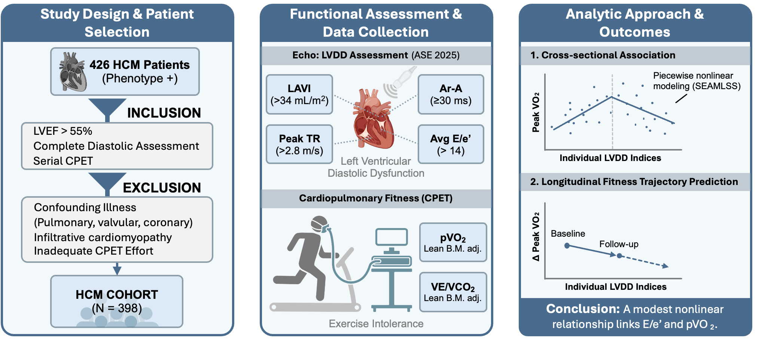
Figure 1: Conceptual summary. This retrospective longitudinal analysis investigates the hemodynamic determinants of exercise intolerance in non-obstructive hypertrophic cardiomyopathy (HCM). ASE = American Society of Echocardiography; CPET = cardiopulmonary exercise testing; HCM = hypertrophic cardiomyopathy; VO₂ = oxygen consumption.

Table 1: Patient demographics and relevant health information (Age, sex, race/ethnicity, NYHA functional status, CPX parameters, comorbidities, beta blocker Y/N (to interpret CPX).
Characteristic | N = 397¹
Age, years | 47.3 (16.1)
Sex
Male | 248 (62%)
Female | 149 (38%)
Body Mass Index, kg/m² | 27.2 (5.7)
Body Surface Area, m² | 1.9 (0.3)
Lean Body Mass Index, kg/m² | 23.4 (5.8)
HCM Phenotype
Apical | 49 (14%)
Asymmetric Septal | 253 (72%)
Burned-out | 3 (0.9%)
Symmetric | 45 (13%)
Peak RER | 1.1 (0.1)
Peak VO₂ (PP - FRIEND 2.0) | 75.5 (236.9)
VO₂ (PP – WASSERMAN) | 98.8 (83.2)
VE/VCO₂ Slope | 31.3 (5.8)
Heart Rate Recovery (1-min) | 27.5 (11.8)
¹Mean (SD); n (%)

Figure 1
Figure 1. Anthropometric and Cardiopulmonary Exercise Characteristics. Distribution of baseline biometrics and functional capacity in patients with hypertrophic cardiomyopathy (HCM). (A-B) Histograms and density plots for age and body mass index (BMI). (C) Lean body mass index (LBMI) calculated via race-agnostic NHANES equations. (D) Comparison of peak VO₂ (% predicted) using the FRIEND 2.0 (blue) and Wasserman (red) reference equations. (E) Ventilatory efficiency VE/VCO₂ slope across the cohort. VO₂, oxygen consumption; VCO₂, carbon dioxide production; VE, minute ventilation.

Figure 2
Figure 2: Longitudinal functional trajectories and parameter correlations. (A) Individual patient trajectories of peak oxygen consumption (VO₂) as a percentage of predicted capacity (FRIEND 2.0 equation) over time, illustrating global linear regression (red line) with 95% confidence intervals (shaded region). (B) Temporal map of cardiopulmonary exercise testing follow-up. (C) Heatmap of Pearson correlation coefficients (ρ) between baseline demographics, anthropometrics, and longitudinal functional parameters.

Table 2: nonlinear coefficients.

