Stakeholders

|  |  |  |  |
| --- | --- | --- | --- |
| **Role** | **Group** | **Concerns** | **Views** |
| Project Manager | Project Managers | Keep to schedule; Project Success | Project plan |
| Program Sponsor | Sponsors | Project Value ($, Time, Quality) | Project plan |
| Product Owner | Product Owners | Achieving consensus among all stakeholders, constantly aligning customer’s requirements | Project plan |
| Enterprise Architect | Architects | Overall enterprise and segment architecture | Infrastructure diagram |
| Solution Architect | Architects | Design of particular system components, component compatibility |  |
| Team Lead | Project Team | Project coordination; Strong tech skills and wide-view to construct high-level implementation plan | Application components integration diagram |
| Developer | Project Team | Clear tasks description and implementation details |  |
| QA Engineer | Project Team | Clear business requirements and use cases | Business requirements document |
| Business Analyst | Project Team | Requirements traceability; Stakeholders availability |  |
| System Engineer | Project Team | Maintain up-to-date deployment diagram | Deployment diagram, Infrastructure diagram |
| Customer | End Users | Cost reduce; Time-to-market; Usability; Performance; |  |
| Supplier | Suppliers |  |  |
| Domain Expert | SME |  |  |
| Inhibitor | Competitive department (inside company) | Fear to lose position / budgets / or to be fired after the project goes to production (due to new automated operations for example) |  |

Power/Interest matrix

High

Keep Satisfied Key Players

Sponsors PM

Architects

Team Leads

Some SMEs

**Power**

Minimal Effort Keep Informed

Customers Project Team

End Users Some SMEs

Suppliers Competitive department

Low

Low **Interest** High

Stakeholders Responsibilities (RACI matrix)

**Legend**

* **Responsible**:  The stakeholder performs the project work activities.
* **Accountable**: The stakeholder is accountable to the sponsor or to the customer for the result of the work activities.
* **Consulted**: The stakeholder is asked for opinions on objectives, assumptions, constraints, or methods of planning and developing products or process due to expertise or position in the organization.
* **Informed**: The stakeholder is notified of the outcome of project decisions.

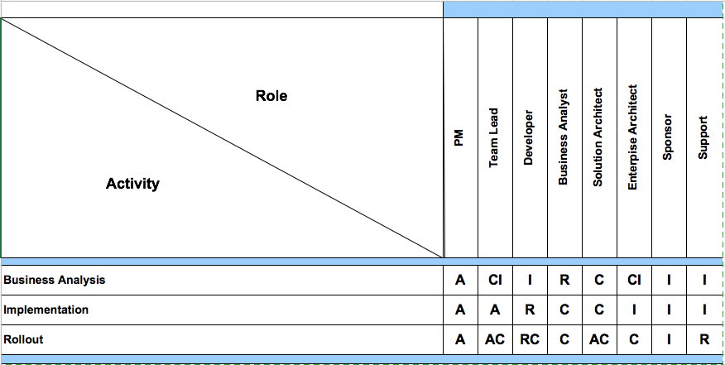

Requirements Management

|  |  |  |
| --- | --- | --- |
| **Business Drivers** | **Business Goals** | **Business Objectives** |
| Booking management process is too expensive. | Cost reduction via centralized reporting and hotel management; | To reduce average hotel and transfer booking using centralized system with ability to choose the best option from the several. |
| Booking management process is completely manual now and takes too much time. | Automation to reduce a number of manual processes. | Minimize a number of manual processes leaving only critical things for manual verification. Other operations should be done automatically when possible (change statuses, sending confirmation e-mails, etc.). |
| Booking management process is poorly incorporated into existing EPAM systems. | Integration with Cost Tracking Center, UPSA and SSO. | Build integration channels between this system and existing systems. |
| Booking management process is too complex. | Make simplistic and intuitive common look and feel view for all system users and administrators. | To reduce average time-to-book applying common EPAM’s look and feel patterns and minimizing number of clicks before booking completion for end users. |
|  |  |  |
|  |  |  |
|  |  |  |

Functional Decomposition