Utility Tree (ASRs)

EPAM Booking Service

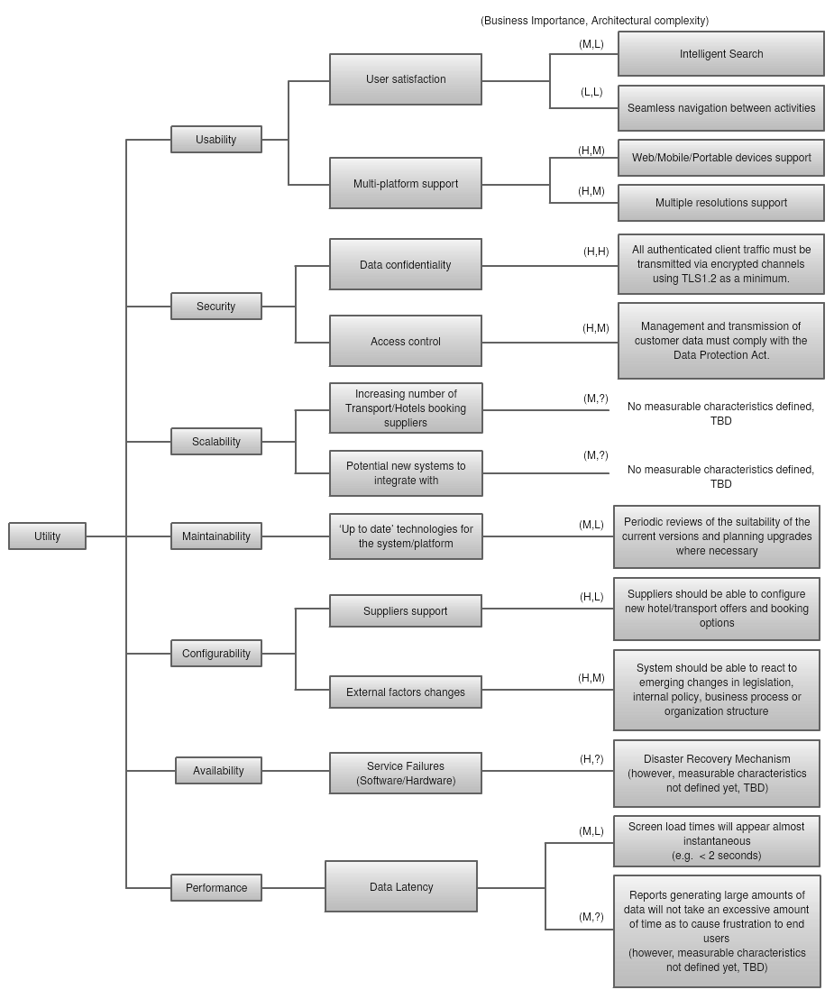

Quality Attributes Achieving (Patterns/Tactics)

1. Modifiability

|  |  |
| --- | --- |
| **Tactic** | **Pattern Description** |
| Reduce size of a module | Split Module |
| Increase cohesion | Increase Semantic Coherence |
| Reduce coupling | * Encapsulate * Use and Intermediary * Restrict Dependencies * Refactor * Abstract Common Services |
| Defer Binding | Try to bind values as late as possible providing more general solutions on each stage.  Compile/Build Stage   * Component replacement (e.g. in a buildscript) * Compile-time parameterization * Aspects   Deployment Stage   * Configuration-time binding   Startup/Initialization Stage   * Resource files   Runtime Stage   * Dynamic lookup * Shared repositories * Publish-Subscribe model * Polymorphism |

1. Performance

|  |  |
| --- | --- |
| **Tactic** | **Pattern Description** |
| Control Resource Demand | * Manage sampling rate (reduce frequency) * Limit Event Response (make queues) * Prioritize events * Reduce overhead * Bound execution times |
| Manage Resources | * Increase resources * Introduce concurrency * Use load balancer * Use caching and data replication * Bound queue size * Schedule resources |

1. Usability

|  |  |
| --- | --- |
| **Tactic** | **Pattern Description** |
| Support User Initiative | * Cancel (free resources, return state to initial) * Undo (return state to previous * Pause/Resume (for long-running tasks) * Aggregate (group operations over single) |
| Support System Initiative | * Maintain task model * Maintain system model * Maintain user model |