
Front Desk Guide
Booking, check-in and check-out in the Solkeb Hotel Management System
October 2026

Contents

1. Overview
This guide shows how a guest's stay moves through the system, from the first booking to check-out. Every screenshot was taken from the real application using sample (training) data.
A booking always moves through the same stages:
Stage | What it means | Room on the room board
Confirmed | The booking is saved and the room is held for those dates. | Reserved (arriving)
Checked in | The guest has arrived, their ID is recorded and the room nights are on the bill. | Occupied
Checked out | The bill is fully paid and the guest has left. | Available, needs cleaning
Cancelled / No-show | The booking was cancelled, or the guest never arrived. The room is released. | Available

Who can do what
Task | Admin | Manager | Receptionist | Accountant
View bookings, guests, room board | Yes | Yes | Yes | Yes
Create and edit bookings, check in, check out | Yes | Yes | Yes | No
Add services and charges to a bill | Yes | Yes | Yes | No
Record payments | Yes | Yes | Yes | Yes
Give a discount, remove a bill line | Yes | Yes | No | No
Record a refund | Yes | Yes | No | Yes
Delete a booking made by mistake | Yes | Yes | No | No
Restore a deleted booking | Yes | No | No | No

2. Logging in and finding your way

Logging in
Each staff member has their own account. Everything you do is recorded under your name, so never share your login.
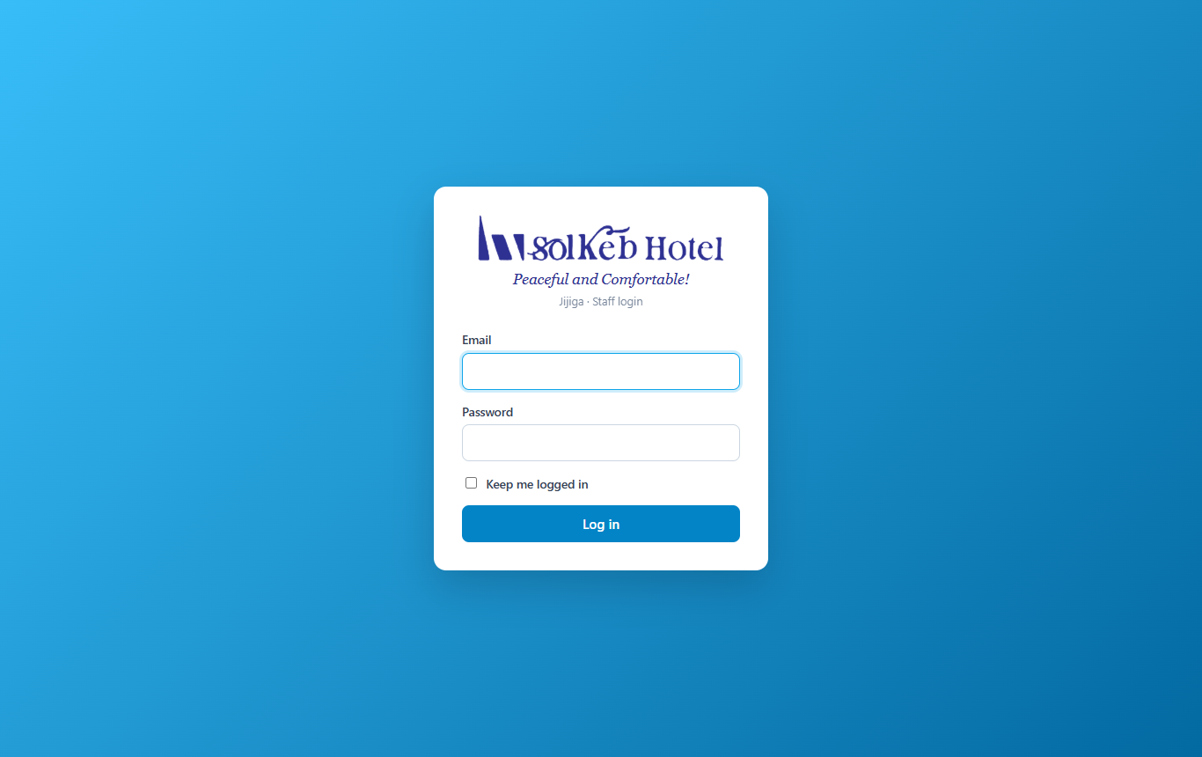
Figure 1. The login page

The dashboard
After logging in you see today's overview: occupancy, guests arriving and leaving today, rooms waiting to be cleaned and money collected today. Click Open next to any guest to go straight to their booking.
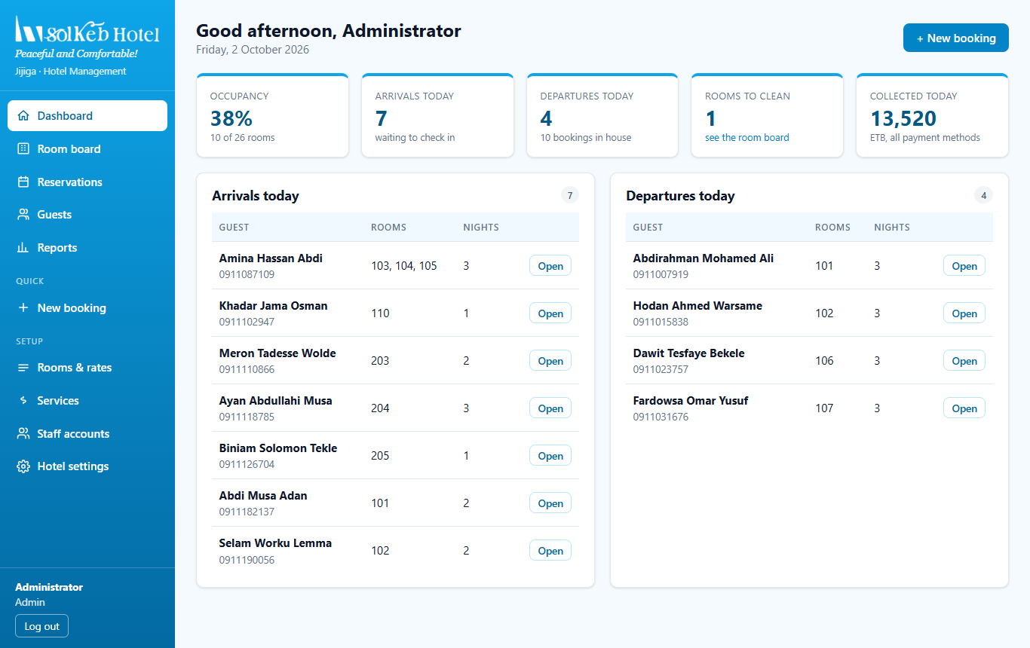
Figure 2. Dashboard with today's arrivals and departures

The room board
The room board shows every room by floor, colour-coded by status: Available, Reserved (arriving), Occupied and Out of order. Rooms that belong to the same organisation booking share a colour (for example, the purple UNICEF rooms below).
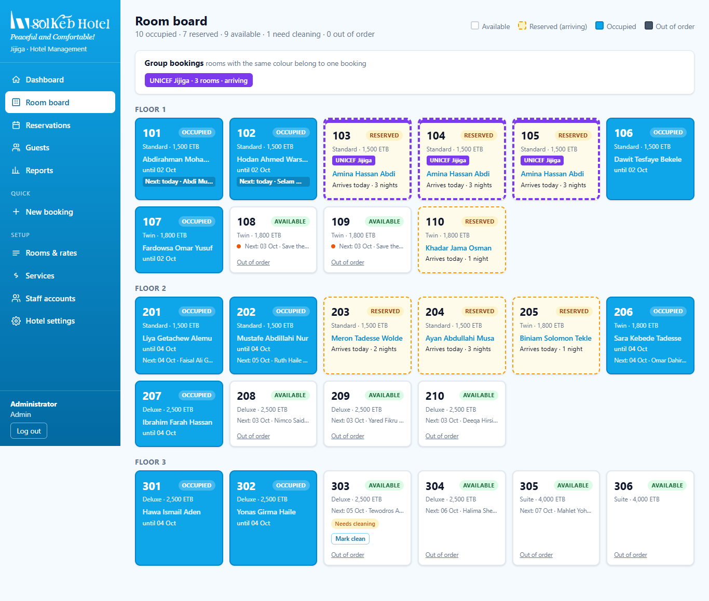
Figure 3. Room board showing occupied, reserved and available rooms

The reservations list
Reservations lists every booking. You can search, and filter by status.
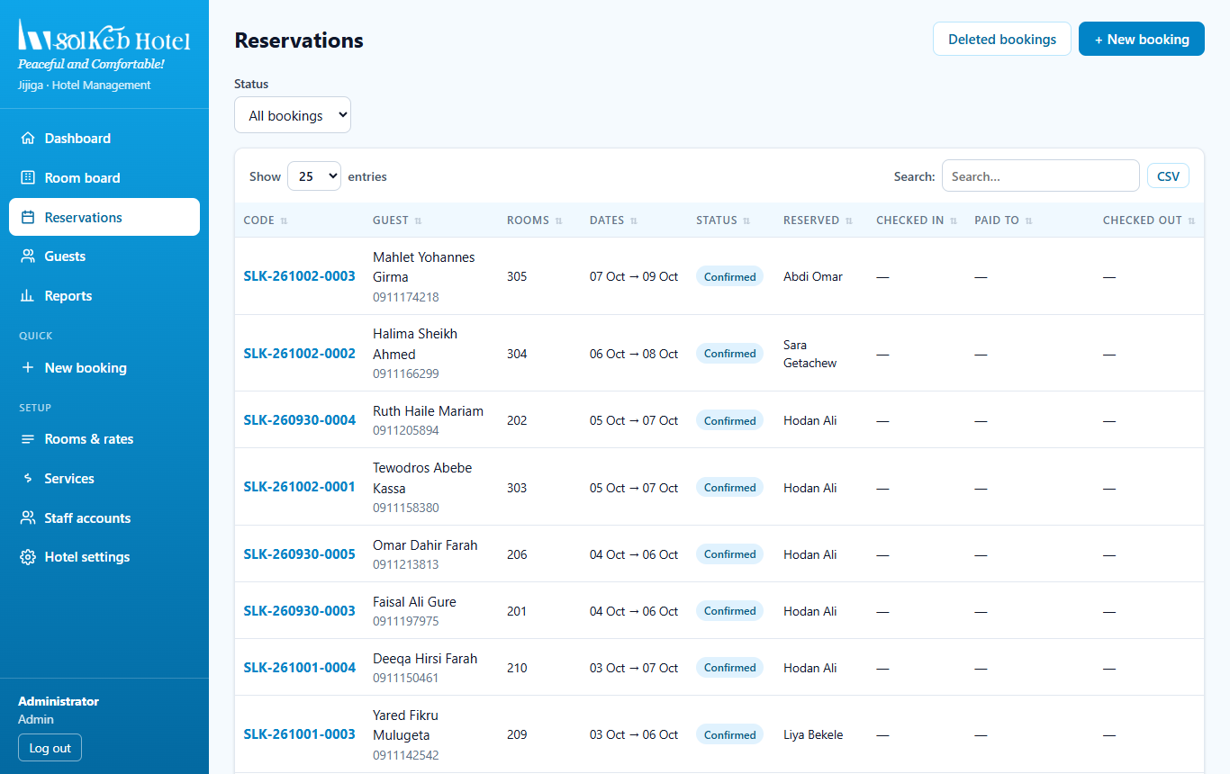
Figure 4. Reservations list

3. Making a booking
Go to New booking in the menu (or the + New booking button on the dashboard).
- Choose the dates. Set the check-in and check-out dates and click Show free rooms. Only rooms that are free for the whole stay are shown, grouped by room type with their nightly price.
- Pick one or more rooms. Click a room to select it. For an organisation booking, select several rooms; they will share a colour on the room board.
- Enter the guest. Type the first name and phone number (required). If the phone number already belongs to a returning guest, the booking is added to their existing record instead of creating a duplicate. The ID can be added now or at check-in.
- Stay details. Number of adults and children, how the booking came in (walk-in, phone, website, Booking.com, travel agent, corporate) and any special requests.
- Deposit (optional). If the guest pays something in advance, enter the amount and method.
- Click Create booking.
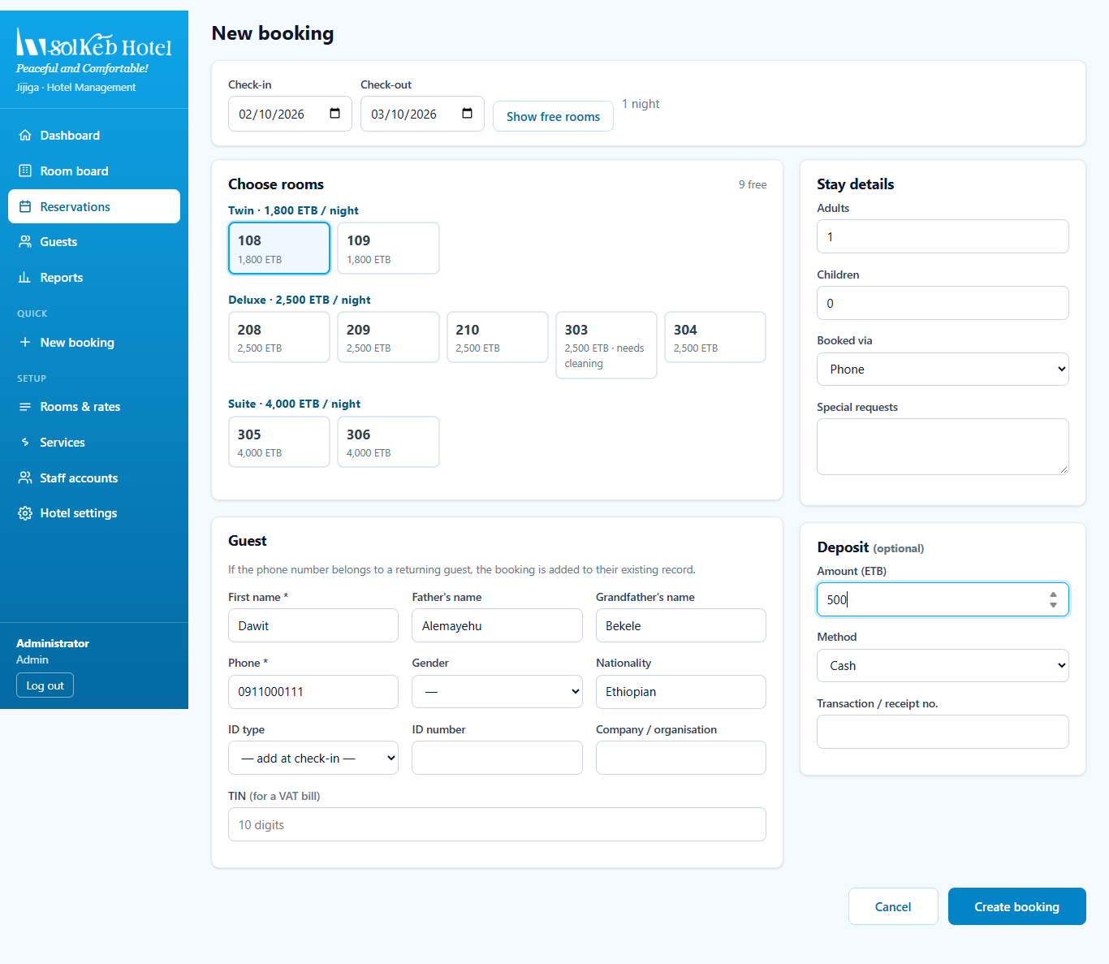
Figure 5. New booking form: room 108 selected, guest details and a 500 ETB deposit entered
The booking is saved as Confirmed and gets a booking code such as SLK-261002-0004. The deposit appears under Payments, and the History shows who created the booking.
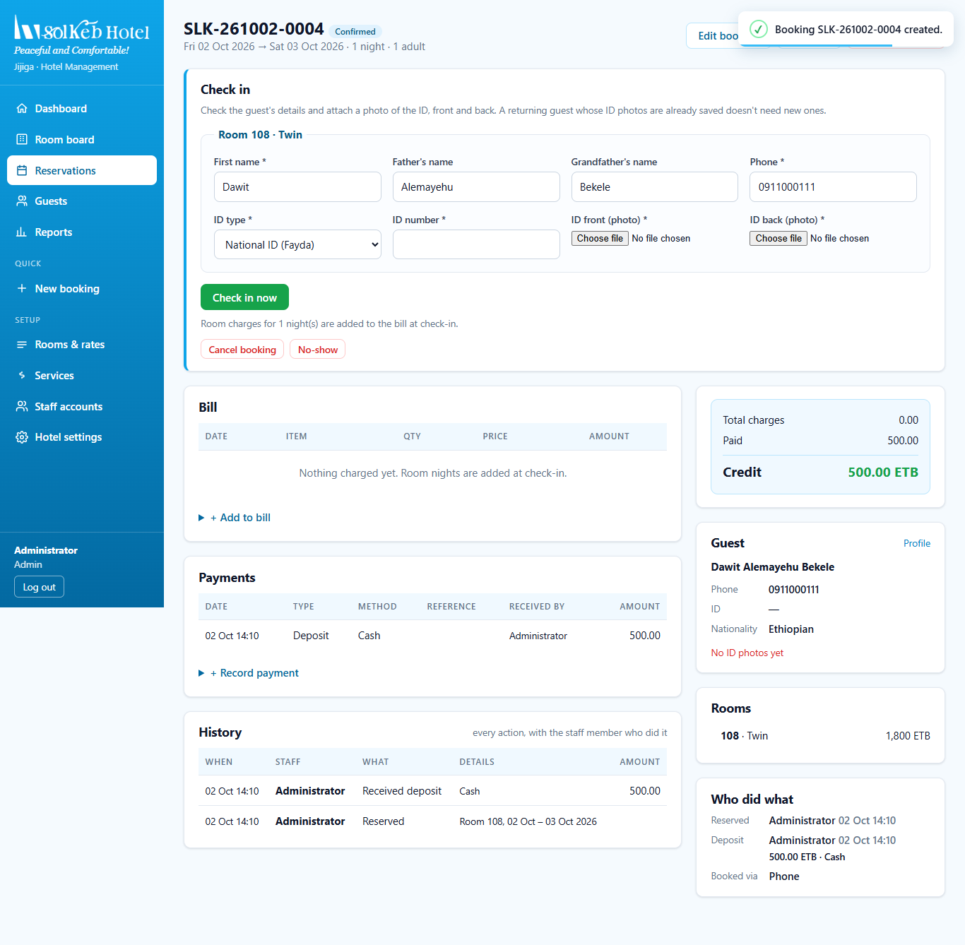
Figure 6. The new booking, confirmed, with the check-in form ready
If a room was just taken: if someone else booked the same room while you were filling in the form, the system stops and asks you to choose again. A room can never be double-booked.

Changing or cancelling before arrival
- Edit booking changes the dates, rooms or number of guests. The original nightly price is kept for rooms that stay on the booking.
- Cancel booking cancels it and releases the room.
- No-show marks a guest who never arrived and releases the room.

4. Checking a guest in
Open the booking (from the dashboard's Arrivals today list, the room board or Reservations). The Check in box is at the top of the page.
- Check the guest's name and phone. For the first room these are filled in from the booking; change them if someone else is staying.
- Choose the ID type and enter the ID number.
- Attach a photo of the front and back of the ID (a passport only needs the front). Photos are reduced in size automatically; "Photo ready" appears when each one is attached.
- Click Check in now and confirm.
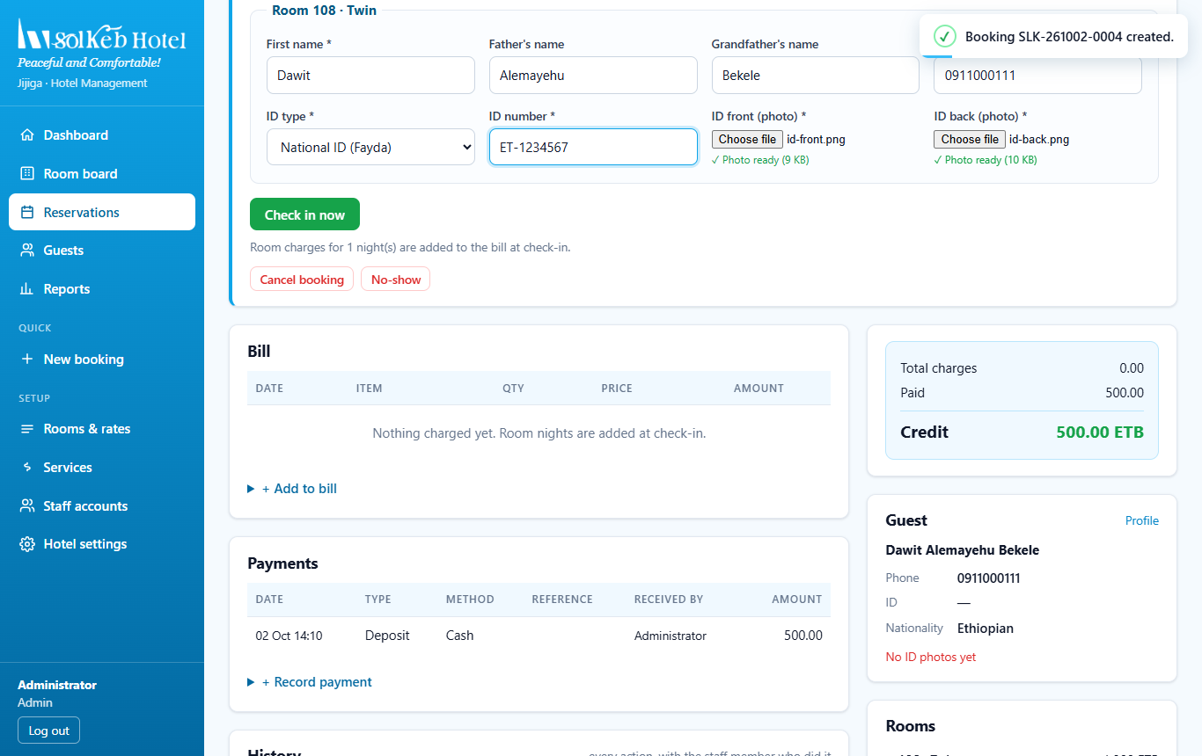
Figure 7. Check-in form with ID details and both ID photos attached
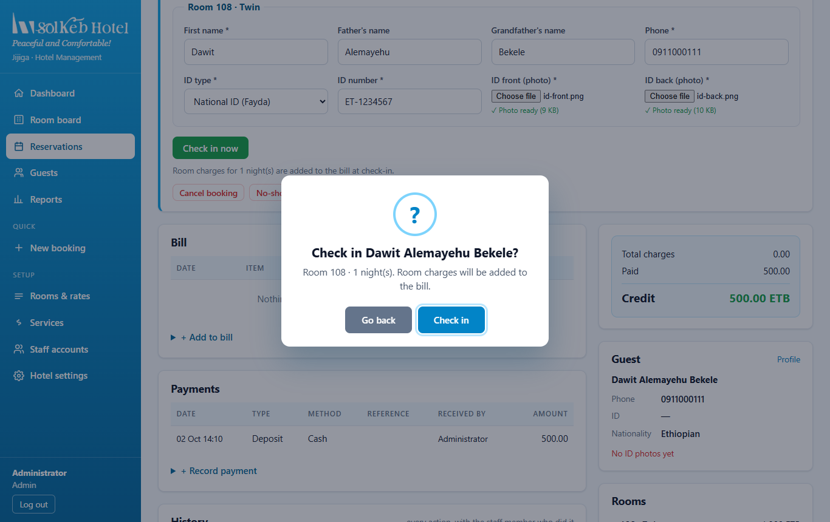
Figure 8. Confirmation before checking in
After check-in, the booking shows Checked In, the room becomes Occupied and the room nights are added to the bill automatically. The ID photos are saved on the guest's profile.
Organisation bookings: when a booking has several rooms, there is one section per room. Enter the person actually staying in each room, with their own ID.
Returning guests are recognised by their ID number (or phone and first name). If their ID photos are already saved, you do not need to upload them again.

When check-in is blocked
Message | What to do
Check-in date is in the future | Use Edit booking to change the dates first if the guest arrives early.
Room is still occupied | Check the previous guest out of that room first.
Attach a photo of the front / back of the ID | Attach the missing ID photo.

5. During the stay

Adding to the bill
Open + Add to bill on the booking page. Choose a service (food, drinks, laundry and so on) and a quantity, or add any other charge with a description and amount. Managers can also give a discount here.
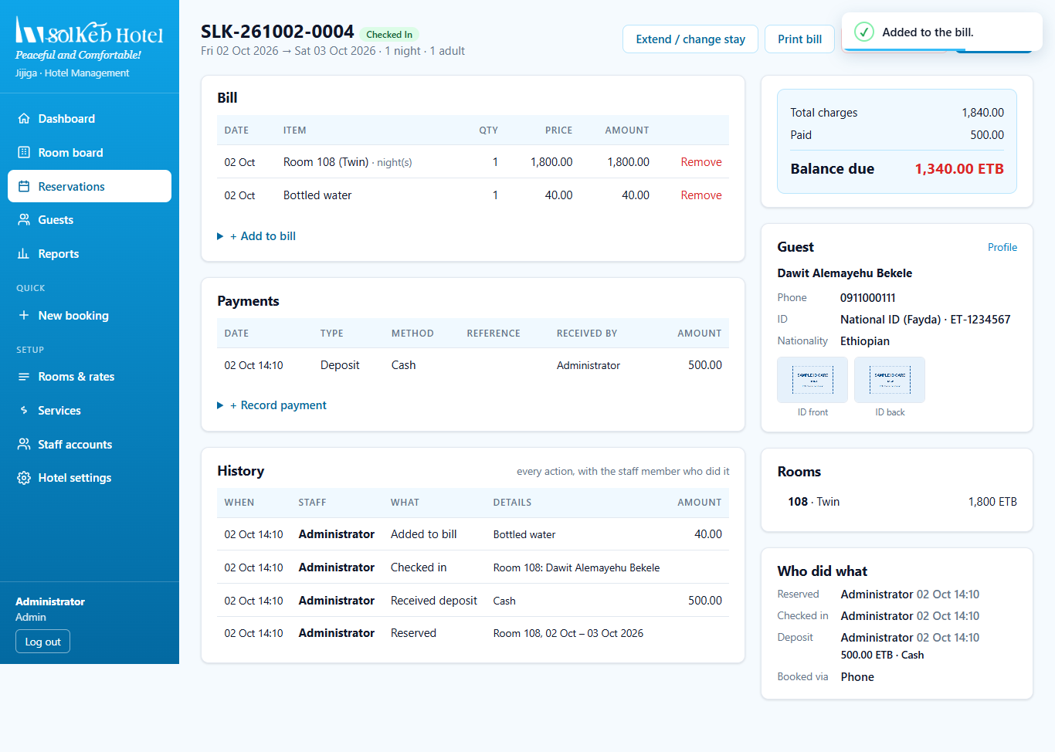
Figure 9. Bottled water added to the bill: the balance due updates straight away

Extending or shortening the stay
Click Extend / change stay to change the check-out date. The room nights on the bill are recalculated.

Recording a payment
Open + Record payment. The amount is filled in with the balance due. Choose the method and type, then click Record payment and confirm.
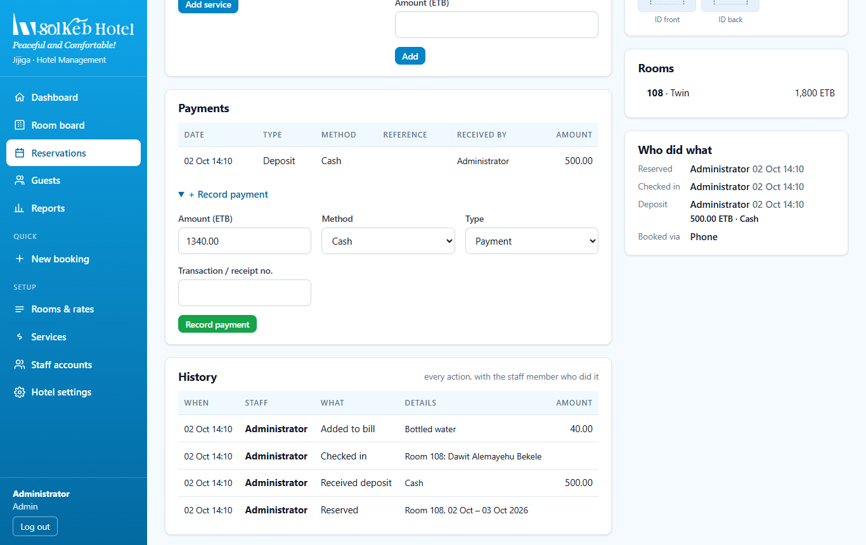
Figure 10. Recording a payment of the remaining balance
Telebirr, CBE Birr and bank transfer payments need the transaction number, so the money can be matched to the bank statement later.

6. Checking a guest out
Click Check out at the top of the booking page and confirm.

The bill must be paid first
If there is still money owed, check-out is stopped and the system tells you how much is due. Record the payment, then check out again.
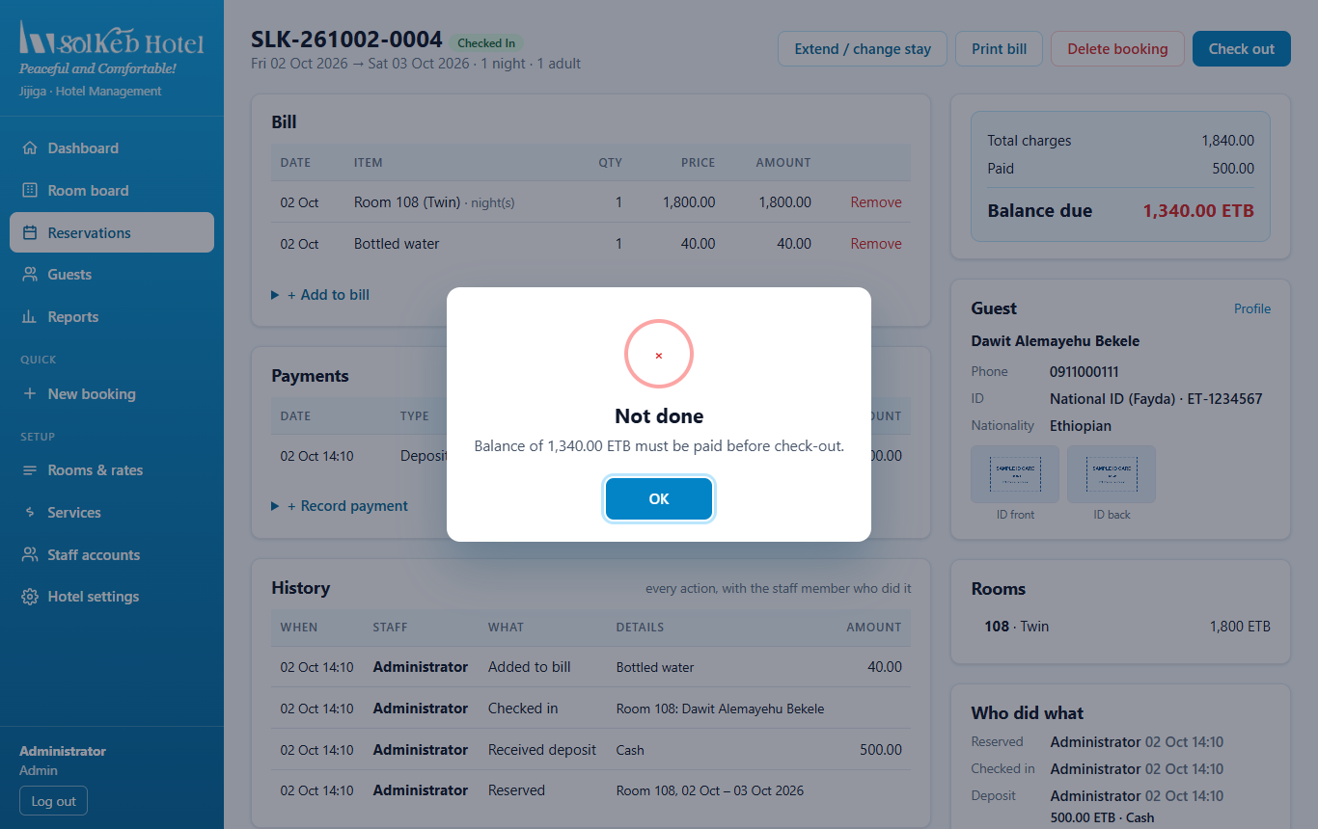
Figure 11. Check-out stopped because 1,340 ETB is still due

After check-out
Once the balance is 0, the guest is checked out. The bill is closed, and the room goes back to Available but is marked Needs cleaning on the room board.
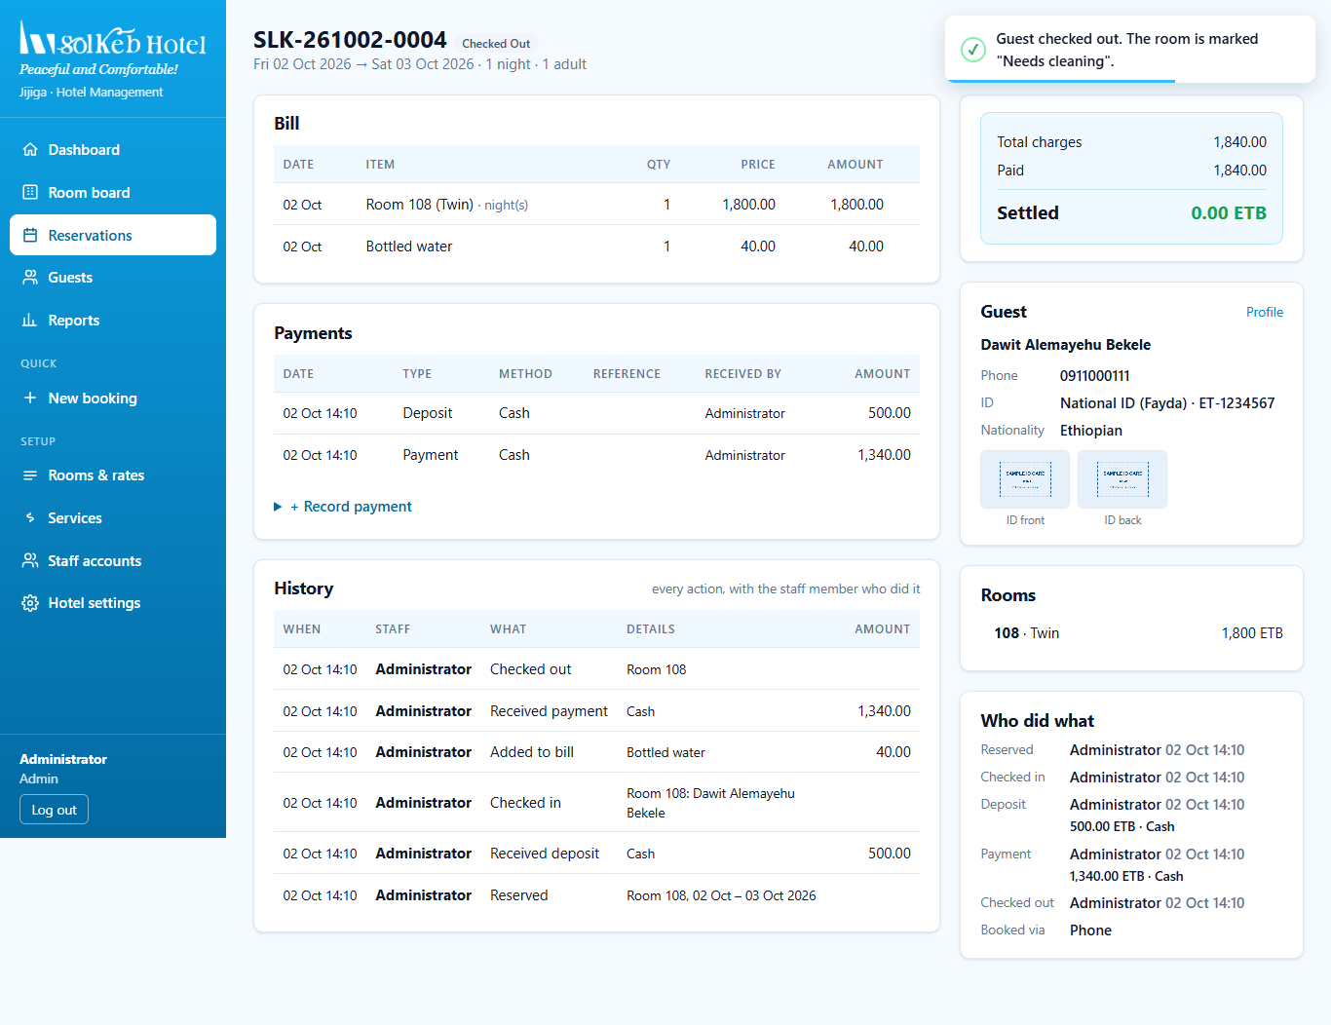
Figure 12. Checked out: bill settled, with the full history of who did what
Early departure or late stay: at check-out the room nights are recalculated for the nights actually stayed. If the guest paid more than the final bill, the system reminds you to record a refund.

Printing the invoice
Click Print bill to open the invoice. It shows every item, the VAT included (15%), payments and the balance, with space for the guest's signature.
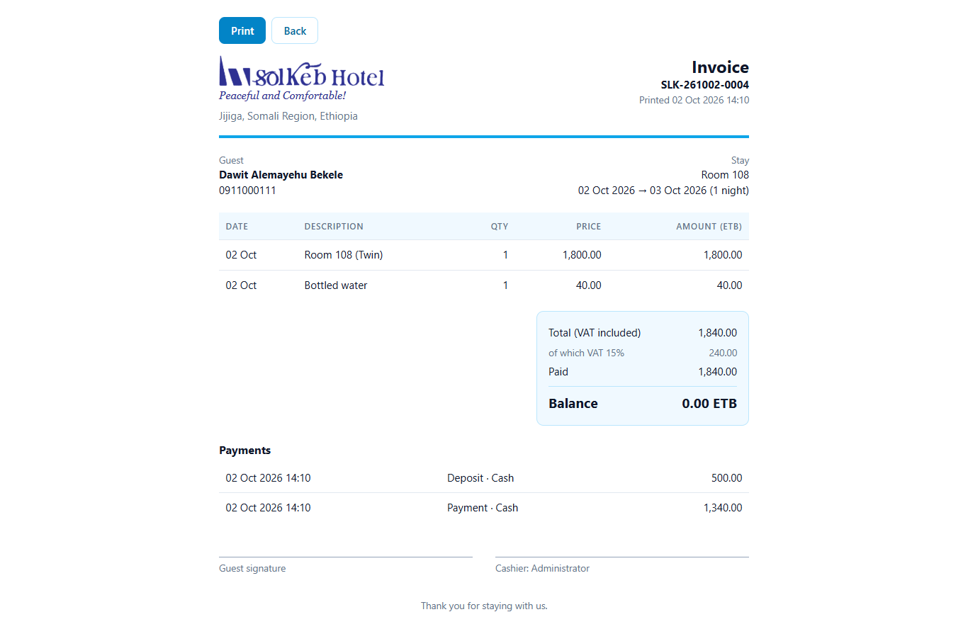
Figure 13. Printable invoice

Cleaning the room
On the room board, the room shows Needs cleaning. When housekeeping has finished, click Mark clean so the room is ready for the next guest.
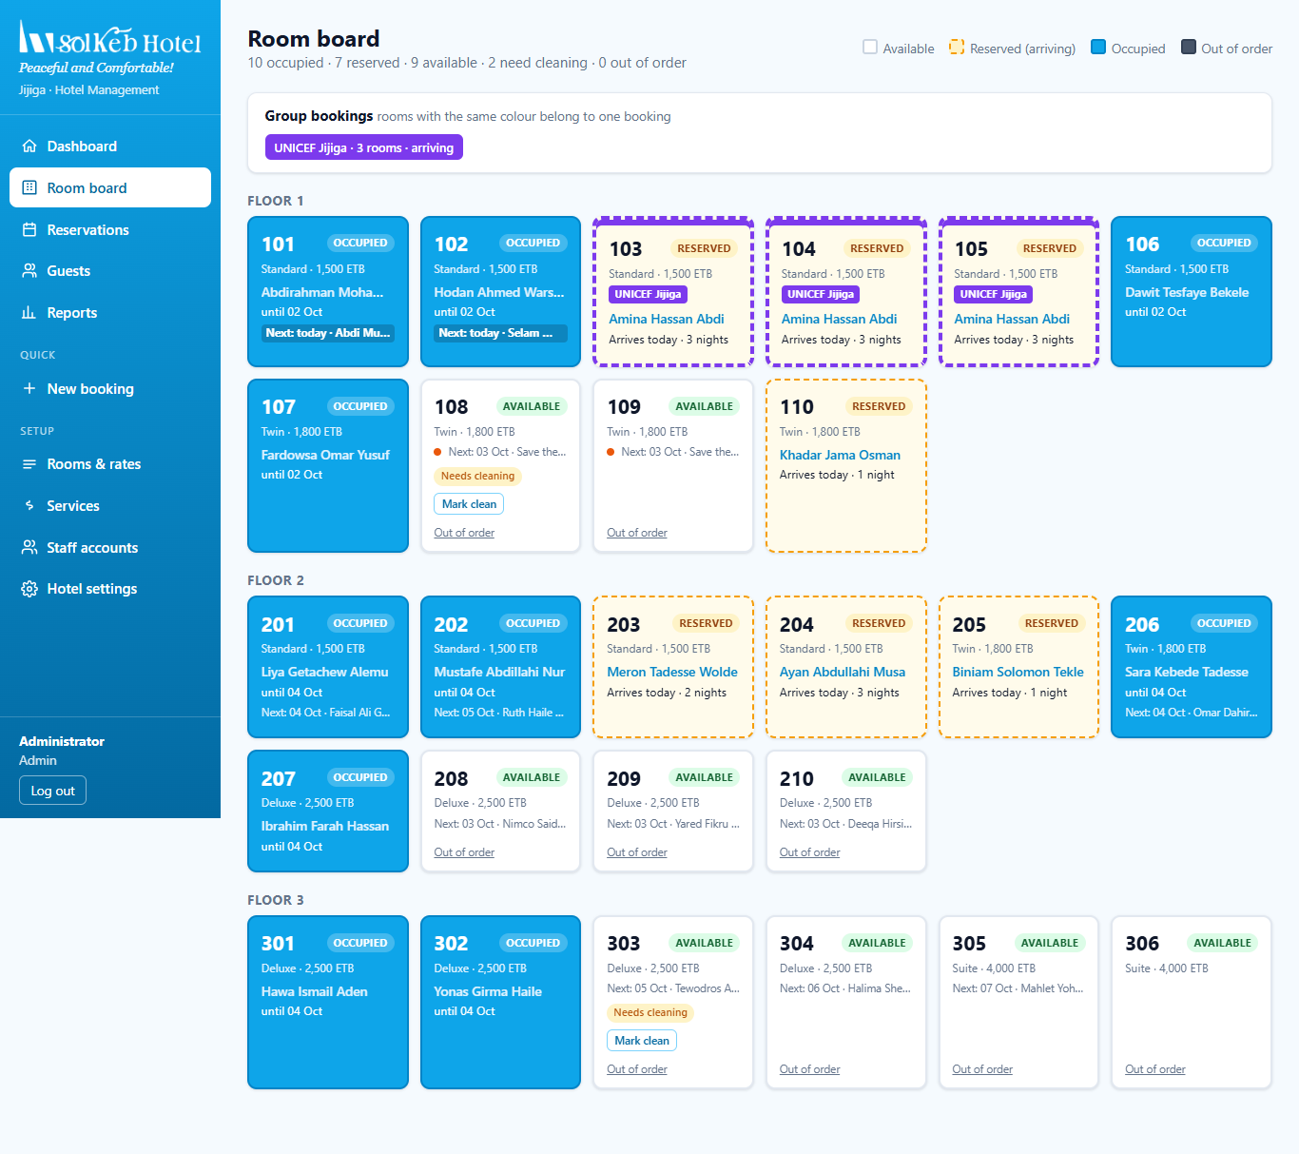
Figure 14. Room 108 back to Available and marked Needs cleaning

7. Deleting a booking made by mistake
- A manager can delete a booking, but must give a reason.
- Deleted bookings are not lost: they go to the Deleted bookings log, together with the reason and who deleted them.
- Only the admin can restore a deleted booking, and only if its rooms have not been given to someone else.
- A finished (checked-out) stay is part of the hotel's accounts, so only the admin can delete it.

Quick reference
I want to... | Where
Make a booking | Menu → New booking
Check a guest in | Booking page → Check in box → Check in now
Add food, drinks, laundry | Booking page → + Add to bill
Take a payment | Booking page → + Record payment
Change the dates | Booking page → Edit booking / Extend / change stay
Check a guest out | Booking page → Check out (balance must be 0)
Print the bill | Booking page → Print bill
Mark a room clean | Room board → Mark clean

